August 13, 2012

Prepared By: David B. Augustine
Specification: Vacuum 3 inch Gate Valve Specification for Proton Improvement Plan
The longitudinal width of the valve shall not exceed 3.625. This dimension can be a little shorter but must be approved in advance.
Aperture | size | 3 inch clear through valve
Material | Body, Carriage, and Gate | 300 Series Stainless Steel
Material | Bellows | AM-350 Stainless Steel
Material | Air Cylinder | Teflon Coated Aluminum
Material | Bolts | 300 Series Stainless Steel
Material | Vacuum Flange | Fermi Drawing | 0315-MB-19022
Gasket | Bonnet UHV | OFE Copper
Gasket | Gate | O-ring EPDM colorized series purple | DO NOT use silicone grease on this O-ring, high outgas rate. | Higher radiation resistance than Viton
Gasket | Piston | O-ring EPDM colorized series purple | Lubricate piston chamber and piston seal ONLY with Dow Corning Silicone Stopcock grease. | Higher radiation resistance than Viton
Electropneumatic Actuator | Air Pressure | 70 to 100 psig
Electropneumatic Actuator | Solenoid Power | 120 Vac, 60 hz | No diode in solenoid coil | Will not survive in radiation field
Electropneumatic Actuator | Power Loss | Valve closes | Mechanically locks when closed, no air pressure required to remain leak tight.
Electropneumatic Actuator | Position Indicators | Mechanical, Vernier adjustable, hinged-roller type micro switches suitable for 5A, 120/240 Vac | Open and Close
Vacuum | Range | 1x10⁻¹¹ | Torr
Vacuum | Leak test | 2x10⁻¹⁰ | Cc/sec Helium
Temperature | Bakeability | Open or closed | 150 Celsius

Suggested Valve Body
From MDC Web Site
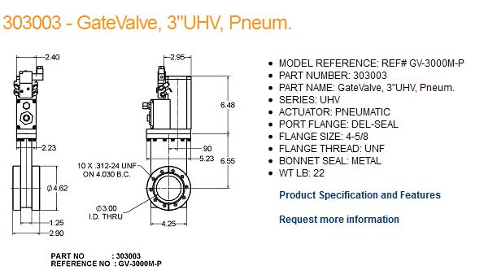

Fermi Drawing of Booster Vacuum flanges
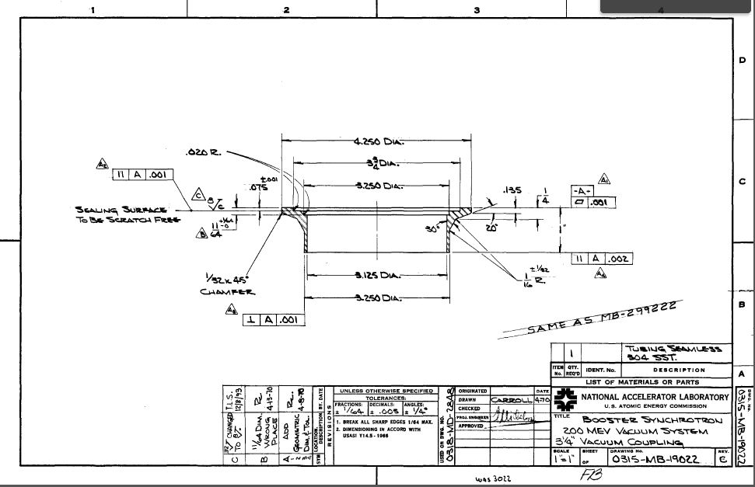

Clamp for flange above is
VOSS 514503H-438-BA
6-93

Conceptual Design Drawing by MDC, August 9, 2012
