Booster LLRF Open Loop Transfer Function Analysis
Ed Cullerton
3/19/2019
In this note, a simplified model of the Booster LLRF open loop transfer function is analyzed using MATLAB and Simulink Simulations, and the simulation results are compared to measured data. The MATLAB model simulates the mathematical transfer functions of phase in the s-domain. The gain, delay, and phase shift of the model can be adjusted to best match the measured data. The Simulink model is simulated in the time domain and is designed to simulate hardware components where possible. The response of the Simulink hardware model is shown to agree with the mathematical MATLAB model, giving increased confidence in the models.
For the MATLAB mathematical model, each section of the of the LLRF system has been modeled by a phase transfer function in the s-domain. Figure 1 shows the components of the LLRF system that has been modeled. The LLRF system has been simplified for understanding purposes and the radial position loop is excluded. The model shows configuration of the open loop VSA measurement and closed loop operation(dotted line).
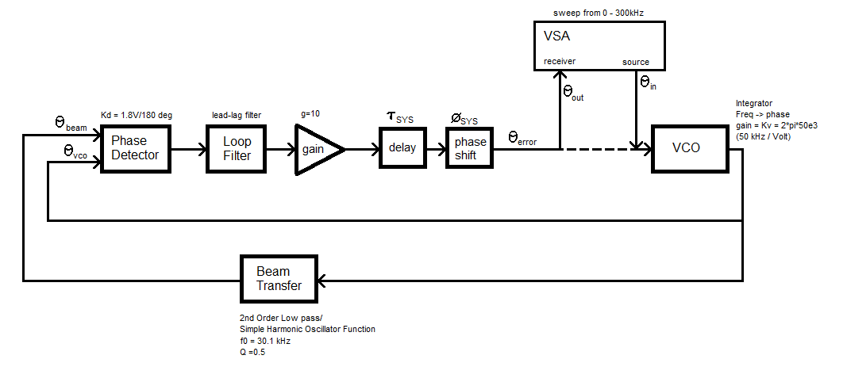
Figure 1. MATLAB mathematical model of the Booster LLRF system.
The phase detector has a gain of 1.8 Volts/degree and is modeled by simple subtraction. Following the phase detector is a lead-lag low pass loop filter. The s-domain transfer function of the lead-lag loop filter is:
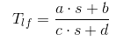
where,
a = c = 20000 * 1960 * 0.047e-6
b = 20000 * 1960
d = 1960
The transfer function of the above lead-lag filter is shown figure 4 below. Following the lead-lag filter is a gain block of 10 dB.
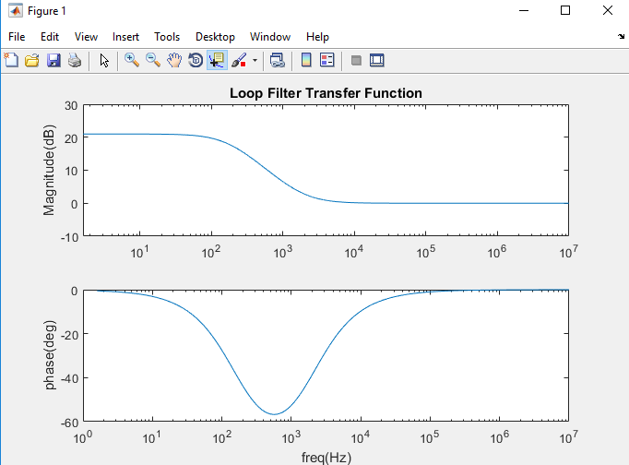
Figure 4. Transfer function of the lead-lag filter.
The VCO transfer function is an integrator with gain. It is rumored that VCO gain is an ACNET parameter that is frequently changed. This is understandable because this would be loop gain control knob operators could use. It is not really known what the gain of the VCO is, so for now, the model uses a value of 12kHz/V. With this value, the s-domain transfer function of the VCO is:
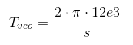
A plot of the above transfer function is shown in figure 5 below.
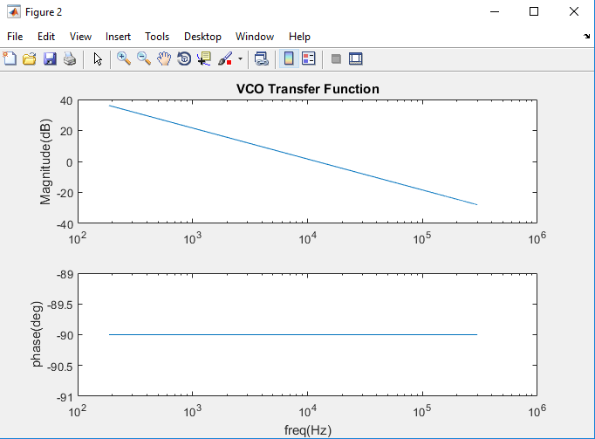
Figure 5. Transfer function of the VCO.
The transfer function of the beam is modeled as a simple harmonic oscillator, or just a second order low pass filter. The s-domain transfer function of the beam is:
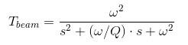
where,
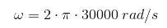
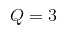
A plot of the above transfer function is shown in figure 6 below. The values of w and Q are not known at this time. A valid measurement might give insight to actual values.
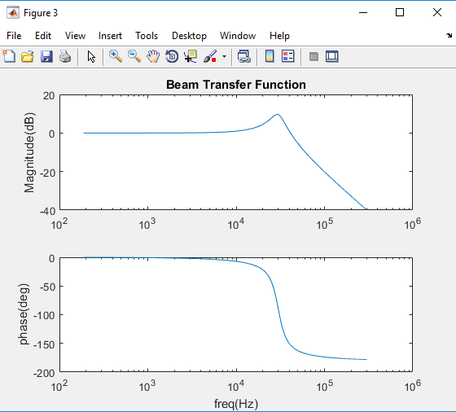
Figure 6. Simple Harmonic Oscillator beam transfer function.

The open and closed loop transfer function equations are shown below. To have an easy reference for deriving the open and closed loop equations, a copy of figure 1 is shown below in figure 7.
Figure 7. MATLAB mathematical model of the Booster LLRF system.
Open Loop Equations:
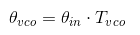
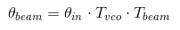
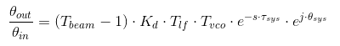
Closed Loop Equations:
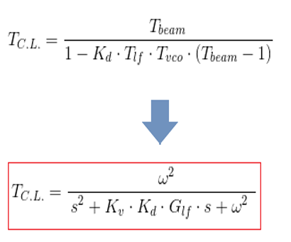
A plot of the open loop transfer function is shown in figure 8, and the closed transfer function is shown in figure 9.
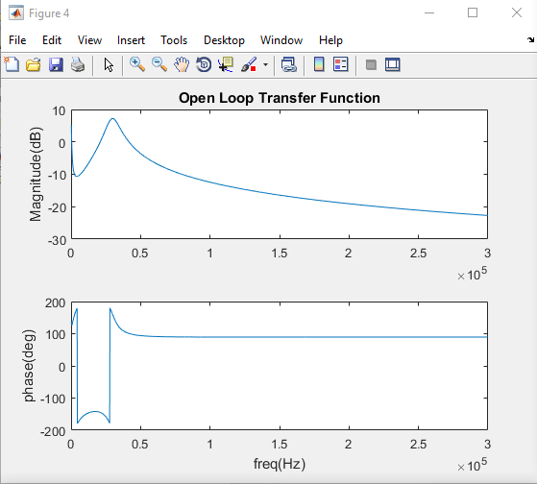
Figure 8. Open loop transfer function.
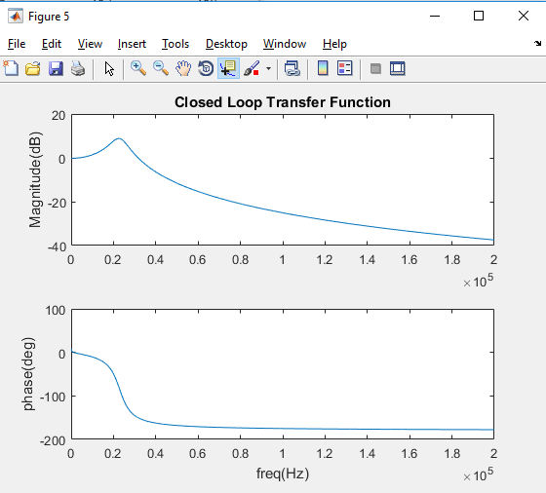
Figure 9. Closed loop transfer function.
To observe the effects of delay, an electrical delay of 4.5us is added to the model. The plot of open and close loop transfer functions is shown in figure 10 and 11.
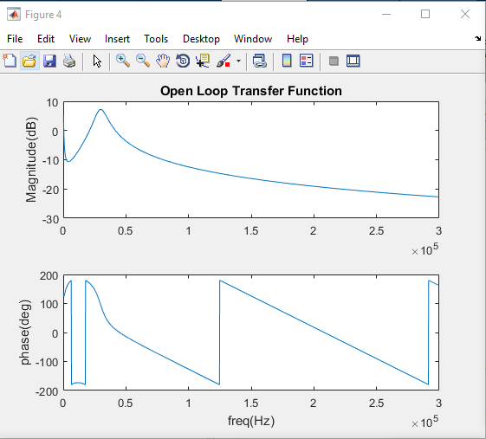
Figure 10. Open loop transfer function with an electrical delay of 4.5 us.
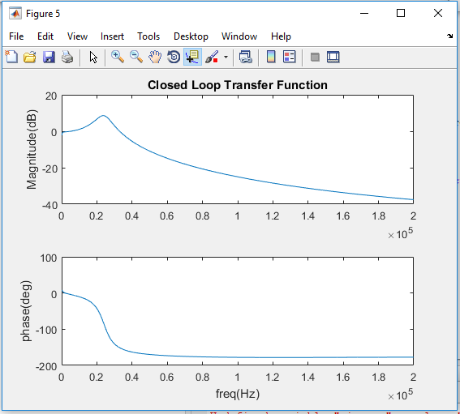
Figure 11. Closed loop transfer function with an electrical delay of 4.5 us.

To further examine the Booster LLRF system, a time domain Simulink model has been created. A block diagram of the Simulink model is shown in figure 12. The Simulink model is intended to explore the physical hardware characteristics of the LLRF system where possible.
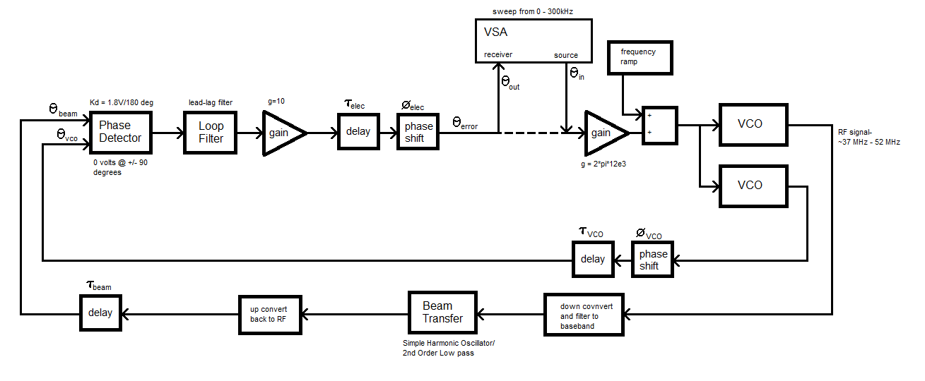
Figure 12. Simulink Model.
The phase detector hardware uses an Analog Devices 8302 phase detector. The two RF inputs are driven into saturation by log amplifiers to remove amplitude dependence. The phase output (taken from the data sheet) of the detector is shown in figure 13. The hardware adds an offset of -0.9 Volts to the phase detector output. The Simulink model of the phase detector is shown in figure 14, and the output of the phase detector is shown in figure 15. The output of the phase detector is 0 volts at +/- 90 degrees difference between the two inputs. It is assumed we operate on the -90 degree point at 0 volts.
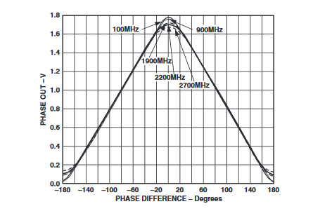
Figure 13. Phase output of the Analog Device 8302 phase detector.
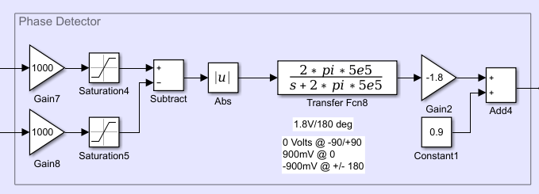
Figure 14. Simulink model used to simulate the phase detector hardware.

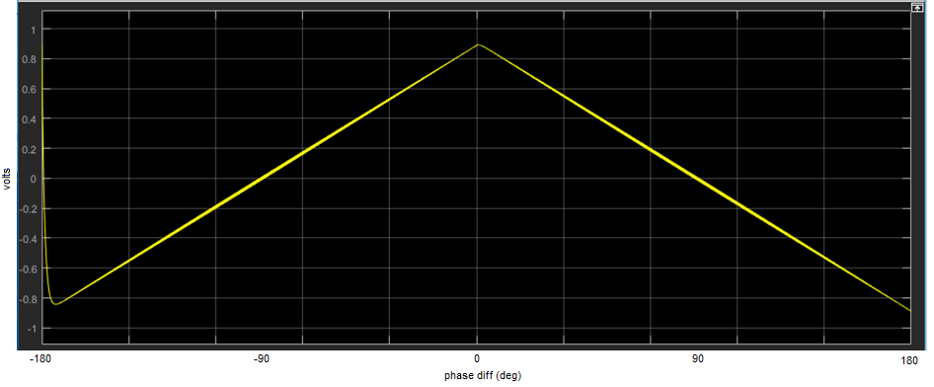
Figure 15. Output of the Simulink phase detector with a delta phase swept from -180 to +180 degrees.
The lead-lag loop filter is modeled as a transfer function in the s-domain again for simplicity. A delay block is added to compensate for actual delay. Figure 16 below shows the lead-lag loop filter along with the gain block and delay block. The delay block shown in figure 16 compensates for all the delay of the electronics.
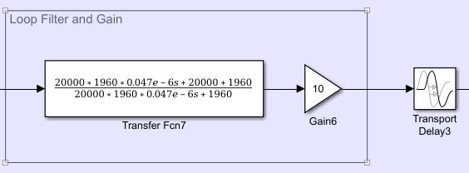
Figure 16. Lead-lag loop filter transfer function.
The Simulink model of the VCO is shown in figure 17. There are two VCO’s in this model. One of the VCO drives the RF system, and the other VCO is delayed and fed back to the phase detector. The VCO that drives the RF system includes a phase shift to allow the phase detector to operate at the 0 volt output (-90 degrees). The output frequency of both VCO’s allows for sweeping the RF frequency, but the model currently holds the RF frequency at 37.8 MHz.
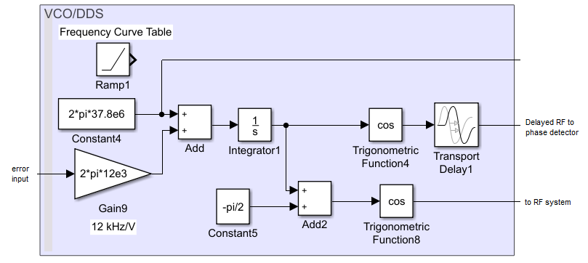
Figure 17. Simulink model of VCO/DDS outputs
To easily model the beam transfer function, the RF output signal of the VCO needs to be brought down to baseband to apply the 2nd order low pass filter function. Below is the Simulink model of the beam transfer function in figure 18. The up and down conversion is single sideband IQ conversion. The beam transfer model is in the time domain, but the 2nd order low pass is described in the s-domian. A delay block is added to simulate the delay through the RF system, beam, and detector electronics. Amplitude characteristics of the up and down conversion are ignored because the loop is phase dependent only.

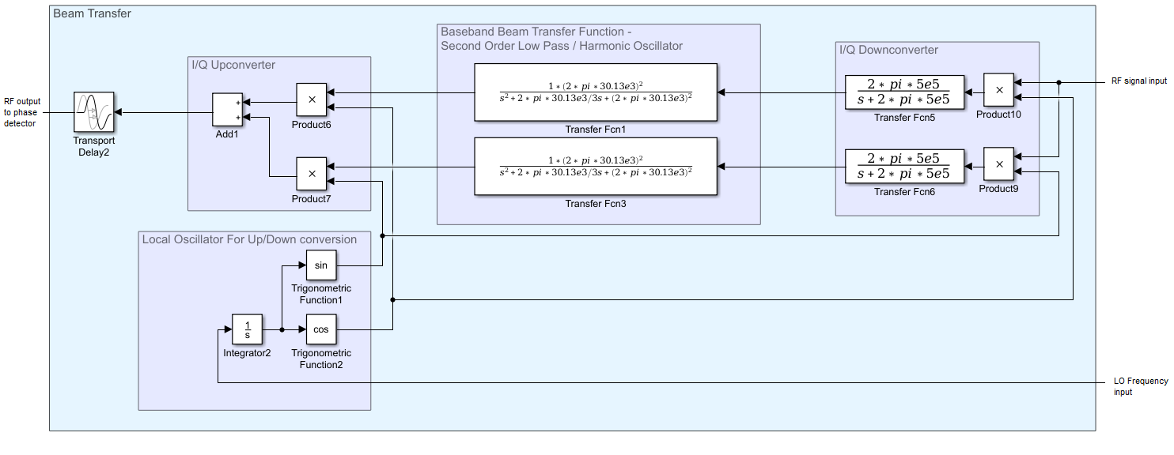
Figure 18. Simulink model of beam transfer function.
The Simulink model of the VSA is shown in figure 19. The VSA is linearly swept from 0 to 300 kHz over the time period of the simulation. The receiver is a baseband IQ detector, which is probably close to the real hardware, but this has not been confirmed at this time. The important consideration of this model is the sweep time of the measurement. It will be shown that sweep time is critical for an accurate measurement.
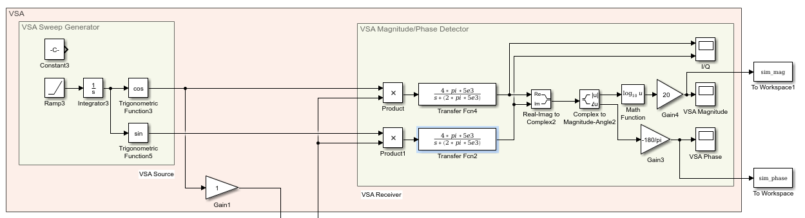
Figure 19. Simulink VSA model.
The complete Simulink model is shown in figure 20. Several simulations are made to verify the model against the mathematical MATLAB model. Figure 21 shows a comparison of the two models with no added delay in the system. The Simulink VSA is swept from 0 to 300 kHz with a sweep time of 30 ms. The two models show good agreement. The Simulink model shows a small amount of delay through the system, probably caused by the conversion filtering. (not confirmed yet)
A total of 6us of delay is added to the Simulink model to match the MATLAB model with delay. In the Simulink model, a delay of 1.1 us seconds is added to both the beam transfer function and the delayed RF. A delay of 4.9 us is added to the electronics to for a total of 6 us added delay. A plot of the transfer functions is shown in figure 22.

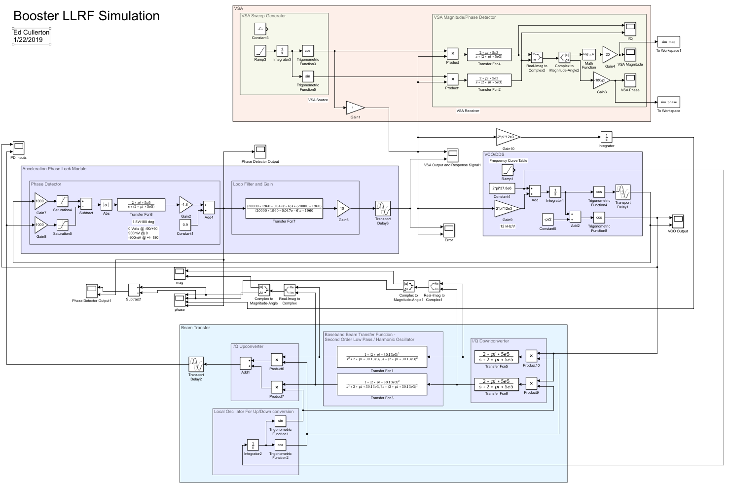
Figure 20. Simulink model of the Booster LLRF system.
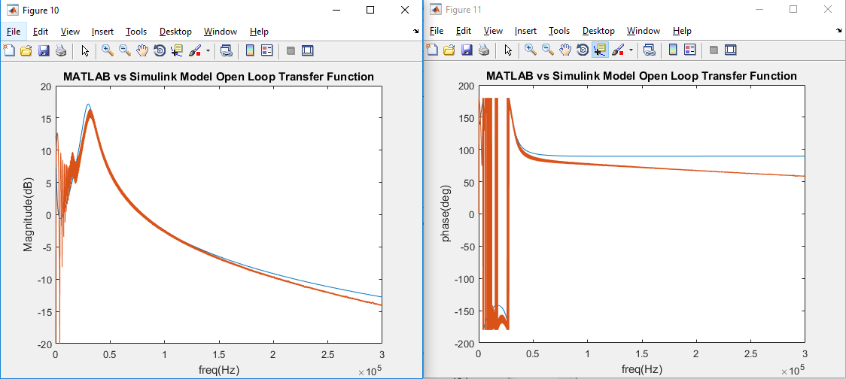
Figure 21. MATLAB vs Simulink simulation results. (0 added delay, 30 ms sweep time).
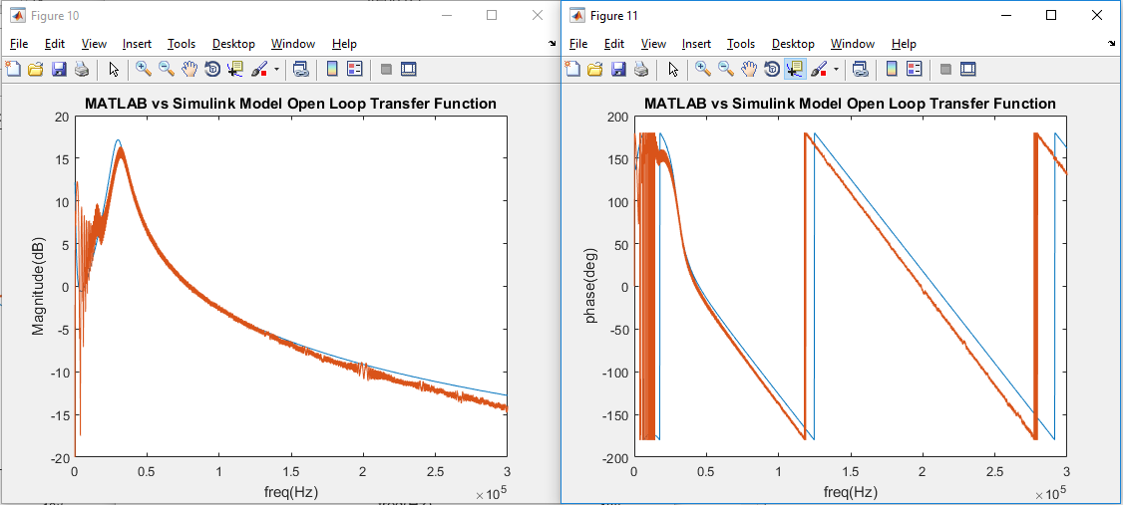
Figure 22. MATLAB vs Simulink simulation results with a total of 6 us delay added to the models.

A measurement of the open loop transfer function has been made. The open loop measurement and the simulation results are plotted in figures 23. The measured data implies that there is nearly 4.5 us of delay in the system. This delay of 4.5 us is a limitation on loop gain which reduces the loops ability to correct errors quickly.
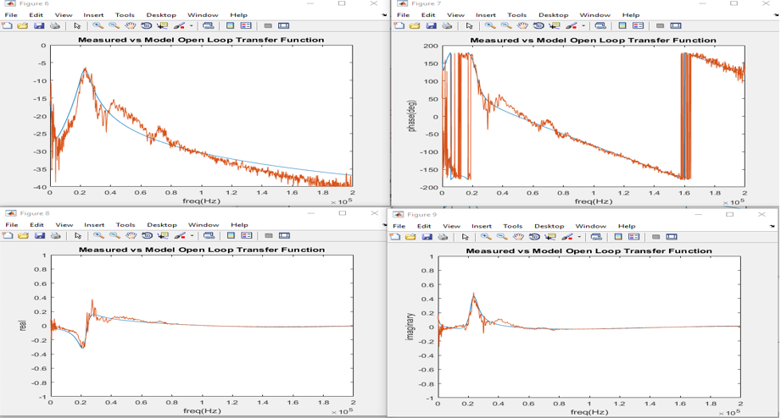
Figure 23. Measured open loop magnitude transfer function and simulation.

Many characteristic of the Booster LLRF system can be explored using the above models. The model can also be used to drive bench top measurements to verify closed loop performance and delay characteristics of the electronics without beam. Other features of the LLRF system can be added to the model including, but are not limited to, radial position control loop, RF frequency sweeping, transition behavior, RF system models, and improved beam transfer function models.

