Using Altera Tools for SoC/FPGA LLRF Design

Ed Cullerton
10/27/2016

Table of Contents:

- Introduction……………………………………………………….……... 3

- Setting up the Design Environment………………………….…....... 4

- Testing the Golden Hardware Reference Design (GHRD)….…… 7

- Building a Linux Application…………………………………………. 13

- Receiving GPIO Interrupts in Linux User Space Application…... 22

- Building an Interrupt Latency Test………………………………...... 26

- Adding a NIOS FPGA CPU to Automate Latency Test………….. 42

- LLRF DAQ Test System Design……………………………………… 59

- Appendix A. Interrupt Latency Test System Details…………..…. 67

- Appendix B. LLRF DAQ Test System Details……………………. 82

- List of Figures………………………………………………………….. 122

1. Introduction

The Altera Cyclone 5 SoC firmware/software design environment is created in a Mint 17.3 xfce Linux virtual machine running on Windows 7. A spare Ethernet port is recommended on the machine for Ethernet debugging. The virtual machine allows the complete design environment to be archived.

The firmware/software development in this guide is done using the Arrow SoCkit board with Quartus Prime 15.1, Qsys, ModelSim, and Signal Tap. Software development will be done using the Nios II FPGA based CPU and the Nois II eclipse package with JTAG debugging. Linux applications for the SOC-ARM CPU is done with the SOC-EDS eclipse package, based on the ARM DS-5 IDE, using Ethernet debugging.

2. Setting Up the Design Environment

Download the latest version of “VMware player” from the following website:

http://www.vmware.com/

Download the 64-bit desktop version of Mint 17.3 xfce from the following website:

https://www.linuxmint.com/

Create a folder on a hard disk called “virtual machines”. It is best to use a large secondary drive for this. This is where all your virtual machines will live.

Click on the vmware player .exe file to install the VMware Player.

Open the Vmware Player and install Ubuntu using the steps below.

**The player may ask you to upgrade some vmware tools during the process, click OK.

- Click on “Create a New Virtual Machine”

- Select “Install disk image file (iso)” and browse for your Ubuntu desktop download. Click next.

- Enter your name, user name, and password. Click next.

- Give the machine a name, and the location of the machine will be the “virtual machines” folder you created. Click next.

- The machine size should be at least 100 GB and put it on a single disk file. Click next.

- Before finishing, select ‘Customize Hardware…’. Give the machine at least 8 GB of memory, check ‘show all USB devices’, and give it all the processors you can. Next click ‘Add…’ at the bottom of the window and add another Network Adapter. Check the ‘NAT’ option then click ‘Finish’. Click close to exit the ‘Customize Hardware’ menu, then click ‘Finish’ to start the setup process.

The virtual machine should start up and Linux Mint will start. Once the machine has booted, clock on the install icon to start the installation process. If all went well, restart the virtual machine and log in. You may, or may not, want to update the software to the latest packages.

After update the software, turn on the SoCkit board and plug in the USB UART serial and JTAG connections. In the virtual machine, in the upper right corner, hover over the USB icons and look for ‘future devices usb uart’ and ‘altera cv socket’. Right click on the icons and click ‘connect’ if they are not connected already.

Next, go to the Altera website and download Quartus Prime 15.1 for Linux. I would recommend downloading the individual files below:

- Quartus Prime Standard Edition (includes Nios EDS)
- ModuleSim-Altera Edition (includes Starter Edition)
- Cyclone V device support
- SoC Embedded Design Suite (EDS)

After downloading the files, change the permissions, and then run the set-up script using the following commands in a terminal:

$ cd ~/Downloads
$ chmod +x QuartusSetup-15.1.0.185-linux.run
$ ./QuartusSetup-15.1.0.185-linux.run

*Check the ModelSim-Altera Starter Edition (Free) box to install ModelSim

After installation finishes and Quartus starts up, a menu about licensing will pop up. Hit OK to start quartus. There may be some errors, but just ignore them. Once Quartus has started, open the menu item ‘License Setup…’ in the Tools menu bar. Enter the following network license:

27000@beams-license

A license message may pop up each time you start Quartus, but you can click OK ignore.

Once you see Quartus is up and running OK, exit Quartus.

The permissions of the USB blaster must be configured in order for Quartus to recognize them:

Create a rules file for the USB blaster and give users with non-root access permission. Create a new rules file using the following command and enter the lines below into the file. (You may, or may not, want to install gedit for a text editor.)

$ sudo apt-get install gedit
$ sudo gedit /etc/udev/rules.d/51-altera-usb-blaster.rules

# USB-Blaster
SUBSYSTEM=="usb", ATTR{idVendor}=="09fb", ATTR{idProduct}=="6001", MODE="0666"
SUBSYSTEM=="usb", ATTR{idVendor}=="09fb", ATTR{idProduct}=="6002", MODE="0666"
SUBSYSTEM=="usb", ATTR{idVendor}=="09fb", ATTR{idProduct}=="6003", MODE="0666"
# USB-Blaster II
SUBSYSTEM=="usb", ATTR{idVendor}=="09fb", ATTR{idProduct}=="6010", MODE="0666"
SUBSYSTEM=="usb", ATTR{idVendor}=="09fb", ATTR{idProduct}=="6810", MODE="0666"

Save the file and create another file to allow the non-root user access.
$ sudo gedit /etc/udev/rules.d/altera-usb-blaster.rules
ATTR{idVendor}=="09fb", ATTR{idProduct}=="6001", MODE="666"
Restart the virtual computer and open Quartus. Launch the programmer from the toolbar menu and verify that you can see the SoCkit in the ‘Hardware Setup’ menu (CV SoCKit). Make sure the SoCkit board is ON, the USB UART and JTAG connections are made, and the USB devices are connected to the virtual machine.

Next we want to install SOC EDS tools.

* Before the installation process is started, you will have to install xterm.

$ sudo apt-get install xterm
$ cd ~/Downloads
$ chmod +x SoCEDSSetup-15.1.0.185-linux.run
$ sudo ./SoCEDSSetup-15.1.0.185-linux.run

- You may uncheck the programmer install. They should already be installed.

Once installed, start the SOC EDS by searching for ‘Eclipse for DS-5’ in the start menu. After eclipse starts, the license manager requests that you add a license. If you have a subscription license enter the activation code. If you do not have a license, go to the following website to get a web license activation code:

http://ds.arm.com/altera/altera-community-edition/

The web license will only allow Ethernet debugging of your Linux application. You cannot not do system level debugging with the web license. If eclipse starts and everything looks OK, close eclipse.

Finally, test to make sure ModelSim works. One file needs to be modified in order for Modelsim to work on the new 4.x kernel. Use your favorite text editor and open the file:

~/altera/16.0/modelsim_ase/vco

Add the following line at line 210:

4.[0-9]*) vco=”linux” ;;

Save the file and close the editor.

Open a terminal and start the program with the following commands:

$ cd ~/altera/16.0/modelsim_ase/bin
$ ./vsim

When all the software is finished installing, it is recommended to delete the installation packages to save disk space.

3. Testing the Golden Hardware Reference Design (GHRD)

Next, we want to test the GHRD(Golden Hardware Reference Design) for the SoCKit provided at the Rocketboards website. We will compile the design and load it to the SoCkit board. The SD card image will be downloaded for the Altera Cyclone V development board. It is assumed that the SD card for the Altera development board is a stable version of Linux with the latest version of the altera drivers on it. There are a number of files on the SD card image needed to get this system up and running:

- Preloader – Built after Qsys and Quartus compile
- Device tree – Built after Qsys and Quartus compile
- FPGA (.rbf) file – Built after Quartus compile and conversion
- U-boot
- Linux Kernel
- File system

We will use the U-boot, Linux kernel and file system that is already on the SD card. The preloader, device tree, and FPGA file will be replaced manually.

If ambitious, U-boot, Linux kernel, and root file system can be built using a Yocto package from Altera. The source code for the Yocto build can be configured by a scripting package from Altera, or from a git repository maintained by Altera. Instructions for using these tools are on the Rocketboards website. Building these files is only recommended if there are new drivers in the Linux kernel or root file system from Altera that NEED to be used, OR you would like to build your own drivers to handle FPGA implementations. For now, download the SD card image from the rocket boards release server:

https://s3.amazonaws.com/rocketboards/releases/2016.02/sockit-ghrd/bin/linux-sockit-gsrd-15.1-bin.tar.gz

Next, insert a SD card into your card reader, and use the following commands to determine the drive that the SD Card in assigned.

$ cat /proc/partitions

The output should look something like this:

major minor #blocks name

8 0 209715200 sda
8 1 201326592 sda1
8 2 1 sda2
8 5 8385536 sda5
11 0 1048575 sr0
11 1 1048575 sr1
8 16 7639040 sdb
8 17 20480 sdb1
8 18 1048576 sdb2
8 19 1024 sdb3

By looking at the output, the SD card drive name assignment is sdb. (sd1, sdb2, and sdb3 partitions). You should remove the SDCard and enter the command again to make sure you know the correct drive assignment.

Next, once you are sure of your SD card drive name, open a terminal and copy the image to your SD card using the following commands:

$ cd ~/Downloads
$ tar -xzf linux-sockit-gsrd-15.1-bin.tar.gz
$ tar –xzf socket-gsrd-15.1-sdcard.img.tar.gz

*optional step to delete old partitions
$ fdisk /dev/sdb
d – delete partitions

Write the SoCkit image to the disk:

$ sudo dd if=sockit-gsrd-15.1-sdcard.img of=/dev/sdb bs=1M
$ sudo sync

Eject the SD card and remove the SD Card.

The next step is to build the Golden Hardware Reference Design (GHRD) for the SoCkit. Download the SocKit GHRD project from the Rocketboards website.

https://s3.amazonaws.com/rocketboards/releases/2016.02/sockit-ghrd/ghrd/sockit_ghrd_15.1.tar.gz

Create a folder in your HOME directory called PROJECTS. In that directory create a folder called QUARTUS. Extract the files and make them readable using the following commands:

$ mkdir ~/PROJECTS
$ cd ~/PROJECTS
$ mkdir QUARTUS
$ cd QUARTUS
$ mv ~/Downloads/sockit_ghrd_15.1.tar.gz sockit_ghrd_15.1.tar.gz
$ tar -xzf sockit_ghrd_15.1.tar.gz
$ chmod 777 -R sockit_ghrd

Open Quartus and click ‘Open Project’ in the File menu.

Browse to the sockit_ghrd folder and open the soc_system.qpf project.

Next, click on the Qsys icon in the toolbar and open Qsys. Select soc_system.qsys file to open.

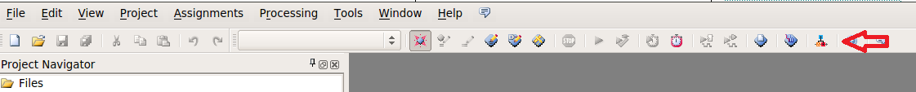

Take some time to examine the qsys components.

Click ‘Generate’ in the top menu, then click ‘Generate HDL…’ to compile the Qsys components. A new file called soc_system.sopcinfo has been created in the project folder. This file will be important when creating the device tree. For now, close Qsys when the compile is complete.

Next, in Quartus, double click on the ghrd_top file in the left side Project Navigator to open the Verilog top level file. Examine the file, and notice that the soc_system generated with Quartus is instantiated in lines 300 – 388.

Click the compile button to compile the design. Quartus will generate a firmware file in the output_files directory of your project called soc_system.sof. Once the compile is complete, you can close Quartus.

The next steps are to generate the preloader, device tree, and .rbf firmware files for loading onto the SD Card. These steps will be performed a lot, so remember them.

Generate a .rbf firmare file:

- Open Quartus and open the socket_ghrd project.
- Open file menu and click ‘Convert Programming Files…’
- In the GUI, select Raw Binary File as the Programming file type.
- Select Fast Passive Parallel x16 as the Mode.
- Change the file name to soc_system.rbf
- Click on the ‘SOF Data’ in the File/Data area, then click ‘Add File…’.
- Find and select your soc_system.sof file in the output_files folder of your project folder.
- Click ‘Generate’. See below for picture of the GUI.

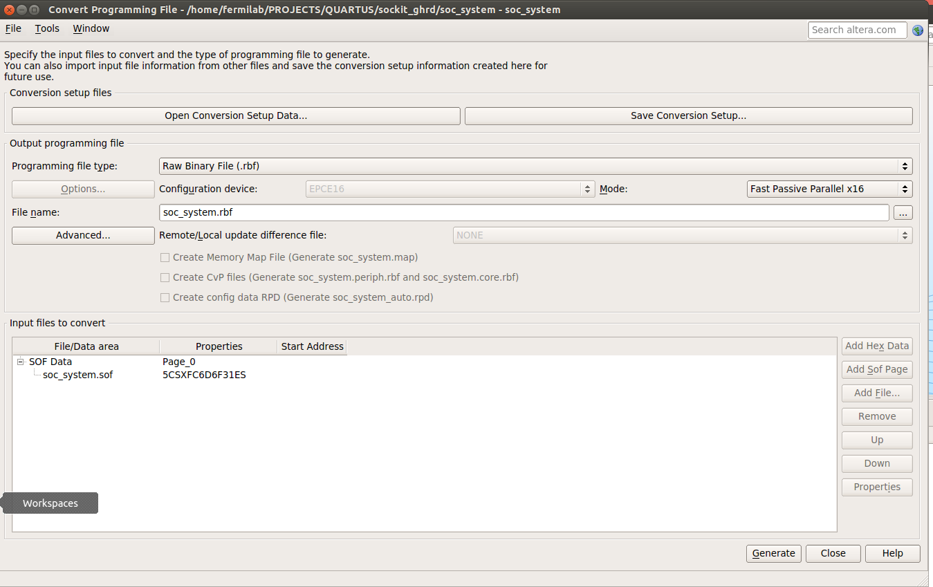

Figure 3-1. Converting .sof FPGA firmware file type to .rbf file for SD card.

Generate a preloader:

- Enter the embedded command shell

$ cd ~/altera/15.1/embedded
$ ./embedded_command_shell.sh

- Open the bsp editor (board support package) to generate the preloader.

$ bsp-editor

- Click the file menu, and click ‘New BSP…’
- Choose the preloader setting directory and click OK:

~/PROJECT/QUARTUS/socket_ghrd/hps_isw_handoff/soc_system_hps_0

- Click ‘Generate’.
- Exit the bsp editor.
- Move to the directory where the preloader source is and compile the pre-loader image:

$ cd ~/PROJECTS/QUARTUS/sockit_ghrd/software/spl_bsp
$ make

Generate the device tree:

First you must have Java installed. Open the Ubuntu Software center, search for java and install the latest JDK(currenty 7) Once Java is installed, close the Ubuntu Software Center and follow the instructions below to create the device tree:

- Start embedded command shell

$ cd ~/altera/15.1/embedded
$ ./embedded_command_shell.sh

- Move to your project directory.

$ cd ~/PROJECTS/QUARTUS/sockit_ghrd

- Run the device tree generator

$ sopc2dts -i soc_system.sopcinfo -b soc_system_board_info.xml -b hps_clock_info.xml -o soc_system.dts

- Compile the device tree.

$ dtc -I dts -O dtb -o socfpga.dtb soc_system.dts

Now that all the files are ready, insert the SD card into your SD card reader and copy the new files to your SD card.

- Insert the SD card and overwrite the preloader image. You should do:

$ cd ~/PROJECTS/QUARTUS/sockit_ghrd/software/spl_bsp
$ sudo dd if=preloader-mkpimage.bin of=/dev/sdb3 bs=64k seek=0

- Copy the .rbf file and device tree to the card.

$ cd ~
$ sudo mkdir sdcard
$ sudo mount /dev/sdb1 sdcard
$ sudo cp ~/PROJECTS/QUARTUS/sockit_ghrd/soc_system.rbf sdcard/
$ sudo cp ~/PROJECTS/QUARTUS/sockit_ghrd/socfpga.dtb sdcard/
$ sudo umount sdcard

Eject the SD Card from your computer and insert it into the SoCkit board. We need to setup a serial terminal to watch the board boot. We will use the software ‘gtkTerm’ for a serial port terminal.

With the SoCKit powered down, find the device assignment of any USB connections:

- Type the command to see the USB connections:

$ ls /dev/ttyUSB*

There may be no USB connections to list.

- Next, make sure the USB UART from the SoCkit is connected to your computer and power up the SocKit.

- Use the command again to see the new USB connection:

$ ls /dev/ttyUSB*

** it will probably be ttyUSB0 or ttyUSB1.
Next, install the gtkterm software:

- Install gtkterm:

$ sudo apt-get install gtkterm

- Start gtkterm and configure it:

$ sudo gtkterm

In the ‘Configuration’ menu, select ‘Port’ and configure as shown:

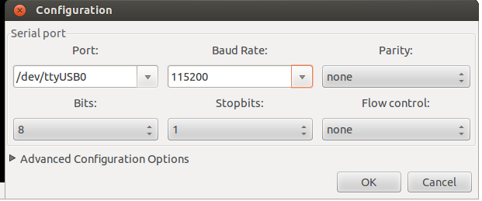

Figure 3-2. Configuring gtkterm serial port.

Power down the SoCKit and set the CLOCK SELECT and BOOT SELECT jumpers to configure the onboard clocks and how the ARM will boot:

J15: 1-2
J16: 1-2
J17: 1-2
J18: 2-3
J19: 1-2

Pin numbers are from the bottom up, with lettering j15 being nearest pin 3.
Set the MSEL [0:4] jumpers to all 0’s to load FPGA firmware from the SD Card.

Power up the SoCkit, then start gtkterm again. You should see the system boot messages and eventually a prompt to login. On the SocKit board, the FPGA_CONF_D LED should be ON, the 4 HPS user LED’s should be always ON, and the 4 FPGA user LED’s should be scrolling.

The scrolling LEDs is part of the startup scripts, which lives in the directory:

/etc/init.d

The name of the script running on our system is called gsrd_init.sh. We can disable the script with the command:

$ update-rc.d –f gsrd_init.sh remove

If we wish to add the script to the startup again, use the command: (leave the script diasabled for now)

$ update-rc.d gsrd_init.sh defaults

This will also be the method for launching applications for a LLRF system. For an initial start-up script, just the Ethernet port will be configured. Later, other startup services can be added. Create a file called LLRF_startup.sh in the init.d directory.

$ vi /etc/init.d/LLRF_startup.sh

#!/bin/bash
#
# LLRF system startup
#
ifconfig eth0 192.168.2.12 up
echo “LLRF: IP configured(192.168.2.12)”

Next, change its permissions and update the startup.

$ chmod +x /etc/init.d/LLRF_startup.sh
$ update-rc.d LLRF_startup.sh default

Now the Linux system will boot up and the Ethernet port will be configured automatically.

4. Building a Linux Application

First, set up the secondary Ethernet port on the WINDOWS OS and give it an IP address of 192.168.2.13. You will need administrator privileges to do this. We will use this later to connect to the SoCkit board for Ethernet debugging. Follow the steps to setup your networks card:

- From the control panel, click on ‘Network and Sharing Center”.
- Select ‘Change adapter settings’
- Find your second Ethernet card, right click on it, and click on ‘Properties’. You will need admin privileges for this.
- Click on ‘Internet Protocol Version 4 (TCP/IPv4)’,
- Set the IP address as shown below.

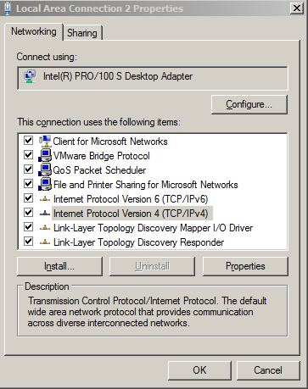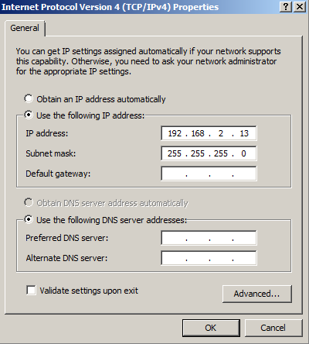

Figure 4-1. Secondary ethernet port setup.

The IP number is one number offset from the SoCKit IP address. This is required for the cross-over Ethernet connection we will make to the board.

Next, in the virtual Ubuntu OS, start Altera’s Eclipse DS-5 with the following commands in a terminal:

$ cd ~/altera/13.1/embedded
$ ./embedded_command_shell.sh
$ eclipse

Set up a project with the following steps:

- Make sure you are the C/C++ Perspective by clicking the button in the upper right corner of Eclipse.
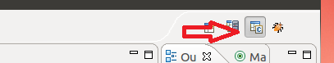

- Right click anywhere in the project window pane on the left hand side of eclipse, and click ‘New’, then ‘C++ Project’.

- Name the project SOC_TEST and create an empty Makefile project. Make sure to select the DS-5 GCC Toolchain.

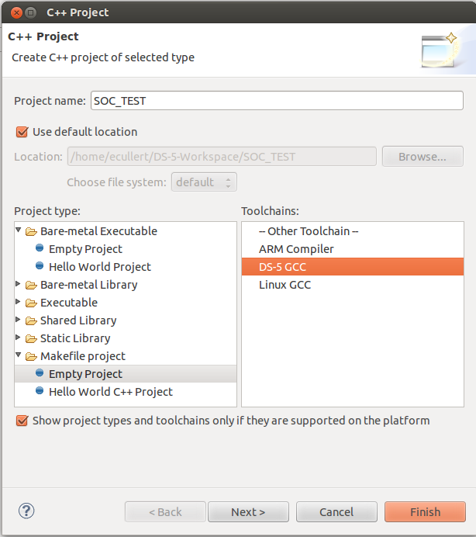

Next, we need to create a header file from the Quartus files created during compile describing our ARM to FPGA bridges. In another terminal, start the embedded command shell again.

$ cd ~/altera/13.1/embedded
$ ./embedded_command_shell.sh

Navigate to the socket_ghrd project folder:

$ cd ~/PROJECTS/QUARTUS/sockit_ghrd

Enter the following command to generate the header file:

$ sopc-create-header-files

Copy the hardware header file into your project.

- Open a file navigator and browse to the PROJECTS/QUARTUS/socket_ghrd folder.

- Drag the hps_0.h file into the SOC_TEST project folder in the Project pane of Eclipse.

Double click on the hps_0.h file in the Project pane to open the file. Examine the file and you will notice details about the Qsys system that was built. Most important will be the hardware address base numbers.

Next, we need to create a C application and a makefile. Right click on the SOC_TEST folder in the Project pane, and select ‘New’, then ‘File’. Name the file main.c, then finish. Right click again on SOC_TEST and make another file. Name the file Makfile, then finish. Open main.c and paste the following code into the file, then save it.

/* SoC LLRF System
* Fermilab
* 9/11/14
*/

#include <stdio.h>
#include <unistd.h>
#include <fcntl.h>
#include <sys/mman.h>
#include "hwlib.h"
#include "socal/socal.h"
#include "socal/hps.h"
#include "socal/alt_gpio.h"
#include "hps_0.h"
#include "poll.h"

#define HW_REGS_BASE ( ALT_STM_OFST )
#define HW_REGS_SPAN ( 0x04000000 )
#define HW_REGS_MASK ( HW_REGS_SPAN - 1 )

int main() {

printf( "Fermilab LLRF System test....\n" );

void *virtual_base; // Memory base pointer
int fd_mem; // Memory file descriptor
int loop_count; // Counter for blinking LEDS

// map the address space for the LED registers into user space so we can interact with them.
// we'll actually map in the entire CSR span of the HPS since we want to access various registers within that span

if( -1 == ( fd_mem = open( "/dev/mem", ( O_RDWR | O_SYNC )))) {
printf( "ERROR: Failed to open \"/dev/mem\"...\n" );
return( -1 );
}

if(MAP_FAILED == (virtual_base = mmap(NULL, HW_REGS_SPAN, (PROT_READ | PROT_WRITE), MAP_SHARED, fd_mem, HW_REGS_BASE))) {
printf( "ERROR: mmap() failed...\n" );
close( fd_mem );
return( -1 );
}

// turn OFF the HPS LEDs
alt_clrbits_word( ( virtual_base + ( ( uint32_t )( ALT_GPIO1_SWPORTA_DR_ADDR ) & ( uint32_t )( HW_REGS_MASK ) ) ), 0x0F000000 );
// turn OFF the FPGA LEDs
alt_clrbits_word( ( virtual_base + ( ( uint32_t )( ALT_LWFPGASLVS_OFST + LED_PIO_BASE ) & ( uint32_t )( HW_REGS_MASK ) ) ), 0x0000000F );

// toggle the LEDs 100 time in 10 second
loop_count = 0;
while( loop_count < 100 ) {

// turn off all LEDs
alt_clrbits_word( ( virtual_base + ( ( uint32_t )( ALT_GPIO1_SWPORTA_DR_ADDR ) & ( uint32_t )( HW_REGS_MASK ) ) ), 0x0F000000 );
alt_clrbits_word( ( virtual_base + ( ( uint32_t )( ALT_LWFPGASLVS_OFST + LED_PIO_BASE ) & ( uint32_t )( HW_REGS_MASK ) ) ), 0x0000000F );

usleep( 50000);

// turn on all LEDs
alt_setbits_word( ( virtual_base + ( ( uint32_t )( ALT_LWFPGASLVS_OFST + LED_PIO_BASE ) & ( uint32_t )( HW_REGS_MASK ) ) ), 0x0000000F );
alt_setbits_word( ( virtual_base + ( ( uint32_t )( ALT_GPIO1_SWPORTA_DR_ADDR ) & ( uint32_t )( HW_REGS_MASK ) ) ), 0x0F000000 );

usleep( 50000 );
loop_count++;
}

// leave the LEDs in the OFF state
alt_clrbits_word( ( virtual_base + ( ( uint32_t )( ALT_GPIO1_SWPORTA_DR_ADDR ) & ( uint32_t )( HW_REGS_MASK ) ) ), 0x0F000000 );
alt_clrbits_word( ( virtual_base + ( ( uint32_t )( ALT_LWFPGASLVS_OFST + LED_PIO_BASE ) & ( uint32_t )( HW_REGS_MASK ) ) ), 0x0000000F );

// clean up our memory mapping and exit
if( munmap( virtual_base, HW_REGS_SPAN ) != 0 ) {
printf( "ERROR: munmap() failed...\n" );
close( fd_mem );
return( -1 );
}

close( fd_gpio );
close( fd_mem );
return( 0 );
}

Code Snip 4-1. Linux test program for turning blinking LED’s.

Open the file Makefile and paste the following code into the file, then save it. (You will have to change the INCLUDES path if your username is not fermilab)

# Fermilab LLRF Project Makefile
# Ed Cullerton
# 9/10/14

C_SRC := main.c
INCLUDES := /home/fermilab/altera/13.1/embedded/ip/altera/hps/altera_hps/hwlib/include
CFLAGS := -g -O0 -Werror -Wall -I$(INCLUDES) -lpthread

CROSS_COMPILE := arm-linux-gnueabihf-
CC := $(CROSS_COMPILE)gcc
NM := $(CROSS_COMPILE)nm
OD := $(CROSS_COMPILE)objdump

ifeq ($(or $(COMSPEC),$(ComSpec)),)
RM := rm -rf
else
RM := cs-rm -rf
endif

ELF ?= $(basename $(firstword $(C_SRC)))
OBJ := $(patsubst %.c,%.o,$(C_SRC))

.PHONY: all
all: $(ELF)

.PHONY:
clean:
$(RM) $(ELF) $(OBJ) *.objdump *.map

$(OBJ): %.o: %.c
$(CC) $(CFLAGS) -c $< -o $@

$(ELF): $(OBJ)
$(CC) $(CFLAGS) $(OBJ) -o $@ $(LDFLAGS)
$(NM) $@ > $@.map

Code Snip 4-2. Linux C application Makefile.

Now the makefile project is ready to build. Click the build button in the eclipse toolbar.

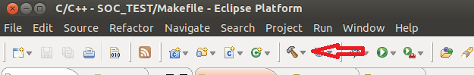

There should be no errors. Click on the Console tab in the bottom pane to see what the Makefile created. It should look like the following picture:

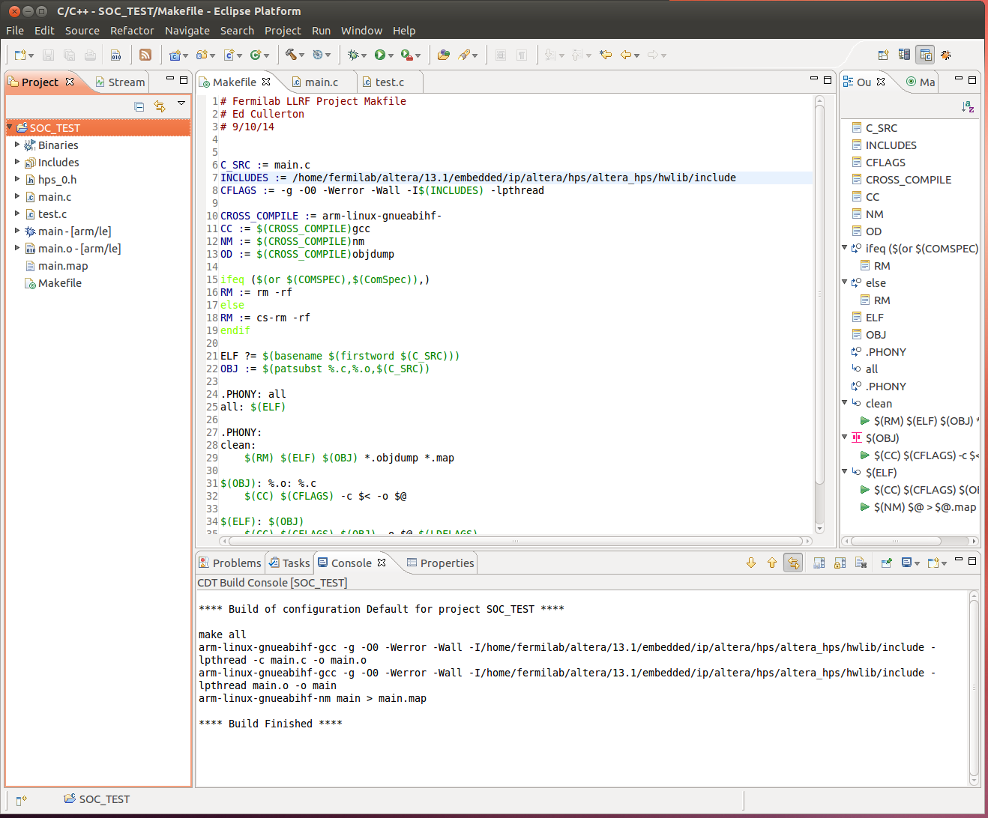

Figure 4-2. Eclipse environment with Linux application program and Makefile setup.

Next, we need to set up the remote connection to the SoCKit with a cross-over Ethernet cable. Boot the SoCkit and startup gtkTerm to login. Once logged in, create a password for root using the passwd command. The password is not remembered, so each time you power cycle the SocKit board, you will have to reset the password.

In the upper right corner of eclipse, select the remote system perspective.

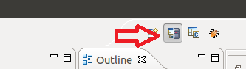

Right click in the left side ‘Remote System’ pane, and select ‘new’, then select ‘connection’. Select ‘SSH Only’.

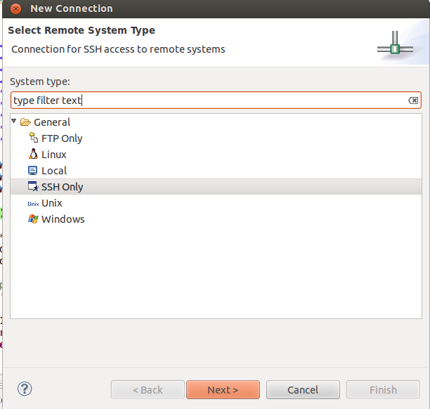

Next, enter the Host name, Connection name, and Description as shown:

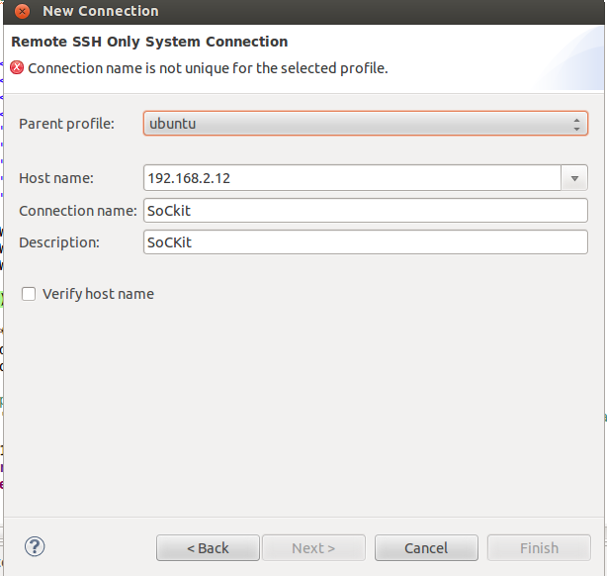

When done click ‘Finish’. Your Remote Systems pane should look like below:

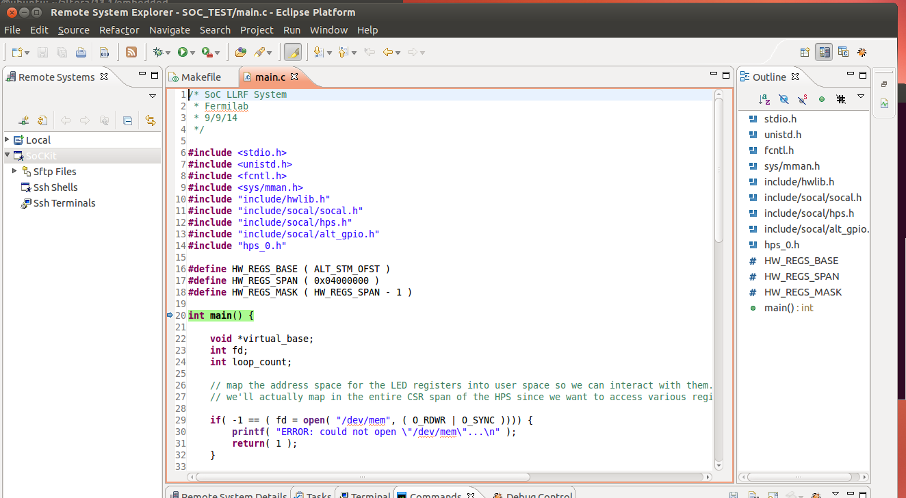

Figure 4-3. Remote System perspective in Eclispe.
Right click on the SocKit connection in the Remote Systems pane and click ‘connect’. A window will pop asking you for a user name and password. Enter root as the user name, and type in the password you set on the SoCKit earlier. You must have a password or this will not work!

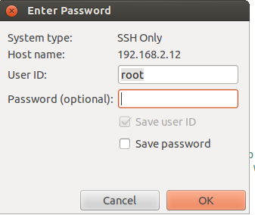

If all is well, you should be able to navigate the directory on SOCKit board as shown below:

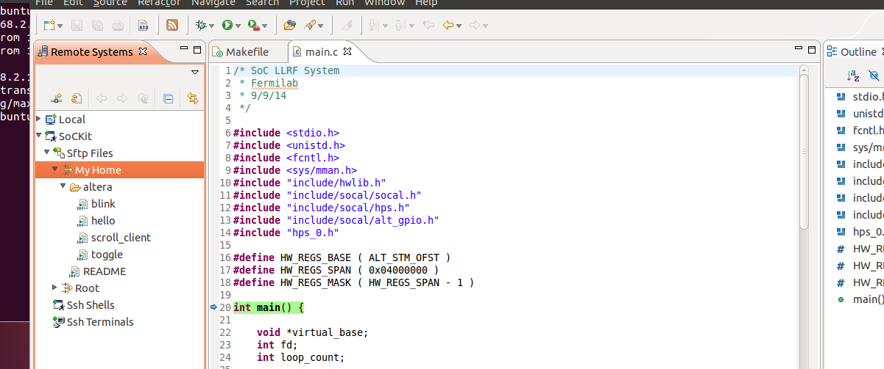

Next we will set up the debugger. Under the ‘Run’ menu in eclipse, select ‘Debug configurations…’. The debug configurations window will pop up. On the left side, right click ‘DS-5 Debugger’, and select ‘New’. Name the configuration ‘SoCKit’. In the ‘Select Target’ section, choose ‘Generic -> gdbserver-> Linux Application Debug-> Download and debug application’. Below is a picture of the setup:

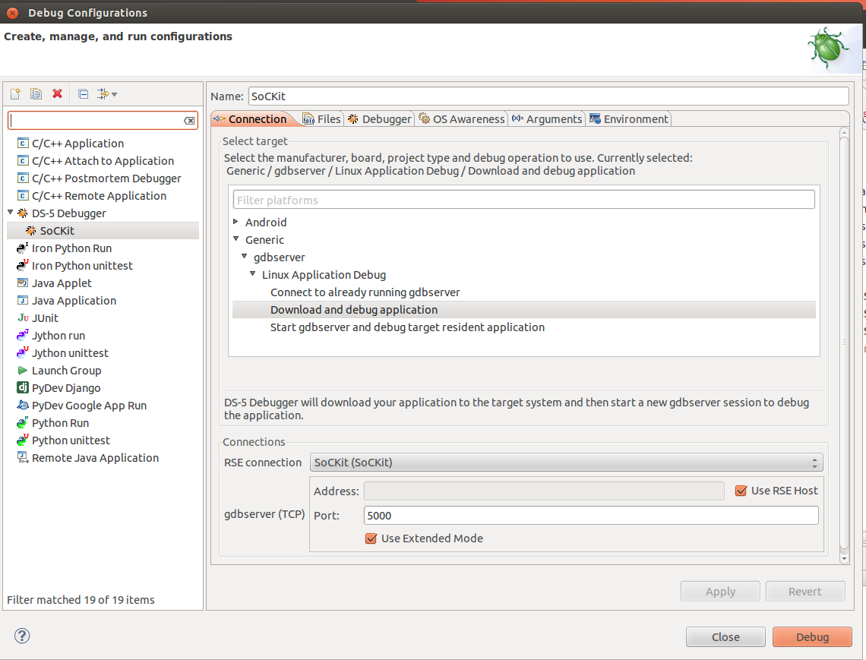

Figure 4-4a. Ethernet debugging Configuration.
Next, go to the ‘Files’ tab. In the ‘Target Configuration’, select the ‘Workspace’ button, select the ‘main’ executable, and make sure the ‘Load Symbols’ is checked. Enter /home/root in the Target download directory and Target working directory. The configuration is shown below:

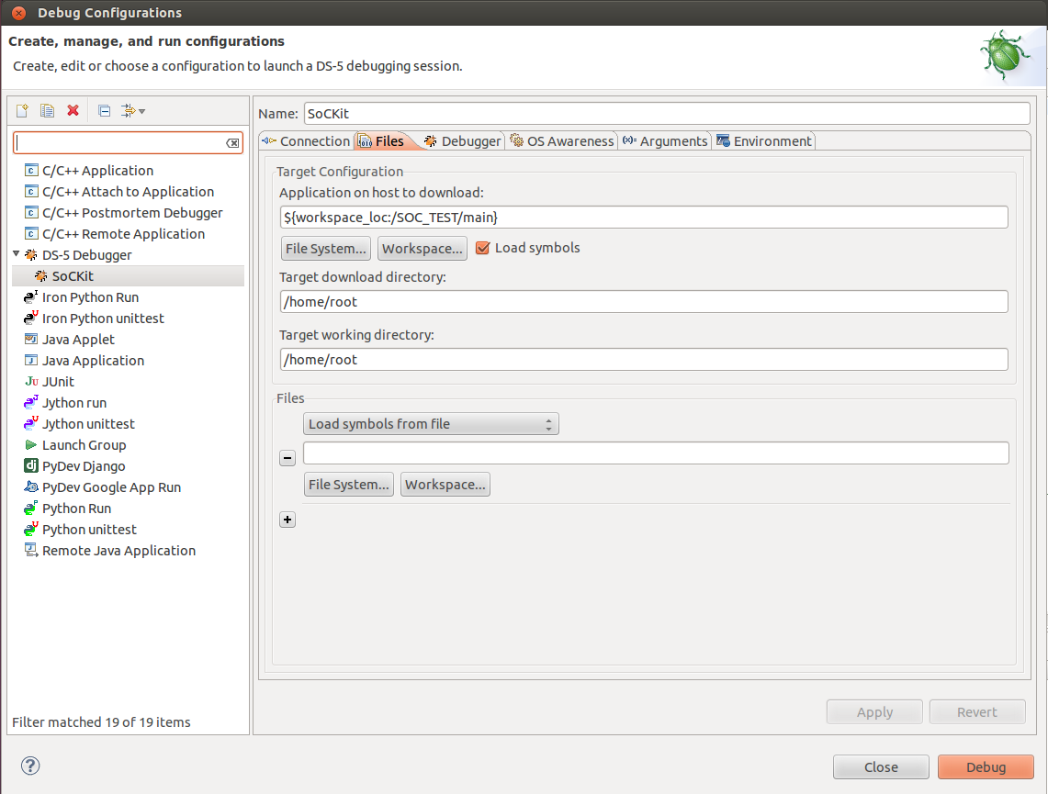

Figure 4-4b. Ethernet debugging Configuration.

Select the ‘Apply button’ and then ‘Close’. Next, switch to the debug perspective:

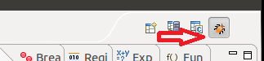

Click the Debug button and select the SoCKit debug configuration.

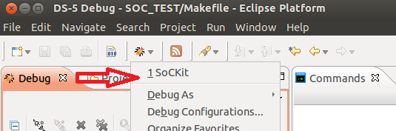

The debugger should start, the executable will be downloaded to the /home/root directory, and the program will halt at main and wait for you to continue.
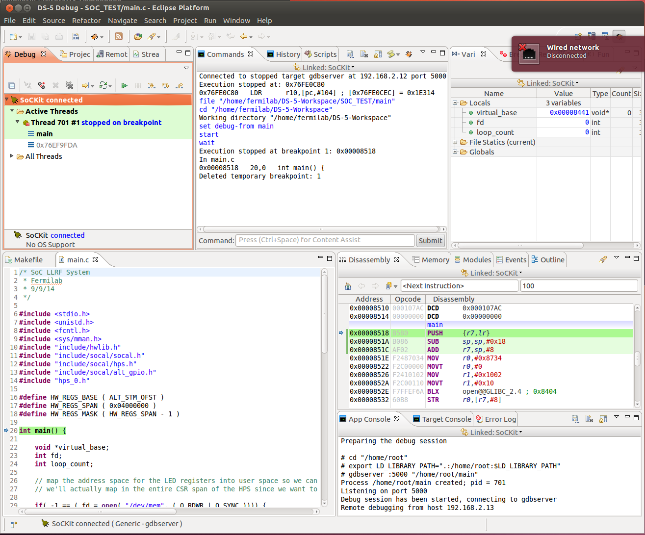

Figure 4-5. Ethernet debugging perspective in Eclipse.

Press the play button in the Debug pane and the program should execute. If everything worked correctly, the LED’s should start flashing and end after 60 flashes.

At this point, the complete design environment should be setup and working. Next, a Linux application to receive an interrupt from the FPGA will be built. Then a latency test to measure the round trip time through the data paths in the system will be built.

5. Receiving GPIO interrupt in Linux User Space Application

For the data aquisition system that will be built, a GPIO (General Purpose I/O) interface to send interrupts from the FPGA to Linux user space will be used. The structure of the interface is a PIO (Parallel Input/Output) module in the Qsys design, coupled with the gpio-altera kernel driver. The kernel driver uses the sysfs interface to communicate between the kernel and the user space application. With the SoCKit on and the GHRD project on the SD card, the steps to test the interrupt are listed below:

Examine the sysfs directory to see what gpio kernel modules are loaded. From the gtkterm terminal, enter the command:

$ ls /sys/class/gpio/

export gpiochip160 … unexport

Load the gpio-altera kernel module and examine the sysfs directory again.

$ modprobe gpio-altera

$ ls /sys/class/gpio/

export gpiochip150 gpiochip152 gpiochip160 … unexport

Notice the gpiochip150 and gpiochip152. These are the pushbutton PIO and dipswitch PIO that is in the GHRD Qsys design. The number 150 is the number of the first push button. The second push button will be number 151. The dipswitches start at 152. You can determine that these are the pushbutton PIO’s by looking at the ‘label’ file in the gpiochip150 directory.

$ cat /sys/class/gpio/gpiochip150/label

/sopc@0/bridge@0xc0000000/gpio@0x1000100C0

You may ask yourself; “Shouldn’t push button 3 and 4 be number 152 and 153”? Take another look at the pushbutton module the Qsys design in the ghrd_sockit project. You’ll notice that there are only 2 lines defined. That is why Linux does not know about pushbuttons 3 and 4. For practice, modify the pushbutton PIO to have 4 lines, recompile the project, create the device tree, preloader, and .rbf file, and load them onto the SD card. You will also have to generate the header file again. The new sysfs directory should look like below, with all 4 pushbuttons starting at 148.

$ ls /sys/class/gpio/

export gpiochip148 gpiochip152 gpiochip160 … unexport

- Next create a control interface for the first push button.
$ cd /sys/class/gpio
$ echo 148 > export

This creates a control interface for the pushbutton. Now take a look at the sysfs directory again and notice that gpio148 has been added.

$ ls

export gpio148 gpiochip148 gpiochip152 …

Take a look at the files in the gpio148 directory:

$ ls gpio148

active_low direction edge power subsystem uevent value

To configure the interrupt, we need to set the direction and type of edge we are using to trigger the interrupt.

$ cd gpio148
$ echo in > direction
$ echo falling > edge

Now that the linux kernel is ready to handle interrupts, we want to see the interrupt in a Linux application. Open eclipse from the embedded shell and open the SOC_TEST project. Delete everything in main.c and copy the following code into main.c:

/* SoC LLRF System
* Fermilab
* 9/11/14
*/

#include <stdio.h>
#include <unistd.h>
#include <fcntl.h>
#include <sys/mman.h>
#include "hwlib.h"
#include "socal/socal.h"
#include "socal/hps.h"
#include "socal/alt_gpio.h"
#include "hps_0.h"
#include "poll.h"

#define HW_REGS_BASE ( ALT_STM_OFST )
#define HW_REGS_SPAN ( 0x04000000 )
#define HW_REGS_MASK ( HW_REGS_SPAN - 1 )

int main() {

printf( "Fermilab LLRF System test....\n" );

void *virtual_base; // Memory bas pointer
int fd_mem; // Memory file descriptor
int loop_count; // Counter for blinking LEDS

struct pollfd fdset[1]; // GPIO poll
int fd_gpio; // Pushbutton 'value' file descriptor
int rv; // Return value
char buf[2]; // read() buffer

// Create a pushbutton 'value' file descriptor
if ((fd_gpio = open( "/sys/class/gpio/gpio148/value" , O_RDONLY | O_NONBLOCK )) < 0) {
printf( "ERROR: Failed to open gpio...\n");
return(-1);
}
printf( "Pushbutton 'value' file opened....\n" );

// Setup the polling system
fdset[0].fd = fd_gpio;
fdset[0].events = POLLPRI|POLLERR;

// Setup poll with a dummy read() (gets the file position correct for poll?)
rv = read(fdset[0].fd, buf, sizeof(buf));

// Block endlessly and wait for interrupt
rv = poll(fdset, 1, -1);

printf( "Pushbutton interrupt happened....\n" );

// map the address space for the LED registers into user space so we can interact with them.
// we'll actually map in the entire CSR span of the HPS since we want to access various registers within that span

if( -1 == ( fd_mem = open( "/dev/mem", ( O_RDWR | O_SYNC )))) {
printf( "ERROR: Failed to open \"/dev/mem\"...\n" );
return( -1 );
}

if(MAP_FAILED == (virtual_base = mmap(NULL, HW_REGS_SPAN, (PROT_READ | PROT_WRITE), MAP_SHARED, fd_mem, HW_REGS_BASE))) {
printf( "ERROR: mmap() failed...\n" );
close( fd_mem );
return( -1 );
}

// turn OFF the HPS LEDs
alt_clrbits_word( ( virtual_base + ( ( uint32_t )( ALT_GPIO1_SWPORTA_DR_ADDR ) & ( uint32_t )( HW_REGS_MASK ) ) ), 0x0F000000 );
// turn OFF the FPGA LEDs
alt_clrbits_word( ( virtual_base + ( ( uint32_t )( ALT_LWFPGASLVS_OFST + LED_PIO_BASE ) & ( uint32_t )( HW_REGS_MASK ) ) ), 0x0000000F );

// toggle the LEDs 100 time in 10 second
loop_count = 0;
while( loop_count < 100 ) {

// turn off all LEDs
alt_clrbits_word( ( virtual_base + ( ( uint32_t )( ALT_GPIO1_SWPORTA_DR_ADDR ) & ( uint32_t )( HW_REGS_MASK ) ) ), 0x0F000000 );
alt_clrbits_word( ( virtual_base + ( ( uint32_t )( ALT_LWFPGASLVS_OFST + LED_PIO_BASE ) & ( uint32_t )( HW_REGS_MASK ) ) ), 0x0000000F );

usleep( 50000);

// turn on all LEDs
alt_setbits_word( ( virtual_base + ( ( uint32_t )( ALT_LWFPGASLVS_OFST + LED_PIO_BASE ) & ( uint32_t )( HW_REGS_MASK ) ) ), 0x0000000F );
alt_setbits_word( ( virtual_base + ( ( uint32_t )( ALT_GPIO1_SWPORTA_DR_ADDR ) & ( uint32_t )( HW_REGS_MASK ) ) ), 0x0F000000 );

usleep( 50000 );
loop_count++;
}

// leave the LEDs in the OFF state
alt_clrbits_word( ( virtual_base + ( ( uint32_t )( ALT_GPIO1_SWPORTA_DR_ADDR ) & ( uint32_t )( HW_REGS_MASK ) ) ), 0x0F000000 );
alt_clrbits_word( ( virtual_base + ( ( uint32_t )( ALT_LWFPGASLVS_OFST + LED_PIO_BASE ) & ( uint32_t )( HW_REGS_MASK ) ) ), 0x0000000F );

// clean up our memory mapping and exit
if( munmap( virtual_base, HW_REGS_SPAN ) != 0 ) {
printf( "ERROR: munmap() failed...\n" );
close( fd_mem );
return( -1 );
}

close( fd_gpio );
close( fd_mem );
return( 0 );
}

Code Snip 5-1. Linux C application to test interrupts.

Build the code and run the code using the Ethernet debugging. Test it and make sure it works by pressing the pushbutton and watching the terminal print “Pushbutton interrupt happened....”. The LED’s should start flashing after the push button is pressed.

6. Building an Interrupt Latency Test

For a simple latency test, an interrupt generated by a push button will be received by the Linux application from a FPGA PIO module in Qsys as in the previous section. The Linux application will then trigger another PIO signal that is sent back to the FPGA. The interrupt and the received signal will be observed by Signal Tap, and the round trip time from interrupt back to the FPGA can be timed.

To implement this latency test, we are going to add a PIO module to generate the interrupt, and another PIO module to receive the signal back from the Linux application. Open Quartus and open the socket_ghrd project again. For this system design, we will start working in the graphical block diagram world. The graphical block diagram can make the system easier to visualize if done properly, and it also can help in documenting the system. First, make a graphical symbol out of the top level Verilog file provided with GRHD. To do this, click on the Hierarchy tab in the bottom of the ‘Project navigator’ pane. Double click on ghrd_top to open the file. Under the ‘File’ menu, click ‘Create Symbol Files for Current File’ to create a symbol that will be used in a block diagram.

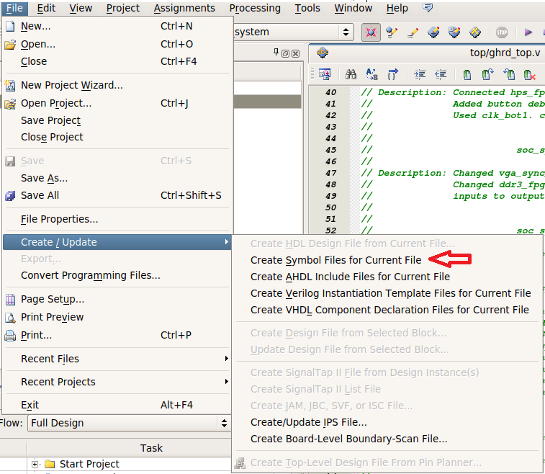

Figure 6-1. Creating a symbol file from a Verilog file.

Next create the top level block diagram. In the File menu, click ‘New…’, and select ‘Block Diagram/Schematic File’. You should now have a file called Block1.bdf. Right click anywhere in the block diagram, click ‘insert’, then click ‘Symbol’.

When the Symbol window pops up, expand the ‘Project’ Directory and find the ghrd_top symbol we just created (ghrd_top). Select the symbol and place it in your block diagram. Right click on the symbol and click ‘Generate Pins for Symbol Ports’. We now have an equivalent block diagram of the Verilog file. In the File menu, click ‘Save as’ and save the file as top_block.bdf.

Next go to the Project navigator pane and again click on the ‘Files’ tab on the bottom. Find the top_block.bdf file that was just created and right click on it. Click ‘Set as Top-Level Entity’. Now click on the ‘Heirarchy’ tab on the bottom of the Project Navigator pane, and you should see top_block as the top level entity.

Click ‘Start Compilation’ in the toolbar to compile the design. You should have no errors in the compile. There are some warnings about unconstrained paths in this file that you will notice. Let’s fix these.

Open TimeQuest Timing Analyzer from the toolbar menu.

On the left side of Timequest, in the ‘Tasks’ pane, double click on ‘Create Timing Netlist’. Next double click on ‘Read SDC File’. Finally, click ‘Update Timing Netlist’.

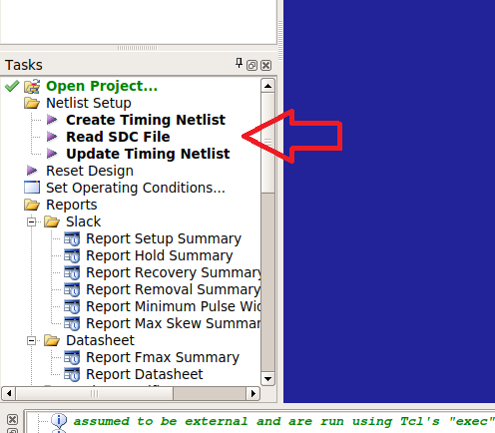

Figure 6-2. Timequest configuration and running.

Again, in the ‘Tasks’ pane, click on the reports you would like to examine. Click on ‘Report Clocks’, and examine all the clocks in the system. Next, click on ‘Report Unconstrained Paths’ to find out the source of the warnings seen after compilation. The report will be in the ‘Report’ pane in the upper left corner. Of interest is the Clock Status Summary, where you will find that clocks hps_i2c1_SCL and hps_usb1_CLK are unconstrained. Also, if you expand Setup Analysis and Hold Analysis, you find several unconstrained Input and Output Ports.

The paths are all associated with the hps components, and I believe at this moment, we can give the clock some arbitrary constraints for now since we are not using the i2c and USB port now. The other paths look to be ports in the hard silicon, so we can set them as false paths.

Find the file ‘soc_system_timing.sdc’ in your socket_ghrd project folder. Open the file with a text editor (gedit) and add the following lines anywhere to fix the constraints:

# EDIT
# Fix Unconstrained Clocks
create_clock -name {hps_i2c1_SCL} -period 40 {hps_i2c1_SCL}
create_clock -name {hps_usb1_CLK} -period 40 {hps_usb1_CLK}

# Fix Unconstrained Input Ports
set_false_path -from [get_ports {hps_i2c1_SDA}] -to *
set_false_path -from [get_ports {hps_spim1_MISO}] -to *
set_false_path -from [get_ports {user_pb_fpga[2]}] -to *
set_false_path -from [get_ports {user_pb_fpga[3]}] -to *

# Fix Unconstrained Output Ports
set_false_path -from * -to [get_ports {hps_i2c1_SDA}]
set_false_path -from * -to [get_ports {hps_i2c1_SCL}]
set_false_path -from * -to [get_ports {hps_spim1_MOSI}]
set_false_path -from * -to [get_ports {hps_spim1_SS0}]

Code Snip 6-1. Constraints file edit.

Go back to Timequest and click on ‘Reset Design’ in the ‘Tasks’ pane. Again, double click on ‘Read SDC File’ and ‘Update Timing Netlist’ to generate a new report. The unconstrained paths should now be gone.

Close Timequest and return to Quartus. Click compile again and make sure the timing warnings are gone. Now that we have an error free design in a graphical design environment, we can continue on with building our latency test.

Start Qsys and open the soc_system.qsys file. In the ‘Library’ pane on the left side of Qsys, search for PIO, then select it. Click the ‘Add…’ button in the bottom right corner of the ‘Library’ pane. When the configuration window pops up, configure it as shown in the picture below:

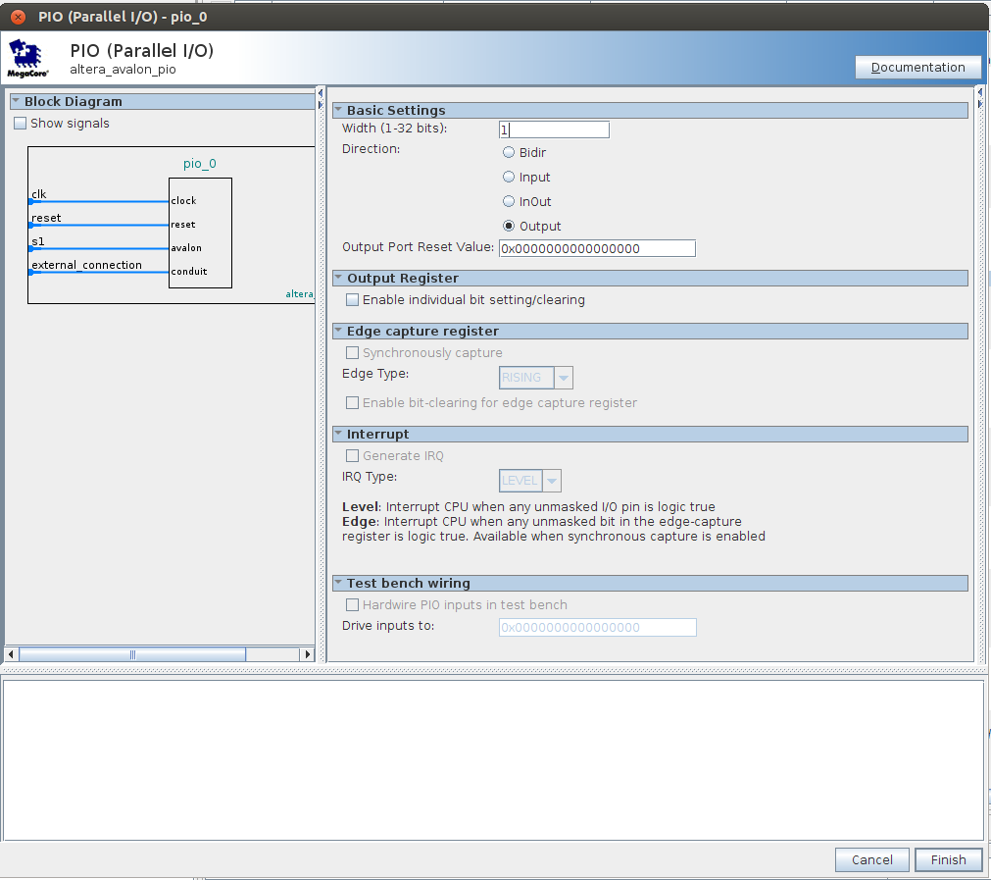

Figure 6-3. Qsys PIO configuration.

When done, click Finish’. The new PIO module is now at the bottom of the Qsys system. You can move it up to sit next to the other PIO’s (button_pio and dipsw_pio). Rename the module to something meaningful like ‘ltncy_pio_rcvr’. Connect the clk, reset, and s1 line. Also double click on the Export column for external connections. Finally give the PIO an address of 0x00040000. The Qsys system should look like the picture below.

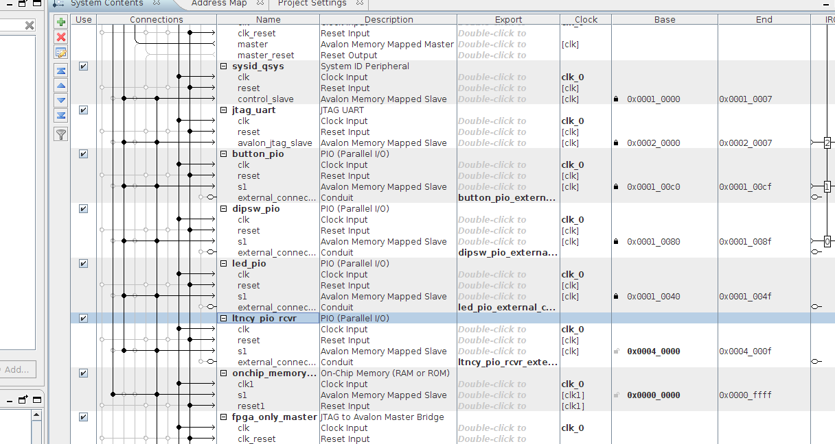

Figure 6-5. Qsys configuration after adding PIO.

Add another PIO to the system for the latency sender interrupt. Configure it as shown below:

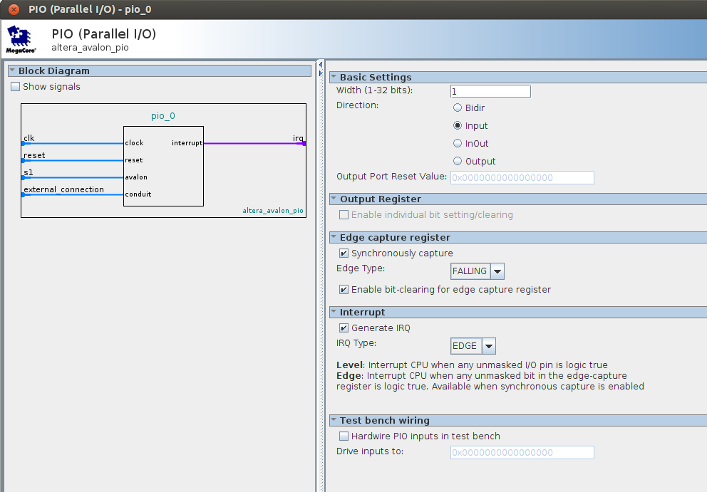

Figure 6-6. Adding input PIO to the Qsys system for receiving interrupts.

Connect the lines as done with the other PIO and give it an address of 0x00040040. This module also has to be connected to the interrupt receivers, similar to the button_pio module. The Qsys system should look like the picture below. The system is done and ready to generate.

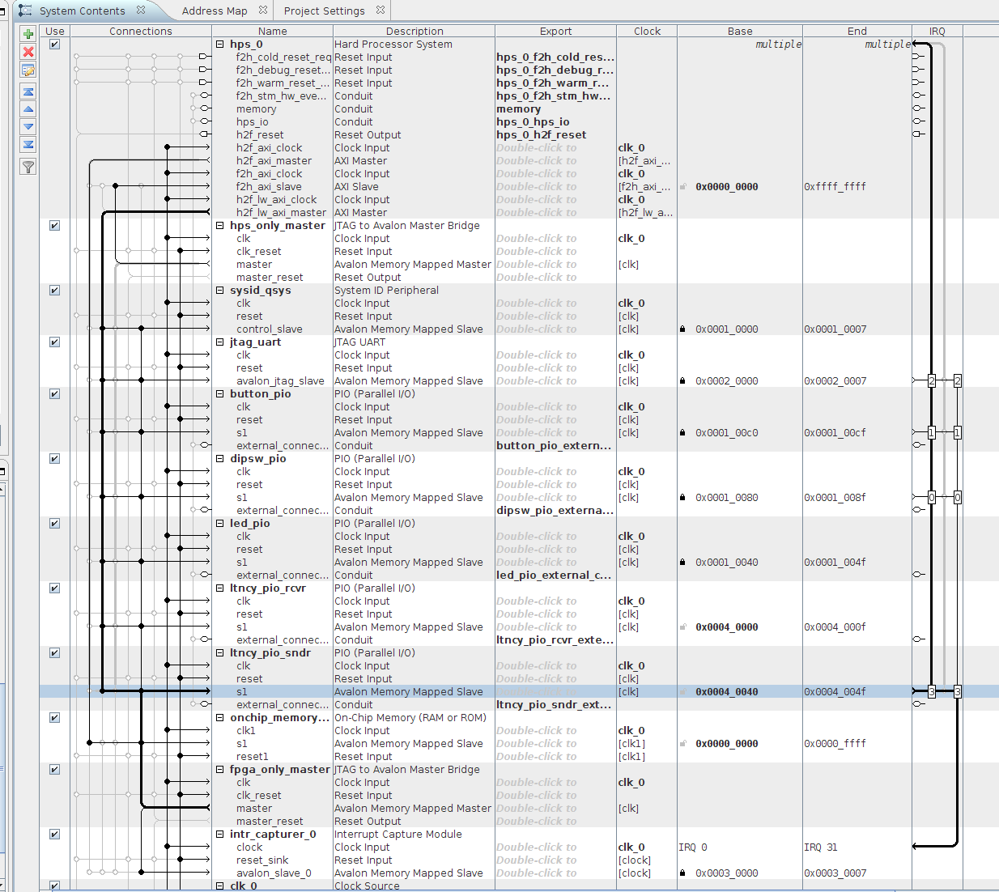

Figure 6-7. Asys configuration after adding PIO interrupt receiver.

After the system is done generating, click on the ‘Generate’ menu, then click ‘HDL example…’. A window will pop up with the Verilog code to instantiate the qsys block. Since we added two external connections to the block (ltncy_pio_rcvr and ltncy_pio_sndr), we need to find these connections in the Verilog code and copy them into the verliog file ghrd_top. The HDL example should look like the picture below:

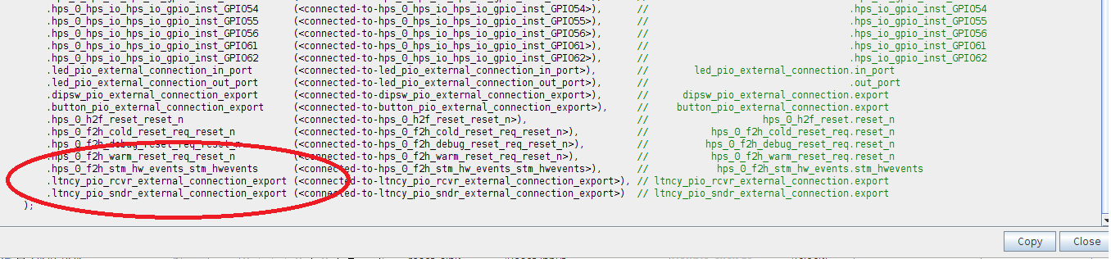

Figure 6-8. Verilog example generated by Qsys.
Close Qsys and go back to Quartus. Now we have to connect the input/ output lines from the Qsys system to the Verilog ghrd_top file input/output lines. In the ‘Project Navigator’ pane, select the ‘Files’ tab on the bottom, and open the top/ghrd_top.v Verilog file. In that file go down to lines 387 and insert the following code to instantiate the new connections as seen in the picture below.

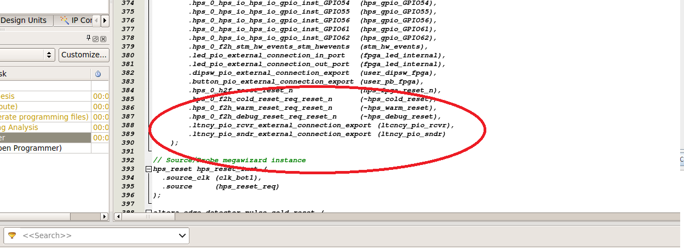

Figure 6-9a. Modify the ghrd_top.v file to instatiate the new qsys components.

Since we connected our Qsys input/output to lines called ltncy_pio_rcvr and ltncy_pio_sndr, we have to add these lines to the input/output lines of the Verilog file. At the top of the file (line 89), add the input and output lines as shown below:

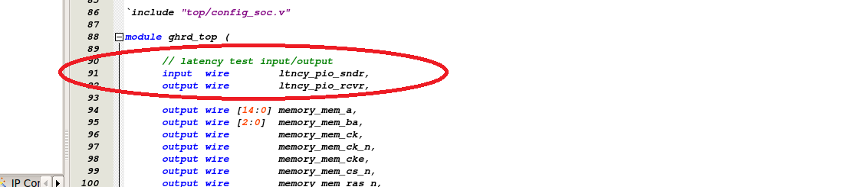

Figure 6-9b. Modify the ghrd_top.v file to instatiate the new qsys components.

Save the file. Now we have to update our symbol file to include the changes. Click on the ‘File’ menu, then select ‘Create/Update’, then select ‘Create Symbol Files for Current File’. If there are no errors creating the symbol file, we are done with the Verilog file. Open the top_block.bdf file we created earlier. We can see that the symbol file did not get updated and the new PIO intputs and outputs are not shown. Right click on the Qsys block and click ‘Update Symbol or Block…’. You’ll notice the symbol has been updated, but now the pins are connected to the wrong lines since all the ports shifted around in the symbol. The solution is to delete all the pins and then right click on the symbol again, and select ‘Generate Pins for Symbol Ports’. You can get fancy with the symbol editor to shift around the lines to match the pins if you want, but for now, we will just use the brute force method. It becomes clear that you really want to complete the Qsys system before moving on to the rest of the FPGA firmware. When done, you should have something that looks like the picture below.
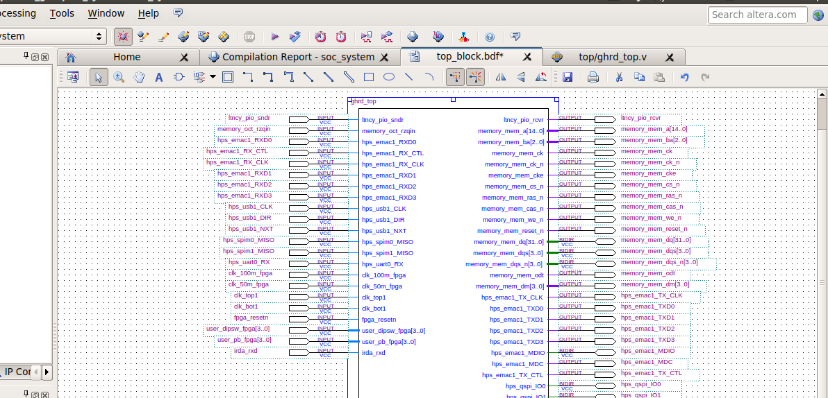

Figure 6-10. Top level block diagram of the FPGA system.

For our latency test, we need to connect the first FPGA push button to the PIO sender. The picture below shows the result of wiring the upper 3 pushbuttons to the Qsys part, and the first push button is used to generate the interrupt.

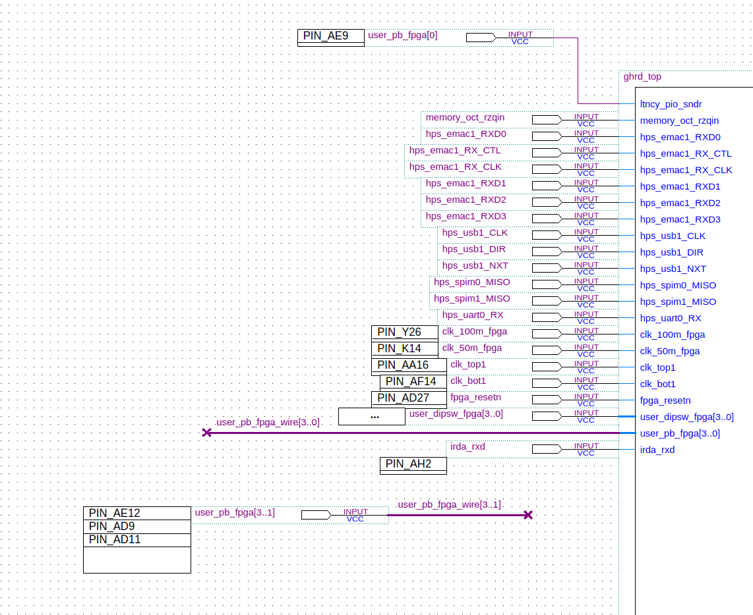

Figure 6-11. Configuring the push buttons for generating an interrupt.
The signal acknowledgment coming back from the Linux application will be routed through the PIO receiver. This signal will also be connected to an LED so we can visually confirm the signal state of the receiver. The pictures below show how to set this up.

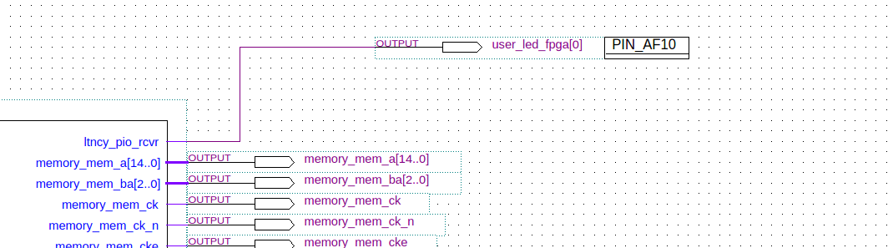

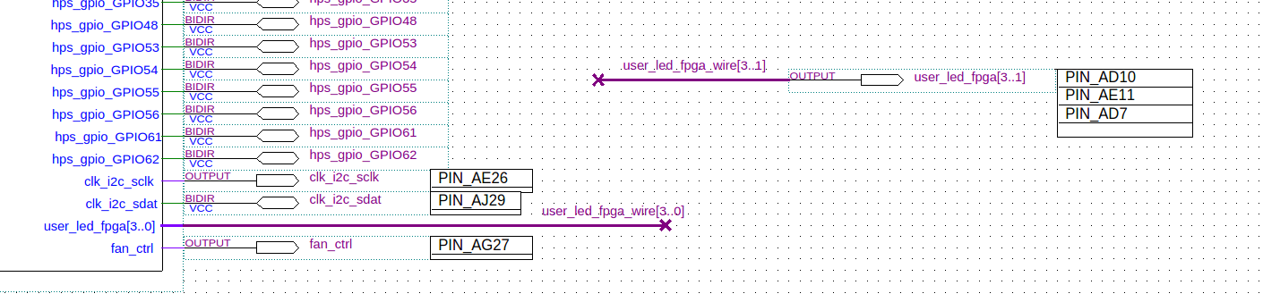

Figure 6-12. Receiving the interrupt acknowledgment from the Linux application.

Compile the design, generate the preloader, device tree, .rbf file, and load them on to the SD Card.

Put the SD card back in the SoCKit board and turn it on. Open up the gtkterm terminal and log in. Make a password again since the password is not remembered when re-booting.

The first thing to do is check to see if ther new PIO’s are recognized.

$ modprobe gpio-altera
$ ls /sys/class/gpio

You should see the existing pushbutton and dipswitch pio’s (148, 152), along with the new sender/receiver pio’s(146, 147). To determine which is the sender and which is the receiver, use the command:

$ cat /sys/class/gpio/gpiochip146/label

/sopc@0/bridge@0xc0000000/gpio@0x100040040

This indicates that it is the sender. Now look at the 147. It should be at address 4000.

$ cat /sys/class/gpio/gpiochip147/label

/sopc@0/bridge@0xc0000000/gpio@0x100040000

Since the sender is going to generate our interrupt, we need to register it. (This could be part of a start-up script later)

$ cd /sys/class/gpio
$ echo 146 > export
$ cd gpio146
$ echo in > direction
$ echo falling > edge

Next create the Linux application to test this. Open the embedded command shell and start eclipse. Delete the hps_0.h header file because it is no longer good. Start another embedded command shell and generate a new header file with the sopc-create-header-files command described back on page 14. Copy the following code into main.c and build the code. Start the debugger to test the code.

/* SoC LLRF System
* Fermilab
* 9/11/14
*/

#include <stdio.h>
#include <unistd.h>
#include <fcntl.h>
#include <sys/mman.h>
#include "hwlib.h"
#include "socal/socal.h"
#include "socal/hps.h"
#include "socal/alt_gpio.h"
#include "hps_0.h"
#include "poll.h"

#define HW_REGS_BASE ( ALT_STM_OFST )
#define HW_REGS_SPAN ( 0x04000000 )
#define HW_REGS_MASK ( HW_REGS_SPAN - 1 )

int main() {

printf( "Fermilab LLRF System test....\n" );

void *virtual_base; // Memory bas pointer
int fd_mem; // Memory file descriptor
int loop_count; // Counter for blinking LEDS

struct pollfd fdset[1]; // GPIO poll
int fd_gpio; // Pushbutton 'value' file descriptor
int rv; // Return value
char buf[2]; // read() buffer

// map the address space for the LED registers into user space so we can interact with them.
// we'll actually map in the entire CSR span of the HPS since we want to access various registers within that span

if( -1 == ( fd_mem = open( "/dev/mem", ( O_RDWR | O_SYNC )))) {
printf( "ERROR: Failed to open \"/dev/mem\"...\n" );
return( -1 );
}

if(MAP_FAILED == (virtual_base = mmap(NULL, HW_REGS_SPAN, (PROT_READ | PROT_WRITE), MAP_SHARED, fd_mem, HW_REGS_BASE))) {
printf( "ERROR: mmap() failed...\n" );
close( fd_mem );
return( -1 );
}

// Create a pushbutton 'value' file descriptor
if ((fd_gpio = open( "/sys/class/gpio/gpio146/value" , O_RDONLY | O_NONBLOCK )) < 0) {
printf( "ERROR: Failed to open gpio...\n");
return(-1);
}
printf( "Pushbutton 'value' file opened....\n" );

// Setup the polling system
fdset[0].fd = fd_gpio;
fdset[0].events = POLLPRI|POLLERR;

// Send a signal to latency receiver to turn ON the LED
alt_setbits_word( ( virtual_base + ( ( uint32_t )( ALT_LWFPGASLVS_OFST + LTNCY_PIO_RCVR_BASE ) & ( uint32_t )( HW_REGS_MASK ) ) ), 0x00000001 );
usleep(100000);
// Send a signal to turn OFF the LED
alt_clrbits_word( ( virtual_base + ( ( uint32_t )( ALT_LWFPGASLVS_OFST + LTNCY_PIO_RCVR_BASE ) & ( uint32_t )( HW_REGS_MASK ) ) ), 0x00000001 );

// Setup poll with a dummy read() (gets the file position correct for poll?)
rv = read(fdset[0].fd, buf, sizeof(buf));
// Block endlessly and wait for interrupt
rv = poll(fdset, 1, -1);

// Send a signal back to the FPGA for Signal tap timing
alt_setbits_word( ( virtual_base + ( ( uint32_t )( ALT_LWFPGASLVS_OFST + LTNCY_PIO_RCVR_BASE ) & ( uint32_t )( HW_REGS_MASK ) ) ), 0x00000001 );

printf( "Interrupt happened....\n" );

// toggle the LEDs 100 times in 10 second
loop_count = 0;
while( loop_count < 100 ) {
// turn off all LEDs
alt_clrbits_word( ( virtual_base + ( ( uint32_t )( ALT_GPIO1_SWPORTA_DR_ADDR ) & ( uint32_t )( HW_REGS_MASK ) ) ), 0x0F000000 );
alt_clrbits_word( ( virtual_base + ( ( uint32_t )( ALT_LWFPGASLVS_OFST + LED_PIO_BASE ) & ( uint32_t )( HW_REGS_MASK ) ) ), 0x0000000F );

usleep( 50000);

// turn on all LEDs
alt_setbits_word( ( virtual_base + ( ( uint32_t )( ALT_LWFPGASLVS_OFST + LED_PIO_BASE ) & ( uint32_t )( HW_REGS_MASK ) ) ), 0x0000000F );
alt_setbits_word( ( virtual_base + ( ( uint32_t )( ALT_GPIO1_SWPORTA_DR_ADDR ) & ( uint32_t )( HW_REGS_MASK ) ) ), 0x0F000000 );

usleep( 50000 );
loop_count++;
}

// leave the LEDs in the OFF state
alt_clrbits_word( ( virtual_base + ( ( uint32_t )( ALT_GPIO1_SWPORTA_DR_ADDR ) & ( uint32_t )( HW_REGS_MASK ) ) ), 0x0F000000 );
alt_clrbits_word( ( virtual_base + ( ( uint32_t )( ALT_LWFPGASLVS_OFST + LED_PIO_BASE ) & ( uint32_t )( HW_REGS_MASK ) ) ), 0x0000000F );

// clean up our memory mapping and exit
if( munmap( virtual_base, HW_REGS_SPAN ) != 0 ) {
printf( "ERROR: munmap() failed...\n" );
close( fd_mem );
return( -1 );
}
close( fd_gpio );
close( fd_mem );
return( 0 );
}

Code Snip 6-2. Linux application to test round trip latency.
When the debugger is started, FPGA LED 1 should blink for a half second and then wait for you to press the push button. After the push button press, the Linux application should receive the interrupt, print a message, and all the LED’s should start flash (except FPGA LED 1). FPGA LED 1 should stay lit indicating that the signal was received by the FPGA.

Now that the signal path is working, Signal Tap needs to be configured. The first thing to do is make a copy of the socket_ghrd project, and rename the project folder to sockit_ghrd_latency. This is done so that the SignalTap configuration/FPGA usage does not interfere with a clean design. Later, we will examine the settings file to remove signal tap configurations from the project. But for now, keep the original design clean so later we continue to build a system without the SignalTap overhead.

Open the sockit_ghrd_latency project in Quartus and select ‘SignalTap II Logic Analyzer’ under the ‘Tools’ menu. The SignalTap window will pop up and the ‘Setup’ view should show the signals that are already configured. The first thing to do is delete all the configured signals. Once deleted, double click that area to add new signals using the ‘Node Finder’ window. In the options section of the Node finder, select ‘Pins: assigned’ as a Filter and click ‘List’ in the upper right corner. The signals should show up as seen in the picture below. Select ‘user_pb_fpga[0]’ and user_led_fpga[0]’ and use the arrow button in the middle to add them to the analyzer. Click OK when done.

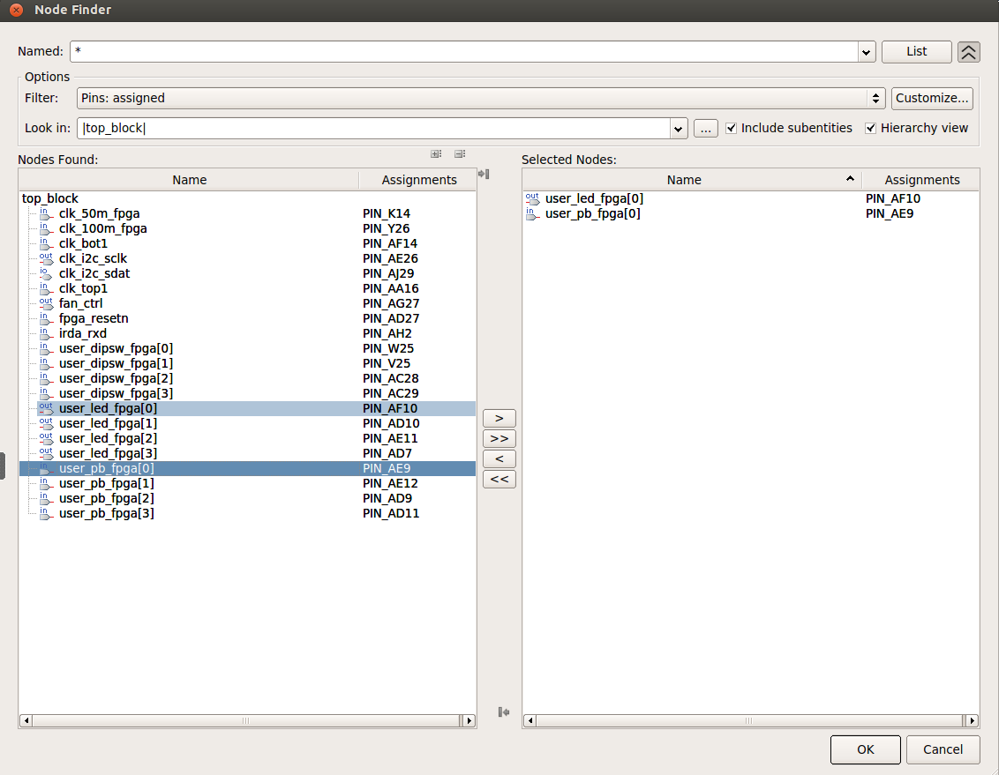

Figure 6-13. Signal Tap node finder.

Once the signal nodes are added to the analyzer, configure the push button to be a falling edge trigger and uncheck ‘Trigger Enable’ from the user_led_fpga[0] node. Also increase the ‘Sample depth’ to 64K and select the ‘CV SoCKit[1-2]’ for the Hardware. In the clock selection, choose clk_bot1 for your clock. The configuration is shown in the picture below.

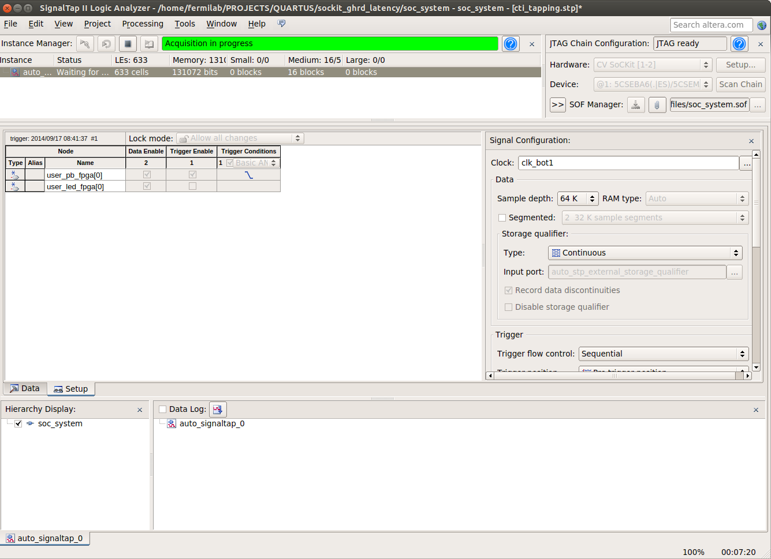

Figure 6-14. Signal Tap configuration.

After the configuration is complete, the design will have to be recompiled. Save the SignalTap set up and re-compile the design in Quartus. When the design is done compiling, we need to test it. Follow the steps below test the setup.

- Restart the Sockit by pressing the warm reset button.
- Load the SignalTap configured firmware after the reboot is complete.
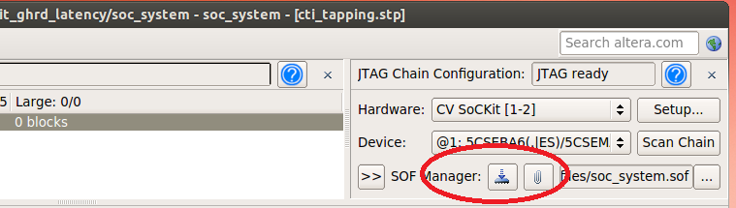
- In the gtkterminal, login, setup your password, and register gpio interrupt 146 as before.
- Start SignalTap in Autorun Analysis mode. It should indicate that acquisition is in progress.
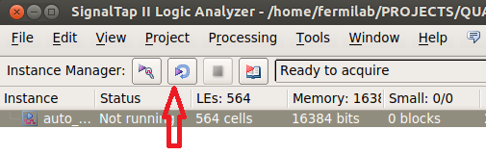
- Start eclipse and start debugging the program as before.
- Once the push button is pressed, the program should respond as before. Take a look at the SignalTap output and you should see the interrupt event, along with the return signal as seen in the picture below.
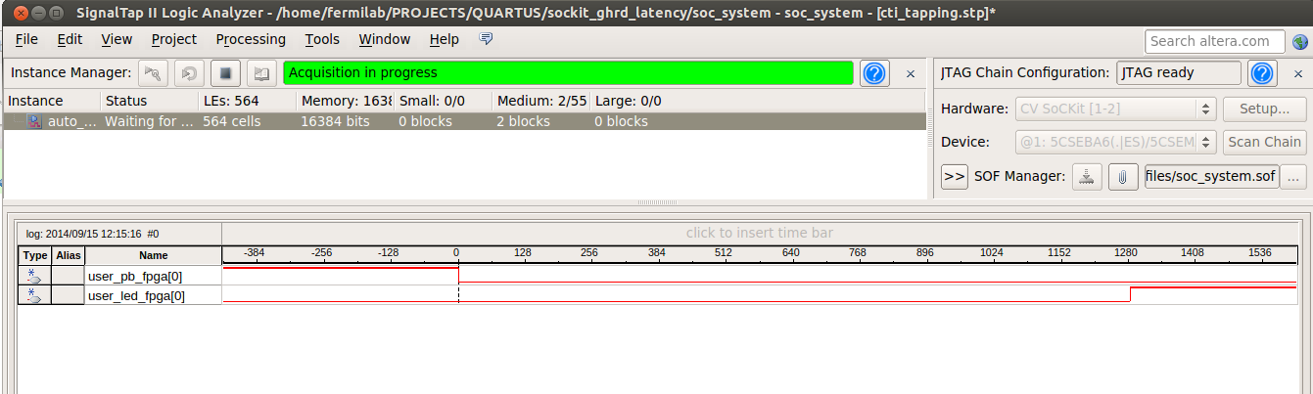

The above picture shows a round trip latency of 1280 clock cycles. Since the clock in running a 50 MHz, the total time is 25.6 us. The latency will not be consistent from interrupt to interrupt, so a larger data set is needed to get some average and max times. From initial testing of a few hundred button presses, the largest number I got was about 1700 clock cycles, or 34 us. This gives a base line for the fastest a data acquisition trigger can go. (~30 kHz). Obviously we can’t run the DAQ trigger at 30 kHz, because things need to happen after the interrupt is received. This leads us to our next test of sending with data packets out Ethernet after the interrupt is received. This setup will give us a better understanding of how fast we can move data.

Paste the code below into main.c and run the same test as before. After the interrupt is received, 128 packets of 512 Bytes of data are sent out Ethernet using UDP.

/* SoC LLRF System
* Fermilab
* 9/11/14
*/

#include <stdio.h>
#include <unistd.h>
#include <fcntl.h>
#include <sys/mman.h>
#include "hwlib.h"
#include "socal/socal.h"
#include "socal/hps.h"
#include "socal/alt_gpio.h"
#include "hps_0.h"
#include "poll.h"

// Ethernet libraries
#include <sys/types.h>
#include <sys/socket.h>
#include <arpa/inet.h>
#include <netinet/in.h>

// Memory addressing
#define HW_REGS_BASE ( ALT_STM_OFST )
#define HW_REGS_SPAN ( 0x04000000 )
#define HW_REGS_MASK ( HW_REGS_SPAN - 1 )

//UDP
#define BUFLEN 512
#define NPACK 10
#define PORT 30

// UDP sockets
struct sockaddr_in si_me, si_other;
int s, i, slen=sizeof(si_other);
char buf[BUFLEN];
char send_data;
bool connected;

// Memory addressing
void *virtual_base;
void *axi_virtual_base;
int fd_mem;

int main() {

int loop_count; // Counter for blinking LEDS
struct pollfd fdset[1]; // GPIO poll
int fd_gpio; // Pushbutton 'value' file descriptor
int rv; // Return value
char int_buf[2]; // read() buffer
int lcv;

void *MEMbase = ( axi_virtual_base ) ;

printf( "Fermilab LLRF System test....\n" );

// map the address space for the LED registers into user space so we can interact with them.
// we'll actually map in the entire CSR span of the HPS since we want to access various registers within that span
if( -1 == ( fd_mem = open( "/dev/mem", ( O_RDWR | O_SYNC )))) {
printf( "ERROR: Failed to open \"/dev/mem\"...\n" );
return( -1 );
}

// HPS to FPGA lightweightbridge (LED's pushbutton, etc)
if( MAP_FAILED == (virtual_base = mmap( NULL, HW_REGS_SPAN, ( PROT_READ | PROT_WRITE ), MAP_SHARED, fd_mem, HW_REGS_BASE )) ) {
printf( "ERROR: LW bridge mmap() failed...\n" );
close( fd_mem );
return( -1 );
}

// *** GPIO interrupt configuration ***
// $ cd /sys/class/gpio
// $ echo 146 > export
// $ echo in > direction
// $ echo falling > edge

// Create a pushbutton 'value' file descriptor
if ((fd_gpio = open( "/sys/class/gpio/gpio146/value" , O_RDONLY | O_NONBLOCK )) < 0) {
printf( "ERROR: Failed to open gpio...\n");
return(-1);
}
printf( "Pushbutton 'value' file opened....\n" );

// Setup the polling system
fdset[0].fd = fd_gpio;
fdset[0].events = POLLPRI|POLLERR;

// Send a signal to latency receiver to turn ON the LED
alt_setbits_word( ( virtual_base + ( ( uint32_t )( ALT_LWFPGASLVS_OFST + LTNCY_PIO_RCVR_BASE ) & ( uint32_t )( HW_REGS_MASK ) ) ), 0x00000001 );
sleep(1);
// Send a signal to turn OFF the LED
alt_clrbits_word( ( virtual_base + ( ( uint32_t )( ALT_LWFPGASLVS_OFST + LTNCY_PIO_RCVR_BASE ) & ( uint32_t )( HW_REGS_MASK ) ) ), 0x00000001 );

// UDP Socket setup
s=socket(AF_INET, SOCK_DGRAM, IPPROTO_UDP);
memset((char *) &si_me, 0, sizeof(si_me));
si_me.sin_family = AF_INET;
si_me.sin_port = htons(PORT);
si_me.sin_addr.s_addr =htonl(INADDR_ANY);
bind(s, &si_me, sizeof(si_me));
memset(buf, 0x00, sizeof(buf));

printf( "Waiting for pushbutton Interrupt....\n" );
// Setup poll with a dummy read() (gets the file position correct for poll?)
rv = read(fdset[0].fd, int_buf, sizeof(int_buf));
// Block endlessly and wait for interrupt
rv = poll(fdset, 1, -1);

// Send 65k of data out
for (lcv=0; lcv<128; lcv++)
sendto(s, (MEMbase + ((uint32_t) (lcv*512) & (uint32_t) (0xFFFFFFFF))), 512, 0, &si_other, slen);

// Send a signal back to the FPGA for Signal tap timing
alt_setbits_word( ( virtual_base + ( ( uint32_t )( ALT_LWFPGASLVS_OFST + LTNCY_PIO_RCVR_BASE ) & ( uint32_t )( HW_REGS_MASK ) ) ), 0x00000001 );

printf( "Interrupt happened and data sent!\n" );

// toggle the LEDs 100 times in 10 second
loop_count = 0;
while( loop_count < 100 ) {

// turn off all LEDs
alt_clrbits_word( ( virtual_base + ( ( uint32_t )( ALT_GPIO1_SWPORTA_DR_ADDR ) & ( uint32_t )( HW_REGS_MASK ) ) ), 0x0F000000 );
alt_clrbits_word( ( virtual_base + ( ( uint32_t )( ALT_LWFPGASLVS_OFST + LED_PIO_BASE ) & ( uint32_t )( HW_REGS_MASK ) ) ), 0x0000000F );

usleep( 50000);

// turn on all LEDs
alt_setbits_word( ( virtual_base + ( ( uint32_t )( ALT_LWFPGASLVS_OFST + LED_PIO_BASE ) & ( uint32_t )( HW_REGS_MASK ) ) ), 0x0000000F );
alt_setbits_word( ( virtual_base + ( ( uint32_t )( ALT_GPIO1_SWPORTA_DR_ADDR ) & ( uint32_t )( HW_REGS_MASK ) ) ), 0x0F000000 );

usleep( 50000 );
loop_count++;
}

// leave the LEDs in the OFF state
alt_clrbits_word( ( virtual_base + ( ( uint32_t )( ALT_GPIO1_SWPORTA_DR_ADDR ) & ( uint32_t )( HW_REGS_MASK ) ) ), 0x0F000000 );
alt_clrbits_word( ( virtual_base + ( ( uint32_t )( ALT_LWFPGASLVS_OFST + LED_PIO_BASE ) & ( uint32_t )( HW_REGS_MASK ) ) ), 0x0000000F );

// clean up our memory mapping and exit
if( munmap( virtual_base, HW_REGS_SPAN ) != 0 ) {
printf( "ERROR: munmap() failed...\n" );
close( fd_mem );
return( -1 );
}

close( fd_gpio );
close( fd_mem );
return( 0 );
}

Code Snip 6-3. Adding Ethernet UDP pack sending to the Linux application.

The result of the test is shown below. It takes ~6500 clock cycles to receive the interrupt, send out 65 kBytes of data over UDP, then send a signal back to the FPGA to indicate the process is done. (~130 us) In theory, this system could trigger 65k data sends at ~7.5 kHz, resulting in a total throughput of ~490 MBytes/sec. This test is just a baseline test, because in reality the Ethernet port will have to handle the data, and something will have to receive the data. This will be exercised in the next test. There are many other factors that can speed up or slow down data transfer, so this test is not the definitive answer. For example, to get a braoder feel for haw fast data moves, the packet size can be adjusted or some data processing can be be done.

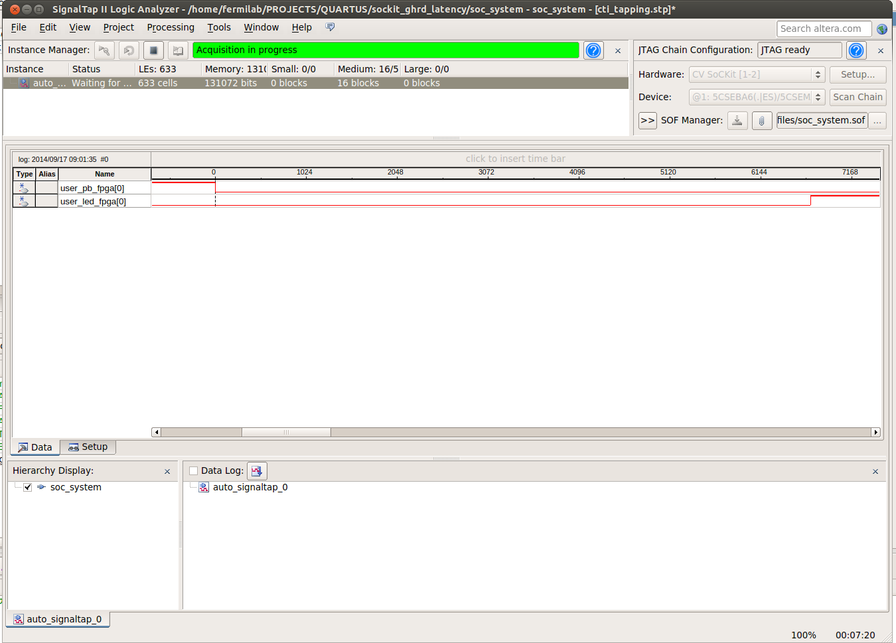

Figure 6-15. Signal Tap test results.

7. Adding a NIOS FPGA CPU to Automate Latency Test

In this section, a Nios FPGA CPU is added to the design to start and stop timers for latency calculations, and data is transmitted to a laptop running Labview to receive data over a UDP connection. The Qsys design will be reconfigured, the ghrd_top.v Verilog file will be modified, and the top block will be modified. The soc_system_board_info.xml file (for device tree generation) will also be modified because we will be removing the led_pio’s which have references in the file. A Nios software application will be created which will control high resolution timers and make the data available to the Linux application. The Linux application will then process the data and send it out Ethernet to a Labview application for display.

Start by copying the original sockit_ghrd design folder into a new folder, and name the folder ‘sockit_ghrd_nios’. Open Qsys and create the system below. The details of the Qsys system are shown in Appendix A.

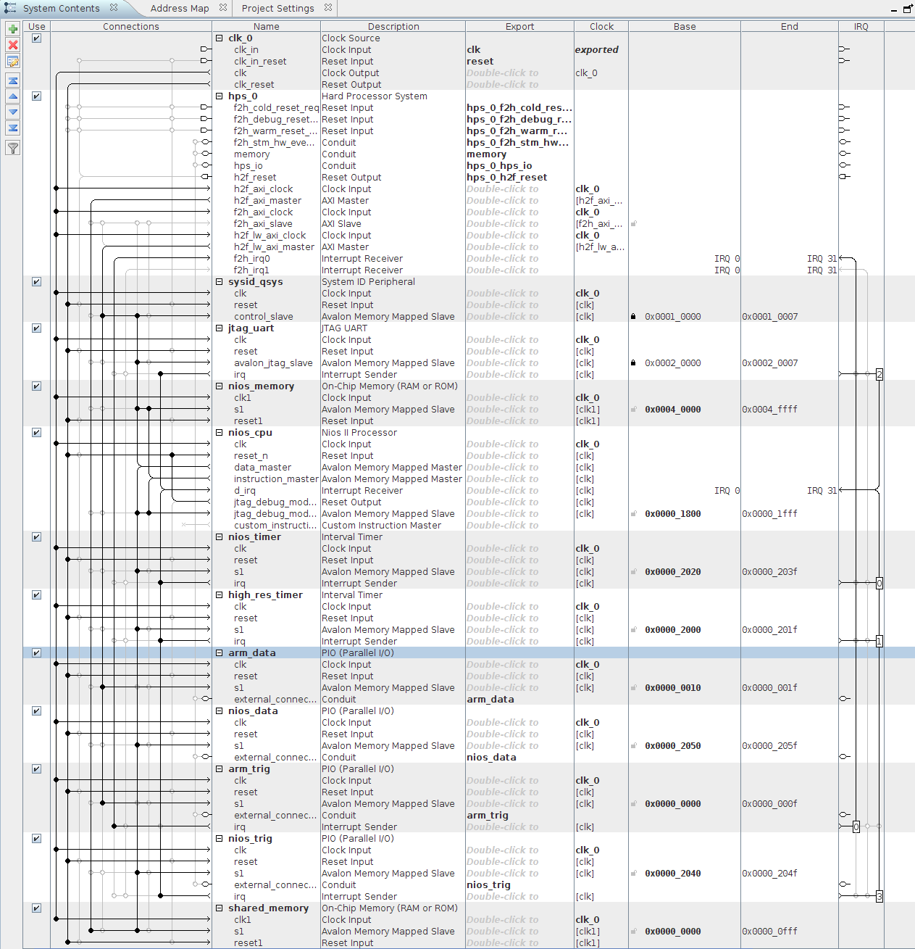

Figure 7-1. Qsys configuration for Nios cpu based system.
Once the new Qsys system is complete, modify the top.v file to include the new inputs and outputs, then create a new symbol file. The complete verilog file is in Appendix A.

The block diagram for the latency test is shown below. The pio data lines are connected to the LED’s for debugging purposes.

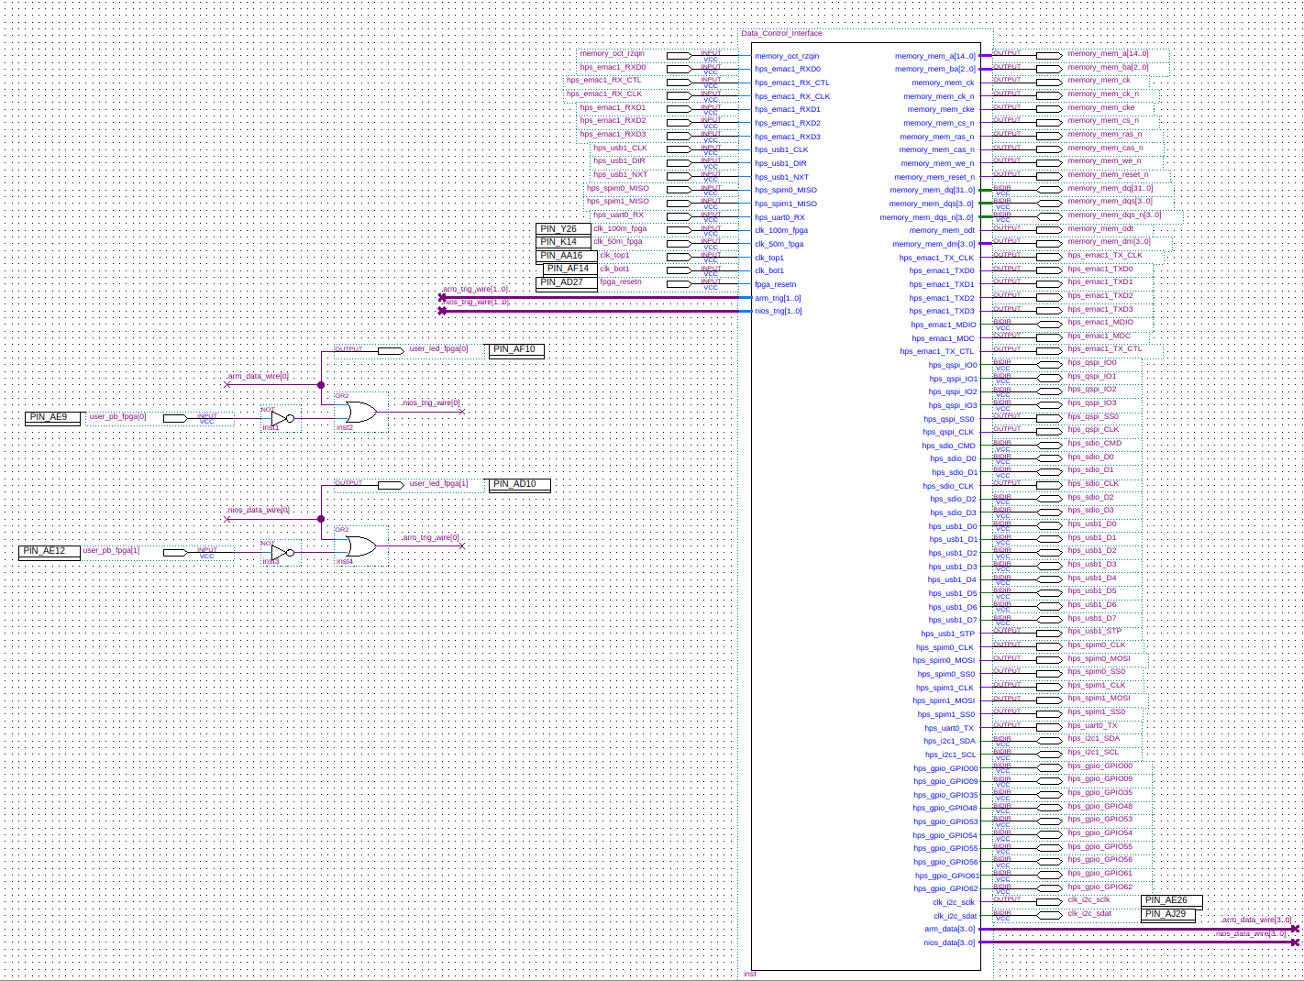

Figure 7-1. Top level block diagram of the nios based system.

Compile the design. You may want to fix the Timequest warnings as done earlier. Modify the soc_system_board_info.xml file so we can create a device tree without errors. Remove the lines of code shown below from the .xml file:

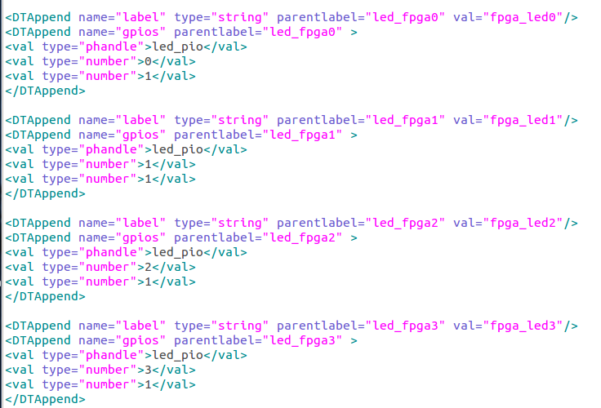

Figure 7-3. Lines that need to be removed from the soc_system_board_info.xml file.
The data path of the above test system is as follows:

- The Nios will start the high resolution timer. The timer has a resolution of 1us.
- A signal is sent to the FPGA fabric using the ‘nios_data’ PIO.
- Once the signal from the nios_data PIO is received by the FPGA fabric, it is sent to the arm_trig PIO which is configured to receive interrupts.
- The interrupt from ‘arm_trig’ will trigger the linux user space interrupt service.
- Data will be transferred over UDP ethernet connection to laptop Labview inapplication.
- The Linux user space interrupt service will send a signal back to the FPGA fabric through ‘arm_data’ PIO.
- The arm_data is then sent to the nios_trig PIO, which is configured to receive interrupts.
- The interrupt from nios_trig will trigger a interrupt service that will stop the high resolution timer.
- The time is sent to shared memory, which then can be viewed by the Linux user space. The round trip time can be then calculated in the interrupt service routine.

Once finished compiling the design and updating the SD card, we can create a Nios application. To start, a simple Nios application is created to test the interrupt service. Open the Nios II Software Build Tools as shown below.

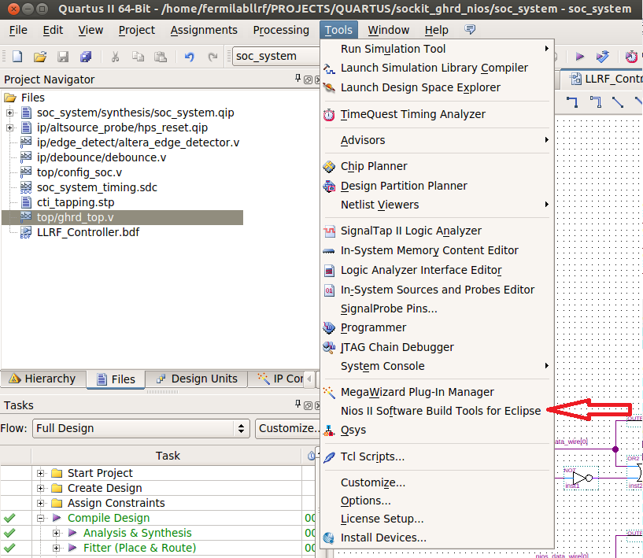

Figure 7-4. Opening the Nios Software Build Tools

Once eclipse is open, right click in the Project Explorer and click ‘New’, then click ‘Nios Application and BSP from Template’ as shown below.

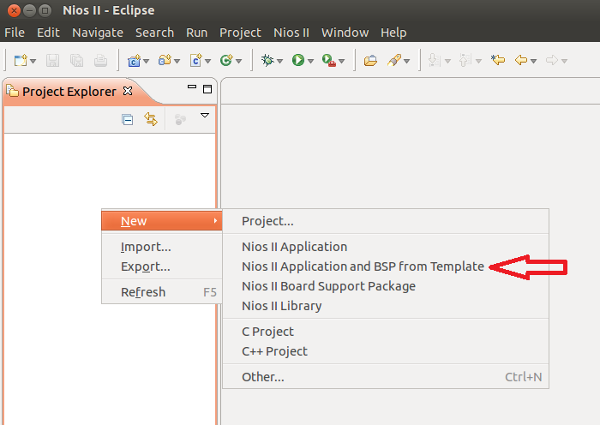

Figure 7-5a. Creating a Nios project from a template.

Use the ‘Hello World’ template and enter the SOPC Information File name and Project name as shown below. Click Finish when done.

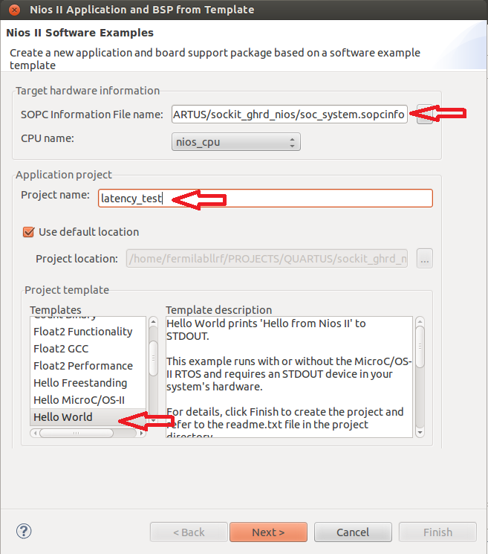

Figure 7-5b. Creating a Nios project from a template.

The Project explore should now contain the folders shown below. Open the hello_world.c file and the system.h file as shown.

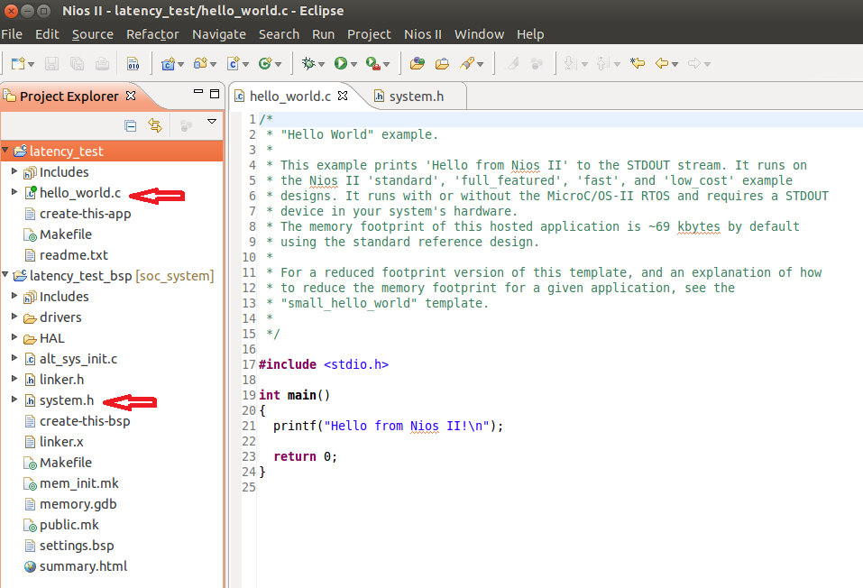

Figure 7-6. Nios project in the Nios eclipse IDE.

To test that everything is working, we need to build the application and run it. But before we build the application, we need to configure the bsp for our timers. Right click on the latency_test bsp folder and open the bsp editor as shown below.

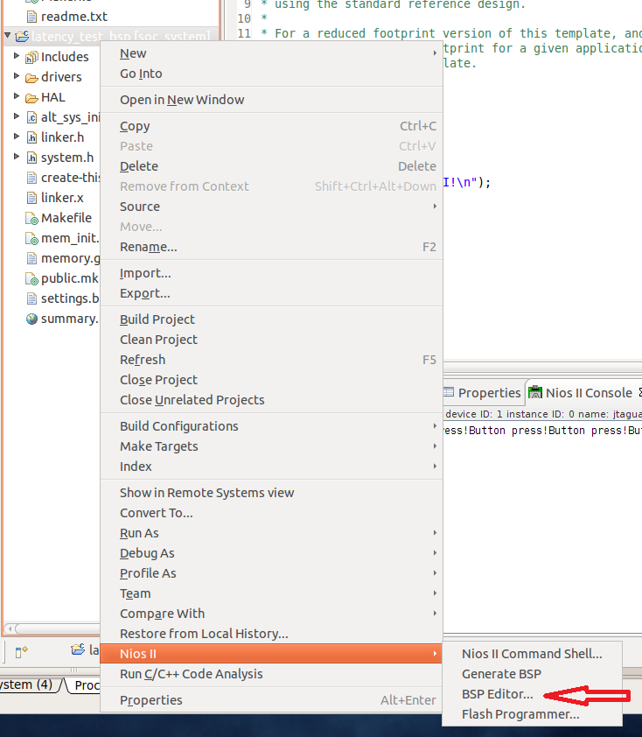

Figure 7-7. Editing the Nios BSP (Board Support Package).
In the hal section of the bsp editor, change the sys_clk_timer and the timestamp timer as shown below. Click generate when done and exit.

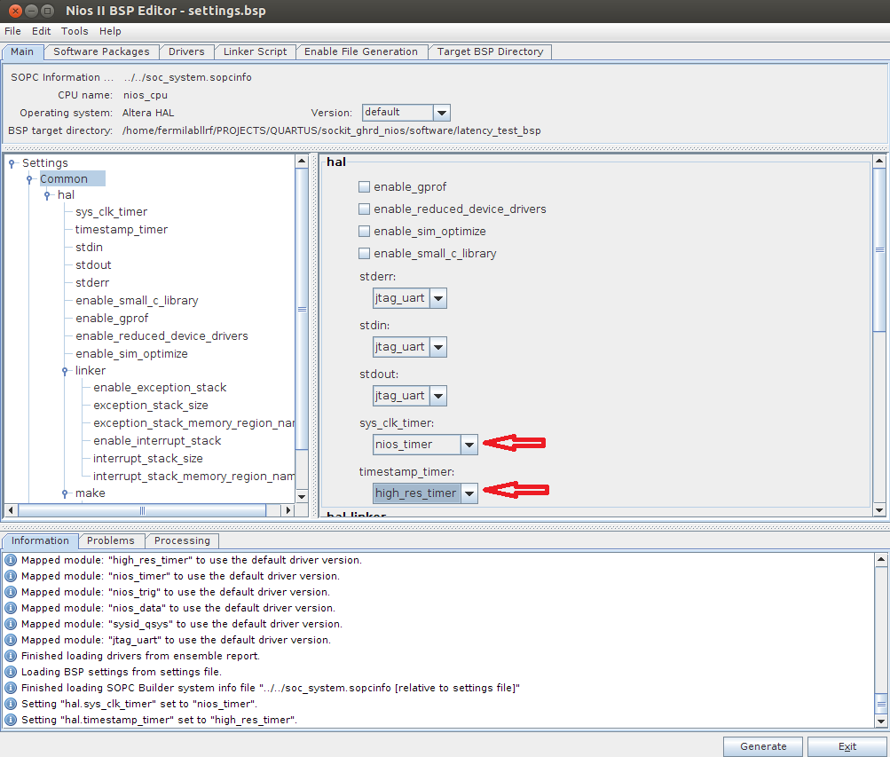

Figure 7-8. Configuring the timers in the bsp editor.

Next, right click on the latency_test bsp folder again and click Build Project.

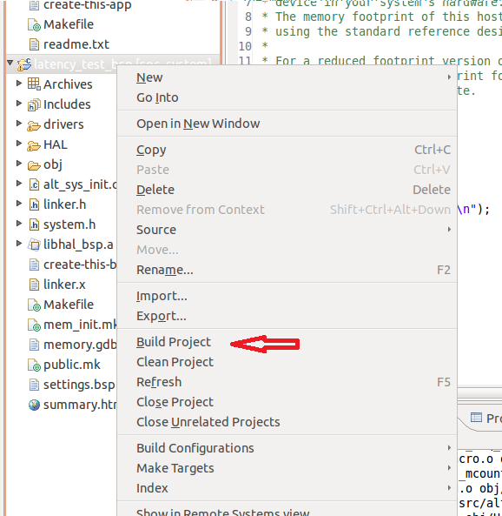

Figure 7-9. Building the bsp project.

Next, right click on the latency test folder and click Build Project.

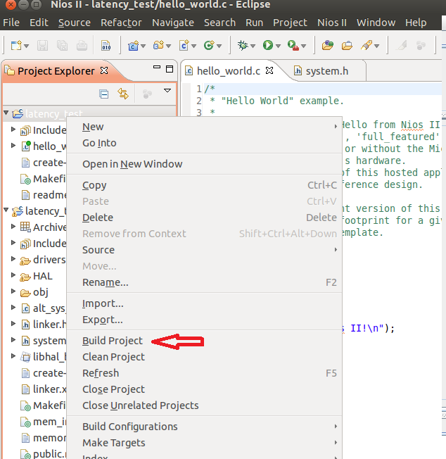

Figure 7-10. Building the latency test project.

Now the project is compiled and ready to test. Right click on the ‘latency test’ folder, click ‘Run As’ , then click ‘Nios II Hardware’.

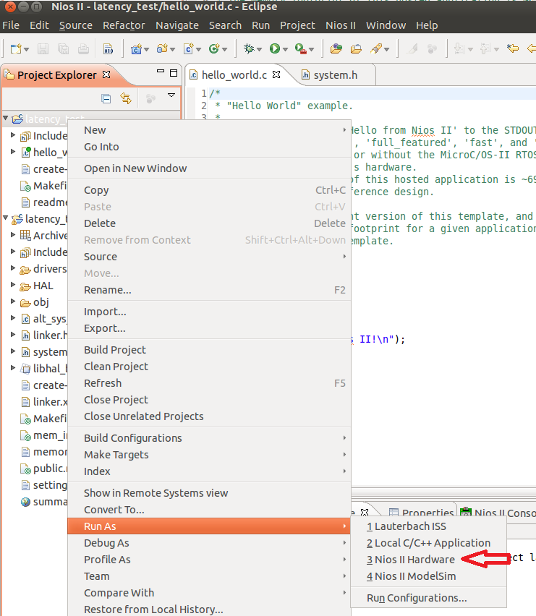

Figure 7-11. Running the Nios application.

The program should be loaded over JTAG and the Nios Console should print ‘Hello from Nios II’ as shown blelow.

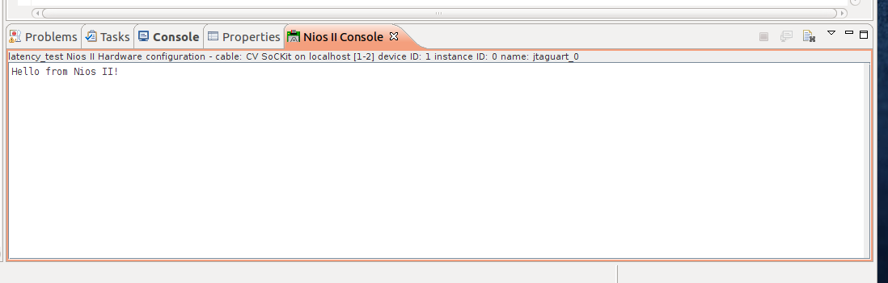

Figure 7-12. Nios Console after the nios program has loaded and run.

*If there is an error where the hardware is not found, go back to the Quartus window and open up the programmer. This may open the connection to the SoCKit. (You may hear some beeps indicating a connection to the USB hardware) Close the nios IDE, then re-open the nios IDE and open the run configurations under the ‘Run’ menu. It should look like the pictures below. Try hitting the ‘Refresh Connections’ button if the hardware was not found the first time.

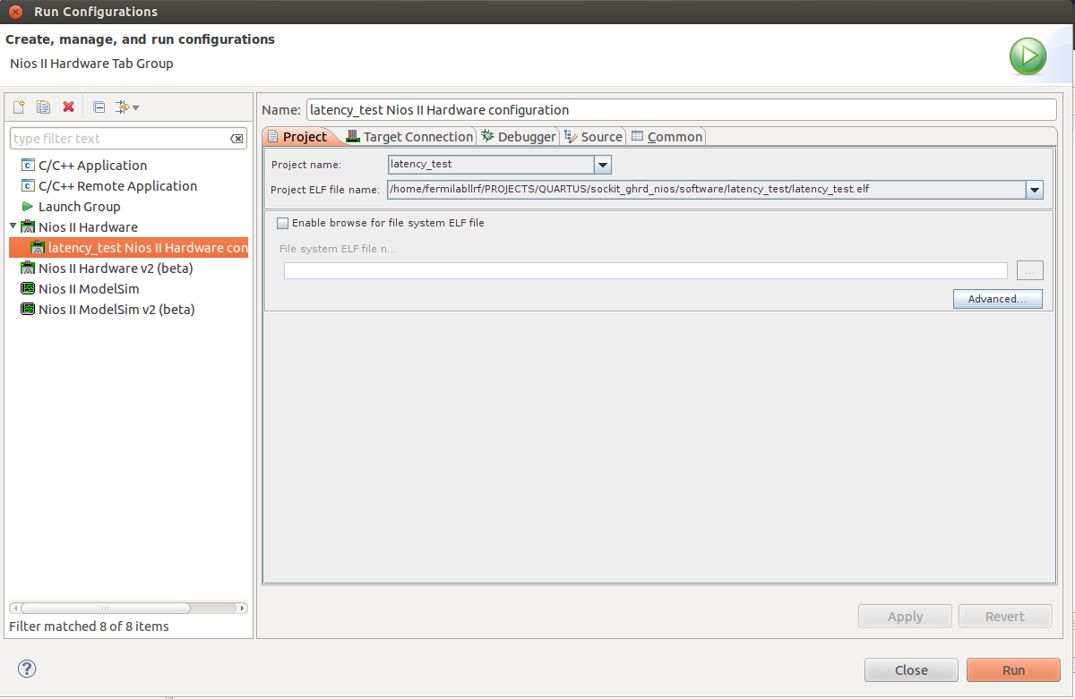

Figure 7-13a. Configuring the run configuration with the SoCkit connection.
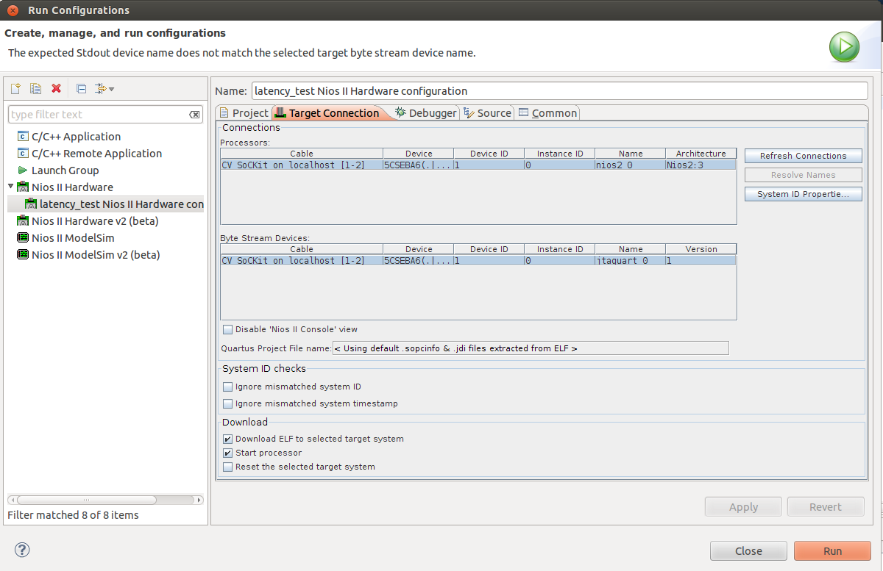

Figure 7-13b. Configuring the run configuration with the SoCkit connection.

Once you are able to get the program running. Hit the stop button in the Nios II console.

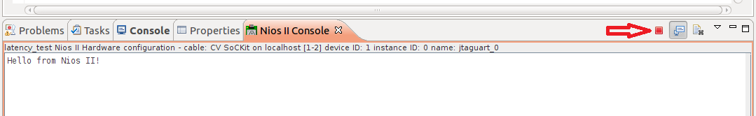

Now write some custom code to handle interrupts. Copy the code below into hello_world.c, then save and build the project again.

// Interrupt check
// Ed Cullerton
// 9/30/14

#include <stdio.h>
#include <unistd.h>
#include "system.h"
#include "sys/alt_irq.h"
#include "altera_avalon_pio_regs.h"

// Hold the value of the edge capture register
volatile int edge_capture;

static void handle_interrupt(void* context) {

volatile int *edge_capture_ptr = (volatile int*) context;
// Store the value in the edge capture register in *context.
*edge_capture_ptr = IORD_ALTERA_AVALON_PIO_EDGE_CAP(NIOS_TRIG_BASE);
// Reset the edge capture register.
IOWR_ALTERA_AVALON_PIO_EDGE_CAP(NIOS_TRIG_BASE, 0xF);
// Print to the console to verify interrupt
printf("Interrupt!\n");
}

int main() {

void *edge_capture_ptr;
// cast edge_capture pointer to match alt_ic_isr_register() prototype
edge_capture_ptr = (void*) &edge_capture;
// Enable interrupts.
IOWR_ALTERA_AVALON_PIO_IRQ_MASK(NIOS_TRIG_BASE, 0x1);
// Reset the edge capture register.
IOWR_ALTERA_AVALON_PIO_EDGE_CAP(NIOS_TRIG_BASE, 0xF);
// Register the interrupt handler.
alt_ic_isr_register( NIOS_TRIG_IRQ_INTERRUPT_CONTROLLER_ID, NIOS_TRIG_IRQ, handle_interrupt, edge_capture_ptr, 0x0);
}

Code Snip 7-1. Nios application to handle interrupts.

Since the first FPGA push button is OR’d into the ‘nios_trig’ PIO, we can easily test the interrupt routine. Run the nios program again and push the first push button and you should see the print statement to the Nios II Console as shown below.

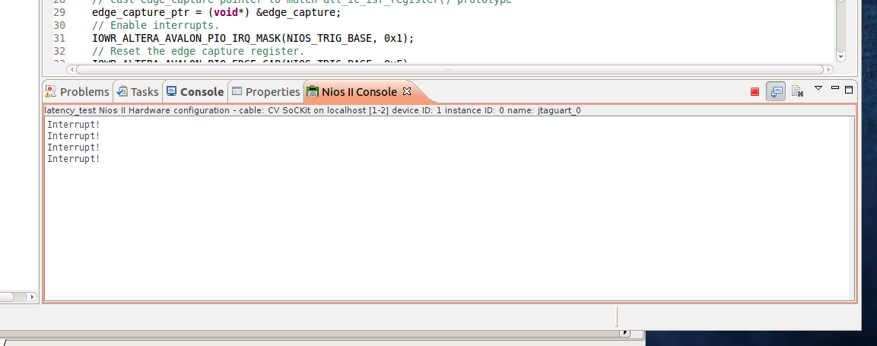

Figure 7-14. Nios console showing the received interrupts.

Stop the program by clicking the stop button in the low left corner. Next open the eclipse for ARM by opening a new terminal and entering the following commands:

$ cd ~/altera/13.1/embedded
$ ./embedded_command_shell.sh
$ eclipse

Next create a Linux program to receive an interrupt from the FPGA fabric. The gpio numbers changed, so we have to figure out which gpio is the interrupt line.

$ modprobe gpio-altera
$ ls /sys/class/gpio

export gpiochip156 gpiochip192 unexport
gpiochip154 gpiochip160 gpiochip224

$ cat /sys/class/gpio/gpiochip154/label

/sopc@0/bridge@0xc0000000/gpio@0x100000000

Our ‘arm_trig’ interrupt line is gpiochip 154, and it is a rising edge this time.

$ echo 154 > /sys/class/gpio/export
$ echo in > /sys/class/gpio/gpio154/direction
$ echo rising > /sys/class/gpio/gpio154/edge

Enter the following Linux application code into main.c.

/* SoC LLRF System
* Fermilab
* 9/11/14
*/

#include <stdio.h>
#include <unistd.h> // read()
#include <fcntl.h> // open()
#include "poll.h" // poll()

int main() {

struct pollfd fdset[1]; // poll function structure
char int_buf[2]; // read() buffer
int rv; // Return value
int fd_gpio; // gpio file descriptor

// Create the arm_trig interrupt 'value' file descriptor
if ((fd_gpio = open( "/sys/class/gpio/gpio154/value" , O_RDONLY | O_NONBLOCK )) < 0) {
printf( "ERROR: Failed to create arm_trig interrupt...\n");
return(-1);
}

// Setup the polling system
fdset[0].fd = fd_gpio;
fdset[0].events = POLLPRI|POLLERR;

printf( "Waiting for Interrupt....\n" );

// Setup poll with a dummy read() (gets the file position correct for poll)
rv = read(fdset[0].fd, int_buf, sizeof(int_buf));
// Block endlessly and wait for interrupt
rv = poll(fdset, 1, -1);
printf( "Interrupt happened!\n" );

close( fd_gpio );
return( 0 );
}

Code Snip 7-2. Linux application to receive interrupt.
Start the debugger and check to see if the code works by pressing the pushbutton. If it works, proceed to getting the test code completed. Copy and paste the following code into main.c:

/* SoC LLRF Latency Test System
* Ed Cullerton
* Fermilab
* 10/2/14
*/

#include <stdio.h>
#include <unistd.h> // read()
#include <fcntl.h> // open()
#include "poll.h" // poll()
#include "hps_0.h" // QSYS components
#include "socal/hps.h" // ALT_STM_OFST, ALT_LWFPGASLVS_OFST
#include "socal/socal.h" // uint32_t, alt_read_word()
#include <sys/mman.h> // mmap()

// Ethernet libraries
#include <sys/types.h>
#include <sys/socket.h>
#include <arpa/inet.h>
#include <netinet/in.h>

// Memory addressing defines
#define HW_REGS_BASE ( ALT_STM_OFST )
#define HW_REGS_SPAN ( 0x04000000 )
#define HW_REGS_MASK ( HW_REGS_SPAN - 1 )
#define ALT_AXI_FPGASLVS_OFST (0xC0000000)
#define HW_FPGA_AXI_SPAN (0x40000000)
#define HW_FPGA_AXI_MASK (HW_FPGA_AXI_SPAN -1)

//UDP
#define BUFLEN 64
#define PORT 30

int main() {

struct pollfd fdset[1]; // poll function structure
char int_buf[2]; // read() buffer
int rv; // Return value
int fd_gpio; // gpio file descriptor
void *lw_bridge_base; // lightwieght brige base
void *fast_bridge_base; // fast bridge base
void *arm_data_base; // arm_data PIO
void *timer_val_base; // location of timer count value (shared_memory)
int fd_mem; // memory map file descriptor
int lcv, lp; // loop control variables

// UDP Server setup
struct sockaddr_in my_addr, cli_addr;
int sockfd;
socklen_t slen=sizeof(cli_addr);
char buf[BUFLEN];
sockfd=socket(AF_INET, SOCK_DGRAM, IPPROTO_UDP);
bzero(&my_addr, sizeof(my_addr));
my_addr.sin_family = AF_INET;
my_addr.sin_port = htons(PORT);
my_addr.sin_addr.s_addr = htonl(INADDR_ANY);
bind(sockfd, (struct sockaddr* ) &my_addr, sizeof(my_addr));

printf( "Fermilab LLRF System test....\n" );

// map the memory
if( -1 == ( fd_mem = open( "/dev/mem", ( O_RDWR | O_SYNC )))) {
printf( "ERROR: Failed to open \"/dev/mem\"...\n" );
return( -1 );
}

// Point to the lightweight bridge memory
if( MAP_FAILED == (lw_bridge_base = mmap( NULL, HW_REGS_SPAN, ( PROT_READ | PROT_WRITE ), MAP_SHARED, fd_mem, HW_REGS_BASE )) ) {
printf( "ERROR: LW bridge mmap() failed...\n" );
close( fd_mem );
return( -1 );
}

// Point to the fast bridge memory
if( MAP_FAILED == (fast_bridge_base = mmap( NULL, HW_FPGA_AXI_SPAN, ( PROT_READ | PROT_WRITE ), MAP_SHARED, fd_mem, ALT_AXI_FPGASLVS_OFST )) ) {
printf( "ERROR: LW bridge mmap() failed...\n" );
close( fd_mem );
return( -1 );
}

// Point to the arm_data PIO base
arm_data_base = ( lw_bridge_base + ( ( uint32_t )( ALT_LWFPGASLVS_OFST + ARM_DATA_BASE ) & ( uint32_t )( HW_REGS_MASK ) ) );
// Point to the location of the timer value in shared memory
timer_val_base = ( fast_bridge_base + ( ( uint32_t )( ALT_AXI_FPGASLVS_OFST + SHARED_MEMORY_BASE ) & ( uint32_t )( HW_FPGA_AXI_MASK ) ) );

// Create the arm_trig interrupt 'value' file descriptor
if ((fd_gpio = open( "/sys/class/gpio/gpio154/value" , O_RDONLY | O_NONBLOCK )) < 0) {
printf( "ERROR: Failed to create arm_trig interrupt...\n");
return(-1);
}

// Setup the polling system
fdset[0].fd = fd_gpio;
fdset[0].events = POLLPRI|POLLERR;

// Clear the arm_data signal
alt_clrbits_word( arm_data_base, 0x0000000F );

// Wait for start command from labview
printf( "Please make sure Nios software is running...\n");
printf( "Waiting for Labview to start....\n" );
recvfrom(sockfd, buf, BUFLEN, 0, (struct sockaddr*)&cli_addr, &slen);
printf("\nReceived Labview start command %s from %s:%d\n", buf, inet_ntoa(cli_addr.sin_addr), ntohs(cli_addr.sin_port));

// Send start signal to Nios
alt_setbits_word( arm_data_base, 0x0000000F );

for (lcv=0; lcv<10000; lcv++) {
// Clear the arm_data signal
alt_clrbits_word( arm_data_base, 0x0000000F );
// Setup poll with a dummy read() (gets the file position correct for poll?)
rv = read(fdset[0].fd, int_buf, sizeof(int_buf));
// Block endlessly and wait for interrupt
rv = poll(fdset, 1, -1);
// Send 2k of data out
for (lp=0; lp<32; lp++)
sendto(sockfd, timer_val_base, BUFLEN, 0, (struct sockaddr*)&cli_addr, slen);
// Send signal back to Nios
alt_setbits_word( arm_data_base, 0x0000000F );
}
printf("Test complete.\n");
// Clean up our memory mapping and exit
munmap( lw_bridge_base, HW_REGS_SPAN );
munmap( fast_bridge_base, HW_FPGA_AXI_SPAN );
close( fd_mem );
close( fd_gpio );
return( 0 );
}

Code Snip 7-3. Linux application for latency testing.

The above code does the following:

main()
- Setup UDP server socket.
- Map the memory with a file descriptor.
- Create pointers to the lightweight and fast bridge memory address.
- Create a pointer to the arm_data PIO address on the lightweight bridge.
- Creates a pointer to the location that the latency timer value is stored in shared memory.
- Set up the poll descriptor set.
- Clear the arm_data PIO.
- Wait for a signal from the Labview application to start the test. (The Labview application will display the latency timing on a chart, calculate networks speed, check for missed packets, and display the sent data packets on a plot)
- Send a signal to the Nios that the Linux system is ready to receive triggers.
- Start the loop to receive a trigger and send out data in shared memory over UDP. ( The first memory location of the shared memory will contain that latency measurement made by the Nios. The rest of the data in shared memory if filled by the Nios. It just contains some incrementing numbers so they can be seen in motion on the Labview plot.)
- Clean up the memory mapping and close the file descriptor.

Next return to the Nios code. Cut and paste the following code into hello_world.c.

// Latency testing
// Ed Cullerton
// 9/30/14

#include <stdio.h>
#include <unistd.h>
#include "system.h"
#include "sys/alt_irq.h"
#include "altera_avalon_pio_regs.h"

volatile int edge_capture; // Hold the value of the edge capture register
volatile int int_hap; // Interrupt indicator

static void handle_interrupt(void* context) {

volatile int *edge_capture_ptr = (volatile int*) context;
// Store the value in the edge capture register in *context.
*edge_capture_ptr = IORD_ALTERA_AVALON_PIO_EDGE_CAP(NIOS_TRIG_BASE);
// Reset the edge capture register.
IOWR_ALTERA_AVALON_PIO_EDGE_CAP(NIOS_TRIG_BASE, 0xF);
// Set the interrupt happened indicator
int_hap=1;
}

int main() {

int timer_freq;
alt_u16 timer_counts;
alt_u16 time_us;
int lcv, lp;
void *edge_capture_ptr;

// cast edge_capture pointer to match alt_ic_isr_register() prototype
edge_capture_ptr = (void*) &edge_capture;

// Enable interrupts.
IOWR_ALTERA_AVALON_PIO_IRQ_MASK(NIOS_TRIG_BASE, 0x1);
// Reset the edge capture register.
IOWR_ALTERA_AVALON_PIO_EDGE_CAP(NIOS_TRIG_BASE, 0xF);
// Register the interrupt handler.
alt_ic_isr_register( NIOS_TRIG_IRQ_INTERRUPT_CONTROLLER_ID, NIOS_TRIG_IRQ, handle_interrupt, edge_capture_ptr, 0x0);

// Find out the timer resolution (ticks/sec)
timer_freq = alt_timestamp_freq();

// Wait for start trigger from ARM
int_hap=0;
while(int_hap==0){}

// Put a dummy value in for the first time result
IOWR_16DIRECT( (alt_u32) SHARED_MEMORY_BASE, 0, 4);

for (lcv=0; lcv<10000; lcv++) {
// Clear the interrupt happened indicator
int_hap=0;
IOWR_ALTERA_AVALON_PIO_DATA(NIOS_DATA_BASE, 0x00000000);
// Start timer
alt_timestamp_start();
// Send signal to Linux
IOWR_ALTERA_AVALON_PIO_DATA(NIOS_DATA_BASE, 0x0000000F);
// Wait for the return interrupt
while(int_hap==0){}
// Stop timer
timer_counts = alt_timestamp();
// Put a time result in shared memory
IOWR_16DIRECT( (alt_u32) SHARED_MEMORY_BASE, 0x0, timer_counts);
// Fill the shared memory with some moving data to be seen on the labview application
for (lp=1; lp<32; lp++)
IOWR_16DIRECT( (alt_u32) SHARED_MEMORY_BASE, 2*lp, lp*lcv);
usleep(1500); // Slow down the ethernet transmission so packets will not be missed
//printf("Sent %d %u\n", lcv, timer_counts); // (debugging)
}

printf("Test Complete.");
return(0);
}

Code Snip 7-4. Nios application for latency testing.

The above code does the following:

main()
- Register the interrupts.
- Wait for the signal from the Linux application to start the test.
- Put a dummy value in for the latency time since we do not have a valid measurement yet.
- Start the loop.
- Start the timer.
- Send a signal to the Linux application to start data transmission.
- Wait for a signal from the Linux application indicating data sent.
- Stop the timer.
- Put the timer value into shared memory.
- Fill shared memory with some moving data to be seen in the Labview application.
- Pause for a while so data packet transmission can complete. (This pause is dependent on network speed)

To get the test started, compile the Linux code and start debugging. The debugging process will download the software to the ARM and pause it at main. The only purpose of this step was to get the program on to the ARM. Stop the debugging. It can be manually started again using the gtkterm terminal later. This is necessary because we are going to disconnect the Ethernet connection from our development machine, and connect it to a laptop running Labview. There are other ways to get the Linux program onto the ARM, but this may be the easiest. The Labview application is shown below:

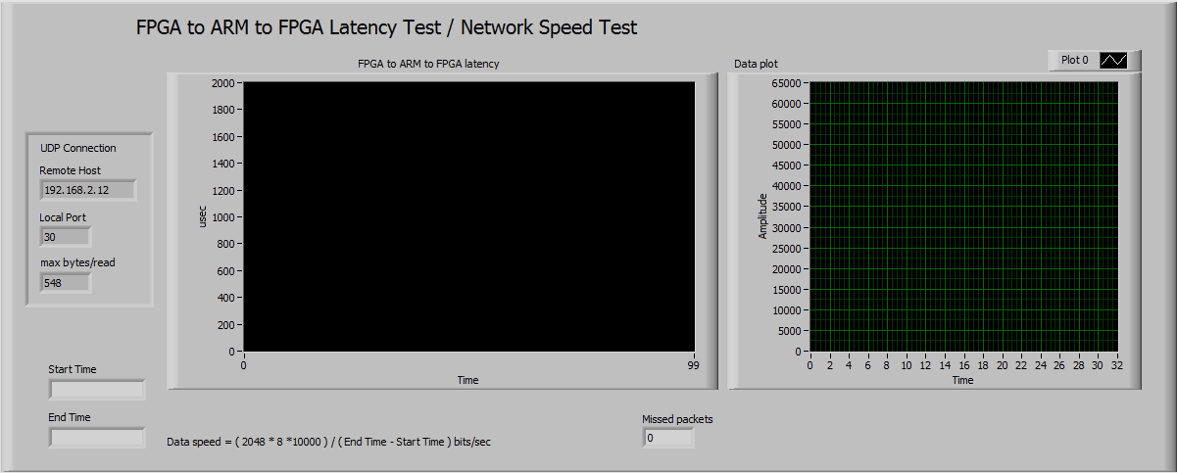

Figure 7-15a. Labview application.

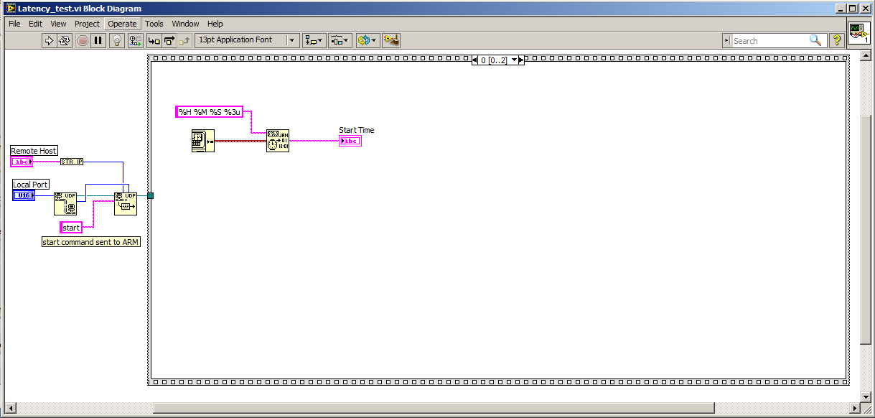

Figure 7-15b. Labview application.
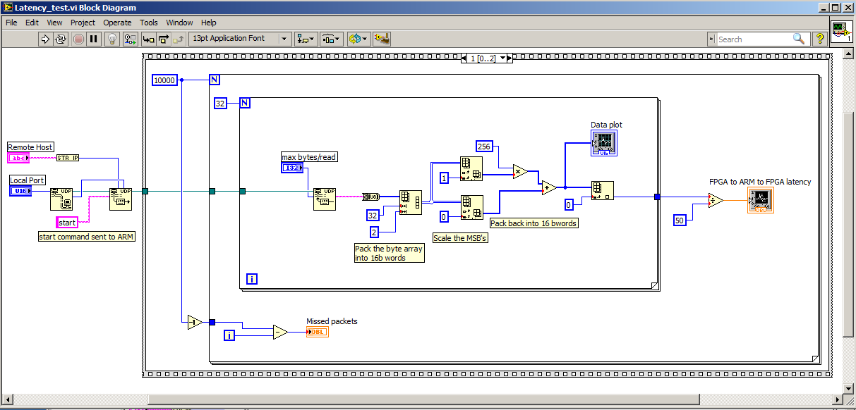

Figure 7-15c. Labview application.

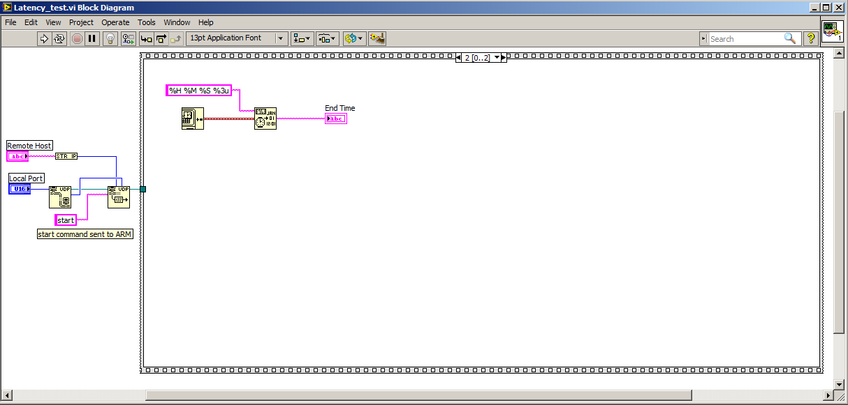

Figure 7-15d. Labview application.

Connect a crossover cable to the laptop running Labview. Start the Linux application by typing ‘./main’ at the gtkterm terminal, then start the Nios application. The software will wait for the Labview application to start and begin the test.

The first test was done with a Ethernet connection of 100Mbits/sec. The data transmission size was 64k byte packets, and the transmission was looped 10000 times. The test results for this setup show a round trip latency from NIOS–ARM-NIOS of 400-600 us, and a network speed of ~95Mbits/sec. A second test was done with a 1000Mbit/sec Ethernet connection. The test results for this setup show a round trip latency from NIOS–ARM-NIOS of 800-1000 us, and a network speed of 200Mbits/sec. The main limiting factor was the Labview interface keeping up with the data transmission. Both of the above tests were done ensuring that no UDP packets were missed. A counter in Labview was used to verify this.

8. LLRF DAQ Test System Design

In this section, a LLRF data acquisition and control system is described. This system contains only the basic functionality needed for a LLRF data acquisition and control system. This basic system includes the following features:

- NIOS II FPGA CPU allowing programmable DMA transfers from FPGA to on chip FPGA memory. The data is accessible from the ARM/Linux user space application for transfer over Ethernet to Labview application.
- Up to 254 32-bit control registers controlled from an ARM/Linux user space application.
- Dual port memory access from the FPGA and ARM/Linux user space application.
- Continuous data acquisition of eight 32 bit channels with programmable sample rates up to 100kHz. Higher data rates are possible.
- GPIO (General Purpose Input/Output) data from the NIOS CPU to FPGA.
- GPIO interrupts from the FPGA to the ARM/Linux user space.
- Complete software/firmware on SD Card.
- Full speed UDP data transfer (Gbit) over Ethernet to Labview application. (Labview display is the speed limitation (200 Mbits/s) )
- Labview interface for data display and sample rate control.
- ARM/Linux software model for easy control system interface.

With the above features, a basic CW data acquisition is built. Below is the block diagram and the the top level Quartus FPGA block diagram of the data acquisition/control system. The block diagram includes a signal multiplexer which is replaced by a test data generator shown in the top level block diagram.
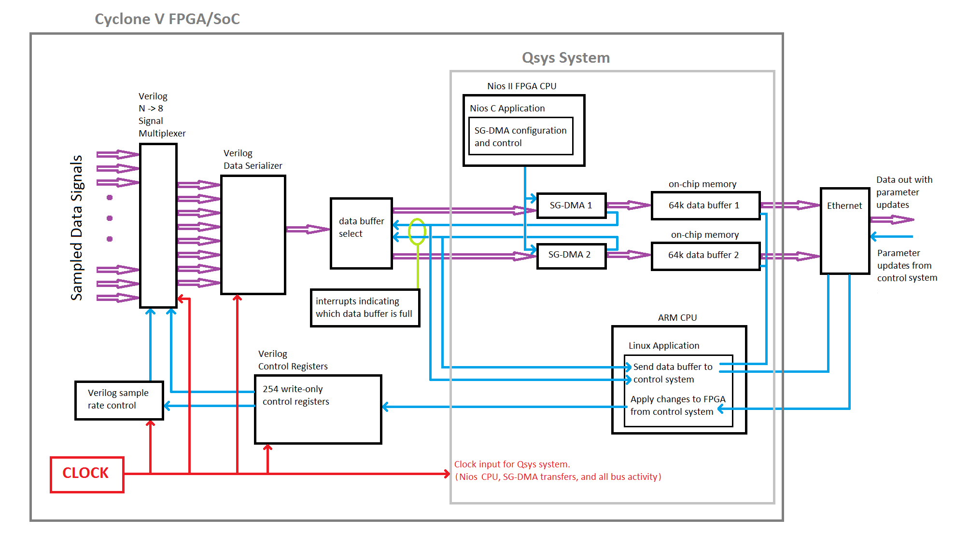

Figure 8-1a. Block Diagram of the LLRF Data Acquisition System.

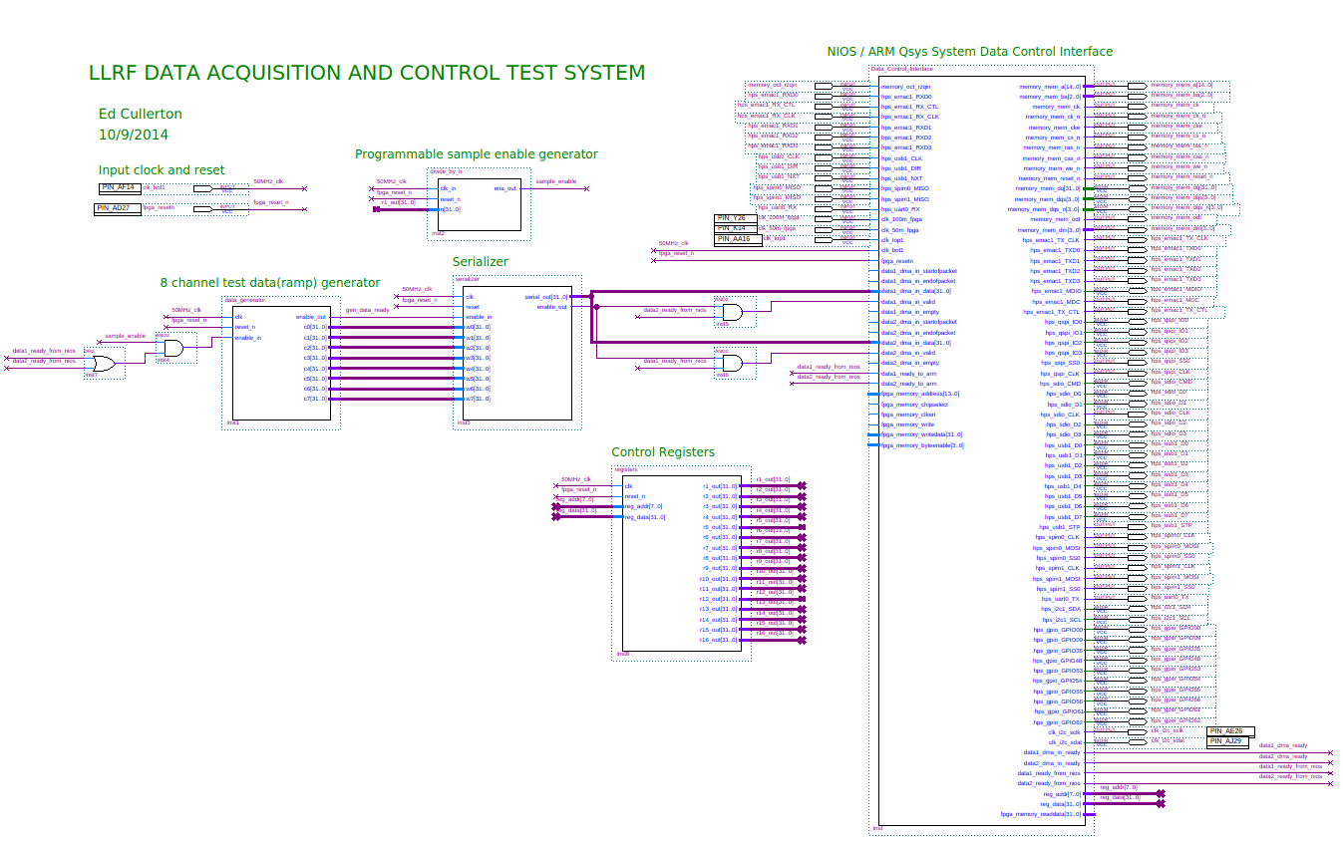

Figure 8-1b. Complete top level block diagram of the basic system.

The CW data acquisition system operates in a ping-pong configuration. While one data buffer is being filled, the other data buffer is being transferred. The data buffers are 64k blocks of on chip memory. The data transfers are controlled by two stream-to-memory scatter-gather DMA’s inside the Qsys system. There are signals that come out of the Qsys system to the FPGA, indicating when the data buffers have been filled by the SG-DMA’s. These signals control which data buffer the streaming data moves to. These signals are also sent back into the QSYS system, where they interface the ARM and interrupt the Linux user space application to move the data in the buffers over Ethernet to a Labview application. The Labview application interfaces with the Linux application to set control registers in the FPGA.

On the right side of the block diagram, the large block is the Qsys system. The important inputs and outputs of the Qsys system block are listed below, followed by a close up picture of the block diagram qsys part.

- NIOS controlled PIO outputs (data1_ready_from_nios, data2_ready_from_nios)
These PIO outputs signal when the DMA data buffers are full. The signals then go to the ARM PIO inputs (described below) to interrupt the Linux user space application to start data processing or data transfer.

- ARM PIO inputs (data1_ready_to_arm, data2_ready_to_arm)
The data[]_ready_from_nios are directly tied to these inputs to generate an interrupt to the Linux user space application.

- Stream to memory scatter gather dma inputs (data1_dma_in_data, data1_dma_in_valid, data1_dma_in_ready, data2_dma_in_data, data2_dma_in_valid, data2_dma_in_ready)
These signals control the serial data stream from the sampled data serializer. The serialized data is transferred to on-chip memory buffers using these scatter gather dma’s. The data[]_dma_valid line is used to control which data buffer is written to. The valid line is set high when the serial data is coming out of the serializer AND the appropriate data buffer is ready to be written to. The Nios controlled PIO lines control which data buffer is ready to be written to. (ie, when one buffer is being written to, the other data buffer is being processed or transferred)

- Control register PIO outputs (reg_addr, reg_data)
These signals contain control register address and data information programmable from the Linux user space application. This is used to set the sample rate controlled by the programmable sample enable generator.

- Fpga memory inputs and outputs (fpga_memory_address, fpga_memory_chipselect, fpga_memory_clken, fpga_memory_write, fpga_memory writedata, fpga_memory_byteenable, fpga_memory_readdata)
This memory access can be used for large data block transfers to the FPGA(ie, lookup tables). This memory can also be used for slower data transfers to Linux user space. (This basic system does not utilized this memory)

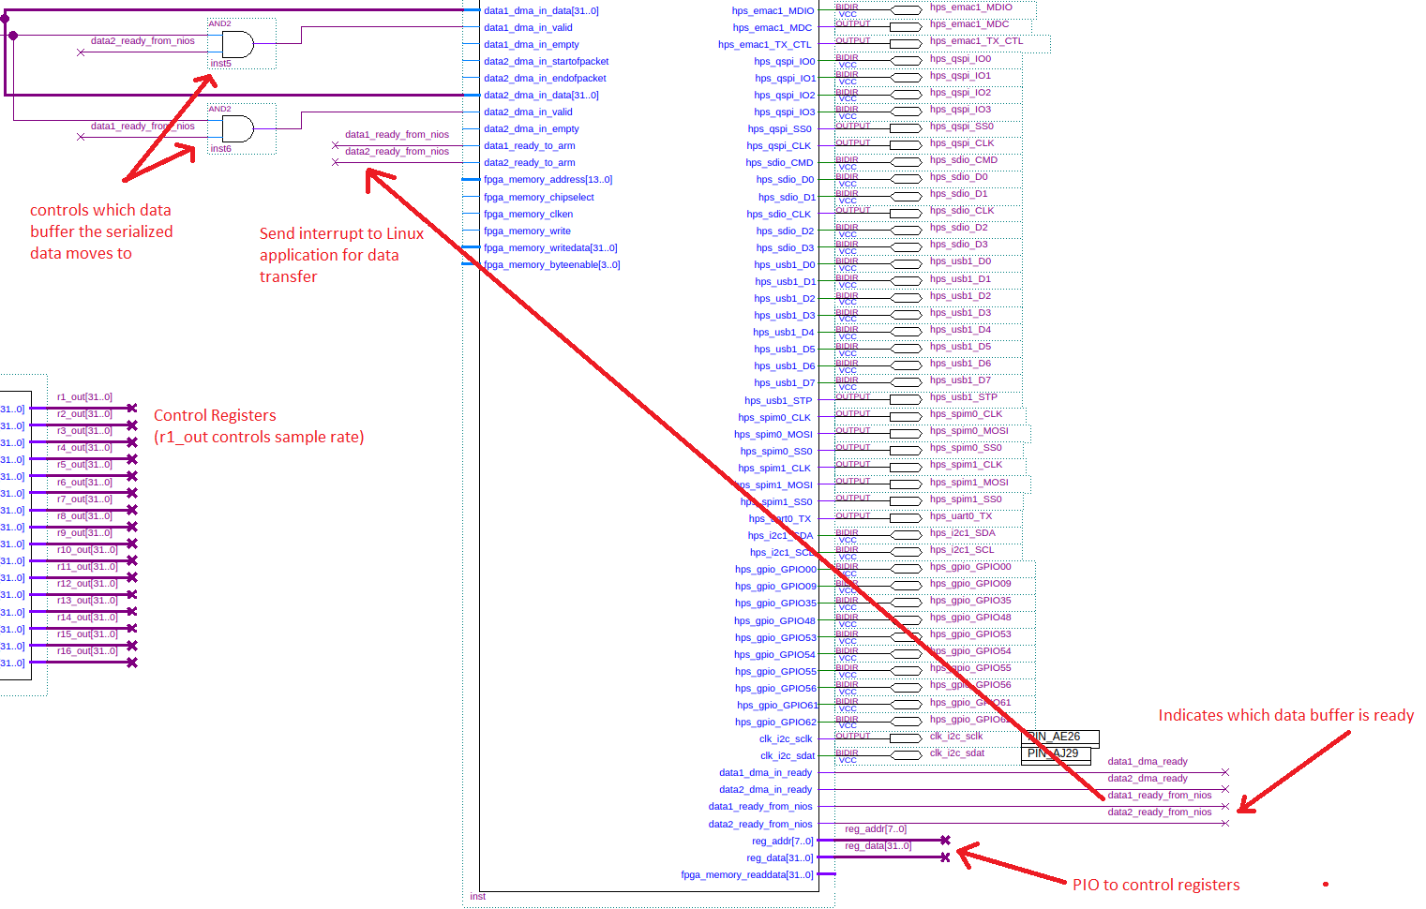
Figure 8-2. Details of the important Qsys inputs and outputs.

The Qsys system configuration is shown below in figure 8-3. The complete Qsys system and individual components are shown in Appendix B. An important feature of this system is the NIOS cpu. A Nios C-program starts the DMA engines, controls the amount of data into the buffers, and signals that DMA process has been completed (through the FPGA PIO’s and ARM PIO’s). The nios_memory on-chip memory component is initialized with the nios program written with the Nios Software Build Tools. Details of the nios program and the procedure to initialize the memory is shown in Appendix B. Initializeing the memory allows the program to be incorporated with the .sof file during compile time. This allows the complete system to be stored on the SD Card.

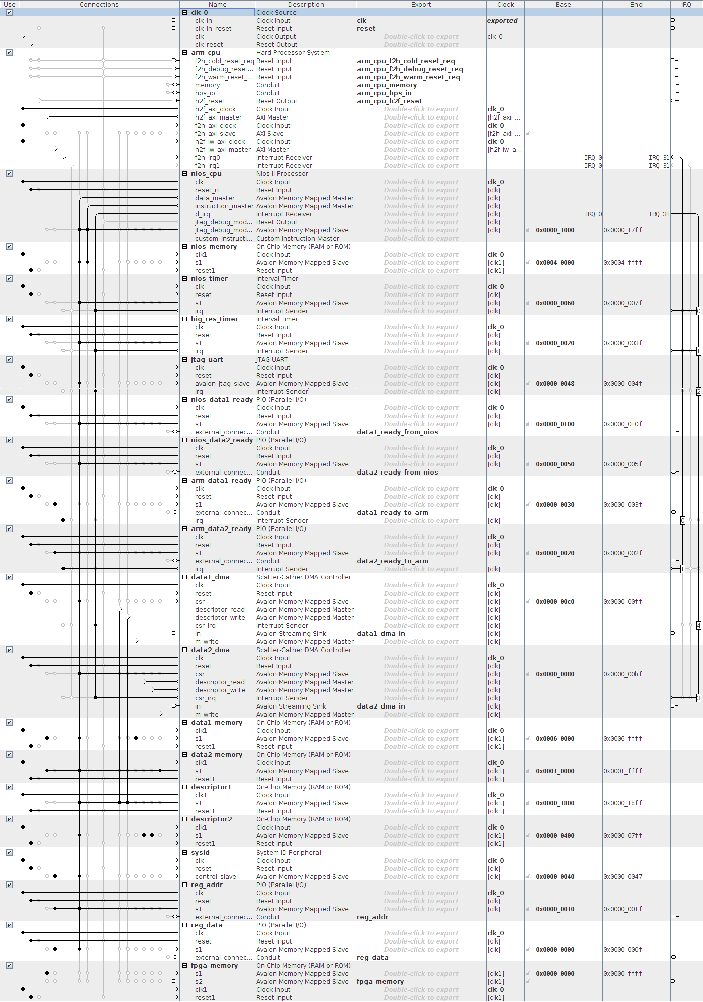

Figure 8-3. Qsys system.

The sample enable generator, control registers, serializer, and data generator are verilog components. The components are simulated with the Altera – Modelsim simulator which is shown in Appendix B. Below is a close up the block diagram level of the verilog components.

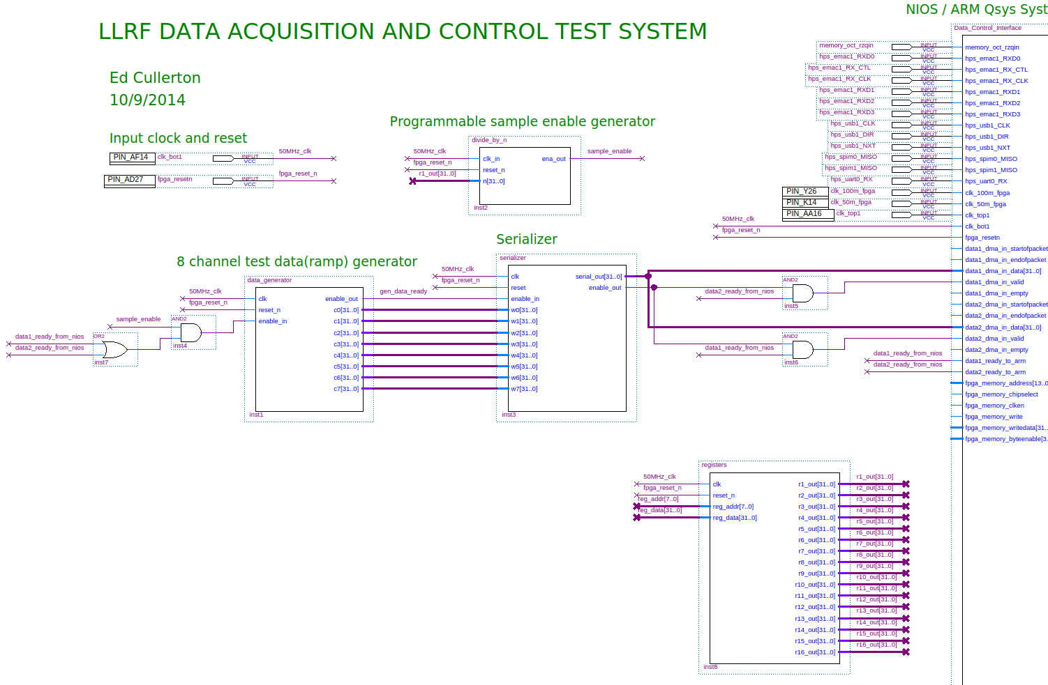
Figure 8-4. Close up of the programmable sample enable generator, test data generator, serializer, registers, and other signal control components.

The sample enable generator controls the sample rate of the data acquisition. The sample rate comes from the Labview application, which is written to one of the control registers(r1_out) through the QSYS PIO components. The control register r1_out is tied to the input to the sample enable generator input.

The test data generator component generates test data for the test system. The output of the data generator is incrementing data that is incremented every time an enable signal is received from the programmable sample enable generator. An enable_out signal goes high when new data is generated on the eight outputs.

The eight outputs of the data generator then go to the serializer. The enable_out signal of the data generator is fed to the serializer to start the serialization of the parallel data. The data is serialized at the clock rate input to the serializer (50 MHz). An enable_out on the serializer indicates that serial data is moving out of the serializer. The enable out is also ANDed with the data ready PIO signal from the NIOS, creating a data valid signal for the serial data to go to the correct data buffer.

The control registers are write-only. The control registers have a 7 bit address input, and a 32 bit data input. The data on the data input will move to the corresponding address output register whenever the address input changes. There is no output register address zero. The sequence of commands is as follows:

- Put data on the data input.
- Put an address on the address input to move the data to the output register.
- Put address zero on the address input.

There are only 254 addresses, because the zero address is no used.

The Linux application that is used for this test system includes the following features:

- The main task that sets up a list of control parameters that will interface between the control systems and the FPGA. The parameters are manually entered for this application, but future expansion of parameters will be done with a spreadsheet. Default values are loaded to the FPGA in the main task. All the memory mapping and interrupt configuration is done in the main task also.
- Two pthreads running simultaneously handle Ethernet sending and Ethernet receiving.
- The receiver thread creates a while loop that starts by waiting for commands from the control systems for parameter changes. Each parameters change is added to a change list if the parameter change is valid.
- The sender thread creates a while loop that starts by waiting for an interrupt from the FPGA. The interrupt indicates that a data buffer is full with sampled acquisition data. Once it receives the interrupt, it will process any parameter changes that have been received from the control system. It will attach the parameter changes to the end of the data buffer and send the the entire buffer over Ethernet UDP to the Labview control system.

The complete linux application is shown in Appendix B.

The labview interface to test the system in shown in figure 8-5 below The Labview block diagram is shown in Appedix B. The control interface allows the sample rate to be adjusted between 1000 Hz and 300000 Hz. This puts a limit on data transfer at 76.8 Mbits per sec. From previous experiments showing a 200 Mbit limit on Labview display, this seemed like a safe place to operate. The interface also incude a dummy float variable called floater to test the setting of float variable to the FPGA.

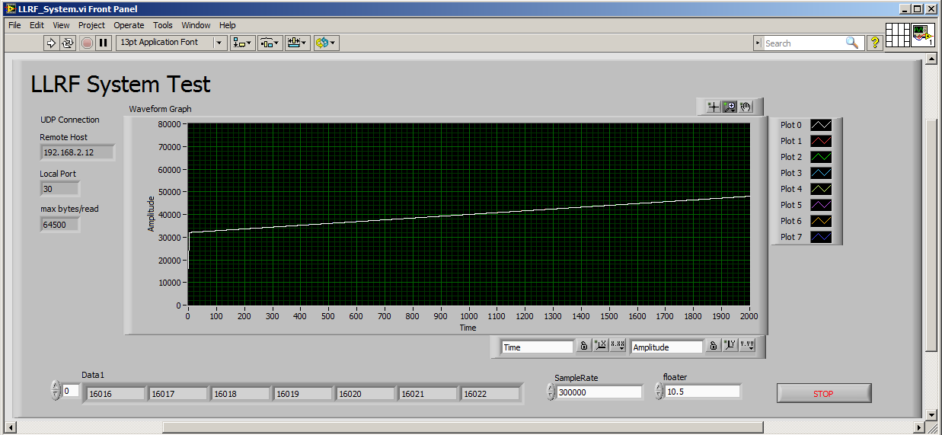

Figure 8-5. Labview test application.
A new startup script has been written for this design which includes the setup for the GPIO interrupts and starting the main application. The startup script is shown below. A seen in the code, the Ethernet configuration has been commented out. The Ethernet address of the board is configured using a different procedure which will be explained below.

#!/bin/bash
#
# LLRF system startup
#
# ifconfig eth0 192.168.2.12 up
# echo "LLRF: IP configured(192.168.2.12)"
modprobe gpio-altera
echo 158 > /sys/class/gpio/export
echo in > /sys/class/gpio/gpio158/direction
echo rising > /sys/class/gpio/gpio158/edge
echo 159 > /sys/class/gpio/export
echo in > /sys/class/gpio/gpio159/direction
echo rising > /sys/class/gpio/gpio159/edge
/home/root/main &

Code Snip 8-1. Startup script (/etc/init.d/LLRF_startup.sh).

The Ethernet address and mac address is configured in the file /etc/network/interfaces. The following lines configure eth0 as DHCP:
# Wired or wireless interfaces
auto eth0
iface eth0 dhcp
Replace the above lines to configure a static Ethernet address, gateway, and MAC address with the following lines:
# Wired or wireless interfaces
auto eth0
iface eth0 inet static
address 131.225.136.11
netmask 255.255.255.0
gateway 131.225.136.200
hwaddress ether 00:80:55:BD:03:01

Code Snip 8-2. Configure the Ethernet (/etc/network/interfaces).

The Ethernet configuration properties need to be givin by the Fermilab network group. Contact Tim Zingelman.
Appendix A. Interrupt Latency Test System Details

Below is the Qsys system used in the latency test project ‘socket_ghrd_nios’.

Figure A-1. Qsys configuration.
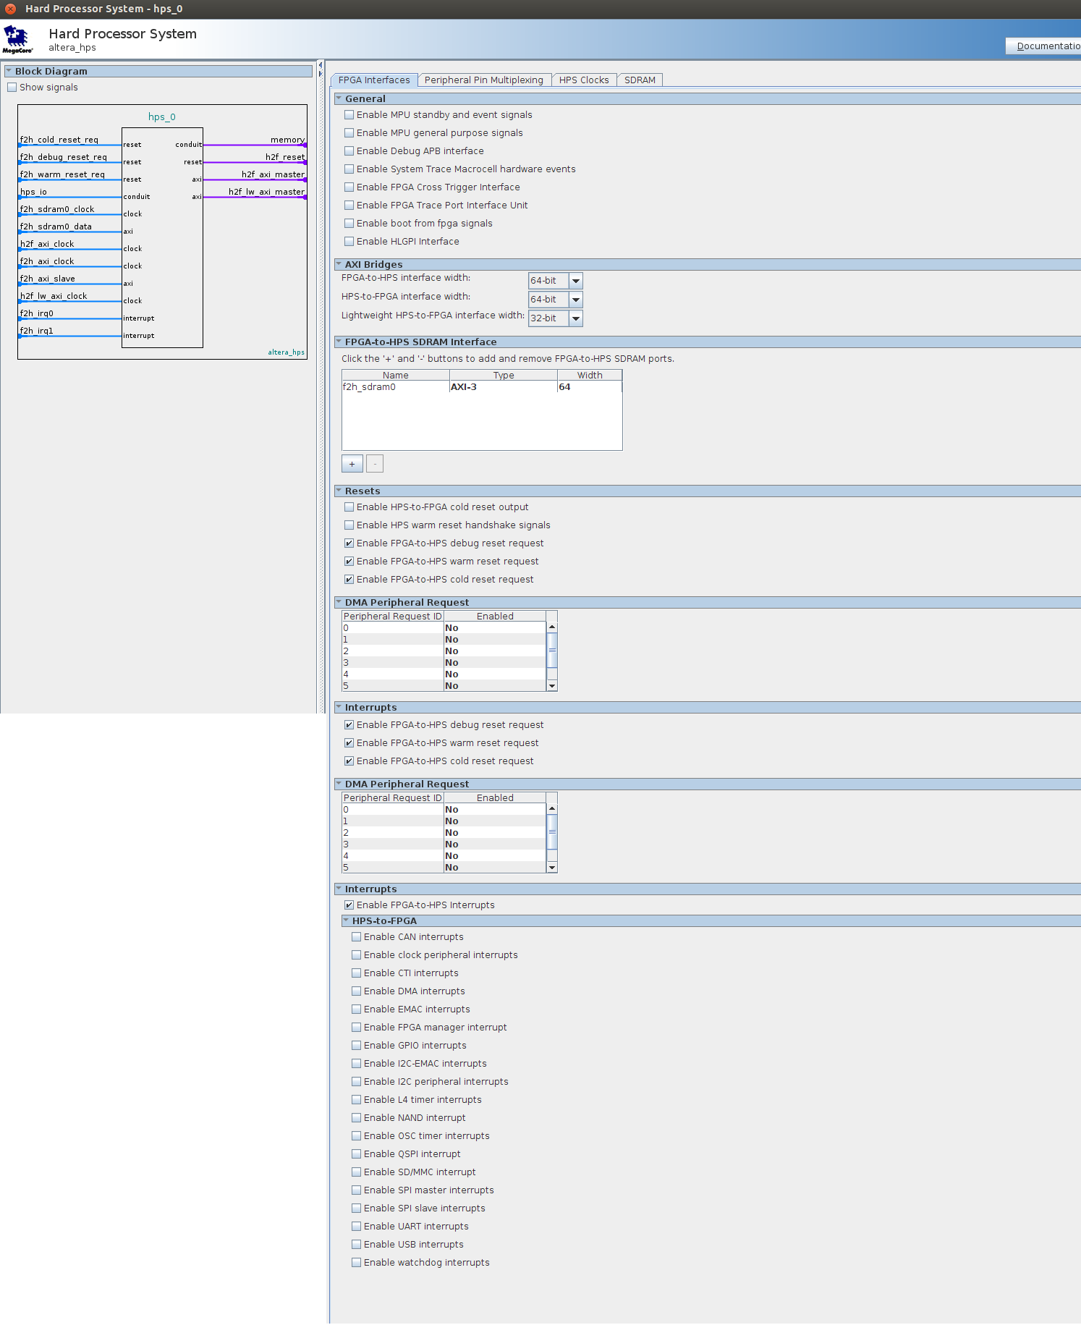

Figure A-2. hps_0/FPGA Interfaces.
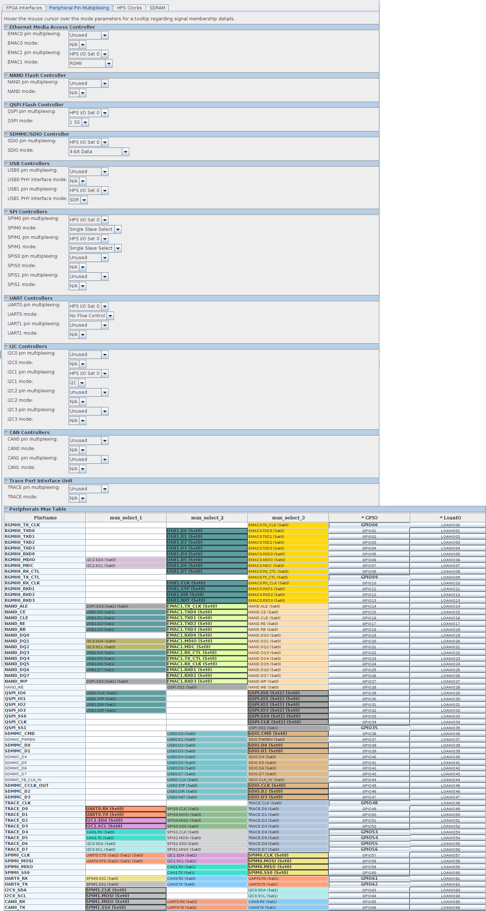

Figure A-3. hps_0/Peripheral Pin Multiplexing.
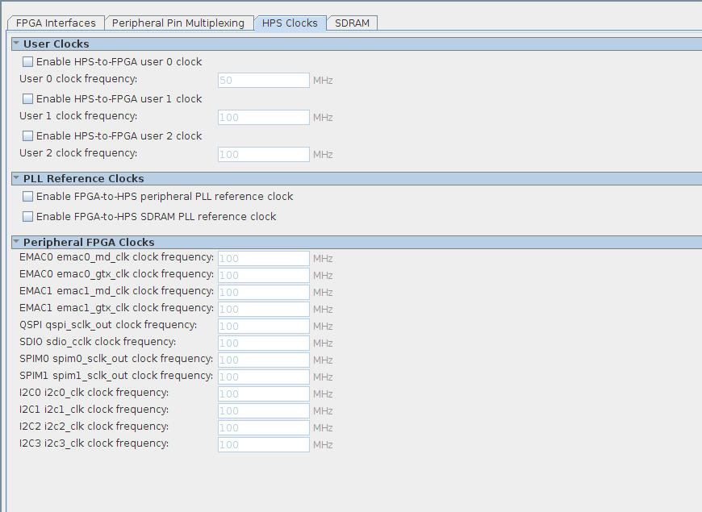

Figure A-5. hps_0/HPS Clocks.

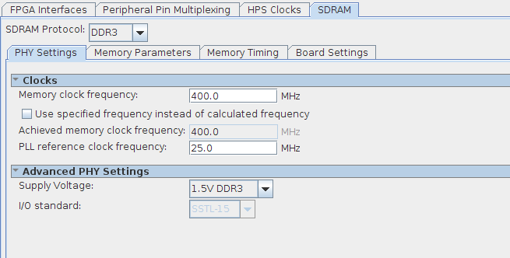

Figure A-6. hps_0/SDRAM/PHY Settings.
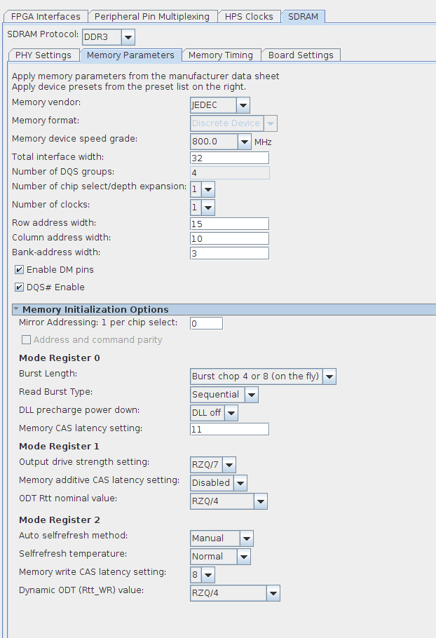

Figure A-7. hps_0/SDRAM/Memory Parameters.
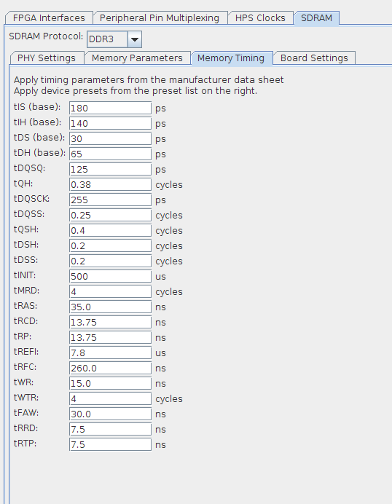

Figure A-8. hps_0/SDRAM/Memory Timing.
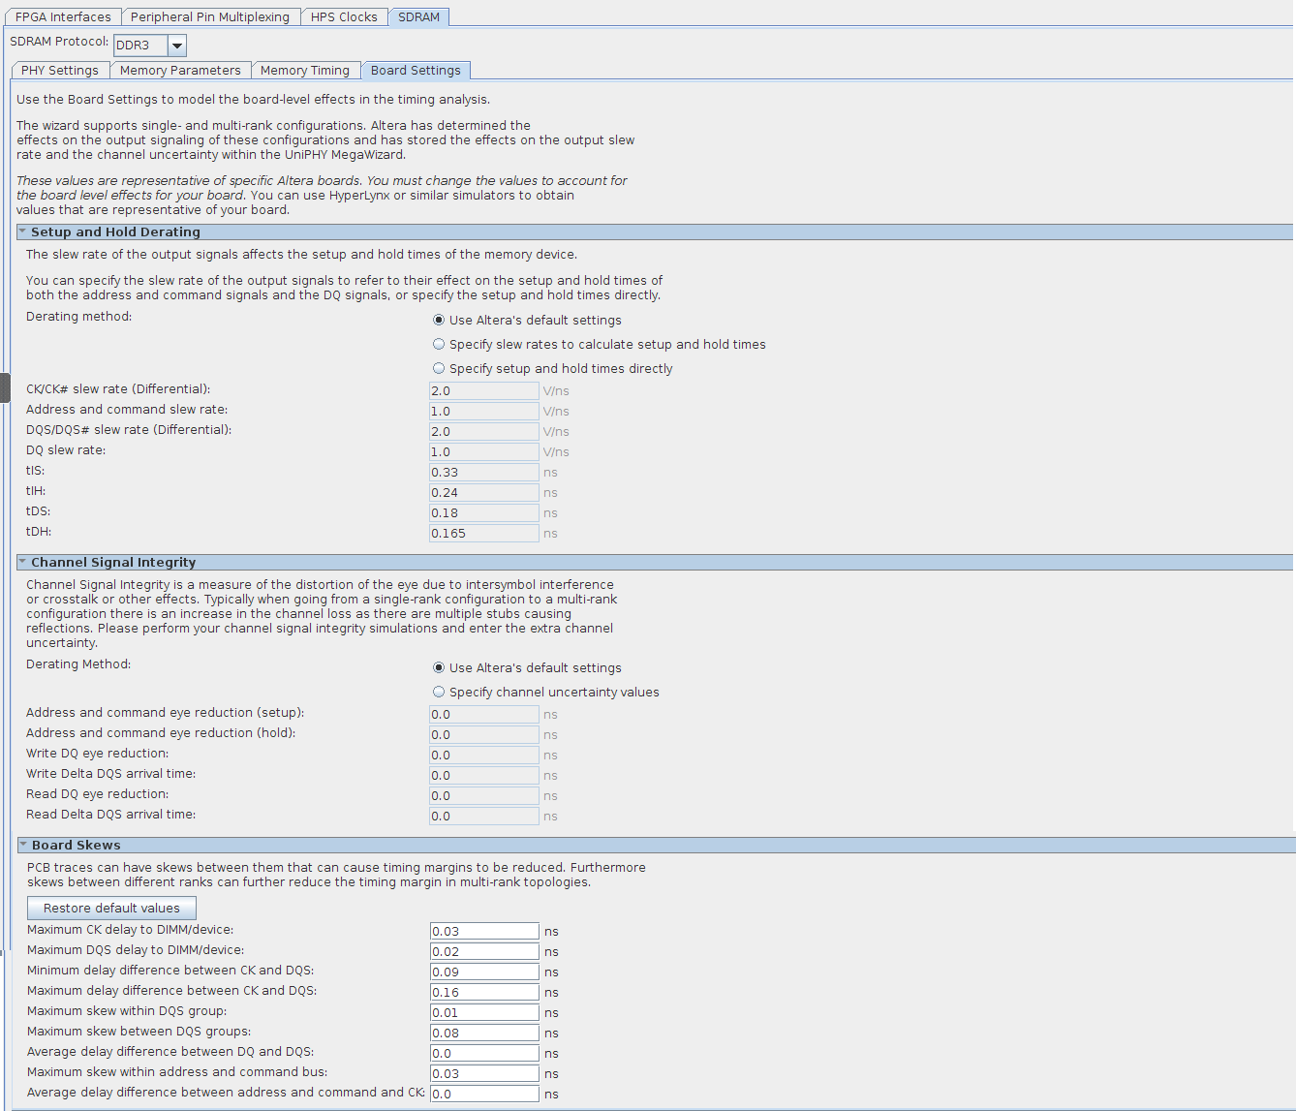

Figure A-9. hps_0/SDRAM/Board Settings.
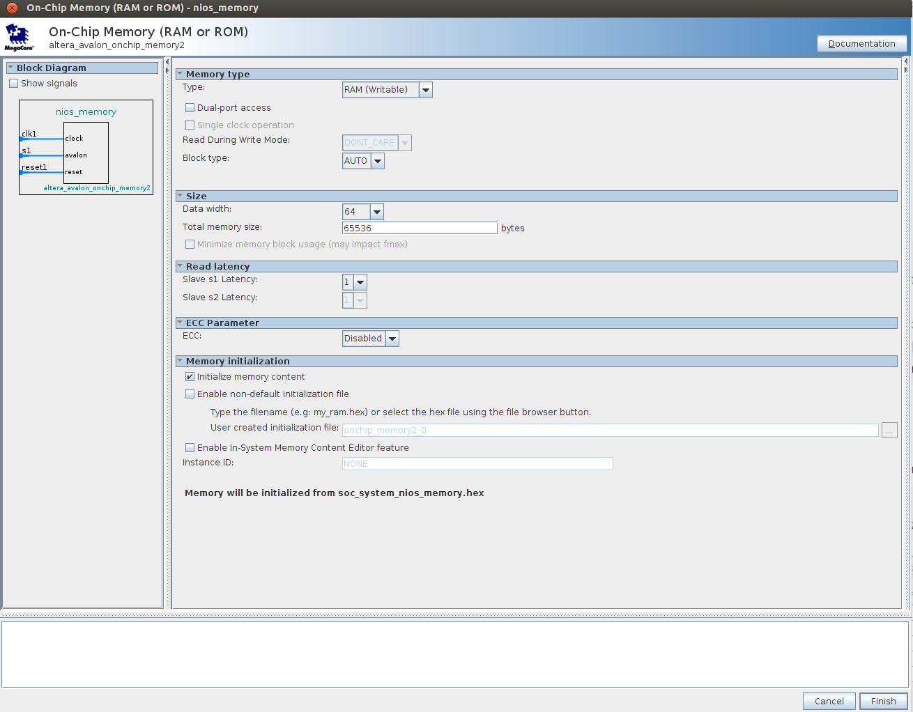

Figure A-10. nios_memory on-chip memory.

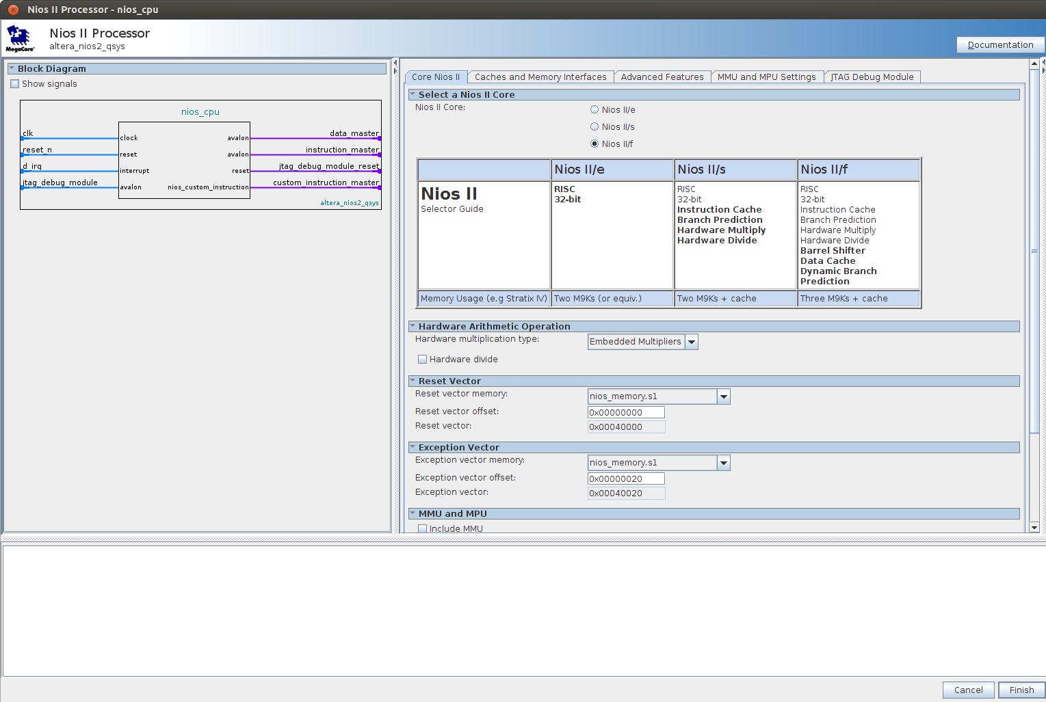

Figure A-11. nios_cpu/Core NIOS II
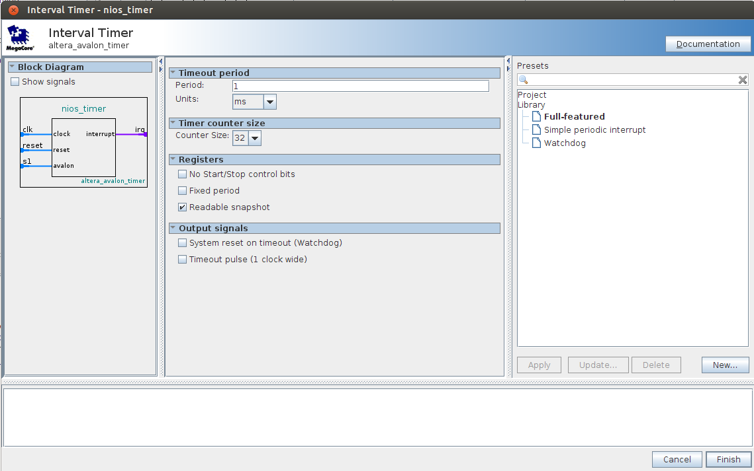

Figure A-12. nios_timer timer.

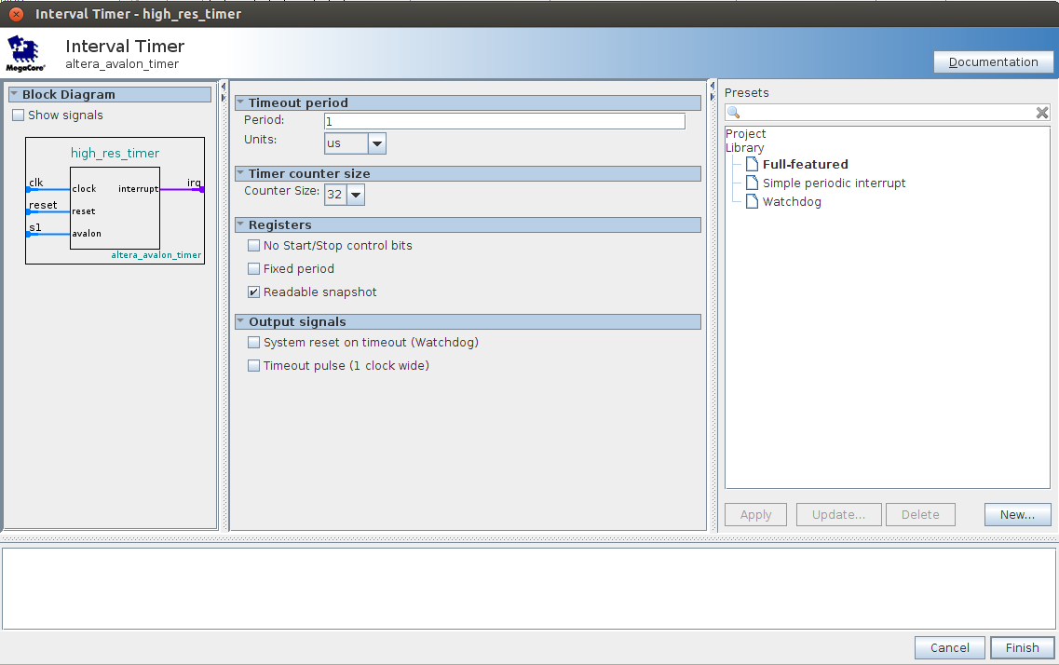

Figure A-13. high_res_timer timer.
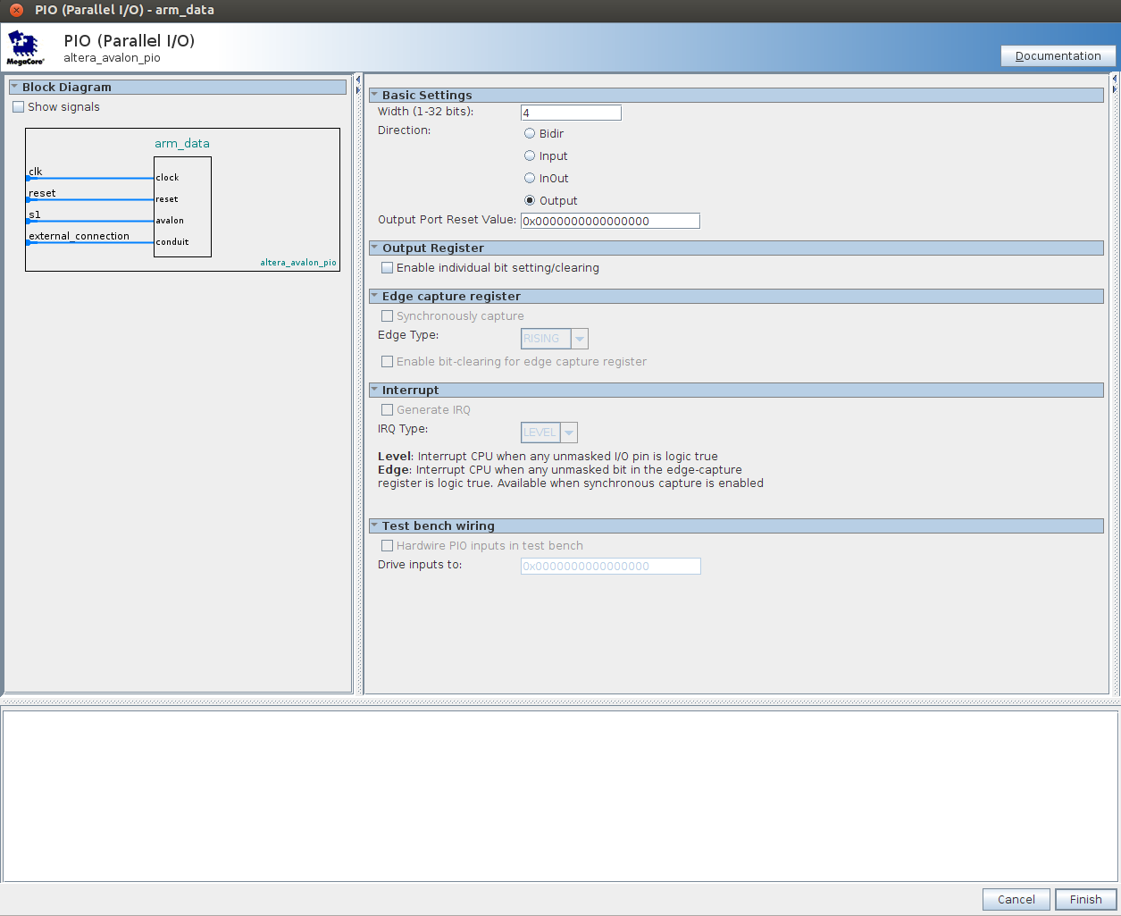

Figure A-14. arm_data PIO.

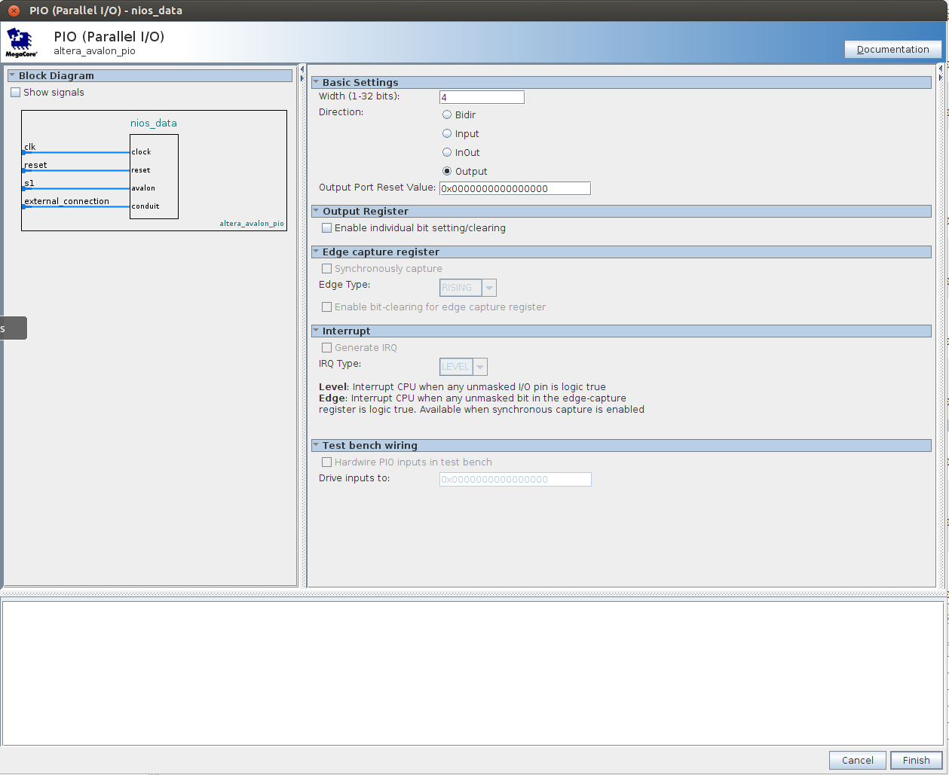

Figure A-15. nios_data PIO.
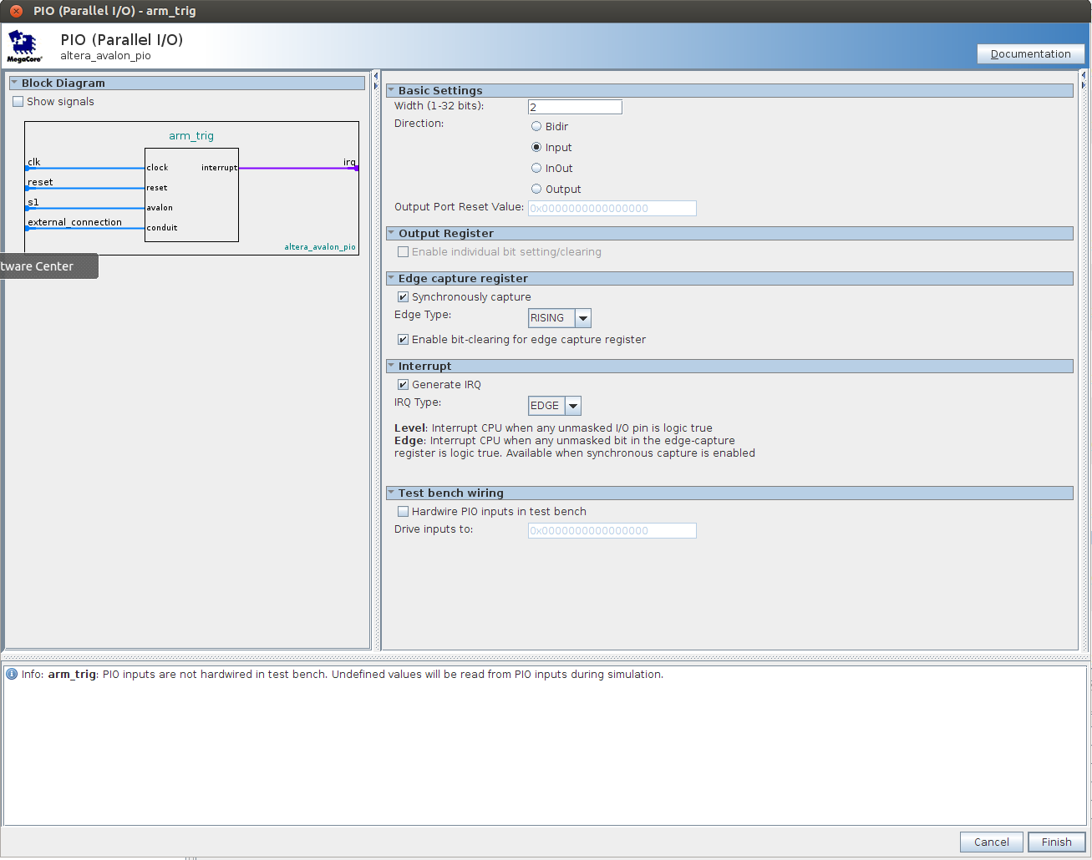

Figure A-16. arm_trig PIO.

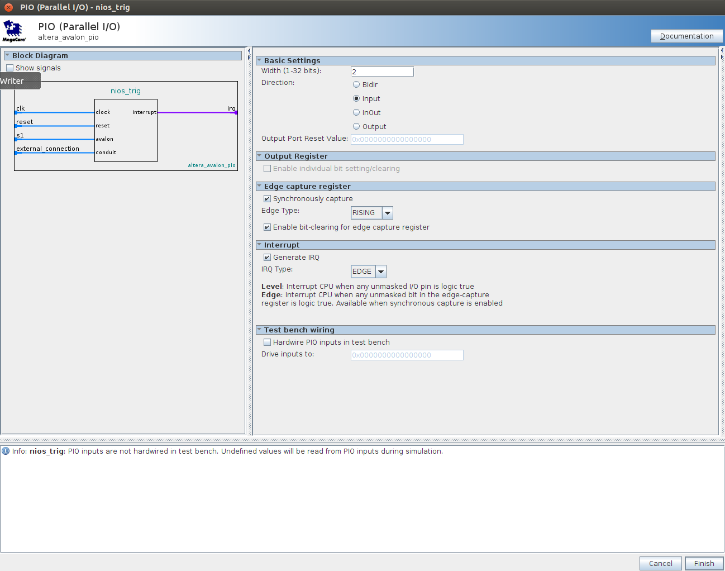

Figure A-17. nios_trig PIO.
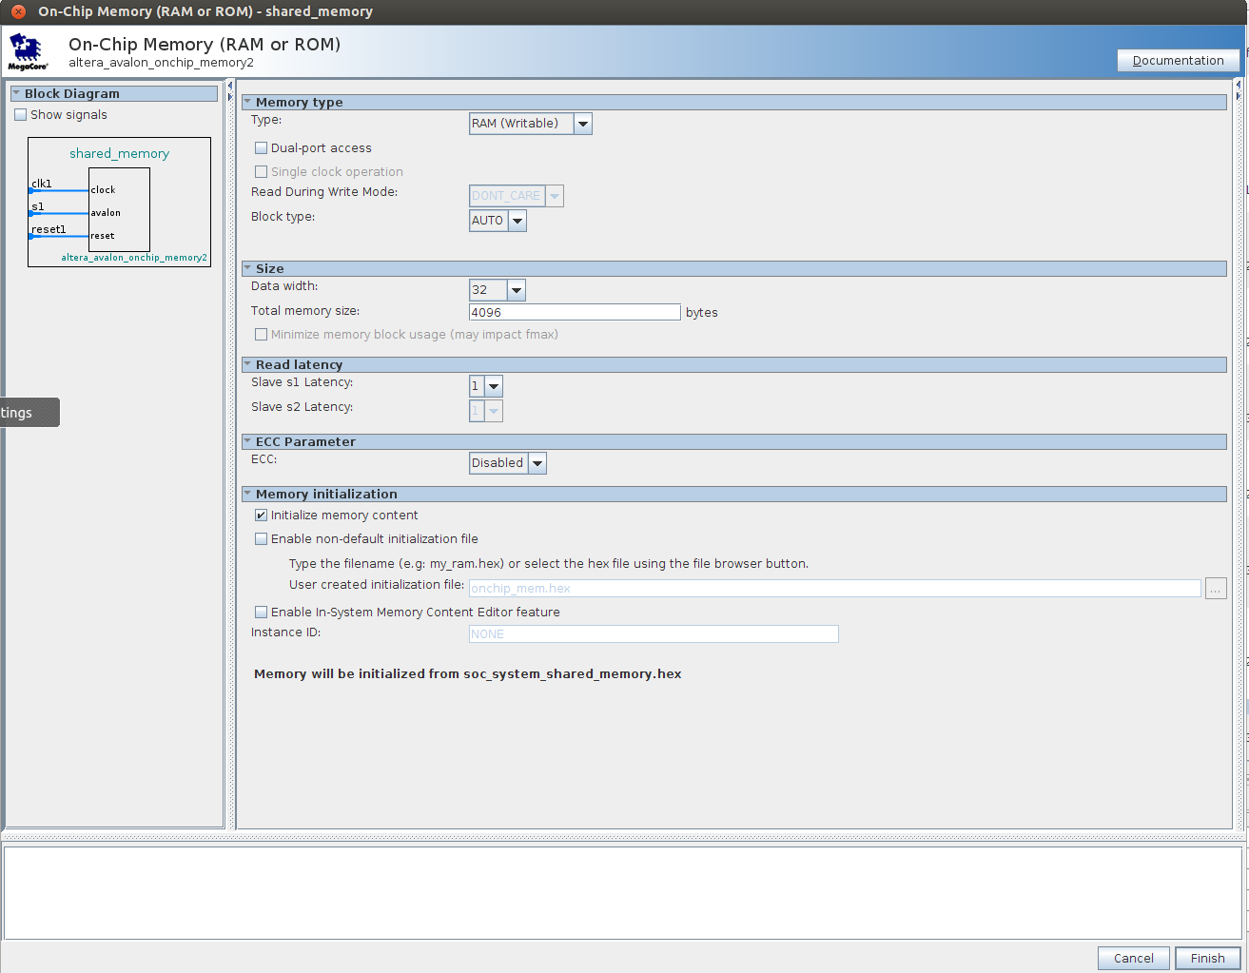

Figure A-18. shared_memory on-chip memory.

The top/ghrd_top.v file is shown below:

module Data_Control_Interface (
output wire [14:0] memory_mem_a,
output wire [2:0] memory_mem_ba,
output wire memory_mem_ck,
output wire memory_mem_ck_n,
output wire memory_mem_cke,
output wire memory_mem_cs_n,
output wire memory_mem_ras_n,
output wire memory_mem_cas_n,
output wire memory_mem_we_n,
output wire memory_mem_reset_n,
inout wire [31:0] memory_mem_dq,
inout wire [3:0] memory_mem_dqs,
inout wire [3:0] memory_mem_dqs_n,
output wire memory_mem_odt,
output wire [3:0] memory_mem_dm,
input wire memory_oct_rzqin,
output wire hps_emac1_TX_CLK,
output wire hps_emac1_TXD0,
output wire hps_emac1_TXD1,
output wire hps_emac1_TXD2,
output wire hps_emac1_TXD3,
input wire hps_emac1_RXD0,
inout wire hps_emac1_MDIO,
output wire hps_emac1_MDC,
input wire hps_emac1_RX_CTL,
output wire hps_emac1_TX_CTL,
input wire hps_emac1_RX_CLK,
input wire hps_emac1_RXD1,
input wire hps_emac1_RXD2,
input wire hps_emac1_RXD3,
inout wire hps_qspi_IO0,
inout wire hps_qspi_IO1,
inout wire hps_qspi_IO2,
inout wire hps_qspi_IO3,
output wire hps_qspi_SS0,
output wire hps_qspi_CLK,
inout wire hps_sdio_CMD,
inout wire hps_sdio_D0,
inout wire hps_sdio_D1,
output wire hps_sdio_CLK,
inout wire hps_sdio_D2,
inout wire hps_sdio_D3,
inout wire hps_usb1_D0,
inout wire hps_usb1_D1,
inout wire hps_usb1_D2,
inout wire hps_usb1_D3,
inout wire hps_usb1_D4,
inout wire hps_usb1_D5,
inout wire hps_usb1_D6,
inout wire hps_usb1_D7,
input wire hps_usb1_CLK,
output wire hps_usb1_STP,
input wire hps_usb1_DIR,
input wire hps_usb1_NXT,
output wire hps_spim0_CLK,
output wire hps_spim0_MOSI,
input wire hps_spim0_MISO,
output wire hps_spim0_SS0,
output wire hps_spim1_CLK,
output wire hps_spim1_MOSI,
input wire hps_spim1_MISO,
output wire hps_spim1_SS0,
input wire hps_uart0_RX,
output wire hps_uart0_TX,
inout wire hps_i2c1_SDA,
inout wire hps_i2c1_SCL,
inout wire hps_gpio_GPIO00,
inout wire hps_gpio_GPIO09,
inout wire hps_gpio_GPIO35,
inout wire hps_gpio_GPIO48,
inout wire hps_gpio_GPIO53,
inout wire hps_gpio_GPIO54,
inout wire hps_gpio_GPIO55,
inout wire hps_gpio_GPIO56,
inout wire hps_gpio_GPIO61,
inout wire hps_gpio_GPIO62,
input wire clk_100m_fpga,
input wire clk_50m_fpga,
input wire clk_top1,
input wire clk_bot1,
input wire fpga_resetn,
output wire clk_i2c_sclk,
inout wire clk_i2c_sdat,
output wire [3:0] arm_data,
output wire [3:0] nios_data,
input wire [1:0] arm_trig,
input wire [1:0] nios_trig );

// internal wires and registers declaration
wire hps_fpga_reset_n;
wire [2:0] hps_reset_req;
wire hps_cold_reset;
wire hps_warm_reset;
wire hps_debug_reset;
wire [27:0] stm_hw_events;

soc_system u0 (
.clk_clk (clk_bot1),
.reset_reset_n (hps_fpga_reset_n),
.memory_mem_a (memory_mem_a),
.memory_mem_ba (memory_mem_ba),
.memory_mem_ck (memory_mem_ck),
.memory_mem_ck_n (memory_mem_ck_n),
.memory_mem_cke (memory_mem_cke),
.memory_mem_cs_n (memory_mem_cs_n),
.memory_mem_ras_n (memory_mem_ras_n),
.memory_mem_cas_n (memory_mem_cas_n),
.memory_mem_we_n (memory_mem_we_n),
.memory_mem_reset_n (memory_mem_reset_n),
.memory_mem_dq (memory_mem_dq),
.memory_mem_dqs (memory_mem_dqs),
.memory_mem_dqs_n (memory_mem_dqs_n),
.memory_mem_odt (memory_mem_odt),
.memory_mem_dm (memory_mem_dm),
.memory_oct_rzqin (memory_oct_rzqin),
.hps_0_hps_io_hps_io_emac1_inst_TX_CLK (hps_emac1_TX_CLK),
.hps_0_hps_io_hps_io_emac1_inst_TXD0 (hps_emac1_TXD0),
.hps_0_hps_io_hps_io_emac1_inst_TXD1 (hps_emac1_TXD1),
.hps_0_hps_io_hps_io_emac1_inst_TXD2 (hps_emac1_TXD2),
.hps_0_hps_io_hps_io_emac1_inst_TXD3 (hps_emac1_TXD3),
.hps_0_hps_io_hps_io_emac1_inst_RXD0 (hps_emac1_RXD0),
.hps_0_hps_io_hps_io_emac1_inst_MDIO (hps_emac1_MDIO),
.hps_0_hps_io_hps_io_emac1_inst_MDC (hps_emac1_MDC),
.hps_0_hps_io_hps_io_emac1_inst_RX_CTL (hps_emac1_RX_CTL),
.hps_0_hps_io_hps_io_emac1_inst_TX_CTL (hps_emac1_TX_CTL),
.hps_0_hps_io_hps_io_emac1_inst_RX_CLK (hps_emac1_RX_CLK),
.hps_0_hps_io_hps_io_emac1_inst_RXD1 (hps_emac1_RXD1),
.hps_0_hps_io_hps_io_emac1_inst_RXD2 (hps_emac1_RXD2),
.hps_0_hps_io_hps_io_emac1_inst_RXD3 (hps_emac1_RXD3),
.hps_0_hps_io_hps_io_qspi_inst_IO0 (hps_qspi_IO0),
.hps_0_hps_io_hps_io_qspi_inst_IO1 (hps_qspi_IO1),
.hps_0_hps_io_hps_io_qspi_inst_IO2 (hps_qspi_IO2),
.hps_0_hps_io_hps_io_qspi_inst_IO3 (hps_qspi_IO3),
.hps_0_hps_io_hps_io_qspi_inst_SS0 (hps_qspi_SS0),
.hps_0_hps_io_hps_io_qspi_inst_CLK (hps_qspi_CLK),
.hps_0_hps_io_hps_io_sdio_inst_CMD (hps_sdio_CMD),
.hps_0_hps_io_hps_io_sdio_inst_D0 (hps_sdio_D0),
.hps_0_hps_io_hps_io_sdio_inst_D1 (hps_sdio_D1),
.hps_0_hps_io_hps_io_sdio_inst_CLK (hps_sdio_CLK),
.hps_0_hps_io_hps_io_sdio_inst_D2 (hps_sdio_D2),
.hps_0_hps_io_hps_io_sdio_inst_D3 (hps_sdio_D3),
.hps_0_hps_io_hps_io_usb1_inst_D0 (hps_usb1_D0),
.hps_0_hps_io_hps_io_usb1_inst_D1 (hps_usb1_D1),
.hps_0_hps_io_hps_io_usb1_inst_D2 (hps_usb1_D2),
.hps_0_hps_io_hps_io_usb1_inst_D3 (hps_usb1_D3),
.hps_0_hps_io_hps_io_usb1_inst_D4 (hps_usb1_D4),
.hps_0_hps_io_hps_io_usb1_inst_D5 (hps_usb1_D5),
.hps_0_hps_io_hps_io_usb1_inst_D6 (hps_usb1_D6),
.hps_0_hps_io_hps_io_usb1_inst_D7 (hps_usb1_D7),
.hps_0_hps_io_hps_io_usb1_inst_CLK (hps_usb1_CLK),
.hps_0_hps_io_hps_io_usb1_inst_STP (hps_usb1_STP),
.hps_0_hps_io_hps_io_usb1_inst_DIR (hps_usb1_DIR),
.hps_0_hps_io_hps_io_usb1_inst_NXT (hps_usb1_NXT),
.hps_0_hps_io_hps_io_spim0_inst_CLK (hps_spim0_CLK),
.hps_0_hps_io_hps_io_spim0_inst_MOSI (hps_spim0_MOSI),
.hps_0_hps_io_hps_io_spim0_inst_MISO (hps_spim0_MISO),
.hps_0_hps_io_hps_io_spim0_inst_SS0 (hps_spim0_SS0),
.hps_0_hps_io_hps_io_spim1_inst_CLK (hps_spim1_CLK),
.hps_0_hps_io_hps_io_spim1_inst_MOSI (hps_spim1_MOSI),
.hps_0_hps_io_hps_io_spim1_inst_MISO (hps_spim1_MISO),
.hps_0_hps_io_hps_io_spim1_inst_SS0 (hps_spim1_SS0),
.hps_0_hps_io_hps_io_uart0_inst_RX (hps_uart0_RX),
.hps_0_hps_io_hps_io_uart0_inst_TX (hps_uart0_TX),
.hps_0_hps_io_hps_io_i2c1_inst_SDA (hps_i2c1_SDA),
.hps_0_hps_io_hps_io_i2c1_inst_SCL (hps_i2c1_SCL),
.hps_0_hps_io_hps_io_gpio_inst_GPIO00 (hps_gpio_GPIO00),
.hps_0_hps_io_hps_io_gpio_inst_GPIO09 (hps_gpio_GPIO09),
.hps_0_hps_io_hps_io_gpio_inst_GPIO35 (hps_gpio_GPIO35),
.hps_0_hps_io_hps_io_gpio_inst_GPIO48 (hps_gpio_GPIO48),
.hps_0_hps_io_hps_io_gpio_inst_GPIO53 (hps_gpio_GPIO53),
.hps_0_hps_io_hps_io_gpio_inst_GPIO54 (hps_gpio_GPIO54),
.hps_0_hps_io_hps_io_gpio_inst_GPIO55 (hps_gpio_GPIO55),
.hps_0_hps_io_hps_io_gpio_inst_GPIO56 (hps_gpio_GPIO56),
.hps_0_hps_io_hps_io_gpio_inst_GPIO61 (hps_gpio_GPIO61),
.hps_0_hps_io_hps_io_gpio_inst_GPIO62 (hps_gpio_GPIO62),
.hps_0_f2h_stm_hw_events_stm_hwevents (stm_hw_events),
.hps_0_h2f_reset_reset_n (hps_fpga_reset_n),
.hps_0_f2h_cold_reset_req_reset_n (~hps_cold_reset),
.hps_0_f2h_warm_reset_req_reset_n (~hps_warm_reset),
.hps_0_f2h_debug_reset_req_reset_n (~hps_debug_reset),
.arm_data_export (arm_data),
.nios_data_export (nios_data),
.arm_trig_export (arm_trig),
.nios_trig_export (nios_trig)
);

// Source/Probe megawizard instance
hps_reset hps_reset_inst (
.source_clk (clk_bot1),
.source (hps_reset_req)
);

altera_edge_detector pulse_cold_reset (
.clk (clk_bot1),
.rst_n (hps_fpga_reset_n),
.signal_in (hps_reset_req[0]),
.pulse_out (hps_cold_reset)
);

defparam pulse_cold_reset.PULSE_EXT = 6;
defparam pulse_cold_reset.EDGE_TYPE = 1;
defparam pulse_cold_reset.IGNORE_RST_WHILE_BUSY = 1;

altera_edge_detector pulse_warm_reset (
.clk (clk_bot1),
.rst_n (hps_fpga_reset_n),
.signal_in (hps_reset_req[1]),
.pulse_out (hps_warm_reset)
);

defparam pulse_warm_reset.PULSE_EXT = 2;
defparam pulse_warm_reset.EDGE_TYPE = 1;
defparam pulse_warm_reset.IGNORE_RST_WHILE_BUSY = 1;

altera_edge_detector pulse_debug_reset (
.clk (clk_bot1),
.rst_n (hps_fpga_reset_n),
.signal_in (hps_reset_req[2]),
.pulse_out (hps_debug_reset)
);

defparam pulse_debug_reset.PULSE_EXT = 32;
defparam pulse_debug_reset.EDGE_TYPE = 1;
defparam pulse_debug_reset.IGNORE_RST_WHILE_BUSY = 1;
endmodule

Code Snip A-1. The ghrd_top. File used to instatiate the SYS system.

Appendix B. LLRF DAQ Test System Details

This appendix contains the details of the LLRF System project. The top level diagram, followed by the Qsys system and all of the Qsys component details are shown. The veriog code is included, along with details on verilog test benches and simulations. The procedure for initializing on-chip memory with a nios C program is detailed in this appendix as well.
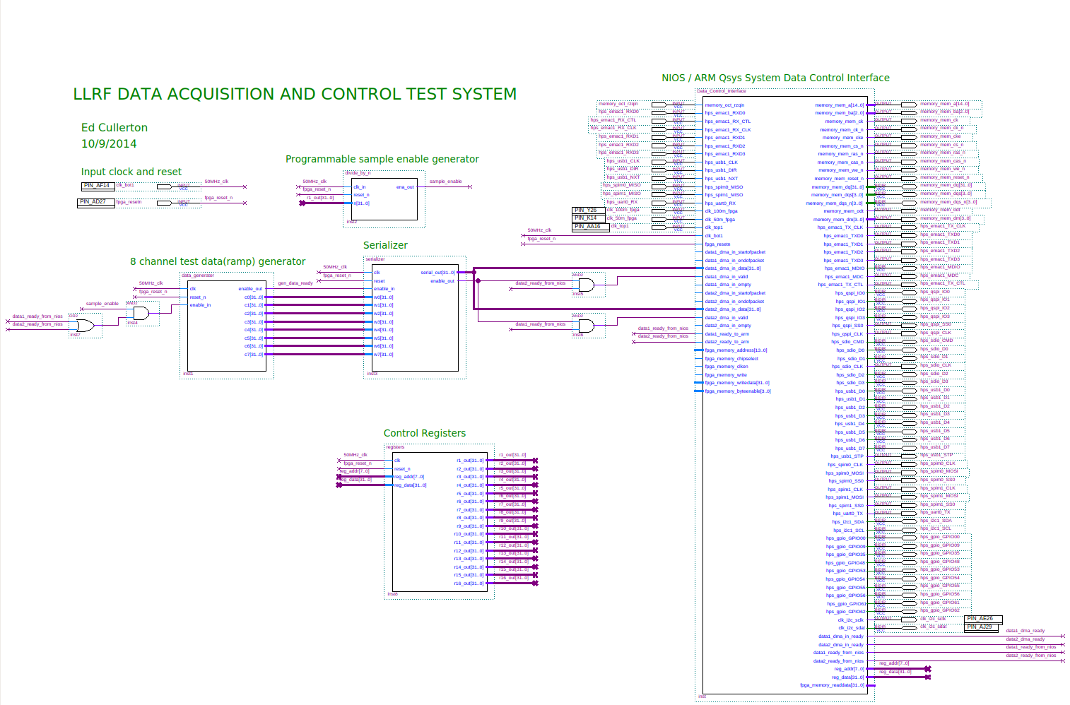

Figure B-1. Complete block diagram of the LLRF DAQ test system.
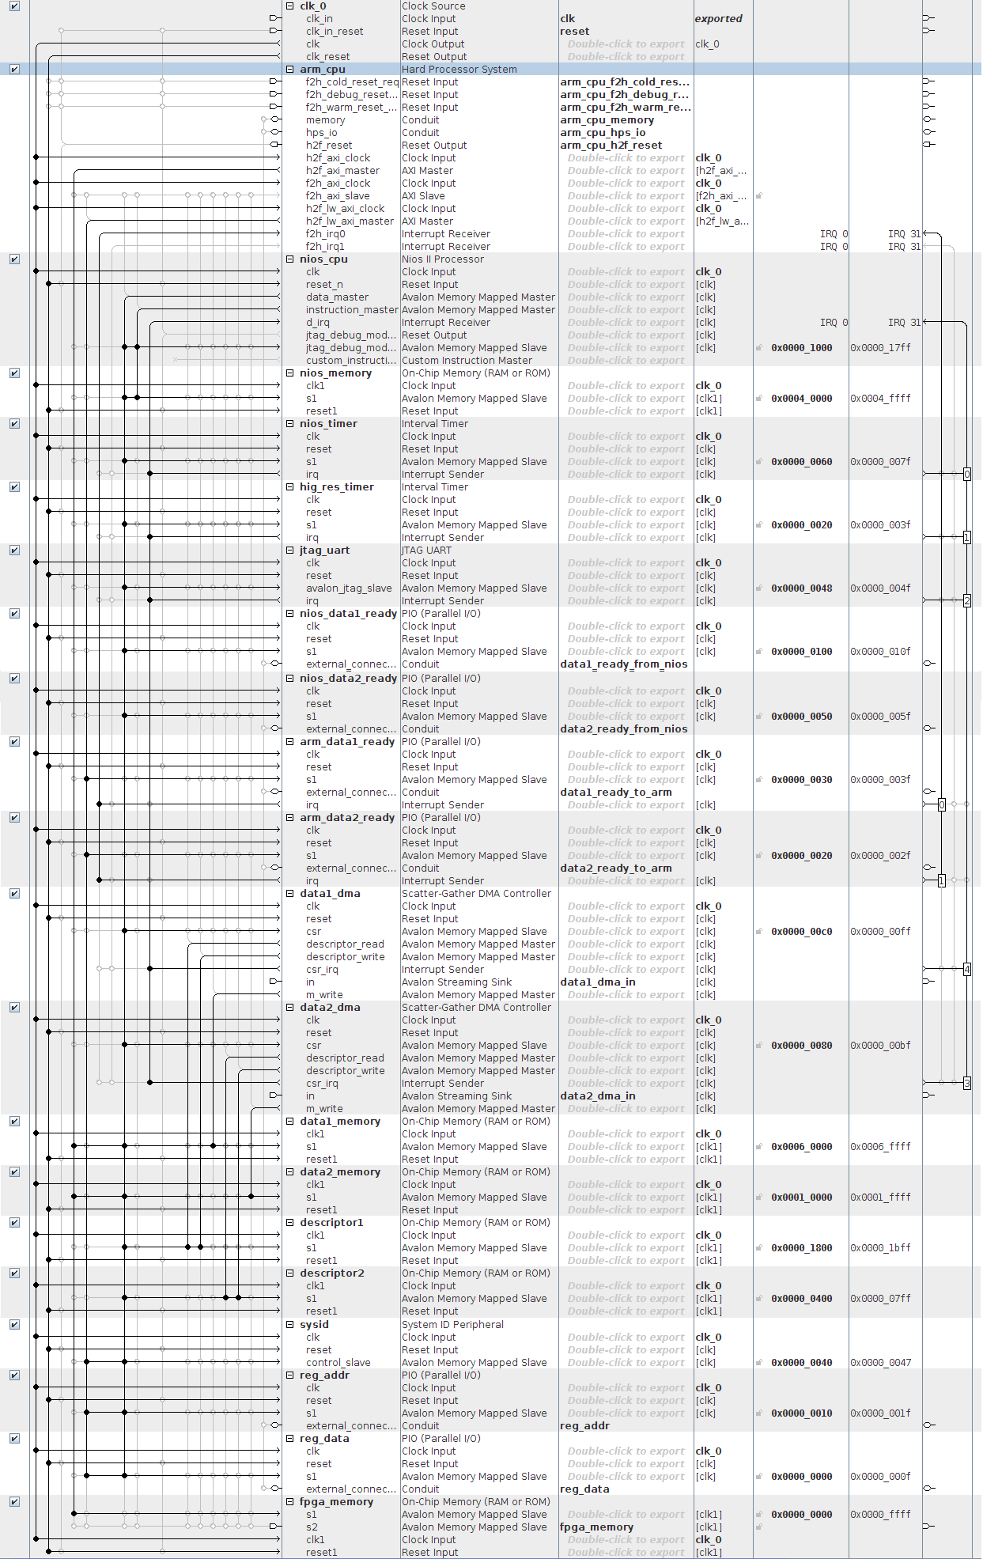

Figure B-2. Qsys configuration.
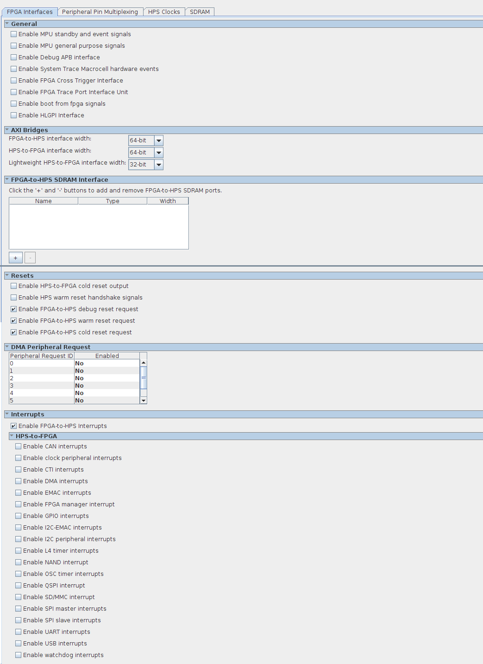

Figure B-3. arm_cpu/FPGA Interfaces.
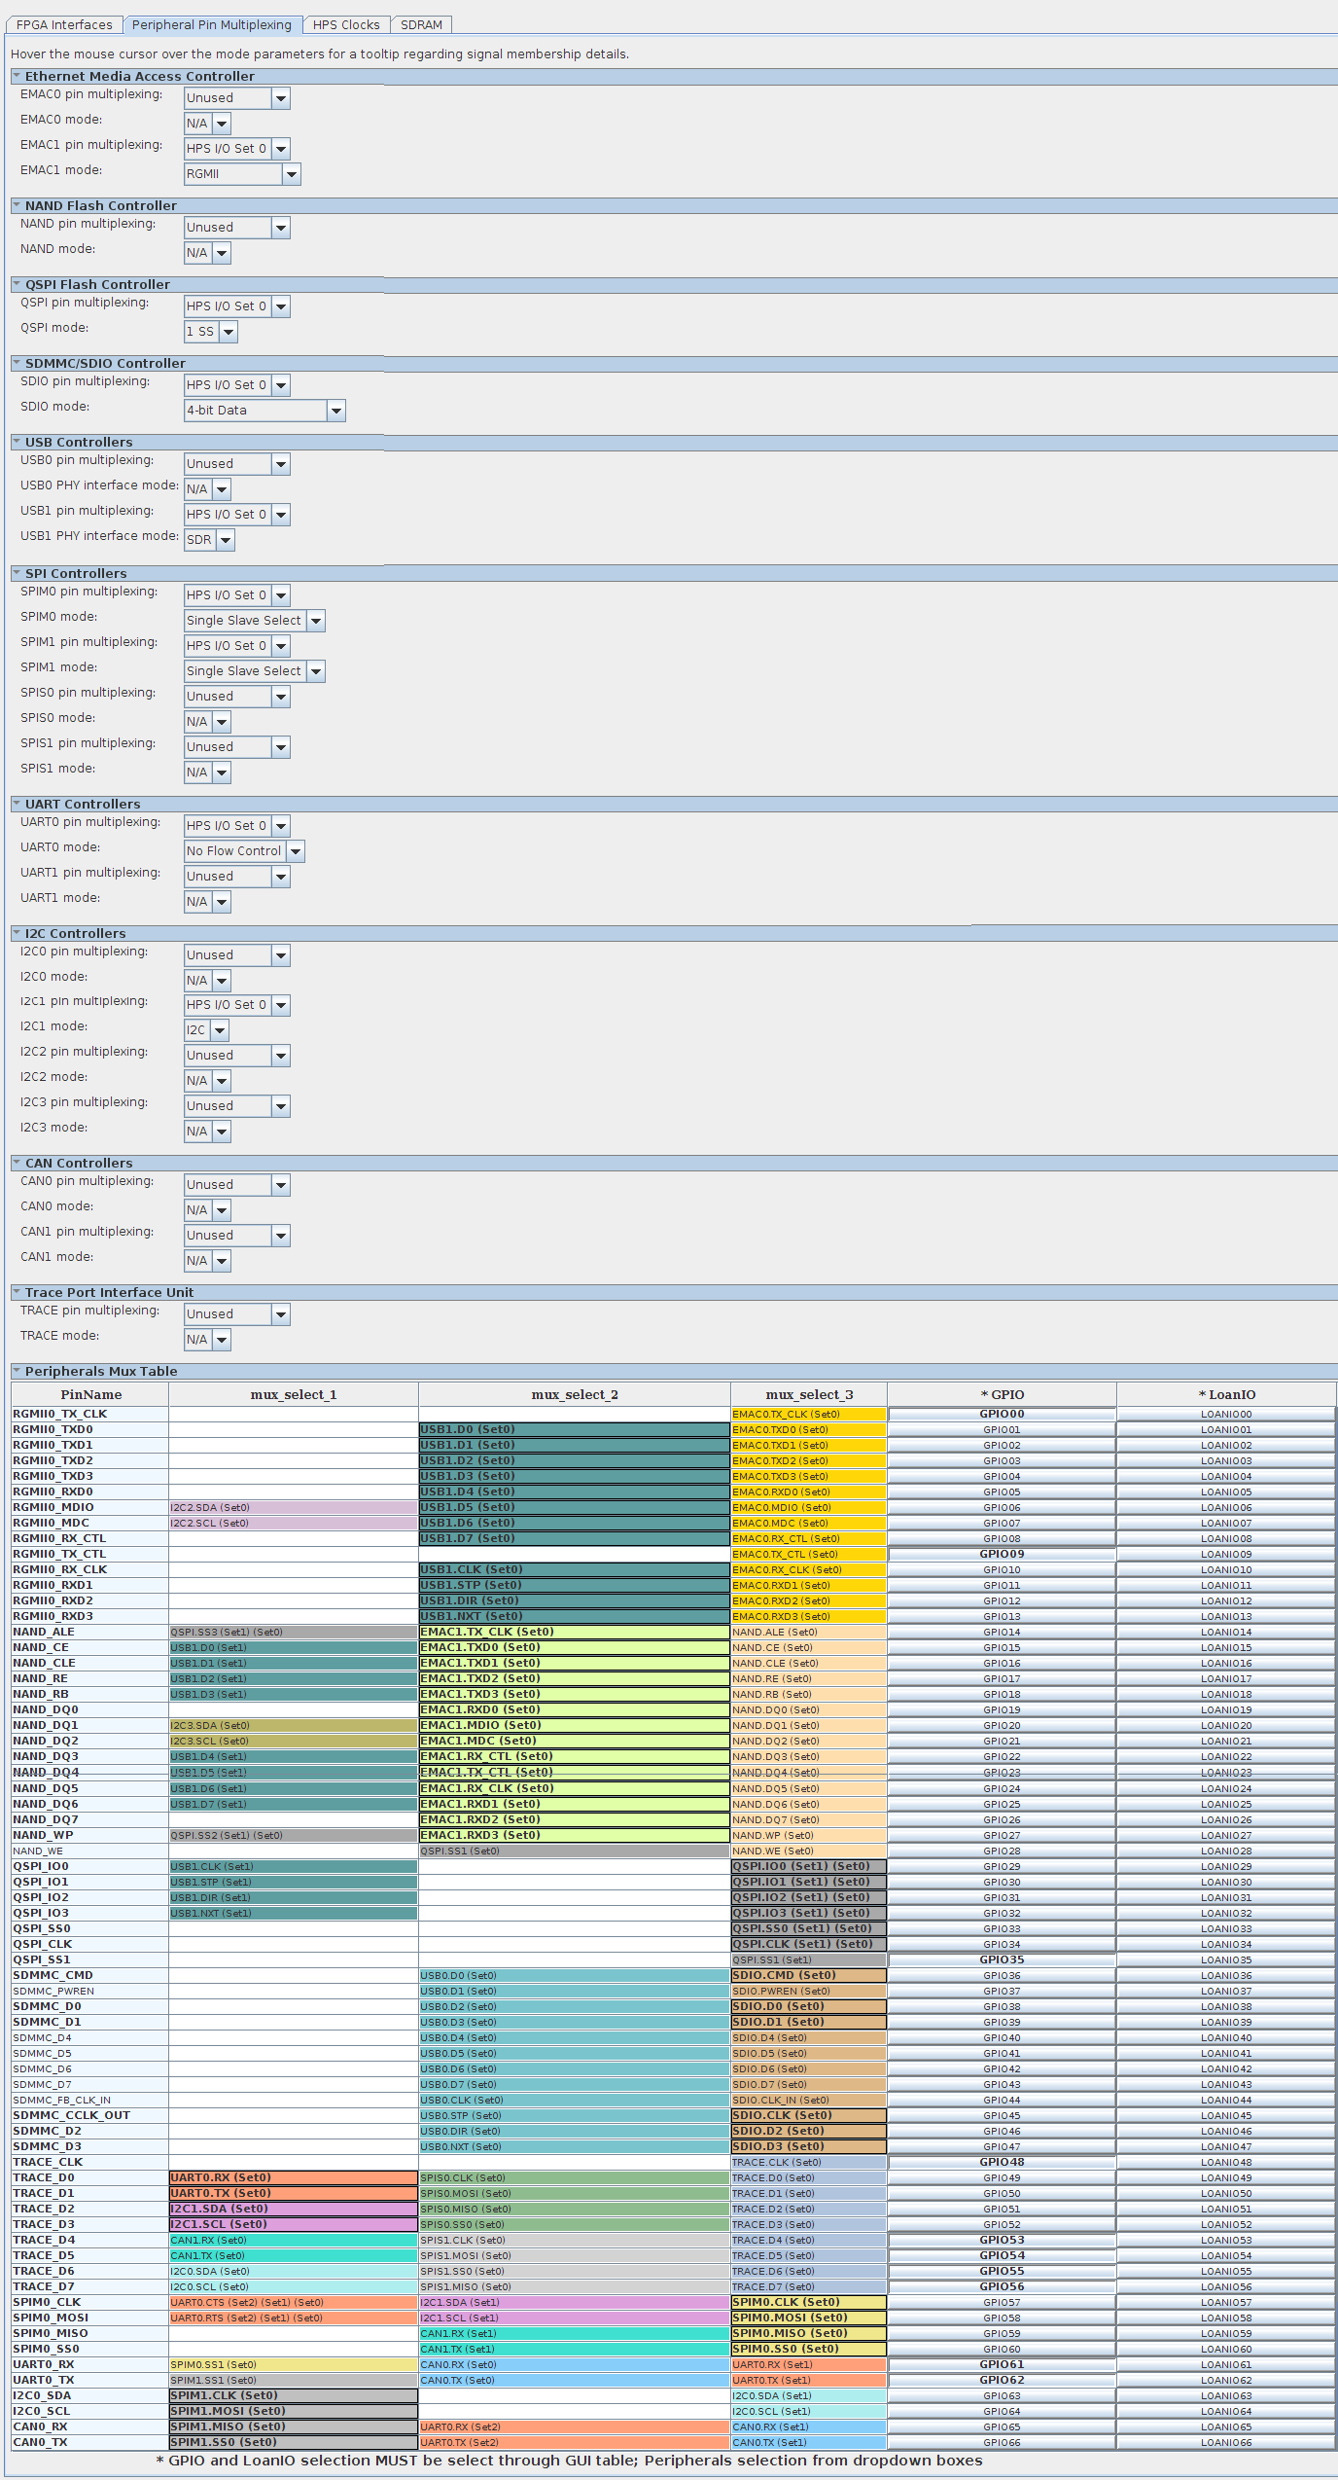

Figure B-4. arm_cpu/Peripheral Pin Multiplexing.
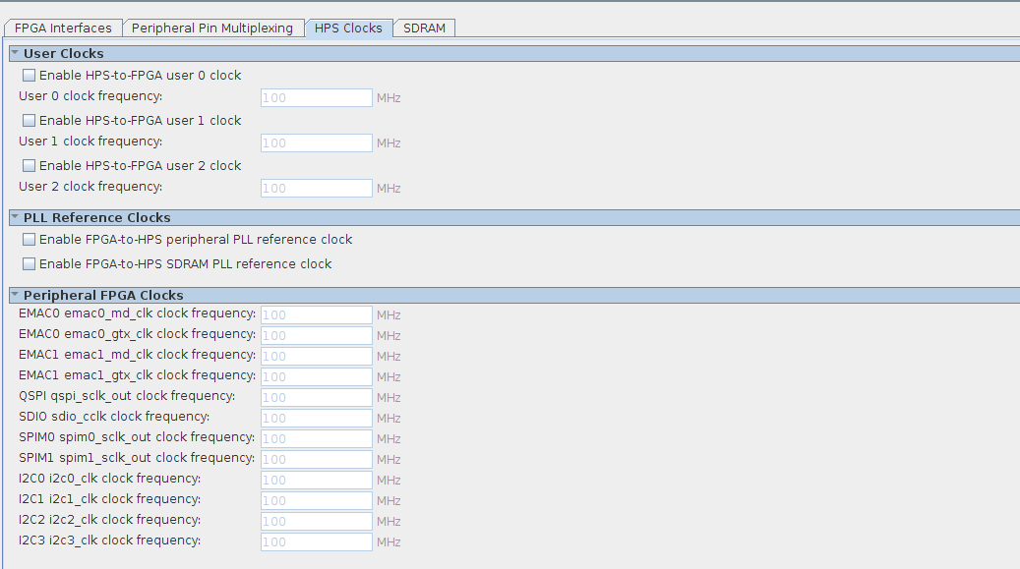

Figure B-5. arm_cpu/HPS Clocks.

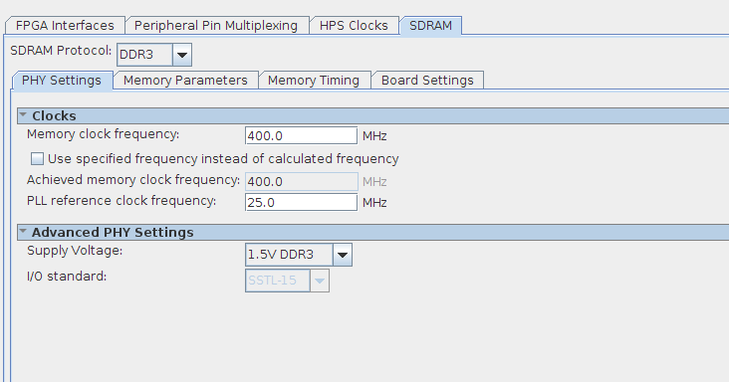

Figure B-6. arm_cpu/SDRAM/PHY Settings
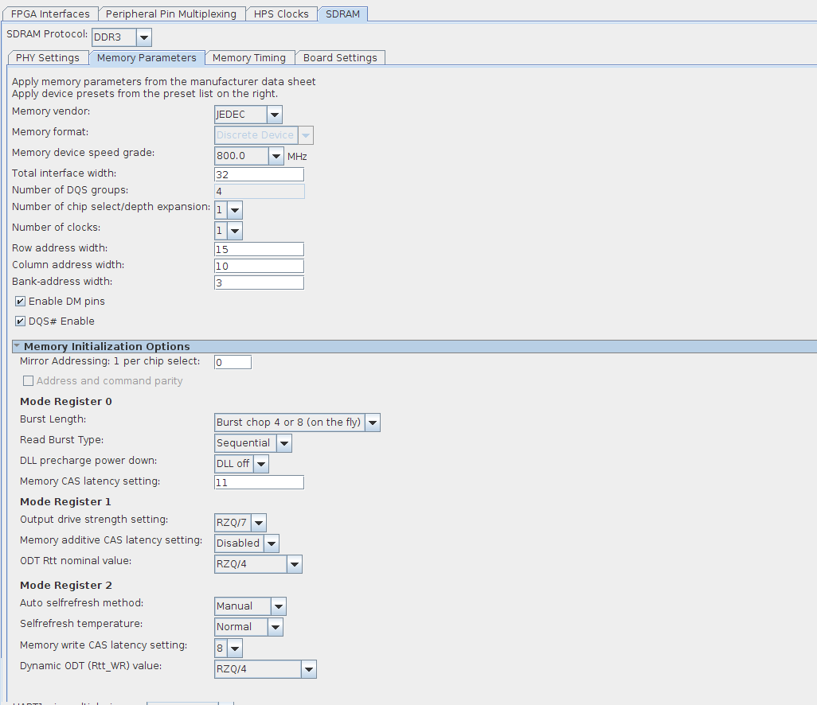

Figure B-7. arm_cpu/SDRAM/Memory Parameters.

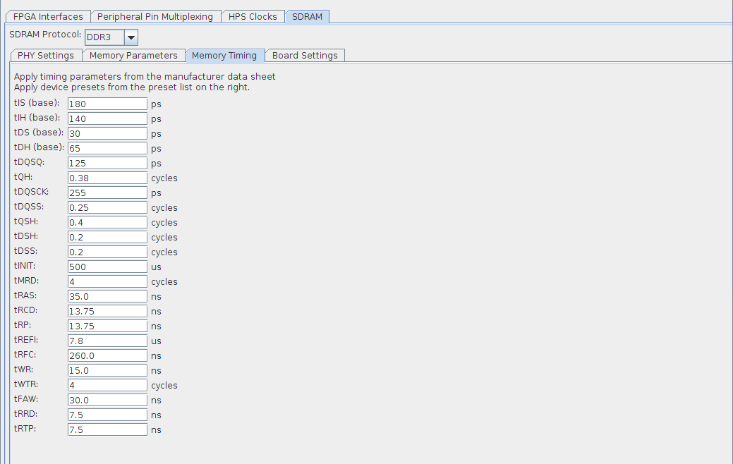

Figure B-8. arm_cpu/SDRAM/Memory Timing.
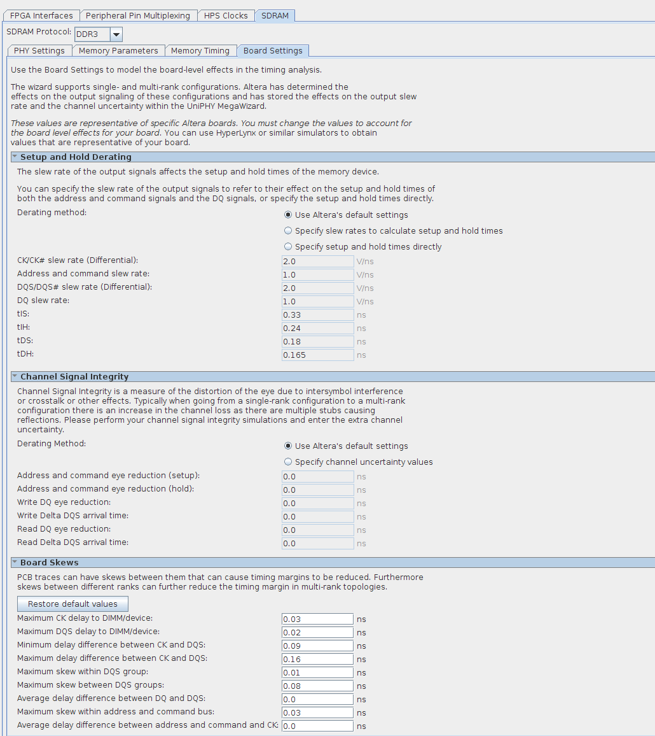

Figure B-9. arm_cpu/SDRAM/Board Settings.
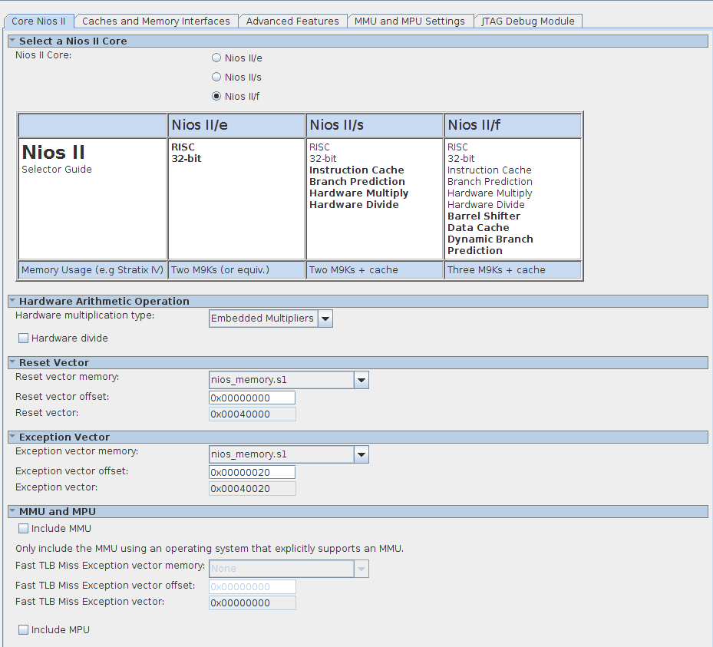

Figure B-10. nios_cpu/Core NIOS II.

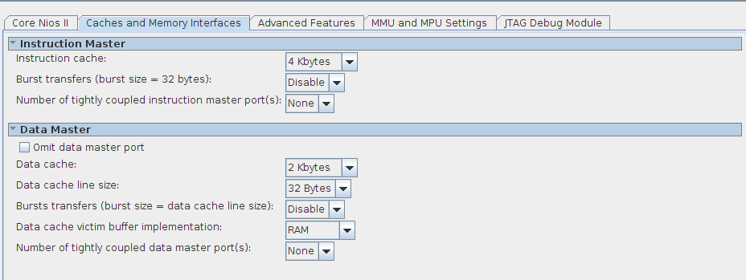

Figure B-11. nios_cpu/Caches and Memory Interfaces.
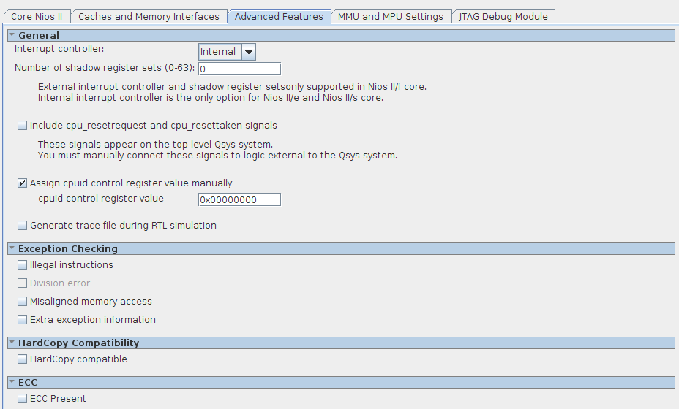

Figure B-12. nios_cpu/Advanced Features.

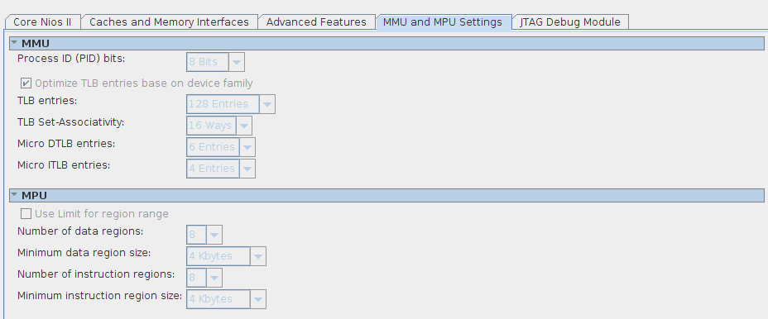

Figure B-13. nios_cpu/MMU and MPU Settings
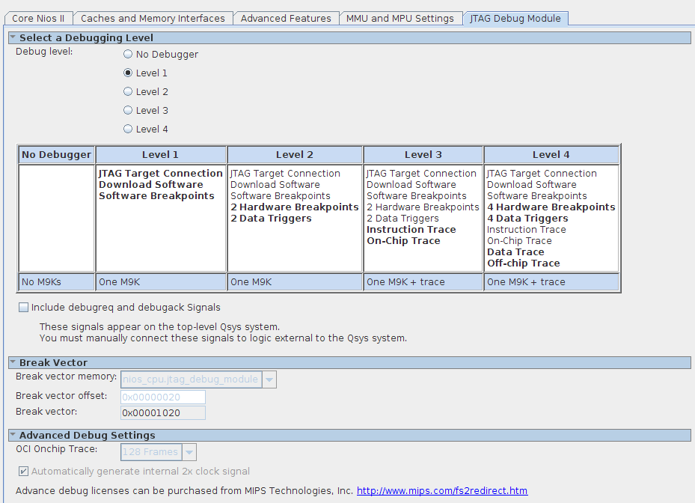

Figure B-14. nios_cpu/JTAG Debug Module.

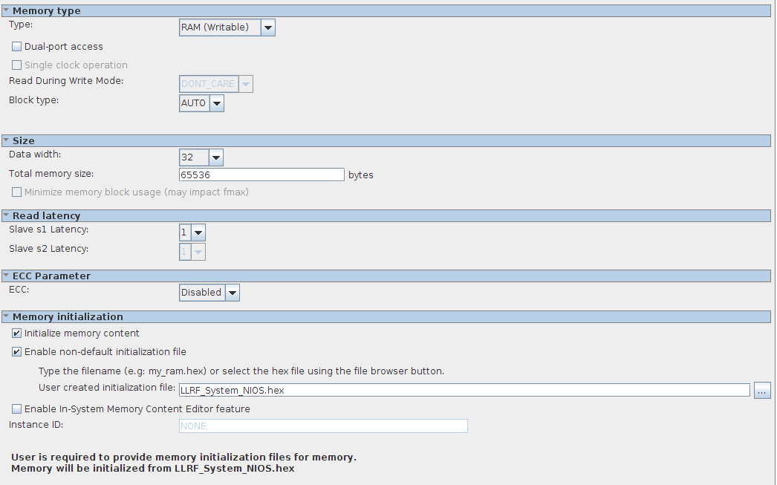

Figure B-15. nios_memory.
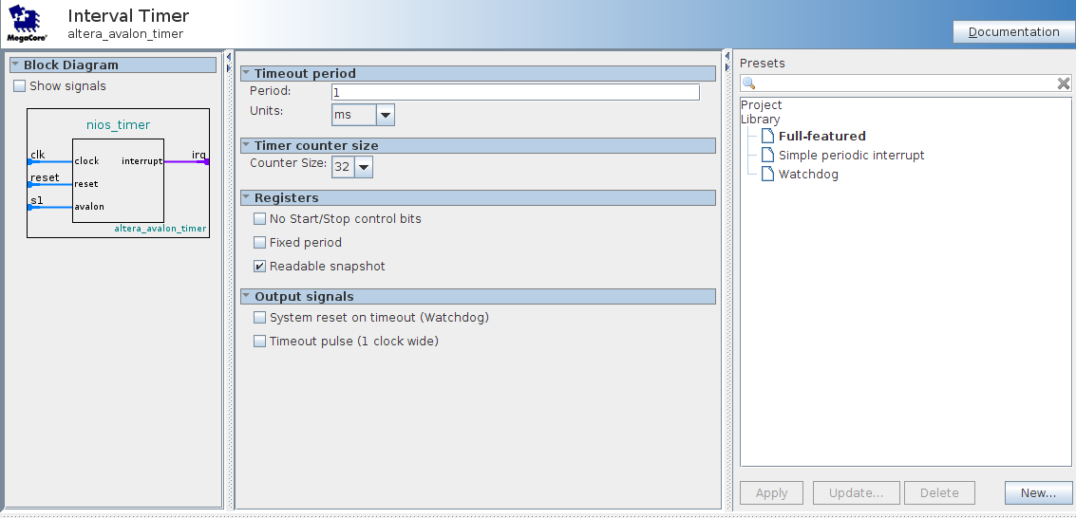

Figure B-16. nios_timer.

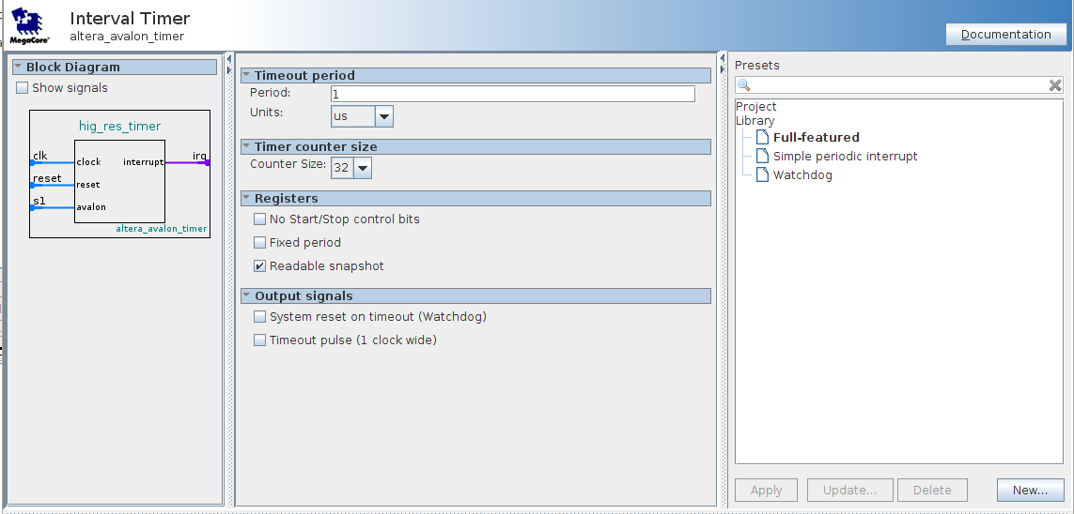

Figure B-17. high_res_timer.

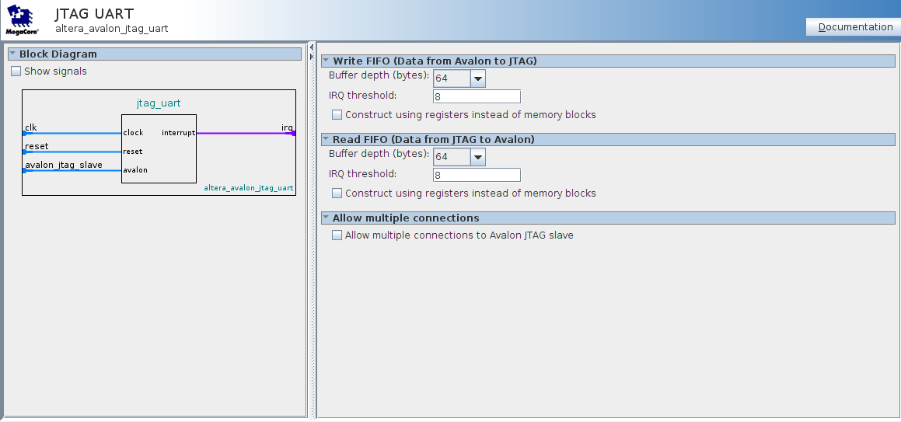

Figure B-18. jtag_uart.

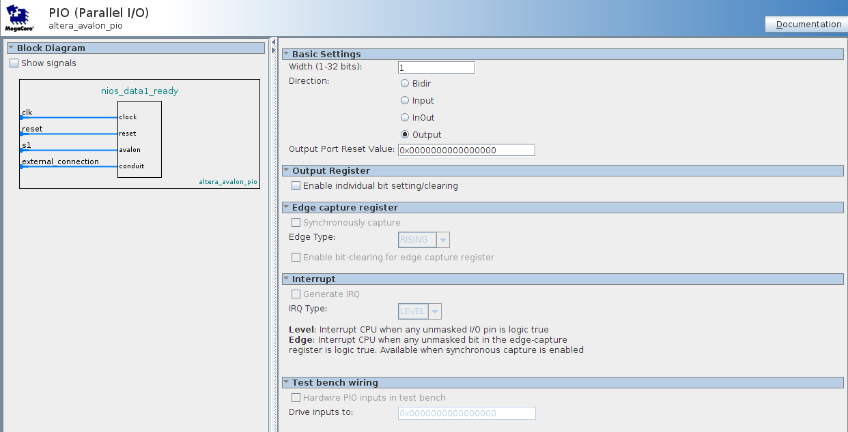

Figure B-19. nios_data1_ready and nios_data2_ready.

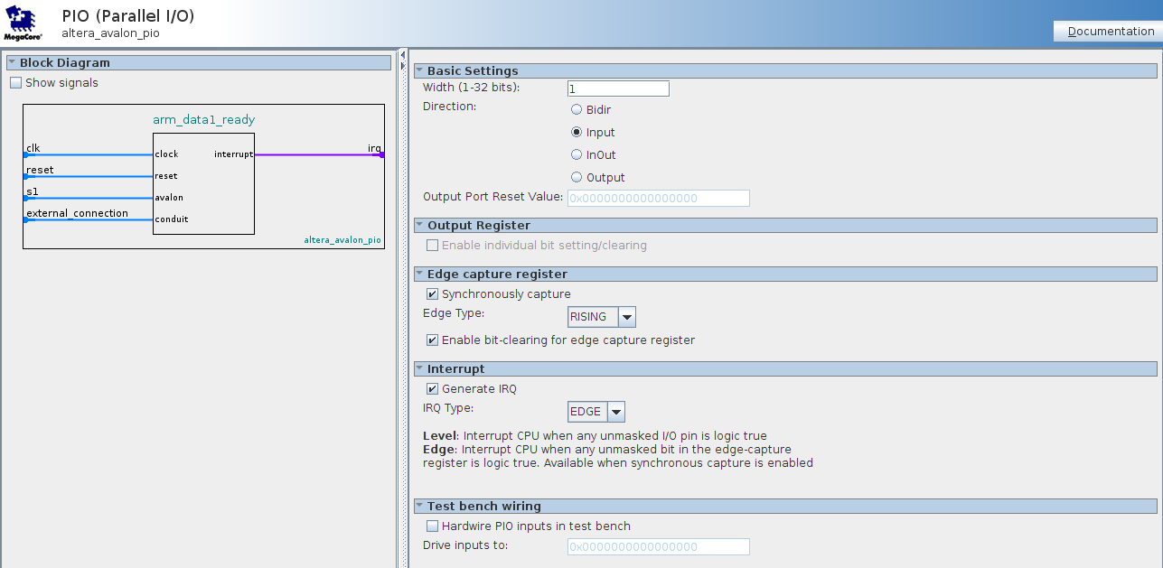

Figure B-20. arm_data1_ready and arm data2_ready.

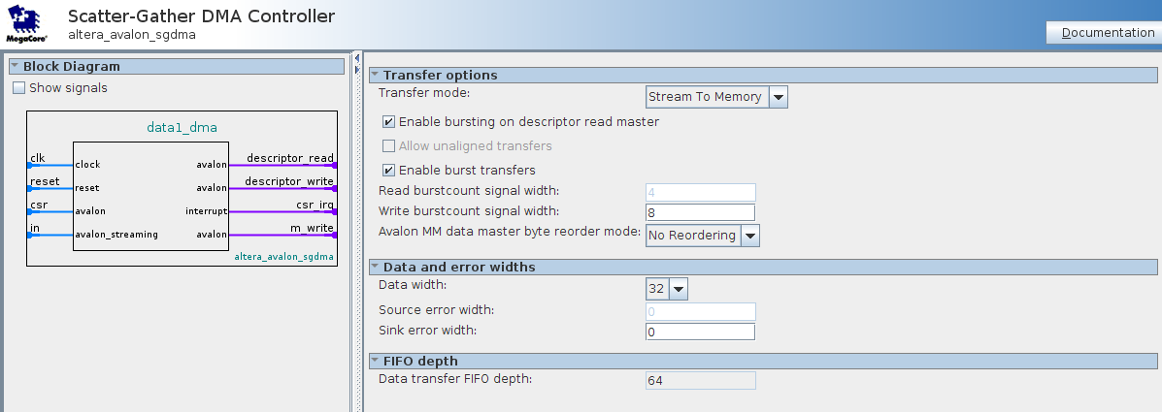

Figure B-21. data1_dma and data2_dma.

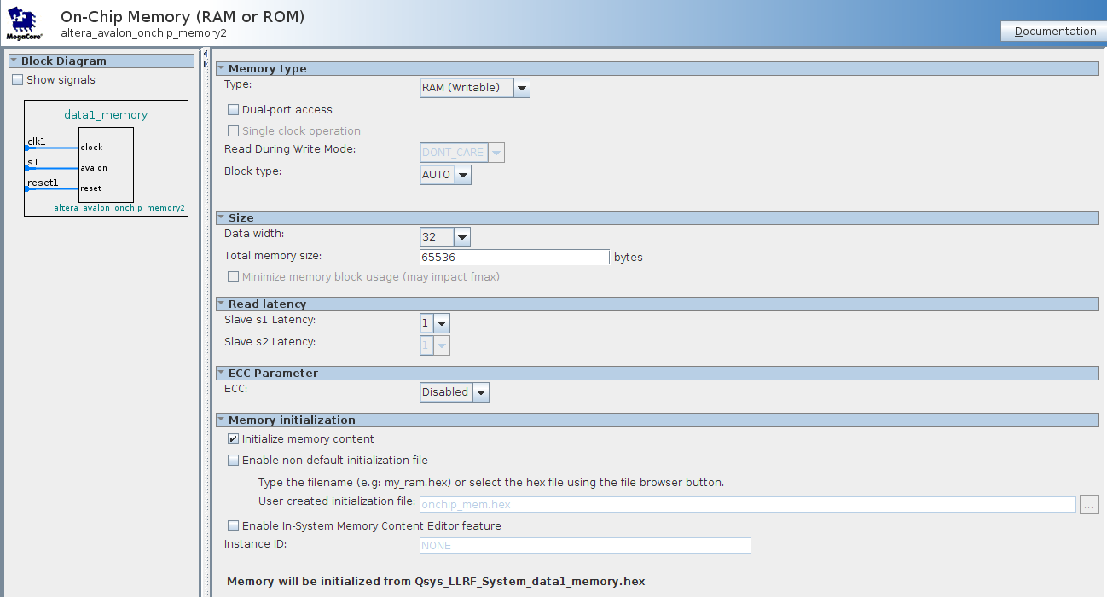

Figure B-22. data1_memory and data2_memory.

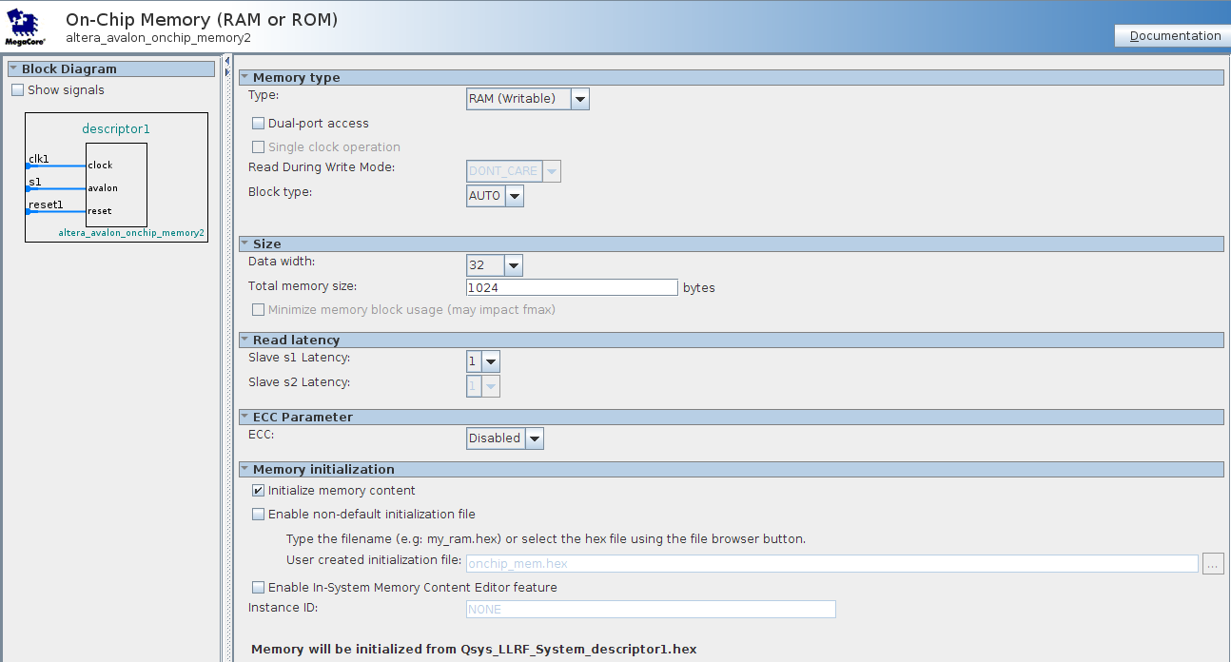

Figure B-23. descriptor1 and descriptor2.

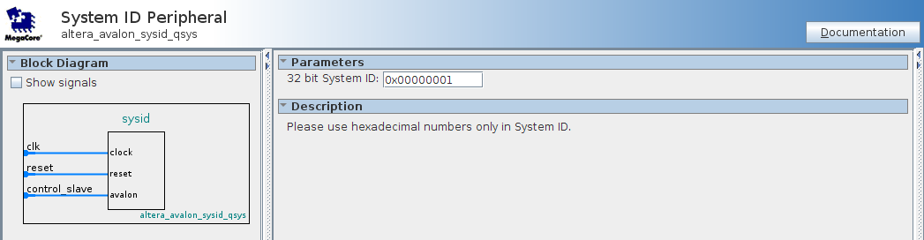

Figure B-24. sysid.

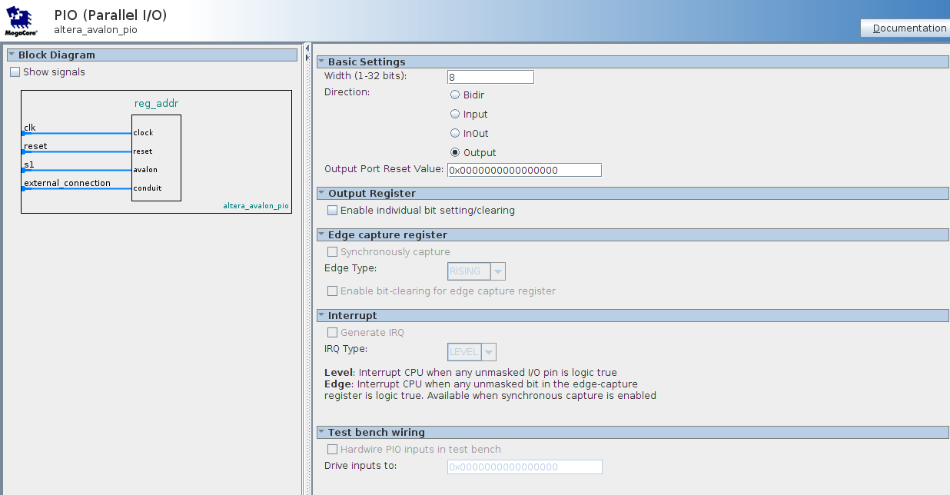

Figure B-25. reg_addr.
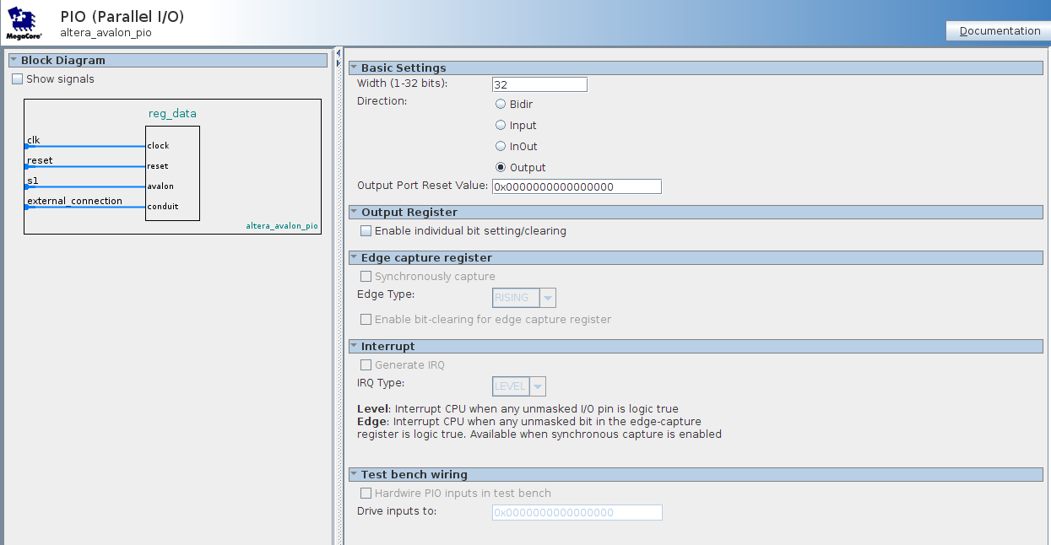

Figure B-26. reg_data.

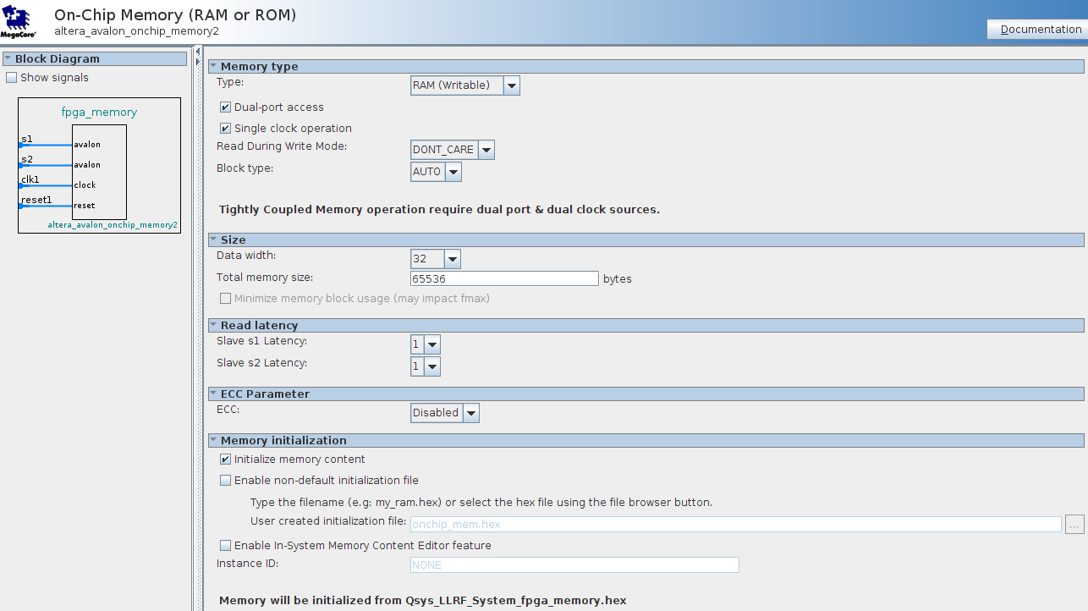

Figure B-27. fpga_memory.

Below is the C program that will run the NIOS CPU. The program initializes the scatter gather DMA’s and starts the data acquisition process. The program specifies how much data is transfered in each DMA and a callback it serviced when the DMA transfer is complete. The callback sends a signal to the FPGA through the use of the PIO’s (nios_data1_ready, nios_data2_ready) to signal the end of DMA transfer and to signal which data buffer is available.

/*
* LLRF Test System
*
* NIOS cpu program to initialize and start scatter gather DMA processes
*
* Ed Cullerton
* 10/10/2014
*
*/

#include <stdio.h>

// DMA transfer definitions
#include <altera_avalon_sgdma.h>
#include <altera_avalon_sgdma_descriptor.h>
#include <altera_avalon_sgdma_regs.h>

// Parrallel I/O definitions
#include "altera_avalon_pio_regs.h"

// DMA Descriptors when using allocated descriptor memory
#define DATA1_DMA_desc (*(alt_sgdma_descriptor *) (DESCRIPTOR1_BASE + 0x000))
#define DATA2_DMA_desc (*(alt_sgdma_descriptor *) (DESCRIPTOR2_BASE + 0x000))

// Scatter-Gather DMA Globals
alt_sgdma_dev *DATA1_DMA;
alt_sgdma_dev *DATA2_DMA;

// DMA write address
alt_u32 *DATA1_write_addr;
alt_u32 *DATA2_write_addr;

void DATA1_DMA_callback_function(void * context) {
// dma1 was processed
IOWR_ALTERA_AVALON_PIO_DATA(NIOS_DATA1_READY_BASE, 1);
IOWR_ALTERA_AVALON_PIO_DATA(NIOS_DATA2_READY_BASE, 0);
}

void DATA2_DMA_callback_function(void * context) {
// dma2 was processed
IOWR_ALTERA_AVALON_PIO_DATA(NIOS_DATA1_READY_BASE, 0);
IOWR_ALTERA_AVALON_PIO_DATA(NIOS_DATA2_READY_BASE, 1);
}

int main() {

// Initialize PIO’s
IOWR_ALTERA_AVALON_PIO_DATA(NIOS_DATA1_READY_BASE, 0);
IOWR_ALTERA_AVALON_PIO_DATA(NIOS_DATA2_READY_BASE, 0);

// Software reset DMA’s
IOWR_32DIRECT(DATA1_DMA_BASE, 16, 0x10000);
IOWR_32DIRECT(DATA2_DMA_BASE, 16, 0x10000);

// Open the CW streaming scatter-gather DMA controllers
DATA1_DMA = alt_avalon_sgdma_open("/dev/data1_dma");
if(DATA1_DMA == NULL)
printf("Could not open the CW SG-DMA1\n");

DATA2_DMA = alt_avalon_sgdma_open("/dev/data2_dma");
if(DATA2_DMA == NULL)
printf("Could not open the CW SG-DMA2\n");

// Set the initial write addresses for data transfers
DATA1_write_addr = (alt_u32 *)(DATA1_MEMORY_BASE);
DATA2_write_addr = (alt_u32 *)(DATA2_MEMORY_BASE);

// Set up the DATA1 descriptor
// The descriptor points back to itself for continuous operation
// The PARK bit of the control register must be set in order to re-use
// the descriptor (done in the callback registration)
alt_avalon_sgdma_construct_stream_to_mem_desc(&DATA1_DMA_desc, &DATA1_DMA_desc, DATA1_write_addr, 64000, 0);
// Set the OWNED_BY_HW bit to 1
DATA1_DMA_desc.control=128;

// Set up the DATA2 descriptor
// The descriptor points back to itself for continuous operation
// The PARK bit of the control register must be set in order to re-use
// the descriptor (done in the callback registration)
alt_avalon_sgdma_construct_stream_to_mem_desc(&DATA2_DMA_desc, &DATA2_DMA_desc, DATA2_write_addr, 64000, 0);
// Set the OWNED_BY_HW bit to 1
DATA2_DMA_desc.control=128;

alt_avalon_sgdma_register_callback(DATA1_DMA,
&DATA1_DMA_callback_function,
(ALTERA_AVALON_SGDMA_CONTROL_IE_GLOBAL_MSK |
ALTERA_AVALON_SGDMA_CONTROL_PARK_MSK |
ALTERA_AVALON_SGDMA_CONTROL_IE_DESC_COMPLETED_MSK |
ALTERA_AVALON_SGDMA_CONTROL_IE_CHAIN_COMPLETED_MSK ),
NULL);

alt_avalon_sgdma_register_callback(DATA2_DMA,
&DATA2_DMA_callback_function,
(ALTERA_AVALON_SGDMA_CONTROL_IE_GLOBAL_MSK |
ALTERA_AVALON_SGDMA_CONTROL_PARK_MSK |
ALTERA_AVALON_SGDMA_CONTROL_IE_DESC_COMPLETED_MSK |
ALTERA_AVALON_SGDMA_CONTROL_IE_CHAIN_COMPLETED_MSK ),
NULL);

// Start the Stream to Memory DMA engines
alt_avalon_sgdma_do_async_transfer(DATA1_DMA, &DATA1_DMA_desc);
alt_avalon_sgdma_do_async_transfer(DATA2_DMA, &DATA2_DMA_desc);

// Start the test data generator
IOWR_ALTERA_AVALON_PIO_DATA(NIOS_DATA1_READY_BASE, 1);

return 0;
}

Code Snip B-1. Nios CPU software.

The nios cpu memory is initialized with the above program. The following steps are to be taken to automatically include this file in the firmare compilation prosses during .sof generation.

Right click on your nios application project in the Nios Software IDE. Select ‘Make Targets’, then select ‘Build…’ as shown in Figure B-28a. Next double click on mem_init_generate as shown in figure B-28b. This will automatically generate the files needed at compile to to merge into the .sof file. This process will have to be repeated after any change made to the Nios program.

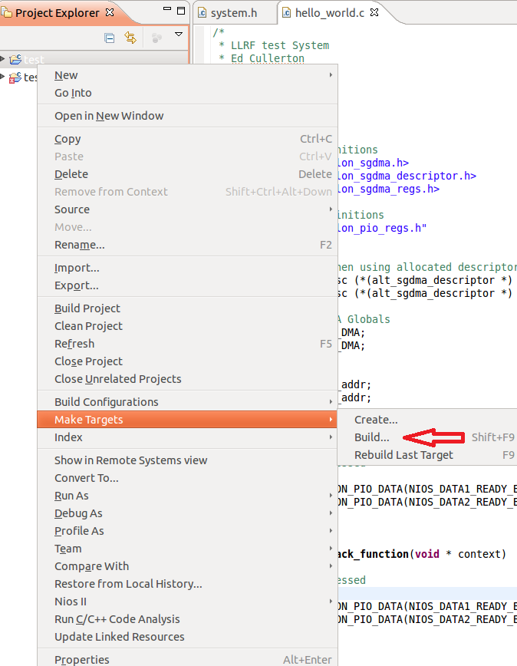

Figure B-28a. Memory initialization file building.

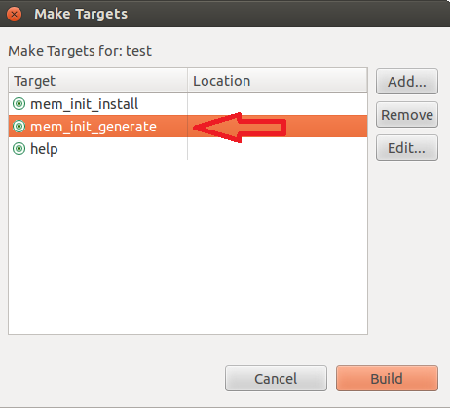

Figure B-28b. Memory initialization file building.

The last step is to add the memory initialization .qip file to the project so that Quartus knows about the files at compile time. In Quartus, under the menu ‘Project’, select ‘Add/Remove Files in Project…’. Browse to the project folder, in the ‘software‘ folder, under the software project folder in the mem_init folder, is the meminit.qip file. Add this file to your project. Now the Nios code will be incuded in the .sof file at compile time.

The programmable sample enable generator verilog code (divider.v) is shown below, followed by simulation results.

// Set the output enable n clock cycles
// Ed Cullerton
// 10/8/14
//
// Divide by n module.
// An enable output will strobe at the input clk divided by n.
//

module divider (
input wire clk_in,
input wire reset_n,
input reg [31:0] n,
output reg ena_out
);

reg [15:0] div;

always @(posedge clk_in or negedge reset_n)
begin
if (!reset_n) begin
ena_out <= 0;
div <= 0;
end
else begin
ena_out <= 0;
div = div + 1;
if ( (div >= n) && (n > 1) ) begin
div <= 0;
ena_out <= 1;
end
end
end
endmodule

Code Snip B-2. Programmable sample enable generator (divider.v).

The procedure to simulate the code is described below. For a reference, read the following tutorial on Modelsim:

ftp://ftp.altera.com/up/pub/Altera_Material/10.1/Tutorials/Using_ModelSim.pdf

Step one is to create a new folder called ‘MODELSIM’ in your ‘PROJECTS’ folder. In the MODELSIM folder, create another folder called ‘divider’. This is where your modelsim project will go. If you wish to create a folder called ‘LLRF verilog’, for example, you can store all your Verilog files for the project there.

Open Modelsim by typing the following command in a terminal:

$ cd ~/altera/13.1/modelsim_ase/bin
$ ./vsim

Create a project with the same name as the Verilog file, and the location is in your projects directory.
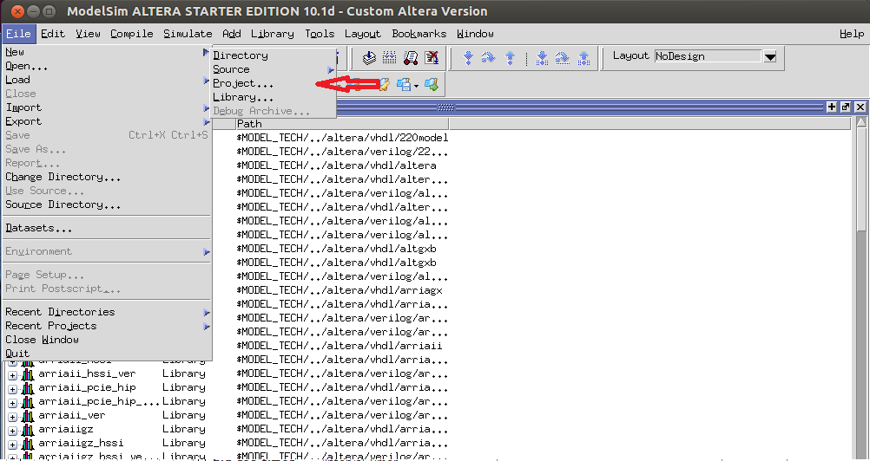

Figure B-29a. Create the new model sim project

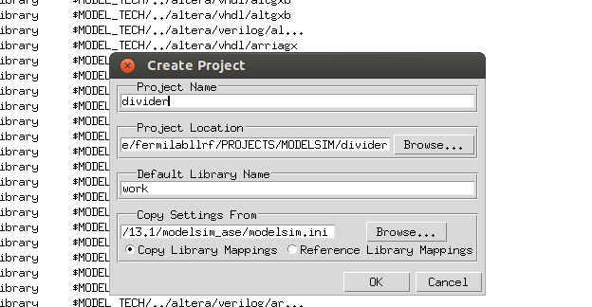

Figure B-29b. Give the project a name and select the ‘divider’ folder that was created.

Add the Verilog file to the project
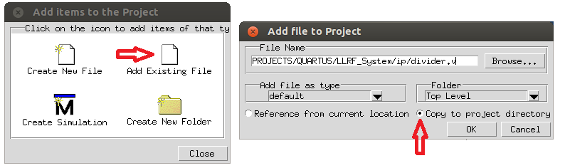

Figure B-30. Add the Verilog file to the project.
To create the test bench, select ‘Create New File’. Make the file name divider_tb.v, and make sure it is Verilog.

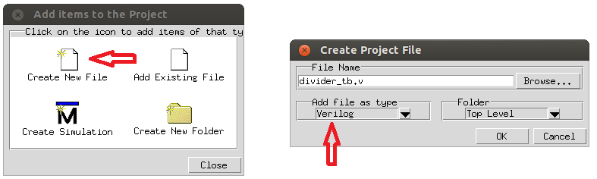

Figure B-31. Create a test bench for divider.v

Double click the divider_tb.v file to open it, and paste the code below in to create the test bench. Save the file.

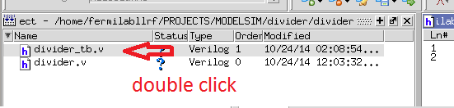

Figure B-32. Open the divider_tb.v file.

module divider_tb;
reg clk;
reg reset_n;
reg [31:0] n;
wire ena_out;

divider U0 (
.clk_in (clk),
.reset_n (reset_n),
.ena_out (ena_out),
.n (n)
);

initial
begin
clk = 0;
reset_n = 1;
n = 0;
end

always
#1 clk = ! clk;

initial
begin
#10 reset_n = 0;
#5 reset_n = 1;
#10 n = 10;
end
endmodule

Code Snip B-3. Test bench for divider.v (divider_tb.v).

Click compile all in the ‘Compile’ menu. There should be no errors. Next, click ‘Start Simulation…’ in the ‘Simulate’ menu. Select your divider_tb in the work directory, then click OK.

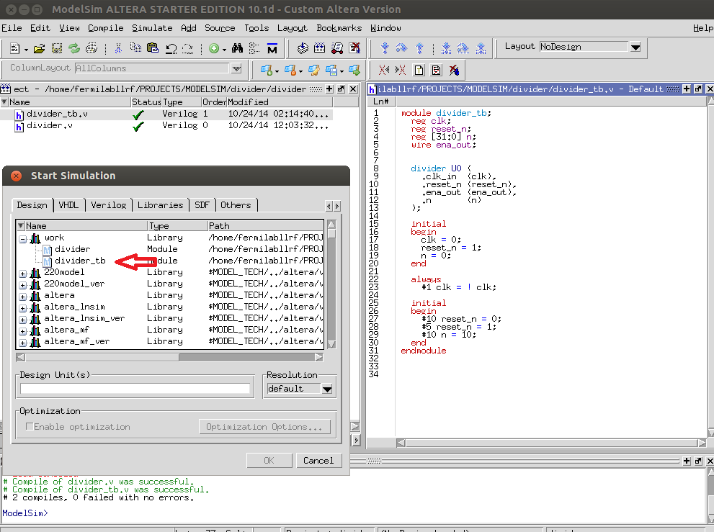

Figure B-33. Starting the simulation.

Next click on the wave window pane on the bottom of the screen, then right click on ‘divider_tb in the ‘Instance’ pane, and click add wave. The signals should be added to the wave pane.

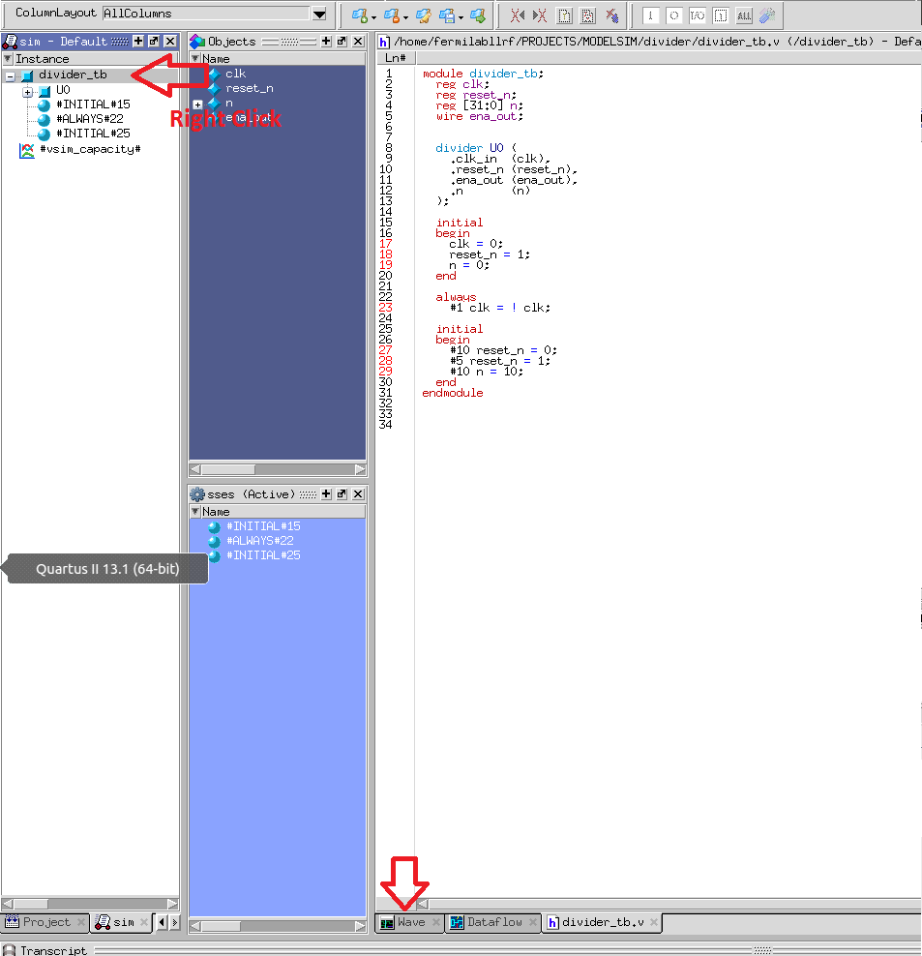

Figure B-34a. Adding the wave output to the simulation.
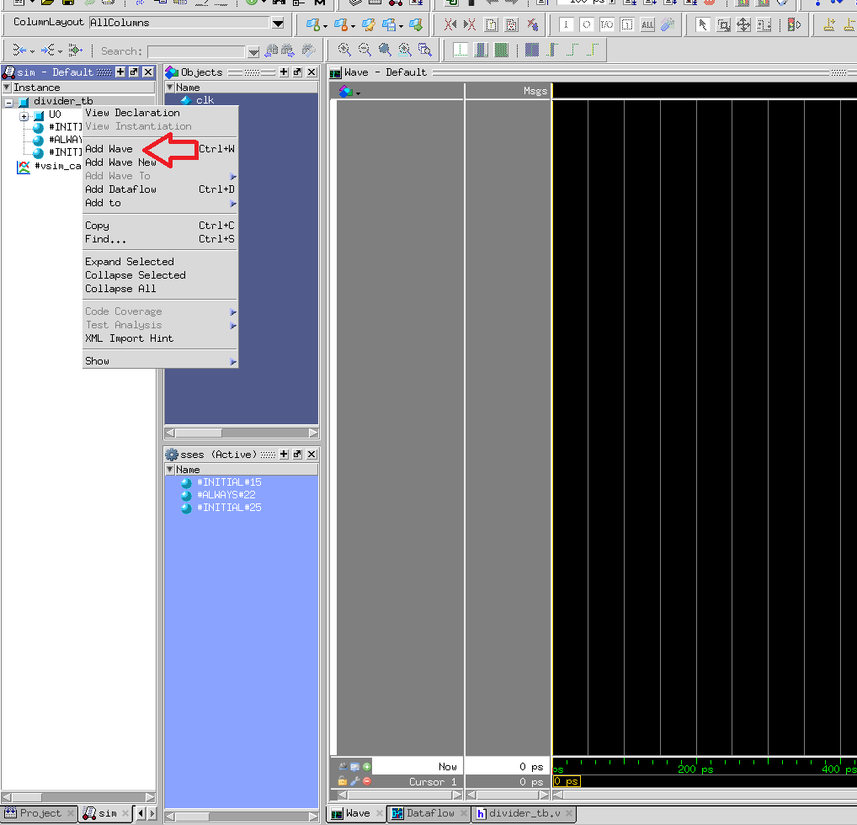

Figure B-34b. Adding the wave output to the simulation.

Hit F9 a few ties to step through 100 steps of the simulation at a time. Take a close look at the result and make sure it works correctly.

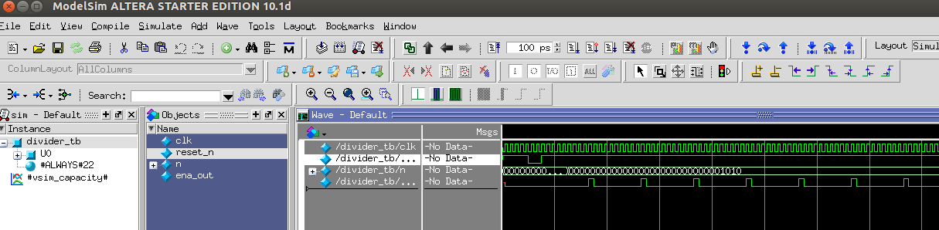

Figure B-35. Simulation results.

Below is the remaining verilog components of the system. The test bench is inculded along with the simulation results.

// Control Registers
// Ed Cullerton
// 10/8/14

// This module will move data on reg_data to the register specified by the reg_addr
// with a change in value of reg_addr. Valid ranges for reg_addr ar 1 - 16. A value of
// 0 for reg_addr is a 'reset' and should be set after each data move.

// Nios Software programming example... (reg_addr is initialized to 0)
//
// IOWR_ALTERA_AVALON_PIO_DATA(REG_DATA_BASE, 0x7); // put data on the line
// IOWR_ALTERA_AVALON_PIO_DATA(REG_ADDR_BASE, 0x1); // change the address to move the data
// IOWR_ALTERA_AVALON_PIO_DATA(REG_ADDR_BASE, 0x0); // reset the address back to zero

module registers
(
clk,
reset_n,
reg_addr,
reg_data,

r1_out,r2_out,r3_out,r4_out,r5_out,r6_out,r7_out,r8_out,
r9_out,r10_out,r11_out,r12_out,r13_out,r14_out,r15_out,r16_out
);

input clk;
input reset_n;
input [7:0] reg_addr;
input [31:0] reg_data;

output [31:0] r1_out;
output [31:0] r2_out;
output [31:0] r3_out;
output [31:0] r4_out;
output [31:0] r5_out;
output [31:0] r6_out;
output [31:0] r7_out;
output [31:0] r8_out;
output [31:0] r9_out;
output [31:0] r10_out;
output [31:0] r11_out;
output [31:0] r12_out;
output [31:0] r13_out;
output [31:0] r14_out;
output [31:0] r15_out;
output [31:0] r16_out;

reg [7:0] wr_addr;
reg [31:0] r1_out;
reg [31:0] r2_out;
reg [31:0] r3_out;
reg [31:0] r4_out;
reg [31:0] r5_out;
reg [31:0] r6_out;
reg [31:0] r7_out;
reg [31:0] r8_out;
reg [31:0] r9_out;
reg [31:0] r10_out;
reg [31:0] r11_out;
reg [31:0] r12_out;
reg [31:0] r13_out;
reg [31:0] r14_out;
reg [31:0] r15_out;
reg [31:0] r16_out;

always @(posedge clk or negedge reset_n) begin
if (!reset_n) begin
wr_addr <= 0;
r1_out <= 0;
r2_out <= 0;
r3_out <= 0;
r4_out <= 0;
r5_out <= 0;
r6_out <= 0;
r7_out <= 0;
r8_out <= 0;
r9_out <= 0;
r10_out <= 0;
r11_out <= 0;
r12_out <= 0;
r13_out <= 0;
r14_out <= 0;
r15_out <= 0;
r16_out <= 0;
end
else begin
if (wr_addr != reg_addr) begin
if (reg_addr == 1)
r1_out <= reg_data;
if (reg_addr == 2)
r2_out <= reg_data;
if (reg_addr == 3)
r3_out <= reg_data;
if (reg_addr == 4)
r4_out <= reg_data;
if (reg_addr == 5)
r5_out <= reg_data;
if (reg_addr == 6)
r6_out <= reg_data;
if (reg_addr == 7)
r7_out <= reg_data;
if (reg_addr == 8)
r8_out <= reg_data;
if (reg_addr == 9)
r9_out <= reg_data;
if (reg_addr == 10)
r10_out <= reg_data;
if (reg_addr == 11)
r11_out <= reg_data;
if (reg_addr == 12)
r12_out <= reg_data;
if (reg_addr == 13)
r13_out <= reg_data;
if (reg_addr == 14)
r14_out <= reg_data;
if (reg_addr == 15)
r15_out <= reg_data;
if (reg_addr == 16)
r16_out <= reg_data;

wr_addr <= reg_addr;
end
end
end
endmodule

Code Snip B-4. Verilog code for control registers (registers.v).

module registers_tb;
reg clk;
reg reset_n;
reg [7:0] reg_addr;
reg [31:0] reg_data;
wire [31:0] r1_out;
wire [31:0] r2_out;
wire [31:0] r3_out;

registers U0 (
.clk (clk),
.reset_n (reset_n),
.reg_addr (reg_addr),
.reg_data (reg_data),
.r1_out (r1_out),
.r2_out (r2_out),
.r3_out (r3_out)

);

initial
begin
clk = 0;
reset_n = 1;
end

always
#1 clk = ! clk;

initial
begin
#10 reset_n = 0;
#5 reset_n = 1;

#5 reg_addr = 0;
#5 reg_data = 12;
#5 reg_addr = 1;
#5 reg_addr = 0;
#5 reg_data = 321;
#5 reg_addr = 3;
#5 reg_addr = 0;
end
endmodule

Code Snip B-5. Test bench for registers.v (registers_tb.v).

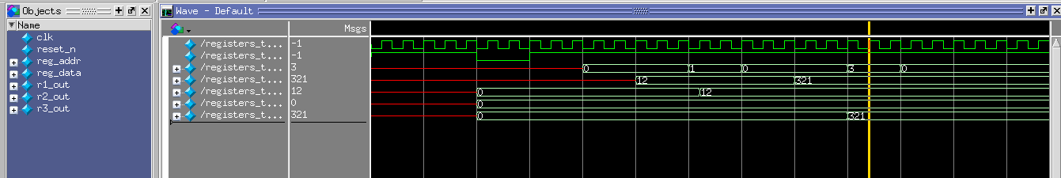

Figure B-36. Result of registers_tb.v simulation.

// Serialize 8 parallel data streams
// Ed Cullerton
// 10/8/14

module serializer
(
clk,
reset,
enable_in,
w0,
w1,
w2,
w3,
w4,
w5,
w6,
w7,
serial_out,
enable_out
);

input clk;
input reset;
input enable_in;
input [31:0] w0;
input [31:0] w1;
input [31:0] w2;
input [31:0] w3;
input [31:0] w4;
input [31:0] w5;
input [31:0] w6;
input [31:0] w7;
output [31:0] serial_out;
output enable_out;

wire clk;
wire reset;
wire enable_in;
wire [31:0] w0;
wire [31:0] w1;
wire [31:0] w2;
wire [31:0] w3;
wire [31:0] w4;
wire [31:0] w5;
wire [31:0] w6;
wire [31:0] w7;
reg [31:0] serial_out;
reg enable_out;
reg armed;
reg [5:0] count;

always @(posedge clk or negedge reset) begin
if (!reset) begin
serial_out <= 0;
enable_out <= 0;
count <= 0;
end
else begin
if (enable_out == 1) begin
if (count == 1)
serial_out <= w1;
if (count == 2)
serial_out <= w2;
if (count == 3)
serial_out <= w3;
if (count == 4)
serial_out <= w4;
if (count == 5)
serial_out <= w5;
if (count == 6)
serial_out <= w6;
if (count == 7)
serial_out <= w7;
if (count == 8)
enable_out <= 0;
count <= count + 1;
end

if (enable_in) begin
count <= 1;
enable_out <= 1;
serial_out <= w0;
end

end
end

endmodule

Code Snip B-6. Verilog code for data serialization (serializer.v).

module serializer_tb;
reg clk;
reg reset;
reg enable_in;
reg [31:0] w0;
reg [31:0] w1;
reg [31:0] w2;
reg [31:0] w3;
reg [31:0] w4;
reg [31:0] w5;
reg [31:0] w6;
reg [31:0] w7;
wire [31:0] serial_out;
wire enable_out;

serializer U0 (
.clk (clk),
.reset (reset),
.enable_in (enable_in),
.w0 (w0),
.w1 (w1),
.w2 (w2),
.w3 (w3),
.w4 (w4),
.w5 (w5),
.w6 (w6),
.w7 (w7),
.serial_out (serial_out),
.enable_out (enable_out)

);
initial
begin
clk = 0;
reset = 1;
end
always
#1 clk = ! clk;

initial
begin
#10 reset = 0;
#5 reset = 1;
w0 = 10;
w1 = 11;
w2 = 12;
w3 = 13;
w4 = 14;
w5 = 15;
w6 = 16;
w7 = 17;
#5 enable_in = 1;
#2 enable_in = 0;
end
endmodule

Code Snip B-7. Test bench for serializer.v (serializer_tb.v).

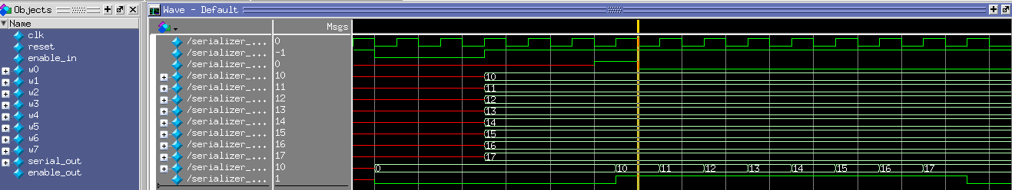

Figure B-37. Result of serializer_tb.v simulation.

// Generate some incremental data for test systems
// Ed Cullerton
// 10/8/14
//
// Incremented data will be placed on the output pins when it receives
// an input enable. The output enable will go high one clock cycle after
// data is placed on the output pins.
//

module data_generator
(
clk,
reset_n,
enable_in,
enable_out,
c0,
c1,
c2,
c3,
c4,
c5,
c6,
c7
);

input clk;
input reset_n;
input enable_in;
output enable_out;
output [31:0] c0;
output [31:0] c1;
output [31:0] c2;
output [31:0] c3;
output [31:0] c4;
output [31:0] c5;
output [31:0] c6;
output [31:0] c7;

reg enable_out;
reg [31:0] c0;
reg [31:0] c1;
reg [31:0] c2;
reg [31:0] c3;
reg [31:0] c4;
reg [31:0] c5;
reg [31:0] c6;
reg [31:0] c7;
reg [31:0] count;
reg enable_arm;

always @(posedge clk or negedge reset_n)
begin
if (!reset_n) begin
enable_out <= 0;
count <= 0;
enable_arm <= 0;
c0 <= 0;
c1 <= 0;
c2 <= 0;
c3 <= 0;
c4 <= 0;
c5 <= 0;
c6 <= 0;
c7 <= 0;
end
else begin

if(enable_arm) begin
enable_out <= 1;
enable_arm <= 0;
end else begin
enable_out <= 0;
end

if (enable_in) begin
c0 <= count;
c1 <= count + 1;
c2 <= count + 2;
c3 <= count + 3;
c4 <= count + 4;
c5 <= count + 5;
c6 <= count + 6;
c7 <= count + 7;
if ((count + 8) < 64000 )
count <= count + 8;
else
count <= 0;

enable_arm <= 1;
end
end
end
endmodule

Code Snip B-8. Verilog code for test data generator (data_generator.v).

Below is the Linux application.

/* SoC LLRF Test System
* Ed Cullerton
* Fermilab
* 10/2/14
*/

#include <stdio.h>
#include <unistd.h> // read()
#include <fcntl.h> // open()
#include "poll.h" // poll()
#include "arm_cpu.h" // QSYS components
#include "socal/hps.h" // ALT_STM_OFST, ALT_LWFPGASLVS_OFST
#include "socal/socal.h" // uint32_t, alt_read_word()
#include <sys/mman.h> // mmap()
#include <sys/types.h> // Ethernet libraries
#include <sys/socket.h> // Ethernet libraries
#include <arpa/inet.h> // Ethernet libraries
#include <netinet/in.h> // Ethernet libraries
#include <pthread.h> // Pthreads
#include "main.h"
#include "parameter.h"

// Module globals
struct Parameter_t Par_Obj[NUM_PARAMS+1];
int change_list[NUM_PARAMS+1]; // List of parameters changed by the control system
int update_idx; // Index for control system parameter update
char data_file[PARAM_DATA_FILE_SIZE]; // Data buffer for parameter data file
struct pollfd fdset1[1]; // poll function structure
struct pollfd fdset2[1]; // poll function structure
int fd_gpio1; // gpio file descriptor
int fd_gpio2; // gpio file descriptor
void *lw_bridge_base; // lightweight bridge base
void *fast_bridge_base; // fast bridge base
void *reg_addr_base; // FPGA register address pointer
void *reg_data_base; // FPGA register data pointer
void *data1_base; // Data buffer pointer
void *data2_base; // Data buffer pointer
int fd_mem; // memory map file descriptor
char *par_update_data[50];
bool connected; // labview connection
struct sockaddr_in my_addr, cli_addr; // UDP Server setup
int sockfd; // UDP Server setup
socklen_t slen=sizeof(cli_addr); // UDP Server setup

// ********** BEGIN - USER REGISTERED CALLBACK FUNCTIONS ***********
/* Collection of CHANGE, WRITE, and DAQ callback functions.
*
* !!!!!! Each callback MUST be registered in their associated function map in
* order for the parameter to link to the functions listed in the parameter data spreadsheet.
* The function maps are (located after the callback functions in this section of code)
*
* Int and Float parameters have a pointer to a CHANGE callback defined in the parameter data spreadsheet.
* The CHANGE callback function is executed when a parameter value is changed by a control
* system, or by other CHANGE callback functions. If any parameters are changed
* within a CHANGE callback, make sure to update all control system values to keep
* equivalence between the control system and local parameter values. All changes to other parameters
* made by CHANGE callbacks will be executed on the same trigger event.
*
* Int and Float parameters have a pointer to a WRITE callback defined in the parameter data spreadsheet.
* The write callback is executed if the writeFPGA flag is true (int).
* The value returned be the WRITE callback is the value written to the FPGA.
*
* Each parameter can have a DAQ callback. The DAQ callback is executed if the daq_callback flag is true. The DAQ
* callback is executed after all readings and settings have taken place. The input value to the DAQ callback is the
* value of the parameter after readings and settings. The output of the DAQ callback will update the local parameter
* value and update the control system value. If the parameter is an array, the input to the callback is the value and
* index, with the output being the new value of that index. If any parameters are changed
* within a DAQ callback, make sure to update all control system values to keep
* equivalence between the control system and local parameter values. Changes made
* within the DAQ callbacks will be processed on the next DAQ trigger event.
*/

// Integer CHANGE callbacks
void int_CHANGE_cb_empty(int value) {
//empty
return;
}

// Integer WRITE/DAQ callbacks
int int_WRITE_cb_Passthrough(int value) {
// This function makes no changes to the value of the parameter
return (value);
}

// Integer WRITE/DAQ callbacks
int int_WRITE_cb_SampleRate(int value) {
// This function calculates a divide ratio for the divide by n module
// from the FPGA clock frequency and the requested sample rate
int newValue = 50000000 / value;
return (newValue);
}

// Float CHANGE callbacks
void flt_CHANGE_cb_empty(float value){
//empty
return;
}

// Float WRITE/DAQ callbacks
float flt_WRITE_cb_Passthrough(float value) {
// This function makes no changes to the value of the parameter
return (value);
}
// ********** END - USER REGISTERED CALLBACK FUNCTIONS ***********

// pthread for send the buffered memory to Labview
void *UDP_Sender( void *ptr) {

int rv; // Return value for interrupt
char int_buf[2]; // read() buffer for interrupt
int chg_idx=0; // Loop control index for setting callback parameter changes
int change_executed=0; // Index to keep track of which change callbacks have been executed
int intWriteBuffer; // Buffer to store processed parameters values to write to the crate
float fltWriteBuffer; // Buffer to store processed parameters values to write to the crate
int lcv; // loop control variables

// Wait for Labview to connect
while(!connected){}

// Start the data sample
alt_clrbits_word( reg_addr_base, 0xFF );
alt_clrbits_word( reg_data_base, 0xFFFFFFFF );
alt_setbits_word( reg_data_base, 5000);
alt_setbits_word( reg_addr_base, 1 );
alt_clrbits_word( reg_addr_base, 0xFF );

while(connected) {
// Block endlessly and wait for interrupt 1
rv = read(fdset1[0].fd, int_buf, sizeof(int_buf));
rv = poll(fdset1, 1, -1);

// Loop through the change list and execute all change callbacks
change_executed=0;
while (change_executed < change_list[0]) {
change_executed++;
if (Par_Obj[ change_list[change_executed] ].type == INT)
Par_Obj[ change_list[change_executed] ].int_CHANGE_cb(Par_Obj[ change_list[change_executed] ].intValue);

if (Par_Obj[change_list[change_executed]].type==FLOAT)
Par_Obj[ change_list[change_executed] ].flt_CHANGE_cb(Par_Obj[ change_list[change_executed] ].fltValue);
}

// Loop through the change list and write data to the FPGA
for (chg_idx=1; chg_idx <= change_list[0]; chg_idx++) {
// Write parameters to the FPGA that have the writeFPGA flag on
if (Par_Obj[ change_list[chg_idx] ].writeFPGA) {
if (Par_Obj[ change_list[chg_idx] ].type == INT) {
// Write the return value of the write callback function to the FPGA
intWriteBuffer=Par_Obj[ change_list[chg_idx] ].int_WRITE_cb(Par_Obj[ change_list[chg_idx] ].intValue);
alt_clrbits_word( reg_addr_base, 0xFF );
alt_clrbits_word( reg_data_base, 0xFFFFFFFF );
alt_setbits_word( reg_data_base, *(uint32_t*)&intWriteBuffer);
alt_setbits_word( reg_addr_base, Par_Obj[ change_list[chg_idx] ].FPGAaddress );
alt_clrbits_word( reg_addr_base, 0xFF );
}//endif INT
if (Par_Obj[ change_list[chg_idx] ].type == FLOAT) {
// Write the return value of the write callback function to the FPGA
fltWriteBuffer=Par_Obj[ change_list[chg_idx] ].flt_WRITE_cb(Par_Obj[ change_list[chg_idx] ].fltValue);
alt_clrbits_word( reg_addr_base, 0xFF );
alt_clrbits_word( reg_data_base, 0xFFFFFFFF );
alt_setbits_word( reg_data_base, *(uint32_t*)&fltWriteBuffer);
alt_setbits_word( reg_addr_base, Par_Obj[ change_list[chg_idx] ].FPGAaddress );
alt_clrbits_word( reg_addr_base, 0xFF );
}//endif INT
printf("Parameter %s written to FPGA register %x\n", Par_Obj[ change_list[chg_idx] ].name, Par_Obj[ change_list[chg_idx] ].FPGAaddress);
}//endif writeFPGA
}//endfor chg_idx
change_list[0]=0;

// Update array data HERE if needed

sendto(sockfd, data1_base, 64000 + update_idx, 0, (struct sockaddr*)&cli_addr, slen);

update_idx=0;

// Block endlessly and wait for interrupt 2
rv = read(fdset2[0].fd, int_buf, sizeof(int_buf));
rv = poll(fdset2, 1, -1);

// Update array data HERE if needed

sendto(sockfd, data2_base, 64000, 0, (struct sockaddr*)&cli_addr, slen);
}
}

// pthread for receiving commands
void *UDP_Receiver( void *ptr)
{
char buf[BUFLEN];
uint32_t rec_value;
char rec_name[20];
int divide_ratio;
int par_idx;
int do_not_change;
int loop;
int lcv;

// Wait for start command from labview
printf( "Please make sure Nios software is running...\n");
printf( "Waiting for Labview to start....\n" );
recvfrom(sockfd, buf, BUFLEN, 0, (struct sockaddr*)&cli_addr, &slen);
printf("\nReceived Labview start command %s from %s:%d\n", buf, inet_ntoa(cli_addr.sin_addr), ntohs(cli_addr.sin_port));
connected = true;
memset(buf, 0x00, sizeof(buf));

while(connected)
{
// Wait for commands from labview
// The received packet is a value (32 bit word) followed by a char name
recvfrom(sockfd, buf, BUFLEN, 0, (struct sockaddr*)&cli_addr, &slen);
// Check for program termination
if (strcmp(buf, "stop") == 0 )
connected=false;
// Convert the value data into uint32_t (first 4 bytes/32 bit word)
rec_value = buf[3] + (buf[2] << 8) + (buf[1] << 16) + (buf[0] << 24);

// Copy the chars of the name received from Labview
for (lcv=0; lcv<20; lcv++)
rec_name[lcv]=buf[lcv+4];

// Set the do not add to the change list until the parameter is determined valid
do_not_change=1;
// find the parameter by name
for (par_idx=1; par_idx<=NUM_PARAMS; par_idx++)
if (strcmp(rec_name, Par_Obj[par_idx].name ) == 0 ){
// Update the parameter with the value if within bounds
if (Par_Obj[par_idx].type == INT)
if ( (*(int*)&rec_value >= Par_Obj[par_idx].intMin ) && (*(int*)&rec_value <= Par_Obj[par_idx].intMax )) {
Par_Obj[par_idx].intValue = *(int*)&rec_value;
printf("\nReceived Labview name: %s, int value = %d\n", rec_name, Par_Obj[par_idx].intValue);
do_not_change=0; // allow the parameter to be added to the change list
}
else { // reject the change and update the labview interface to previous value
printf("\nReceived Labview name: %s, int value = %d OUT OF BOUNDS!\n", rec_name, *(int*)&rec_value);

loop=0;
// Set the name of the changed parameter
while (Par_Obj[par_idx].name[loop] != NULL)
*par_update_data[update_idx++]= Par_Obj[par_idx].name[loop++];

// Put the value in the next 4 bytes
*par_update_data[ update_idx++ ] = ((*(uint32_t*)&Par_Obj[par_idx].intValue) >> 24) & 0xFF;
*par_update_data[ update_idx++ ] = ((*(uint32_t*)&Par_Obj[par_idx].intValue) >> 16) & 0xFF;
*par_update_data[ update_idx++ ] = ((*(uint32_t*)&Par_Obj[par_idx].intValue) >> 8) & 0xFF;
*par_update_data[ update_idx++ ] = (*(uint32_t*)&Par_Obj[par_idx].intValue) & 0xFF;
}

if (Par_Obj[par_idx].type == FLOAT)
if ( (*(float*)&rec_value >= Par_Obj[par_idx].fltMin ) && (*(float*)&rec_value <= Par_Obj[par_idx].fltMax )) {
Par_Obj[par_idx].fltValue = *(float*)&rec_value;
printf("\nReceived Labview name: %s, flt value = %f\n", rec_name, Par_Obj[par_idx].fltValue);
do_not_change=0; // allow the parameter to be added to the change list
}
else { // reject the change, update the labview interface to previous value
printf("\nReceived Labview name: %s, flt value = %f OUT OF BOUNDS!\n", rec_name, *(float*)&rec_value);

loop=0;
// Set the name of the changed parameter
while (Par_Obj[par_idx].name[loop] != NULL)
*par_update_data[update_idx++]= Par_Obj[par_idx].name[loop++];

// Put the value in the next 4 bytes
*par_update_data[ update_idx++ ] = ((*(uint32_t*)&Par_Obj[par_idx].fltValue) >> 24) & 0xFF;
*par_update_data[ update_idx++ ] = ((*(uint32_t*)&Par_Obj[par_idx].fltValue) >> 16) & 0xFF;
*par_update_data[ update_idx++ ] = ((*(uint32_t*)&Par_Obj[par_idx].fltValue) >> 8) & 0xFF;
*par_update_data[ update_idx++ ] = (*(uint32_t*)&Par_Obj[par_idx].fltValue) & 0xFF;
}

// Check overwriting the bounds of the change_list.
if ( (change_list[0] <= NUM_PARAMS) && (do_not_change == 0) ) {
// Prevent a parameter from being on the change list multiple times
for (lcv = 1; lcv <= (change_list[0]); lcv++)
if (change_list[lcv] == par_idx)
do_not_change=1;

// parameter is valid, update the change list
if (do_not_change == 0) {
change_list[0]++; // element 0 is the number of changed parameter in the current trigger cycle
change_list[change_list[0]]=par_idx; // element 1 and up are the list of parameter index numbers that have changed
}
}
}

printf("Change list: %d, %d, %d\n", change_list[0], change_list[1], change_list[2] );
printf("Update index: %d\n", update_idx );
// Use memset command to set all zeros to buffer
memset(buf, 0x00, sizeof(buf));
}
}

int main() {
int par_idx;
int loop;
int lcv;

// Setup UDP sockets
sockfd=socket(AF_INET, SOCK_DGRAM, IPPROTO_UDP);
bzero(&my_addr, sizeof(my_addr));
my_addr.sin_family = AF_INET;
my_addr.sin_port = htons(PORT);
my_addr.sin_addr.s_addr = htonl(INADDR_ANY);
bind(sockfd, (struct sockaddr* ) &my_addr, sizeof(my_addr));

// Create threads
pthread_t thread1,thread2;
const char *message1 = "Thread 1";
const char *message2 = "Thread 2";

printf( "Fermilab LLRF System test....\n" );

// ******** BEGIN - MEMORY MAPPING ********

if( -1 == ( fd_mem = open( "/dev/mem", ( O_RDWR | O_SYNC )))) {
printf( "ERROR: Failed to open \"/dev/mem\"...\n" );
return( -1 );
}
printf( "Main memory mapped.\n" );

// Point to the lightweight bridge memory
if( MAP_FAILED == (lw_bridge_base = mmap( NULL, HW_REGS_SPAN, ( PROT_READ | PROT_WRITE ), MAP_SHARED, fd_mem, HW_REGS_BASE )) ) {
printf( "ERROR: LW bridge mmap() failed...\n" );
close( fd_mem );
return( -1 );
}
printf( "Lightweight bridge memory mapped.\n" );

// Point to the fast bridge memory
if( MAP_FAILED == (fast_bridge_base = mmap( NULL, HW_FPGA_AXI_SPAN, ( PROT_READ | PROT_WRITE ), MAP_SHARED, fd_mem, ALT_AXI_FPGASLVS_OFST )) ) {
printf( "ERROR: LW bridge mmap() failed...\n" );
close( fd_mem );
return( -1 );
}
printf( "Fast bridge memory mapped.\n" );

// Memory base for Labview parameter updates
for (lcv=0; lcv<50; lcv++)
par_update_data[lcv] = ( fast_bridge_base + ( ( uint32_t )( ALT_AXI_FPGASLVS_OFST + DATA1_MEMORY_BASE + 64000 + lcv) & ( uint32_t )( HW_FPGA_AXI_MASK ) ) );

// Memory base of waveform buffer
data1_base = ( fast_bridge_base + ( ( uint32_t )( ALT_AXI_FPGASLVS_OFST + DATA1_MEMORY_BASE) & ( uint32_t )( HW_FPGA_AXI_MASK ) ) );
data2_base = ( fast_bridge_base + ( ( uint32_t )( ALT_AXI_FPGASLVS_OFST + DATA2_MEMORY_BASE) & ( uint32_t )( HW_FPGA_AXI_MASK ) ) );

// Memory base of data registers
reg_addr_base = ( lw_bridge_base + ( ( uint32_t )( ALT_LWFPGASLVS_OFST + REG_ADDR_BASE ) & ( uint32_t )( HW_REGS_MASK ) ) );
reg_data_base = ( lw_bridge_base + ( ( uint32_t )( ALT_LWFPGASLVS_OFST + REG_DATA_BASE ) & ( uint32_t )( HW_REGS_MASK ) ) );

// ******** END - MEMORY MAPPING ********

// Create the arm_data1_ready trig interrupt 'value' file descriptor
if ((fd_gpio1 = open( "/sys/class/gpio/gpio159/value" , O_RDONLY | O_NONBLOCK )) < 0) {
printf( "ERROR: Failed to create arm_trig interrupt...\n");
return(-1);
}
printf( "Interrupt for arm_data1_ready created.\n" );

// Create the arm_data2_ready trig interrupt 'value' file descriptor
if ((fd_gpio2 = open( "/sys/class/gpio/gpio158/value" , O_RDONLY | O_NONBLOCK )) < 0) {
printf( "ERROR: Failed to create arm_trig interrupt...\n");
return(-1);
}
printf( "Interrupt for arm_data2_ready created.\n" );

// Setup the polling system
fdset1[0].fd = fd_gpio1;
fdset1[0].events = POLLPRI|POLLERR;
fdset2[0].fd = fd_gpio2;
fdset2[0].events = POLLPRI|POLLERR;

// ******** BEGIN - LOAD PARAMETER DATA ********
// !!!This section will be replaced be a function to load the parameter data from a spreadsheet
strcpy(Par_Obj[1].name, "SampleRate");
Par_Obj[1].intValue = 10000;
Par_Obj[1].intMax = 300000;
Par_Obj[1].intMin = 1000;
Par_Obj[1].type = INT;
Par_Obj[1].int_CHANGE_cb=int_CHANGE_cb_empty;
Par_Obj[1].int_WRITE_cb=int_WRITE_cb_SampleRate;
Par_Obj[1].writeFPGA = true;
Par_Obj[1].FPGAaddress=0x1;

strcpy(Par_Obj[2].name, "floater");
Par_Obj[2].fltValue = 10.5;
Par_Obj[2].fltMax = 20;
Par_Obj[2].fltMin = 0;
Par_Obj[2].type = FLOAT;
Par_Obj[2].flt_CHANGE_cb=flt_CHANGE_cb_empty;
Par_Obj[2].flt_WRITE_cb=flt_WRITE_cb_Passthrough;
Par_Obj[2].writeFPGA = true;
Par_Obj[2].FPGAaddress=0x2;
// ******** END - LOAD PARAMETER DATA ********

// ******** BEGIN - LOAD DEFAULT VALUES TO FPGA ********
change_list[0]=0;
update_idx=0;
for (par_idx=1; par_idx<=NUM_PARAMS; par_idx++){
if (Par_Obj[par_idx].writeFPGA) {
change_list[0]++;
change_list[change_list[0]]=par_idx;
}

loop=0;
// Set the name of the changed parameter
while (Par_Obj[par_idx].name[loop] != NULL)
*par_update_data[update_idx++]= Par_Obj[par_idx].name[loop++];

// Put the value in the next 4 bytes
if (Par_Obj[par_idx].type == INT ) {
*par_update_data[ update_idx++ ] = ((*(uint32_t*)&Par_Obj[par_idx].intValue) >> 24) & 0xFF;
*par_update_data[ update_idx++ ] = ((*(uint32_t*)&Par_Obj[par_idx].intValue) >> 16) & 0xFF;
*par_update_data[ update_idx++ ] = ((*(uint32_t*)&Par_Obj[par_idx].intValue) >> 8) & 0xFF;
*par_update_data[ update_idx++ ] = (*(uint32_t*)&Par_Obj[par_idx].intValue) & 0xFF;
}
if (Par_Obj[par_idx].type == FLOAT ) {
*par_update_data[ update_idx++ ] = ((*(uint32_t*)&Par_Obj[par_idx].fltValue) >> 24) & 0xFF;
*par_update_data[ update_idx++ ] = ((*(uint32_t*)&Par_Obj[par_idx].fltValue) >> 16) & 0xFF;
*par_update_data[ update_idx++ ] = ((*(uint32_t*)&Par_Obj[par_idx].fltValue) >> 8) & 0xFF;
*par_update_data[ update_idx++ ] = (*(uint32_t*)&Par_Obj[par_idx].fltValue) & 0xFF;
}
}
// ******** END - LOAD DEFAULT VALUES TO FPGA ********

// Debugging...
printf("Change list: %d, %d, %d\n", change_list[0], change_list[1], change_list[2] );
printf("Update index: %d\n", update_idx );

// Start threads passing it one argument
int iret1= pthread_create( &thread1, NULL, UDP_Sender, (void*) message1);
printf( "UDP Sender thread started.\n" );
int iret2= pthread_create( &thread2, NULL, UDP_Receiver, (void*) message2);
printf( "UDP Receiver thread started.\n" );

// Wait until threads are done and terminated
pthread_join( thread1, NULL );
printf("UDP Sender thread complete: %d\n", iret1);
pthread_join( thread2, NULL );
printf("UDP Receiver thread complete: %d\n", iret2);

// Clean up our memory mapping and exit
munmap( lw_bridge_base, HW_REGS_SPAN );
munmap( fast_bridge_base, HW_FPGA_AXI_SPAN );
close( fd_mem );
close( fd_gpio1 );
close( fd_gpio2 );
printf("Memory maps and interrupt file descriptors closed successfully.\n", iret2);
printf("LLRF System shut down.\n");
return( 0 );
}

Code Snip B-9. Linux application for LLRF data acquisition system.

Below is the Labview application for the LLRF test system.

Figure B-38. Labview front panel application.

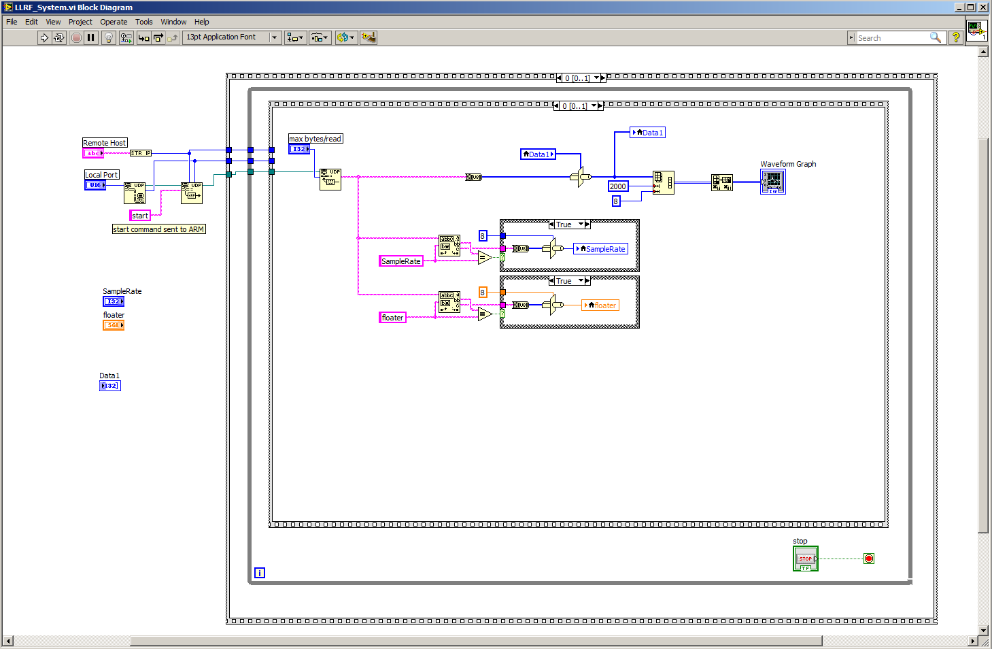

Figure B-39a. Labview block diagram.

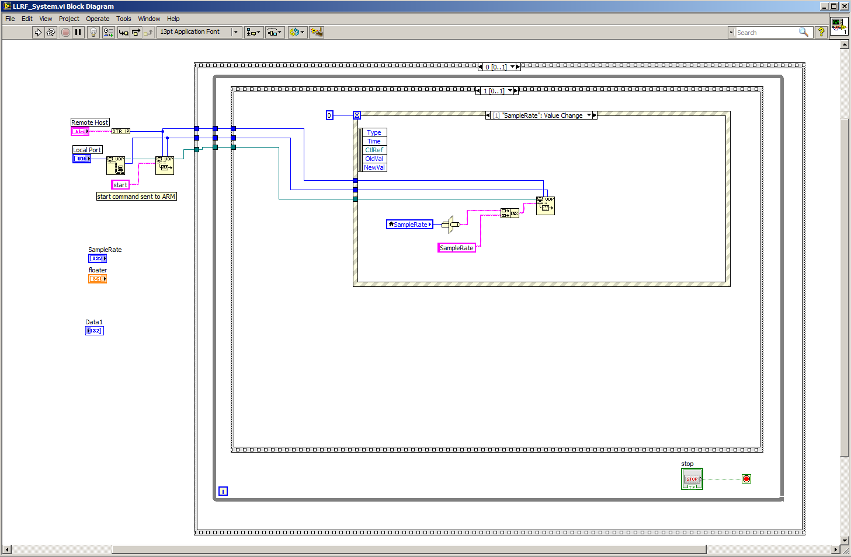

Figure B-39b. Labview block diagram.

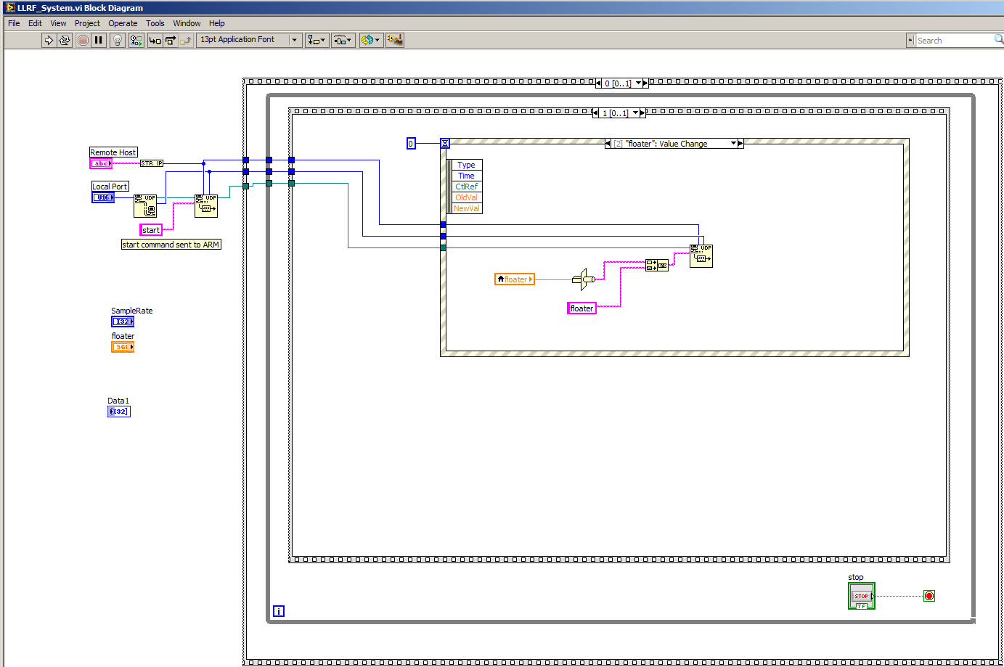

Figure B-39c. Labview block diagram.
List Of Figures

Figure 3-1. Converting .sof FPGA firmware file type to .rbf file for SD card.
Figure 3-2. Configuring gtkterm serial port.
Figure 4-1. Secondary ethernet port setup.
Figure 4-2. Eclipse environment with Linux application program and Makefile setup.
Figure 4-3. Remote System perspective in Eclispe.
Figure 4-4a. Ethernet debugging Configuration.
Figure 4-4b. Ethernet debugging Configuration.
Figure 4-5. Ethernet debugging perspective in Eclipse.
Figure 6-1. Creating a symbol file from a Verilog file.
Figure 6-2. Timequest configuration and running.
Figure 6-3. Qsys PIO configuration.
Figure 6-5. Qsys configuration after adding PIO.
Figure 6-6. Adding input PIO to the Qsys system for receiving interrupts.
Figure 6-7. Asys configuration after adding PIO interrupt receiver.
Figure 6-8. Verilog example generated by Qsys.
Figure 6-9a. Modify the ghrd_top.v file to instatiate the new qsys components.
Figure 6-9b. Modify the ghrd_top.v file to instatiate the new qsys components.
Figure 6-10. Top level block diagram of the FPGA system.
Figure 6-11. Configuring the push buttons for generating an interrupt.
Figure 6-12. Receiving the interrupt acknowledgment from the Linux application.
Figure 6-13. Signal Tap node finder.
Figure 6-14. Signal Tap configuration.
Figure 6-15. Signal Tap test results.
Figure 7-1. Qsys configuration for Nios cpu based system.
Figure 7-1. Top level block diagram of the nios based system.
Figure 7-3. Lines that need to be removed from the soc_system_board_info.xml file.
Figure 7-4. Opening the Nios Software Build Tools
Figure 7-5a. Creating a Nios project from a template.
Figure 7-5b. Creating a Nios project from a template.
Figure 7-6. Nios project in the Nios eclipse IDE.
Figure 7-7. Editing the Nios BSP (Board Support Package).
Figure 7-8. Configuring the timers in the bsp editor.
Figure 7-9. Building the bsp project.
Figure 7-10. Building the latency test project.
Figure 7-11. Running the Nios application.
Figure 7-12. Nios Console after the nios program has loaded and run.
Figure 7-13a. Configuring the run configuration with the SoCkit connection.
Figure 7-13b. Configuring the run configuration with the SoCkit connection.
Figure 7-14. Nios console showing the received interrupts.
Figure 7-15a. Labview application.
Figure 7-15b. Labview application.
Figure 7-15c. Labview application.
Figure 7-15d. Labview application.
Figure 8-1a. Block Diagram of the LLRF Data Acquisition System.
Figure 8-1b. Complete top level block diagram of the basic system.
Figure 8-2. Details of the important Qsys inputs and outputs.
Figure 8-3. Qsys system.
Figure 8-4. Close up of the programmable sample enable generator, test data generator, serializer, registers, and other signal control components.
Figure 8-5. Labview test application.
Figure A-1. Qsys configuration.
Figure A-2. hps_0/FPGA Interfaces.
Figure A-3. hps_0/Peripheral Pin Multiplexing.
Figure A-5. hps_0/HPS Clocks.
Figure A-6. hps_0/SDRAM/PHY Settings.
Figure A-7. hps_0/SDRAM/Memory Parameters.
Figure A-8. hps_0/SDRAM/Memory Timing.
Figure A-9. hps_0/SDRAM/Board Settings.
Figure A-10. nios_memory on-chip memory.
Figure A-11. nios_cpu/Core NIOS II
Figure A-12. nios_timer timer.
Figure A-13. high_res_timer timer.
Figure A-14. arm_data PIO.
Figure A-15. nios_data PIO.
Figure A-16. arm_trig PIO.
Figure A-17. nios_trig PIO.
Figure A-18. shared_memory on-chip memory.
Figure B-1. Complete block diagram of the LLRF DAQ test system.
Figure B-2. Qsys configuration.
Figure B-3. arm_cpu/FPGA Interfaces.
Figure B-4. arm_cpu/Peripheral Pin Multiplexing.
Figure B-5. arm_cpu/HPS Clocks.
Figure B-6. arm_cpu/SDRAM/PHY Settings
Figure B-7. arm_cpu/SDRAM/Memory Parameters.
Figure B-8. arm_cpu/SDRAM/Memory Timing.
Figure B-9. arm_cpu/SDRAM/Board Settings.
Figure B-10. nios_cpu/Core NIOS II.
Figure B-11. nios_cpu/Caches and Memory Interfaces.
Figure B-12. nios_cpu/Advanced Features.
Figure B-13. nios_cpu/MMU and MPU Settings
Figure B-14. nios_cpu/JTAG Debug Module.
Figure B-16. nios_timer.
Figure B-17. high_res_timer.
Figure B-18. jtag_uart.
Figure B-19. nios_data1_ready and nios_data2_ready.
Figure B-20. arm_data1_ready and arm data2_ready.
Figure B-21. data1_dma and data2_dma.
Figure B-22. data1_memory and data2_memory.
Figure B-23. descriptor1 and descriptor2.
Figure B-24. sysid.
Figure B-25. reg_addr.
Figure B-26. reg_data.
Figure B-27. fpga_memory.
Figure B-28a. Memory initialization file building.
Figure B-28b. Memory initialization file building.
Figure B-29a. Create the new model sim project
Figure B-29b. Give the project a name and select the ‘divider’ folder that was created.
Figure B-30. Add the Verilog file to the project.
Figure B-31. Create a test bench for divider.v
Figure B-32. Open the divider_tb.v file.
Figure B-33. Starting the simulation.
Figure B-34a. Adding the wave output to the simulation.
Figure B-34b. Adding the wave output to the simulation.
Figure B-35. Simulation results.
Figure B-36. Result of registers_tb.v simulation.
Figure B-37. Result of serializer_tb.v simulation.
Figure B-38. Labview front panel application.
Figure B-39a. Labview block diagram.
Figure B-39b. Labview block diagram.
Figure B-39c. Labview block diagram.

List of Code Snips
Code Snip 4-1. Linux test program for turning blinking LED’s.
Code Snip 4-2. Linux C application Makefile.
Code Snip 5-1. Linux C application to test interrupts.
Code Snip 6-1. Constraints file edit.
Code Snip 6-2. Linux application to test round trip latency.
Code Snip 6-3. Adding Ethernet UDP pack sending to the Linux application.
Code Snip 7-1. Nios application to handle interrupts.
Code Snip 7-2. Linux application to receive interrupt.
Code Snip 7-3. Linux application for latency testing.
Code Snip 7-4. Nios application for latency testing.
Code Snip 8-1. Startup script (/etc/init.d/LLRF_startup.sh).
Code Snip 8-2. Configure the Ethernet (/etc/network/interfaces).
Code Snip A-1. The ghrd_top. File used to instatiate the SYS system.
Code Snip B-1. Nios CPU software.
Code Snip B-2. Programmable sample enable generator (divider.v).
Code Snip B-3. Test bench for divider.v (divider_tb.v).
Code Snip B-4. Verilog code for control registers (registers.v).
Code Snip B-5. Test bench for registers.v (registers_tb.v).
Code Snip B-6. Verilog code for data serialization (serializer.v).
Code Snip B-7. Test bench for serializer.v (serializer_tb.v).
Code Snip B-8. Verilog code for test data generator (data_generator.v).
Code Snip B-9. Linux application for LLRF data acquisition system.

