How to set up Doxygen for DS-5 on Windows
Ed Cullerton
5/3/2016

Download and install Doxygen on your PC. Follow the link below to get the latest version of Doxygen.
http://www.stack.nl/~dimitri/doxygen/
Start DS-5 and install the Eclox frontend plugin. (plug in for doxygen) Go to “Help -> Install new software”. Add the Eclox repository by clicking on the “Add…” button. Call the repository Eclox, and the location is http://download.gna.eclox.update.
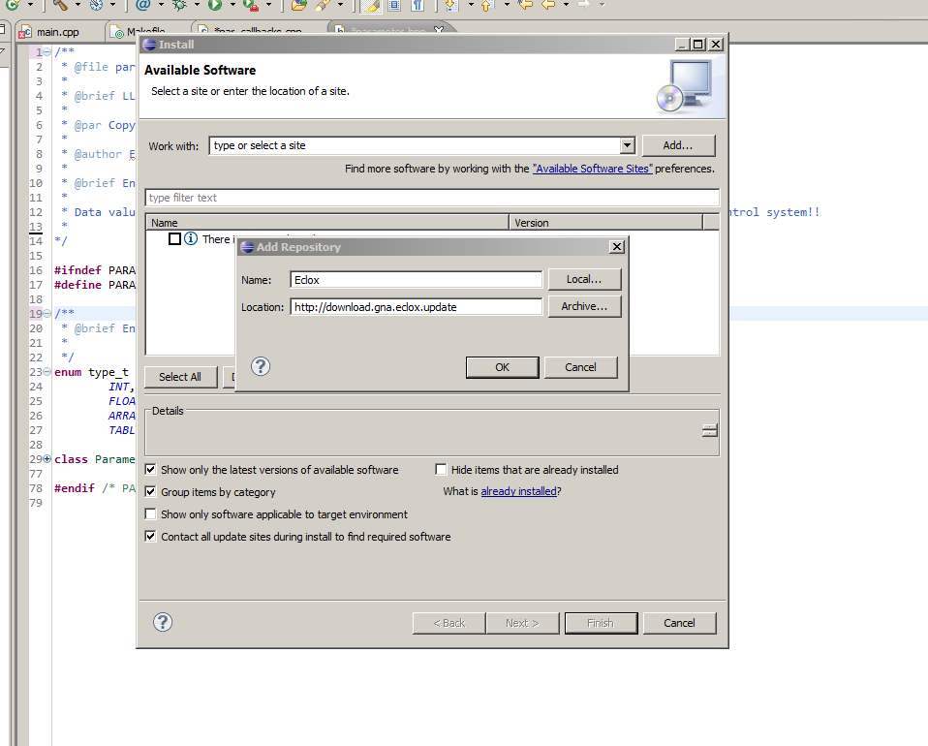
Check the Eclox boxes software and install the software.
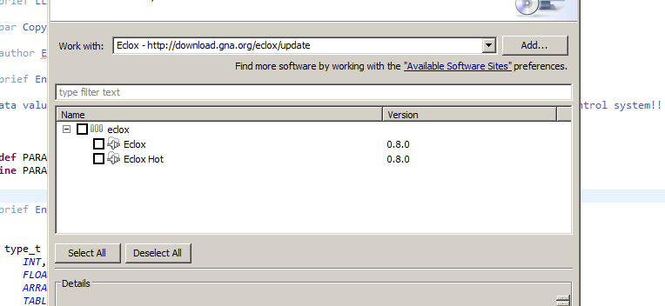

Once installed, click on the doxygen icon. It will tell you to choose a doxyfile (configuration file).
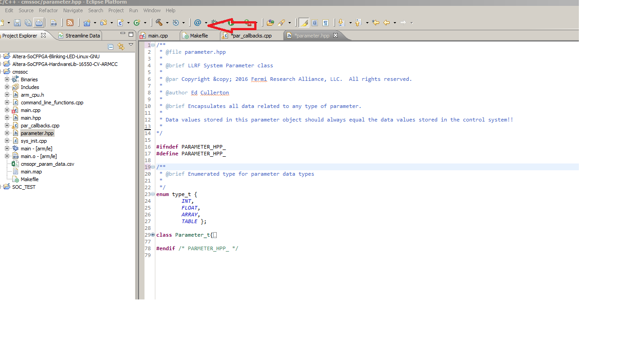
Select your project and give the configuration file a name. 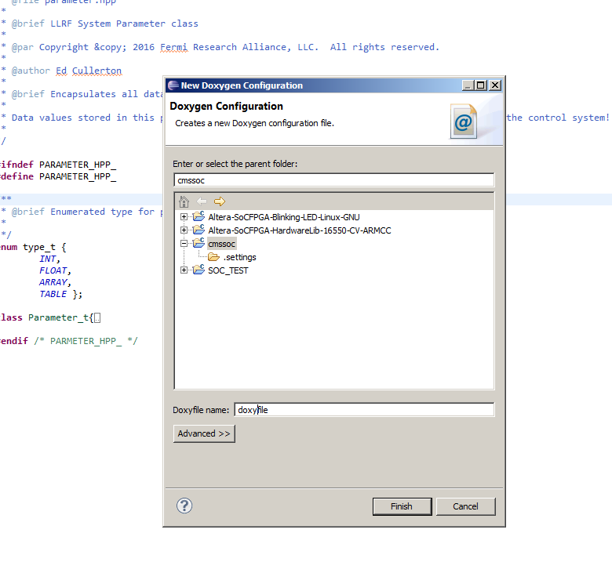
After you give it a name, eclipse will tell it does not know about doxygen and will let you open preferences to take care of that. Click on “Add…”, and find your doxygen installation in C:/Program Files/doxygen/bin.
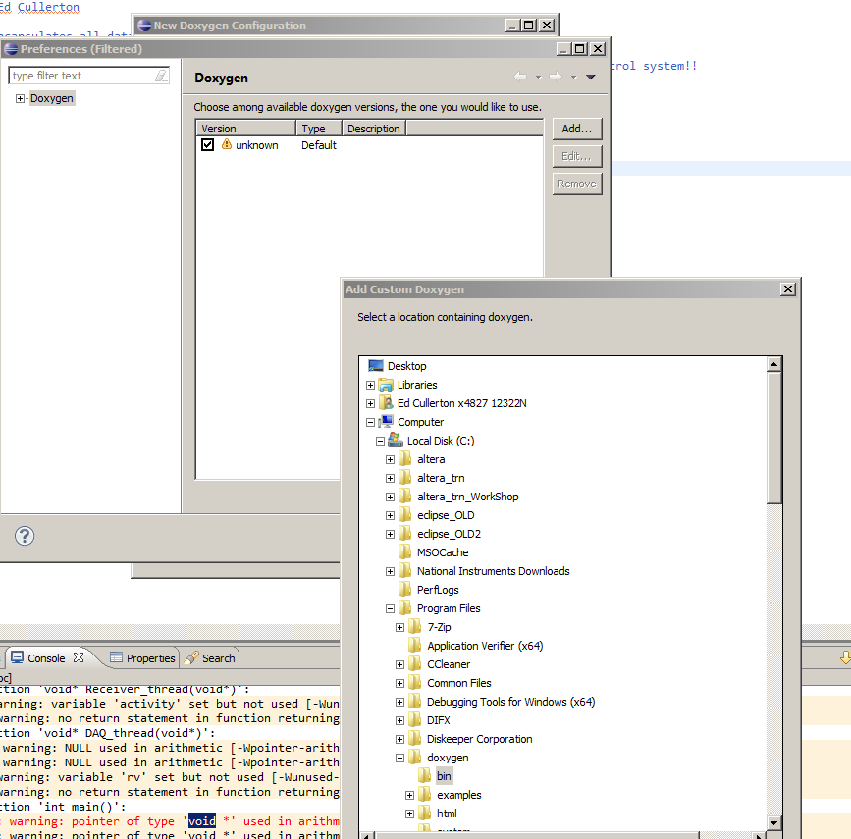
Select the doxygen installation and click “Apply”.
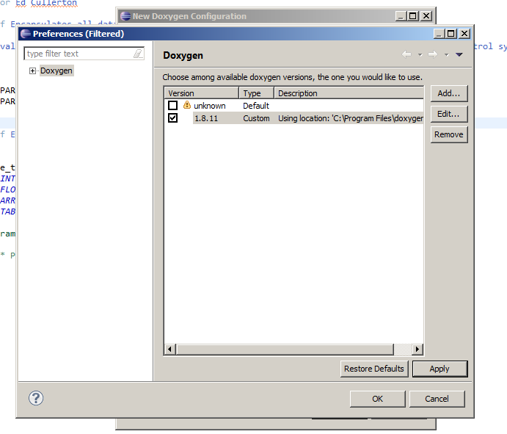

You should see the new configuration file in your project. Click on your file to configure doxygen.
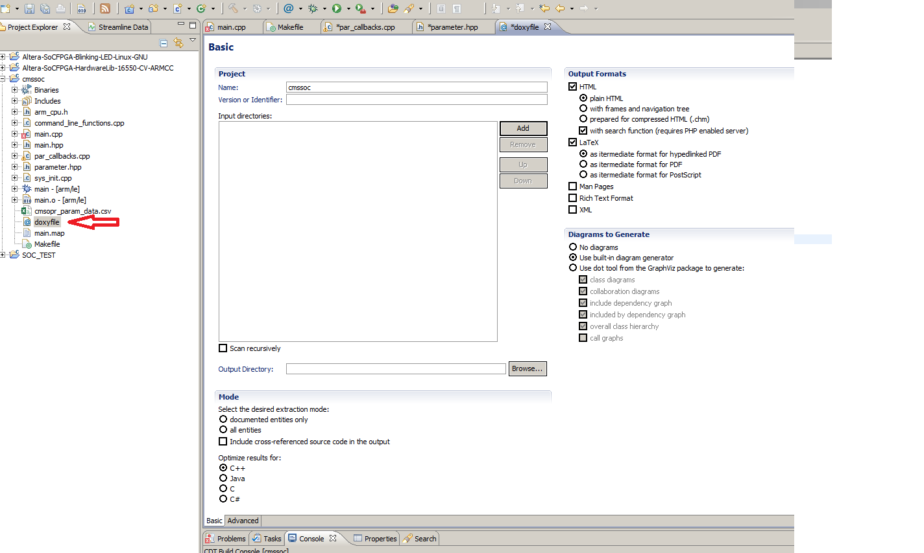
Next, give the project a name, and add the source files to the “Input directory”.
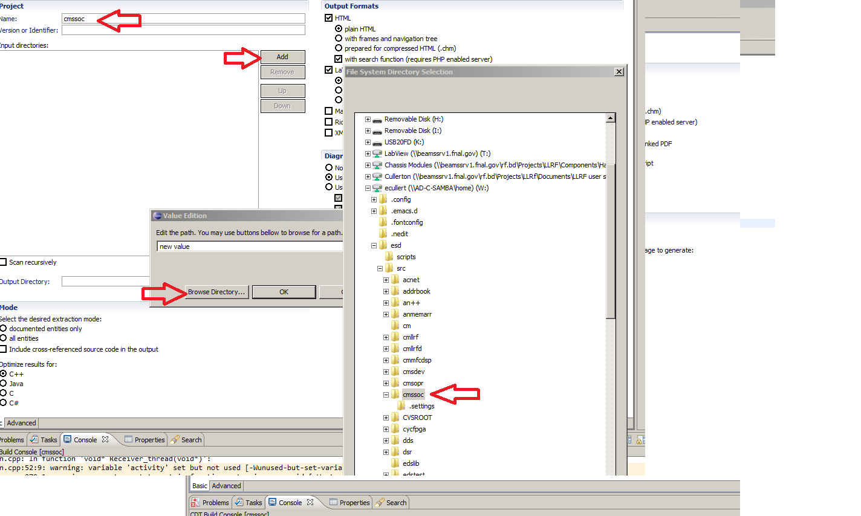
Next select “documented entities only”.
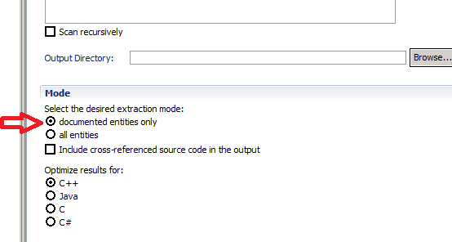

Save the configuration and click on the doxygen icon. Your doxygen files should now be created and in your directory. Under html, click on index for the top level of the document.
