Calculation of Cavity Ql using Labview
Ed Cullerton
2/19/2015

When the Start Decay Measurement button is pressed, the boolean parameter first point is set to true. The Labview interface then stores the value of the gradient, probe power, forward power, and reverse power as the variables, MaxVcav, Initial Probe Pow, Initial Fwd Pow, and Initial Rev pow, respectively, as seen in figure 1. Each of the above values are calculated by converting the raw digital I/Q values of the probe, forward, and reverse using the calibration constants entered in the calibration page. The first point variable gets set to false so that the initialization does not happen again, and a boolean parameter initialize decay gets set to true.
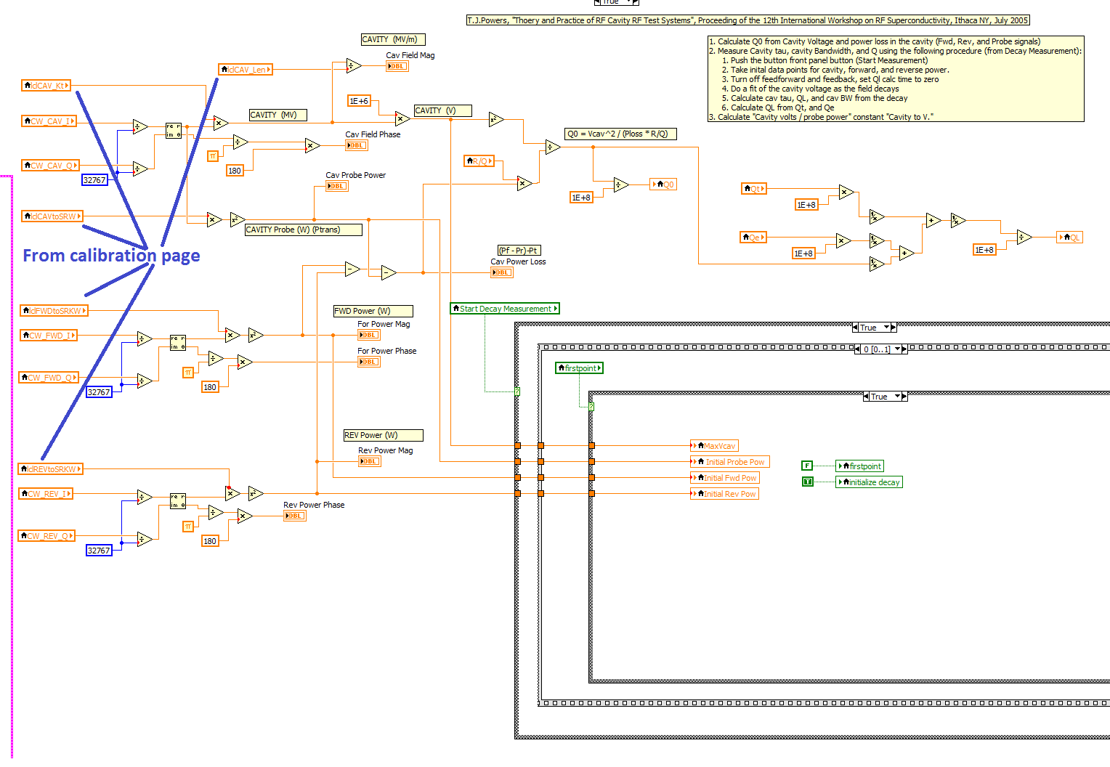
Figure 1. Calculation of initial values when Start Decay Measurement button is pressed.

The next frame calculates Qe, Qt, and updates the Ql display. The variable cavity Ql has not been calculated yet, so the first display value of Ql, Qt, and Qe on the front panel will be invalid. This should not be a problem. Ql will get calculated from Tau on the next 20 Hz cycle and from then on the values should valid. The variable previous Cavity to V. is for internal diagnostics and is not used in any calculations.
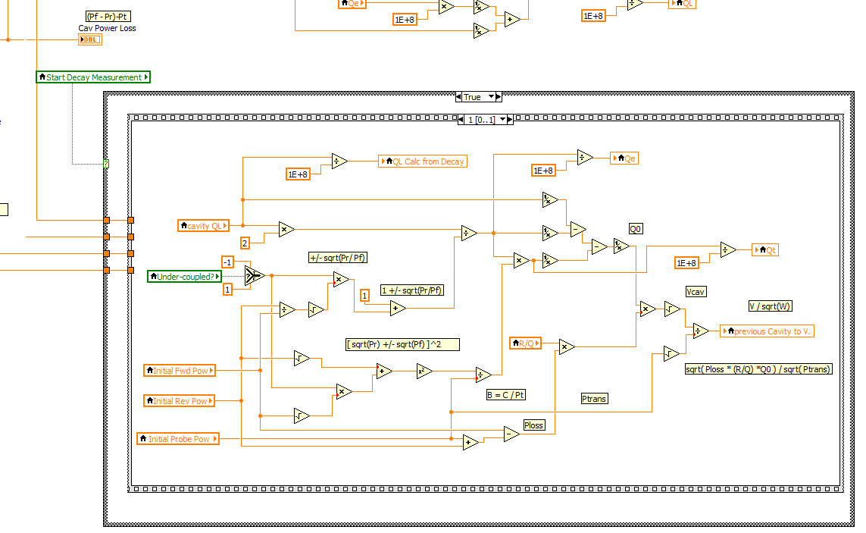
Figure 2. Calculate Qe and Qt, and update the Ql display.

The next 20 Hz cycle, the boolean parameter first point will be false, and the calculations shown in figure 3 are calculated. The boolean initialize decay is true on this cycle and it is used to reset the linear fit component. The boolean initialize decay is set to false this cycle so that the linear fit will not be initialized again. This frame followed by the frame in figure 2, will be executed every 20 Hz cycle until the cavity voltage has reached the end of the calculation window.
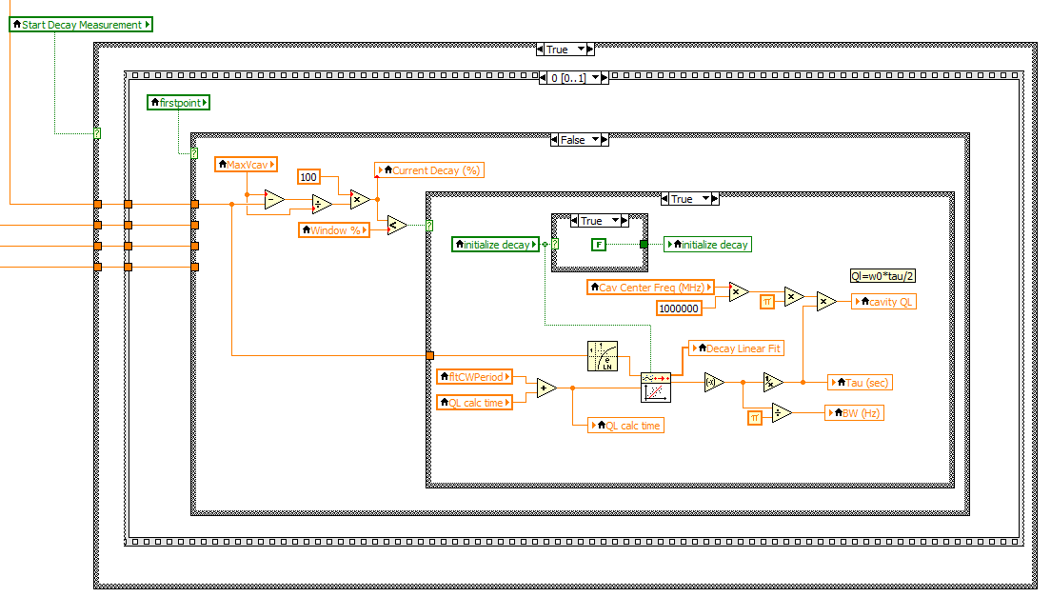
Figure 3. Calculation of Tau, Bandwidth, and Ql.
The Labview help for the log component and linear fit component are shown in figures 4 and 5.
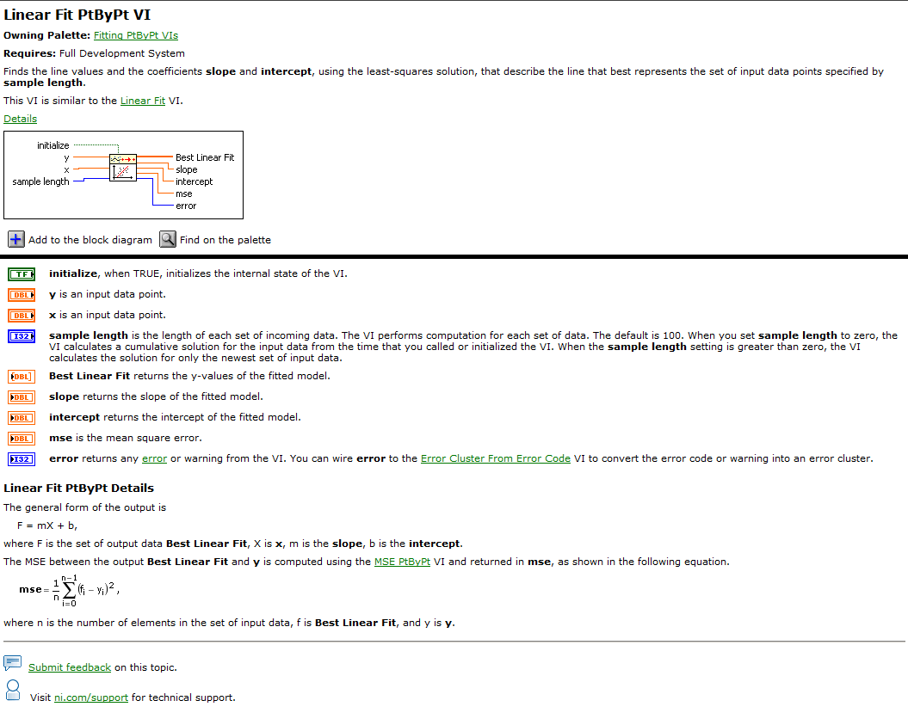
Figure 4. Labview help for linear fit component.

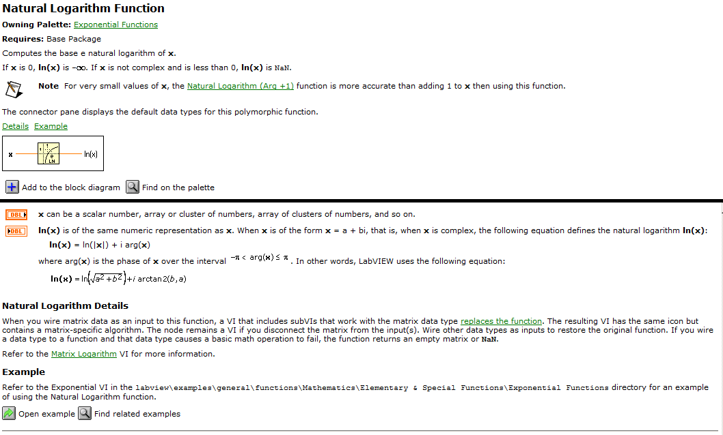
Figure 5. Labview help for natural log function.

