Measurement of Coalesced Proton Bunch Lengths

in the Main Injector and Tevatron

Ronald Moore

21 November 2002

Over the past several months, there has been a discrepancy between the bunch lengths of coalesced proton bunches as reported by the SBD (Sampled Bunch Display) devices in the Main Injector (before extraction to the Tevatron) and the Tevatron (at injection). The bunch lengths in the Main Injector are typically 2.7-2.9 ns, while the measurements in the Tevatron can vary from approximately 3.5-4.5 ns. Figure 1 illustrates the discrepancy for the 36 proton bunches injected for store #1953. The ACNET devices used are I:SBD04S(40) for the Main Injector and T:SBDPSS for the Tevatron.
This apparent discrepancy raised several questions. How could such a large increase in bunch length occur between the Main Injector and Tevatron, or in the Tevatron itself? Is it a problem with the SBD devices? We began a systematic investigation to study the discrepancy. Both SBD devices measure bunch lengths using digitized waveforms from a resistive wall current monitor signal. One difference between the Main Injector and Tevatron SBD bunch length devices is that I:SBD04S calculates the RMS width of the bunch profile, whereas T:SBDPSS reports the sigma of a Gaussian fit to the bunch profile. (Details of background subtraction are not addressed in this note.)
To determine if the bunches were really blowing-up longitudinally in the Tevatron, the digital Tevatron mountain range system was used to obtain a series of digitized bunch profiles from the first ≈50,000 turns in the Tevatron. Figure 2 shows the sigma from a Gaussian fit of the bunch profile over the first 51,000 turns for a single coalesced proton bunch in the Tevatron. The fitted sigmas agree with typical values reported by the Tevatron SBD. Moreover, the sigma oscillates at twice the synchrotron frequency over the first few thousand turns, but no blow-up is observed. The oscillation is an artifact from trying to fit a Gaussian to a bunch profile whose central peak is oscillating at the synchrotron frequency; see Figure 3. Note that such bunch oscillations are typical for coalesced proton bunches. These observations with the Tevatron Mountain Range rule out longitudinal blow-ups in the Tevatron and verify the bunch lengths reported by the Tevatron SBD.
Next, we sought to compare the raw waveform data of longitudinal profiles in the Main Injector and the Tevatron. Longitudinal profiles of coalesced protons in the Main Injector were obtained from a fast digitizing oscilloscope [1]. Waveforms from the Tevatron Mountain Range were used for the comparison. We performed RMS calculations and Gaussian fits on both sets of raw waveform data. Figure 4 and Figure 5 show example profiles for the Main Injector and Tevatron respectively. Although we did not have profiles of the same proton bunches in the Main Injector and Tevatron, the trend was clear. When comparing calculations of bunch lengths using the same algorithms, similar results are obtained. In other words, the RMS bunch length of coalesced protons in the Main Injector and Tevatron are similar, and the Gaussian sigmas are similar, too. The discrepancy exists because the bunch profile is not really Gaussian-like at 150 GeV, and, consequently, the RMS calculation and Gaussian sigma yield bunch length values that are considerably different. When the bunch profile is more Gaussian, as shown in Figure 6 for a coalesced proton bunch at 980 GeV in the Tevatron, the RMS calculation and the Gaussian sigma agree.
In order to make better comparisons of coalesced proton bunch lengths in the Main Injector and the Tevatron at 150 GeV, the Tevatron SBD will implement an RMS length calculation in addition to the current Gaussian fit. [3]

Summary
For several months, there had been an apparent discrepancy in the coalesced proton bunch length as measured in the Main Injector before extraction and in the Tevatron at 150 GeV. The discrepancy was caused by comparing an RMS length calculation by the Main Injector SBD to the sigma from a Gaussian fit by the Tevatron SBD; the longitudinal bunch profiles are not terribly Gaussian after coalescing at 150 GeV, so the RMS and sigma can disagree considerably. When using the same algorithms on raw waveform data from both machines, the bunch lengths agree. The Tevatron SBD will be modified to include an RMS calculation for the bunch length.

References

[1] I. Kourbanis, private communication.
[2] V. Shiltsev, private communication.
[3] R. Flora and S. Pordes, private communication.

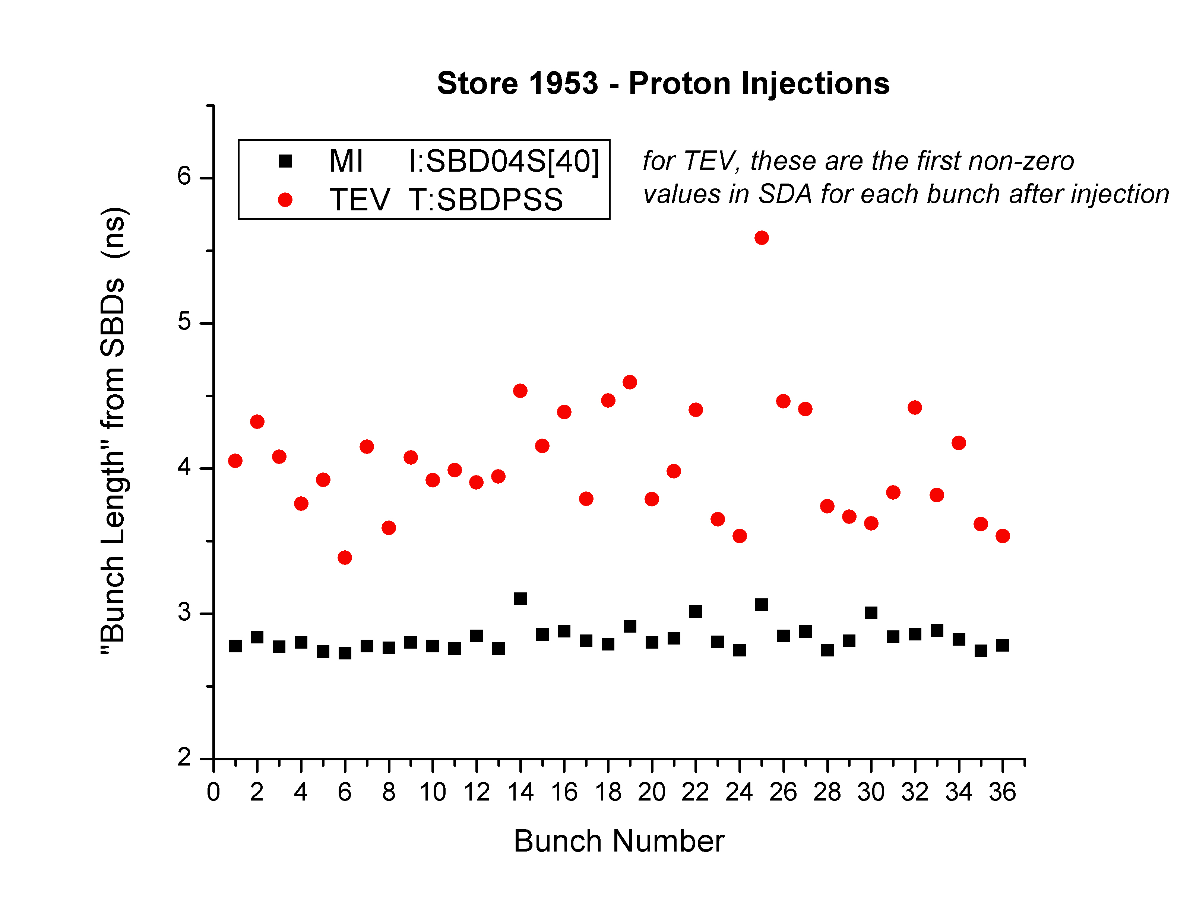
Figure 1: A comparison of the measured proton bunch lengths in the Main Injector and Tevatron for store #1953. The data was taken from SDA.
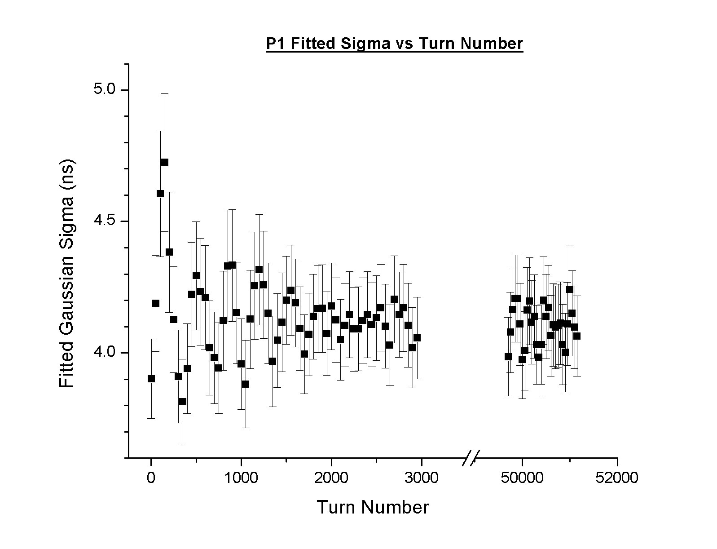
Figure 2: The Gaussian sigma from fits of the longitudinal profiles of a coalesced proton bunch in the Tevatron. The sigma is plotted as a function of turn number in the Tevatron.
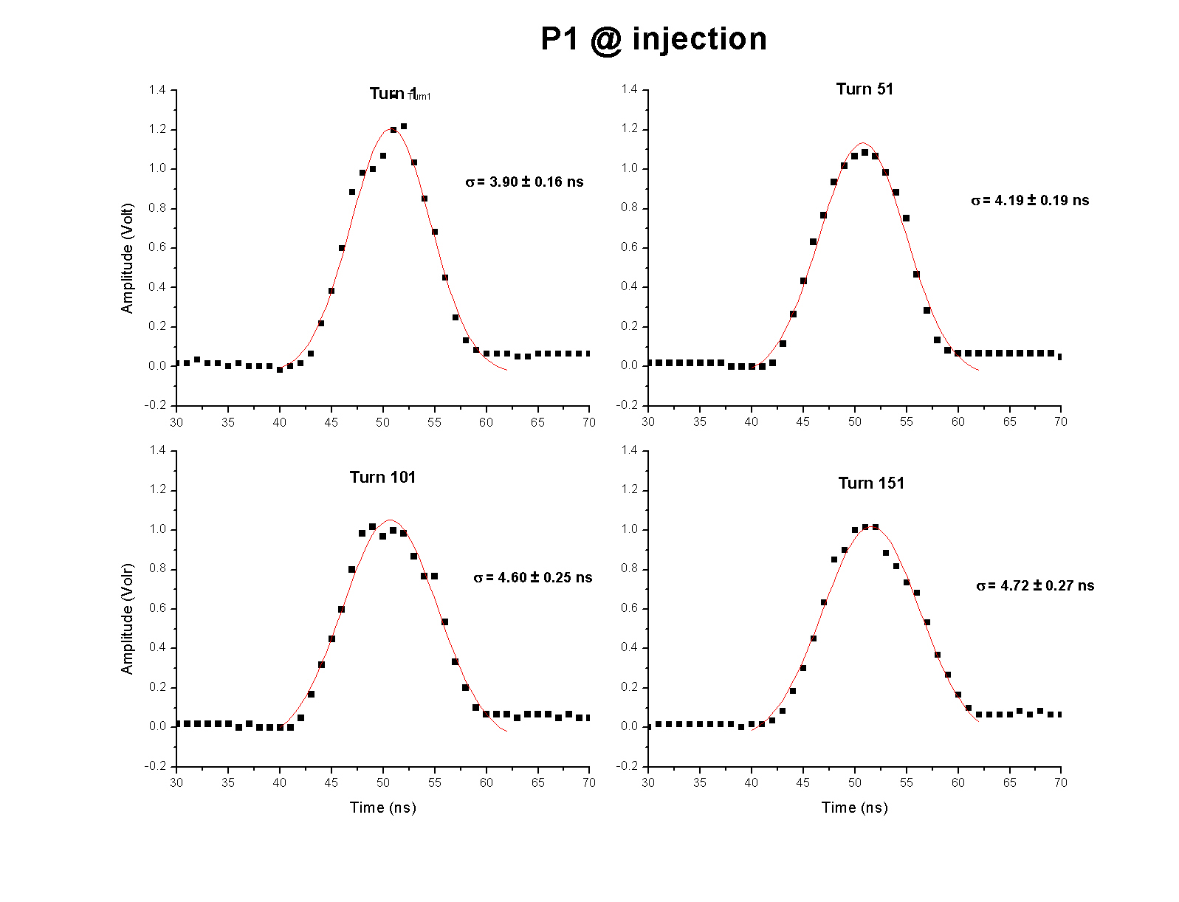
Figure 3: Digitized longitudinal bunch profiles of a coalesced proton bunch in the Tevatron. The sigmas from a Gaussian fit are also shown for each profile. Note the central peak that oscillates back and forth within the bunch.

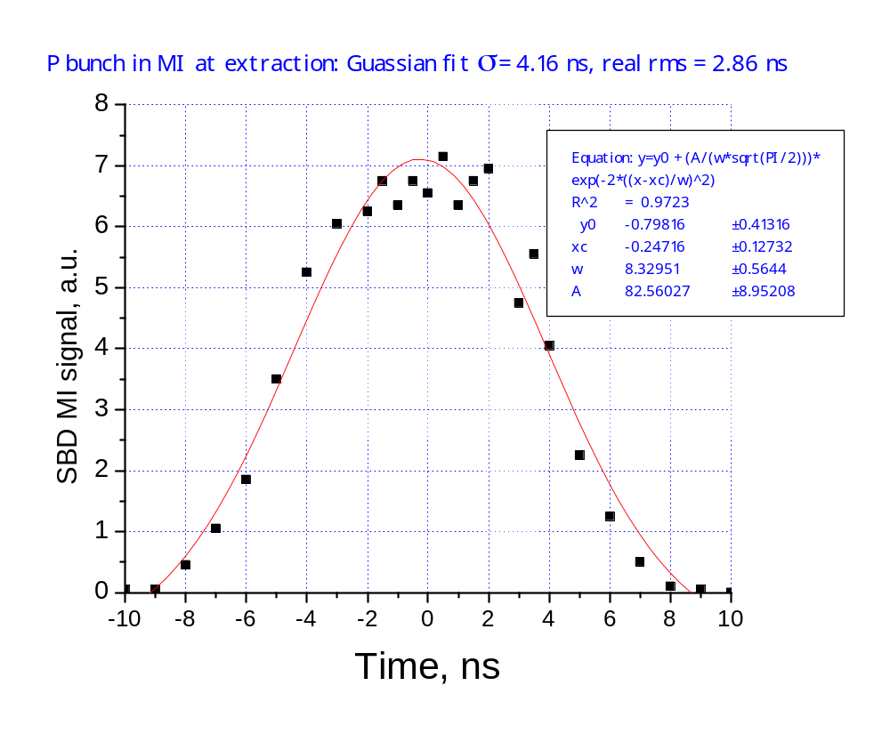
Figure 4: Longitudinal profile of coalesced proton bunch in the Main Injector before extraction. The black dots are digitized waveform data, and the red line is the result from a Gaussian fit. The calculated RMS is 2.9 ns, while the sigma from the fit is 4.2 ns. [2]

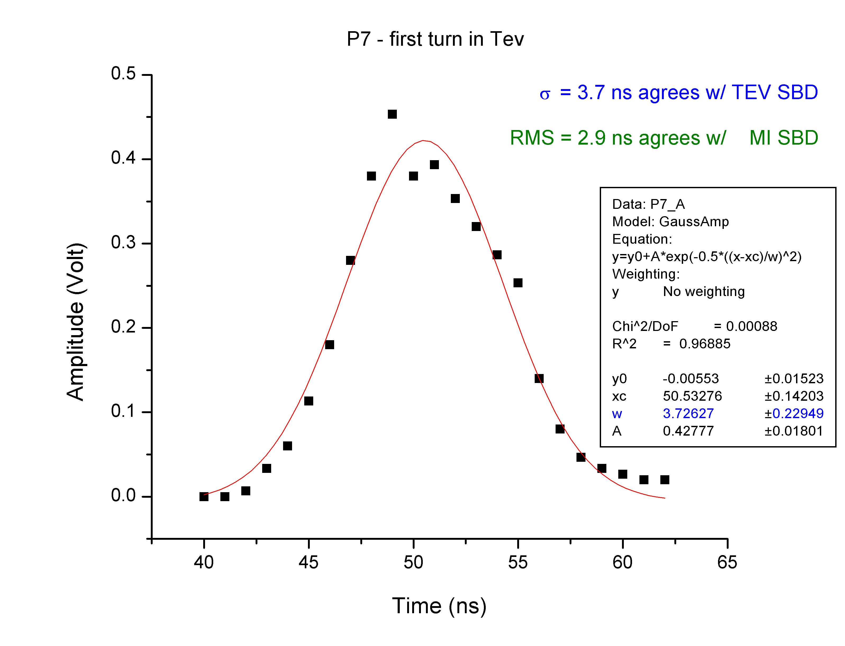
Figure 5: Longitudinal profile of a coalesced proton bunch during the first turn in the Tevatron. The black dots are digitized waveform data, and the red line is the result from a Gaussian fit. The calculated RMS is 2.9 ns, while the sigma from the fit is 3.7 ns.

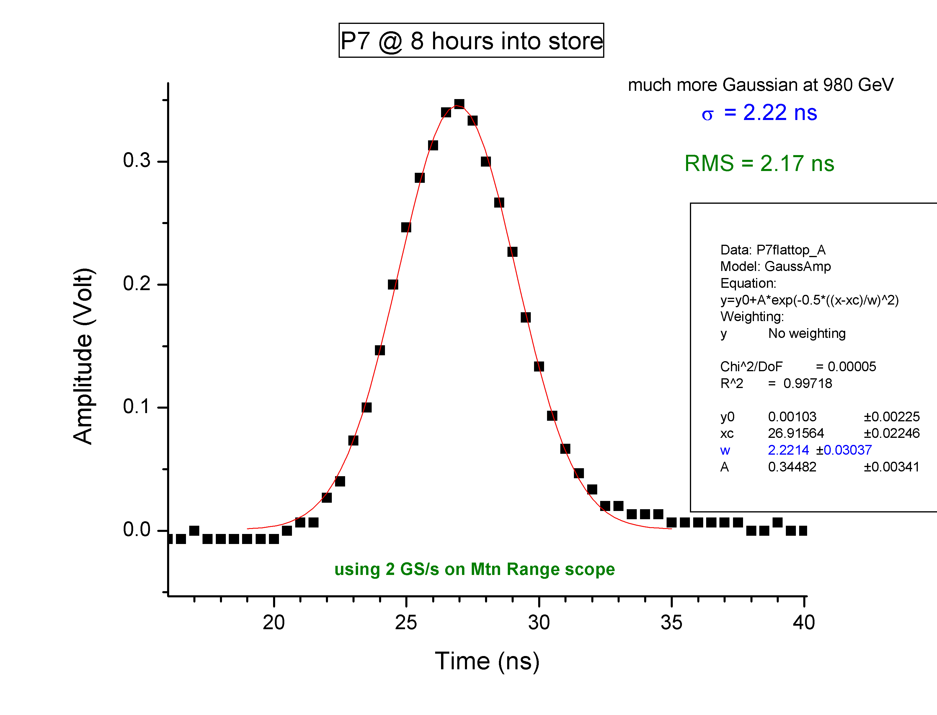

Figure 6: Longitudinal profile of a coalesced proton bunch in the Tevatron at 980 GeV. The black dots are digitized waveform data, and the red line is the result from a Gaussian fit. The calculated RMS is 2.17 ns, while the sigma from the fit is 2.22 ns. This bunch shape is clearly more Gaussian-like than those shown at 150 GeV.

