

A First Look at the Longitudinal Emittance in the Fermilab Recycler Ring

Chandra M. Bhat
MI/RR Beams Division, Fermilab

August 02, 2002

MI Note 287

Abstract :

In this note we present the first measurement of the longitudinal beam emittance in the barrier buckets at the Fermilab Recycler Ring (RR). The results are compared with the beam emittance in the Main Injector (MI) before its injection into the RR. The data clearly indicates that there is no or little emittance growth during the beam transfer. On the other hand, a factor of six longitudinal emittance growths is found for the beam stored in barrier bucket for a long time (about 30 min) with MI ramping. The observed emittance growth cannot be explained by beam dynamics simulations, which include various rf manipulations. A few possible sources of emittance growth are discussed.

1.

Introduction
The Fermilab Recycler Ring (RR) [1] is being commissioned using mainly protons from the Booster and occasionally using pbars from the Fermilab Accumulator. Over the past one and a half years, a lot of progress has been made in identifying and fixing many problems related to the transverse beam dynamics, which are critical to the efficient operation of the RR. As far as longitudinal beam dynamics is concerned, only some preliminary RF barrier bucket manipulations have been investigated.
Addressing the longitudinal beam dynamics in the RR is not trivial. The beam in the RR is stored azimuthally in several regions using barrier buckets [2,3]. The characteristics of these regions can vary considerably from one to another. As a result of this unique feature of the RR beam we had to develop new methods to study the properties of the beam like, bunch intensities [4] and the longitudinal emittance of the beam in barrier buckets. In this report we present the first measurement of longitudinal emittance of the beam in barrier buckets.

2. Measurement of the Longitudinal Emittance in RR and Data Analysis
The longitudinal emittance measurements are made at four separate times on the beam: 1) before injection of 2.5 MHz bunches from MI to RR, 2) at injection in RR, 3) after debunching the beam in RR without any MI high energy physics (HEP) ramps and 4) after 30 min storage of the beam in RR with several MI HEP ramps. To measure the longitudinal emittance of the beam in barrier buckets or bunches in buckets of sinusoidal wave we need to measure the bunch profiles and the rf voltage accurately. Profiles of proton or antiproton bunch in MI and in RR are measured by using resistive wall pickup monitors. The rf voltage is read from the calibrated fan back signals.
The formalism used in evaluation of the longitudinal emittance of the beam in barrier bucket is taken from ref.5. A schematic view of the barrier bucket used in the RR is shown below with the barrier pulse width T1 and gap between barrier pulses T2.
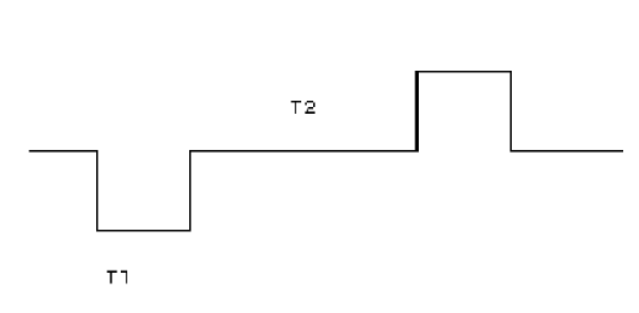
The maximum height (or the beam height when the barrier bucket is full), ΔEb, is given by,
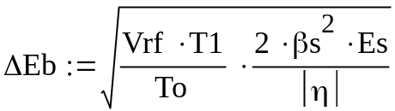
where, To is revolution period of the beam in RR (≈11.12 μsec), Vrf is barrier pulse height, Es is synchronous energy of the beam, η is slip factor of RR ((≈0.0089) and βs is the ratio of beam velocity to that of light. Then the total bucket area is given by,

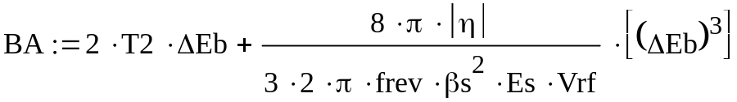
where, frev is beam revolution frequency (=1/To). By measuring T1, penetration of the beam in the barrier, one can evaluate the bunch area i.e., longitudinal emittance of the beam.
2.1 Beam Injection into the RR:
Four short batches of proton beam (with about 7 bunches per one batch) from the Booster are injected into the MI in 53 MHz rf buckets (harmonic number h = 588). Such bunches are adiabatically coalesced into four 2.5MHz rf buckets (harmonic number h = 28) with an rf voltage of about 2 kV [6] and then injected into the RR. A typical wall current monitor data of the bunches with 2.5 MHz structure at injection in RR in the absence of any 2.5 MHz rf voltage is shown in Fig. 1. The average bunch length of the beam in MI 2.5MHz rf buckets just before they are injected into the RR (or in RR just at the time of injection) was about 190 nsec which corresponds to a longitudinal emittance of about 1.4 ± 0.2 eV-sec with a dp/p = ±0.05%[7]. We do not see any difference in bunch lengths for the bunches in MI at extraction and that in RR at injection, hence, no emittance growth is observed during the beam transfer. Thus, we measure the total longitudinal emittance of beam at injection in RR to be about 5.6 eV-sec.

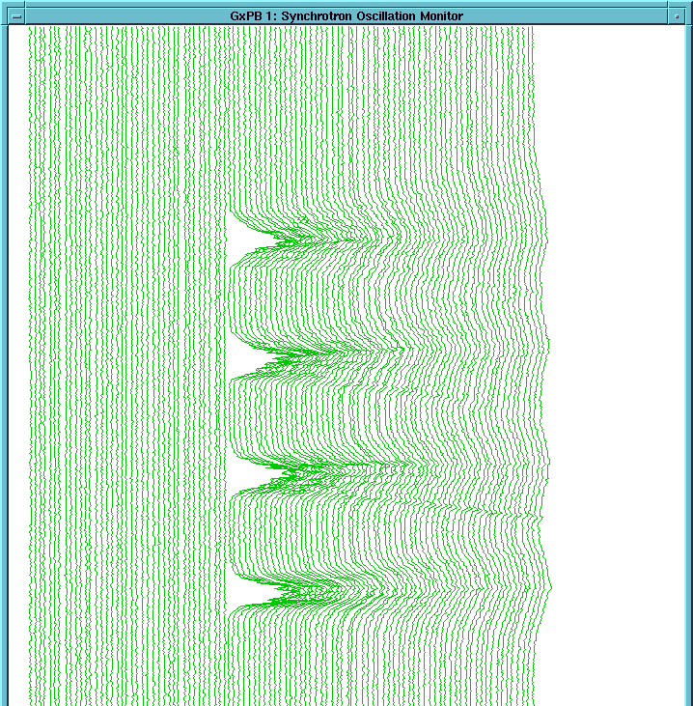

Figure 1. Waterfall picture of the injected beam in the RR. The 2.5 MHz beam bunches are transferred to RR without any 2.5 MHz rf buckets or bounded by barrier buckets. The intra-bunch distance is 21x18.92 nsec. The traces are separated by 1000 RR revolution period of about 11.12 μsec.

Figure 2 shows similar wall current beam monitor data in the RR with a 2.5 MHz rf voltage of about 2kV. Notice that there is some amount of 53 MHz structure in the beam from MI. However, they will disappear after several synchrotron oscillation periods in the RR (which is about 0.12 sec.).

  - Emittance of the Beam in a Barrier Bucket without any MI HEP ramps:
During normal stacking the bunches are injected into matched four 2.5 MHz rf buckets of RR which are bounded in a barrier bucket, and, the four bunches are adiabatically debunched by slowly reducing the 2.5 MHz rf voltage. The beam in a
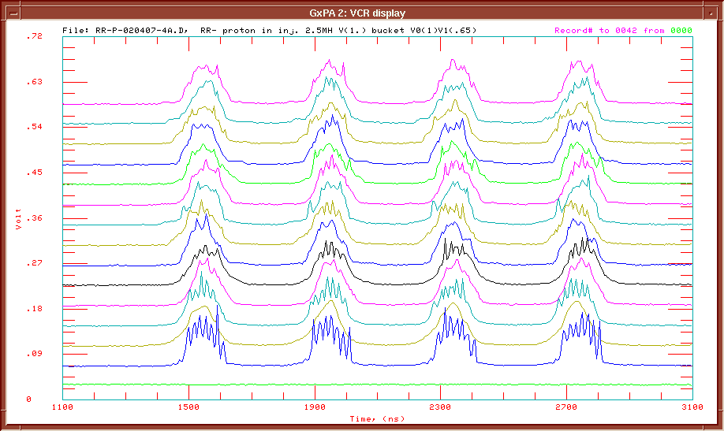
Figure 2. Waterfall or mountain range picture for the injected beam in RR with a 2.5 MHz rf voltage of about 2 kV.

barrier bucket after debunching (with a debunching time of about 15-20 sec) is shown in the bottom trace of figure 3 (in this operation the 2.5MHz rf voltage was brought down from 2kV to zero by hand). The top trace shows the fan back signals from the RR rf cavities. The barrier pulses shown are 624 nsec wide and they are separated by 1.665 μsec. In ideal conditions, one expects that the rf voltage between two barrier pulses to be zero and the beam distribution be flat between barriers. However, with the present operating conditions, the beam in the barrier bucket is peaking at about 2/3 the distance from the left barrier pulse. This clearly indicates that the rf voltage between two barriers is not zero, instead, there is a zero crossing at the location of the peak. The data shown in figures 3 and 4 are taken with MI being at 8 GeV and no HEP ramps in the MI. Using the data shown in figure 3 we estimate the longitudinal emittance for the beam in barrier bucket.

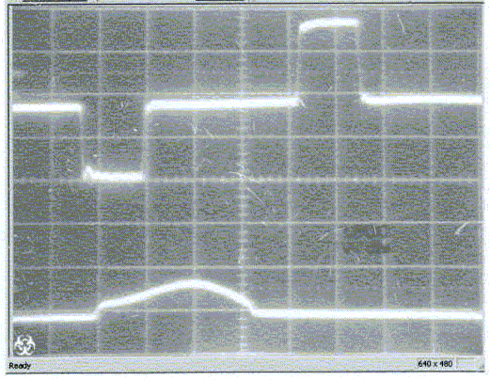
Figure 3. Beam in the RR barrier bucket, after debunching linearly in about 15-20 sec. The experiment is conducted in absence of Main Injector HEP ramp viz., 120 GeV and or 150 GeV cycles. The barrier pulses are selected to be about 624 nsec wide and about 1.6kV in height one being -ve and another being +ve.

We have adopted two different methods to measure the longitudinal emittance of the beam in barrier buckets. The first method uses the current integrator developed to measure the beam intensity in the barrier buckets [4]. The current integrator is a gated device, which integrates the current within a set of two gates aligned with the barrier pulses. The penetration of the beam into the barrier pulses is a function of dp/p of the beam for a given barrier pulse height. By slowly reducing the barrier pulse height simultaneously for both the pulses (+ve as well as –ve pulses with fixed pulse width) one can record rf voltage where beam start leaking out of the barrier bucket. This rf voltage corresponds to the minimum voltage needed to contain a beam in the bucket. Figure 5 shows the current integrator data (red trace, R:IBBINT) compared with RR DCCT data (green trace, R:IBEAM) just at the time of beam leaking out of the barrier. The beam in the barrier bucket found to start leaking out when the barrier rf voltage was reduced from 2kV to about 36 volts. This final barrier pulse with baseline level of zero volts would give rise to total beam area (matched to bucket area) of 10 (±20%) eVsec. Since the beam showed a clear indication of piling up within the barrier and fan back signals do not indicate any noticeable slope in the baseline between barrier pulses, we estimate that the slope is less than a few percent. Hence, we believe that the additional longitudinal emittance is at the level of a few percent.

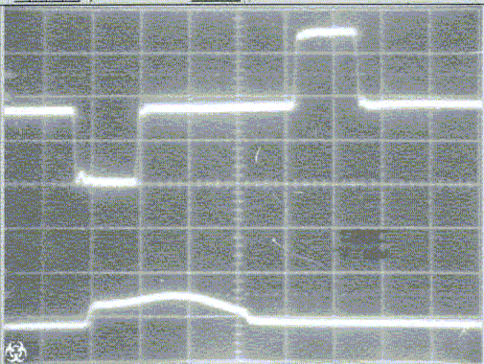

Figure 4. Beam in the RR barrier bucket, after debunching linearly in about 15-20 sec. The beam conditions were similar to that of Fig. 1. In this case the waveform for the right hand pulse is distorted so that the last bit on the pulse shape was ~-80 units rather than having a value of 0 units. Note that the peak +ve or –ve pulse corresponds to 127 units. (one “unit” corresponds to 1/127th of 2 kV)

In the second method to measure the beam emittance, we first estimate the penetration of the beam in the barrier of 2kV by examining the data shown in figures 3 and 4, which is about 2.5 ±1 rf buckets of 53 MHz type, i.e., T1 = 47 ± 20 nsec. This gives a beam emittance of 12.7±2.5 eVsec. Thus the results of longitudinal emittance from these two methods were consistent with one another.
From Section 2.1, the expected beam emittance in the barrier bucket is about 5.6 eV-sec assuming no emittance growth during the debunching process. On the other hand, if the 2.5 MHz rf voltage was brought down to zero in a few milli-seconds (i.e., within a time <0.12 sec) or the beam from MI is injected into RR barrier without any 2.5 MHz rf buckets, we expect a maximum emittance of the beam in the barrier bucket to be about 16 eV-sec. (which is energy spread of 2.5MHz bunches x barrier gap ≈ 9.5 MeV x 1.665 μsec). Multi-particle beam dynamics simulations [8] of debunching with a debunching time of 15 sec showed no emittance growth.

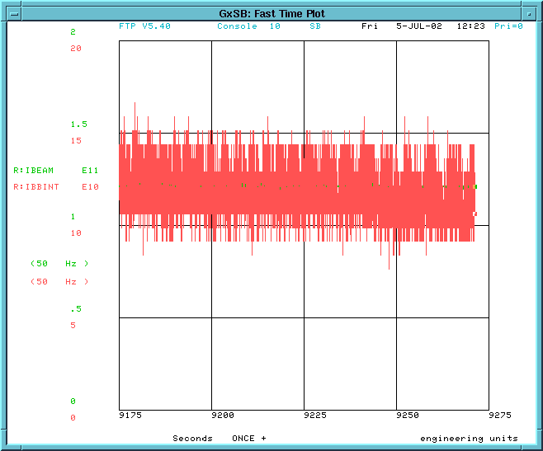

Figure 5. Comparison of barrier current integrator beam (red trace) with RR DCCT measured total current in RR (green trace) just at the time of leaking of the beam from RR barrier bucket. The beam in barrier is made to leak out of the bucket by reducing the barrier RF voltage to about 36 volts.

From these studies we infer about a factor of two higher beam emittance for the beam in barrier bucket as compared with the sum beam emittance at injection. This discrepancy many arise due to 1) bunch mismatch in phase or in energy at injection and 2) non-adiabatic debunching. The figure 1 shows little energy mismatch at injection. The phase mismatch was adjusted to a level of fraction a degree prior to these measurements. Hence, we expect phase mismatch cannot account for this large difference. Thus the emittance growth might be arising from the debunching process. In conclusion one need to give special attention to the debunching process in RR.

  - Emittance of the Beam in a Barrier Bucket in the Presence of MI HEP ramps:

Very early on in the commissioning of the RR, we were concerned about the effect of the MI HEP ramps on the beam in RR. Magnetic field measurements were conducted [9] very close to the RR beam pipes using specially designed Hall probes. This effort led to adding magnetic shielding between the RR and MI. Here, we have made a first attempt to measure the longitudinal emittance of the beam in RR and estimate the emittance growth arising from the MI HEP ramps with the magnetic shielding added.

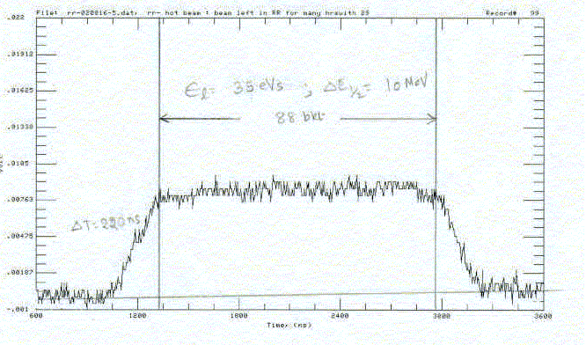
Figure 6. Wall current monitor data of the beam in barrier bucket. This data is taken using RTD720 scope after several $29 ramps in MI.

At present, the general features of the beam in the barrier in the presence of 120 GeV acceleration ramp ($29, $21 and/or $23) or 150 GeV proton/pbar acceleration ramps in the MI are that splashing of the beam synchronous with the ramps as observed by the beam wall current monitor on the first few HEP ramps in the MI after debunching. This is a clear signature of the MI HEP ramps acting as a significant source of longitudinal emittance growth in the RR beam.

To study the longitudinal emittance growth of the beam in the presence of MI HEP ramps the beam in barrier is prepared as explained in Section 2.2. The beam was stored for an extended length of time with MI ramping for normal pbar stacking (about twenty eight $29 cycles/min). During this time no rf manipulations of barrier buckets in RR were carried out. Figure 6 shows the wall current monitor data of the beam taken using RTD720 scope [10] after about 30 min. The data show increasing penetration of the beam from about 47 nsec to 220 nsec. This gives a final longitudinal emittance of ~35 eVsec (with an error of about 10%) and the current integrator method gave ~34 eVsec. From these measurements it is evident that we have seen additional emittance growth by at least a factor of three arising from the MI ramp for half hour even with the existing RR magnetic shielding.

Summary and Conclusions
We have made a first attempt to measure the beam longitudinal emittance in RR barrier buckets. The measurements indicate a factor of two emittance growth for the beam in barrier buckets debunched in 15-20 sec nearly linearly even in the absence of any MI acceleration ramps. So special attention should be given to debunching process. In the presence of MI acceleration ramps we see an additional 300% emittance growth within the first half hour, even in the presence of existing magnetic shielding.
Longitudinal emittance growth of this magnitude may be catastrophic for the successful operation of the Fermilab Recycler Ring and diminish the effectiveness of its cooling systems - stochastic cooling system, which is in use and, the electron cooling system that is being built. We propose to conduct similar measurements with MI ramps and MI RF power supplies, one ON and another OFF. Based on the observations, we may be able to isolate main contributions to the longitudinal kicks on the beam in the RR accordingly to help us to develop a remedy for this problem.

Acknowledgements
I thank Dave Wildman for many useful discussions in the course of this work and Brian Fellenz for help in setting up the barrier bucket current integrator.

References

- The Fermilab Recycler Ring Technical Design Report, Gerry Jackson, Fermilab TM-1991.
- G.E. Griffin et. al, IEEE, Trans. Nucl. Sci., NS-30, 3502 (1983).
- J.E. Dey and D.W. Wildman, IEEE, Proc. the 1999 Part. Accel. Conf. New York, NY, 869, 1999).
- C.M. Bhat and B. Fellenz, “ A beam integrator to measure the beam intensity in RR Barrier buckets.”, MI Note 289 (under preperation).
- S.Y. Lee and K. Y. Ng, Phys. Rev. E, Vol. 55, 5992 (1997).
- Preparing the Proton Bunches in 2.5 MHz Buckets in MI for RR Tune-up, C.M. Bhat, MI Note 263 June 1, 2000
- Pbar Acceleration in the Main Injector RR/AR → MI → Tevatron: Simulations and Tune up Studies Using Protons, C. M. Bhat, MI Note 268, (November 2000). (Method used to extract the longitudinal emittance of the beam in buckets of sinusoidal rf wave is outlined here.)
- “Stacking and Extraction of the beam from RR, ESME Simulations”, C.M. Bhat et al, MI Note 288 (under preperation).
- Stan Pruss, (private communations, July, 2002)
- Ming-Jen Yang, “A Console Applications Program for taking data from wall current monitor using RTD720 scope and data analysis, R87”, (private communications, 2002)

