
Fermilab/BD/TEV
Beams-doc-436
February 7, 2003

Measurement of the Tevatron tune shift versus RF frequency and strength of the T:SF and T:SD circuits.

M. Martens
Fermilab, Beams Division

A sextupole feeddown effect is one hypothesis that might explain the observed tune and coupling drift in the Tevatron during the 150 Gev front porch. Off-centered beam orbits in the time varying sextupole fields create a feeddown quadrupole that changes the tune as a function of time. The sources of time varying sextupole fields in the Tevatron are the drifting b₂ components in the dipole magnets and the b₂ drift compensation in the chromaticity sextupole circuits T:SF and T:SD. To help determine if the feeddown hypothesis is correct we made beam based measurements of the average beam position offset in the T:SF and T:SD magnets.

By measuring the tune shift as a function of the current in chromaticity sextupoles and as a function of the RF frequency, we estimate that the nominal horizontal orbit is, on the average, passing through the center of the T:SF magnets, and, on the average, 0.31 mm to the radial outside of the T:SD magnets. During these measurements the beam orbit was also measured with the Beam Position Monitor (BPM) system. The BPM system measured an average horizontal orbit position of 0.70 mm to the radial inside at the locations of the T:SF magnets. The measured offset from the tune measurements is inconsistent with the BPM results and this discrepancy has not been explained.

These measurements also provide a calibration of the chromaticity sextupole circuits (T:SF and T:SD) and give an approximate measurement of the horizontal dispersion. This data is also presented in this note.

The data in this note were taken during Tevatron studies on 11/06/02.

Measurement of tune shift versus current in T:SF, T:SD, and RF frequency offset.

On 11/06/02 measurements were made of the tune shift created by a 0.5 Amp change in the sextupole corrector circuits T:SF and T:SD. The tune shift from this corrector current change was also measured as a function of the RF frequency offset. During this time orbit data was also collected. The measurements were made with uncoalesced beam on the central orbit (i.e. separators off) about 30 minutes into the 150 Gev front porch. The front porch was preceded by a 20 minute dry squeeze sequence with about a 60 second back porch and the chromaticity and tune drift compensations were active during these measurements.

In Figure 1 and Figure 2 we show the results as plots of the tune shift for a 0.5 Amp change in the T:SF (or T:SD) circuit versus the RF frequency offset. With the T:SF circuit no change in the horizontal or vertical tune is observed when the RF frequency offset is at its nominal value of 0 Hz. This suggests that the nominal orbit in the Tevatron is, on the average, passing horizontally through the center of the magnets in the T:SF circuit since no feeddown effect is observed when the current is changed in these magnets.

With the T:SD circuit, no change in the horizontal or vertical tune is observed when the RF frequency offset is at +19.9 Hz or equivalently the beam momentum offset is Δp/p = -1.34×10⁻⁴. Using the average value of the calculated dispersion at the locations of the T:SD magnets, ⟨D_{x}⟩ = 2.27 meters, this measurement suggests that nominal horizontal orbit in the T:SD magnets is +0.31 mm ( = ⟨Δx_{avg}⟩ = -(Δp/p) × ⟨D_{x}⟩ ) to the radial outside of the center of the T:SD magnets. In other words, the beam had to be moved radially inward by 0.31 mm to reach the average center of the T:SD magnets.

Before these measurements were made the Tevatron was decoupled and the measured minimum tune split was less than 0.003 tune units. After decoupling the tunes were then split to 0.566 vertically and 0.585 horizontally. In Figure 3 the measurement of the horizontal and vertical tunes with no current change in T:SF and T:SD are plotted for the measurements made for the T:SF circuit and the measurements made for the T:SD circuits. These two sets of data were taken at different times on the front porch and their agreement demonstrates that the tune drift compensation algorithm was tuned up properly during these measurements.

We conclude from these measurements that the horizontal orbit is, on average, passing though the center of the T:SF magnets, and passing +0.31 mm to the radial outside of the center of the T:SD magnets. The vertical orbit offset is not determined from theses measurements. This data does not agree with the BPM data that is presented in another section of this note. We note that no attempt was made to include coupling effects.
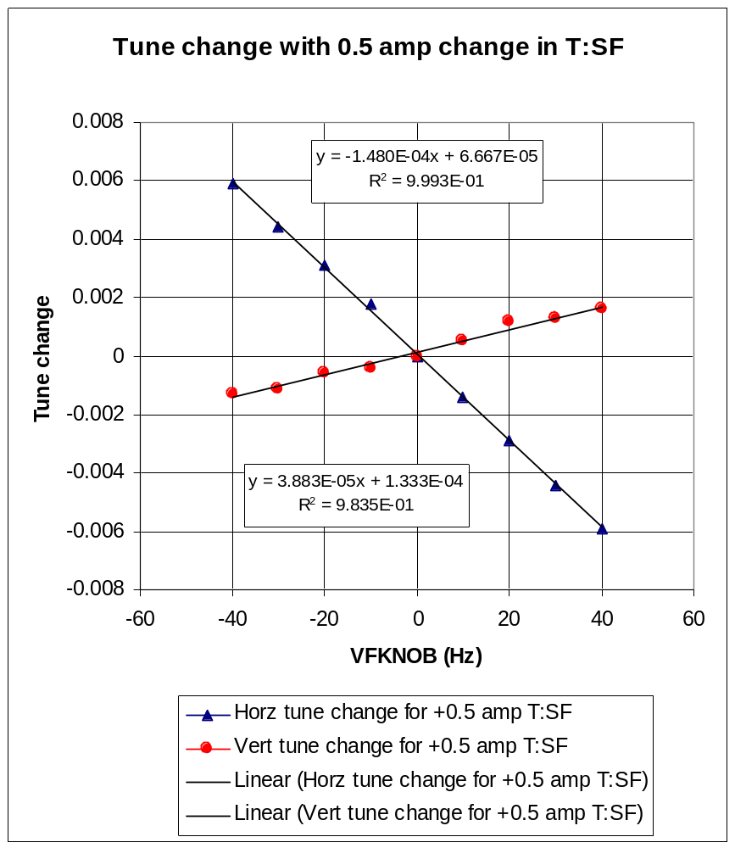
Figure 1 Plot of the horizontal and vertical tune change for a +0.5 Amp change in the T:SF circuit as a function of the RF frequency offset. Also shown are linear fits to the data.

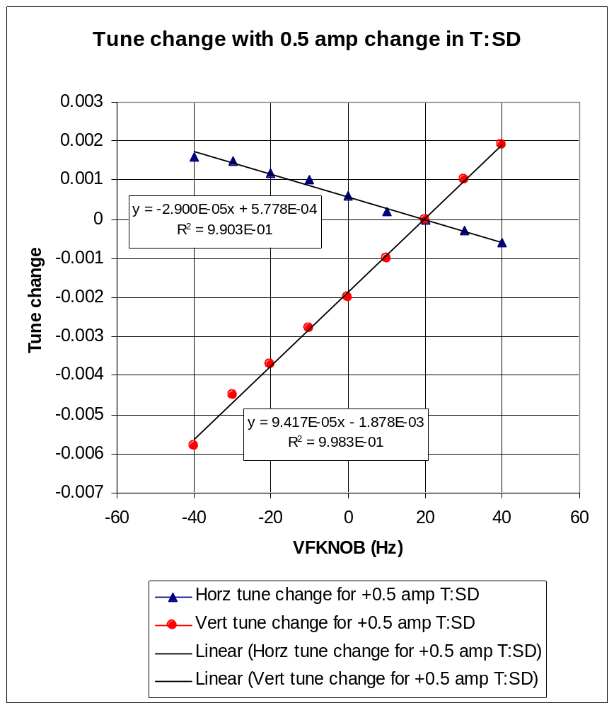
Figure 2 Plot of the horizontal and vertical tune change for a +0.5 Amp change in the T:SD circuit as a function of the RF frequency offset. Also shown are linear fits to the data.

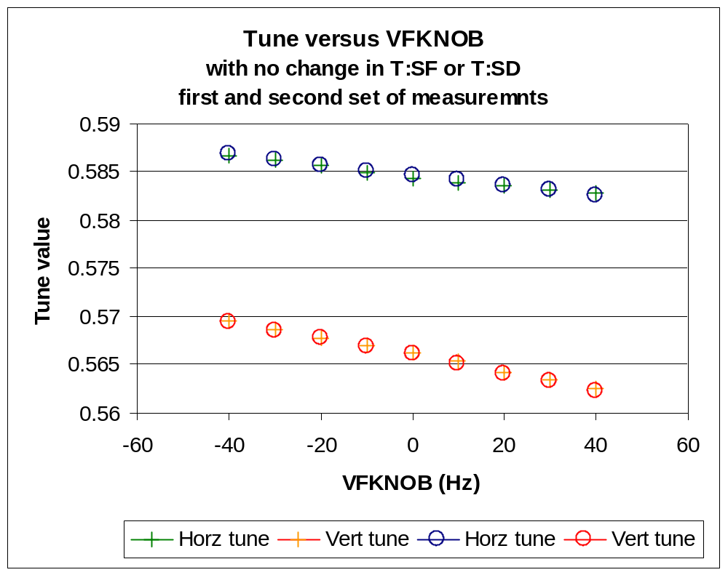
Figure 3 Measurement of the horizontal and vertical tunes for two sets of measurements with no current change in T:SF and T:SD. The first set of data (the crosses) agrees with the second set of data (the circles) taken at a later time on the front porch. These measurements confirm that the tune drift compensation was correctly tuned up during these studies.
Calibration of chromaticity sextupole circuits

The slopes of the curves from the measurements in Figure 1 and Figure 2 provide a calibration of the chromaticity sextupole circuits. From linear fits to the slopes and using the calculated value of the slip factor, η=0.002787, the measured changes in chromaticity from changes in current in T:SF and T:SD are

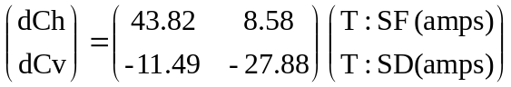.

For comparison we give the values calculated by MAD with the design 150 Gev lattice and using the integrated sextupole field strength of 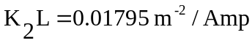at 150 Gev. The MAD calculated values are

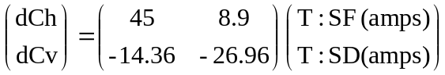.

And, for the record, we also include the values presently used in the C49 program to convert chromaticity changes into changes in current in T:SF and T:SD
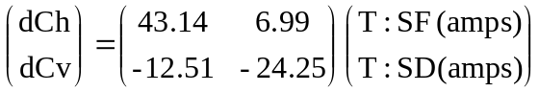.

Orbit Data

During these measurements the orbits in the Tevatron were collected for RF frequency offsets of -40 Hz, 0 Hz, and 40 Hz. These are plotted in Figure 4. Clearly there is a systematic horizontal beam offset towards the radial inside for the nominal Tevatron orbit at 150 Gev.

If we average the horizontal beam position measurements at the BPMs located next to the T:SF magnets we find that there is an average beam offset of –0.71 mm. (For an RF frequency offset of +40 Hz the average is –1.63 mm and for an offset of –40 HZ the average is +0.23 mm.) If the BPM measurements are accurate and if the T:SF magnets are properly aligned in the tunnel, then the BPM measurements are inconsistent with the tune measurements, which suggest the orbit is passing through the center of the T:SF magnets.

The difference of 0.7 mm seems rather large to explain with measurement error or a systematic error in the BPM measurements. This discrepancy is left unexplained in this note.

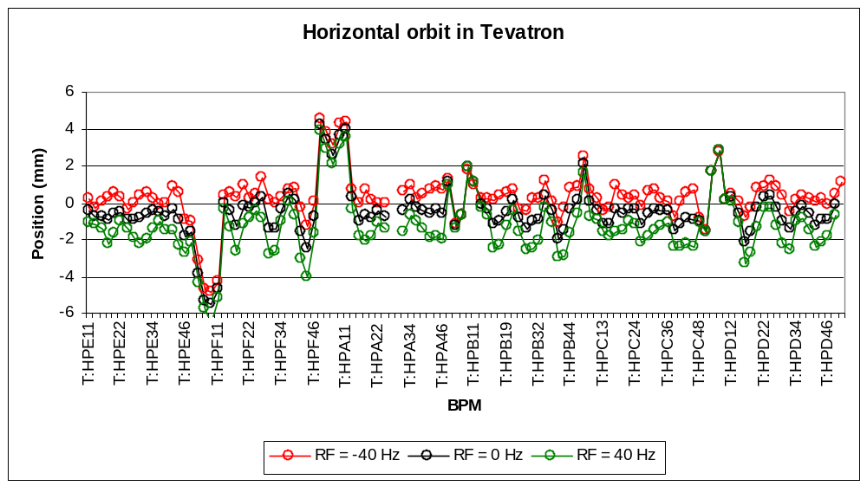
Figure 4 BPM measurements of horizontal position at the horizontal BPMs for three different RF frequency offsets.

Measured horizontal dispersion

We can estimate the horizontal dispersion at 150 Gev by using the BPM orbit measurements at the different RF frequency offsets. In Figure 5 we show a plot of the measured and the calculated horizontal dispersion at the location of the horizontal BPMs. The measurements are based on the orbit data taken with an RF frequency offsets of ± 40 Hz. In Figure 6 we show a plot of the measured horizontal dispersion versus the calculated values at the locations of the horizontal BPMs. A linear fit to the data suggests that the measured dispersion is 10% less than the calculated values if the BPM measurements are assumed to be accurate.

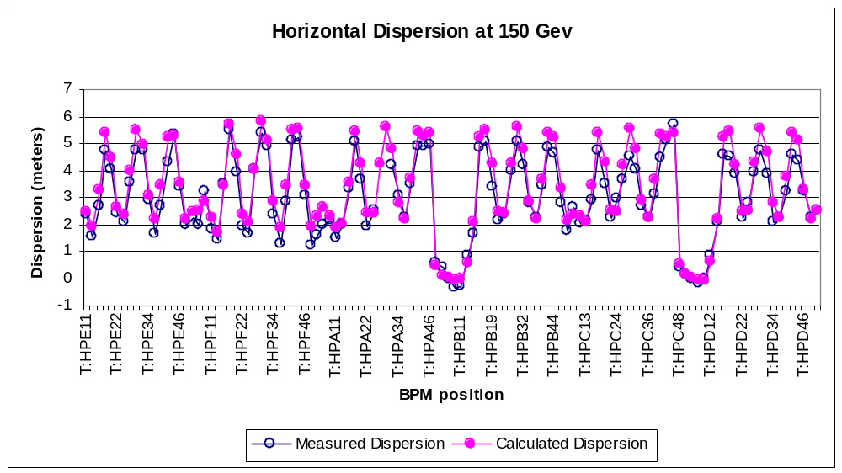
Figure 5 Plot of measured and calculated horizontal dispersion in the Tevatron at 150 Gev at the locations of the horizontal BPMs.
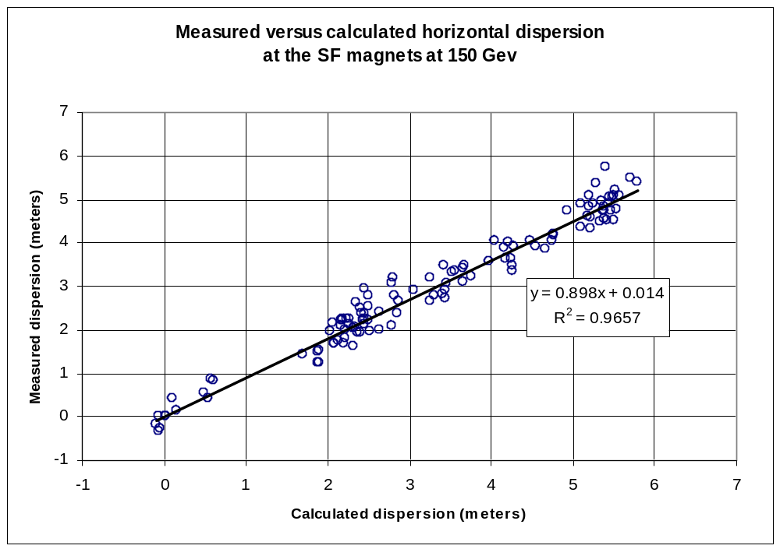
Figure 6 Plot of measured horizontal dispersion versus the calculated dispersion at the locations of the horizontal BPMs in the Tevatron at 150 Gev. Also plotted is a linear fit to the data, which suggests that the measured dispersion is 10% less than the calculated dispersion if the BPMs measurements are considered accurate.

The T:SF and T:SD magnets are normal sextupoles and a horizontal position offset in them results in a normal quadrupole feeddown field, which changes the tune of the Tevatron.

