Proton longitudinal emittance vs proton intensity during MI $2B cycle (Preliminary)

K. Koba, I. Kourbanis and W. Pellico

Jan./4/2002

We measured the longitudinal emittance on 2B cycles as a function of beam intensity. Main Injector was operating under normal conditions. Booster damper parameters were adjusted for intensity.

(1) Measurement
The number of booster turns was changed from 2 turns to 10 turns and seven bunches were exracted to Main Injector. The intensity was from 75e9 particles to 330e9 particles. The bunch signal came from the wide band wall current monitor and was digitized with a 8GHz/sample rate. The trigger was set for injection (0.15sec), before coalescing (1.58sec) and extraction (2.7sec). Figure 1 shows typical operation for 2B cycles. Booster damper conditions were as follows for each intensity:
2~4 Booster turns: Mode 48 and Mode 1 dampers ON, Quadrupole damper OFF
6 Booster turns: Mode 48 and Mode 1 dampers ON, Quadrupole damper ON
8~10 Booster turns: Mode 48 and Mode 1 dampers ON, Quadrupole damper OFF

(2) Analysis
Since we assumed the bunch was already matched to the RF bucket, we could get longitudinal emittance from the bunch length.
The bunch length was obtained for each of the 7 bunches. Data for a 20n sec time span were fitted with a Gaussian distribution. Four-sigma was taken as the bunch length. Emittance was calculated using value of RF voltage, and the total emittance was taken to be the sum of the emittances of each of the 7 bunches. The result was shown in Fig. 2.

(3) Comment
Using figure 2, the blowup ratio during acceleration, from injection to flat top, was found to be ~10%. The longitudinal emittance at injection at 6 Booster turns or greater was difficult to be calculated because of the irregular bunch shapes. The emittance at extraction was saturated after 150E9 particles (4 booster turns), therefore the blowup ratio during coalescing was not clear. The calculated RF bucket area at flat top and extraction were ~4.68eV-sec, so that bucket was already full after 4 booster turns. It should be pointed out that we didn’t try to optimize coalescing durin study period. In order to keep the emittance to be less than 3eV-sec at high intensity, either the emittance at injection must be kept less than 0.5eV-sec, or the coalescing efficiency must be increase.

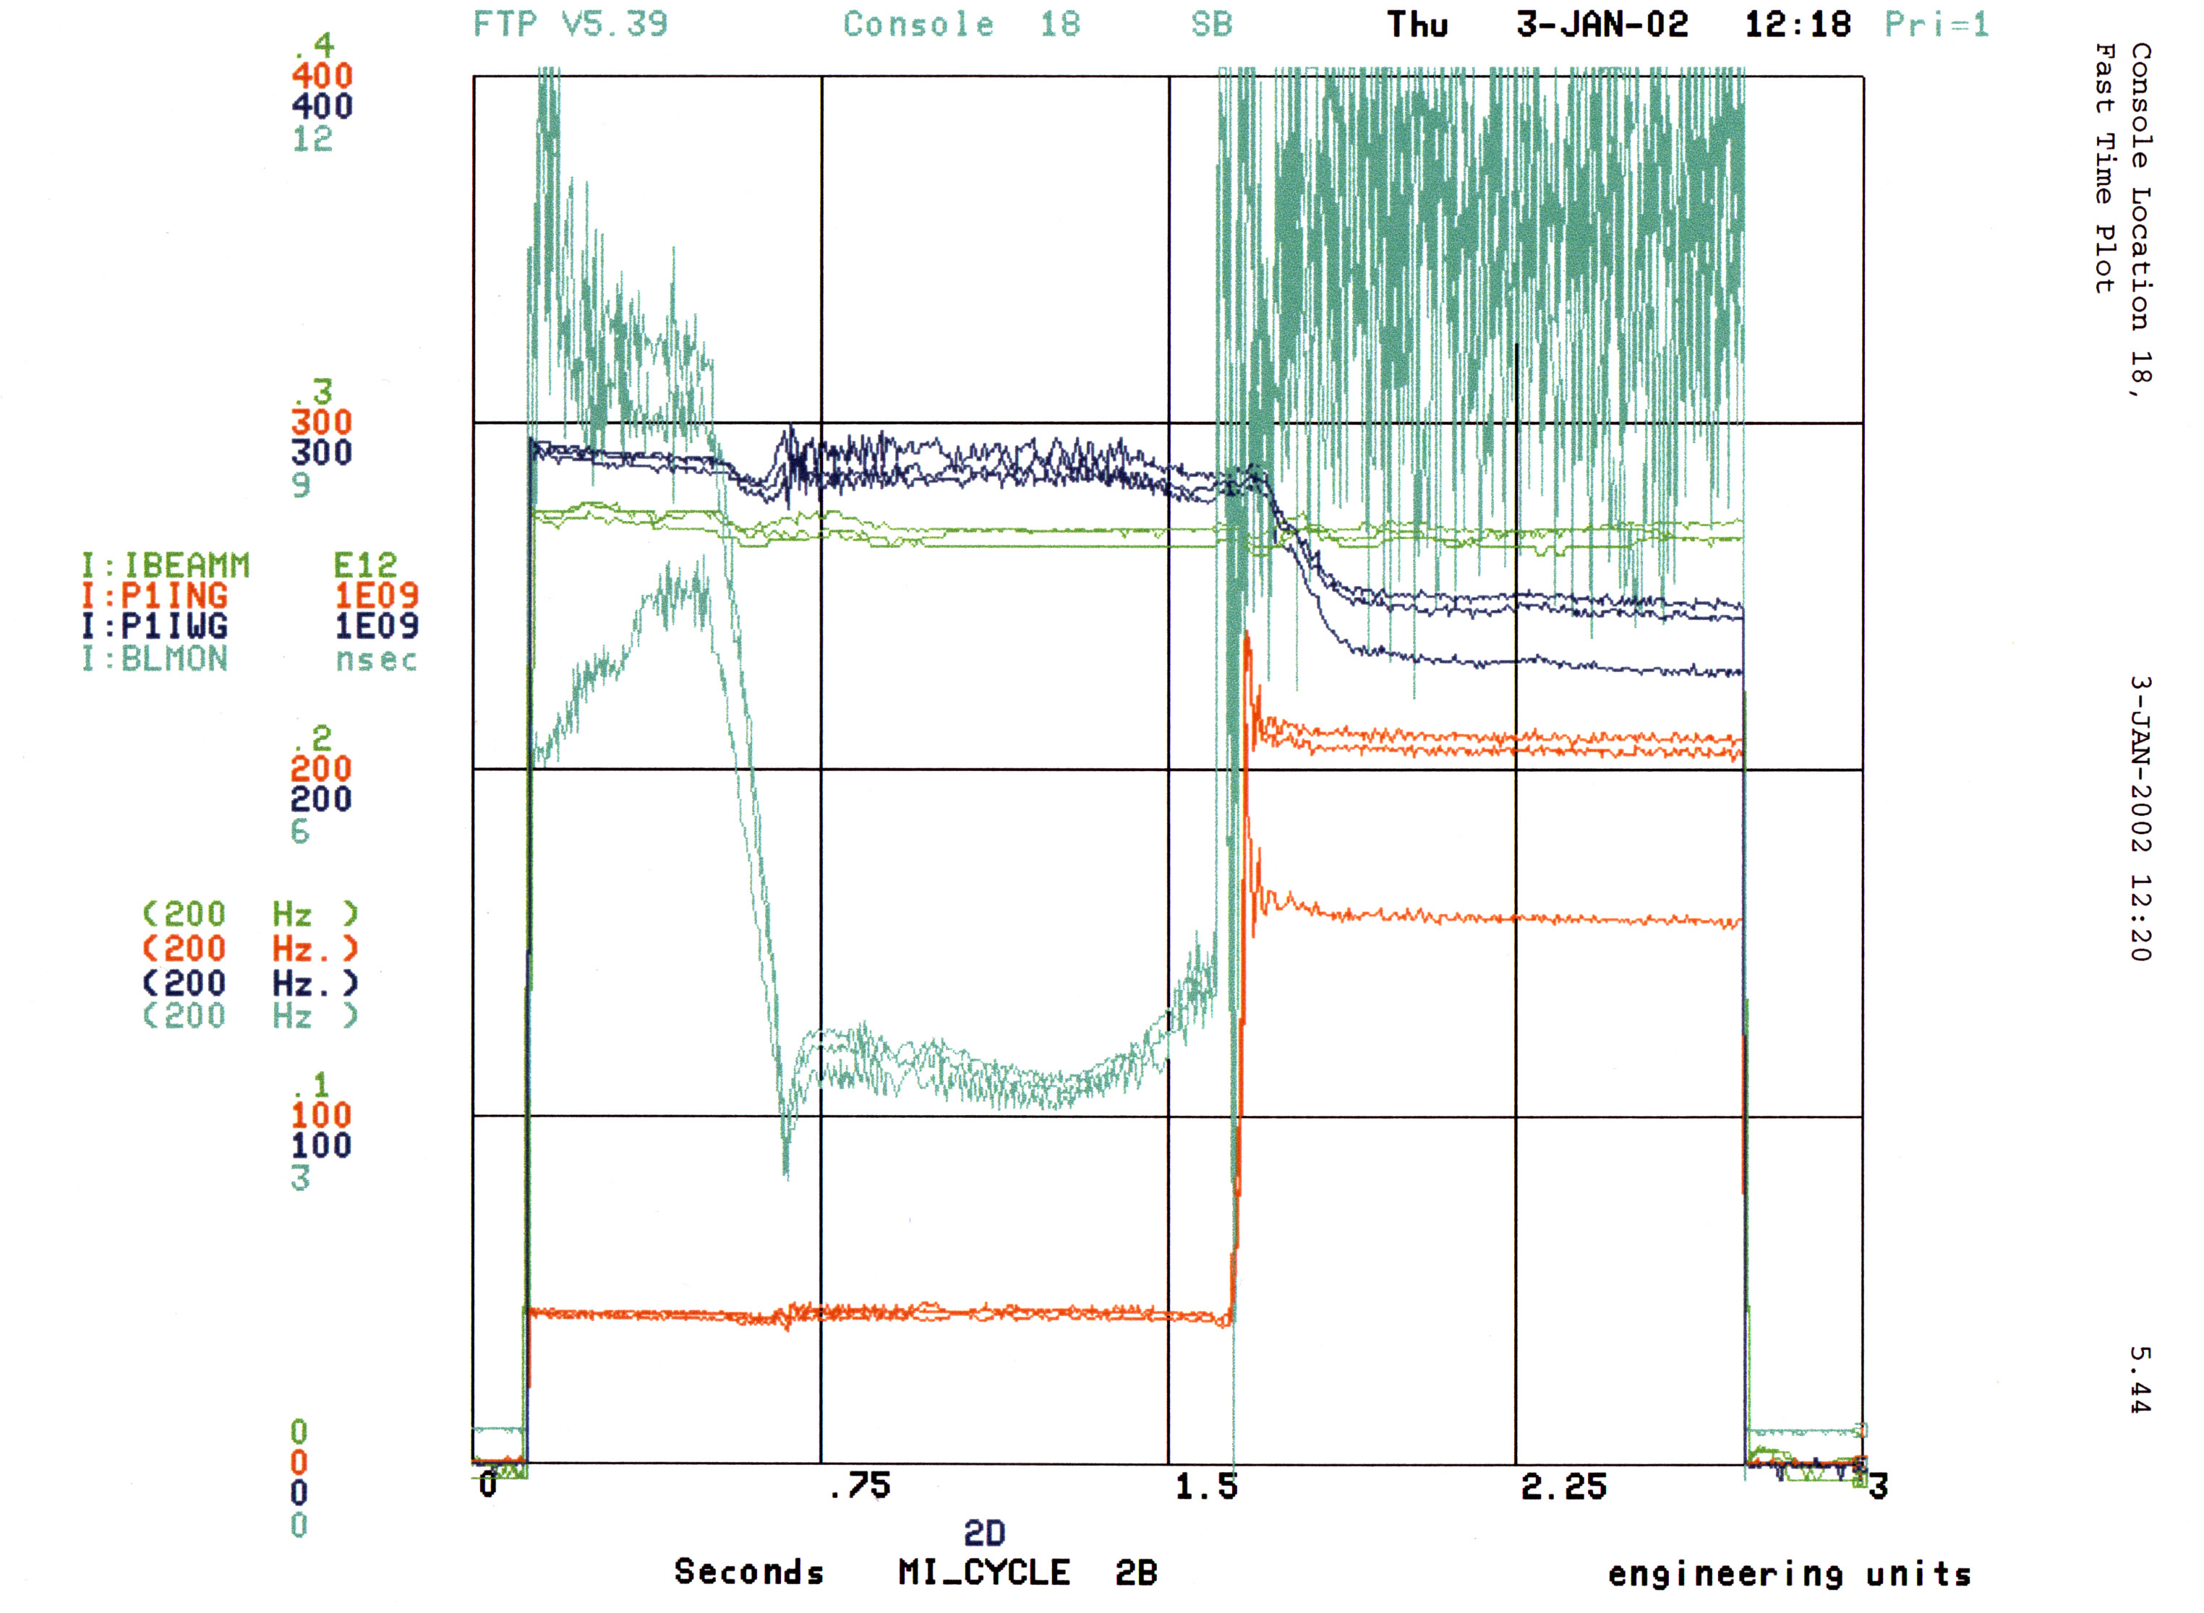

Fig. 1 Operation condition for 2B cycles with 8 Booster turns 7 bunches.

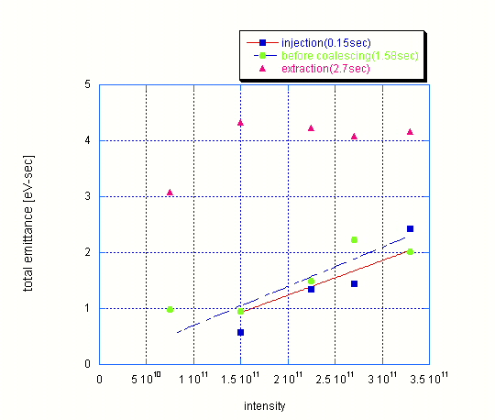

Fig. 2 Emittance at injection (0.15sec), before coalescing (1.58sec) and extraction (2.7sec) as a function of intensity.

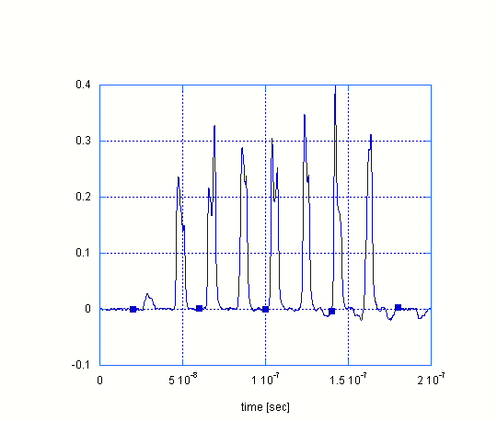

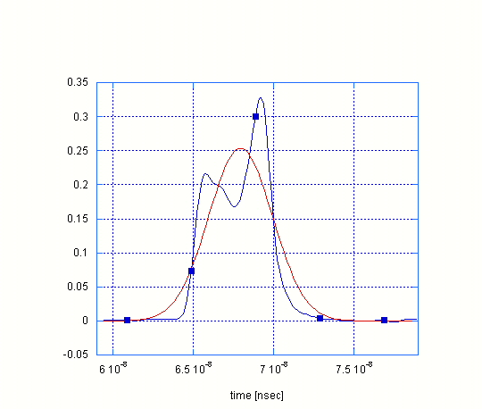

Fig. 3 Bunch shape at injection at 6 Booster turns and fitting result.

