Proton Deceleration from 150GeV to 8.9 GeV in the Main Injector:
Simulations and Beam Tests

Chandra Bhat
MI/ BD, Fermilab3/15/01

April 15, 2000
Revised on December 15, 2000
MI Note 271

Abstract

In this report we present the results of beam dynamics simulations as well as experiments with protons for deceleration from 150 GeV to 8.9 GeV. The simulation is carried out on two different deceleration schemes: deceleration with a fast recovery MI cycle using 53 MHz rf system and deceleration with a slow recovery MI cycle using 2.5 MHz rf system for part of the cycle. During October of 1999 we did the first successful deceleration of proton beam in the Main Injector from the Tevatron extraction energy of 150 GeV to the Recycler injection energy of 8.9 GeV.

Pbar recycling from the Tevatron collider runs is essential for pbar economy as well as to reach the Run-II luminosity goals. Presently scheme we are planning to recycle the unused anti-proton beam from the Tevatron by decelerating it first in the Tevatron and then in the MI, then storing and cooling the beam in the Recycler Ring [The Fermilab Recycler Ring Technical Design Report, G. Jackson, Fermilab TM-1991] till the beam is needed for next collider shots.

In this report we concentrate only on the beam deceleration schemes in the MI. We have performed beam dynamics simulations as well as experiments with protons for deceleration from 150 GeV to 8.9 GeV in the MI. In this case I have studied two schemes- one with fast recovery MI cycle and another with a slow recovery MI cycle. The fast recovery of beam in the MI comprises of a MI deceleration ramp which is almost a mirror reflection of the beam (protons or anti-protons) acceleration cycle. The deceleration of the beam from 150 GeV to 8.9 GeV is accomplished by h=588 system (53 MHz rf system). The bunches from the Tevatron are transferred to h=588 system and after some rf decelerated to 8.9 GeV. We will go through the transition energy at about 200 GeV/c/sec. At 8.9 GeV the beam bunches are transferred to h=28 system once again (2.5 MHz system) and finally beam is transferred to Recycler Ring. The entire deceleration process takes about 3 sec. A typical momentum ramp in the MI for this case is shown in Fig.1 (left).

In the slow recovery operation the beam is initially decelerated to about 25 GeV using h=588 system and the adiabatically transferred to h= 28 system and decelerated slowly to 8.9 GeV. The beam will go through the transition at a rate of <2.5 GeV/c/sec (The deceleration rate is mainly decided by the available peak rf voltage from the 2.5 MHz rf system). It is very essential to maintain the longitudinal emittance of the beam during the deceleration. The entire deceleration process will take <12 sec. A schematic wave form of the ramp to be used during this process is shown in Fig. 1. The result of a preliminary calculation carried out on these two schemes are reported earlier [C.M.Bhat and J. MacLachlan, IEEE, PAC97, p 1590].

During October of 1999 we did the first successful deceleration of proton beam in the Main Injector from the Tevatron extraction energy of 150 GeV to the Recycler injection energy of 8.9 GeV. Various steps of study of deceleration and results of beam measurements are also presented here.
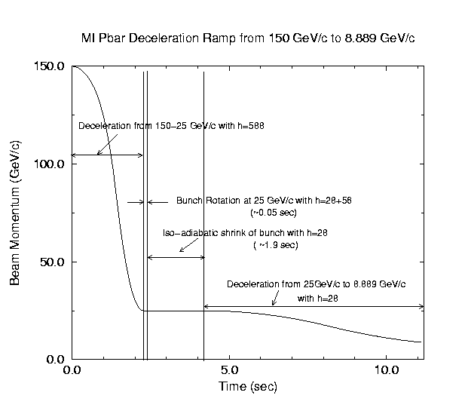
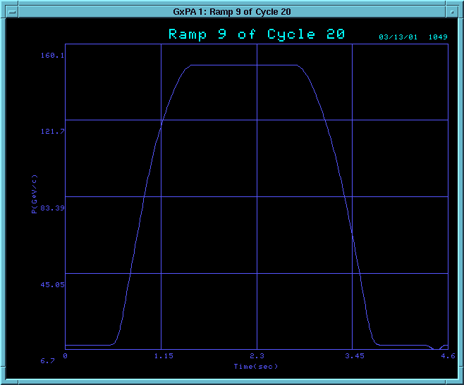

Figure 1. MI Ramps for fast (left) and slow (right) deceleration scenarios. Entire momentum ramp is shown in the case of fast ramp. Here deceleration of the beam is carried out with h=588 system. For the slow ramp we show only the deceleration part of the cycle; the up-ramp is very similar to that from left. In this case, up to 25 GeV back-porch the deceleration is carried out with 53 MHz rf system and the rest is done with 2.5 MHz rf system. rf manipulations proposed during the deceleration are indicated.

ESME Simulations :

Longitudinal beam dynamics simulations have been carried out with ESME [J. MacLachlan, ESME2000] for both the cases discussed here using the MI parameters from "Fermilab Main Injector Technical Design Hand Book, 1994". We assumed the beam particle distribution is parabolic in dE-dt space, where E is the synchronous energy of the beam particles and t is the time. The 53 MHz bunches from the Tevatron are expected to have longitudinal emittance of about 3 eVsec and two bunches are typically separated by twenty one 53 MHz bunches during Run IIA and by seven 53 MHz rf buckets during Run IIB. In our calculations we have assumed that a single bunch from the Tevatron is injected in to the MI at 150 GeV.

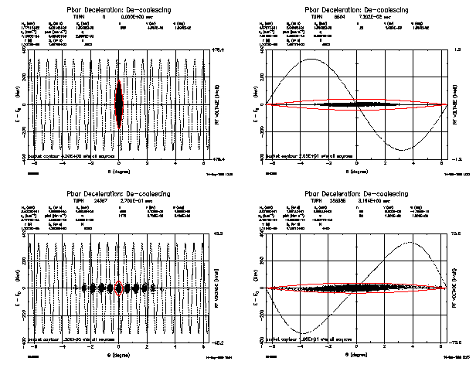

Figure 2. ESME simulations for fast deceleration ramp. dE vs dθ for the particle distributions are shown in each display. The closed contours represent bucket and the sinusoidal curve represent the rf voltage wave form. Top left: beam bunch in h=588 bucket at 150 GeV, top right: bunch in h=28 bucket at 150 GeV, bottom left: bunch in h=588 bucket at 150 GeV after re-bunching, and, bottom right: beam in h=28 system at 8 GeV before injection into the Recycler Ring.

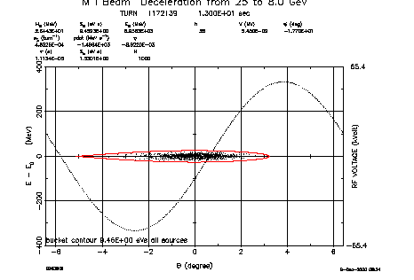
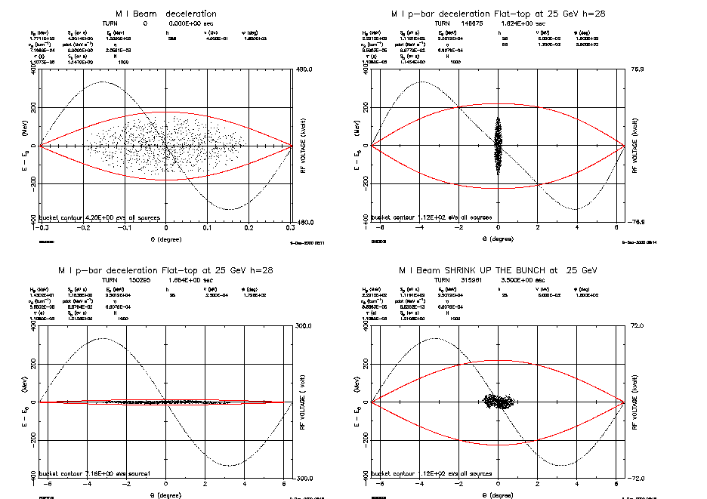
150 GeV, h=588
25 GeV, h=28,
after bunch shrink
25 GeV, h=28 after
bunch rotation
25 GeV, h=28
8 GeV, before injection to RR

Figure 3. ESME simulations for a slow deceleration ramp. The figure descriptions are given in caption for Figure 2. Top left: beam bunch in h=588 bucket at 150 GeV, top right: bunch in h=28 bucket at 25 GeV before rotation, 2nd row left: bunch in h=28 bucket at 25 GeV after rotation and matching, and, 2nd row right: beam in h=28 system at 25 GeV just before slow-deceleration, and bottom: beam at 8 GeV before injection into the Recycler Ring.

The figure 2 shows ESME results for the fast deceleration scenario. A 53 MHz bunch with longitudinal emittance of 3 eV-sec is transferred from the Tevatron and to MI at 150 GeV. We can not decelerate such high emittance bunch in the MI pass the transition. Hence, the bunch is then adiabatically re-bunched in 53 MHz buckets. This involves further rf manipulations like capturing a bunch in h=28 system and rotate by quarter synchrotron period and finally adiabatic recapture in h= 588 system. This produces a train of about 11 bunches with the maximum emittance of 0.3 eV-sec for a bunch per 53 MHz rf bucket . Such a train of bunches is decelerated all the way to 8 GeV. At 8 GeV the 53MHz bunches are recaptured in h=28 system adiabatically and finally transferred to the Recycler Ring.

Table 1

Comparison between ESME results for slow and fast deceleration schemes in the MI.

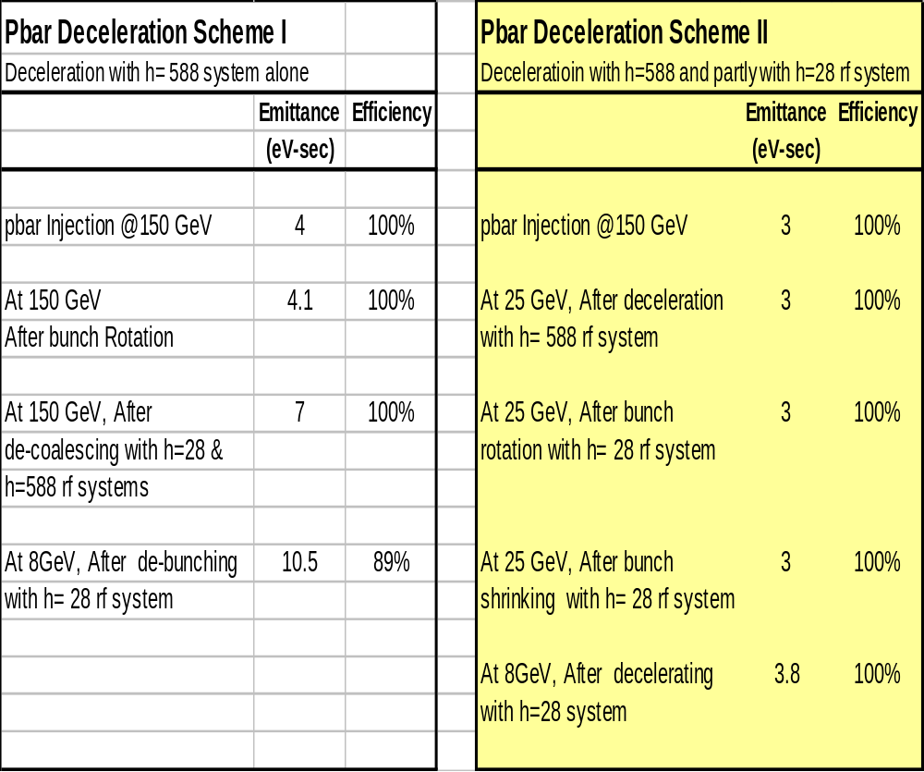

The figure 3 shows results of simulations for slow deceleration. In this scheme the Tevatron beam is transferred to MI similar to the one discussed above. However, the beam bunch is decelerated to 25 GeV back-porch without any delay using h=588 rf system. At 25 GeV the bunch is transferred to h=28 system. The bunch is rotated, shrunk and decelerated from 25 GeV to 8.9 GeV using an rf bucket with peak voltage of about 50kV. To accommodate enough bucket area we decelerate very slowly with a phase angle very close to 180 deg above transition and close to 0 deg below transition. The minimum dp/dt during the deceleration between 25 GeV to 8.9 GeV is -1.7 GeV/c/sec. In the simulation we see very small emittance growth in this method.

Table 1 compares the simulation results for slow (Pbar Deceleration Scheme II) and fast (Pbar Deceleration Scheme I). During these simulations we found that fast deceleration scheme dilutes the beam by about factor of three as compared with slow deceleration. Further we have also seen beam loss at transition in the MI with fast deceleration scheme. Thus the beam dynamics calculations showed that slow deceleration is more favorable than the fast deceleration from the point of view of transfer efficiency as well as emittance preservation. However, the slow deceleration in the MI needs hardware as well as software developments which may be desired in the long run.

Proton Deceleration in the MI from 150 GeV to 8.9 GeV:

Guided by the ESME simulations we have conducted a series of systematic experiments in the MI to decelerate the proton beam from 150 GeV to 8.9 GeV. We decided to use slow ramp for testing the proof of principle .

A controlled beam deceleration in MI is in general not very straight forward. This involves

- Ramp development - dipole, quadrupole magnet power supplies control including the hysteresis corrections
- Sextupole magnet ramp development with beam eddy current
- HLRF control
- LLRF control

The hysteresis of MI magnets plays a very important role during deceleration cycles. Besides, the MI dipole magnets will saturate at 150 GeV. Even though the momentum ramp is fairly simple, the relationship between magnet current and the corresponding magnetic field is not linear. Over the years we did a detailed study of the magnetic field as a function of the magnet current for all MI magnets both for up as well as down ramps. However, implementation of the data in real control is not trivial. For example dipole magnets, two types of quadrupoles (one for horizontal and another for vertical tunes) and two types of sextupole magnets quadrupoles (one for horizontal and another for vertical chromaticity) are found to follow one path during acceleration. In contrast to this behavior, during deceleration the quadrupole and sextupole magnetic field will follow different paths depending upon the final tune and chromaticities (i.e., the relation between magnetic field and the magnet currents are different for different final values of tune and chromaticities. [C.M. Bhat et al., PAC1997, Vancouver, p 3242]

An MI-reset event $20 is exclusively reserved for deceleration cycle. Further, three more special purpose TCLK events are also inserted in MI control system viz., $D0, to prepare deceleration, $D1- to start deceleration and and $D2- to indicate end of the deceleration. In the present experiment about twenty bunches of Booster beam is injected into the MI and accelerated to 150 GeV using normal 150GeV ramp in about 2.5 sec. The beam is held at 150 GeV for about half sec. Immediately, there after the beam is decelerated using h=588 rf system on a ramp similar to the one shown on second scheme of beam deceleration discussed earlier.

In MI the BPM gives information about the beam orbit and we have developed an orbit correction ACNET program which can be used to correct the orbit systematically on the deceleration cycle. We corrected the MI orbit on about seven break points on the down ramp. A typical example of such corrected orbit measured using MI horizontal and vertical BPM systems with about twenty 53 MHz bunches are shown in figure 4 for a break point at about 15 GeV.
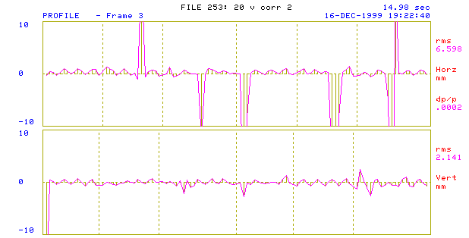

Figure 4. Horizontal (top) and vertical (bottom) BPM data taken at about 15 GeV on the down ramp in the MI. The orbit deviations from about >2 mm in horizontal plane are explained in the text above. Vertically the orbit deviation is better than 1 mm in most of the places in the ring except at MI101 location. At this location we have a vertical bump to accommodate the 8 GeV Booster beam injection in to the MI ring.

The horizontal sections on figure. 4 represent six sections of the MI ring from MI10 to MI60. The vertical scale show beam orbit displacement in mili-meter. Note that the at some locations the BPM show clear deviation from about 2 mm. These are well known locations in the MI ring. The five of them respectively correspond to MI220, MI320, MI400, MI522 and MI620 beam extraction and injection bumps. +10mm orbit near MI620 had a bad BPM. Similar data taken on the up ramp at this break point showed very little difference relative to the one shown here.

Figure 5 shows I:IBEAM (MI beam intensity in units of E10- two magenta traces), I:BLMON (measured bunch length in nsec- green trace), I:MMNTUM (beam momentum in GeV/c- pink trace) and I:RFSUM (total rf voltage in MV- red trace) as a function of time (sec).

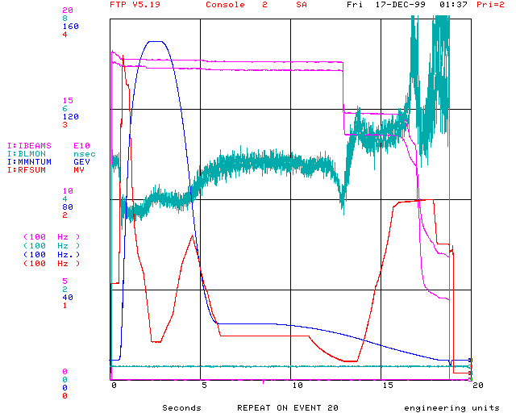
Beam
Momentum Ramp
Bunch Length
Vrf(53MHz)
Transition
Loss

Figure 5. I:IBEAM (MI beam intensity in units of E10), I:BLMON (measured bunch length in nsec), I:MMNTUM (beam momentum in GeV/c) and I:RFSUM (total rf voltage in MV) as a function of time (sec) are shown here.

Table 2 shows the measured longitudinal emittance of the beam for the entire process. We have used I:BLMON data and correct phase angle at 8.9 GeV, 150 GeV, and at 25 GeV in these measurements. (In the present LLRF system the phase of the bunch relative to the rf wave is calibrated only at 0.0deg i.e., at 8 GeV, and at 180.0 deg, i.e., at 25 GeV or 150 GeV. At other energies the phase measurements are not very reliable.) Though the 25 GeV back-porch was not necessary in the present deceleration tune up, it helped immensely to map out the longitudinal emittance at various stages of deceleration cycle.

Table 2

Measured longitudinal emittance on the deceleration ramp. The first data (injection) is taken at 8.9 GeV soon after the proton beam is injected into the MI from the Booster. The subsequent data are taken at 150, 25 and 8.9 GeV on the down ramp.
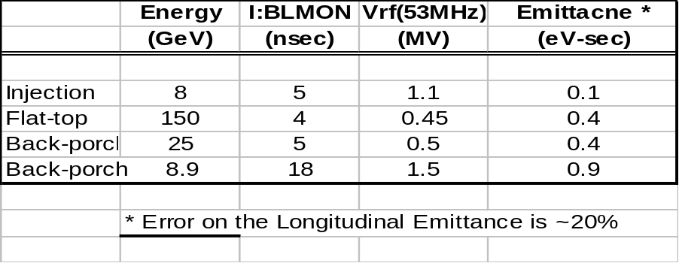
The data clearly shows that the first major emittance growth has occurred during acceleration from 8.9 GeV to 150 GeV. This may be possibly during transition crossing (We are still trying to identify this problem and fix it). During deceleration from 150 GeV to 25 GeV (possibly up to transition energy of 20.49 GeV) we do not observe any emittance growth. At transition, however, we see beam loss. This beam loss can be understood as follows:

The non-adiabatic time, Tc, for the case studied here is about 20 msec as shown in Table-3. The maximum (dp/p)99% corresponding to the MI admittance of 0.5 eV sec is 0.9 %. But, the (dp/p)99%(beam) corresponding to I:BLMON of 4 nsec ( from the figure 5) near transition energy is about 1.1%. Hence, we see beam loss near transition as expected. About 15% beam loss is observed under present conditions.

A simple extrapolation of the results of the experiment to a case of deceleration with h=28 system (as proposed in RR design report) with about 60 kV of rf voltage suggests that one should be able to decelerate a bunch with longitudinal emittance as big as 7 eV-sec through transition without any beam loss.

Table 3

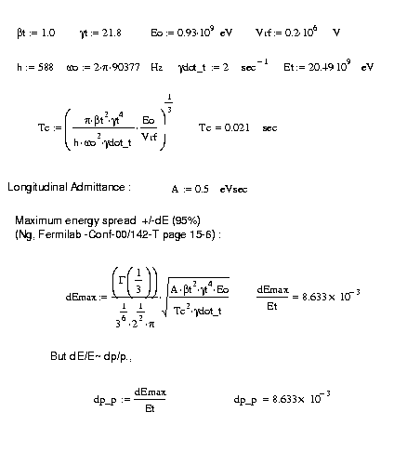Calculation of non-adiabatic time Tc and Maximim dE/E at transition. All the required quantities are listed in the below chart. (The formulae are taken from K.Y. Ng Fermilab TM-1696 page 134.)

The Figure 5 also shows that there is beam loss from about 13.5 GeV (at about 15.8 sec on the figure). The dp/dt at this point in the deceleration cycle is about -2.2GeV/c/sec. The rf voltage was 2MV. This implies that the deceleration phase angle is ≈0 deg and the bucket area (BA) is same as stationary bucket area; BA= 2.9 eV-sec. As we can see the bunch length is about 5.5 nsec and the estimated longitudinal emittance of the bunch is about 0.5 eV sec (with a small emittance growth; possibly arising during transition energy crossing). In any case there is enough bucket area below 13.5 GeV. However we observed beam loss. My conclusion is that this beam loss is not because of lack of rf buket area. It needs further investigation on issues like power supplies turn off order during deceleration or any instrumentation problems.

Table 4

Comparison between set values and measured values of horizontal and vertical tunes in the MI for the deceleration ramp. The errors are also indicated.

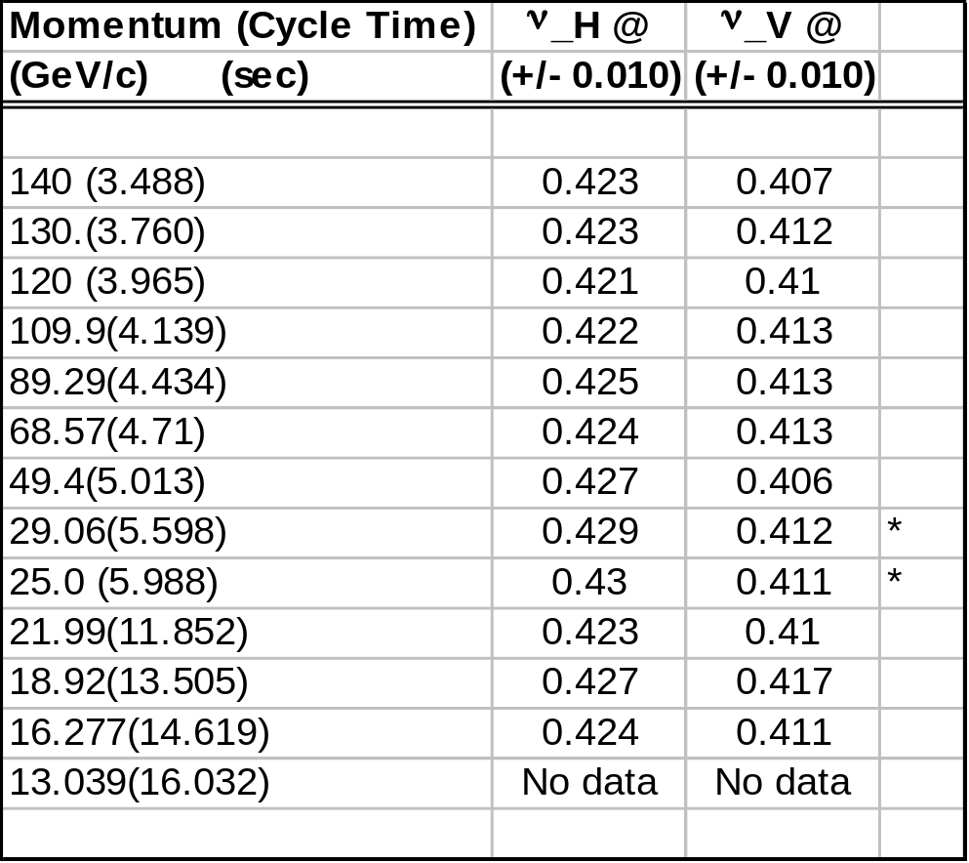
@ The measured tunes have error ≈ ±0.005 above 49.5 GeV
and ≈ ±0.01 for P < 45 GeV
* Multiple measurements of tune on different days

Tune Measurement from 150 GeV - 8 GeV
with a set values of ν_H=0.425 and ν_V=0.415

We have also measured the tune of the MI during beam deceleration after a careful calibration of the tune table. These measurements were carried out using turn by turn program (I42) which collects BPM data and does FFT to extract the fractional part of the tune of the machine. The results of measurements are shown in Table 4 and is compared with the set values of Qh=25.425 and Qv=26.415. We have measured tune only up to about 16.3 GeV. The tune data below 16.3 GeV were not reliable because of large uncertainty in the FFT of the BPM data.
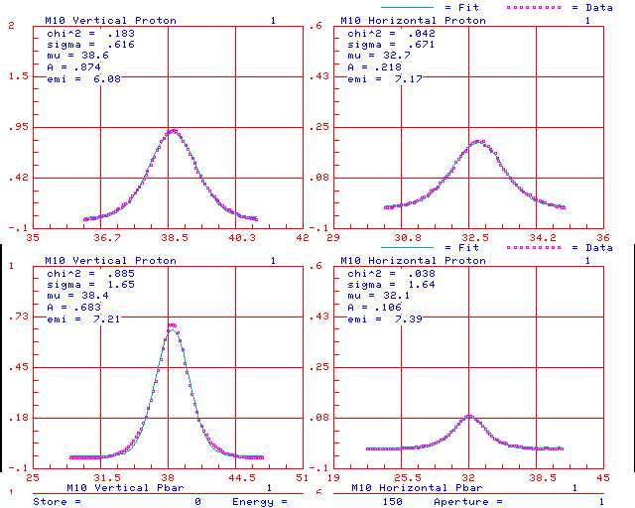
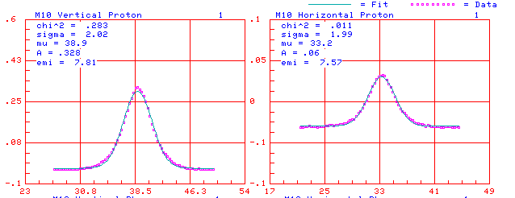
150 GeV
18 GeV
25 GeV

Figure 6. Flying wire data for measured transverse emittance in the MI during deceleration. The data clearly shows no transverse emittance dilution during deceleration from 150 GeV to 18 GeV

The transverse emittance are measured using flying wires of MI. Typical data from 150 GeV to 18 GeV are shown in Figure 6. We did not see any transverse emittance growth during the deceleration.

Conclusions and Future Prospects :

We have carried out longitudinal beam dynamics simulations of beam deceleration in the MI for two potential deceleration schemes. We find that the deceleration scheme which uses 2.5 MHz (h=28) system for part of the deceleration has advantage over the other scheme which uses h=588 system throughout the deceleration process. The major merit lies during transition crossing. However, the first method needs additional hardware and soft ware developments implemented in the MI accelerator system. With the existing instrumentation second method is more practical at present.

We have conducted series of deceleration experiments using proton beam in the MI. This was the first attempt of proof of principle for decelerating the beam in the MI. The deceleration was carried out with h= 588 rf system on a slow ramp and we were able to successfully decelerate the beam from 150 GeV to 8.9 GeV. The beam transmission efficiency was about 100% up to transition energy and from transition to about 13 GeV it is about 85%. From then on beam is lost significantly because of limited bucket area. At 8.9 GeV about 40% of the beam survived. We have made longitudinal as well as transverse emittance measurements during the deceleration. We have observed significant longitudinal emittance dilution below transition energy. However, the measured transverse emittance did not show any noticeable dilution.

We plan to continue our effort to improve the transmission efficiency through the deceleration cycle. Our future plan include

- Test the feasibility of beam deceleration with the first scheme outlined earlier. Though we anticipate the longitudinal emittance of the beam at 8 GeV to be about three times larger than MI to RR transfer line admittance and , by this method we may be able to recover only about 50% of the Tevatron pbars, implementing this method of deceleration in MI is operationally simpler.

- The slow deceleration will also be tried. As mentioned earlier this needs HLRF and LLRF improvements. During the last few months we have carried out a set of heating experiments on the 2.5 MHz rf system and we are convinced that the 2.5 MHz rf cavities should not pose any problems [C.M. Bhat and Joe Dey MI Note-272]. However, one need to implement 2.5 MHz bunch diagnostics in the MI to make this method feasible.

Acknowledgments :

I would like to thank Guan Wu for his help in modifying the MI orbit correction program, "I50" to include the deceleration ramp, Keith Meisner and Brain Chase for their help in LLRF system. My special thanks are due to MCR operation group.

