MI-0294

Slip Stacking at Low Intensity – Status of the Beam Studies

Kiyomi Koba

February 03 03

Abstract

We have started beam studies for ‘slip stacking’ in Main Injector(MI) in order to increase proton intensity for anti-proton production. It has been verified that the system for slip stacking works for a low intensity beam. Although no beam loss was observed, there was an unexpected longitudinal emittance growth.

1. Introduction

For slip stacking, we use three different rf systems and follow four steps. Step 1: The first bunch train is injected from the Booster on the central orbit and captured by the first rf system. To make a room for the second bunch train, the first bunch train is then decelerated until it circulates on the inside of the central orbit. Step 2: The second bunch train is injected on the central orbit and captured by the second rf system. Step 3: As the two bunch trains have slightly different energies, they can move relative to each other. Step 4: When the two bunch trains coincide at the same longitudinal location, they are captured by the third rf system.

Beam studies of the slip stacking process have started and we have already established that the stacking procedure works as expected. Frequency separation and Booster bunch rotation studies were also done to allow us minimize the longitudinal emittance at recapture.

2. Momentum aperture scan

Since two bunch trains have different energies, MI must have an enough momentum aperture to accept both. The momentum aperture of MI is +/-0.7% at injection, Fig. 1, corresponding to the frequency separation of +/-3000Hz from the central value of 52.8114MHz.
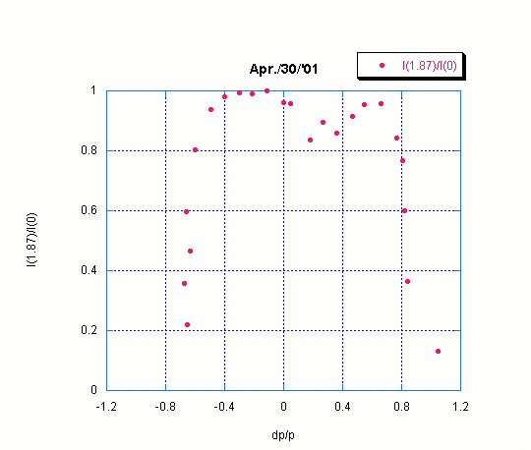
Figure 1. Momentum aperture scan at MI injection. Beam loss ratio as a function of momentum spread.

3. Frequency separation

Since there are two rf voltages during stacking, they act on both bunch trains. The bunch shape has been measured to demonstrate that the frequency separation between the first and the second rf systems is adequate.

In this measurement, one bunch train was injected, then two rf voltages were raised and the frequency separation was increased from 400 to 1200Hz. Figure 2 shows the bunch shape at injection and at 150msec after injection. The signals, plotted here with 5nsec/div, were obtained with a wall current monitor. It is clear that the frequency separation of 1200Hz is enough to keep the bunch shape unchanged.
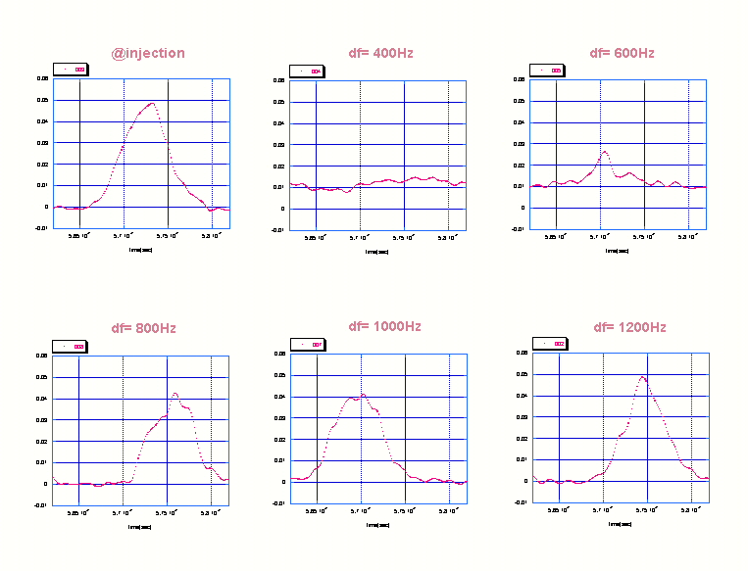
Figure 2. Wall current monitor signals at injection and after 0.15msec.

4. RF system

MI has 18 53MHz cavities. These are in to two groups, A and B, each with 9 cavities. Low level RF (LLRF) signals go to two groups of cavities individually. For the slip stacking, we are using one out of 9 cavities in each group at injection. The rf voltage at injection is adjusted so that one cavity produces 62 kV in order to achieve a low momentum spread.

5. Injection matching from Booster to MI

At extraction, the Booster rf voltage is 380kV, which matches to MI injection voltage of 1MV for the normal operation. Since the MI injection rf voltage is 62 kV for the slip stacking, a bunch rotation is carried out in Booster before extraction so that the bunch shape will be matched to the rf bucket of MI at injection. As the Booster rf voltage is rapidly reduced, the bunch starts to rotate in the phase space. After a quarter of synchrotron period, the bunch is injected to MI. Figure 4 shows the wall current monitor (WCM) signal at Booster extraction. The rf voltage was changed from 380kV to 130kV in 50μsec and the bunch started a rotation with the rotation period of ~300μsec.
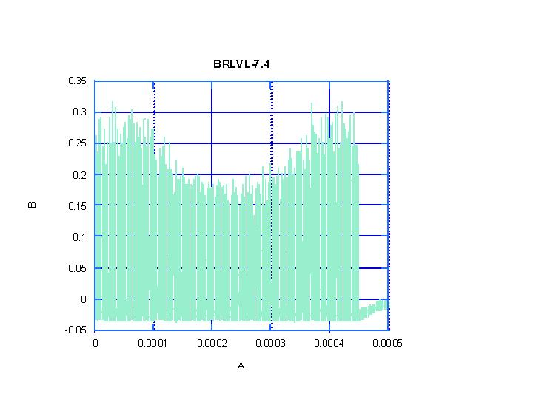
Figure 3. Bunch rotation process at Booster extraction. WCM voltage as a function of time.Horizontal scale is 100μsec/div.

6. RF frequency curves

The frequency as a function of time is shown in Figure 4 for the first and the second rf systems. Of 18 cavities at 53MHz, one was used for the first system, another for the second system. The frequency separation was kept at 1200Hz. The first bunch train was injected on the central orbit with nominal frequency at 0.13msec and captured by the first rf system of 62kV. At this time, the frequency of the second rf system was 1200Hz higher than the first rf system. The first bunch was then decelerated to the frequency 1200Hz lower than the original value. After one Booster cycle of 66.7msec, the second train was injected on the central orbit and captured by the second rf system. After slipping, both bunch trains were captured by all 18 cavities with 800kV and 0 frequency separation.
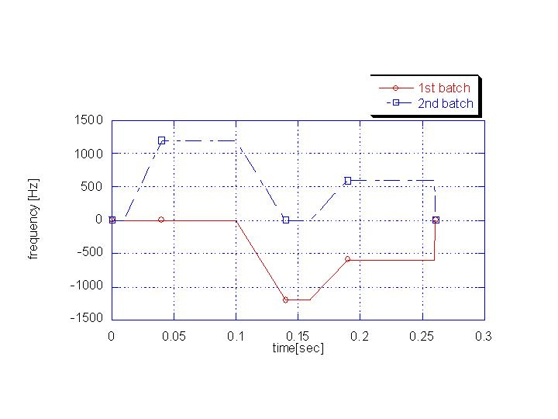
Figure 4. Frequency for 1st bunch train and 2nd bunch train as a function of time.

7. Beam studies with low intensity for slip stacking

Two bunch trains, each with 82 bunches, were injected to MI. The total intensity for two trains was low, 0.8*10¹²ppp, in order to reduce beam loading effects.

Figure 5, a mountain range picture of the signals from the WCM, reveals the progress of slip stacking from the beginning to the end. The signal came from WCM with a resolution of 0.5nsec/sample. The data were obtained every 1.42msec for 0.18sec. At the same time, the total beam-intensity and the intensity within the gate equivalent to one rf bucket width were also measured and plotted in Fig.6. The one bucket intensity was 9E9 which is equal to 0.8E12/(82*2). This indicates that there was no beam loss during the slip stacking process. The intensity of the 1st bunch of the1st bunch train was estimated by integration of bunch area obtained by the WCM. Figure 7 shows the result of the integration and the position of the center of the bunch. When two bunches were recaptured by one rf bucket after 0.17 sec, the intensity became twice of what was before while the bunch position did not move.

The length of the 1st bunch of the 1st bunch train shown in Fig. 5 was used to estimate the emittance. Figure 8 shows the estimated 95% emittance during 0.18sec. Since there was an empty space between upper and lower bunches, there should be an emittance growth. The calculated growth rate is a factor of 3.2. From the plot, we see that there is no emittance growth before the two batches are recaptured by one rf bucket but there is a factor of 4.0 emittance growth after the recapture.
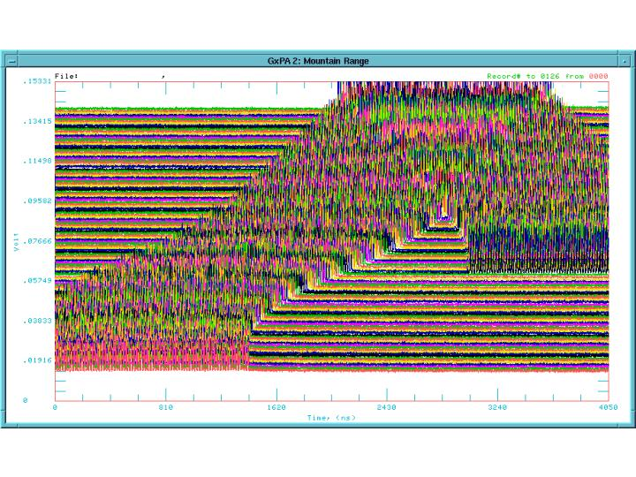
Figure 5. Mt range plot. The signal came from WCM with a resolution of 0.5nsec/sample. The data were obtained every 1.42msec for 0.18sec.

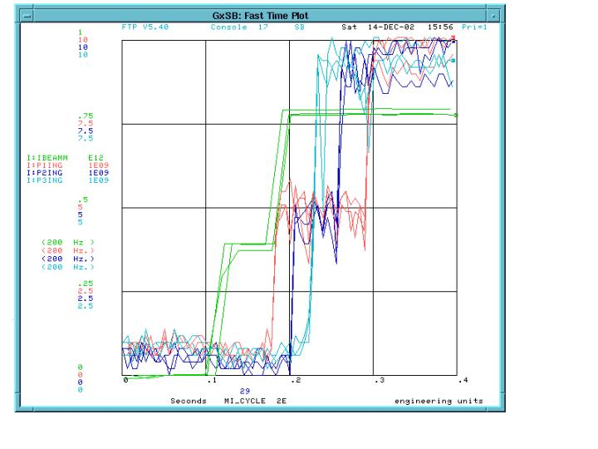
Figure 6. Total beam-intensity(I:BEAMM) and the intensity within the gate equivalent to one RF bucket width at 2000nsec(I:P1ING), 2400nsec(I:P2ING) and 2800nsec(I:P3ING).
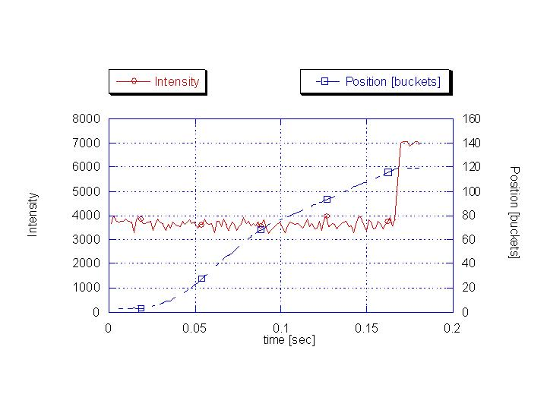
Figure 7. The intensity of the 1st bunch of the1st bunch train was estimated by integration of bunch area shown in Fig.5. The center position of the bunch was also measured.
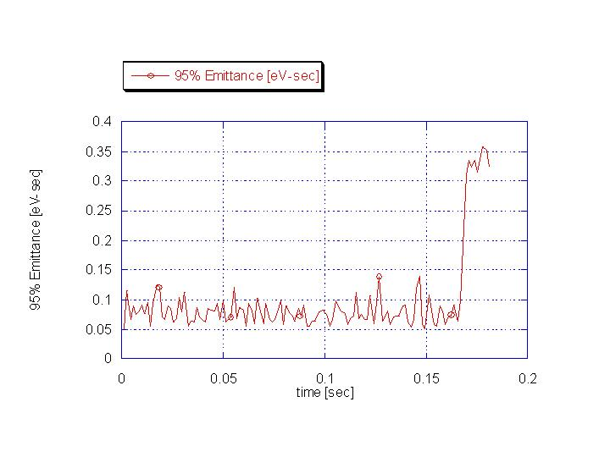
Figure 8. The 95% emittance estimated by bunch length shown in Fig.5.

8. Simulation studies

To understand what caused the emittance growth at recapture, simulation studies were carried out using the code, ESME. In the simulation studies, the time and voltage to recapture bunches were varied because LLRF timing had a jitter and also the rf voltage was changing after the recapture as shown in Fig. 9.

Figure 10 shows the phase space at recapture time. The delay was changed from 0 to 250 μsec and the 95 % bunch length after 15msec was measured. The emittance plotted in Fig. 11 was estimated from the bunch length. It is increased by a factor of 3.2 to 7.0 with increasing delay. Since LLRF has a time jitter of 1.38msec maximum, it could cause the emittance growth.

The recapture voltage was changed from 0.5 to 1.0MV because the voltage is changing from 0.8 to 1.0MV after the time to recapture. The 95% emittance plotted in Fig. 12 shows the emittance growth by a factor of 3.2 to 3.6.

By the two simulation studies, it was verified that the emittance growth is mainly due to LLRF jitter.

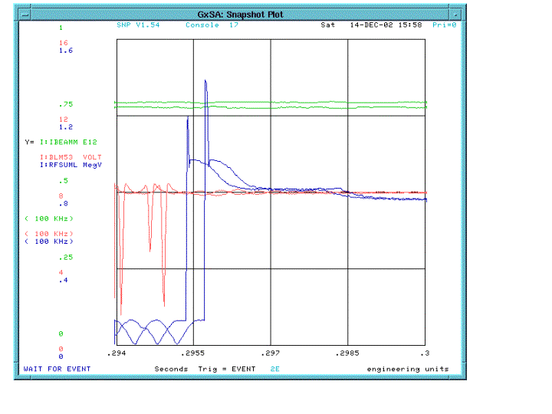
Figure 9. Total rf voltage(I:RFSUML).
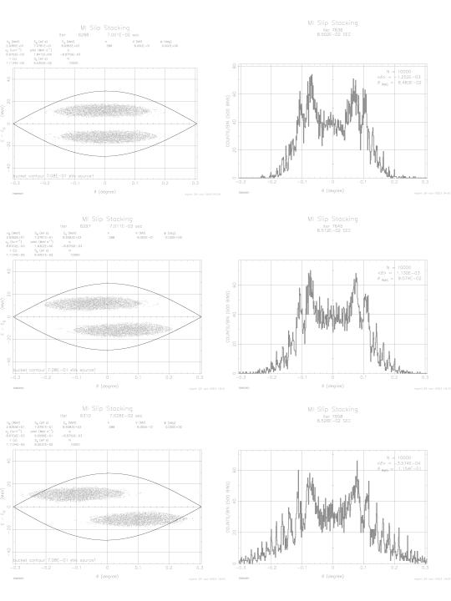
Figure 10. The phase space at recapture time and bunch shape after 15msec. The delay were 0sec(upper), 100μsec(middle) and 250 μsec(lower).
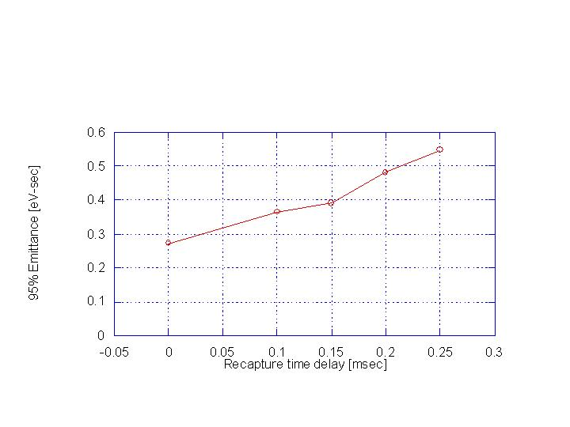
Figure 11. The 95% emittance estimated VS recapture delay time.
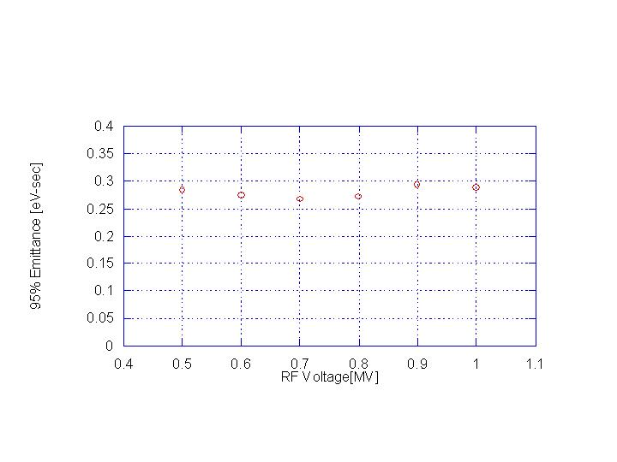
Figure 12. The 95% emittance estimated VS recapture rf voltage.

9. Conclusion

Beam studies have stared for the slip stacking process and we have already verified that, at least for low beam intensity, the stacking procedure works as expected.

There was no beam loss during the process, but there was emittance growth when two bunch trains were recaptured. Simulation studies have indicated that the emittance growth is caused by LLRF timing jitter. During a shutdown (Jan.13 03 ~ Feb.03 03), the LLRF jitter was improved to the resolution of 10 μsec and this should help reducing the emittance growth.

For higher intensity operation, development work of the feedback and feedforward system is under way.

