
Fermilab/BD/TEV
Beams-doc-1065-v7
March 30, 2004

Electronic Design document

Vince Pavlicek, Mark Bowden, Bill Haynes, Ken Treptow, Margaret Votava
Fermilab, Computing Division, CEPA

Bob Webber, Jim Steimel
Fermilab, Accelerator Division, Accelerator Controls Department

Abstract

This document contains the specification for the Beam Position Monitor/Beam Loss Monitor (BPM/BLM) upgrade data acquisition hardware. Expected operating modes and interactions with the BPM software are described. Analog signal processing, timing system and diagnostic circuits are specified in this document. Calibration and diagnostics procedures are described.

The BLM upgrade is a separate project. References to the BLM system are included to provide only the functionality equivalent of the existing system. It is expected that the BLM upgrade project will supersede and replace functions described in this document before the BPM hardware is complete

While this document is in draft form, Vince Pavlicek will be the editor. If you have suggestions or changes, use a copy of the document, turn on change tracking, and send the document to Vince@fnal.gov. He will integrate the changes into the database document. Thanks.

Overview 3
Beam Position System 4
Sensor 4
BPM Data Acquisition System 4
BPM Requirements 7
Data Acquisition Operation 8
Functional Overview 8
Tevatron Filter board 8
Echotek Data Converter Module 9
Timing Generator Fanout (TGF) Module 10
Timer Counter 17
Sub Rack Processor Module 17
Sub Rack Cables 17
Data Acquisition Operations 17
BPM Measurement types 17
BPM Data Acquisition Modes 18
Closed Orbit operation 19
Turn by turn 19
Injection 19
Diagnostic Mode 19
Appendix 21
Schematics, Layouts and drawings. 21
Timing Generator Fanout Module 21
Tevatron Filter board 21
Filter Specifications 21
Cable Specifications 21
Sub rack Specifications 21
BLM Notes 21
Beam Loss Monitor 21
BLM Operations 21
Echotek DSR Module 22

Overview
This document describes the hardware needed for the data acquisition component of the Tevatron Beam Position Monitor (BPM) upgrade project. The data acquisition (DA) hardware will digitize the analog position signal from the BPM sensors, digitally filter the signals and make them available to a VME front-end computer. The DA could also provide the interface to the Beam Loss Monitor (BLM) circuitry through the External Device Bus (EDB) to replace the functionality of the existing system. Figure 1 shows the functional block diagram and the different elements involved with the BPM upgrade project.

Figure 1 BPM Front End Functional Block Diagram

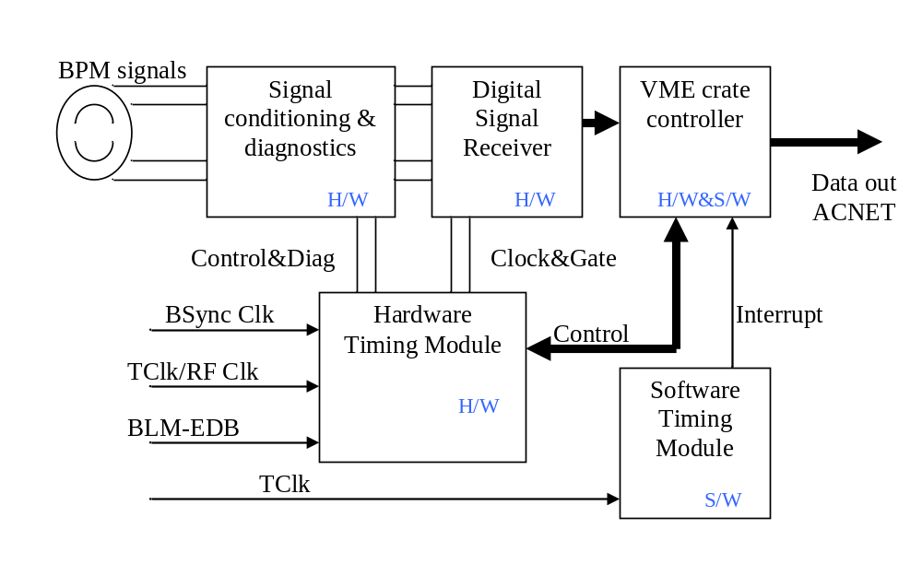The hardware functions described in Figure 1 are implemented in four modules that match the hardware blocks above. The signal conditioning and diagnostics are implemented on the Filter module being designed at FNAL. The Digital Signal Receiver (DSR) is a Commercial-Off-The-Shelf (COTS) module from Echotek Corporation, the ECDR-GC814/8-FV2. The timing functions are implemented on the VME Timing Generator Fanout module designed at FNAL. The VME sub rack controller is a COTS Single Board Computer from Motorola Corporation, the MVME2400

Beam Position System

Sensor
The Tevatron BPM sensors ^{and} are two opposing curved stripline plates approximately 18 cm long along the beam and oriented to partially surround the beam. Each plate subtends approximately 110 degrees of the full circle around the beam. The circular aperture of the pair (the diameter of the opening) is 6.6 cm. There are connections at both ends of each plate, one connection emphasizing the proton direction of flight and the other the anti-proton direction. The signal taps are at the ends of the individual plates. The convention for the naming of the four signals from a specific BPM sensor are a letter designator for each of the two plates, the A plate, and the B plate, and whether it is the proton end or the anti-proton end. Each of the four BPM signals is treated identically in this Data Acquisition (DA) system except for a resistive attenuator which matches the sensor voltage to the input voltage range of the Echotek module and can also be used to approximately match the proton and anti-proton signal amplitude ranges. The signal of interest is the amplitude variation of the sensor signals as the beam position moves in the sensor but the amplitudes are also proportional to the number of particles passing through the sensor and to the bunch length. In 2004 the bunch size based variation of the amplitude of the proton signals at the proton outputs is approximately 5 times as large as the anti-proton signal at the anti-proton outputs. The 236 Tevatron sensors are on the end of quadrupole magnets in the beam tunnel and the BPM DA electronics modules are in service buildings around the ring. 200 to 300 meter long RG-8 cables bring the sensor signals to the DA system and the Tevatron Filter board.

BPM Data Acquisition System
The BPM signals pass through the Tevatron Filter board for amplitude conditioning and band pass filtering. The filter is centered at the 53.104 MHz accelerator RF frequency with a bandwidth of approximately 7 MHZ. The filter specifications are in Beams Document #1065. This module also has the capability to switch in a diagnostic signal and drive that signal out to the sensor or back toward the Echotek module input. By sequentially driving one output of a sensor and digitizing the other three sensor signals the general condition of that sensor and its associated cable plant can be determined.

Short coaxial cables move the signals from the Tevatron Filter board outputs to the Echotek commercial digital signal receiver module that is the Analog to Digital converter and main signal processing element. On the module, the sensor signals are converted from analog to digital representation, passed to a Digital Down Converter (DDC) signal processing chip for base banding, filtering and then placed in memory that is accessible through the VME backplane bus. The data movement is controlled by firmware in a reprogrammable FPGA device on the module. The VME sub rack controller is a Motorola MVME2400 type processor that controls the data acquisition process. The software that resides on the front-end microprocessors, also referred to as the Data Acquisition (DA) software, is described in Beams Document #860, Tevatron BPM Upgrade Software Specifications for Data Acquisition. The system timing is controlled by the VME BPM Timing Generator Fanout module. The TGF timing is based on three Tevatron timing signals. 1) the Tevatron RF Clock (RFClk) at 53.104 MHz which is synchronous to the Tevatron beam, 2)Tevatron Beam Sync (TVBS), running at 7.5 MHz synchronous with the RFClk and containing some Tevatron commands and the encoded turn marker, encoded as 0xAA, and 3) Tevatron Clock (TClk) running at 10 MHz and containing accelerator-complex-wide commands.

The sensor front-end electronics depicted in Figure 1 are contained within a VME sub rack holding a series of pairs of Tevatron Filter boards and BPM VME digitizing boards, the BPM Timing Generator Fanout card, the sub rack controller and, if necessary, BLM interface hardware. Error: Reference source not found illustrates the organization of the cards in the BPM VME sub rack. One sub rack can hold the necessary electronics needed for a service building (sometimes called a house). There are 30 service buildings or houses around the Tevatron ring, 27 of them contain BPM electronics and each BPM house has up to 6 BPM digitizing boards. There are also up to 23 BLM digitizing boards in separate analog crates. Table 1 is the current organization of BPM and BLM sensors relative to the service buildings.
Table 1
Service Building | BPMs | BPM Modules | BLMs
A0 | 4 | 2 | 12
A1 | 10 | 5 | 9
A2 | 9 | 5 | 9
A3 | 8 | 4 | 8
A4 | 9 | 5 | 8
B0 | 6 | 3 | 22
B1 | 10 | 5 | 9
B2 | 9 | 5 | 9
B3 | 8 | 4 | 8
B4 | 9 | 5 | 12
C1 | 10 | 5 | 12
C2 | 9 | 5 | 9
C3 | 8 | 4 | 8
C4 | 9 | 5 | 8
D0 | 6 | 3 | 23
D1 | 10 | 5 | 9
D2 | 9 | 5 | 9
D3 | 8 | 4 | 8
D4 | 9 | 5 | 8
E1 | 10 | 5 | 9
E2 | 9 | 5 | 9
E3 | 8 | 4 | 8
E4 | 11 | 6 | 11
F1 | 12 | 6 | 12
F2 | 9 | 5 | 9
F3 | 8 | 4 | 8
F4 | 9 | 5 | 8

The BPM digitizing modules are Echotek module ECDR-GC814/8-FV2, and each module digitizes signals from 8 channels. An individual BPM sensor generates information on 4 channels – the A and B plates for the proton end of the sensor and the A and B plates for the antiproton end. Therefore one Echotek module will be capable of accepting signals from two BPM sensors. The digitized output that results from each channel of the digitizing module may be either a calculated position or the digitized and filtered signal data. The details are in the Software Specifications document. If it is the digitized and filtered signal data, each channel is actually represented by two components: a real (Q) and imaginary (I) part.

The operation of the Echotek module is controlled by two inputs that are common for all eight channels. They are the CLK and SYNC signals. The digitizing clock paces the Echotek module and comes from the BPM Timing Generator Fanout (TGF) Module. A phase-lock-loop on the Timing module creates a clock output that has a fractional relationship to the Tevatron RF clock frequency. TeV RF is approximately 53.104 MHz. The Echotek clock is 7/5^{ths} or approximately 74.346 MHz. This means that the 53.104 MHz signal is technically under-sampled but the signals-of-interest are modulated onto that RF signal and filtering and signal processing techniques allow the module to extract those signals-of-interest. The digitization process can be gated, singly triggered or triggered for a specified number of samples by the SYNC signal. SYNCs are generated in the TGF and normally initiated with respect to the Tevatron-wide TCLK signal which carries Main Control Room (MCR) commands and state information. There are two TCLK decoders, called UCD modules) in a given house; one PCMUCD on the sub rack controller, in a PMC slot, and one on the TGF Module. The TCLK decoder on the TGF can initiate digitizing sequences based on selected TCLK commands and can add fixed delays, with a resolution of one RFClk period, in order to remove cable delays (w/ a resolution of one RFClk period) or to time-in similar actions between the widely separated service buildings around the Tevatron ring. The ACNET/MOOC software infrastructure and applications can also be triggered by interrupts generated by the same or other TCLK signals that are decoded by the PMUCD card and this is discussed in detail in front-end software design document (#1067).

CPU
Timing
Generator
Digital Receivers
PMC
UCD
Tevatron Filter board
Clock generator incorporated into Timing Generator module
Figure 2 Sub Rack Module, Example Configuration

BPM Requirements
The requirements for this system are based on the system requirements documented in Tevatron BPM Upgrade Requirements Document (Beams Doc #554). A summary of the functional requirements are:

- Continuous closed orbit sampling with ~ 1 kHz of IF bandwidth and 500 Hz measurement rate.
- Closed orbit position should be stable for single bunch, multiple bunches and uncoalesed bunches.
- Turn-by-turn sampling with ~ 100 kHz of IF bandwidth and 47 kHz measurement rate. Store 8192 points/turn-by-turn request.
- Simultaneous measurement of protons and pbars. Measure pbars with closed orbit sampling and proton de-convolution (no change from closed orbit sampling) or use short gate sampling. Short gate sampling is a technique uses to separate proton signals from anti-proton signals on the same sensor lines. The technique is described in Beams Document #1200.

Data Acquisition Operation

Functional Overview

The communication between the front-end processor and the Echotek modules happens through the VME backplane. If necessary, BLM data is exchanged through a digital I/O interface on the TGF board or as an I/O daughter board on the sub rack processor.

Data coming from the BPM are stored into a set of buffers in the sub rack controller. The depth and number of logical buffers that reside on the sub rack controller is defined in the Front-end Software Design Document (Beams Doc #1067). Some of the buffers, most notably the turn by turn data, is first stored in memory on the Echotek boards and then transferred to the sub rack controller on demand, as the processor/backplane does not have the bandwidth to acquire it in real time. The actual physical implementation of the sub rack controller buffers will be described in the front-end software design document.

Tevatron Filter board

The Tevatron Filter board conditions the signals from the Tevatron BPM sensors for input to the Echotek DSR Module. It also provides for injecting a diagnostic signal back into the sensor, into the Echotek Module, or both. Schematics for the Filter Card are in the Tevatron Filter board Appendix.

The Filter Card has eight channels so that one module is required for each Echotek Module. Each channel (Figure x) consists of an attenuator network, a band pass filter, and two relays. The BPM signals enter and exit via SMB connectors on the front panel.

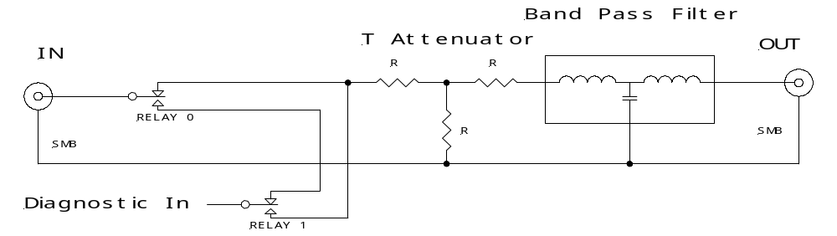
Figure 3 Filter Card BPM Channel Block Diagram

The Timing Generator Fanout Card (TGF) controls the relays and provides the diagnostic signal via bused TTL lines on the VME backplane. The Filter Card has a three position DIP switch to set the card address. This allows up to eight modules per sub rack. The TGF Card interface consists of the following lines:

- TFO_A (0-2) – Module Address lines from the TFG.
- TFO_CS* – Card Select line From the TFG, active low.
- TFO_CLK – Clock line from the TFG (2 MHz maximum).
- TFO_DOUT – Serial Data from the TFG.
- TFO_DIN – Serial Data to the TFG.
- TFO_RST* – Reset signal from the TFG, active low.
- TFO_DIAG – Diagnostic signal from the TFG.
- TFO_SP (0-3) – Spare outputs from the TFG.
- TFO_SPIN – Spare input signal to the TFG.

The TFG configures the relays by sending a 16 bit serial word to the Filter Card. It Drives the A (0-2), CS* to select a module and then clocks out the 16 serial bits RC (0-15). The Most Significant Bit (MSB) (RC15) is shifted in first as shown in Table 2. The TFG then raises the CS* line to complete the operation. The state of the relays is changed on the rising edge of the CS* signal. The table shows the two relays, R0 and R1 for each channel, as shown in Figure 3 and the RCn bit that controls it. If the bit is a one the relay is activated and switches to the normally open connection. Otherwise it is in the normally closed position.

Table 2
Ch8 |  | Ch7 |  | Ch6 |  | Ch5 |  | Ch4 |  | Ch3 |  | Ch2 |  | Ch1
R1 | R0 | R1 | RO | R1 | R0 | R1 | R0 | R1 | R0 | R1 | R0 | R1 | R0 | R1 | R0
RC15 | - | - | - | - | - | - | - | - | - | - | - | - | - | - | RC0

The Filter Card receives the TTL diagnostic signal from the TFG, buffers it, sends it through a low pass filter and then distributes it on a bus to buffers on each of the eight channels.

The Filter Card has the following LEDs on the front panel:

- SEL – Indicates that the card is currently being address by the TFG (yellow).
- SW (0-2) – Indicates the setting of the address switches (green).
- 5V, 12V, -12V – Power supply indicators (green).

Echotek Data Converter Module
The Echotek module ECDR-GC814/8-FV2 is the baseline data converter. This module belongs to a general type of modules called Digital Signal Receivers (or Radios) (DSR). These modules have high speed digitizers that convert the analog, usually radio frequency, inputs into digital information very early in the signal processing. This reduces the amount of analog circuitry in the system.. The subsequent digital circuitry is used to down convert or base band the RF information, removing the high frequency carrier (53 MHz in this case) and revealing the information modulated onto that carrier, 48 KHz revolution information, 20 KHz betatron signals etc. The base banded signals are filtered in n stages of digital FIR filters and the output data is stored in a buffer memory on the module. The sub rack processors can readout the data memory over the sub rack VME backplane.
The data sheets for module are in the Appendix as Echotek DSR Module.
.

Timing Generator Fanout (TGF) Module
The Timing Generator Fanout (TGF) is a double width, 6U VME card that generates timing signals that control and initiate acquisition of the BPM signals. The timing signals are based on inputs from the accelerator controls clock system. These signal inputs include the Tevatron Beam Sync clock (TVBS), the Tevatron event clock (TCLK) and the Tevatron RF Clock (RFClk). The RFClk is the synchronization timebase for the major functionality of the TGF. The RFClk is used to over sample and decode the TVBS and TCLK signals. The TVBS base frequency is the same as the rate of the particle bunches in the Tevatron (7.5 MHz) and the revolution timing mark (0xAA, also called BSync) is encoded on the carrier and can be extracted from it. The revolution timing mark allows synchronization with whole cycles of the train of particles circling around the Tevatron ring. The TCLK signal is very similar to TVBS with a 10MHz carrier frequency and from it the module can extract a large number of commands from the Main Control Room and changes in the state of the Tevatron. The TGF can be set to look for up to eight specific commands at any one time.
For each Echotek DSR module the TGF creates a time base clock that paces the data conversions and filtering on the board as well as supplies a gate or trigger signal for control of the data inputs. For the Tevatron BPM system, the TGF multiplies the RF clock frequency by exactly 7/5 to produce the digitization clock. The RF frequency shifts as the energy of the beam changes. At approximately 980 GeV the RF clock frequency is typically 53.10468 MHz which produces a digitization rate of 74.346552 MHz.
Gate/triggers will typically be based on the revolution timing mark so that the signals can be related to the particle bunches and measurements in separate service buildings can be related to each other as necessary.

The Timing Generator Fanout Module inputs are:
- RFCLK - Tevatron RF Clock (very close to 53.10468 MHz)
- TVBS – Tevatron Beam Sync is an approximately ~7.5 MHz carrier with a modified Manchester encoding of Tevatron beam specific events.
- TCLK – Tevatron Clock, a 10 MHz carrier modulated by a fixed protocol of bit patterns that can carry commands and data events to electronics across the accelerator complex.
- MDAT – A 10 MHz carrier modulated like TCK to carry additional data and events. Not required for the BPM project.
- An External Trigger Input – Permits the TVBS decoding to be bypassed by creating a hard trigger rather than a decoded trigger. Used for testing and future expansion.
- (Opt.) BLM External Device Bus – actually bidirectional but predominately a readout link for data from the Analog Box that processes the signals from the BLM sensors.

The Timing Generator Fanout Module outputs are:
- A2D Clock signals [0-7] – the digitization clock to the Echotek modules
- A2D Sync signals [0-7] - the synchronization for a sequence of digitization
- Diagnostic clock – A 53.104 MHz clock to the Filter/Diagnostic board for the diagnostic functions. This signal is routed on the VME backplane.
- An External Trigger Output –Allows an external device to be triggered from an internal firmware trigger condition such as a decoded BSync event. Used for testing and future expansion.
- DAC Output –14-bit DAC for testing and possible future expansion
- VME Interrupts for signaling the sub rack controller.
- Backplane connections that allow the TGF to control the Tevatron Filter boards. These lines will also allow a level of auto-detection on a per sub rack basis so that the TGF will ‘know’ how many Filter boards there are to control.

The A2D Sync signal variations are:
- TCLK trigger direct
- TCLK + programmable delay
- TCLK + repeated programmable delay
- TVBS trigger direct AA (turn marker) detect.
- TVBS + programmable delay
- TVBS + repeated programmable delay
- External Input Triggered – Similar to above TCLK or TVBS except it is a direct trigger and bypasses the Manchester decoding section.

The sub rack controller can be programmed to read out BPM values based on a specific TCLK signal (e.g. TCLK $77 which is a TeV Flash command). The sub rack controller does not receive Tevatron Beam Sync (TVBS) events. In the sub rack controller, the preparation for digitization and read out is signaled by an arm event. An arm event is usually originated by commands from the MCR. For example, a turn by turn measurement could be armed by a TCLK command or state change and then started on the next ‘AA’ turn marker plus a pre-programmed delay.

The overall TGF firmware will not be changeable remotely. The board and programmer workstation or laptop will need to be directly connected together to change the firmware. However the functional programmability is controlled by the following registers that are accessible over the VME bus by the sub rack controller.
BPM Timing Generator Fanout - Register Map from Offset = 0h

Table 3 | REGISTER | MAP
Register Number | I/O Address | Register Name | Register width | Effective width
0 | 0x00 | Acquisition Bucket Delay 0 | 16-bits | 11-bits | R/W
1 | 0x02 | Acquisition Bucket Delay 1 | 16-bits | 11-bits | R/W
2 | 0x04 | Acquisition Bucket Delay 2 | 16-bits | 11-bits | R/W
3 | 0x06 | Acquisition Bucket Delay 3 | 16-bits | 11-bits | R/W
4 | 0x08 | Acquisition Bucket Delay 4 | 16-bits | 11-bits | R/W
5 | 0x0A | Acquisition Bucket Delay 5 | 16-bits | 11-bits | R/W
6 | 0x0C | Not Used | 16-bits | 11-bits | R/W
7 | 0x0E | Not Used | 16-bits | 11-bits | R/W
8 | 0x10 | Gate Count 0 | 16-bits | 11-bits | R/W
9 | 0x12 | Gate Count 1 | 16-bits | 11-bits | R/W
10 | 0x14 | Gate Count 2 | 16-bits | 11-bits | R/W
11 | 0x16 | Gate Count 3 | 16-bits | 11-bits | R/W
12 | 0x18 | Gate Count 4 | 16-bits | 11-bits | R/W
13 | 0x1A | Gate Count 5 | 16-bits | 11-bits | R/W
14 | 0x1C | Not Used | 16-bits | 11-bits | R/W
15 | 0x1E | Not Used | 16-bits | 11-bits | R/W
16 | 0x20 | Not Used | 16-bits | 11-bits | R/W
17 | 0x22 | Not Used | 16-bits | 11-bits | R/W
18 | 0x24 | Not Used | 16-bits | 11-bits | R/W
19 | 0x26 | Turn Scaler for Background | 16-bits | 11-bits | R/W
20 | 0x28 | Mdat Type | 16-bits | 8-bits | R/W
21 | 0x2A | Mdat Frame Value | 16-bits | 16-bits | R/W
22 | 0x2C | Mdat scale factor |  |  | Read
23 | 0x2E | Pre-Trigger Delay All | 16-bits | 6-bits | R/W
24 | 0x30 | Control |  | See Table 5 | R/W
25 | 0x32 | Status | 16-bits | See Table 6 | Read Only
26 | 0x34 | Bsync Turn Event | 16-bits | 8-bits | Wait on read/W
27 | 0x36 | Bsync Start Event | 16-bits | 8-bits | R/W
28 | 0x38 | Diagnostics Counter | 16-bits | 16-bits | Read Only
29 | 0x3A | Diagnostic Counter w/ wait | 16-bits |  | Wait on read
30 | 0x3C | MDAT Data sampled on Start | 16-bits
31 | 0x3E |  | 16-bits
32 | 0x40 |  | 16-bits
33 | 0x42 |  | 16-bits
34 | 0x44 |  | 16-bits
35 | 0x46 |  | 16-bits
36 | 0x48 |  | 16-bits
37 | 0x4A |  | 16-bits
38 | 0x4C |  | 16-bits
39 | 0x4E | Switch | 16-bits |  | Read Only
40 | 0x50 |  | 16-bits
41 | 0x52 |  | 16-bits
42 | 0x54 |  | 16-bits
43 | 0x56 |  | 16-bits
44 | 0x58 |  | 16-bits
45 | 0x5A |  | 16-bits
46 | 0x5C |  | 16-bits
47 | 0x5E |  | 16-bits
48 | 0x60 | Irq Vector Reg 1 | 16-bits | See Figure 4 | R/W
49 | 0x62 | Irq Vector Reg 2 | 16-bits | See Figure 4 | R/W
50 | 0x64 |  | 16-bits
51 | 0x66 |  | 16-bits
52 | 0x68 |  | 16-bits
53 | 0x6A |  | 16-bits
54 | 0x6B |  | 16-bits
55 | 0x6C |  | 16-bits
56 | 0x70 | IRQ1 Source Mux | 16-bits | See Table 4 | R/W
57 | 0x72 | IRQ2 Source Mux | 16-bits | See Table 4 | R/W
58 | 0x74 |  | 16-bits
59 | 0x76 |  | 16-bits
60 | 0x78 |  | 16-bits
61 | 0x7A |  | 16-bits
62 | 0x7C |  | 16-bits
63 | 0x7E |  | 16-bits

Note: Aggregate Delay Registers located at I/O addresses 0x3A through 0x5E have been deleted 1/15/2003 CRM

Table 4 | IRQ SOURCE MUX | I/O Address 0x70...0x72
DATA | SOURCE
0x00 | Null
0x01 | Start Event
0x02 | Revolution Event
0x03 | MDAT Type Match
0x04 | Turn Counter Trigger Out
0x05 | Delay Timer Enabled
0x06 | Delay Timer Trigger
0x07 | Delay Timer Terminal Count
0x08 | Turn Counter Trigger
0x09 | Periodic timer (BGFlash rate)

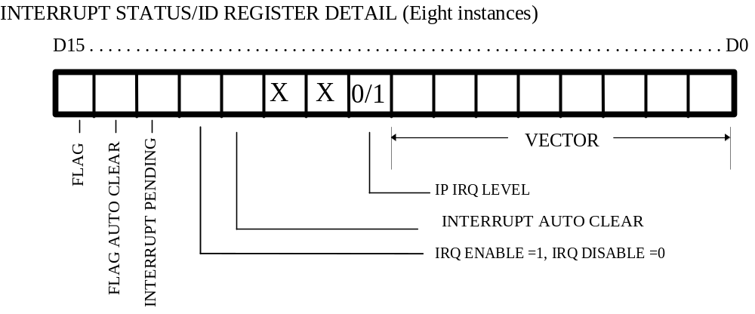
Figure 4

Table 5 | CONTROL AND MODE REGISTER |  | I/O Address 0x30
DATA
Low Byte
0xXX01 | Control[0] | Enable Pre-Trigger Counter | Zero = Disabled, One = Enabled
0xXX02 | Control[1] | Enable Delay Timer | Zero = Disabled, One = Enabled
0xXX04 | Control[2] | Not Used
0xXX08 | Control[3] | Enable MDAT DATA
0xXX10 | Control[4] | Trigger Source | Zero = PreTrigger, One = External,  Two = Start Event
0xXX20 | Control[5] | Trigger Source | Zero = PreTrigger, One = External,  Two = Start Event
0xXX40 | Control[6] | “Start” Source | Zero = Start Event, One = Null , Two=Turn Scaler (periodic)
0xXX80 | Control[7] | “Start” Source | Zero = Start Event, One = Null , Two=Turn Scaler (periodic)
High Byte
0x01XX | mode[1] | Not Used
0x02XX | mode[2] | Not Used
0x04XX | Control[10] | Enable Beam Sync | Zero = Disabled, One = Enabled
0x08XX | Control[11] | Enable MDAT | Zero = Disabled, One = Enabled
0x10XX | Control [12] | Single/Repetitive gate out | Zero = Repetitive, One = Single
0x20XX | Control[13] | Reset Mdat Decoder | Zero = No action, One = Reset
0x40XX | Control[14] |  | Zero = Disabled, One = Enabled
0x80XX | Control[15] | Reset TSG | Zero = No action, One = Reset

Table 6 | STATUS REGISTER BIT DEFINITIONS | I/O Address 0x32
DATA | DESCRIPTION
Bit-0 | Turn Marker
Bit-1 | Start Marker
Bit-2 | Mdat Frame valid
Bit-3 | Mdat Parity Error
Bit-4 | Bsync Parity Error
Bit-5 | Mdat Strobe
Bit-6 | Mdat Enabled
Bit-7 | Mdat Clock
Bit-8 | Turn Counter Enabled
Bit-9 | 53MHz present

Table 7 | Change trigger source to: | IP-TSG INPUT OUTPUT DEFINITIONS
SIGNAL NAME |  | TEST POINT | SIGNAL ALIAS | ALTERA PIN OUT | IPTSG I/O
"MDAT_IN" |  |  |  | 45 | P2-45
"extTrigger" |  |  |  | 199 | P2-26
"bsync_in" |  |  |  | 30 | P2-44
"53Mhz" |  |  |  | 79 | P2-46
"tc0" | Trigger 23 |  |  | 167 | P2-5
"tc1" | Trigger 22 |  |  | 168 | P2-6
"tc2" | Trigger 21 |  |  | 94 | P2-7
"tc3" | Trigger 20 |  |  | 103 | P2-8
"tc4" | Trigger 3 |  |  | 89 | P2-9
"tc5" | Trigger 2 |  |  | 40 | P2-10
"tc6" | Trigger 1 |  |  | 143 | P2-11
"tc7" | Trigger 0 |  |  | 195 | P2-12
"tc8" | Trigger 27 |  |  | 121 | P2-13
"tc9" | Trigger 26 |  |  | 120 | P2-14
"tc10" | Trigger 25 |  |  | 166 | P2-15
"tc11" | Trigger 24 |  |  | 202 | P2-16
"tc12" | Trigger 7 |  |  | 12 | P2-17
"tc13" | Trigger 6 |  |  | 62 | P2-18
"tc14" | Trigger 5 |  |  | 14 | P2-19
"tc15" | Trigger 4 |  |  | 192 | P2-20
"tc16" | Trigger 31 |  |  | 186 | P2-21
"tc17" | Trigger 30 |  |  | 15 | P2-22
"tc18" | Trigger 29 |  |  | 187 | P2-23
"tc19" | Trigger 28 |  |  | 190 | P2-24
"ADCTrigger/" |  |  |  | 86 | P2-25
Start Event |  | TP1 | IRQ Source 1 | 39 | P2-1
Turn Event |  | TP2 | IRQ Source 2 | 158 | P2-2
MDAT Type Match |  | TP3 | IRQ Source 3 | 99 | P2-3
Turn Counter Trigger Out |  | TP4 | IRQ Source 4 | 164 | P2-4
Delay Timer Enabled |  | TP5 | IRQ Source 5 | 149 | P2-39
Delay Timer Trigger |  | TP6 | IRQ Source 6 | 28 | P2-40
Delay Timer Terminal Count |  | TP7 | IRQ Source 7 | 150 | P2-41
Turn Counter Trigger |  | TP8 | IRQ Source 8 | 13 | P2-42
IP IRQ 0 |  | TP9 |  | 147 | P2-37
53/2 MHz |  | TP10 |  | 10 | P2-38
Mdat Strobe |  | TP11 |  | 127 | P2-35
Bsync Strobe |  | TP12 |  | 148 | P2-36
CS[7] |  | TP13 |  | 24 | P2-33
ip_ack |  | TP14 |  | 16 | P2-34
IP Cycle wait |  | TP15 |  | 71 | P2-31
mValidFrame |  | TP16 |  | 57 | P2-32
mdat Parity Error |  | TP17 |  | 63 | P2-29
mvalid |  | TP18 |  | 19 | P2-30
sclock |  | TP19 |  | 163 | P2-27
sdata |  | TP20 |  | 85 | P2-28
2xclock |  | TP21 |  | 36 | U1-12

INTERRUPT CONTROL BIT | DEFINITION
8 | IRQ LEVEL: ZERO OR ONE
9 | NA
10 | NA
11 | INTERRUPT AUTO CLEAR
12 | INTERRUPT ENABLE
13 | NA
14 | FLAG AUTO CLEAR
15 | FLAG

Timer Counter

A 16-bit counter with 200ns resolution exists at I/O address location 0x38. The counter is read-only. The counter will be reset to zero upon the occurrence of the START event. Note: writing a value to I/O location (xx Bill finish xx)

Sub Rack Processor Module
The sub rack controller CPU board is responsible for establishing the communication link between user applications and the Echotek modules. All control and data transferred to/from the BPM modules pass through the sub rack controller.
The processor chosen for this system is a Motorola MVME2400-0361 with 512MB of on-board memory. The processor will run the VxWorks embedded operating system which is widely used throughout the lab. The ESS department in the Computing Division has a MVME 2400 data sheet on its web site.

Sub Rack Cables
Interconnection cables are an important facet of this upgrade. The signal cables moving sensor outputs around the electronics must not distort, attenuate or add noise to the signals of interest. Also the signals from the two outputs of each side of a sensor must travel through cables that have the signal delay matched to better than 50 picoseconds. This is approximately one degree of phase shift at 53 MHz. The timing cables also have a similar delay matching specification so that clock and gate delays within a sub rack are uniform. The chosen default cable is double-shielded RG-400. The short jumpers between the Filter board and the Echotek DSR are RG-316 because of their flexibility requirement. The Cable Specifications are Beams Document #1257.
The connectors chosen for the cables are a mixture of SMA and SMB style connectors which have excellent signal characteristics at 53 MHz. Connections to existing systems use the SMA style. Where the connectors are too close together, the SMB style connectors are used because they snap on and off rather than requiring a nut be tightened.

Data Acquisition Operations

BPM Measurement types

Rewrite this for the hardware perspective of bandwidth and data rate. There are two different types of measurements that can be made from the data in the digitizing cards. The data types are:

- Closed Orbit Measurements, also called Frame data. Frame data is an average of n measurements. The average is usually based on 8, 16, 32 or 64 single turn measurements, and is configurable. Frame data is the only data measurement made in normal operation mode. Note: the number used in the averages for normal operation mode is not necessarily the same number as in injection mode.
- Turn Data is the instantaneous single value (i.e., not averaged over n readings) of the sensors once the trigger is received. The BPM DA must operate in a Turn by Turn mode (TBT) where a large number (8096?) of sequential turns are sampled without missing a turn. Then the DA can stop sampling, read-out the data from the Echotek modules and do whatever processing and telemetry is necessary. Normal TBT mode is continuous cycling between TBT sampling and readout activities.
- A third mode is a variation on Turn by turn mode where a single measurement is acquired by

It is important to note that for turn measurements, all BPMs are triggered relative to the same bunch. However, for a closed orbit measurement, the specific bunches used in the averaging can be different across BPMs.

The data acquisition system must support systematic triggering of N events for both of these data types. For turn buffers, the arrays are of N consecutive measurements (i.e., Turn by Turn). On the other hand, closed orbit buffers are built by a number of triggers of a specific type.

The measurement types require different setups in the Echotek DDC modules, and, therefore have a time penalty associated with changing setup. In general the data acquisition modes must switch to acquire a different type of measurement.

BPM Data Acquisition Modes

There are different modes of BPM data acquisition. These modes are currently mutually exclusive due to the necessity to configure the filters and timing in the Echotek modules for a specific mode. However, the Echotek module appears to have the capability to run two filter processes in parallel. This capability will be explored because it would be advantageous to be able to run two modes simultaneously. The modes are:
- Closed Orbit operation.
- Injection
- Turn by Turn
- Diagnostic
- Calibration

The modes are described in more detail in the following sections. The buffers are described in the Software specifications document.

Closed Orbit operation
This is the default mode of the data acquisition system. The TGF is set up to delay from the turn marker a fixed amount and to sample the signals for a number of turns. This is the burst count. The 53 MHz signal from the BPM sensors is sampled by the 74 MHz digitization clock. These digital samples are down converted using a 21 MHz clock in order to select the modulation signals riding on the 53 MHz sensor signal. The resulting signal is band limited at 48 KHz to approximately 100 Hz bandwidth which averages together many turns of the accelerator particles. The resulting samples come out of the Echotek module at a xx Hz rate. The samples are stored in the output memory of the Echotek module until the burst count is reached. The sub rack controller is then interrupted and the data is readout to be handled by the sub rack controller software.
The arming and triggering of the mode has not yet been specified.

Turn by turn
Turn by turn mode is used to take a sample every turn of the particle bunches in the accelerator, approximately every 21 microseconds. The 53 MHz signal from the BPM sensors is sampled by the 74 MHz digitization clock. These digital samples are down converted using a 21 MHz clock in order to select the modulation signals riding on the 53 MHz sensor signal. The resulting signal is band limited at 48 KHz to approximately 1 KHz bandwidth which produces a sample per turn. The resulting samples come out of the Echotek module at a xx Hz rate. 8K consecutive turns are taken and stored in the Echotek output buffer when a turn by turn request is made. At the end of the sampling the sub rack controller is interrupted and the data is readout to be handled by the sub rack controller software.
The arming and triggering of the mode has not yet been specified.

Injection
Injection is a special type of turn by turn mode used to sample the first pass of a particle bunch. It is most often used when proton bunches are first introduced into the Tevatron. Only one sample is taken per data acquisition cycle and the timing of the data is set up carefully before the particles arrive at the BPM sensor. Injection mode needs to be disabled and re-enabled on request because there are times when closed orbit data is preferred during proton injection.
The arming and triggering of the mode has not yet been specified.

Diagnostic Mode
Normal or turn by turn modes can be used. The diagnostic signal is enabled and the relays in the Tevatron Filter board are activated to either inject the diagnostic signal out the input connector toward the sensor or out the output connector toward the Echotek module. Multiple channels can be driven at the same time but the data collected will be hard to interpret if more than one of the four connections to a specific BPM sensor has the diagnostic signal imposed on it. The best configuration is for one of the four connections to be driven and the four associated Echotek channels are recorded. If the signal is directed toward the sensor, the specific Echotek channel that was disconnected from the sensor should have no input and show local background noise while the other three channels of that sensor will have diagnostic signal that is coupled through the sensor itself. This will test the wiring to the sensors and the sensor itself. If all four connections to the sensor are diagnosed this way a complete picture of the health of the sensor and its wiring will be collected. If the diagnostic signal is directed toward the Echotek input that channel can be tested and a general calibration collected. All of the Echotek connection to the Filter/Diagnostic board can be tested this way.

Appendix

Schematics, Layouts and drawings.

Timing Generator Fanout Module
Schematic: Beams Document #1260
Layout: Beams Document #1261
Bill of Materials: Beams Document #1265

Tevatron Filter board
Schematic: Beams Document #1244
Layout: Beams Document #1259
Bill of Materials: Beams Document #1264

Analog Filter Specifications
Beams Document #1065

Cable Specifications
Beams Document #1257

Sub rack Specifications
Beams Document #1245

BLM Notes

Beam Loss Monitor
The BLM analog circuitry and digitizers are in separate analog crates and the data is readout into the VME sub rack through a bus interface designed into the Timing Generator Fanout Module or through a COTS digital I/O PMC board. The BLM appears as a read-write memory block over the External Device Bus (EDB). The VME sub rack processor writes to specific memory locations to set up and control the BLM hardware and reads from specific locations to acquire BLM data and status.

BLM Operations
The BLMs are functionally simple devices with relatively long time constants from the BPM perspective. They are self paced and require very little control. BLM values are read out periodically on triggers as programmed in the DA application. The data are always available although they may not have updated since the previous read. There is no need for mode switching for BLMs and there are no turn by turn requirements. The BLM sub rack is read out through an External Device Bus (EDB), a parallel, bidirectional connection. The control, configuration and readout of the BLM devices is done through memory mapped registers within the EDB address space.
The External Device Bus is described in Beams document #772, Beam Loss Monitor System Description. The register structure is described in Beams document #764, BLM Data Structures and General Information.
The upgrade project will provide the functional connection through the crate control through the EDB to the BLM Analog sub rack such that the BLM system appears identical to the existing system.

Echotek DSR Module

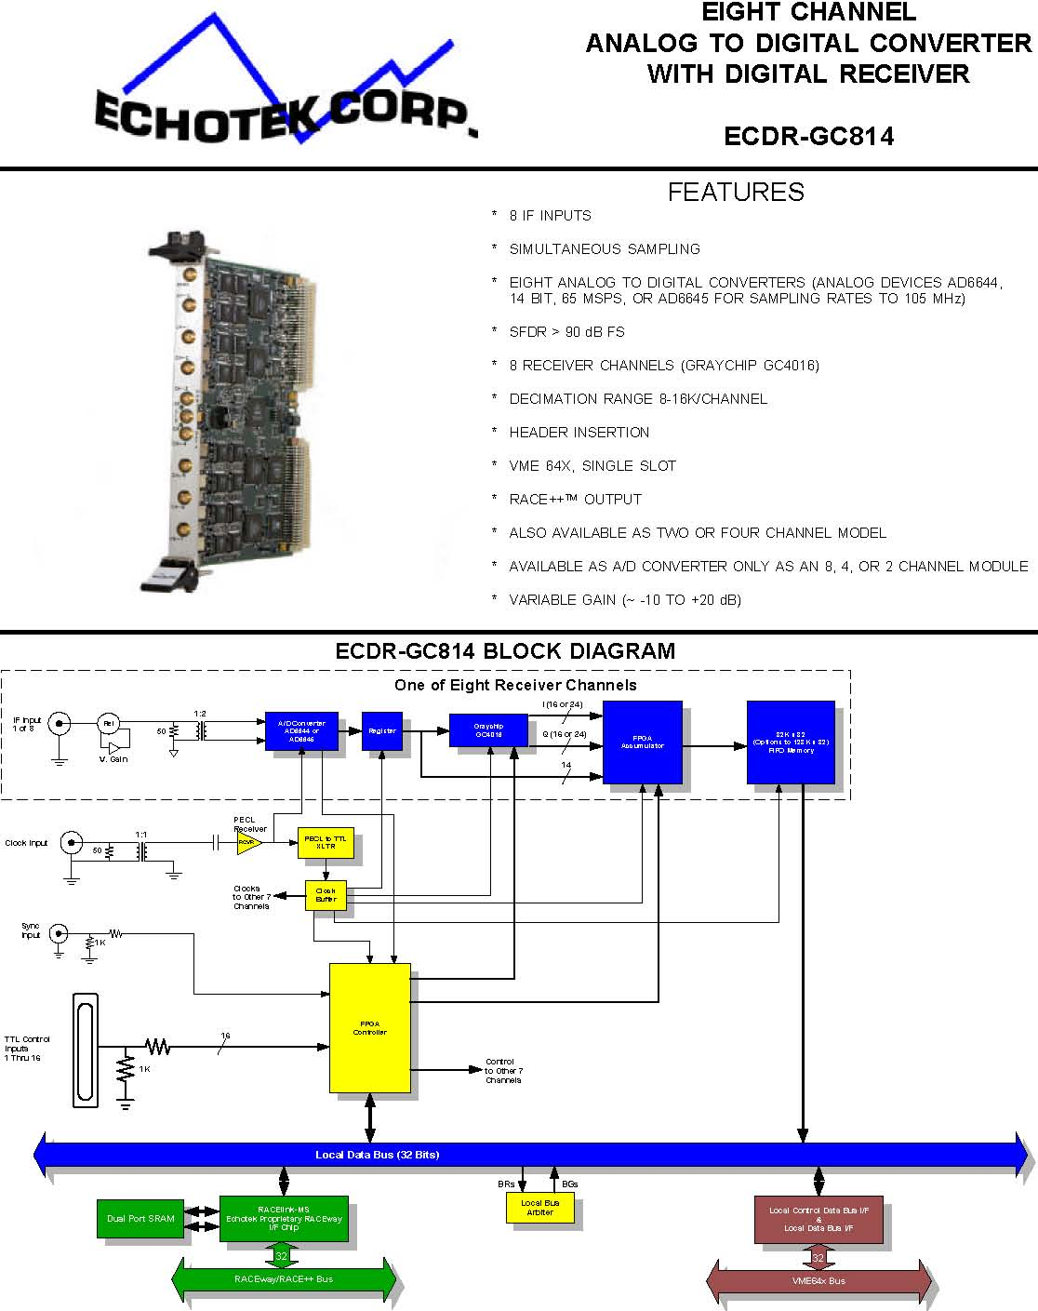
ECHOTEK CORPORATION 555 SPARKMAN DRIVE #400 HUNTSVILLE, AL 35816 PHONE 256 721 1911 FAX 256 721 9266 E-MAIL: sales@echotek.com
ECDR-GC814
This analog to digital converter and digital drop receiver board provides eight channels of 14 bit, 105 MHz analog to digital conversion and digital processing suitable for wideband and narrowband down conversion and filtering in a single 6U VME slot. Data decimation range of each receiver channel is user programmable from 8 to 16384. The receiver section of each channel may be bypassed to output raw A/D data.

Data Inputs
Up to eight analog signals may be input to this board via front panel SMA connectors. Each signal is converted using Analog Devices AD6644, 14 bit, 65 MHz A/D converters or AD6645 for sampling rates to 105 MHz. Direct digitization for IF’s > 200 MHz are supported. These high quality analog to digital converters exhibit Spur Free Dynamic Ranges in excess of 90 dBFS.

Clocks
The A/D clock is provided by the user via front panel SMA connector. This clock signal (sine wave into 50 ohms) is buffered and distributed to all eight channels so that all channels are sampled simultaneously.

Other Inputs
The user may also input a sync signal through the front panel and up to 16 bit wide digital word - normally used to insert a header into the data stream or for tagging data.

Receiver Channels
The digitizer outputs from each A/D converter interfaces to the input crossbar switch on the Graychip GC4016 multi-standard quad digital down converter chip. A receiver channel block diagram is shown below for clarity - the Graychip GC4016 contains four such channels that can be combined as mentioned below, only one Graychip 4016 channel or channel combination is output per receiver channel on the ECDR-GC814.
The ECDR-GC814 supports the various channel combination configurations allowed by the Graychip 4016, that is: Sample Accumulator:
A | No channels combined. In this mode, each channel supports decimations from 32 to 16384.
B | Channel pair combinations supports decimations of 16 to 8192 while in this mode
C | Four channel combination resulting in one wideband output channel:
 | - supports decimations of 8 to 4096 while in this mode.

The output of the receivers or the A/D converter (in receiver bypass mode) is directed to an FPGA that outputs the sum of a programmed number of samples. The output may be the sum of 1, 2, 4, 8, 16, 32, 64, 128, or 256 raw A/D samples or I’s or Q’s.

FIFO Buffer
Data is output from the sample accumulator to each channel’s FIFO buffer. The FIFO buffer is 16K x 32 bits (by default) and may be configured at the factory as large as 128K x 32 bits.

Data Output
Data, raw A/D output, complex receiver data, or either of the quadrature components, is output via the RACE++ interface. The data may also be output via the VME64X interface - but this interface was designed to be used for control in real time and, therefore, is not optimized for high speed data transfer.

Operating Modes
The ECDR-814 supports both CW and pulsed system applications. The board may be controlled in one of two basic operating modes:
Gate Mode - Data acquisition occurs when the gate signal is active. The gate signal may be provided via external front panel input or a software write.
Counted Burst - A preprogrammed number of samples are acquired and processed with each occurrence of an external trigger pulse. This trigger pulse also has a software bit counterpart associated with it.

Set-Up and Control
All set-up and control registers are accessible via the VME interface. Additionally, the RACE++ interface may be programmed by either VME or RACE++ and can be a RACE++ master or slave.

Driver Support
Drivers are supplied for VxWorks Operating Systems.

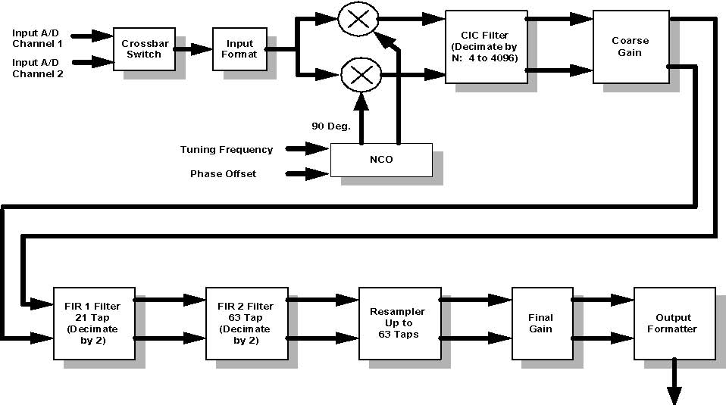
Parallel Data Output

Model | Part Number | Ruggedization | Options
ECDR-GC814/8 | 12-0050/CC334A | Commercial | 65 MHz A/D, 16K FIFO
ECDR-GC814/8 | 12-0050/CC335 | Commercial | 65 MHz A/D, 128K FIFO
ECDR-GC814/8-80 | 12-0050/CC450 | Commercial | 80 MHz A/D, 16K FIFO
ECDR-GC814/8-80 | 12-0050/CC512 | Commercial | 80 MHz A/D, 128K FIFO
ECDR-GC814/8-105 | 12-0050/CC495 | Commercial | 105 MHz A/D, 16K FIFO
ECDR-GC814/8-105 | 12-0050/CC496 | Commercial | 105 MHz A/D, 128K FIFO
ECDR-GC814/4 | 12-0057/CC339 | Commercial | 65 MHz A/D, 16K FIFO
ECDR-GC814/4 | 12-0057/CC337 | Commercial | 65 MHz A/D, 128K FIFO
ECDR-GC814/4-80 | 12-0057/CC494 | Commercial | 80 MHz A/D, 16K FIFO
ECDR-GC814/4-80 | 12-0057/CC451 | Commercial | 80 MHz A/D, 128K FIFO
ECDR-GC814/4-105 | 12-0057/CC477 | Commercial | 105 MHz A/D, 16K FIFO
ECDR-GC814/4-105 | 12-0057/CC497 | Commercial | 105 MHz A/D, 128K FIFO
ECDR-GC814/2 | 12-0058/CC350 | Commercial | 65 MHz A/D, 16K FIFO
ECDR-GC814/2 | 12-0058/CC498 | Commercial | 65 MHz A/D, 128K FIFO
ECDR-GC814/2-80 | 12-0058/CC420 | Commercial | 80 MHz A/D, 16K FIFO
ECDR-GC814/2-80 | 12-0058/CC340 | Commercial | 80 MHz A/D, 128K FIFO
ECDR-GC814/2-105 | 12-0058/CC499 | Commercial | 105 MHz A/D, 16K FIFO
ECDR-GC814/2-105 | 12-0058/CC500 | Commercial | 105 MHz A/D, 128K FIFO
DC COUPLED OPTION:
ECDR-GC814/8-DC | 12-0107/CC426 | Commercial | 65 MHz A/D, 16K FIFO
ECDR-GC814/8-DC | 12-0107/CC431 | Commercial | 65 MHz A/D, 128K FIFO

Model Part Number Ruggedization Options
ECDR-GC814/4-DC 12-0108/CC427 Commercial 65 MHz A/D, 16K FIFO
ECDR-GC814/4-DC 12-0108/CC432 Commercial 65 MHz A/D, 128K FIFO

Ruggedization Levels | Operating Temp (°C) | Storage Temp (°C) | Vibration | Shock | Humidity | Notes
Commercial | 0 to +55°C with 300ft./ min. airflow | -50 to +85°C | 0.002g2/Hz from 10 to 2000Hz random and 2g sinusoidal from 5 to 500 Hz | 20g peak saw tooth, 11mS duration | Up to 95% RH | Commercial Grade, cooled by blown air, for use in benign environments and software development applications

ECDR-GC814/2-DC | 12-0109/CC428 | Commercial | 65 MHz A/D, 16K FIFO
ECDR-GC814/2-DC | 12-0109/CC433 | Commercial | 65 MHz A/D, 128K FIFO

The Tevatron Beam Position and Beam Loss Monitoring Systems (Beams-Doc-806)
Fermilab Energy Doubler Beam Position Detector (Beams-DOC-809)
BLM Data Structures and General Information (Beams-Doc-764)

