A.Shemyakin
RR meeting
December 8, 2004

BPM measurements in the cooling section

Measurements:

- CS positions with MI ramping; 720 Hz rate, snapshot + E-mailing - Sergei

- Parallel shifts; 1 Hz, EXCEL - Cons & myself

- Angle 4-bumps; 1 Hz, EXCEL - Cons & myself

- Scraping by a parallel shift; 1 Hz, EXCEL - Cons & myself

BPM positions with MI ramping (ramp 29)

Example of BPM readings in the time of MI ramp 29.
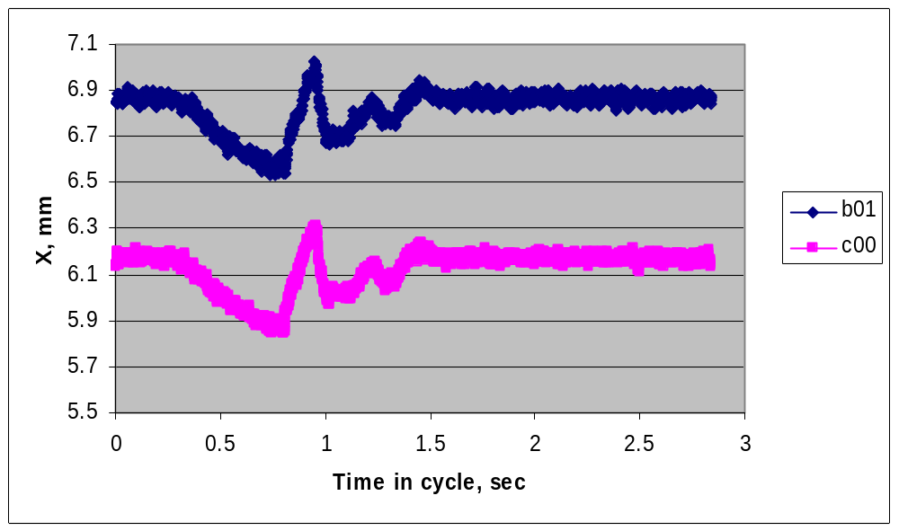

BPM noise in the Fast mode is 10 – 20 μm rms (14 μm average).

Rate 720 Hz.

At each moment, the shifts are linear with the BPM coordinate along the cooling section.

The changes represent straight lines in the cooling section. In each given moment, there are offsets (X0, Y0) of the differential trajectory and its slope along the cooling section (AlfaX, AlfaY).
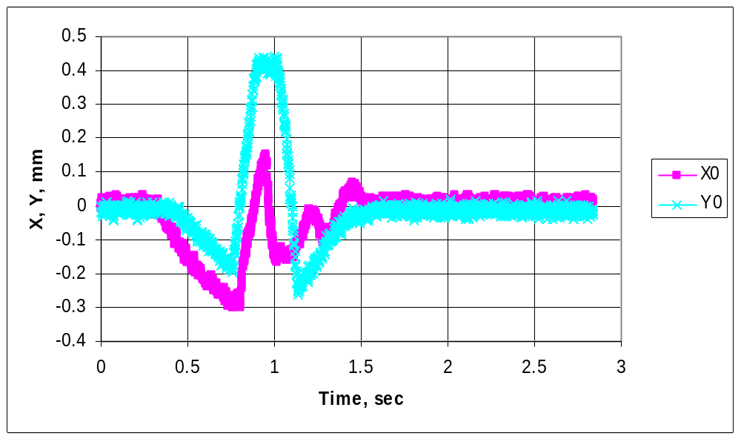

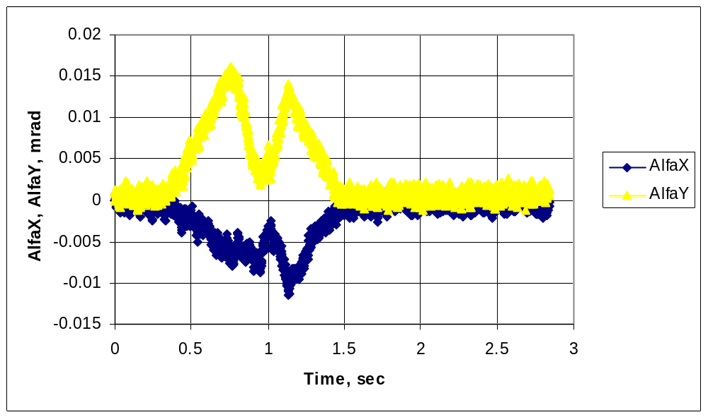

At this level, pbar motion caused by MI ramps should not contribute significantly into the total angle budget, where the upper boundary for an effective cooling is 0.2 mrad rms.
Angle 4-bumps

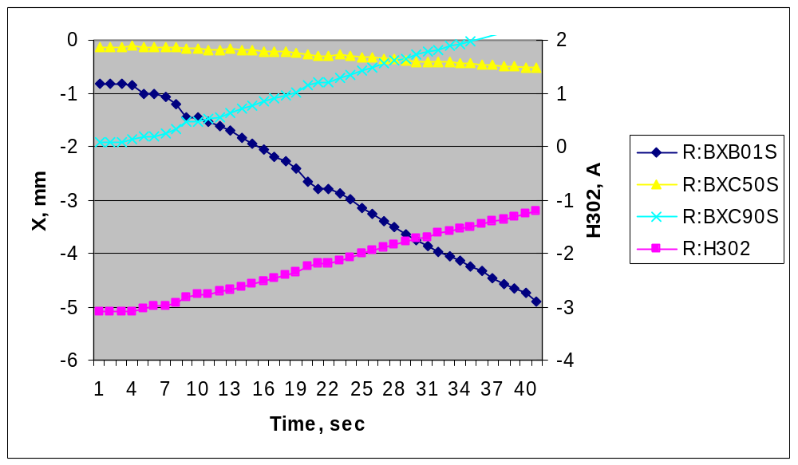

Angle X 4-bump.
X- BPMs are in the Slow mode, and Ys are in the Fast mode (mistakenly). EXCEL, 1 Hz. The data are taken in quiet 40 seconds of the supercycle. Offsets are not subtracted.

Linearity of BPMs vs the bump current
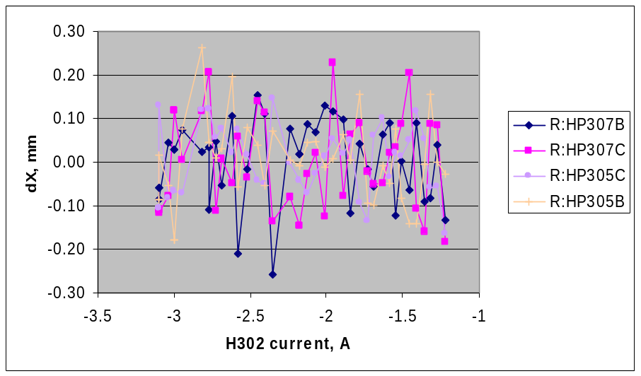
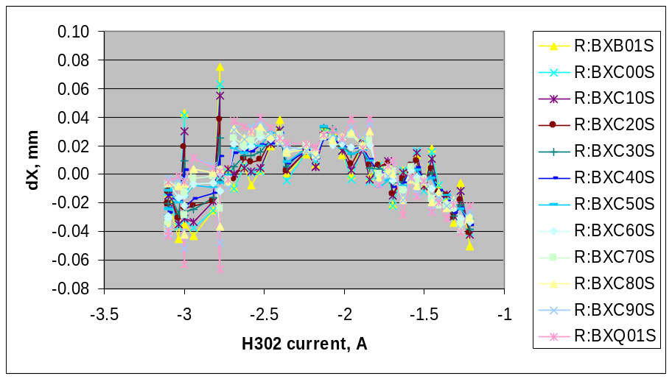
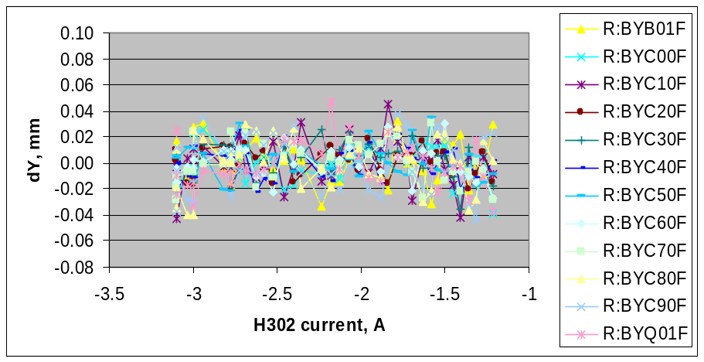
Linearity of BPMs is better than the bump linearity.
Offsets

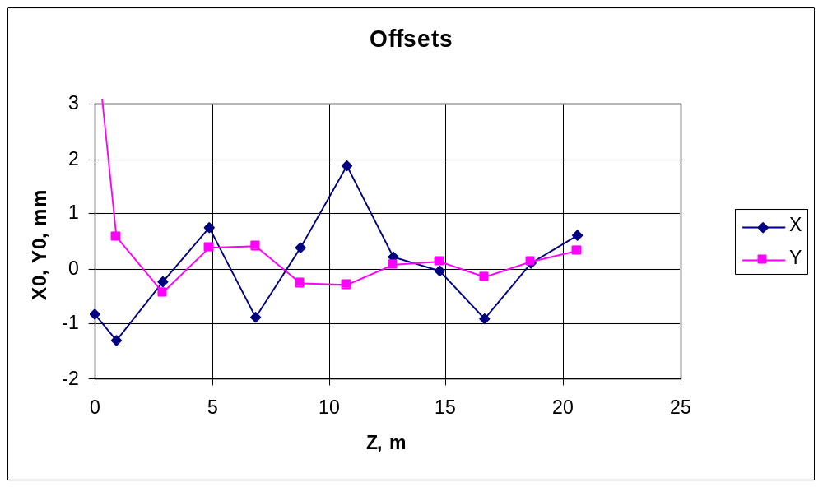
BPM readings after centering the trajectory in the cooling section. Z=0 corresponds to the center of B_B01.

Average values over CS BPMs: <X> =0, <Y> = 60 μm.
Comparison of BPMs

Procedure:

- Data from an angle 4-bump
- Subtract offsets and get X, Y
- For each moment, make a linear fit of BPM readings along the cooling section, X = C⋅Z+D. B01 and Q01 were not used for fitting.
- Subtract the fit
- Plot the resulting differences (ERRORS) versus positions in each BPM (with offsets subtracted)

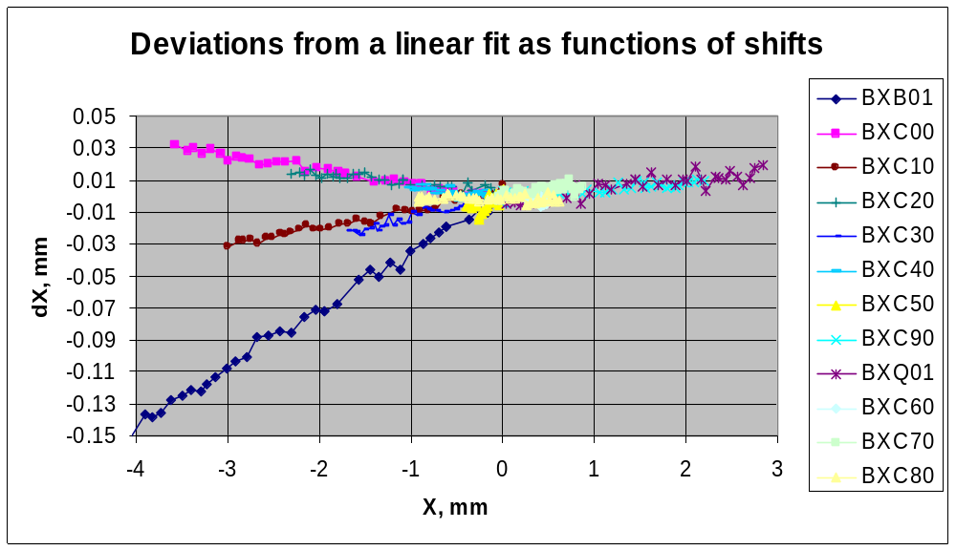
The same angle X 4-bump.

At these shifts, nonlinearity is not found. However, there are variations in linear coefficients.
Comparison of BPMs (cont.)
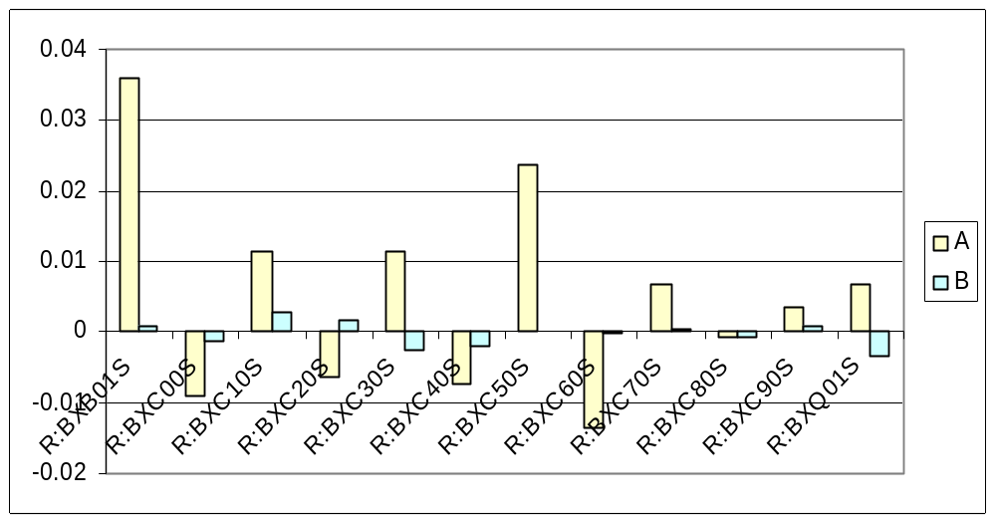
Linear coefficients (A) and offsets (B) after fitting for each BPM by ERRORS = A⋅X+B. The same angle X 4-bump.

Notes:
- it’s suspicious that positive and negative values of As alternate, but I have no explanation.
- total shifts for B50 and B60 are 0.4 and 0.25 mm, correspondingly. Hence, the A-values have a large error here.
- Non-zero values of Bs result from the measurement noise.
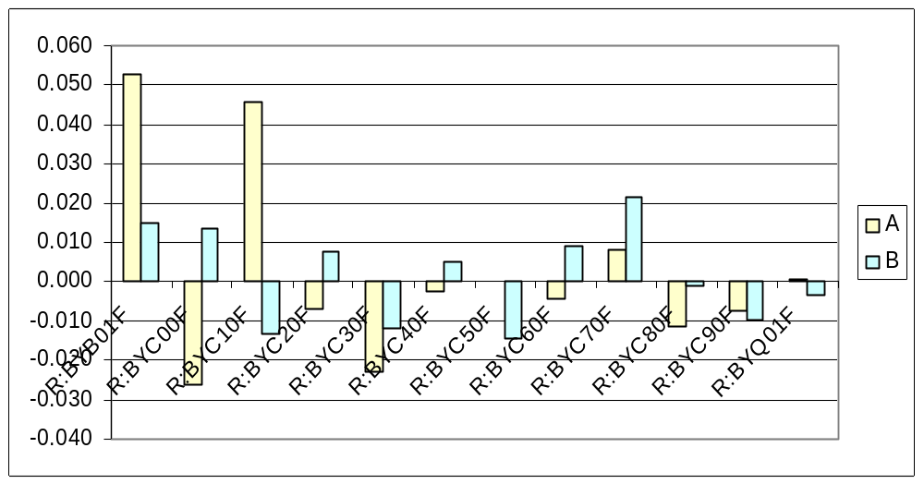
The same for Y angle 4-bump. The noise is larger because Fast readings were used.
Parallel shift

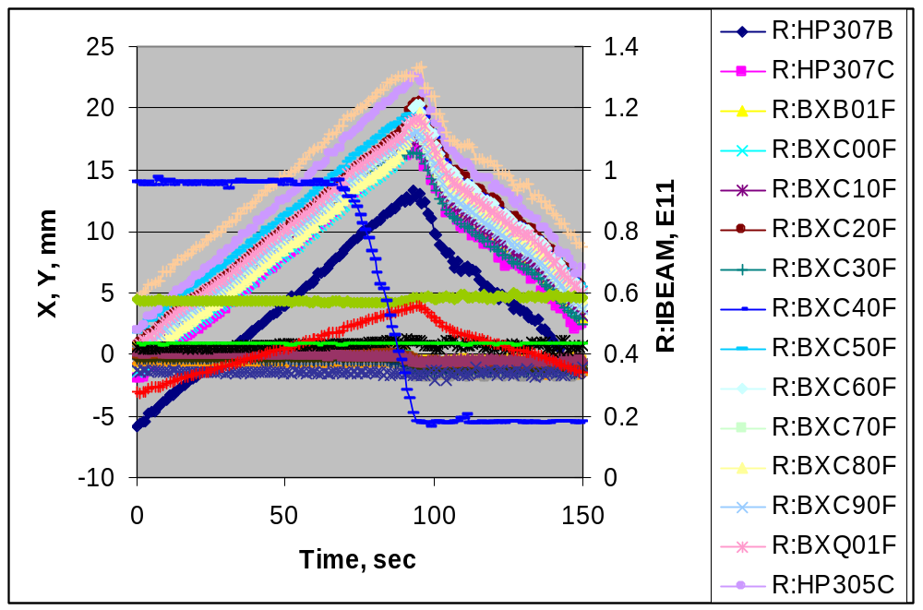
Parallel X 4-bump. The beam was shifted until scraping and then moved back. All measurements were in the Fast mode. The MI was ramping. Measurements were made with EXCEL at 1 Hz asynchronous with MI .
Comparison of RR and ECool BPMs calibration

Procedure:
- Data from the parallel shift corresponding to full intensity
- Subtract offsets and get X, Y
- For each moment, calculate an average of BPM readings (X or Y) in the cooling section, <Xcs>, <Ycs>
- Calculate dX = X - <Xcs> for all data points
- Make a linear fit dX = A⋅<Xcs> + B

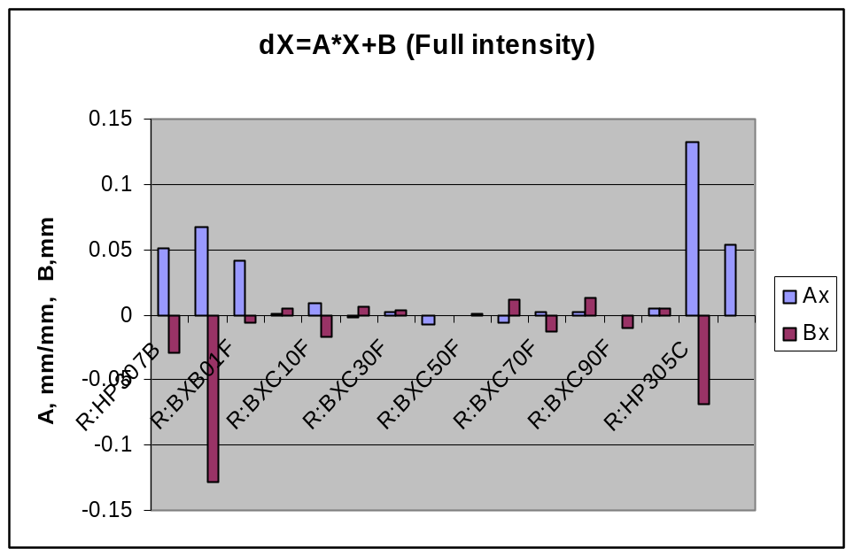
R:IBEAM = 0.96 E11, BYC90I = 436.

- The shift by ~ 20 mm is parallel with precision of calibration of CS BPMs, ≤ 60 μm.
- RR BPM calibration may differ from Ecool’s by 5-10 %
Comparison of Ecool BPMs calibration from angle and parallel bumps

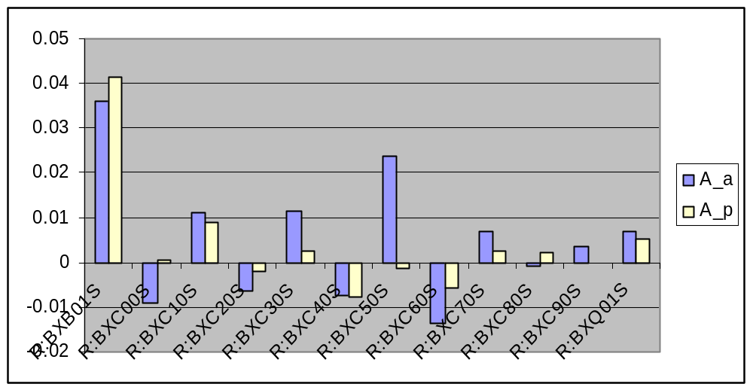
A_a and A_p are differences in slopes measured by the angle and parallel bumps, correspondingly.

Agreement is reasonable except BXC00S.

Data for a lower intensity (R:IBEAM=0.2, BYC90I=87) are too noisy to check the difference in BPM calibration at different intensities. Changes in offsets seem to be large, ~ 0.5 mm.
X –Y coupling in BPMs
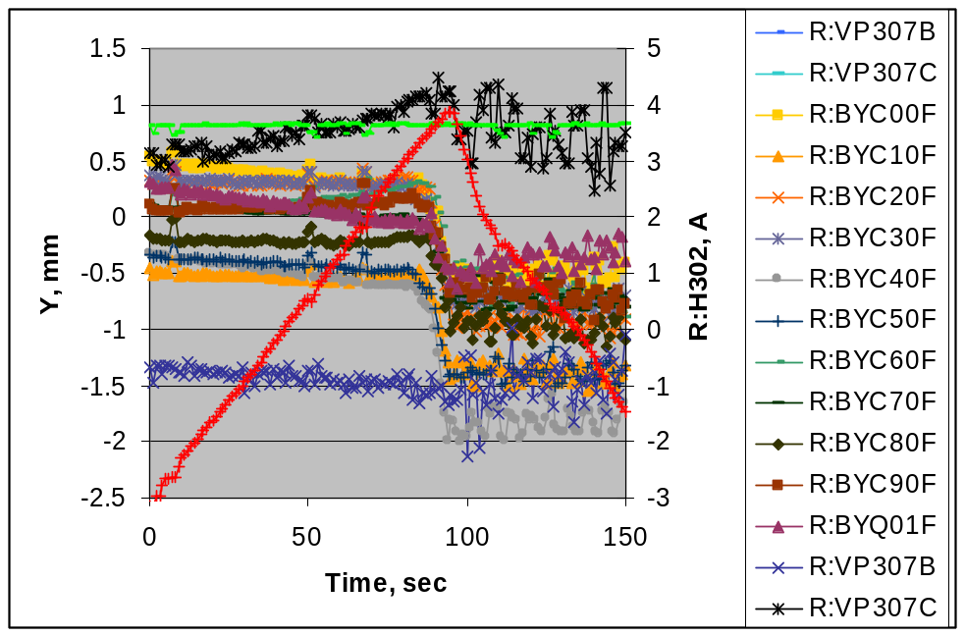
Parallel shift data. Corresponding shift in X is ~ 20 mm.

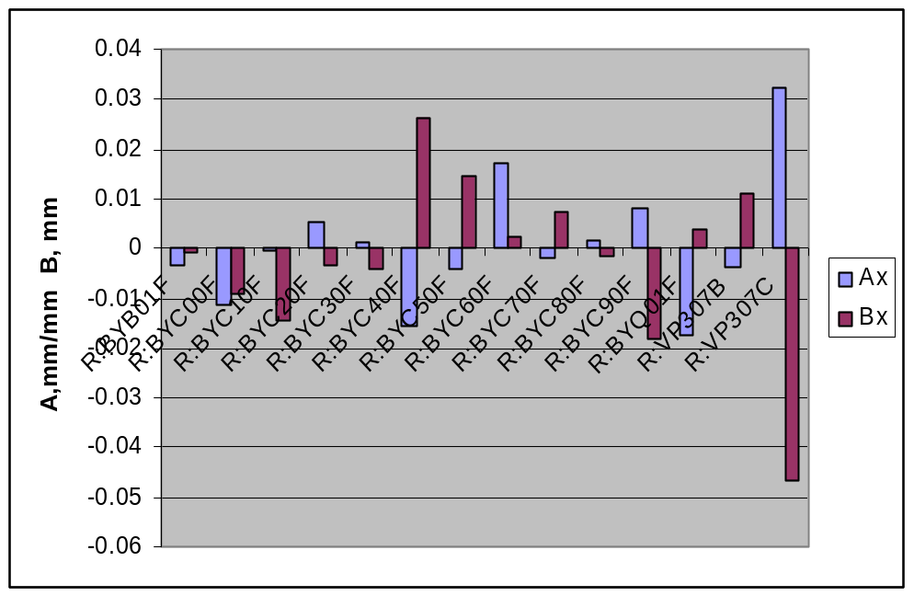
Coefficients of linear fits dY = A⋅<Xcs> + B

There is no slope along the cooling section. Most likely, the numbers represent mechanical rolls of BPMs.
Byproduct: Loss monitors signals
Scraping in the time of a parallel Y 4-bump.
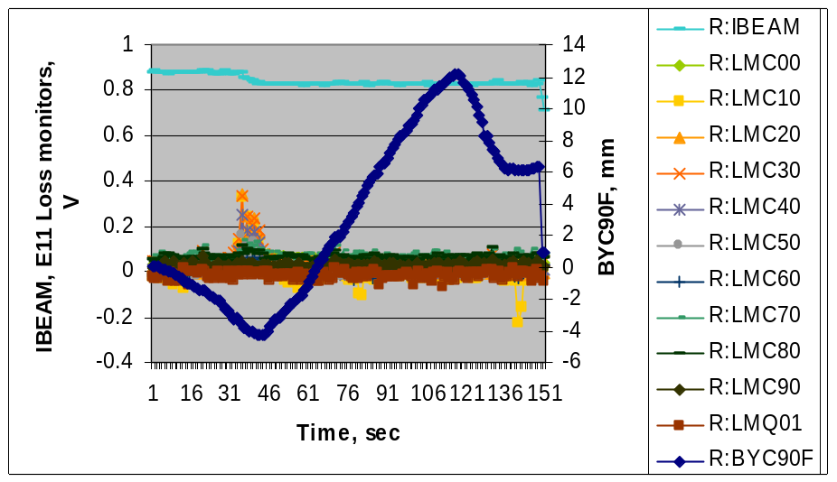
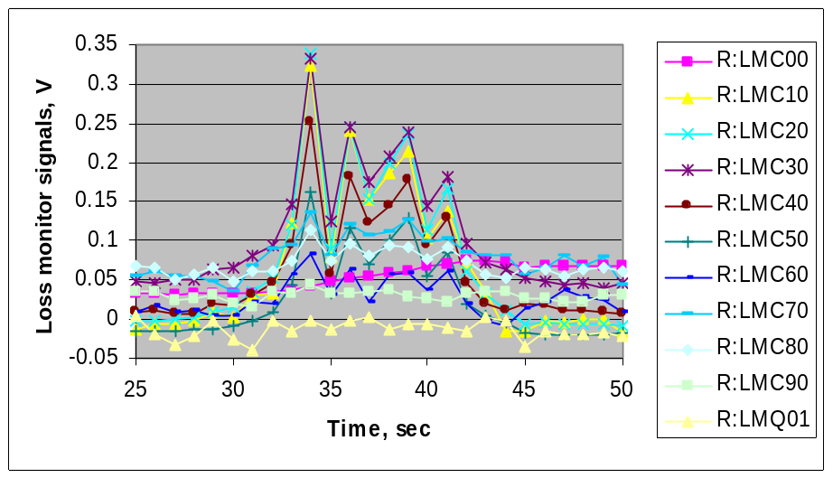
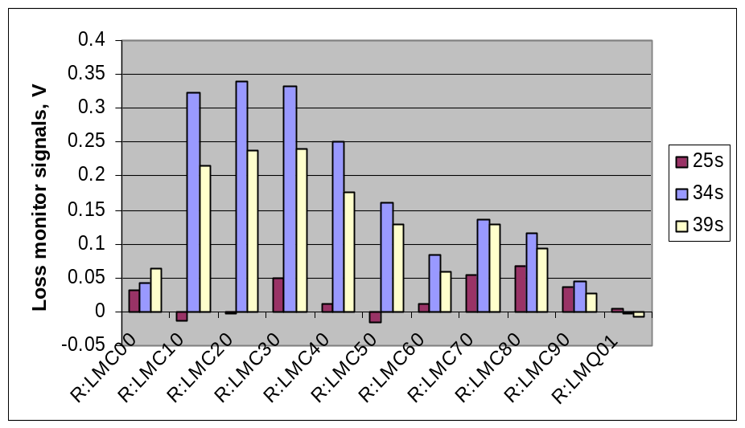
Summary

- Ecool BPM noise is 15 μm rms in the fast mode and 3 μm rms in the slow mode. Corresponding number for RR BPMs is ~ 50 μm.

- Currently errors in relative BPM readings are determined by variations in the linear coefficients, which are as high as 5% in several instances, and by roll-out of BPMs (up to 0.03 rad).

- Non-linearity of BPMs is lower than non-linearity of an angle 4-bump. The effect is < 10 μm at 4 mm shifts.

- Measured differences in BPM offsets are much larger than beam shifts due to ramping, up to 3 mm. The trend in offsets is the same as was found in the stretched wire measurements.

Miscellaneous

- Contribution of the Pbar motion caused by MI ramping into the total budget of angles in the cooling section is low.

- Loss monitors in the cooling section work.

Proposal

- To measure trajectories at the same settings but different intensities.

- To chose a “zero” trajectory in ECool BPMs corresponding to <Xcs>=0, <Ycs> =0, measured at a high intensity, and change the electrical offsets to read zeros for this position.

- To repeat parallel shift measurements in the slow mode and in phase with MI. Calculate as precisely as possible linear correction coefficients for BPMs and put them into a correction table.

- After that, make measurements with 3 and angular 4-bumps to estimate nonlinearity, relying on straightness of the proton trajectory in the cooling section.

