
Fermilab/BD/TEV
Beams-doc-1498-v2
December 10, 2004

BPM Sub Rack Technical Details

Bill Haynes, Vince Pavlicek, Ken Treptow
Fermilab - Computing Division - CEPA

Jim Steimel
Fermilab - Accelerator Division - Tevatron Department

Abstract

This document contains technical details that will assist the assembly of electronics sub racks for the BPM system installation.

Index

BPM VME sub rack setup. 2
Sub Rack Maps 2
Timing Generator/Fanout Module Addressing 5
Filter Module Addressing 5
Appendix 10
Numbers of sensors by service building. 10

BPM VME sub rack setup.
The following Module Maps are defined to assist airflow.
If modules are not installed, the slots must be filled with air dams.

Fan column legend: B = blade, H = hub, N = nothing, in order of preference. The airflow is expected to be highest over the blades, less over the hubs and the least over the gaps between the blades. The boards are assigned to the slots expected to provide the best air flow to cool the modules.

The “Cable Panel Slot” column indicates which slots are used in the cable panels mounted just above and below the VME crates in the service buildings.

There are five different configurations to accommodate the variety of the number of BPMs sensors in a service building. All of the Timing Generator/Fanout modules have the same address. The Echotek and Filter modules addresses depend on the number of modules in the sub rack and the position of the modules within the sub rack. Maps for the service buildings, in order of quantity of modules needed, follow.

Sub Rack Maps

11 or 12 BPM Crate for Service Buildings E4, F1

Slot | Contents | VME Address | TGF Address | Fan | CablePanelSlots
1 | MVME CPU | Lots | ---------- | B
2 | Timing Generator Fanout | 0x2000 | Master | B
3 | TGF panel | ---------- | ---------- | H
4 | Air Dam | ---------- | ---------- | H
5 | Echotek #0 | 0x8000 | ---------- | B | Slot 1 - MPT
6 | Filter #0 | ---------- | 0 | B
7 | Air Dam | ---------- | ---------- | N | Slot2 - Used
8 | Echotek #1 | 0x9000 | ---------- | B
9 | Filter #1 | ---------- | 1 | B | Slot3 - Used
10 | Echotek #2 | 0xA000 | ---------- | H
11 | Filter #2 | ---------- | 2 | H | Slot4 - Used
12 | Echotek #3 | 0xB000 | ---------- | B
13 | Filter #3 | ---------- | 3 | B | Slot5 - Used
14 | Air Dam | ---------- | ---------- | N
15 | Air Dam | ---------- | ---------- | N | Slot6 - MPT
16 | Echotek #4 | 0xC000 | ---------- | B
17 | Filter #4 | ---------- | 4 | B | Slot7 - Used
18 | Air Dam | ---------- | ---------- | H
19 | Air Dam | ---------- | ---------- | H | Slot8 - MPT
20 | Echotek #5 | 0xD000 | ---------- | B
21 | Filter #5 | ---------- | 5 | B | Slot9 - Used

9 or 10 BPM Crate for A2, A4, B2, B4, C2, C4, D2, D4, E2, F2, F4, A1, B1, C1, D1, E1.

Slot | Contents | VME Address | TGF Address | fan | CablePanelSlots
1 | MVME CPU | Lots | ---------- | B
2 | Timing Generator Fanout | 0x2000 | Master | B
3 | TGF panel | ---------- | ---------- | H
4 | Air Dam | ---------- | ---------- | H
5 | Echotek #0 | 0x8000 | ---------- | B | Slot 1 - MPT
6 | Filter #0 | ---------- | 0 | B
7 | Air Dam | ---------- | ---------- | N | Slot2 - Used
8 | Echotek #1 | 0x9000 | ---------- | B
9 | Filter #1 | ---------- | 1 | B | Slot3 - Used
10 | Air Dam | ---------- | ---------- | H
11 | Air Dam | ---------- | ---------- | H | Slot4 - MPT
12 | Echotek #2 | 0xA000 | ---------- | B
13 | Filter #2 | ---------- | 2 | B | Slot5 - Used
14 | Air Dam | ---------- | ---------- | N
15 | Air Dam | ---------- | ---------- | N | Slot6 - MPT
16 | Echotek #3 | 0xB000 | ---------- | B
17 | Filter #3 | ---------- | 3 | B | Slot7 - Used
18 | Air Dam | ---------- | ---------- | H
19 | Air Dam | ---------- | ---------- | H | Slot8 - MPT
20 | Echotek #4 | 0xC000 | ---------- | B
21 | Filter #4 | ---------- | 4 | B | Slot9 - Used

7 or 8 BPM Crate for A3, B3, C3, D3, E3, F3.

Slot | Contents | VME Address | TGF Address | fan | CablePanelSlots
1 | MVME CPU | Lots | ---------- | B
2 | Timing Generator Fanout | 0x2000 | Master | B
3 | TGF panel | ---------- | ---------- | H
4 | Air Dam | ---------- | ---------- | H
5 | Echotek #0 | 0x8000 | ---------- | B | Slot 1 - MPT
6 | Filter #0 | ---------- | 0 | B
7 | Air Dam | ---------- | ---------- | N | Slot2 - Used
8 | Echotek #1 | 0x9000 | ---------- | B
9 | Filter #1 | ---------- | 1 | B | Slot3 - Used
10 | Air Dam | ---------- | ---------- | H
11 | Air Dam | ---------- | ---------- | H | Slot4 - MPT
12 | Echotek #2 | 0xA000 | ---------- | B
13 | Filter #2 | ---------- | 2 | B | Slot5 - Used
14 | Air Dam | ---------- | ---------- | N
15 | Air Dam | ---------- | ---------- | N | Slot6 - MPT
16 | Echotek #3 | 0xB000 | ---------- | B
17 | Filter #3 | ---------- | 3 | B | Slot7 - Used
18 | Air Dam | ---------- | ---------- | H
19 | Air Dam | ---------- | ---------- | H | Slot8 - MPT
20 | Air Dam | ---------- | ---------- | B
21 | Air Dam | ---------- | ---------- | B | Slot9 - MPT

6 BPM Crate for B0.

Slot | Contents | VME Address | TGF Address | fan | CablePanelSlots
1 | MVME CPU | Lots | ---------- | B
2 | Timing Generator Fanout | 0x2000 | Master | B
3 | TGF panel | ---------- | ---------- | H
4 | Air Dam | ---------- | ---------- | H
5 | Echotek #0 | 0x8000 | ---------- | B | Slot 1 - MPT
6 | Filter #0 | ---------- | 0 | B
7 | Air Dam | ---------- | ---------- | N | Slot2 - Used
8 | Echotek #1 | 0x9000 | ---------- | B
9 | Filter #1 | ---------- | 1 | B | Slot3 - Used
10 | Air Dam | ---------- | ---------- | H
11 | Air Dam | ---------- | ---------- | H | Slot4 - MPT
12 | Echotek #2 | 0xA000 | ---------- | B
13 | Filter #2 | ---------- | 2 | B | Slot5 - Used
14 | Air Dam | ---------- | ---------- | N
15 | Air Dam | ---------- | ---------- | N | Slot6 - MPT
16 | Air Dam | ---------- | ---------- | B
17 | Air Dam | ---------- | ---------- | B | Slot7 - MPT
18 | Air Dam | ---------- | ---------- | H
19 | Air Dam | ---------- | ---------- | H | Slot8 - MPT
20 | Air Dam | ---------- | ---------- | B
21 | Air Dam | ---------- | ---------- | B | Slot9 - MPT

4 BPM Crate for A0.

Slot | Contents | VME Address | TGF Address | fan | CablePanelSlots
1 | MVME CPU | Lots | ---------- | B
2 | Timing Generator Fanout | 0x2000 | Master | B
3 | TGF panel | ---------- | ---------- | H
4 | Air Dam | ---------- | ---------- | H
5 | Echotek #0 | 0x8000 | ---------- | B | Slot 1 - MPT
6 | Filter #0 | ---------- | 0 | B
7 | Air Dam | ---------- | ---------- | N | Slot2 - Used
8 | Echotek #1 | 0x9000 | ---------- | B
9 | Filter #1 | ---------- | 1 | B | Slot3 - Used
10 | Air Dam | ---------- | ---------- | H
11 | Air Dam | ---------- | ---------- | H | Slot4 - MPT
12 | Air Dam | ---------- | ---------- | B
13 | Air Dam | ---------- | ---------- | B | Slot5 - MPT
14 | Air Dam | ---------- | ---------- | N
15 | Air Dam | ---------- | ---------- | N | Slot6 - MPT
16 | Air Dam | ---------- | ---------- | B
17 | Air Dam | ---------- | ---------- | B | Slot7 - MPT
18 | Air Dam | ---------- | ---------- | H
19 | Air Dam | ---------- | ---------- | H | Slot8 - MPT
20 | Air Dam | ---------- | ---------- | B
21 | Air Dam | ---------- | ---------- | B | Slot9 - MPT

Timing Generator/Fanout Module Addressing
The address switches are identified below. The switch pack is 8 switches, four of which set the board address and the other four are option selectors for the module logic. The address switches are the four bits of the most significant digit of the 16 bit address of the module, in other words N of 0xN000.

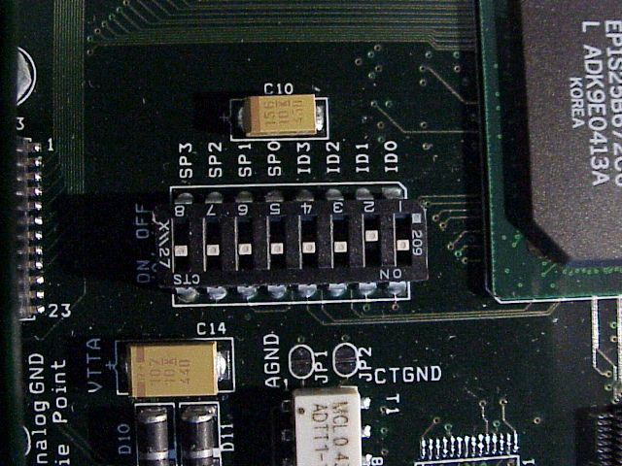
MSB
LSB
UP = ON = 0
Front
Panel
Side

The address for the TGF module is always 0x2000 which is selected using the following table. Switch ON is bit = 0, switch OFF is bit =1.

TGF address | SW0-LSB | SW1 | SW2 | SW3-MSB
2 | On | Off | On | On

Filter Module Addressing
The address switches are identified below.

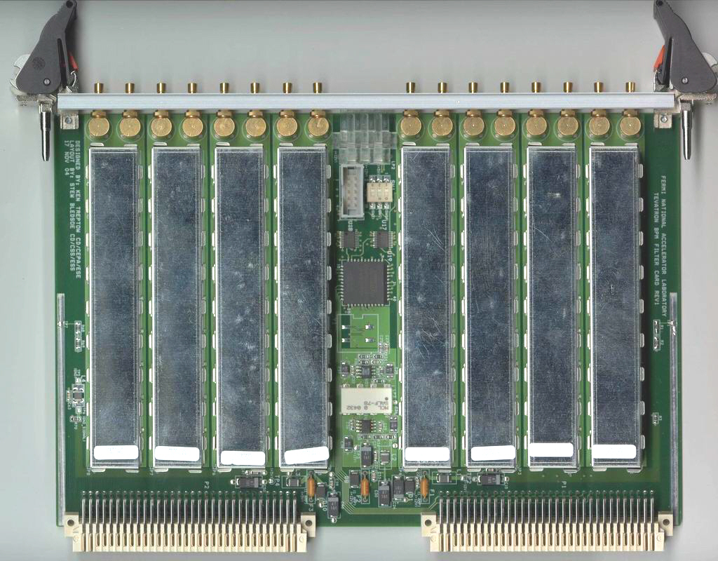

The addresses are selected using the following table. See detailed view below.

Filter address | SW0 | SW1 | SW2
0 | Off | Off | Off
1 | On | Off | Off
2 | Off | On | Off
3 | On | On | Off
4 | Off | Off | On
5 | On | Off | On
6 | Off | On | On
7 | On | On | On

Setting the switches.

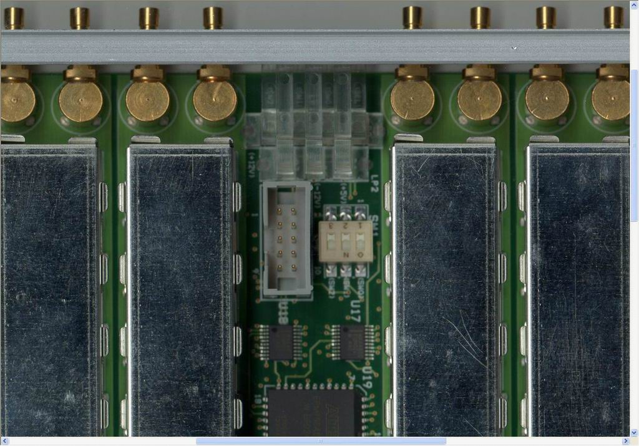
Sw0 – LSB (1)
Sw2 – MSB (4)
Toward FP = off = 0
This module has address zero.
Echotek Module Addressing
The address switches are identified below.

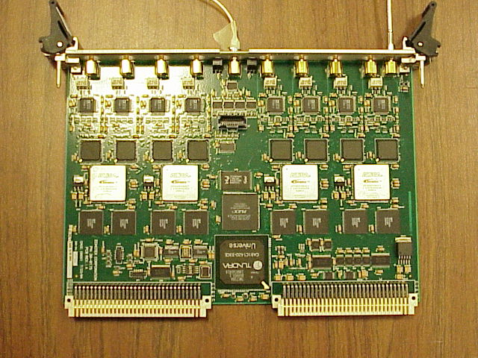
Address Switches

The switches set the high hexadecimal digit (N) of the board VME address, or 0xN000. Echotek addresses must be 0x8000 or higher for the VxWorks driver, so SW3, the 8 bit, is always on.

VME address | SW0 - LSB | SW1 | SW2 | SW3 - MSB
0x8000 | Off | Off | Off | On
0x9000 | On | Off | Off | On
0xA000 | Off | On | Off | On
0xB000 | On | On | Off | On
0xC000 | Off | Off | On | On
0xD000 | On | Off | On | On
0xE000 | Off | On | On | On
0xF000 | On | On | On | On

Setting the switches.

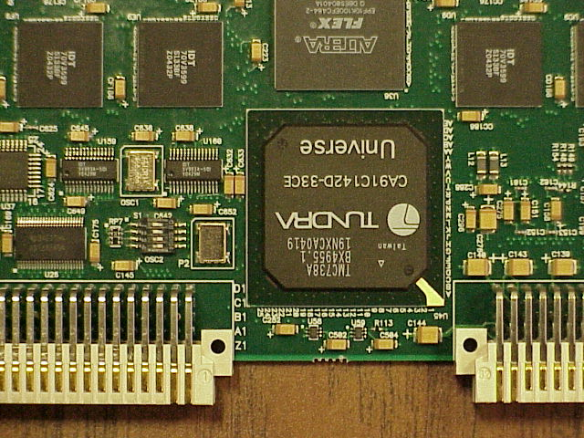
LSB
(1)
MSB (8)
Right = on = 1

Appendix

Numbers of sensors by service building.

Service Building | BPMs | Analog Module Pairs | Filled Slots | MT |  | BLMs
A0 | 4 | 2 | 7 | 14 |  | 12
B0 | 6 | 3 | 9 | 12 |  | 9
D0 | 6 | 3 | 9 | 12 |  | 9
A3 | 8 | 4 | 11 | 10 |  | 8
B3 | 8 | 4 | 11 | 10 |  | 8
C3 | 8 | 4 | 11 | 10 |  | 22
D3 | 8 | 4 | 11 | 10 |  | 9
E3 | 8 | 4 | 11 | 10 |  | 9
F3 | 8 | 4 | 11 | 10 |  | 8
A2 | 9 | 5 | 13 | 8 |  | 12
A4 | 9 | 5 | 13 | 8 |  | 12
B2 | 9 | 5 | 13 | 8 |  | 9
B4 | 9 | 5 | 13 | 8 |  | 8
C2 | 9 | 5 | 13 | 8 |  | 8
C4 | 9 | 5 | 13 | 8 |  | 23
D2 | 9 | 5 | 13 | 8 |  | 9
D4 | 9 | 5 | 13 | 8 |  | 9
E2 | 9 | 5 | 13 | 8 |  | 8
F2 | 9 | 5 | 13 | 8 |  | 8
F4 | 9 | 5 | 13 | 8 |  | 9
A1 | 10 | 5 | 13 | 8 |  | 9
B1 | 10 | 5 | 13 | 8 |  | 8
C1 | 10 | 5 | 13 | 8 |  | 11
D1 | 10 | 5 | 13 | 8 |  | 12
E1 | 10 | 5 | 13 | 8 |  | 9
E4 | 11 | 6 | 15 | 6 |  | 8
F1 | 12 | 6 | 15 | 6 |  | 8

