Mask At MI Q301
Dave Johnson, Recycler Department
August 22, 2005
September 2, 2005

Introduction

The electron cooling insert in the Recycler is located above the MI in between MI quads Q305 and Q307 at the Recycler elevation. The return line for the electrons is approximately 12 inches above the MI on the Main Injector centerline. Loss monitors attached to the return line are inputs into the Pellatron protection system to monitor for electron beam mis-steering. Figure 1 shows a cartoon of the MI30 straight section .

Loss Monitor R:LMR04
ECOOL solenoids
Return line
R:LMR06
180 deg bend
I:LM301
I:LM302
R:LMR02
e⁻ beam ->
Recycler

Q305
Q301
Q307
MI centerline

Figure 1: Cartoon of the MI30 layout for Main Injector and ECOOL showing location of loss monitors and proposed mask (magenta).

These loss monitors are also sensitive to losses in the Main Injector. Beams-doc 1938 contains slides describing the impact of the losses. Figure 2 shows an example of the MI losses and their impact on the ECOOL loss monitor R:LMR04.
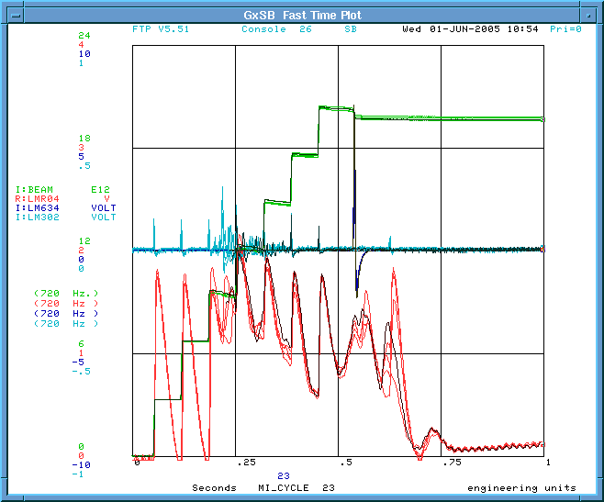

Figure 2: Plot showing an example of MI beam loss on the MI loss monitor LM302 (cyan) and the ECOOL Loss monitor LMR04 (red) during NuMI mixed mode cycles.

It should be noted that only the loss monitor at Q301 and 302 show any loss correlated to the loss seen on LMR04. Here, all of the loss monitors LMR01 thru LMR06 show roughly the same loss amplitude, indicating a fairly uniform flux of ionizing radiation through out the ECOOL section as seen in Figure 3a and b.
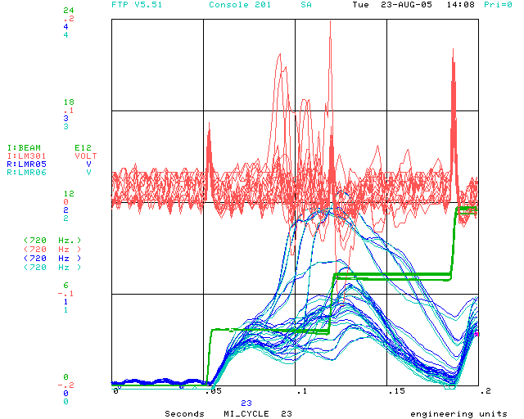
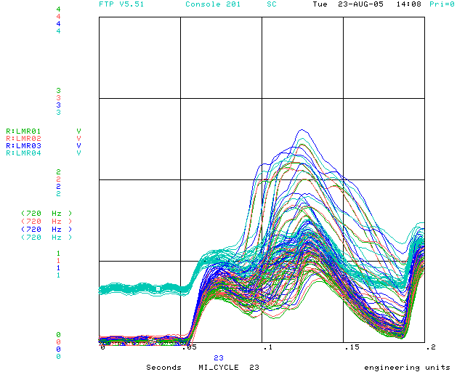

3a 3b
Figure 3: Plot (a) shows the MI loss monitor LM301 during slip stacking and the ECOOL loss monitors LMR05 and LMR06. Plot (b) shows the ECOOL loss monitors LMR01-LMR04. ECOOL was circulating 200 mA of electrons when these pictures were taken.

The initial spike on LM301 occurs during the first 1000 turns (not first turn loss) and the loss seen between the first and second injection is beam being lost during slip stacking. It is clear from the data in the Main Injector logbook on Aug 3, 2005 that the first turn loss seen on the ECOOL loss monitors went away after the 8 Gev line was re-matched to the MI and re-appeared with circulating beam. Also clear is that the transverse coupling seen at injection was strong enough to transfer motion between the planes in less than 64 turns ! The response on all ECOOL loss monitors corresponds to the losses seen at 301. The increase in DC level of LMR04 is due to ECOOL running beam. Figure 4 shows response of both MI loss monitors LM301 and LM302 along with the LMR04 monitor in the time period to include the first two NuMI batches.
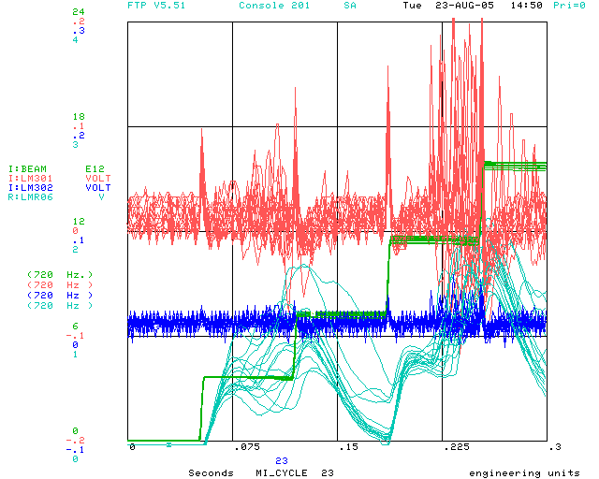

Figure 4: Response of LM301 (red), LM302 (blue), and LMR04 (cyan) to MI beam loss on the $23 cycle. The MI beam (green) shows 4 injections, with the first two slip-stacked for pbar production and the next two for NuMI (last three NuMI batches not shown).
The losses seen on LM301, LM302, and LMR04 at 0.225 sec. occur when the MI damper is in the anti-damping mode to clear uncaptured beam from the injection region for NuMI batch injection. Not shown are the null responses from loss monitors LM303-LM306.

The Main Injector MI30 straight section lattice is shown in Figure 5. Here the plot starts at the middle of the quad Q232 and ends in the middle of the quad at Q310. The vertical beta function is given by the dashed line and the horizontal is shown as solid. The vertical beta max is located at each of the verticaly focusing quads. Quads 301, 305, and 309 have a vertical beta max of 62 m. while the beta max at 303 and 307 is 55 m. The horizontal beta max is 56 m at Q302 and 306 and 59 m at Q304 and 308.

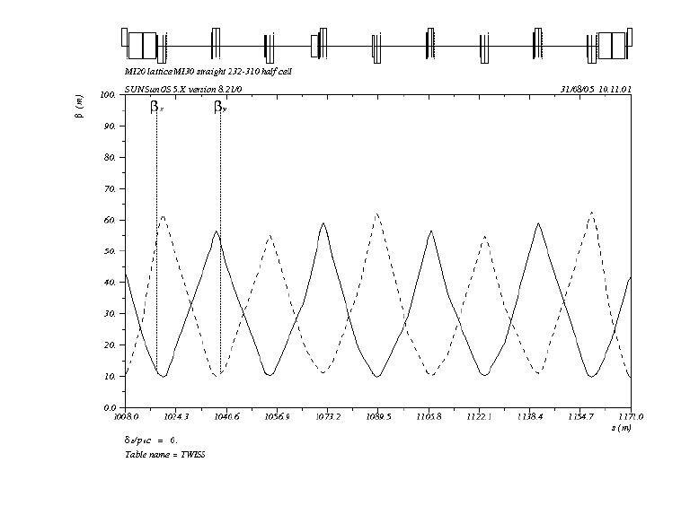

Figure 5: Main Injector lattice functions in the MI30 straight section

The physical aperture through the MI30 straight section is that of the elliptical MI beam pipe with an inside dimension of 120mm (H) by 50 mm (V). The exceptions to this aperture are the Recycler kicker (measured) upstream of Q304 (83.82 mm (H) by 35.56 mm (V) ), the QXR quads located downstream of Q302 and Q304 (nom. 100 mm dia.), and the DCCT located just downstream of Q305 (nom. 100 mm dia.). If we assume that there are no major vertical alignment issues or a large lattice distortion through this region, one would expect to get approximately the same (beta weighted) vertical aperture at each of the locations in the straight section. Its clear that all ECOOL loss monitors are correlated with losses from 301 to 305. It is also clear that the closer the MI loss point is to the ECOOL section, the more sensitive the ECOOL loss monitors are. This gives an apparent reduced vertical aperture from 301 to 305 as seen on the ECOOL loss monitors. It is also clear that the beam halo fills the vertical aperture at the higher Booster intensities so that only small vertical movement at 305 is seen on the ECOOL loss monitors.

Vertical aperture scans through out the ECOOL region, i.e. V301, V303, V305 have been done to determine vertical aperture through this region. Prior to the sacn, the position at VP305 was raised by a mm. This reduced losses seen on ECOOL loss monitors, particularly those at the downstream end, LMR05 and LMR06. Currently, the losses seen on the ECOOL loss monitors at the downstream end are factor 2 smaller than those at the upstream end, clearly a geometry effect. There was essentialy no change seen on the MI loss monitor at 305A. See MI logbook Aug. 25, 2005.
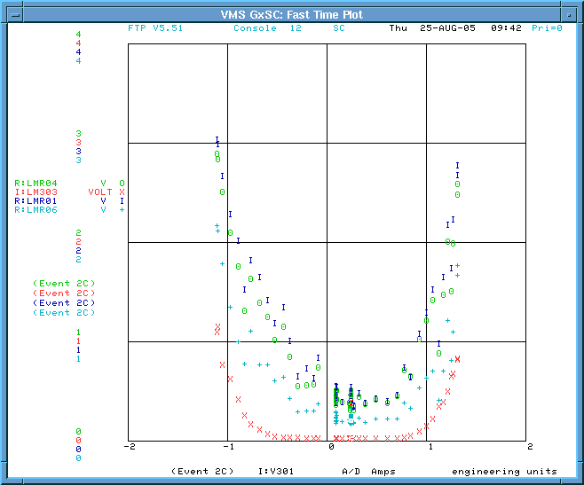
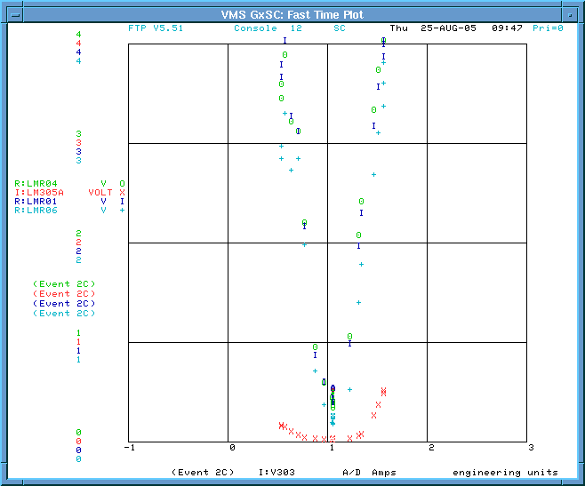
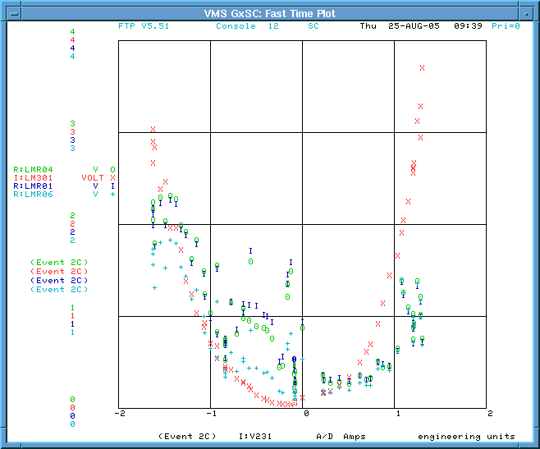
VP301
VP303
VP305

w
w

Figure 6: Aperture scans of three vertical locations in MI30. V301 and V303 are upstream of the ECOOL section and V305 is located adjacent to the 180 degree bend magnet, or the upstream end of the cooling insert. These plots show the MI loss monitor (red) at the bump location and the ECOOL loss monitors LMR01 (yellow), LMR04 (green) and LMR06 (cyan). The red curves are uses to illustrate (a)symmetry of the MI losses.

Figure 6 shows the results of vertical aperture scans performed at three locations in MI 30 on the first injection of the $23 NuMI mixed mode cycle, with 10 turns (3.6E12/batch) on the pbar production cycles. The three ECOOL loss monitors chosen are at each end and the middle of the ECOOL section. LMR01 is on the top of the 180 degree bend magnet, just downstream of MI Q305. LMR04 is just upstream of MI Q306 (in the middle of the return line, on the underneath side of the return line . LMR06 is at the downstream end of the return line, just upstream of MI Q307 and the 90 degree bend magnet.

Comparison of the response between the MI loss monitors and the ECOOL loss monitors must take into account the location of the loss monitors in the tunnel. The MI loss monitors are typically located on the MI outside wall about midway between the MI and Recycler, attatched to the cable conduit just downstream of the MI quad. The ECOOL loss monitors on the return line are on the MI centerline and about 12 inches above the MI beampipe. This will make them much more sensitive to small angle showers and beam halo interacting with the beam pipe.

The ECOOL loss monitors utilize the beamline log amp with a response of

Rads/sec = 0.00155 x 10^{(MADC volts/1.688)} .

The ACNET parameters are plotted on a linear scale so that 1 v on the ECOOL loss monitors corresponds to 0.0058 Rad/sec. and 4 volts on MADC corresponds to 0.351 Rad/sec.
The fast output of the MI loss monitors has full scale range of 10-9 Coulombs with an integration time of 1 ms. This full scale corresponds to 1 uA input current or 14.28 Rad /sec.

The horizontal scale is the current on the first corrector in the three-bump . This produces about 3 mm/amp at the bump center, so the full scale range of each plot is +/- 6 mm The free aperture from these scans are 301 ~ minimal, 303 ~ 4 mm, and 305 ~ 1.2 mm as measured from the “zero” loss on the MI loss monitors. Comparison of the “zero” loss width on the MI loss moniotrs can be related to beta’s at these locations by (50 -W₃₀₃)²/(50 -W₃₀₅)² ~ 0.88. The expected ratio from MAD is β₃₀₃/ β₃₀₅ = 55/62 = 0.88.

Besides the difference in width of the ”zero” loss regions, by looking at the V301 scan, the minimum in the ECOOL loss monitors does not correspond to the minimum in MI loss at LM301. This implies there is a background not necessairly associated with the loss at 301. Raising the beam at 301 to scrape reduces the losses as seen on all ECOOL monitors until te current on the 1st corrector reaches 1 amp, then the losses are correleated with the losses at 301. Note that the losses on all ECOOL loss monitors are the same amplitude. This means that there is a relatively uniform flux of secondaries entering the ECOOL region. As the beam is lowered, the losses on ECOOL monitors increase immediately and seem to be correlated with the losses at 301. The losses at the upstream monitors are always larger than LMR06. As the beam is lowered farther, the losses on the ECOOL loss monitors begin to turn over.

Looking at the V303 scan, we see the ECOOL losses are minimum in the region of 0 to ¾ amp on V301, then they start to rise with the MI loss on the top and before the MI loss when bending down. This loss point is ~100 ft closer than 301. Note that LMR01 is mostly the largest followed by LMR04 and then LMR06 is the smallest loss. As the beam is bent down, the losses increase ~ linearly and start before the losses at LM303 are seen.

Looking at the V305 scan, it is clear that the effective aperture here is zero and that any vertical motion of the beam is seen by the ECOOL monitors. This loss point is yet again 100 feet closer than V303, so the flux per proton lost should be 200 greater than at V301.
According to the MI loss monitor there is a small vertical position where the losses are “zero” (small). There is an asymmetry in this scan. Losses increase faster moving the beam up, than down. The red dashed line in the figure is just the mirror of the loss on the -x azis. The relative loss between upstream and downstream ECOOL loss monitors is different due to geometrical considerations.

The residual activation of the components are indicative of integrated beam loss between times of monitoring. Many locations are being monitored around the Main Injector. The region downstream of Q301 has been activated for some time. The beam valve downstream was re-aligned and a new section of beam pipe was installed d.s. of the valve during last shutdown. There seems to be a significant hot spot on the beam pipe approximately 12 inches downstream of the valve. This has been documented numerous times. Previous residual measurements have shown on contact readings downstream of the beam valve as high as 10R within a few hours of turning beam off (May 2005). The latest measurement is shown in Figure 6.

Beams-doc 1382 (Bruce Brown) contains the results of a simulation by Nikolai Mokhov which estimate the residual dose rates for 10⁷ p/s (8 Gev) on a MI beam pipe in a similar configuration as 301. The residual (contact) dose rate obviously depends on the activation time and cool down time before measurement. In a subsequent discussion with Nikolai Mokhov, he indicated that the residual dose rates reported in this document were about a factor 3 too large. I will assume that it will take a factor 3 larger beam intensity to produce the same activation curves. From figure 6 in his document, it takes ~100 days at 3x10⁷ p/s (factor 3 larger than reported on the plot) to produce residual activation of ~ 50 mR/hr four hours after the beam is turned off. This would scale to a loss of ~6x10⁸ p/s to produce activation levels of 1R/hr. If the activation time was shorter, say 1 day, it would require a loss rate of on the order of 3x10⁹ p/s. Assuming we run 1.5x10¹³ p/s (2 sec NuMI mixed mode), the fractional loss is ~2x10⁻⁴ !

Preliminary Mars simulations of the loss on a beam pipe and beam pipe plus mask show nearly two orders of magnitude reduction in residual dose outside the mask with the mask in place. More detailed model of the region is being built to include true beam pipe dimensions, the quads and their magnetic fields, loss monitor locations, the tunnel and surrounding soil. MARS simulations are then used to “Calculate detailed 3-D distributions of star density, prompt, absorbed and residual dose, total and partial particle fluxes, and particle spectra in the mask region and at the ECOOL’s LMR02.” (quote from e-mail from Nikolai).

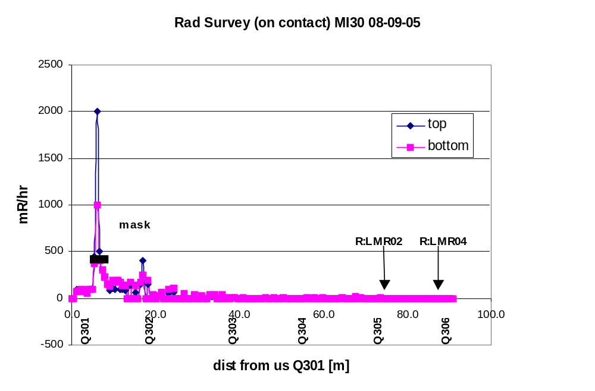

Figure 7: A record of on contact residual radiation dose (mRem/hr) in MI30 straight section

There are several strategies for mitigating the impact of losses in the MI on ECOOL:
- Adjustments in Booster to reduce halo formation at high intensities
- Adjustments to Main Injector such that no beam is lost in this region (steering and coupling and
- Collimate the halo in the 8 Gev line
- Collimate the losses in Main Injector
- Mask the ECOOL loss monitors from the shower (at the monitor or at the source)
- Other…

Each of these strategies are being pursued at some level, but this note only addresses the addition of a mask on the outside of the MI beam pipe that would reduce the small angle shower downstream. Based upon the residual dose rates the largest beam loss point is just downstream of the beam valve at 301. The residual activation suggest that a factor of 10 more beam is lost at this point than anywhere else upstream of Q303 and a factor of >100 more than anywhere else downstream of Q303. The goal is to install enough steel above and to the sides of the loss point that would attenuate the shower by several orders of magnitude and reduce the prompt shower and the residual activation by a factor of 100.

Based upon the criterion of reducing the residual activity at the loss point by a factor of 100 on the top and sides, the mask geometry shown in Figure 7 was settled upon. The length of the mask used in the simulation was 50 inches, however the as built length was increased by 10 inches to fit between the beam valve and the 1st ion pump downstream. This set the length to 60 inches. The two inches on the bottom of the mask was chosen to contain the showers produced.

6”
2”
6”
~5”
6”
2”

Figure 8: Cartoon of the cross-sectional geometry of the mask.

A picture of the tunnel in the region of quad 301 is shown in Figure 9. It indicated the the location of the hot spot and the proposed location of the mask.

Summary:

The addition of the mask is but a single step in the reduction of losses seen by the ECOOL loss monitors. It is not expected to be the whole solution. It is clear that losses created at 301 will be seen by the ECOOL loss monitors. It is also clear that the ECOOL loss monitors also see losses from loss points downstream of 301 as well. The relative contribution from losses at the various locations needs further study, but it is clear that the closer the loss point, the larger a response from the ECOOL loss monitors. Current data suggests that only a small amount of loss come from first turn halo, but the strong coupling at 8 Gev in the Main Injector will couple the particles with the large horizontal amplitude to the vertical plane. Additional study time is needed to understand and correct this situation. The 8 Gev line collimators in both the horizontal and vertical planes will be used to reduce the large amplitude particles at the largest Booster intensities (turns). Additional study time is also warrented to document and quantify the impact of the collimators. Lastly, there are other processes which contribute significantly to the losses seen by ECOOL. The main culpret is the uncaptured beam during the slip-stacking process. This gets deposited in this region during the slip-stacking process itself, the process of clearing the NuMI injection region by antidamping the particles in the injection gap prior to injection, and the loss of uncaptured beam during acceleration.

Based upon these processes, it is expected that, in addition to the mask, we will need to pursue the 8 Gev line collimator , shielding the loss monitors locally, and a system to catch the uncaptured beam ( in a specific, shielded location) without spraying it around the tunnel, i.e. MI collimators.

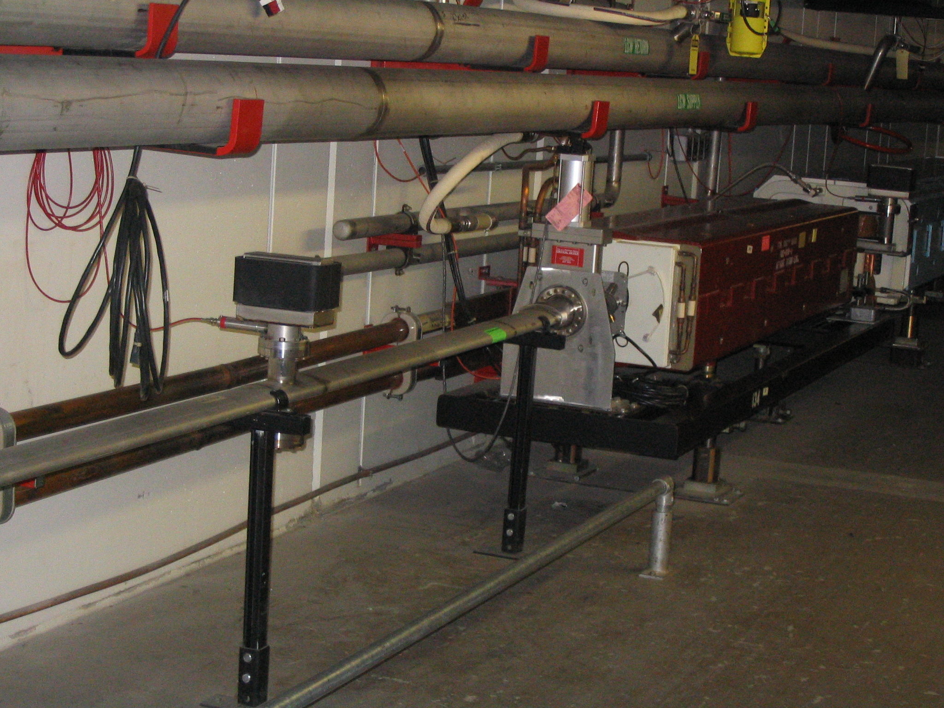
HOT SPOT
MASK LOCATION
Q301

Figure 9: Tunnel geometry of the Main Injector at Q301 showing the quad, beam valve, hot spot, and location of the proposed mask.

