Table of Contents
1. Table of Contents 1
2. Introduction 1
3. Setup for Reverse Protons 2
a. Pbar Annex Sequencer: Fast Recycler Start 4
b. Pbar Annex Sequencer: Fast Recycler Reverse Protons 25
c. Pbar Annex Sequencer: Fast Recycler Finish Reverse Protons 28
d. Pbar Sequencer: Reverse Protons to the Debuncher 38
e. De-tune the DRF1 Rotator Cavities 47
4. Circulating Beam in the Debuncher (Sequencer commands provided by Brian Drendel. Section to be written by Stan Johnson). 48
a. $16/$2D in the TLG 48
b. One Shots 48
5. Debuncher Orbits (Section to be written by Al Sondgeroth) 49
a. Java Orbit Preparation 49
b. Java BPM Orbits 49
6. Debuncher Admittance Measurement 49
a. Pbar Sequencer: Deb Hor aperture scan rev p 50
b. Pbar Sequencer: Deb Vert aperture scan rev p 58
7. Beam up AP2 66
a. Establishing beam up the AP2 line 66
b. Beam Modes 67
i. Obie Box Primer 68
ii. Partial Debuncher Turn to AP2 70
iii. Circulating Debuncher beam to AP2 72
8. Java AP2 BPM Orbits (to be written by Al Sondgeroth) 74
9. D/A Orbit Studies (to be written by Al Sondgeroth) 74
10. Return to Stacking (Sequencer commands provided by Brian Drendel. Section to be written by Stan Johnson). 74
a. Finish Out “Reverse Protons to Debuncher” 74
b. Return to Stacking 75
11. References 92
a. “Obie Box Primer” 92
2004 Pbar Electronic Logbook Chapter 638 (http://www-bd.fnal.gov/cgi-mach/machlog.pl?nb=pbar05&action=view&page=638&anchor=183706&hilite=18:37:06-%20target=_top), Steve Werkema 92
b. “Pbar Dedicated Studies,” 92
2004 Pbar Electronic Logbook Chapters 681 to 730 (http://www-bd.fnal.gov/cgi-mach/machlog.pl?nb=pbar05&action=view&page=681&load=), Pbar Department 92
c. “Pbar Online Tuning Guide,” 92
http://www-drendel.fnal.gov/TuningGuide/tuning-guide.htm, Brian Drendel 92

Introduction

The purpose of this document is to outline the procedural steps required to enter various Reverse Proton Studies modes. When we are stacking, the P1, P2 and AP1 lines are all configured for 120 GeV protons. When switching to Reverse Protons, we must stop stacking and setup the lines for 8 GeV protons. The 8 GeV protons then are sent down the AP3 line, where they are injected onto the injection orbit in the Accumulator. From there, we can extract the 8 GeV beam down the D/A line to the Debuncher. We can either circulate the reverse protons in the Debuncher or extract them up the AP2 line. We will outline how to configure the Antiproton Source in a number of different Reverse Proton studies configurations.

First, we will outline how to establish Reverse Protons circulating in the Debuncher from either dedicated TLG events or “one shots.” We will then outline how to extract the Reverse Protons from the Debuncher down the AP2 line either from circulating Debuncher beam or using partial turn Debuncher extraction. We will then cover how to setup for up D/A line studies. Lastly, we will cover how to return Pbar to normal stacking.

Many of the steps needed to enter and exit these study modes are consolidated into two Pbar sequencers called the Pbar Sequencer and Pbar Annex Sequencer. Other steps require manual intervention. We will assume that we are starting with the Pbar source configured in stacking mode.

Setup for Reverse Protons

From stacking mode, our first goal is to configure the Antiproton Source for reverse protons. To do so, we will run the first three aggregates in the Pbar Annex sequencer, followed by the first portion of the Pbar Sequencer “Reverse Protons to Debuncher” aggregate.

We will start by entering the Pbar Sequencer, which can be found on Acnet page P64.

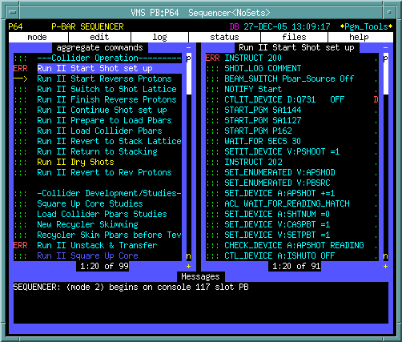
Figure 3-1: The Pbar Sequencer.

After entering the Pbar Sequencer, click on the menu bar item “mode” in the upper left corner of the screen. Select the Pbar Annex (Mode 17) from the selection menu.

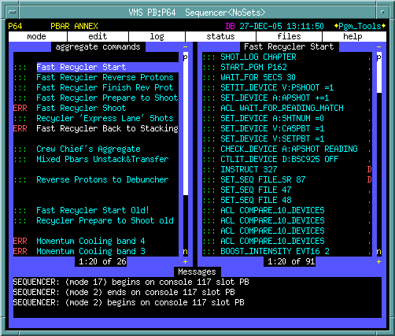
Figure 3-2: The Pbar Annex Sequencer.

We will now run the first three aggregates in the Pbar Annex Sequencer. The same three aggregates are used in the initial stages of the Accumulator to Recycler transfers so there are some commands that may not be necessary for our Reverse Proton studies. We will attempt to point these out as we go along.

Pbar Annex Sequencer: Fast Recycler Start

Click on “Fast Recycler Start” in the left column of the sequencer. The right column now shows the commands in this sequencer. To start this aggregate, click on the green “:::” on the first command in the sequence. We will now step through each command in the sequencer.

- SHOT_LOG CHAPTER

This command starts a new shot log chapter in the Recycler shot scrapbook at http://www-bd.fnal.gov/cgi-mach/machlog.pl?nb=rscrap03&load=no. Since we are not completing a Recycler shot, we can actually skip this command and start the aggregate at the next command.

- START_PGM P162

Starts the Accumulator BPM TBT Page P162 (keeper is Keith Gollwitzer). This page, as shown below, checks the status of the Accumulator BPM houses and issues resets to any house that is not online. This allows plenty of time for the BPM houses to reboot before they are need in the beam line tune-up. Upon completion, this application self terminates and the window will close on its own.

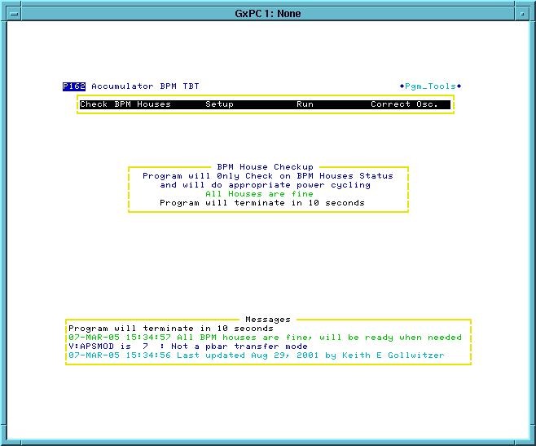
Figure 3-3:

- WAIT_FOR SECS 30

This command waits 30 seconds for the previous command to complete.

- SETIT_DEVICE V:PSHOOT =1

Sets the state parameter V:PSHOOT to 1, then pauses long enough to verify that the setting was completed successfully.

Devices that start with V: are called state parameters. State parameters define the operational state of a device or accelerator, allow the sequencers to be more automated, and prevent the different sequencers from getting out of sequence with each other. Often one sequencer waits at a certain spot until another sequencer changes a state parameter.

V:PSHOOT is a state parameter for the Pbar transfer state. V:PSHOOT state 1 means “not ready for transfer.” Later in this aggregate, V:PSHOOT is set to 4 (“Ready for Main Injector Tune up”). The Main Injector Shot Transfer Line Tune-up aggregate waits for PSHOOT to be set to 4 (“Ready for Main Injector Tune up”) before starting its beam line tune-up.

- SET_DEVICE A:APSHOT +=1

Increments A:APSHOT by 1. This is the Pbar transfer series number, which is incremented before and after any Pbar transfer from the Accumulator to the Tevatron or Accumulator to the Recycler. This command is not necessary for Reverse Proton Studies.

- ACL WAIT_FOR_READING_MATCH

A Runs an Accelerator Command Language (ACL) script called WAIT_FOR_READING_MATCH that waits for "SDA Shot/Store #" (A:FILE) to read the same value as the Pbar transfer series number (A:APSHOT). More information on ACL scripts can be found at http://adcon.fnal.gov/userb/www/controls/clib/intro_acl.html.

- SET_DEVICE A:SHTNUM =0

Sets the “Pbar transfer series Shot #” parameter (A:SHTNUM) to zero. Later on A:SHTNUM is incremented by one for every Pbar transfer. This is not used during Reverse Proton Studies.

- SET_DEVICE V:CASPBT =1

The "Pbar transfer SDA case trigger" state (V:CASPBT) is set to 1, which represents "Set up." Possible values for this state parameter include: 1 = Set up, 2 = Unstack Pbars, 3 = Transfer Pbars from Accumulator to Main Injector, 4 = Accelerate Pbars in the Main Injector, 5 = Coalesce Pbars in the Main Injector. This is not necessary for Reverse Proton Studies.

- SET_DEVICE V:SETPBT =1

Sets the "Pbar transfer SDA set in case" state device to 1. D88 currently shows no state information descriptions for the different states of this parameter.

- CHECK_DEVICE A:APSSHOT READING

Prints the value of the “Pbar Transfer Series Number” parameter (A:APSHOT) in the message window at the bottom of the sequencer in the following format.

COM: A:APSHOT present value = #####.00000

- CTLIT_DEVICE D:BSC925 OFF

Puts in the AP3 beam stop to prevent reverse proton beam from being injected into the Accumulator.

- INSTRUCT 327 D

This is a bypassed command that is not needed at this time.

- SET_SEQ FIEL_SR 87 D

This is a bypassed command that is not needed at this time.

- SET_SEQ FILE 47

Executes sequencer file #47 which resets AP3 line devices. This will clear any trip status before trying to turn the supplies on. Devices in this list are located in AP30 (D:Q901, D:V901, D:Q903, D:Q907 and D:Q909), F27 (D:Q913, D:Q914, D:Q916, D:Q917, D:Q919), and AP0 (D:H914, D:Q924, D:Q926 and D:H926).

- SET_SEQ FILE 48

Executes sequencer file #48 which turns on the same AP3 line devices that were reset in the previous sequencer command. With the AP3 line supplies on we will be able to run reverse proton beam up the AP3 line toward the Accumulator.

- ACL COMPARE_10_DEVICES
- ACL COMPARE_10_DEVICES
- ACL COMPARE_10_DEVICES
- ACL COMPARE_10_DEVICES

The above four commands each runs an Accelerator Command Language (ACL) script called COMPARE_10_DEVICES. The script verifies that all 8GeV values are the same on all cycles for ramped P1 and P2 line devices. There are a limited number of devices that can be verified in one ACL script, so the script is run four times in order to cover all of the trims. More information on ACL scripts can be found at http://adcon.fnal.gov/userb/www/controls/clib/intro_acl.html.

- BOOST_INTENSITY EVT16 2

This command sets the Booster $16 event to an intensity of 2 turns each with 35 bunches. This intensity ensures that the P1-P2 line BPMs have enough intensity to report reliable read backs. At this intensity, one must be cautious not to run beam continuously as radiation trips will result.

- CHECK_DEVICE A:R2DDS1 SAVE_SET

Reads and saves the present setting of A:R2DDS1. This is the stabilizing RF frequency.

- CHECK_DEVICE A:R2LLAM SAVE_SET

Reads and saves the value of A:R2LLAM. This is the stabilizing RF amplitude.

- CHECK_DEVICE A:DPHATT SAVE_SET

Reads and saves the value of A:DPHATT. This is the Accumulator horizontal damper attenuator setting.

- CHECK_DEVICE A:SCRES SAVE_SET

Reads and saves the value of A:SCRES. This is an Accumulator timing event.

- WAIT_DEVICE V:MSHOOT

The commands waits for the Main Injector transfer state parameter V:MSHOOT to equal 4. A state of 4 indicates that the Main Injector has finished the Main Injector reverse proton tune-up.

- SPECTRUM_LOAD 2 7

Loads P41 file #7 to Spectrum Analyzer #2 at AP30. This is the unstacking display and can be viewed on CATV Pbar #28.

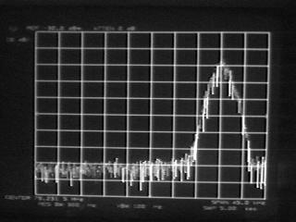
Figure 3-4

- SEQ_PGM REQUEST Unstack SA D

This is a bypassed command that is not needed at this time.

- SEQ_PGM REQUEST AP0 Scope D

This is a bypassed command that is not needed at this time.

- SEQ_PGM REQUEST Acc Gap Mon

Starts the Pbar GBIP command editor program P188 (keeper is Jim Budlong). The Request qualifier tells the application to load file 6, which is used to setup the Accumulator AP10 gap monitor scope for capturing Pbar unstacking events. The P188 window automatically closes when the file load is complete. This is used for Pbar transfers and is not necessary for Reverse Protons.

- ACKNOWLEDGE

Displays the following acknowledge command. It reminds the operator to start the emittance FTP (next command) on a different console.

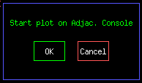
Figure 3-5

- AUTO_PLOT Core Emittances

Starts a Fast Time Plot to monitor emittances. Operators should monitor this plot while the Pbar experts do their studies.
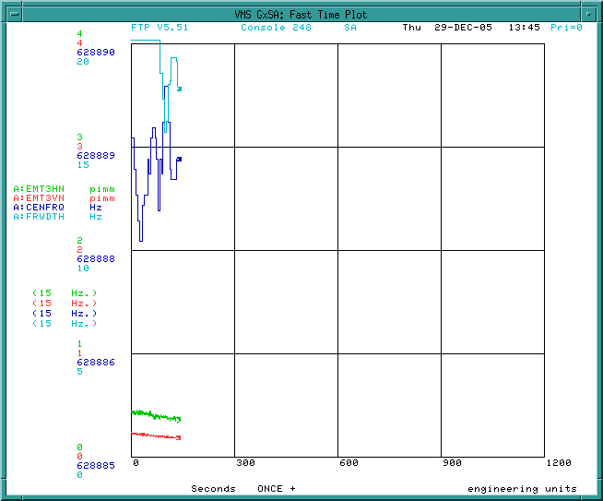
Figure 3-6

- START_PGM SA1127

Pbar Radiation Detector Display (keeper is Tony Leveling) is started on comfort display 102. This SA can be used during the beam line tune-up to verify that radiation levels are not high enough to cause a radiation trip. The program emulates the actions of the radiation detector cards. It updates every 60 seconds and takes a 15 minutes rolling average of the radiation losses and normalizes each radiation detector so that a value of 1 corresponds to the radiation trip level. The parameters for the individual radiation detectors can be found on D106 ACC/DEB < 1> to < 3>. G:RA{####} is an integrating real-time read back of the radiation detector. Every 60 seconds, which is not concurrent with the supercycle, G:RA{####} is reset to zero and starts integrating all over again. G:RD{####} takes the number of G:RA{####} before it is reset and keeps that value until G:RA{####} is reset again. When doing the reverse proton tune-up later in the shot, if any radiation detector gets near to 1 on the plot, the beam switch should be taken to avoid a radiation trip. If the SA1127 plot dies, it can be restarted by reissuing this command, or manually through Acnet page P151. A screen capture of SA1127 is shown below.

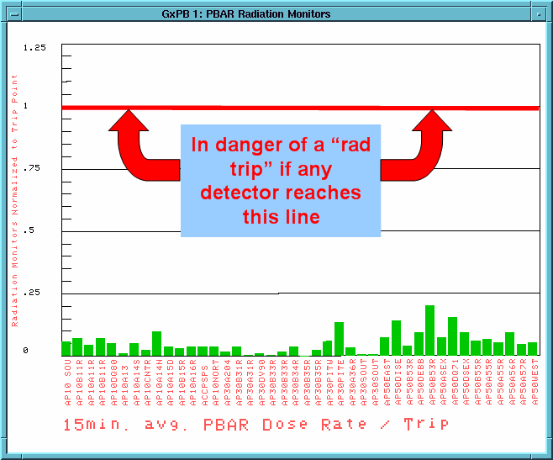
Figure 3-7

- BEAM_SWITCH Pbar_Source Off

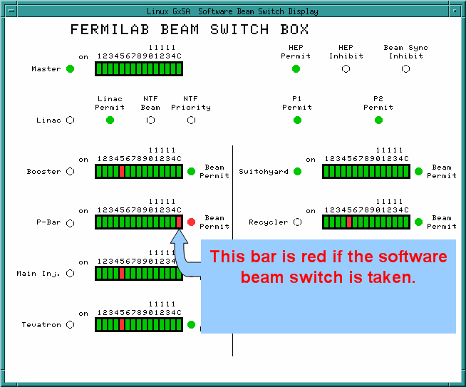
Figure 3-8

- NOTIFY Start

Sends a Channel 13 Notify message to http://www-bd.fnal.gov/cgi-bin/notify_mes.pl?ch13=text

- SET_ENUMERATED V:APSMOD

V:APSMOD is a state parameter representing the operational mode of the Pbar Source. The set_enumerated command asks the user to select from a menu of V:APSMOD state values as shown below. When setting up for Reverse Proton Studies, the operator should chose state 8 = Reverse Protons.

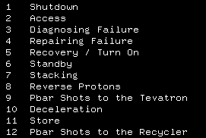
Figure 3-9

- SHOT_LOG COMMENT

Adds the following comment to the Pbar portion of the shot log chapter. This is not necessary for Reverse Proton Studies.

{Time}- Beginning shots to the Recycler, the starting stack size is ###.######. – Sequencer

- ABORT_MASK PBAR_SOFT ENABLED

This command enables the “PBAR_SOFT” Pbar abort mask. The logic is confusing, but when the abort mask is enabled, no aborts are seen.

This is the Pbar Software abort which is connected to the 204 module (viewed from P103) that monitors 120 GeV AP1 line power supply analog outputs. Since we are not running 120 GeV protons in the AP1 line when we do 8 GeV reverse proton studies, we can mask this entry.

- ABORT_MASK AP1_120_PS ENABLED

This command enables the “AP1_120_PS” Pbar abort mask. This abort monitors the digital status of the AP1 line 120GeV power supplies. Again, since we are not running 120GeV protons in the AP1 line while we are doing 8 GeV reverse proton studies, we can mask this entry.

- INSTRUCT 206 D

This command is bypassed and not needed at this time.

- ALARM_LIST PBAR 2

This command bypasses analog alarms for AP1 120 GeV power supplies.

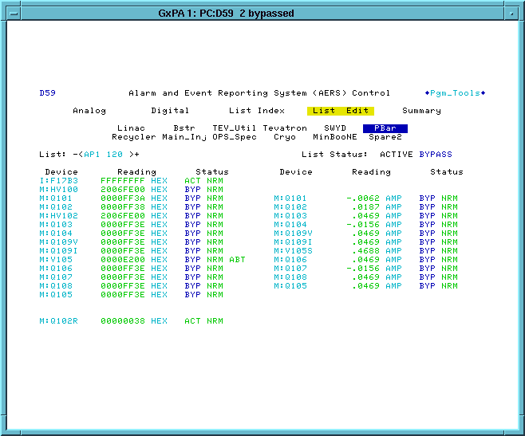
Figure 3-10

- SET_SEQ FILE 37

This command turns off AP1 120 GeV power supplies. The devices that are turned off are M:HV100, M:Q101, M:Q102, M:HV102, M:Q103, M:Q104, M:Q105, M:V105, M:Q106, M:Q107, M:Q108, M:Q109I, M:Q109V, AND M:CSF23 (Ap1 trim bulk supply).

- INSTRUCT 307 D

This command is bypassed and not needed at this time.

- SET_SEQ FILE_SR 79 D

This command is bypassed and not needed at this time.

- SET_SEQ FILE 41

Sequencer File 41 sends resets to AP1 8 GeV supplies. This is done to clear any trip status prior to turning the devices on. The devices that are reset are I:F17B3, M:HV200, M:Q201, M:HV202, M:Q203, M:Q204, M:Q205, M:V205, M:Q206, M:Q207, M:Q208, M:Q209, M:CSF23, M:HT100D, M:VT101D, M:VT11AD, M:HT105D, M:HT107D, AND M:VT108D. I:F17B3 is located in the F2 service building, and the rest of the devices in this list are located in the F23 service building.

- SET_SEQ FILE 42

Sequencer File 42 turns on AP1 8 GeV supplies. It also sets the polarity of M:Q102R negative. Devices that are turned on are I:F17B3, M:HV200, M:Q201, M:HV202, M:Q203, M:Q204, M:Q205, M:V205, M:Q206, M:Q207, M:Q208, M:Q209, M:CSF23, M:HT100D, M:VT101D, M:VT11AD, M:HT105D, M:HT107D, AND M:VT108D. I:F17B3 is located in the F2 service building, and the rest of the devices in this list are located in the F23 service building.

- ALARM_LIST PBAR 12

This command enables the Pbar Alarm list entitled AP3. This alarm list is composed of the “AP3 DGTL” and “AP3 ANLG” alarm lists.

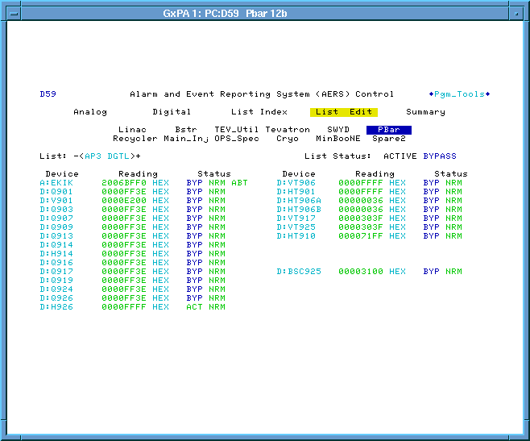 | 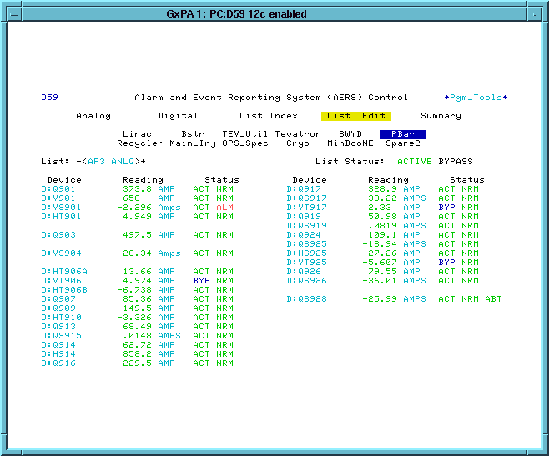
Figure 3-11

- EVENT 91 DISABLE

This command disables the TCLK event $91, which the Pbar unstacking cycle reset.

- WAIT_FOR SECS 10

Ten second wait.

- CTL_DEVICE M:Q102 RESET

Issues a “reset” to M:Q102. M:Q102 was already issued a "reset" and "on" in file 41 above; however, it has a transfer switch that takes a finite amount of time to switch over. This command and the command that follows make sure that M:Q102 is on before 8 GeV beam is run in the AP1 line.

- CTLIT_DEVICE M:Q202 ON

Issues an “on” to M:Q102. . This command and the previous command help ensure that M:Q102 is on before 8 GeV beam is run in the AP1 line.

- ALARM_LIST PBAR 3

Enables the D59 alarm list entitled “AP1 8GEV”. We want to monitor the AP1 8 GeV line supplies when sending 8 GeV beam through the line.

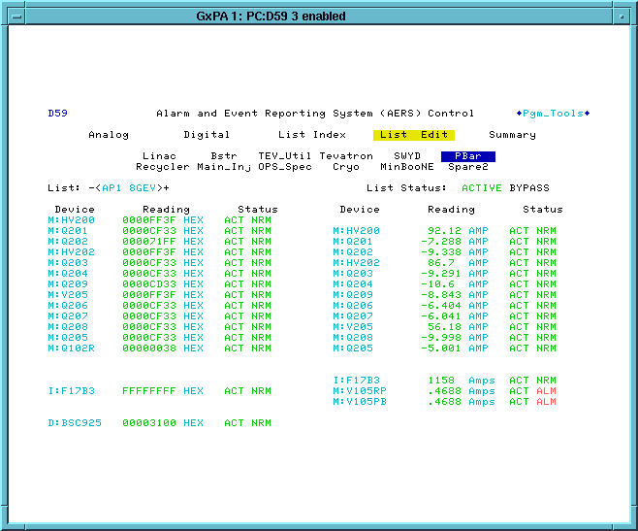
Figure 3-12

- SET_ENUMERATED V:APSMOD D

This command is bypassed since it was moved earlier in the sequencer.

- LOAD_TLG 101 REPEAT

Loads Timeline #101. This is the timeline used for Recycler shots. It contains MiniBooNE and NuMI events. It has $16/$2D 8 GeV reverse proton events spaced 20 seconds apart. There is also an $8E event prior to the first $16/$2D. This event is use to reset the fields in the P1 and P2 line magnets.

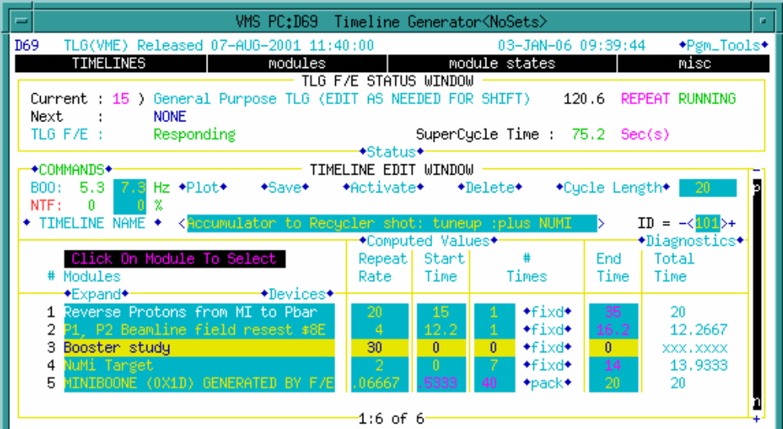
Figure 3-13

- ABORT_MASK AP1_8_PS DISABLED

This command disables the abort mask for AP1 8 GeV supplies. Now that we are about to run 8 GeV beam in the AP1 line, we want to pull the beam permit if any of those power supplies trip.

- EVENT 88 TRIGGER

Triggers TCLK event $88.

- SETIT_DEVICE V:PSHOOT =4 D

This command is bypassed and not needed at this time.

- BEAM_SWITCH Pbar_Source On D

This command is bypassed and not needed at this time.

- ALARM_LIST PBAR 52

Bypasses the D59 alarm list entitled “ARF1”. ARF1 is used during stacking to move beam from the injection orbit to the deposition orbit. It is not needed for reverse proton studies.

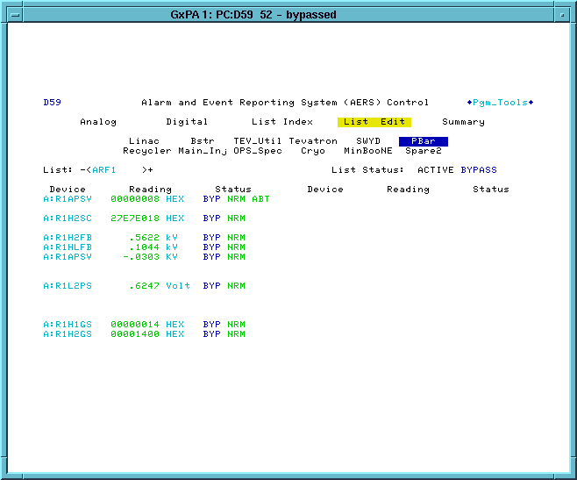
Figure 3-14

- WAIT_FOR SECS 3

A three second wait to ensure that the previous sequencer command finished before moving to the next command.

- ALARM__LIST PBAR 23

Bypasses the D59 alarm list entitled “PULSED” (pulsed devices).
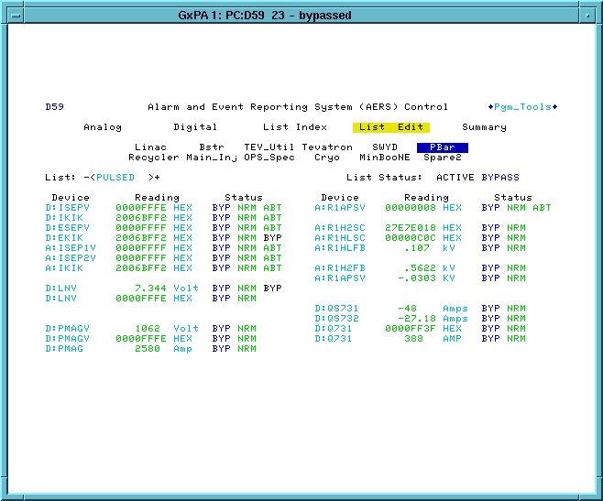
Figure 3-15

- SET_SEQ FILE 1

This command turns off devices that had their alarms bypassed in the previous three commands. The pulsed devices (D:LNV, D:PMAGV, D:ISEPV, D:IKIK, D:EKIK, D:EKIKQ, D:ESEPV, D:ISEP1V, D:ISEP2V, and A:IKIK) and ARF1 devices (A:R1L1AM, A:R1L2AM, A;R1HLSC) turned off. In addition, A:EXTRAT is disabled, and A:EKIKTG is set to its reverse proton value.

- SET_SEQ FILE 83

File #83 sets core horizontal and vertical 4-8 GHz cooling to gate off during reverse proton events injections. The on and off times (A:CBPON and A:CBPOFF) are both enabled and set to TCLK $99 + 3 seconds and TCLK $99 + 0 seconds respectively.

- SET_SEQ FILE 85

File #85 is labeled RunIIb Misc. settings. It sets up the ARF1 fanback voltage and phase read back sample and hold trigger timers (A:R1HLT1 AND A:R1LLT3) both to be 1.575 seconds after an Accumulator to Main Injector transfer event $9A. It also sets up the ARF1 Accumulator to Main Injector frequency track and hold timer (A:R1LLT4) to be 0.000211 seconds after a TCLK $94. In addition, the file sets the Accumulator beam sample timers A:IBMS1 and A:IBMS2 to $91 (or $80) + .1 seconds and TCLK $91 (or $80) + 1 second respectively. Lastly, the file sets the Debuncher Extraction kicker septa charge timer. It changes it from $80 + 0.4 seconds to $90 + 0.00001 seconds.

- CTL_DEVICE A:ISHUTO OFF

Turns off the accumulator injection shutter open timer. The Accumulator injection shutter will now not be told to open.

- CTL_DEVICE A:ESHUTO OFF

Turns off the accumulator extraction shutter open timer. The Accumulator extraction shutter will now not be told to open.

- CTL_DEVICE A:ISHUTC ON

Turns on the accumulator injection shutter close timer. The shutter open timer was disabled and the shutter closed timer was enabled. This ensures that the Accumulator Injection shutter stays closed. The Accumulator injection shutter position can be verified by looking at A:ISHTST. A reading of 1 means open and a reading of 2 means closed.

- CTL_DEVICE A:ESHUTC ON

Turns on the accumulator extraction shutter close timer. The shutter open timer was disabled and the shutter closed timer was enabled. This ensures that the Accumulator Extraction shutter stays closed. The Accumulator extraction shutter position can be verified by looking at A:ESHTST. A reading of 1 means open and a reading of 2 means closed.

- START_PGM SA1144
- START_PGM SA1144

Starts the Stack-o-meter SA (keeper is David Sutherland)on comfort display console 101. If this plot dies, it can easily be restarted as follows. From CNS1, do a CNTL-SHIFT-4 to get to the CNS101 comfort display. Go to P69 and then click PLOT!! under the lifetime category. Operators should use this display to help monitor the Accumulator while the Pbar Experts are doing their reverse proton studies.

- INSTRUCT 302

Instruct 302 informs the Operator that the VSA SA should be run on Slot GxSC. Unless otherwise instructed from Pbar Experts, operators should continue to run the VSA during Pbar studies to monitor the frequency width.


Figure 3-16

- SET_DEVICE A:VSARST =9

A:VSARST is set to 9, which terminates any existing instances of the VSA.

- WAIT_DEVICE A:VSARST

Waits for VSA reset to complete.

- START_PGM SA1156 D

This command is bypassed and not needed at this time. This command and the next command are the two versions of the VSA code. As the code is developed, we at times switch between the two SAs.

- START_PGM SA1136

Accumulator Momentum profile using the VSA (keeper is Dave McGinnis). This is normally run on the SC screen of the console that runs the Pbar Sequencer, and can be restarted from P142. SA1136 calculates the center frequency (A:CENFRQ) and frequency width (A:FRWDTH) of the Accumulator beam. If the momentum cooling is being run too hard, you will see a coherent spike on the display. If bad enough, the coherent spike can be larger than the plot scale. This is in indication of an instability, and it also effects the VSA calculations (for example, it makes the frequency width artificially small). If coherent spikes are seen on the trace, you can lower the 2-4GHz momentum power until the spike goes away. A:SPIKE is a datalogged parameter that measures how bad the coherent spike is on the VSA display. Values above 20% can indicate excessive coherent spikes on the display. Below is a typical SA1136 display that is not exhibiting coherent spike problems.

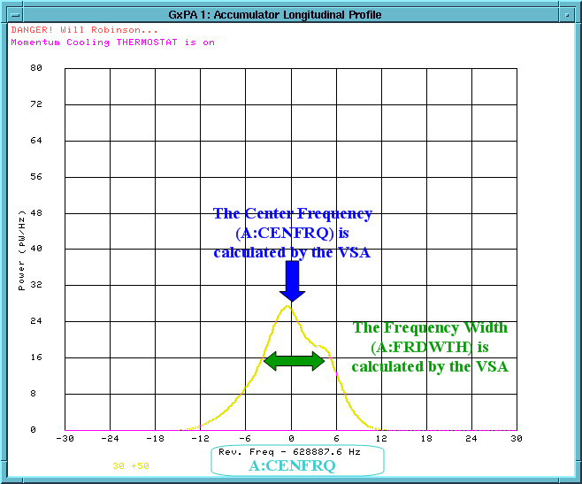
Figure 3-17

What if the VSA plot dos not start? Occasionally the VSA does not start. When that is the case, follow the directions in the Pbar Elog at http://www-bd.fnal.gov/cgi-mach/machlog.pl?nb=pbar04&action=view&page=19&anchor=174245&hilite=17:42:45-%20target=_top to configure the VSA.

- WAIT_FOR SECS 15

A fifteen second delay to ensure that the VSA SA starts.

- ACL SET_FROM_READING

Sets the desired accumulator frequency width (A:VSAFWD) to the value of the calculated desired frequency width based on stack size (A:VSAFWS).

- SET_DEVICE A:VSAFWD -=5

Lowers the desired accumulator frequency width by 5Hz. The result of the two last commands is A:VSAFWD = A:VSAFWS – 5Hz.

- SETIT_DEVICE A:DTMHVE =.5

Sets the horizontal minus vertical emittance difference for VSA vertical thermostat. If the VSA is in momentum and vertical thermostat mode (A:VSARST = 7), then this parameter would be used to determine when to turn off the vertical cooling. When running in this mode, if the difference between the horizontal and vertical emittances becomes greater than A:DTMHVE, then the vertical cooling is gated off.

- SETIT_DEVICE A:VSARST =6

This puts the VSA in a momentum thermostat mode that is based on running both the 2-4 GHz and the 4-8 GHz momentum cooling systems. This is similar to the stacking momentum thermostat. The difference is this thermostat regulates on A:VSAFWD instead of A:CMFRWD[x].

On initialization it moves the 4-8 GHz arrays to the alignment position A:CMARPI without asking the operator to check TV Ch. 20 (The value A:CMARPI was set during the last time the momentum stacking thermostat was initialized). It starts with the last used PIN attenuator setting. When the 4-8 GHz attenuator reaches its max value it shuts off both the 2-4 GHz and 4-8 GHz momentum systems (unlike the stacking thermostat which just shuts of the 4-8 GHz momentum system.) When turning on the 4-8 GHz system it also turns on the 2-4 GHz system.

- CHECK_DEVICE A:VSAFWS READING

Checks the analog reading of A:VSAFWS and displays the results in the message window. This command is configured with the number of tries equal to zero, which means that no checks are made. A:VSAFWS is the suggested desired frequency based on stack size.

- INSTRUCT 303

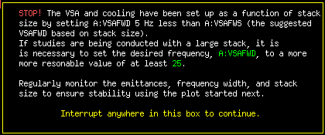
Figure 3-18

- CUSTOM COOL_GAIN

Sets core cooling PIN attenuators to values obeying an equation mult(i)*(A:IBEAMB)+offset(i). The constants “offset” and “mult” are stored in a table maintained by the AD\Pbar department. Custom cooling gain usually undershoots cooling power for larger stacks.

- SET_DECICE A:DPHATT =5

Sets the Horizontal Damper attenuator setting to 5dB.

- SET_DEIVCE A:SCRES +=1.8

Increments A:SCRES by 1.8 seconds. During stacking, A:SCRES is normally set to $80 (or $85 or $93) + 0.504 seconds.

- ALARM_LIST PBAR 76

Bypasses the D59 alarm list entitled “DEB COOL” (Debuncher Cooling). This list contains a number of other lists.

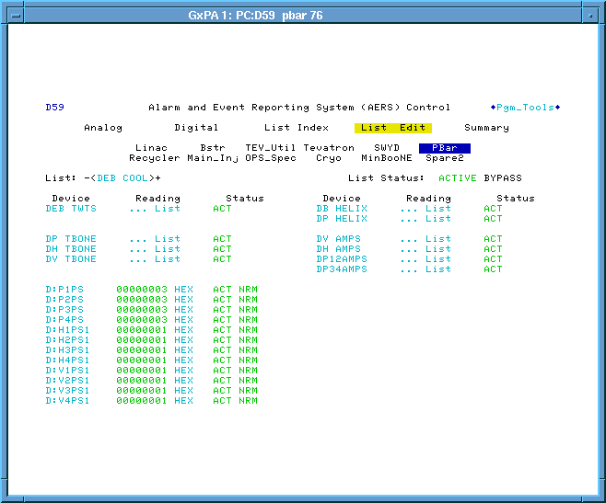
Figure 3-19

- SET_SEQ FILE 92

File #92 opens the Debuncher cooling PIN switches to turn off the Debuncher cooling during the shot setup. The PIN switches that are turned off are D:H1PS1, D:H2PS1, D:H3PS1, D:H4PSI, D:V1PSI, D:V2PS1, D:V3PS1, D:V4PS1, D:P1PS1, D:P2PS1, D:P3PS1, AND D:P4PS1.

Pbar Annex Sequencer: Fast Recycler Reverse Protons

We next more on to the second aggregate in the Pbar Annex sequencer.

- ACKNOWLEDGE

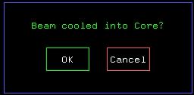

- CTLIT_DEVICE A:SPPS01 OFF

Turns off the stacktail pin switch. With the Accumulator beam cooled into the core, we no longer need to run the stacktail.

- SET_SEQ FILE 28

File 28 turns off stacktail high level amps. The devices that are turned off are A:SPAH11, A:SPAH12, A:SPAHD1, A:SPAHD1, A:SPAHD2, A:SPAHD3, A:SPAHD4.

- SET_SEQ FILE 94

File 94 turns on power leveling and sets the diode voltage for he core horizontal and vertical transverse systems. The devices that are modified are A:CH1D1, A:CH2D1, A:CH3D1, A:CV1D1, A:CV2D1, and A:CV3D1. With power leveling enabled, changing the PIN attenuators does not change the power. To change the power the diode voltages need to be modified. The diode voltages can be found on P36 CORE_M_&_B <39>.

- SET_SEQ FILE 30

File 30 sets the 2-4GHz momentum cooling attenuation level. It also turns on and enabled digital alarms for the 4-8GHz cooling system. The devices that are modified are A:CPPA01, A:CMTW01, AND ACMTW02.

- CTLIT_DEVICE A:CMTW01 ON

This command turns on 4.8 GHz momentum TWT #1. This is a repeat of the same command in file #30 above. The command is issued a second time to ensure that the TWT get turned on.

- CTLIT_DEVICE A:CMTW02 ON

This command turns on 4.8 GHz momentum TWT #2. This is a repeat of the same command in file #30 above. The command is issued a second time to ensure that the TWT gets turned on.

- CHECK_DEVICE A:ISHTST READING

Verifies that A:ISHTST is reading 2, which means that the Accumulator injection kicker shutter is closed. A:ISHTST has two readings: 1 = shutter is open, 2= shutter is closed.

Keeping the shutters closed minimizes any impact that the Reverse Proton beam will have on the Pbar stack.

- CHECK_DEVICE A:ESHTST READING

Verifies that A:ESHTST is reading 2, which means that the Accumulator extraction kicker shutter is closed. A:ESHTST has two readings: 1 = shutter is open, 2= shutter is closed.

Keeping the shutters closed minimizes any impact that the Reverse Proton beam will have on the Pbar stack.

- CHECK_DEVICE A:R2HLSC ON D

This command is bypassed and not needed at this time.

- CHECK_DEVICE A:R3HLGS ON

Verifies that A:R3HLGS is “on,” which means that the ARF3 cavity short is in.

- ALARM_LIST PBAR 38

Bypasses the “CORE HOR” alarm list.

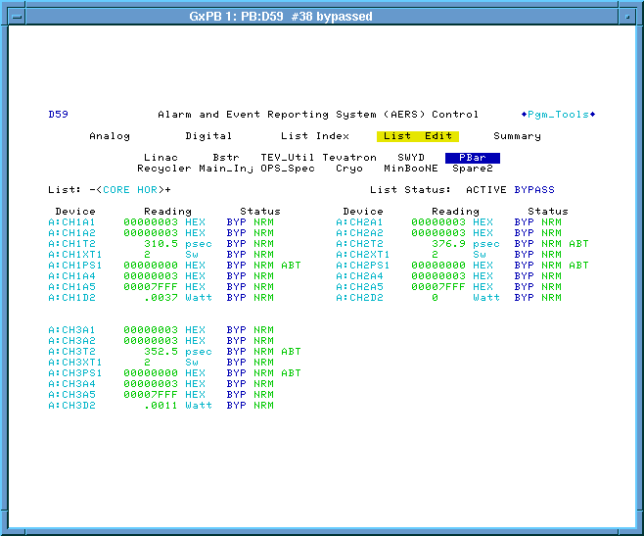
Figure 3-20

- CHECK_DEVICE A:FRWDTH READING

Displays the current value of A:FRWDTH (frequency width) in the message box.

- SETIT_DEVICE A:VSARST =3 D

This command is bypassed and not needed at this time.

- ACKNOWLEDGE D

This command is bypassed and not needed at this time.

- WAIT_FOR SECS 20 D

This command is bypassed and not needed at this time

- WAIT_DEVICE A:VSARST D

This command is bypassed and not needed at this time

- SETIT_DEVICE A:VSARST =7 D

This command is bypassed and not needed at this time

- ACKNOWLEDGE

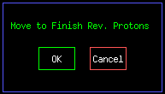

Pbar Annex Sequencer: Fast Recycler Finish Reverse Protons

We next move on to the third aggregate in the Pbar Annex sequencer.

- SHOT_LOG COMMENT

Adds a comment to the Pbar portion of the Recycler shot scrapbook.

14:22:25- Finishing reverse proton tune up. The stack size is {A:IBEAMB}. - Sequencer

- EVENT 9C DISABLE

Disables the TCLK $9C event. This is the sudden beam loss event, which triggers and annunciation and stops the power supply transient recorders. Since unstacking events would be misinterpreted as a sudden beam loss in the Accumulator, the $9C is disabled for the duration of the Recycler transfers.

- BEAM_SWITCH Pbar_Source Off

Turns off the Pbar Software Beam Switch to prevent beam from being injected.

- BOOST_INTENSITY EVT16 1

Sets the $16/$2D events to 1 turn, 10 bunches. Prior to 2006, we had to run 35 bunches for the P1 and P2 line BPMs.

- CTLIT_DEVICE D:BSC925 ON

Pulls out the AP3 beam stop which will allow us to send reverse protons up the AP3 line to the Accumulator.

- CTLIT_DEVICE D:ESEPV ON

We will take reverse protons all of the way to the Debuncher. We will now selectively turn on the pulsed devices that allow this to happen. We first turn on the Debuncher Extraction septum power supply. In reverse proton direction, this is injection into the Debuncher from the D/A line.

- CTLIT_DEVICE A:ISEP1V ON
- CTLIT_DEVICE A:ISEP2V ON

Turns on the Accumulator Injection Septum. In reverse proton direction, this is Accumulator Extraction to the D/A line.

- CTLIT_DEVICE A:EKIK ON

Turns on the Accumulator Extraction kicker. In reverse proton direction, the is Accumulator injection from the AP3 line.

- CTLIT_DEVICE A:EKIKQ ON D

This command is bypassed and not needed at this time

- EVENT 88 TRIGGER

Triggers TCLK event $88.

- AUTO_PLOT Beamline tune-up

Starts a FTP as shown below. The plot shows the Main Injector intensity, AP1 line intensity, AP3 line intensity and Accumulator beam intensity. The plot is triggered from 0 to 4 seconds on a $93.
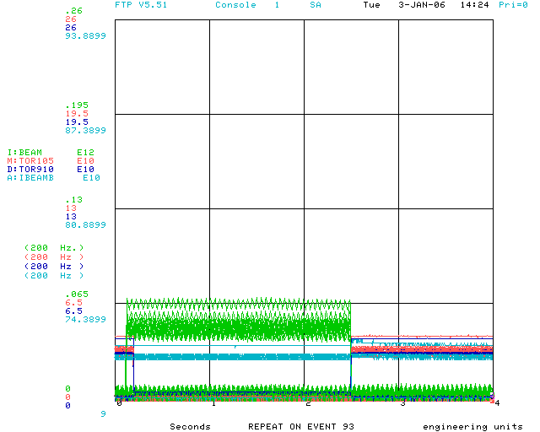
Figure 3-21

- BEAM_SWITCH Pbar_Source On

This enables the software beam switch. Once all of the hardware beam switches are enabled, we should be able to take beam.

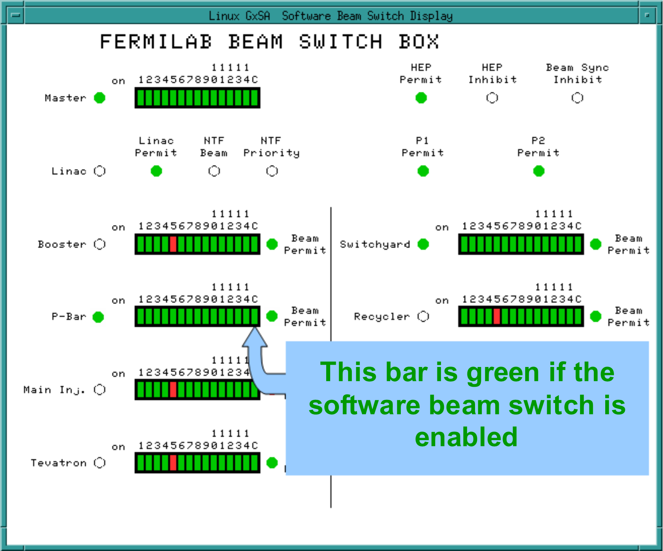
Figure 3-22

- INSTRUCT 231 D

This command is bypassed and not needed at this time

- START_PGM P150 D

This command is bypassed and not needed at this time. The above two commands are only used when using P150 to tune-up the beamlines.

- INSTRUCT 214

Instruct 214 has us check the transfer efficiency. Take a pulse of beam. If the efficiency from Main Injector to the AP3 line (D:TOR910) is less than 75%, then we need to unbypass and run the two previous sequencer commands. By continuing past this instruct, we are saying that the beamline tune-up is complete. We will next move on to the turn by turn tune-up.

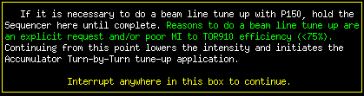

- BEAM_SWITCH PBAR_SOURCE OFF

The Pbar beam switch is turned off so that we do not take bema.

- SETIT_DEVICE V:PSHOOT =7

Sets the state parameter V:PSHOOT to 7, then pauses long enough to verify that the setting was completed successfully. State 7 is defined as “Pbar Beamline Tune-up Complete.”

- ACKNOWLEDGE D

This command is bypassed and not needed at this time

- BOOST_INTENSITY EVT16 1

Sets the $16/$2D events to 1 turn, 10 bunches, which was already set in an earlier step.

This command is present for historical reasons. Prior to 2006, we had to run 35 bunches for the P1 and P2 line BPMs to complete the beamline tune-up and could use 10 bunches for the Accumulator BPMs for the turn by turn tune-up. Running 35 bunches continuously would result in a Pbar rad trip. As a result we ran the 35 bunches for the beamline tune-up, and then backed down to 10 turns for the turn by turn. We can now run 10 bunches continuously without rad tripping and all BPM can be used at 10 turns. The result is that we can run all of our entire tune-up at 10 turns.

- BEAM_SWITCH Pbar_Source On D

This command is bypassed and not needed at this time

- INSTRUCT 316

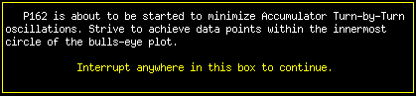

- AUTO_PLOT TBT eff D

This command is bypassed and not needed at this time. We used to run different intensities on beamlines and turn by turn tune-ups. As a result, we used to need differently scaled plots. Since the intensity does not change, we can run the same plot for the entire tune-up process.

- START_PGM P162

Starts the turn by turn application. The application waits for a TCLK event $93 to fire, and then takes horizontal and vertical turn by turn data.

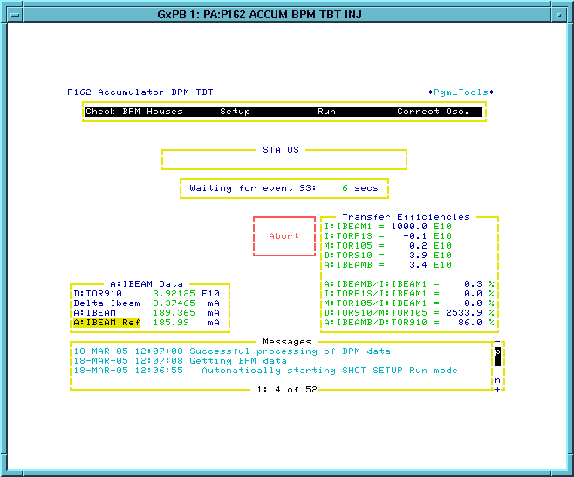
Figure 3-23

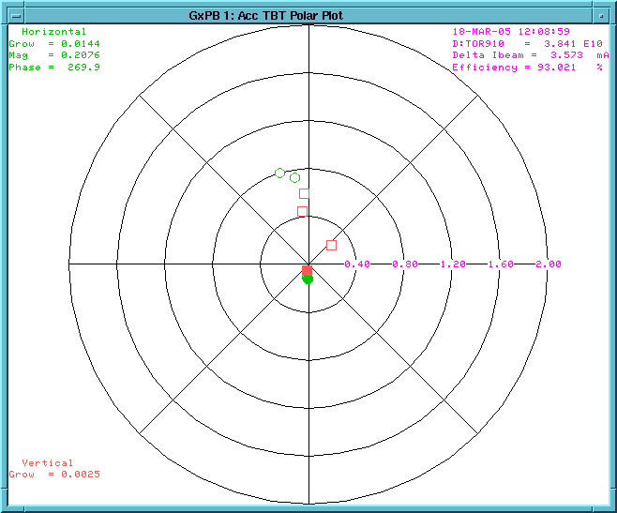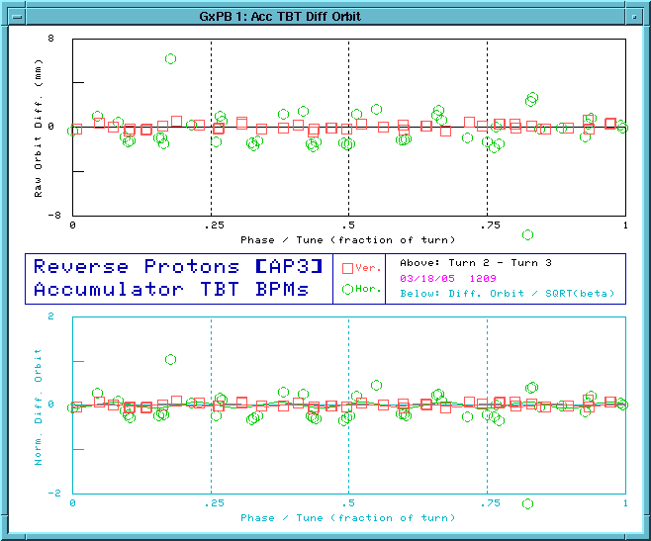
Figure 3-24

- BEAM_SWITCH Pbar_Source On

Enables the software beam switch to take beam for the turn by turn tune-up.

- INSTRUCT 215

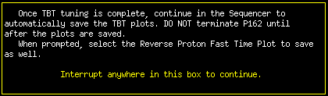
Figure 3-25

- ACKNOWLEDGE

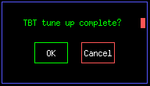

- COPY_SCREEN LCL MY SLOT
- COPY_SCREEN LCL MY SLOT
- SHOT_LOG IMAGE

The above three commands copy the tune-up plots to D5 save and to the Recycler shot scrapbook. Since this is not needed for Reverse Proton studies, these steps can be skipped. Below are the plots that are copied to the shot scrapbook.

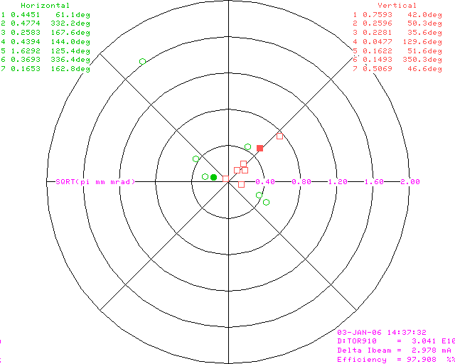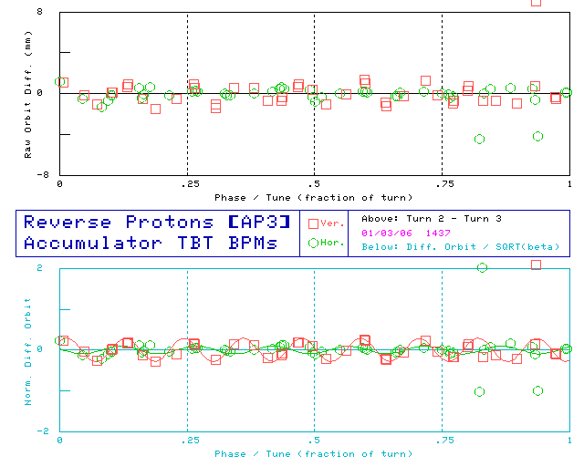
Figure 3-26
- SHOT_LOG Comment

Pastes the following comment into the Recycler Shot scrapbook. This step can be skipped for Reverse Proton studies.

HH:MM:SS- Reverse proton tuning is complete. – Sequencer

- BEAM_SWITCH Pbar_Source Off

Turns off the Pbar beam switch so that we stop taking beam.

- CHECK_DEVICE A:CENFRQ READING

Checks the reading for A:CENFRQ (Accumulator Center Frequency) and displays the value in the messages window. This command does not wait for a nominal value, it just makes the reading.

- CHECK_DEVICE A:VFACCM READING

Checks the reading of A:VFACCM (Main Injector Frequency to Accumulator) and displays the value in the messages window. This command does not wait for a nominal value, it just makes the reading.

- SET_DEVICE A:RLLEXF =628767.50

Sets the ARF4 extraction frequency to 628767.5 Hz. This is not needed for reverse proton studies.

- CTLIT_DEVICE A:EKIK ON

Issues an “on” to the Accumulator Extraction kicker, which should already be on. In reverse proton direction, the is Accumulator injection from the AP3 line. This is to ensure that any reverse proton beam gets kicked out of the Accumulator before proceeding.

- CTLIT_DEVICE A:EKIKQ ON D

This command is bypassed and not needed at this time

- ACKNOWLEDGE

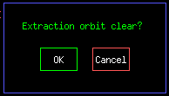
- CTLIT_DEVICE A:EKIK OFF D

This command is bypassed and not needed at this time.

- CTLIT_DEVICE A:EKIK OFF
- CTLIT_DEVICE A:IKIK OFF
- CTLIT_DEVICE A:ISEP1V OFF
- CTLIT_DEVICE A:ISEP2V OFF
- CTLIT_DEVICE D:IKIK OFF
- CTLIT_DEVICE D:ESEPV OFF

Now that beam is out of the machine, we will turn off Accumulator and Debuncher pulsed devices.

- CHECK_DEVICES A:SCRES RESTORE

The A:SCRES timer is restored to the value that was saved with the CHECK_DEVICE A:SCRES SAVE_SET command in the Fast Recycler Shot aggregate.

- SET_DEVICE D:H926PB D:H9267RP
- SET_DEVICE M:V105PB M:V105RP
- SET_DEVICE M:H100PB M:H100RP
- SET_DEVICE M:V101PB M:V101RP
- SET_DEVICE M:V11APB M:V11ARP
- SET_DEVICE M:H105PB M:H105RP
- SET_DEVICE M:H107PB M:H107RP

AP1 and AP3 ramped devices have three ramps flattop values as shown below (M = M or D, H = H or V, ### = location, and two letters at the end indicating the ramp type):
- M:H###RP: 8 GeV Reverse Protons
- M:H###PB: 8 GeV Pbars
- M:H###ST: 120 GeV Stacking
If a beamline tune-up was done, then the Reverse Proton ramps on AP1 and AP3 ramped devices may have changed. Ideally the 8 GeV reverse proton values and the 8 GeV Pbar values are the same, so the above commands copy the reverse proton values into the 8 GeV Pbar values.

- ACKNOWLEDGE

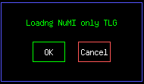

- LOAD_TLG 103 REPEAT

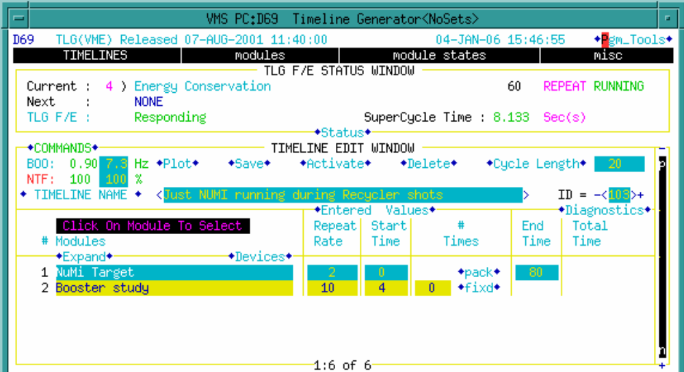

The timeline now has only NuMI events. This is the timeline normally used during Recycler shots. During Reverse Proton studies we can change the timeline to fit current needs. We will have the option to either run one-shots, or change the timeline to have dedicated $16/$2D events for reverse protons.

Figure 3-27

It is at this point that we vary from our Recycler Shots path. We will now switch to the Pbar Sequencer to establish the Reverse Proton Beam to the Debuncher.

From the Pbar Annex Sequencer, click on the menu bar item “mode” in the upper left corner of the screen. Select the P-bar Sequencer (Mode 2) from the selection menu.

Pbar Sequencer: Reverse Protons to the Debuncher

- ACKNOWLEDGE

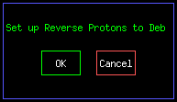

- SET_SEQ FILE 90

File 90 turns off devices for reverse protons. Devices that are turned off are the Debuncher cooling PIN switches (D:H1PS1, D:H2PS1, D:H3PS1, D:H4PS1, D:V1PS1, D:V2PS1, D:V3PS1, D:V4PS1, D:P1PS1, D:P2PS1, D:P3PS1, and D:P4PS1), DRF2 (D:R2HLSC), ARF3 (A:R3HLSC), ARF1 (A:R1HLSC), DRF1 rotator cavity levels (D:R1LL2RL, D:R1LL3RL, D:R1LL4RL, D:R1LL5RL, D:R1LL6RL, D:R1LL7RL ), and DRF1 adiabatics (D:R1H1SC and D:R1H8SC).

In addition, the DRF rotators regulation enable is changed from 1 to 0 (D:ENABC2, D:ENABC3, D:ENABC4, D:ENABC5, D:ENABC6, and D:ENABC7), and the DRF rotator heater settings are set at 20 (D:R1HT02, D:R1HT03, D:R1HT04, D:R1HT05, D:R1HT06, and D:R1HT07).

A number of timing changes are also made.
- The D:VAREVT timer is enabled, has the $82 removed, the $90 added, and the delay set to 0.02 seconds.
- The D:DAP2X (Debuncher extraction to AP2) timer is enabled, has both the $82 and $90 events added and is set to 1.0 seconds.
- The DRF adiabatic debunch on timer D:R1LLT4 has the $80 removed, the $82 added, and set to 0.43 seconds.
- The Debuncher Injection Septum charge timer D:ISEPC has the $80 removed and the $82 added, and the Debuncher Injection Septum on timer has the &D, $79, and $7E removed and the $76 added.
- The $80 is removed from A:SCRES.

- CHECK_DEVICE D:R1HT02 SAVE_SET
- CHECK_DEVICE D:R1HT03 SAVE_SET
- CHECK_DEVICE D:R1HT04 SAVE_SET
- CHECK_DEVICE D:R1HT05 SAVE_SET
- CHECK_DEVICE D:R1HT06 SAVE_SET
- CHECK_DEVICE D:R1HT07 SAVE_SET

The above six commands read and save the values of the DRF1 rotator cavity heater settings. Since all of these parameters were set to 20 in Sequencer File #90 above, it is unclear to the logic of having these commands in this location.

- SET_DEVICE D:R1HT02 -=15 D
- SET_DEVICE D:R1HT03 -=15 D
- SET_DEVICE D:R1HT04 -=15 D
- SET_DEVICE D:R1HT05 -=15 D
- SET_DEVICE D:R1HT06 -=15 D
- SET_DEVICE D:R1HT07 -=15 D

The above six commands are currently bypassed and not needed at this time. The commands would decrement the DRF rotator cavity heater settings by 15 degrees.

- ACKNOWLEDGE

This is a friendly reminder to check the core emittances and lifetime. ARF1 was just turned off, so if there any instabilities, they could get worse at this point.

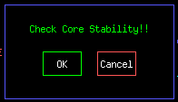

- BOOST_INTENSITY EVT16 1

Sets the Booster intensity of the $16 study events to 1 turn 7 bunches.

- ALARM_LIST PBAR 72

Bypasses Pbar Alarm List 72

- WAIT_FOR SECS 5

A five second pause to let D59 complete.

- ALARM_LIST PBAR 76

Bypasses the D59 alarm list entitled “DEB COOL” (Debuncher Cooling). This list contains a number of other lists. This command is redundant since these alarms were already bypassed in the Pbar Annex Sequencer Aggregate Fash Recycler Shots.

Figure 3-28

- ACL SET_FROM_READING

Sets the desired accumulator frequency width (A:VSAFWD) to the value of the calculated desired frequency width based on stack size (A:VSAFWS).

- SET_DEVICE A:VSAFWD +=5

Lowers the desired accumulator frequency width by 5Hz. The result of the two last commands is A:VSAFWD = A:VSAFWS + 5Hz.

In the Pbar Annex Sequencer Fast Recycler Start aggregate we had set the desired frequency width to 5Hz less than VSAFWS. Here we set it to 5 Hz more than VSAFWS.

- ACKNOWLEDGE

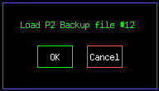
- START_PGM PA1583

Launches the Acnet program P2 (keeper is Steve Werkema).

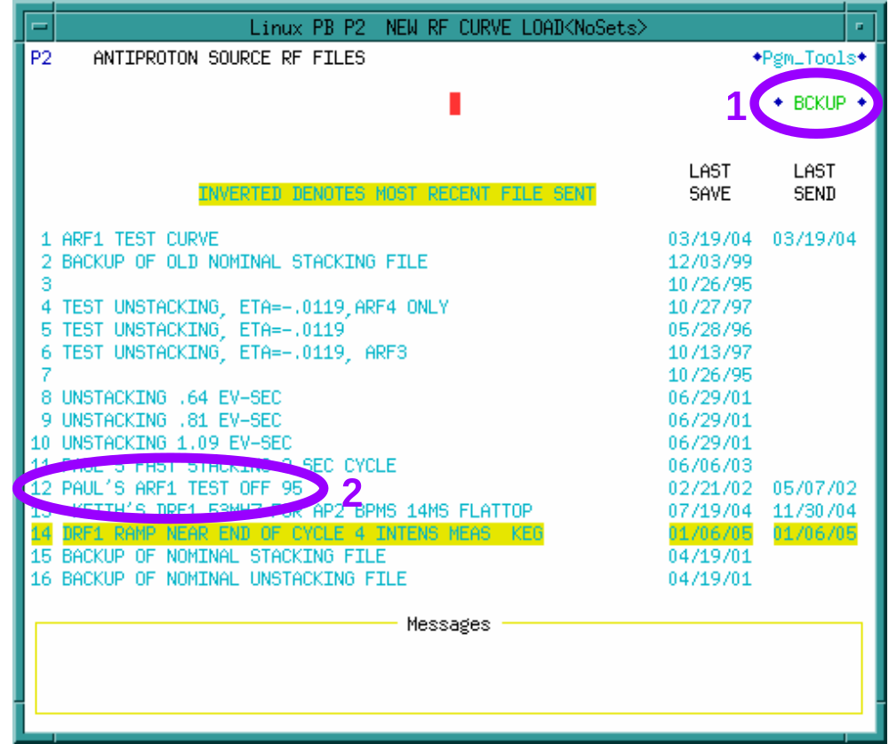
Figure 3-29

The Pbar Sequencer operator should be sure to select BCKUP in the upper right corner of the screen and then select file 12.

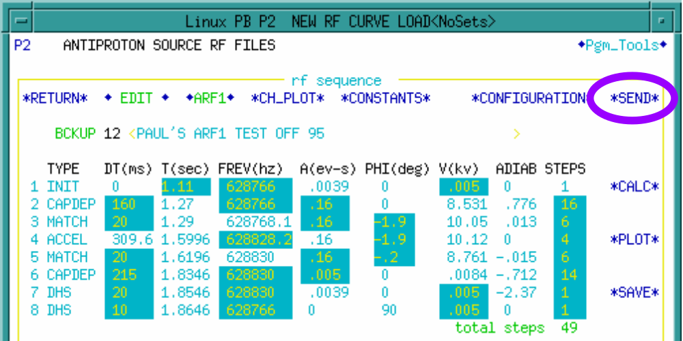
Figure 3-30

Click “SEND” to send out the file.

- A:VSARST =5

Turns on the old VSA momentum thermostat which keeps A:FRWDTH at A:VSAFWD, but only uses either the 2-4 GHz or the 4-8 GHz momentum system, not both.

- CTL_DEVICE A:R1HLSC RESET

Resets ARF1 HLRF.

- CTLIT_DEVICE A:R1HLSC ON

Issues an “on” command ARF1, waits for a short time, and then verifies that the device is on before continuing.

- SETIT_DEVICE A:EKIKTG =13.8365

Set the Accumulator Extraction kicker timer to 13.8365 MRev.

- CHECK_DEIVCE D:IKIKP SAVE_SET

Checks and saves the setting value for the Debuncher Injection kicker.

- CHECK_DEVICE D:AP10T0 SAVE_SET

Checks and saves the setting value for a TCLK timer at AP10 in crate $1E slot 9.

- CHECK_DEVICE D:DAP2X SAVE_SET

Checks and saves the setting value for the Debuncher Extraction to AP2 line timer.

- CHECK_DEVICE D:R1LLT4 SAVE_SET

Checks and saves the setting value for the DRF1 adiabatic debunch timer.

- CTLIT_DEVICE A:ISHUTO OFF
- CTLIT_DEVICE A:ESHUTO OFF

Turns off the Accumulator Injection Kicker and Accumulator Extraction Kicker shutter open timers.

- CTLIT_DEVICE A:ISHUTC ON
- CTLIT_DEVICE A:ESHUTC ON

Turns on the Accumulator Injection Shutter and Accumulator Extraction shutter close times.

The result of the above four commands is that the Accumulator Shutters will be forced closed.

- WAIT_DEVICE A:ISHTST
- WAIT_DEVICE A:ESHTST

The above two commands wait for the Accumulator injection and extraction shutters to read closed. For these parameters a value of 2 means closed and a value of 1 means open.

- CTL_DEVICE A:EKIK ON
- CTL_DEIVE A:IKIK ON
- CTL_DEVICE A:ISEP1V ON
- CTL_DEVICE A:ISEP2V ON
- CTL_DEVICE D:EKIK ON
- CTL_DEVICE D:ESEPV ON
- CTL_DEVICE D:Q731 RESET
- CTL_DEVICE D:Q731 ON

Before we can run beam to the Debuncher, we need to turn on the pulsed devices used to injection reverse protons from the AP3 line to the Accumulator (A:EKIK) extract beam from the Accumulator into the D/A line (A:ISEP1V, A:ISEP2V, and A:IKIK), and inject beam from the D/A line into the Debuncher (D:EKIK and D:ESEPV). One quadrupole that has a history of overheating is also turned on because it is normally turned off when we are not taking beam.

- ACKNOWLEDGE

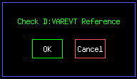

This acknowledge reminds us to verify the TCLK event references in D:VAREVT. D:VAREVT determines how long reverse proton beam circulates in the Debuncher before firing the Debuncher Injection kicker to extract beam down the AP2 line.

The reason that this check is in the sequencer is for historical reasons. VAREVT makes a TCLK $82 event. Once after a long shutdown, an $82 was accidentally added to the VAREVT reference. This meant that VAREVT was referencing itself. This resulted in a TCLK overload during a shot setup that resulted in a Tevatron quench.

In the SET_SEQ file 90 above, if any $82 event is referenced by VAREVT, then it is removed. This command provides independent verification that there is no $82 event in the VAREVT reference.

- CTLIT_DEVICE D:VAREVT ON

Once it is verified that D:VAREVT has the appropriate reference, it is safe to turn on the event.

- CHECK_DEVICE A:SCRES SAVE_SET

Reads and saves the present settings of A:SCRES.

- SET_DEVICE A:SCRES +=2

Increments A:SCRES by 2.

- FTP beam 0 D
- AUTO_PLOT Deb/AP2 rev prot

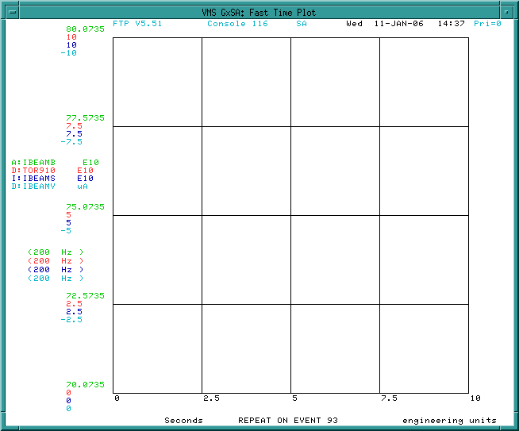
- ACKNOWLEDGE

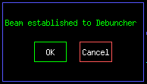
- ACKNOWLEDGE

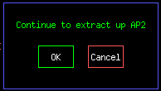

We pause at this point in the sequencer. We are setup to circulate beam in the Debuncher. Next we will de-tune the DRF1 rotator cavities and then prepare to take beam. We can either take beam as dedicated $16/$2D events in the TLG, or we can ask for one shots.

If we want to send beam up the AP2 line, we would continue on into the next portion of this sequencer aggregate.

De-tune the DRF1 Rotator Cavities

In the past, the DRF1 cavities were always turned off for Reverse Proton studies. As a result, when stacking was re-established the DRF1 cavities would have to warm up and get back in tune. This would strongly impact stacking for on the order of an hour.

De-tuning the DRF1 cavities allows us to continue to run the cavities while in Reverse Proton mode. The result is a much faster restoration of normal stacking after studies.

The procedure to de-tune the cavities is straightforward and is outlined on P60 TUNSY <19> and <20>.

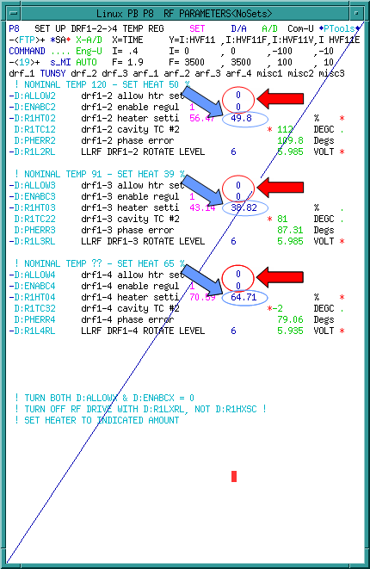 | 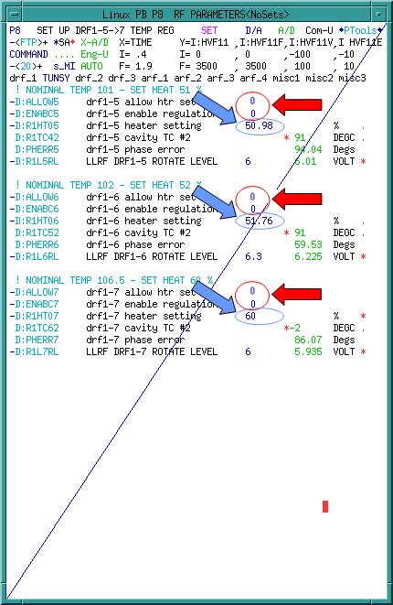
Figure 3-31:

Circulating Beam in the Debuncher (Sequencer commands provided by Brian Drendel. Section to be written by Stan Johnson).

$16/$2D in the TLG

One Shots

We issue the last five commands of the aggregate and then start from the top.

- CHECK_DEVICE D:HT609S RESTORE
- CHECK_DEVICE D:HT606S RESTORE
- CHECK_DEVICE D:HT605S RESTORE
- ACKNOWLEDGE
- ACKNOWLEDGE

With the last five commands run, we will go to the top of the same aggregate.

- FTP Deb Rev Prot 0
- CTL_DEVICE A:EKIK ON
- CTL_DEVICE A:ISEP1V ON
- CTL_DEVIOCE A:ISEP2V ON
- CTL_DEVICE A:IKIK ON
- CTL_DEVICE D:ESEPV ON
- CTL_DEVICE D:EKIK ON
- CHECK_DEVICE D:HT609S SAVE_SET
- CHECK_DEVICE D:HT606S SAVE_SET
- CHECK_DEVICE D:HT605S SAVE_SET

- BEAM_SWITCH Pbar_Source On
- START_PGM D47
- ACKNOWLEDGE
- LOAD_TLG 75 ONESHOT
- ACKNOWLEDGE
- BEAM_SWITCH PBAR_SOURCE OFF

- CTL_DEVICE A:EKIK OFF
- CTL_DEVICE A:ISEP1V OFF
- CTL_DEVICE A:IKIK OFF
- CTL_DEVICE D:ESEPV OFF
- CTL_DEVICE D:EKIK OFF
- SETIT_DEVICE D:HT609S =0
- SETIT_DEVICE D:HT606S =0
- SETIT_DEVICE D:HT605S =0

- ACKNOWLEDGE

Debuncher Orbits (Section to be written by Al Sondgeroth)

Java Orbit Preparation

asdfasdfa

Java BPM Orbits

asdfasdfa

Debuncher Admittance Measurement

To measure the Debuncher admittance with Reverse Protons, we inject circulating beam into the Debuncher, blow the beam up to fill the aperture, and then run a collimator through the beam. The point at which the collimator first touches the beam, as seen by loss monitors downstream of the collimator, is called the touch point. The point where the beam intensity, as measured by the video output of a spectrum analyzer connected to the Debuncher longitudinal Schottky, goes to zero is the extinction point.

We run a horizontal collimator into the beam, and measure the distance between the touch and extinction points as

We also know the Accelerator lattice at the point of the collimator, so we can then calculated the horizontal admittance as

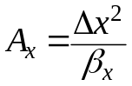

with β_{x} = 12.27m at the location of the collimator.

We use the Pbar Sequencer to run all of the commands need to blow up the beam and move the collimator through the beam. A Java application was written that collects data logger data on collimator position, losses and spectrum analyzer output during our admittance measurements. The application then calculates the touch and extinction points to determine the measured admittance.
Below are the Pbar sequencer commands used to measure the admittance.

Pbar Sequencer: Deb Hor aperture scan rev p

We issue the last five commands of the aggregate and then go to the top of the aggregate.

- CHECK_DEVICE D:HT609S RESTORE
- CHECK_DEVICE D:HT606S RESTORE
- CHECK_DEVICE D:HT605S RESTORE

The above three commands set the DEX bump references so that we inject beam cleanly.

- ACKNOWLEDGE
- ACKNOWLEDGE

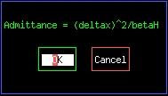

The last two commands of the aggregate are Acknowledges. The last acknowledge reminds us how to calculate the admittance. With the last five commands of the aggregate run, we will go to the top of the same aggregate.

- FTP Deb Rev Prot 0

A Fast time Plot shows beam in the AP1 line (M:Tor109), beam in the AP3 line (D:Tor910), beam in the Accumulator (A:IBEAMV), and beam in the Debuncher (D:IBEAMV). The time scale is 0 to 10 seconds after a TCLK $93 event.

- CTL_DEVICE A:EKIK ON
- CTL_DEVICE A:ISEP1V ON
- CTL_DEVIOCE A:ISEP2V ON
- CTL_DEVICE A:IKIK ON
- CTL_DEVICE D:ESEPV ON
- CTL_DEVICE D:EKIK ON

Pulsed devices are turned on to allow beam to be transferred from the AP3 line to the Accumulator and the Accumulator to the Debuncher.

- CHECK_DEVICE D:HT609S SAVE_SET
- CHECK_DEVICE D:HT606S SAVE_SET
- CHECK_DEVICE D:HT605S SAVE_SET

The DEX bump references are saved at this point. After we inject beam, we will turn off the DEX Bumps. These values will be restored next time we want to inject beam.

- BEAM_SWITCH Pbar_Source On

We are now ready to inject beam into the Debuncher. We turn on the software beam switch.

- START_PGM D47 D

This command is currently bypassed. It would start the beam switch box application that allows the operator to see the status of the beam switch.

- ACKNOWLEDGE

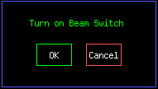

- LOAD_TLG 75 ONESHOT

This command loads the one-shot TLG. At the start of the next supercycle, a one shot will be loaded sending $2D beam to Pbar.

- ACKNOWLEDGE

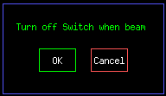

After beam is injected, we turn off the beam switch. Beam should now be circulating in the Debuncher If we fail to inject beam into the Debuncher, we can try again, by hitting “Cancel” at this point and running the one-shot commands above. Else, continue onward.

- BEAM_SWITCH PBAR_SOURCE OFF

With beam circulating in the Debuncher, the software beam switch has now been taken.

- CTL_DEVICE A:EKIK OFF
- CTL_DEVICE A:ISEP1V OFF
- CTL_DEVICE A:IKIK OFF
- CTL_DEVICE D:ESEPV OFF
- CTL_DEVICE D:EKIK OFF

With beam already circulating in the Debuncher, we turn off the pulsed devices.

- SETIT_DEVICE D:HT609S =0
- SETIT_DEVICE D:HT606S =0
- SETIT_DEVICE D:HT605S =0

We now turn off the DEX Bumps.

- ACKNOWLEDGE

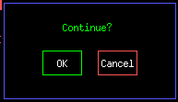

If we are circulating beam in the Debuncher for studies, we pause at this point. If we want to do an admittance measurement, we continue. The next steps will move the horizontal Debuncher collimator to the edge of the beam and blow up the beam with the Debuncher dampers.

- SPECTRUM_LOAD 4 25 D

This command is bypassed. It would load P41 file 25 to Spectrum Analyzer #4. We now use Spectrum Analyzer #5 for this measurement. The video output from spectrum analyzer #5 is used to determine the extinction point of the beam.

- FTP Deb Horz 0 D

This command is bypassed. We used to use a live FTP to make our admittance measurement. It plotted the SA output, Debuncher beam intensity, and loss monitors downstream of the collimator. Pbar experts would manually measure the difference between the touch and extinction points and calculate the admittance. A copy of the old plot is included below for completeness.

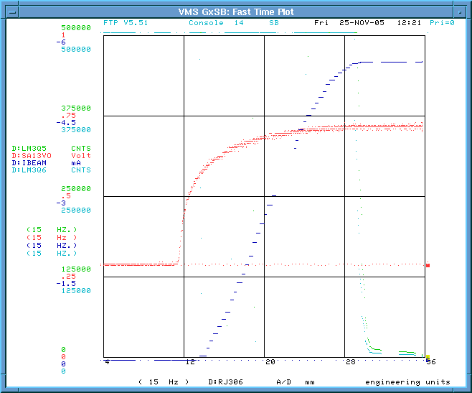

We ran into problems plotting these parameters at 15Hz on the plot package. Pbar experts also developed a Java application to more accurately make the measurements. For this reason, the above plot is no longer used.

- REPLAY P60 d;rj306 to edge D

This command replays a script to move the Debuncher horizontal collimator to the edge of the beam. With our new Java application, this step is not required, so this command is bypassed.

- ACKNOWLEDGE D

This command is bypassed. It asked the Pbar Sequencer operator to verify that the above script has moved the collimator to the edge of the beam.

- CTLIT_DEVICE D:DPENI OFF
- CTLIT_DEVICE D:DPENI POSITIVE
- ACKNOWLEDGE D
- CHECK_DEVICE D:DPHATT SAVE_SET
- SET_DEVICE D:DPHATT = 0.75

The above commands setup the horizontal dampers to blow up the Debuncher beam.

- ACKNOWLEDGE

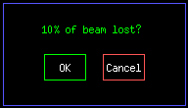

The horizontal damper has blown up the beam. When we see that 10% of the beam intensity has been lost, we can be sure that the beam is filling the aperture. We now will restore the Debuncher dampers so that we do not continue to lose beam.

- CHECK_DEVICE D:DPHATT RESTORE
- CTLIT_DEVICE D:DPENI NEGATIVE
- CTLIT_DEVICE D:DPENI ON

The Debuncher horizontal dampers have now been restored to their normal configuration and the Debuncher beam is filling the aperture.

- CTL_DEVICE D:LM30CL ON

We now turn on the clear timer for the AP30 Debuncher loss monitors to clear out any accumulated signals on the loss monitors before we complete our scan. We will use one of these loss monitors to determine the touch point of the beam.

- FTP Deb 0 D

- ACKNOWLEDGE D

The above two commands are bypassed.

- ACKNOWLEDGE

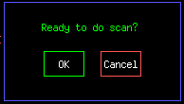

We are now ready to complete the scan.

- CTL_DEVICE D:LM30CL OFF

We now disable the clear timer for the AP30 loss monitors. We will use one of these loss monitors to determine the touch point of the collimator.

- REPLACE P60 Deb Horz scrape

This command plays a script that moves the collimator through the beam.

- ACKNOWLEDGE

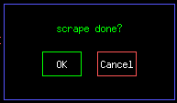

We hold at this acknowledge until the scrape is complete.

- COPY_SCREEN 0 SB D
- COPY_SCREEN 0 SB D

The above two commands are bypassed. They were used to copy the Fast Time Plots when we used to manually measure the admittances from those plots.

- REPLAY p60 d;rj306 retract

This command replays a script to retract the horizontal collimator back to its initial position of ~45.5mm.

- WAIT_DEVICE D:RJ306

This command has the sequencer hold off until the Debuncher horizontal collimator is pulled all of the way out of the beam, which is ~45.5mm.

- CTL_DEVICE D:LM30CL ON

The AP30 loss monitor clear time is now enabled to clear out the data from our measurement.

- CHECK_DEVICE D:HT609S RESTORE
- CHECK_DEVICE D:HT606S RESTORE
- CHECK_DEVICE D:HT605S RESTORE

The DEX Bumps are turned back on.

- ACKNOWLEDGE D
- ACKNOWLEDGE

This acknowledge reminds us how to calculate the admittance. Instead of doing this manually, we start the Java Pbar aperture scan application from http://www-bd.fnal.gov/appix/start?p=55000288&n=50000643.

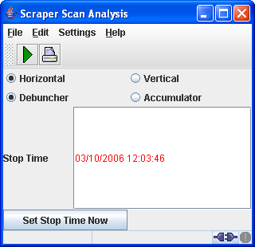

Select Debuncher and Horizontal, then either type an end time to look in the datalogger or enter a stop time manually.

Click  to collect your plot.

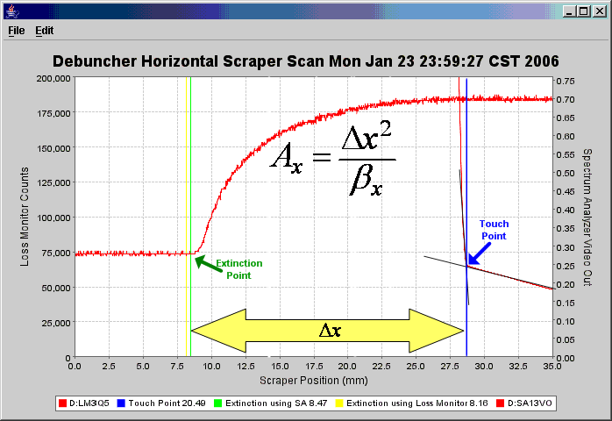

Above is the result of a horizontal aperture scan. The touch point and extinction point are labeled for clarity. In this example, we had

- Touch point at 28.8mm
- Extinction point at 8.8mm
- β_{x} = 12.27m
- A_{x} = 32.6π mm-mrad

Pbar Sequencer: Deb Vert aperture scan rev p

Once the horizontal aperture scan is complete, we can move on to the vertical plane. In this case, we use a vertical scraper and measure the distance between touch and extinction points.

And then easily calculate the emittance as

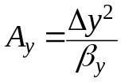
given β_{y} = 10.66m.

To complete this task, we simply start from where we left off in the Pbar Sequencer after doing the horizontal scan. We switch over to the vertical aperture scan aggregate. The procedure is very similar to the horizontal scan. We issue the last five commands of the aggregate and then start from the top.

- CHECK_DEVICE D:HT609S RESTORE
- CHECK_DEVICE D:HT606S RESTORE
- CHECK_DEVICE D:HT605S RESTORE

The above three commands set the DEX bump references so that we inject beam cleanly.

- ACKNOWLEDGE D
- ACKNOWLEDGE

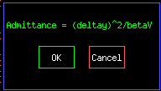

This acknowledge command reminds the sequencer operator how the vertical admittance will be calculated.

With the last five commands run, we will go to the top of the same aggregate.

- FTP Deb Rev Prot 0 D

A Fast time Plot shows beam in the AP1 line (M:Tor109), beam in the AP3 line (D:Tor910), beam in the Accumulator (A:IBEAMV), and beam in the Debuncher (D:IBEAMV). The time scale is 0 to 10 seconds after a TCLK $93 event. This command is currently bypassed.

- CTL_DEVICE A:EKIK ON
- CTL_DEVICE A:ISEP1V ON
- CTL_DEVIOCE A:ISEP2V ON
- CTL_DEVICE A:IKIK ON
- CTL_DEVICE D:ESEPV ON
- CTL_DEVICE D:EKIK ON

Pulsed devices are turned on to allow beam to be transferred from the AP3 line to the Accumulator and the Accumulator to the Debuncher.

- CHECK_DEVICE D:HT609S SAVE_SET
- CHECK_DEVICE D:HT606S SAVE_SET
- CHECK_DEVICE D:HT605S SAVE_SET

The DEX bump references are saved at this point. After we inject beam, we will turn off the DEX Bumps. These values will be restored next time we want to inject beam.
+
- BEAM_SWITCH Pbar_Source On

We are now ready to inject beam into the Debuncher. We turn on the software beam switch.

- START_PGM D47 D

This command is currently bypassed. It would start the beam switch box application that allows the operator to see the status of the beam switch.

- ACKNOWLEDGE

- LOAD_TLG 75 ONESHOT

This command loads the one-shot TLG. At the start of the next supercycle, a one shot will be loaded sending $2D beam to Pbar.

- ACKNOWLEDGE

After beam is injected, we turn off the beam switch. Beam should now be circulating in the Debuncher If we fail to inject beam into the Debuncher, we can try again, by hitting “Cancel” at this point and running the one-shot commands above. Else, continue onward.

- BEAM_SWITCH PBAR_SOURCE OFF

With beam circulating in the Debuncher, the software beam switch has now been taken.

- CTL_DEVICE A:EKIK OFF
- CTL_DEVICE A:ISEP1V OFF
- CTL_DEVICE A:IKIK OFF
- CTL_DEVICE D:ESEPV OFF
- CTL_DEVICE D:EKIK OFF

With beam already circulating in the Debuncher, we turn off the pulsed devices.

- SETIT_DEVICE D:HT609S =0
- SETIT_DEVICE D:HT606S =0
- SETIT_DEVICE D:HT605S =0

We now turn off the DEX Bumps.

- ACKNOWLEDGE

- SPECTRUM_LOAD 4 25 D

This command is bypassed. It would load P41 file 25 to Spectrum Analyzer #4. We now use Spectrum Analyzer #5 for this measurement.

- SPECTRUM_LOAD 5 25

Loads P41 file 25 to spectrum analyzer #5. The video output from spectrum analyzer #5 is used to determine the extinction point of the beam.

- FTP Deb Horz 0

This command is bypassed. We used to use a live FTP to make our admittance measurement. It plotted the SA output, Debuncher beam intensity, and loss monitors downstream of the collimator. Pbar experts would manually measure the difference between the touch and extinction points and calculate the admittance. A copy of the old plot is included below for completeness.

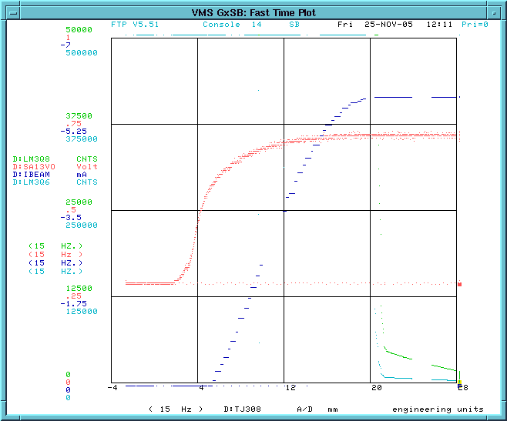

- REPLAY P60 d;tj308 to edge

This command replays a script to move the Debuncher vertical collimator to the edge of the beam.

- ACKNOWLEDGE

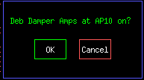

- CTLIT_DEVICE D:DPENI OFF
- CTLIT_DEVICE D:DPENI POSITIVE
- ACKNOWLEDGE
- CHECK_DEVICE D:DPVATT SAVE_SET
- SET_DEVICE D:DPVATT = 3.75
- ACKNOWLEDGE

The vertical damper has blown up the beam. When we see that 10% of the beam intensity has been lost, we can be sure that the beam is filling the aperture. We now will restore the Debuncher dampers so that we do not continue to lose beam.

- CHECK_DEVICE D:DPVATT RESTORE
- CTLIT_DEVICE D:DPENI NEGATIVE
- CTLIT_DEVICE D:DPENI ON

The Debuncher vertical dampers have now been restored to their normal configuration and the Debuncher beam is filling the aperture.

- CTL_DEVICE D:LM30CL ON

We now turn on the clear timer for the AP30 Debuncher loss monitors to clear out any accumulated signals on the loss monitors before we complete our scan. We will use one of these loss monitors to determine the touch point of the beam.

- TIMER A:VAREVT ENABLE D
- FTP Deb 0 D
- ACKNOWLEDGE D

The above three commands are bypassed.

- ACKNOWLEDGE

- CTL_DEVICE D:LM30CL OFF

We now disable the clear timer for the AP30 loss monitors. We will use one of these loss monitors to determine the touch point of the collimator.

- REPLAY P60 Deb Vert Scan

This command plays a script that moves the collimator through the beam.

- ACKNOWLEDGE

We hold at this acknowledge until the scrape is complete.

- COPY_SCREEN 0 SB D
- COPY_SCREEN 0 SB D

The above two commands are bypassed. They were used to copy the Fast Time Plots when we used to manually measure the admittances from those plots.

- REPLAY p60 d;tj308 retract

This command replays a script to retract the vertical collimator back to its initial position of ~41.5mm.

- WAIT_DEVICE D:TJ308

This command has the sequencer hold off until the Debuncher vertical collimator is pulled all of the way out of the beam, which is ~41.5mm.

- CTL_DEVICE D:LM30CL ON

The AP30 loss monitor clear time is now enabled to clear out the data from our measurement.

- CHECK_DEVICE D:HT609S RESTORE
- CHECK_DEVICE D:HT606S RESTORE
- CHECK_DEVICE D:HT605S RESTORE

The DEX Bumps are turned back on.

- ACKNOWLEDGE D
- ACKNOWLEDGE

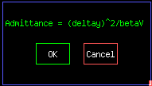

This acknowledge reminds us how to calculate the admittance. Instead of doing this manually, we start the Java Pbar aperture scan application from http://www-bd.fnal.gov/appix/start?p=55000288&n=50000643.

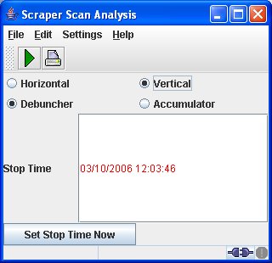

Select Debuncher and Horizontal, then either type an end time to look in the datalogger or enter a stop time manually.

Click to collect your plot.

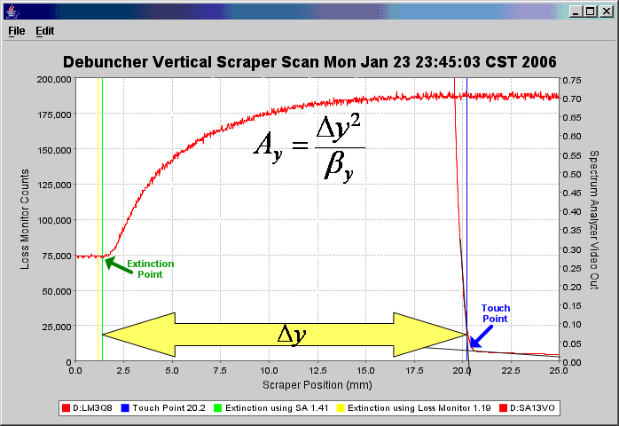

Above is the result of a vertical aperture scan. The touch point and extinction point are labeled for clarity. In this example, we had

- Touch point at 20.8mm
- Extinction point at 1.6mm
- β_{y} = 10.66m
- A_{y} = 34.6π mm-mrad

Beam up AP2

Establishing beam up the AP2 line

To establish beam up the AP2 line, we continue where we left off in the Pbar Sequencer Aggregate entitled “Reverse Protons to Debuncher.” This is about half way down the aggregate.

- ACKNOWLEDGE

- SETIT_DEVICE D:IKIKP =0
- SETIT_DEVICE D:IKIK =64
- CTLIT_DEVICE D:IKIKTG OFF
- CTLIT_DEVICE D:IKIKRV ON

We first configure the Debuncher Injection kicker to extract beam out of the Debuncher and up the AP2 line.

- EVENT 82 ENABLE

We next enable D:VAREVT which determines how long beam circulates in the Debuncher before it is kicked out the AP2 line.

- EVENT 76 ENABLE

This command enables MIBS $76 (not TCLK $76), which is the MIBS Debuncher to AP2 line beam synch event that tells the kickers to fire.

- EVENT 87 ENABLE

This command enables TCLK event $87 for 8 GeV protons up the AP2 line.

- WAIT_FOR EVENT 87

The sequencer waits for the next TCLK event $87 to play.

- CTLIT_DEVICE D:IKIK ON
- CTLIT_DEVICE D:ISEPV ON

D:IKIK and D:ISEPV are now turned on. Beam injected into the Debuncher will now be extracted up the AP2 line.

Beam Modes

When sending beam from the Debuncher to the AP2 line, there are two modes that we can setup. The first is to complete partial turn extraction. In this scenario, when beam is injected at the 10 straight section into the Debuncher by the Debuncher Extraction kicker, we let the beam travel counter-clockwise to the 30 straight section, where we immediately extract the beam down the AP2 line. The beam never gets a chance to circulate in the Debuncher in this mode of operation.

The second mode of operation has us inject the beam into the Debuncher and let is circulate for a few seconds before sending it up the AP2 line. This is the normal mode of operations.

Below we will go through the steps needed to toggle back and forth between these two operational modes. This is not a common setup, and no Pbar Sequencer aggregates are setup to complete them. All changes are completed manually.’

Obie Box Primer

Portions of this section were borrowed from the “Obie Box Primer” found in the Pbar Electronic Logbook Chapter 638.

In order to understand the steps used to switch back and forth between our two Reverse Proton AP2 transfer methods, we must first understand how the various Pbar extraction and injection kickers get their timing. This is done through the “Obie Boxes.” There are three Obie boxes.
      - Debuncher Injection Obie Box: Located at AP50, this box handles timing for transfers to and from the Debuncher and AP2 lines.
      - D/A Obie Box: Located at AP10, this box handles timing for all transfers involving the D-A line.
      - Accumulator Extraction Obie Box: Located at AP10, this box handles timing for transfers to and from the AP3 line and Accumulator. This “Obie Box” works differently than the other two and will not be discussed in this write-up.
Note that the words injection and extraction above refer to beam going in the Pbar direction. Our first two “Obie Boxes” mentioned above function in a similar manner. Each box has three inputs.
      - MIBS Timer input
      - TCLK Timer input
      - H=1 synch input
If the h=1 synch is enabled and the TCLK timer input is active, the output pulse will occur at the coincidence of a TTL pulse on the TCLK timer input and the next occurrence of some feature (e.g. zero-cross) of the h=1 synch input. If the h=1 synch is disabled the Obie box output mirrors the active input timer. The h=1 synch is automatically disabled when the MIBS timer input is active.
How does the timing work with each “Obie box?”

- Debuncher Injection Obie Box

The Debuncher Injection Obie Box handles transfers between the Debuncher and the AP2 line, which means it handles the timer for D:IKIK. In Reverse Proton mode, this would be extraction from the Debuncher.

There are three Acnet parameters associated with this Obie Box.
  - D:IKIKTC is the digital status for the kicker timer. This device must be on for the kicker to fire.
  - D:IKIKTG is the MIBS timer input. This is the timer that we use when we extract beam down the AP2 line after only going through a partial turn in the Debuncher.
  - D:IKIKRV is the TCLK timer input. This is the timer that is used when we circulate beam in the Debuncher before extraction to the AP2 line.

The MIBS timer input is enabled by turning D:IKIKTG ON. The timing of the MIBS input to the Obie box is governed by the event list and offset value of D:IKIKTG. The TCLK timer input is enabled by turning D:IKIKRV ON. The timing of the TCLK input to the Obie box is governed by the event list and offset value of D:IKIKRV.
NOTE: Even though D:IKIKRV is an MIBS timer device, it still functions as the TCLK input to the Obie box -- that's just the way it is.

If D:IKIKRV is on, the h=1 synch is enabled by setting the digital status of D:IKIKTC to A (or ON). The h=1 synch is disabled by setting the digital status of D:IKIKTC to B (or OFF). If D:IKIKTG is ON the h=1 synch is automatically disabled (even if the digital status still indicates A).

- D-A Line Obie Box

The D-A Obie Box handles all transfers to and from the D-A line from both the Accumulator and Debuncher. This means it handles the timing for the Accumulator Injection kicker and Debuncher Extraction Kicker. In Reverse Proton direction this is extraction from the Accumulator and Injection into the Debuncher.

There are three Acnet parameters associated with this Obie Box.
  - D:EXTRAC is the digital status for the kicker timers. This device must be on for the kickers to fire.
  - D:EXTRAM is the MIBS timer input.
  - D:EXTRAT is the TCLK timer input.

The MIBS timer input is enabled by turning D:EXTRAM ON. The timing of the MIBS input to the Obie box is governed by the event list and offset value of D:EXTRAM. The TCLK timer input is enabled by turning D:EXTRAT ON. The timing of the TCLK input to the Obie box is governed by the event list and offset value of D:EXTRAT.

If D:EXTRAT is on, the h=1 synch is enabled by setting the digital status of D:EXTRAC to A (or ON). The h=1 synch is disabled by setting the digital status of D:EXTRAC to B (or OFF). If D:EXTRAM is ON the h=1 synch is automatically disabled (even if the digital status still indicates A).

Partial Debuncher Turn to AP2

We assume the we have followed the sequencer steps covered above to establish beam down the AP2 line. Once at this point, we can switch back and forth between our two modes of AP2 line extraction:
- In our normal configuration, we instead inject beam into the Debuncher and let it circulate for a few seconds before extracting down the AP2 line.
- In partial turn extraction mode, we send reverse protons into the Debuncher at D10 and only let them circulate a third of a turn to D30 where we extract them down the AP2 line.

Currently, there is no sequencer setup to switch back and forth between the two modes, so all changes are done manually. The following pages will be needed to complete the switch:
- P62 – The Camac 165 card ramp page for D:IKIK
- T63 – The Beam Synch timer page enabling the appropriate MIBS event to send to the Debuncher Injection Obie Box.
- P60 DEB30 <30> and <31> to setup extraction timing to the AP2 line.
- P60 DTOA < 3> to setup D-to-A line kicker timing.
- P60 INJ < 7> , <10> to setup extraction from the Debuncher into the AP2 line.

Below are the individual devices that we need to change in order to establish partial turn extraction. The alert Pbar expert will have the beam switch taken during the process of making the changes.

- Enable the MIBS $EE Event
- Enable the $EE event from Acnet Page T63.
- Set D:ETSTEV to $90 + 0.51666 seconds. The digital status will show “on” when the $EE is enabled on T63.
- Setup D:IKIK
- From T62, change the D:IKIK “B” ramp reference from $82 to $90.
- The three kicker timers D:EKIKM1, D:EKIKM2, and D:EKIKM3 should have the most recent reverse proton values.
- Setup D:ISEP and D:ESEP change times
- D:ISEPC should be on with a value of <90/ > + 0.034 seconds.
- D:ISEPON should be on with a value of [76/EE] + 2.0754717 MRev.
- D:ESEPC should be on with a value of <90/ > + 0.00001 seconds.
- Set the D-A Line Obie Box timers
- D:EXTRAM is turned on with a value of $90 + 0.497 MRev. This is the MIBS timer for this Obie Box.
- D:EXTRAT is turned off. This is the TCKL timer, and we want to trigger off of MIBS and not TCLK.
- D:EXTRAC should show “M” in it’s digital status signifying the MIBS input.
- Set the D:IKIK Obie Box timers:
- D:IKIKTG is off. This is the timer with the MIBS input.
- D:IKIKRV is on with a value of [EE/76] + 13.522013 MRev. This is the timer with the TCLK input.
- D:IKIKTC should show “T” in it’s digital status signifying the TCLK input.
- Setup other Timers
- A:SCRES generates the TCLK $90. It should be on with a value of <93/85/ > + 4.544 seconds.
- D:VAREVT should be off. D:VAREVT generates the $82, which normally fires D:IKIK. However, in partial turn extraction, we use the $EE to generate a $90 to fire the kicker instead.
- Setup ARF1 to bunch beam for AP2 BPMs
- Load P2 Test File #1.
- A:R1HLSC should be on
- A:R1L2AM should be on..
- Setup the AP2 BPMs
- D:27TRGM should be on with a value of [79/76/EE/ ] + 13.710692 MRev.
- D:AP2BP5S should be on with a value of [79/76/EE/ ] + 13.459119 MRev.
- D:BPGARP should be set to 1.9. This is the gain control for the AP2 BPMs.
- Setup IC728 timers
- D:IC728C should be on with a value of <81/85/82/90> + 0.000001 seconds. This is the IC728 clear timer.
- D:IC728S should be on with a value of [79/7D/76/EE] + 13.018868 MRev. This is the IC728 start timer.
- Setup Debuncher TBT timer
- D:TBT should be on with a value of <90> + .516667 seconds.
- Setup SEM start timers.
- D:SMA2S should be on with a value of [79/76/EE] + 14.213836 MRev.
- D:SMA3S should be on with a value of [79/76/EE] + 14.339623 MRev.
- D:SMA8S should be on with a value of [79/76/EE] + 14.402516 MRev.
- Setup DRF1 Adiabatic for AP2 BPMs
- Not needed.

Circulating Debuncher beam to AP2
To revert back to Circulating Debuncher beam to AP2, we would setup the following.

- Disable the MIBS $EE Event
- Disable the $EE event from Acnet Page T63.
- Turn off D:ETSTEV
- Setup D:IKIK
- From T62, change the D:IKIK “B” ramp reference from $90 to an $82.
- The three kicker timers D:EKIKM1, D:EKIKM2, and D:EKIKM3 should have the most recent reverse proton values.
- Setup D:ISEP & D:ESEPC change times
- D:ISEPC should be on with a value of <82/90> + 0.034 seconds.
- D:ISEPON should be on with a value of [76/EE] + 2.0754717 MRev.
- D:ESEPC should be on with a value of <90/ > + 0.00001 seconds.
- Set the D-A Line Obie Box timers
- D:EXTRAM is turned off. This is the MIBS input for the Obie Box.
- D:EXTRAT is turned on with a value of <90/ > + 0.497 seconds.
- D:EXTRAC should show “T” in it’s digital status signifying the TCLK input.
- Set the D:IKIK Obie Box timers:
- D:IKIKTG is off. This is the timer with the MIBS input.
- D:IKIKRV is on with a value of [$EE/$76] + 13.522013 MRev. This is the timer with the TCLK input.
- D:IKIKTC should show “T” in it’s digital status signifying the TCLK input.
- Setup other Timers
- A:SCRES generates the TCLK $90. It should be on with a value of $93/$85 + 4.544 seconds.
- D:VAREVT should be on with a value of <90/ > + “circulating beam time.” This timer determines how long beam circulates in the Debuncher before being extracted up the AP2 line. It generates a TCLK $82 which fires D:IKIK. To circulate beam continuously in the Debuncher, turn this timer off as well as D:IKIK and D:ISEPV.
- Setup ARF1 to bunch beam for AP2 BPMs
- Load P2 Backup File #13.
- A:R1HLSC should be on
- A:R1L2AM should be on..
- Setup the AP2 BPMs
- D:27TRGM should be on with a value of [79/76EE/ ] + 13.710692 MRev.
- D:AP2BP5S should be on with a value of [79/76/EE/ ] + 13.459119 MRev.
- D:BPGARP should be set to 5.0 for D:VAREVT = 2 seconds. It should be set successively smaller down to 1.9 for D:VAREVT = 0.12 seconds. This parameter is the gain control for the AP2 BPMs.
- Setup IC728 timers
- D:IC728C should be on with a value of <81/85/82/90> + 0.000001 seconds. This is the IC728 clear timer.
- D:IC728S should be on with a value of [79/7D/76/EE] + 13.018868 MRev. This is the IC728 start timer.
- Setup Debuncher TBT timer
- D:TBT should be on with a value of <90> + .75 seconds.
- Setup SEM start timers.
- D:SMA2S should be on with a value of [79/76/EE] + 14.213836 MRev.
- D:SMA3S should be on with a value of [79/76/EE] + 14.339623 MRev.
- D:SMA8S should be on with a value of [79/76/EE] + 14.402516 MRev.
- Setup DRF1 Adiabatic for AP2 BPMs
- Turn on D:R1H8SC to bunch the beam with DRF1 for the AP2 BPMs.

Java AP2 BPM Orbits (to be written by Al Sondgeroth)

D/A Orbit Studies (to be written by Al Sondgeroth)

Return to Stacking (Sequencer commands provided by Brian Drendel. Section to be written by Stan Johnson).

Finish Out “Reverse Protons to Debuncher”

- ACKNOWLEDGE

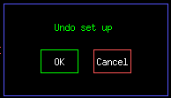

We will wait at this acknowledge. Before we run our return to stacking aggregate, we must finish the last commands in this aggregate to undo the changes made earlier in the aggregate.

- CHECK_DEVICE A:SCRES RESTORE
- CHECK_DEVICE D:IKIKP RESTORE
- CTLIT_DEVICE D:IKIKRV OFF
- CTLIT_DEVICE D:IKIKTG ON
- CTL_DEVICE D:Q731 OFF
- CTL_DEVICE A:EKIK OFF
- CTL_DEVICE IKIK OFF
- CTL_DEVICE A:ISEP1V OFF
- CTL_DEVICE A:ISEP2V OFF
- CTL_DEVICE D;EKIK OFF
- CTL_DEVICE D:ESEPV OFF
- SETIT_DEVICE D:IKIK =0
- CHECK_DEVICE D:R1HT02 RESTORE
- CHECK_DEVICE D:R1HT03 RESTORE
- CHECK_DEVICE D:R1HT04 RESTORE
- CHECK_DEVICE D:R1HT05 RESTORE
- CHECK_DEVICE D:R1HT06 RESTORE
- CHECK_DEVICE D:R1HT07 RESTORE
- SET_SEQ FILE 91

Undo Debuncher Reverse Proton Setup

- ALARM_LIST PBAR 72

Enable

- WAIT_FOR SECS 5
- ALARM_LIST PBAR 76

Enable

- ACKNOWLEDGE

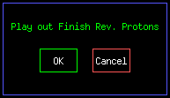

Return to Stacking

::: INSTRUCT 261 .

::: SHOT_LOG IMAGE .

::: SHOT_LOG COMMENT .

::: SET_SEQ FILE 29 .

A:SPAH11 TURN DEVICE ON ok
A:SPAH12 TURN DEVICE ON ok
A:SPPA06 SET DEVICE 12 ok
A:SPPS01 TURN DEVICE ON ok
A:CPPS01 TURN DEVICE ON ok
A:CPPA01 SET DEVICE 40 ok
A:CPTW01 ANA_ALARM ENABLE ok
A:CMTW01 ANA_ALARM DISABLE ok
A:CMPS01 TURN DEVICE OFF ok
A:CMPS01 DIG_ALARM DISABLE ok

::: EVENT 9C ENABLE .

::: ALARM_LIST PBAR 121 .

::: SETIT_DEVICE A:CPPA01 =35 .

::: INSTRUCT 270 .

::: SET_SEQ FILE_SR 4 .

M:HT100 RESTORE (D1 file) SETTING 941 ok
M:HT100 RESTORE (D1 file) ANL ALARM 941 ok
M:HT105 RESTORE (D1 file) SETTING 941 ok
M:HT105 RESTORE (D1 file) ANL ALARM 941 ok
M:HT107 RESTORE (D1 file) SETTING 941 ok
M:HT107 RESTORE (D1 file) ANL ALARM 941 ok
M:VT101 RESTORE (D1 file) SETTING 941 ok
M:VT101 RESTORE (D1 file) ANL ALARM 941 ok
M:VT101A RESTORE (D1 file) SETTING 941 ok
M:VT101A RESTORE (D1 file) ANL ALARM 941 ok
M:VT108 RESTORE (D1 file) SETTING 941 ok
M:VT108 RESTORE (D1 file) ANL ALARM 941 ok
M:TR105S RESTORE (D1 file) SETTING 941 ok
M:TR105T RESTORE (D1 file) SETTING 941 ok
M:TR105S RESTORE (D1 file) BASIC STS 941 ok
M:SMA1S RESTORE (D1 file) SETTING 941 ok
M:SMA1S1 RESTORE (D1 file) SETTING 941 ok
M:SMA1S RESTORE (D1 file) BASIC STS 941 ok
M:SMA1C RESTORE (D1 file) SETTING 941 ok
M:SMA1C1 RESTORE (D1 file) SETTING 941 ok
M:SMA1C RESTORE (D1 file) BASIC STS 941 ok
D:TRSM1S RESTORE (D1 file) SETTING 941 ok
D:TRSM1R RESTORE (D1 file) SETTING 941 ok
D:TRSM1S RESTORE (D1 file) BASIC STS 941 ok
D:TRSM1C RESTORE (D1 file) SETTING 941 ok
D:TRSM1D RESTORE (D1 file) SETTING 941 ok
D:TRSM1C RESTORE (D1 file) BASIC STS 941 ok
M:TR109S RESTORE (D1 file) SETTING 941 ok
M:TR109T RESTORE (D1 file) SETTING 941 ok
M:TR109S RESTORE (D1 file) BASIC STS 941 ok
D:TRBPM RESTORE (D1 file) SETTING 941 ok
D:TRBPMS RESTORE (D1 file) SETTING 941 ok
D:TRBPM RESTORE (D1 file) BASIC STS 941 ok
M:TR109G RESTORE (D1 file) SETTING 941 ok
M:TR109H RESTORE (D1 file) SETTING 941 ok
M:TR109G RESTORE (D1 file) BASIC STS 941 ok
D:TORIDS RESTORE (D1 file) SETTING 941 ok
D:TORIDR RESTORE (D1 file) SETTING 941 ok
D:TORIDS RESTORE (D1 file) BASIC STS 941 ok
D:TORIDC RESTORE (D1 file) SETTING 941 ok
D:TORIDD RESTORE (D1 file) SETTING 941 ok
D:TORIDC RESTORE (D1 file) BASIC STS 941 ok
D:PMAGC RESTORE (D1 file) SETTING 941 ok
D:PMAGCS RESTORE (D1 file) SETTING 941 ok
D:PMAGC RESTORE (D1 file) BASIC STS 941 ok
D:PMGSH RESTORE (D1 file) SETTING 941 ok
D:PMGSHS RESTORE (D1 file) SETTING 941 ok
D:PMGSH RESTORE (D1 file) BASIC STS 941 ok
D:PMAGON RESTORE (D1 file) SETTING 941 ok
D:PMAGOS RESTORE (D1 file) SETTING 941 ok
D:PMAGON RESTORE (D1 file) BASIC STS 941 ok
D:SMB2S RESTORE (D1 file) SETTING 941 ok
D:SMB2S1 RESTORE (D1 file) SETTING 941 ok
D:SMB2S RESTORE (D1 file) BASIC STS 941 ok
D:SMB2C RESTORE (D1 file) SETTING 941 ok
D:SMB2C1 RESTORE (D1 file) SETTING 941 ok
D:SMB2C RESTORE (D1 file) BASIC STS 941 ok
D:SMB3S RESTORE (D1 file) SETTING 941 ok
D:SMB3S1 RESTORE (D1 file) SETTING 941 ok
D:SMB3S RESTORE (D1 file) BASIC STS 941 ok
D:SMB3C RESTORE (D1 file) SETTING 941 ok
D:SMB3C1 RESTORE (D1 file) SETTING 941 ok
D:SMB3C RESTORE (D1 file) BASIC STS 941 ok
D:SMA2S RESTORE (D1 file) SETTING 941 ok
D:SMA2S1 RESTORE (D1 file) SETTING 941 ok
D:SMA2S RESTORE (D1 file) BASIC STS 941 ok
D:SMA2C RESTORE (D1 file) SETTING 941 ok
D:SMA2C1 RESTORE (D1 file) SETTING 941 ok
D:SMA2C RESTORE (D1 file) BASIC STS 941 ok
D:SMA3S RESTORE (D1 file) SETTING 941 ok
D:SMA3S1 RESTORE (D1 file) SETTING 941 ok
D:SMA3S RESTORE (D1 file) BASIC STS 941 ok
D:SMA3C RESTORE (D1 file) SETTING 941 ok
D:SMA3C1 RESTORE (D1 file) SETTING 941 ok
D:SMA3C RESTORE (D1 file) BASIC STS 941 ok
D:SMA4S RESTORE (D1 file) SETTING 941 ok
D:SMA4S1 RESTORE (D1 file) SETTING 941 ok
D:SMA4S RESTORE (D1 file) BASIC STS 941 ok
D:SMA4C RESTORE (D1 file) SETTING 941 ok
D:SMA4C1 RESTORE (D1 file) SETTING 941 ok
D:SMA4C RESTORE (D1 file) BASIC STS 940 ok

::: SET_SEQ FILE_SR 5 .

D:SMA5S RESTORE (D1 file) SETTING 941 ok
D:SMA5S1 RESTORE (D1 file) SETTING 941 ok
D:SMA5S RESTORE (D1 file) BASIC STS 941 ok
D:SMA5C RESTORE (D1 file) SETTING 941 ok
D:SMA5C1 RESTORE (D1 file) SETTING 941 ok
D:SMA5C RESTORE (D1 file) BASIC STS 941 ok
D:SMA7S RESTORE (D1 file) SETTING 941 ok
D:SMA7S1 RESTORE (D1 file) SETTING 941 ok
D:SMA7S RESTORE (D1 file) BASIC STS 941 ok
D:SMA7C RESTORE (D1 file) SETTING 941 ok
D:SMA7C1 RESTORE (D1 file) SETTING 941 ok
D:SMA7C RESTORE (D1 file) BASIC STS 941 ok
D:SMA8S RESTORE (D1 file) SETTING 941 ok
D:SMA8S1 RESTORE (D1 file) SETTING 941 ok
D:SMA8S RESTORE (D1 file) BASIC STS 941 ok
D:SMA8C RESTORE (D1 file) SETTING 941 ok
D:SMA8C1 RESTORE (D1 file) SETTING 941 ok
D:SMA8C RESTORE (D1 file) BASIC STS 941 ok
D:SMB5S RESTORE (D1 file) SETTING 941 ok
D:SMB5S1 RESTORE (D1 file) SETTING 941 ok
D:SMB5S RESTORE (D1 file) BASIC STS 941 ok
D:SMB5C RESTORE (D1 file) SETTING 941 ok
D:SMB5C1 RESTORE (D1 file) SETTING 941 ok
D:SMB5C RESTORE (D1 file) BASIC STS 941 ok
D:SMB7S RESTORE (D1 file) SETTING 941 ok
D:SMB7C RESTORE (D1 file) SETTING 941 ok
D:SMB7C1 RESTORE (D1 file) SETTING 941 ok
D:SMB7C RESTORE (D1 file) BASIC STS 941 ok
D:SMB8S RESTORE (D1 file) SETTING 941 ok
D:SMB8S1 RESTORE (D1 file) SETTING 941 ok
D:SMB8S RESTORE (D1 file) BASIC STS 941 ok
D:SMB8C RESTORE (D1 file) SETTING 941 ok
D:SMB8C1 RESTORE (D1 file) SETTING 941 ok
D:SMB8C RESTORE (D1 file) BASIC STS 941 ok
A:CHP11 RESTORE (D1 file) SETTING 941 ok
A:CHP111 RESTORE (D1 file) SETTING 941 ok
A:CHP11 RESTORE (D1 file) BASIC STS 941 ok
A:CHP21 RESTORE (D1 file) SETTING 941 ok
A:CHP211 RESTORE (D1 file) SETTING 941 ok
A:CHP21 RESTORE (D1 file) BASIC STS 941 ok
A:CPP11 RESTORE (D1 file) SETTING 941 ok
A:CPP111 RESTORE (D1 file) SETTING 941 ok
A:CPP11 RESTORE (D1 file) BASIC STS 941 ok
A:CPP21 RESTORE (D1 file) SETTING 941 ok
A:CPP211 RESTORE (D1 file) SETTING 941 ok
A:CPP21 RESTORE (D1 file) BASIC STS 941 ok
A:CVP11 RESTORE (D1 file) SETTING 941 ok
A:CVP111 RESTORE (D1 file) SETTING 941 ok
A:CVP11 RESTORE (D1 file) BASIC STS 941 ok
A:CVP21 RESTORE (D1 file) SETTING 941 ok
A:CVP211 RESTORE (D1 file) SETTING 941 ok
A:CVP21 RESTORE (D1 file) BASIC STS 941 ok
A:CHP2ON RESTORE (D1 file) SETTING 941 ok
A:CHP2OP RESTORE (D1 file) SETTING 941 ok
A:CHP2ON RESTORE (D1 file) BASIC STS 941 ok
A:CHP2OF RESTORE (D1 file) SETTING 941 ok
A:CHP2OP RESTORE (D1 file) SETTING 941 ok
A:CHP2OF RESTORE (D1 file) BASIC STS 941 ok
A:CVP2ON RESTORE (D1 file) SETTING 941 ok
A:CVP2OP RESTORE (D1 file) SETTING 941 ok
A:CVP2ON RESTORE (D1 file) BASIC STS 941 ok
A:CVP2OF RESTORE (D1 file) SETTING 941 ok
A:CVP2OG RESTORE (D1 file) SETTING 941 ok
A:CVP2OF RESTORE (D1 file) BASIC STS 941 ok
A:DPVATT RESTORE (D1 file) SETTING 941 ok
A:DPVATT RESTORE (D1 file) ANL ALARM 941 ok
A:DPHATT RESTORE (D1 file) SETTING 941 ok
A:DPHATT RESTORE (D1 file) ANL ALARM 941 ok
A:CPTWT1 RESTORE (D1 file) SETTING 941 ok
A:CPTWTS RESTORE (D1 file) SETTING 941 ok
A:CPTWT1 RESTORE (D1 file) BASIC STS 941 ok
A:CPPS01 RESTORE (D1 file) BASIC STS 941 ok
A:CMPS01 RESTORE (D1 file) BASIC STS 941 ok
A:CV2PS1 RESTORE (D1 file) BASIC STS 941 ok
A:CV2PS1 RESTORE (D1 file) BASIC STS 941 ok
A:CV2PS1 RESTORE (D1 file) BASIC STS 941 ok
A:CV2PS1 RESTORE (D1 file) BASIC STS 940 ok

::: SET_SEQ FILE_SR 6 .

A:BPA1S5 RESTORE (D1 file) SETTING 941 ok
A:BPA1S6 RESTORE (D1 file) SETTING 941 ok
A:BPA2S5 RESTORE (D1 file) SETTING 941 ok
A:BPA2S6 RESTORE (D1 file) SETTING 941 ok
A:BPA3S5 RESTORE (D1 file) SETTING 941 ok
A:BPA3S6 RESTORE (D1 file) SETTING 941 ok
A:BPA4S5 RESTORE (D1 file) SETTING 941 ok
A:BPA4T6 RESTORE (D1 file) SETTING 941 ok
A:BPA5S5 RESTORE (D1 file) SETTING 941 ok
A:BPA5S6 RESTORE (D1 file) SETTING 941 ok
A:BPA6S5 RESTORE (D1 file) SETTING 941 ok
A:BPA6S6 RESTORE (D1 file) SETTING 941 ok
D:BPD1S5 RESTORE (D1 file) SETTING 941 ok
D:BPD1S6 RESTORE (D1 file) SETTING 941 ok
D:BPD2S5 RESTORE (D1 file) SETTING 941 ok
D:BPD2S6 RESTORE (D1 file) SETTING 941 ok
D:BPD3S5 RESTORE (D1 file) SETTING 941 ok
D:BPD3S6 RESTORE (D1 file) SETTING 941 ok
D:BPD4S5 RESTORE (D1 file) SETTING 941 ok
D:BPD4S6 RESTORE (D1 file) SETTING 941 ok
D:BPD5S5 RESTORE (D1 file) SETTING 941 ok
D:BPD5S6 RESTORE (D1 file) SETTING 941 ok
D:BPD6S5 RESTORE (D1 file) SETTING 941 ok
D:BPD6T6 RESTORE (D1 file) SETTING 941 ok
D:TBT RESTORE (D1 file) SETTING 941 ok
D:TBT1 RESTORE (D1 file) SETTING 941 ok
D:TBT RESTORE (D1 file) BASIC STS 941 ok
D:IKIKM1 RESTORE (D1 file) SETTING 941 ok
D:IKIKM2 RESTORE (D1 file) SETTING 941 ok
D:IKIKM3 RESTORE (D1 file) SETTING 941 ok
D:EKIKM1 RESTORE (D1 file) SETTING 941 ok
D:EKIKM2 RESTORE (D1 file) SETTING 941 ok
D:EKIKM3 RESTORE (D1 file) SETTING 941 ok
D:IKIKRV RESTORE (D1 file) SETTING 941 ok
D:IKIKRW RESTORE (D1 file) SETTING 941 ok
D:IKIKTG RESTORE (D1 file) SETTING 941 ok
D:IKIKSG RESTORE (D1 file) SETTING 941 ok
D:IKIKTG RESTORE (D1 file) BASIC STS 941 ok
A:IKIKM1 RESTORE (D1 file) SETTING 941 ok
A:IKIKM2 RESTORE (D1 file) SETTING 941 ok
A:IKIKM3 RESTORE (D1 file) SETTING 941 ok
A:EKIKM1 RESTORE (D1 file) SETTING 941 ok
A:EKIKTG RESTORE (D1 file) SETTING 941 ok
A:EKIKSG RESTORE (D1 file) SETTING 941 ok
D:ISEPC RESTORE (D1 file) SETTING 941 ok
D:ISEPD RESTORE (D1 file) SETTING 941 ok
D:ISEPC RESTORE (D1 file) BASIC STS 941 ok
D:ISEPON RESTORE (D1 file) SETTING 941 ok
D:ISEPOM RESTORE (D1 file) SETTING 941 ok
D:ISEPON RESTORE (D1 file) SETTING 941 ok
D:ESEPC RESTORE (D1 file) SETTING 941 ok
D:ESEPD RESTORE (D1 file) SETTING 941 ok
D:ESEPC RESTORE (D1 file) BASIC STS 941 ok
D:ESEPON RESTORE (D1 file) SETTING 941 ok
D:ESEPOS RESTORE (D1 file) SETTING 941 ok
D:ESEPON RESTORE (D1 file) BASIC STS 941 ok
A:ISEP1O RESTORE (D1 file) SETTING 941 ok
A:ISEP1N RESTORE (D1 file) SETTING 941 ok
A:ISEP1O RESTORE (D1 file) BASIC STS 941 ok
A:ISEP2O RESTORE (D1 file) SETTING 941 ok
A:ISEP2N RESTORE (D1 file) SETTING 941 ok
A:ISEP2O RESTORE (D1 file) BASIC STS 941 ok
A:ISEP1C RESTORE (D1 file) SETTING 941 ok
A:ISEP1D RESTORE (D1 file) SETTING 941 ok
A:ISEP1C RESTORE (D1 file) BASIC STS 941 ok
A:ISEP2C RESTORE (D1 file) SETTING 941 ok
A:ISEP2D RESTORE (D1 file) SETTING 941 ok
A:ISEP2C RESTORE (D1 file) BASIC STS 941 ok

::: SET_SEQ FILE_SR 7 .

A:ISHUTO RESTORE (D1 file) SETTING 941 ok
A:ISHUTP RESTORE (D1 file) SETTING 941 ok
A:ISHUTO RESTORE (D1 file) BASIC STS 941 ok
A:ISHUTC RESTORE (D1 file) SETTING 941 ok
A:ISHUTD RESTORE (D1 file) SETTING 941 ok
A:ISHUTC RESTORE (D1 file) BASIC STS 941 ok
A:ESHUTO RESTORE (D1 file) SETTING 941 ok
A:ESHUTP RESTORE (D1 file) SETTING 941 ok
A:ESHUTO RESTORE (D1 file) BASIC STS 941 ok
A:ESHUTC RESTORE (D1 file) SETTING 941 ok
A:ESHUTD RESTORE (D1 file) SETTING 941 ok
A:ESHUTC RESTORE (D1 file) BASIC STS 941 ok
D:LM10ST RESTORE (D1 file) SETTING 941 ok
D:LM10SS RESTORE (D1 file) SETTING 941 ok
D:LM10ST RESTORE (D1 file) BASIC STS 941 ok
D:LM10CL RESTORE (D1 file) SETTING 941 ok
D:LM10DL RESTORE (D1 file) SETTING 941 ok
D:LM10CL RESTORE (D1 file) BASIC STS 941 ok
D:LM10ET RESTORE (D1 file) SETTING 941 ok
D:LM10FT RESTORE (D1 file) SETTING 941 ok
D:LM10ET RESTORE (D1 file) BASIC STS 941 ok
D:LM30ST RESTORE (D1 file) SETTING 941 ok
D:LM30SS RESTORE (D1 file) SETTING 941 ok
D:LM30ST RESTORE (D1 file) BASIC STS 941 ok
D:LM30CL RESTORE (D1 file) SETTING 941 ok
D:LM30DL RESTORE (D1 file) SETTING 941 ok
D:LM30CL RESTORE (D1 file) BASIC STS 941 ok
D:LM30ET RESTORE (D1 file) SETTING 941 ok
D:LM30FT RESTORE (D1 file) SETTING 941 ok
D:LM30ET RESTORE (D1 file) BASIC STS 941 ok
D:LM50ST RESTORE (D1 file) SETTING 941 ok
D:LM50SS RESTORE (D1 file) SETTING 941 ok
D:LM50ST RESTORE (D1 file) BASIC STS 941 ok
D:LM50CL RESTORE (D1 file) SETTING 941 ok
D:LM50DL RESTORE (D1 file) SETTING 941 ok
D:LM50CL RESTORE (D1 file) BASIC STS 941 ok
D:LM50ET RESTORE (D1 file) SETTING 941 ok
D:LM50FT RESTORE (D1 file) SETTING 941 ok
D:LM50ET RESTORE (D1 file) BASIC STS 941 ok
D:LMDATM RESTORE (D1 file) SETTING 941 ok
D:LMDATN RESTORE (D1 file) SETTING 941 ok
D:LMDATM RESTORE (D1 file) BASIC STS 941 ok
D:LMAP2S RESTORE (D1 file) SETTING 941 ok
D:LMAP2R RESTORE (D1 file) SETTING 941 ok
D:LMAP2S RESTORE (D1 file) BASIC STS 941 ok
D:LMAP2T RESTORE (D1 file) SETTING 941 ok
D:LMAP2Q RESTORE (D1 file) SETTING 941 ok
D:LMAP2T RESTORE (D1 file) BASIC STS 941 ok
D:VAREVT RESTORE (D1 file) SETTING 941 ok
D:VAREV1 RESTORE (D1 file) SETTING 941 ok
D:VAREVT RESTORE (D1 file) BASIC STS 941 ok
D:DAP2X RESTORE (D1 file) SETTING 941 ok
D:DAP2R RESTORE (D1 file) SETTING 941 ok
D:DAP2X RESTORE (D1 file) BASIC STS 941 ok
D:BEEPT RESTORE (D1 file) SETTING 941 ok
D:BEEPS RESTORE (D1 file) SETTING 941 ok
D:BEEPT RESTORE (D1 file) BASIC STS 941 ok
M:TF14KE RESTORE (D1 file) SETTING 941 ok
M:TF14K1 RESTORE (D1 file) SETTING 941 ok
M:TF14KE RESTORE (D1 file) BASIC STS 941 ok
M:TF14KX RESTORE (D1 file) SETTING 941 ok
M:TF14KX RESTORE (D1 file) BASIC STS 941 ok
M:TF14KD RESTORE (D1 file) SETTING 941 ok
M:TF14K2 RESTORE (D1 file) SETTING 941 ok
M:TF14KD RESTORE (D1 file) BASIC STS 941 ok

::: SET_SEQ FILE_SR 8 .D:TR806S RESTORE (D1 file) SETTING 941 ok
D:TR806T RESTORE (D1 file) SETTING 941 ok
D:TR806S RESTORE (D1 file) BASIC STS 941 ok
D:LMDATM RESTORE (D1 file) SETTING 941 ok
D:LMDATN RESTORE (D1 file) SETTING 941 ok
D:LMDATM RESTORE (D1 file) BASIC STS 941 ok
M:LMHLD RESTORE (D1 file) SETTING 941 ok
M:LMHLDS RESTORE (D1 file) SETTING 941 ok
M:LMHLD RESTORE (D1 file) BASIC STS 941 ok
D:EXTRAM RESTORE (D1 file) SETTING 941 ok
D:EXTRAN RESTORE (D1 file) SETTING 941 ok
D:EXTRAM RESTORE (D1 file) BASIC STS 941 ok
D:EXTRAT RESTORE (D1 file) SETTING 941 ok
D:EXTRAS RESTORE (D1 file) SETTING 941 ok
D:EXTRAT RESTORE (D1 file) BASIC STS 941 ok
D:EXTRAC RESTORE (D1 file) BASIC STS 941 ok
A:SCRES RESTORE (D1 file) SETTING 941 ok
A:SCRES1 RESTORE (D1 file) SETTING 941 ok
A:SCRES RESTORE (D1 file) BASIC STS 941 ok
A:MRTASD RESTORE (D1 file) SETTING 941 ok
T:TD92 RESTORE (D1 file) SETTING 941 ok
T:TR92 RESTORE (D1 file) SETTING 941 ok
T:TD92 RESTORE (D1 file) BASIC STS 941 ok
A:R1HLT1 RESTORE (D1 file) SETTING 941 ok
A:R1HLS1 RESTORE (D1 file) SETTING 941 ok
A:R1HLT1 RESTORE (D1 file) BASIC STS 941 ok
A:R1HLT1 ADD TIMER EVENT 90 14 6 A:R1HLT2 ADD TIMER EVENT 90 14 6 A:R1LLPS RESTORE (D1 file) SETTING 941 ok
A:R1LLT3 RESTORE (D1 file) SETTING 941 ok
A:R1LLS3 RESTORE (D1 file) SETTING 941 ok
A:R1LLT3 RESTORE (D1 file) BASIC STS 941 ok
A:R1LLT4 RESTORE (D1 file) SETTING 941 ok
A:R1LLS4 RESTORE (D1 file) SETTING 941 ok
A:R1LLT4 RESTORE (D1 file) BASIC STS 941 ok
a:r2cwt1 EVENT DISABLE ok
a:r2cwt1 SET TIMER REFER 0F ok
a:r2cwt2 EVENT ENABLE ok
a:r2cwt2 SET TIMER REFER 0F ok
A:RLLFS1 RESTORE (D1 file) SETTING 941 ok
RESTORE (D1 file) SETTING 925 ok

::: SET_SEQ FILE_SR 9 .

A:R1LLMG RESTORE (D1 file) SETTING 941 ok
A:R1LLNG RESTORE (D1 file) SETTING 941 ok
A:R1LLMG RESTORE (D1 file) BASIC STS 941 ok
A:R1LLT1 RESTORE (D1 file) SETTING 941 ok
A:R1LLS1 RESTORE (D1 file) SETTING 941 ok
A:R1LLT1 RESTORE (D1 file) BASIC STS 941 ok
A:R1LLT2 RESTORE (D1 file) SETTING 941 ok
A:R1LLS2 RESTORE (D1 file) SETTING 941 ok
A:R1LLT2 RESTORE (D1 file) BASIC STS 941 ok
A:R1HLT2 RESTORE (D1 file) SETTING 941 ok
A:R1HLS2 RESTORE (D1 file) SETTING 941 ok
A:R1HLT2 RESTORE (D1 file) BASIC STS 941 ok
A:CH1PS1 RESTORE (D1 file) BASIC STS 941 ok
A:CH2PS1 RESTORE (D1 file) BASIC STS 941 ok
A:CH3PS1 RESTORE (D1 file) BASIC STS 941 ok
A:CV1PS1 RESTORE (D1 file) BASIC STS 941 ok
A:CV2PS1 RESTORE (D1 file) BASIC STS 941 ok
A:CV3PS1 RESTORE (D1 file) BASIC STS 941 ok
A:CH1T2 RESTORE (D1 file) ANL ALARM 941 ok
A:CH2T2 RESTORE (D1 file) ANL ALARM 941 ok
A:CH3T2 RESTORE (D1 file) ANL ALARM 941 ok
A:CV1T2 RESTORE (D1 file) ANL ALARM 941 ok
A:CV2T2 RESTORE (D1 file) ANL ALARM 941 ok
A:CV3T2 RESTORE (D1 file) ANL ALARM 941 ok

::: CHECK_DEVICE A:R2DDS1 RESTORE .

::: SET_SEQ FILE 40 .

M:HV200 TURN DEVICE OFF ok
M:Q201 TURN DEVICE OFF ok
M:Q202 TURN DEVICE OFF ok
M:HV202 TURN DEVICE OFF ok
M:Q203 TURN DEVICE OFF ok
M:Q204 TURN DEVICE OFF ok
M:Q205 TURN DEVICE OFF ok
M:V205 TURN DEVICE OFF ok
M:Q206 TURN DEVICE OFF ok
M:Q207 TURN DEVICE OFF ok
M:Q208 TURN DEVICE OFF ok
M:Q209 TURN DEVICE OFF ok

::: SET_SEQ FILE 46 .

D:Q901 TURN DEVICE OFF ok
D:V901 TURN DEVICE OFF ok
D:Q903 TURN DEVICE OFF ok
D:HT906A TURN DEVICE OFF ok
D:HT906B TURN DEVICE OFF ok
D:Q907 TURN DEVICE OFF ok
D:Q909 TURN DEVICE OFF ok
D:Q913 TURN DEVICE OFF ok
D:Q914 TURN DEVICE OFF ok
D:H914 TURN DEVICE OFF ok
D:Q916 TURN DEVICE OFF ok
D:Q917 TURN DEVICE OFF ok
D:Q919 TURN DEVICE OFF ok
D:Q924 TURN DEVICE OFF ok
D:Q926 TURN DEVICE OFF ok
D:H926 TURN DEVICE OFF ok

::: SET_SEQ FILE 38 .

I:F17B3 RESET DEVICE ok
M:HV100 RESET DEVICE ok
M:Q101 RESET DEVICE ok
M:Q102 RESET DEVICE ok
M:HV102 RESET DEVICE ok
M:Q103 RESET DEVICE ok
M:Q104 RESET DEVICE ok
M:Q105 RESET DEVICE ok
M:V105 RESET DEVICE ok
M:Q106 RESET DEVICE ok
M:Q107 RESET DEVICE ok
M:Q108 RESET DEVICE ok
M:Q109I RESET DEVICE ok
M:Q109V RESET DEVICE ok

::: SET_SEQ FILE 39 .

I:F17B3 TURN DEVICE ON ok
M:HV100 TURN DEVICE ON ok
M:HT100 TURN DEVICE ON ok
M:Q101 TURN DEVICE ON ok
M:VT101 TURN DEVICE ON ok
M:VT101A TURN DEVICE ON ok
M:Q102R SET POSITIVE ok
M:Q102 TURN DEVICE ON ok
M:HV102 TURN DEVICE ON ok
M:Q103 TURN DEVICE ON ok
M:Q104 TURN DEVICE ON ok
M:Q105 TURN DEVICE ON ok
M:HT105 TURN DEVICE ON ok
M:V105 TURN DEVICE ON ok
M:Q106 TURN DEVICE ON ok
M:Q107 TURN DEVICE ON ok
M:HT107 TURN DEVICE ON ok
M:Q108 TURN DEVICE ON ok
M:VT108 TURN DEVICE ON ok
M:Q109I TURN DEVICE ON ok
M:Q109V TURN DEVICE ON ok

::: SET_SEQ FILE 26 .

D:SM900 TURN DEVICE OFF ok
D:SM906 TURN DEVICE OFF ok
D:SM909 TURN DEVICE OFF ok
D:SM913 TURN DEVICE OFF ok
D:SM917 TURN DEVICE OFF ok
D:SM921 TURN DEVICE OFF ok
D:SM926 TURN DEVICE OFF ok

::: SET_SEQ FILE 93 .

D:H1PS1 TURN DEVICE ON ok
D:H2PS1 TURN DEVICE ON ok
D:H3PS1 TURN DEVICE ON ok
D:H4PS1 TURN DEVICE ON ok
D:V1PS1 TURN DEVICE ON ok
D:V2PS1 TURN DEVICE ON ok
D:V3PS1 TURN DEVICE ON ok
D:V4PS1 TURN DEVICE ON ok
D:P1PS TURN DEVICE ON ok
D:P2PS TURN DEVICE ON ok
D:P3PS TURN DEVICE ON ok
D:P4PS TURN DEVICE ON ok

::: SET_SEQ FILE 95 .

A:CH1D1 TURN DEVICE OFF ok
A:CH2D1 TURN DEVICE OFF ok
A:CH3D1 TURN DEVICE OFF ok
A:CV1D1 TURN DEVICE OFF ok
A:CV2D1 TURN DEVICE OFF ok
A:CV3D1 TURN DEVICE OFF ok

::: CHECK_DEVICE I:HT702S RESTORE .

::: CHECK_DEVICE I:HT704S RESTORE .

::: CHECK_DEVICE I:VT701S RESTORE .

::: CHECK_DEVICE I:VT703S RESTORE .

::: ALARM_LIST PBAR 76 .

::: WAIT_FOR SECS 5 .

::: ALARM_LIST PBAR 17 .

::: CTL_DEVICE A:R4HLSC NEGATIVE .

::: CHECK_DEVICE A:DPHATT RESTORE .

::: SET_SEQ FILE 3 .

D:PMAGV RESET DEVICE ok
D:PMAGV TURN DEVICE ON ok
D:LNV RESET DEVICE ok
D:LNV TURN DEVICE ON ok
D:ISEPV RESET DEVICE ok
D:ISEPV TURN DEVICE ON ok
D:IKIK RESET DEVICE ok
D:IKIK TURN DEVICE ON ok
D:EKIK RESET DEVICE ok
D:EKIK TURN DEVICE ON ok
d:ekikq TURN DEVICE ON ok
D:ESEPV RESET DEVICE ok
D:ESEPV TURN DEVICE ON ok
A:ISEP1V RESET DEVICE ok
A:ISEP1V TURN DEVICE ON ok
A:ISEP2V RESET DEVICE ok
A:ISEP2V TURN DEVICE ON ok
A:IKIK RESET DEVICE ok
A:IKIK TURN DEVICE ON ok
A:R1HLSC RESET DEVICE ok
A:R1HLSC TURN DEVICE ON ok
A:SPPS01 TURN DEVICE ON ok
A:CMPS01 TURN DEVICE OFF ok
A:CMPS01 DIG_ALARM DISABLE ok
A:EKIK TURN DEVICE OFF ok
A:R3HLSC TURN DEVICE OFF ok
A:R3HLSC DIG_ALARM DISABLE ok
A:R3LLT1 EVENT DISABLE ok
A:R3LLT2 SET TIMER REFER 0F ok
A:R3LLT2 EVENT ENABLE ok
A:R3HLGS TURN DEVICE ON ok
A:RLLFS0 SET DEVICE 628888 ok
A:R2LLT1 SET DEVICE 0 ok
A:R2LLT1 SET TIMER REFER 0F ok
A:R2LLT1 EVENT ENABLE ok
A:R2LLT2 EVENT DISABLE ok
a:r2llfr SET DEVICE 1.25778 ok
a:r2llam SET DEVICE 1.275 ok
A:R2LLAM TURN DEVICE ON ok
A:R2CPAM TURN DEVICE OFF ok
A:R2CPFR TURN DEVICE OFF ok
A:R2HLSC TURN DEVICE ON ok
D:H926 RESET DEVICE ok
D:H926 TURN DEVICE ON ok
D:H926 DIG_ALARM ENABLE ok
D:SA11T SET DEVICE 1.03 ok
D:SA11T SET TIMER REFER 80 ok
D:SA11T EVENT ENABLE ok
D:Q701 RESET DEVICE ok
D:Q702 RESET DEVICE ok
D:H704 RESET DEVICE ok
D:Q701 TURN DEVICE ON ok
D:Q702 TURN DEVICE ON ok
D:H704 TURN DEVICE ON ok
A:R4HLSC SET NEGATIVE ok
A:R4HLSC DIG_ALARM DISABLE ok

::: CTL_DEVICE I:F17B3 RESET .

::: CTLIT_DEVICE I:F17B3 ON .

::: CTL_DEVICE D;Q731 RESET .

::: CTLIT_DEVICE D;Q731 ON .

::: WAIT_FOR SECS 15 .

::: CTLIT_DEVICE M:Q102 ON .

::: ALARM_LIST PBAR 122 .

::: WAIT_FOR SECS 3 .

::: SPECTRUM_LOAD 2 2 .

::: WAIT_FOR SECS 3 .

::: SPECTRUM_LOAD 1 3 .

::: WAIT_FOR SECS 3 .

::: SEQ_PGM REQUEST ap0 scope .

::: ACKNOWLEDGE .

::: SEQ_PGM REQUEST AP0 Scope .

::: SET_DEVICE A:VSARST =9 .

::: WAIT_FOR SECS 10 .

::: SEQ_PGM REQUEST Stacking VSA .

::: WAIT_FOR SECS 10 .

::: SEQ_PGM REQUEST Flux Capacitor .

::: START_PGM SA1144 .

::: START_PGM P2 .

::: INSTRUCT 17 .

::: START_PGM P153 .

::: CHECK_DEVICE A:R2LLAM RESTORE .

::: CTLIT_DEVICE A:R2LLAM ON .

::: FTP TRANSFER 0 .

::: WAIT_FOR EVENT 90 .

::: CHECK_DEVICE A:R1LLMR OFF .

::: CHECK_DEVICE A:R1LLH2 OFF .

::: CHECK_DEVICE A:R1LLFP ON .

::: CHECK_DEVICE A:R1LLFR OFF .

::: CHECK_DEVICE A:R1LLEN OFF .

::: CHECK_DEVICE A:R4MIPS RESTORE .

::: CHECK_DEVICE A:R1LLPS RESTORE .

::: CHECK_DEVICE A:R4CDPS RESTORE .

::: CHECK_DEVICE A:R4BKMP RESTORE .

::: CHECK_DEVICE A:R4BKMX RESTORE .

::: CHECK_DEVICE A:R4PHRG RESTORE .

::: SET_DEVICE V:SETPBT =5 .

::: SET_DEVICE A:APSHOT +=1 .

::: SETIT_DEVICE V:PSHOOT =1 .

::: SETIT_DEVICE V:APSMOD =7 .

::: SETIT_DEVICE V:APSLAT =1 .

::: NOTIFY Stacking .

::: ABORT_MASK PBAR_SOFT DISABLED .

::: ABORT_MASK AP1_C204 DISABLED .

::: ABORT_MASK AP1_120_PS DISABLED .

::: ABORT_MASK AP1_8_PS ENABLED .

::: EVENT 88 TRIGGER .

::: ACKNOWLEDGE .
ok BEAM_SWITCH PBAR_SOURCE ON .

References

“Obie Box Primer”

2004 Pbar Electronic Logbook Chapter 638 (http://www-bd.fnal.gov/cgi-mach/machlog.pl?nb=pbar05&action=view&page=638&anchor=183706&hilite=18:37:06-%20target=_top), Steve Werkema

“Pbar Dedicated Studies,”

2004 Pbar Electronic Logbook Chapters 681 to 730 (http://www-bd.fnal.gov/cgi-mach/machlog.pl?nb=pbar05&action=view&page=681&load=), Pbar Department

“Pbar Online Tuning Guide,”

http://www-drendel.fnal.gov/TuningGuide/tuning-guide.htm, Brian Drendel

