Electron Cloud Study for Tevatron and Fermi Proton Plan Project

Xiaolong Zhang, Weiren Chou, Francois Ostiguy
May 2006

Abstraction:
In this report we will brief discuss the history and the background of the electron cloud effects on beam storage rings, especially the proton rings. We will mainly focus on it’s implication on Fermi proton plan and Tevatron. Some observations at Tevatron and initial simulation results on main injector will be also presented. Based on these estimations, we will outline the proposal to proceed the further studies, which will needed to mitigate these problems.

Electron Cloud Effect AND BACKGROUND

The electron cloud refers to the electron accumulated around the beam in the beam pipe to form a quasi equilibrium distribution, which can in turn interacting with beam to affect the operation of the accelerator, such as to lead to the beam loss by causing beam instability, emittance growth, vacuum pressure increase and degradation of the beam diagnostic system, etc. The primary electrons are generated by any of the mainly three processes: photoelectrons by the synchrotron radiation, beam ionization of the residual gas by beam particle loss on the beam pipe. In addition, the multipacting effect induced by the bunched beam can cause the number of electrons grow exponentially until saturation when the beam is neutralized or the space charge effect suppressing the secondary electrons leaving the wall of the beam pipe. In this case the secondary electron yield plays a very important role.
The electron cloud effect was first observed in the mid-60’s at Budkur Institute of Nuclear Physics(BINP) proton storage ring for coasting beam instabilities which were characterized as two-stream instability. In the early 70’s at CERN ISR, the intensive vacuum pressure rise was observed with bunched proton beams, which was identified as the beam induced multipacting causing the gas adsorption. Since the mid 80’s at the PSR(LANL) the instability caused by the proton beam trapped electron cloud was observed. In the early 90’s the electron cloud instability was observed at the positron storage ring of the Photon Factory(PF) of KEK and subsequently confirmed by the Beijing Electron-Positron Collider(BEPC) at Institute of High Energy Physics Institute. Since then, the precaution was taken for PEPII to coating their vacuum chamber with low secondary yield material TiN. And for KEKB, all of the field free space of the positron ring vacuum chamber are wired with solenoid to suppress the electron cloud, so that they can minimize the emittance blowup to reach the designed luminosity. At RICH(BNL) they have to coating their vacuum chamber to suppress the electron cloud induced vacuum pressure rise and related beam loss, especially during the transition crossing. The results are not very satisfactory. At SPS(CERN), a lot of beam study time was dedicated for the LHC beam. They observed electron cloud induced headtail beam instability and vacuum pressure rise. They conclude the electron cloud will be a serious problem for the LHC and a dedicated and detailed intensive study program has been carried on since 1996. At SNS, they have coated their beam pipe hoping to minimize the electron cloud effects. In one word, for every modern high intensity high power positive charge accelerators, electron cloud problem become a obstacle and a lot of efforts and money have been put into to find a solutions for this problem.
At Fermilab, since the main injector is running at a lower intensity and Tevatron operated at larger bunch spacing. We seem have not seen this problem yet. Some observations at Tevatron have already shown the signs of electron cloud induced vacuum pressure rise and beam quality degradation as we intentionally injected 4 times of the normal intensity uncoalesced beam into Tevatron (see appendix). Therefore, a lot of effort has been carried out to understanding the MI upgrading parameters vs. the electron cloud effects. Some of the preliminary simulation results were shown in the attached plots and the Miguel Furman’s note. As the results, the electron cloud problem is predicted to be a serious problem for the Fermilab proton plan, Super NuMI and proton driver. It might cause beam emittance growth, beam lifetime degradation and even higher beam loss when the proton bunch intensity is over the threshold of 1.5e11 protons/bunch. And it is also one of the limiting factor for the positron damping ring of the future ILC. So an emergency and crush study on electron cloud will need to be carried out.

THE PROPOSAL

As stated above, the electron cloud study is a much needed project at Fermilab now. We have a team that is working part time now organized by Mr. Weiren Chou and Mr. Xiaolong Zhang has been worked on electron cloud effects at CERN before. And we also have collaborators from LBNL, ANL and CERN. But that’s far from enough. We have to strength our efforts on every issue concerning the electron cloud effects. The research proposal here includes theoretical simulation studies and the experiments.

Theoretical Simulation Studies:

There are a lot of simulation codes exist at different research labs now for electron cloud formation and instability simulations. They all can give a qualitatively estimation on electron cloud effects for given machines. But quantitatively, the results are different from each other since the physics behind it is very complex. And they all depend on heavily on the details of the physics of secondary electron yield. In this direction, we need to collaborate with other labs to perfect the simulation code and the physics model adapted to the machines of Fermilab for a better understanding how the electron cloud will affect the machines such as main injector, Tevatron and booster, etc. The simulation will be needed to adapt the machine parameter changes, operation mode variations and hardware changes. And the crosschecks between simulations and experiment observations have to be performed at the every stage of the accelerator development and upgrades.
Labor: 0.5 FTE year
Budget: $10,000/year (Travel and inviting experts from other labs)

Experimental Studies

The experimental studies are more important, which are needed to develop the mitigation methods.

- Electron Cloud Detector:
As our ANL collaboration, we got two the electron detectors (RFA) designed at ANL. One is installed at B48 with specially designed MI type of vacuum pipe insertion of Tevatron and the other is installed at MI the 6” round pipe. They will be used to measure the build up of the electron cloud and it’s relation to beam operation parameters and compare with simulations. The correspond electronics and software have to be developed.
Labor: 0.5FTE year is needed.
Budget: $20,000/year (Travel, cabling, amplifier, inviting outside experts, etc.)

- Secondary Electron Yield Measurement:
The secondary electron yield if essential to the electron cloud buildup, however there are few secondary yield measurement. CERN, KEK, SLAC and BNL are all have established measurement systems. We need to collaborate with them to measure various samples to find a better material.
Labor: 0.3FTE
Budget: $30,000/year (prepare samples + travel)
or higher $? If we develop our own systems

- Vacuum Chamber Coating Technology Researches
Study the main TiN and TiZrV coating technology for stainless steels which are common in recent machines. A better coating material and cost effective coating technique is essential.
Labor: 1 FTE year
Budget: $100,000/year

- Clearing electrode development: Similar to Tevatron SNEG thin electrode which can be fixed to the bottom of the elliptical beam pipe; bake-able and can be operated around 700V.
Labor: 1 FTE year
Budget: $100,000/year

- Solenoid test for field free regions. 50Gs solenoid field needed by wire around the beam pipe.

Appendix:

- Electron Cloud Effect Observation at Tevatron, Beams-doc-1991-v1
- Preliminary Simulation Studies For Main Injector

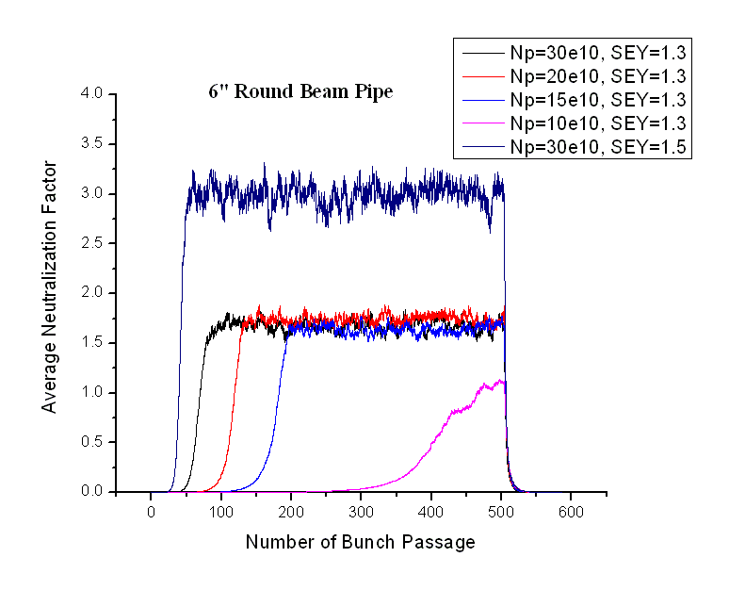
Figure 1. For the 6” beam pipe, the electron cloud happens even at bunch intensity of 10e10 proton/bunch at low SEY=1.3
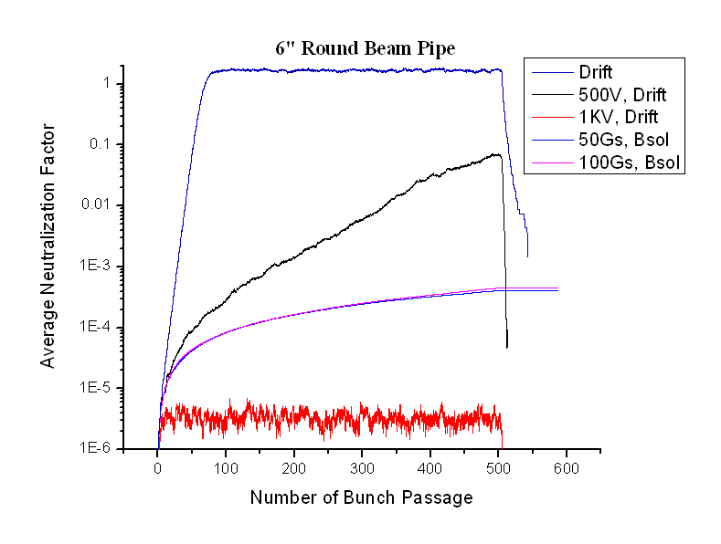
Figure 2. The electron cloud can be suppressed by 50Gs solenoid or over 500V clearing electrode.
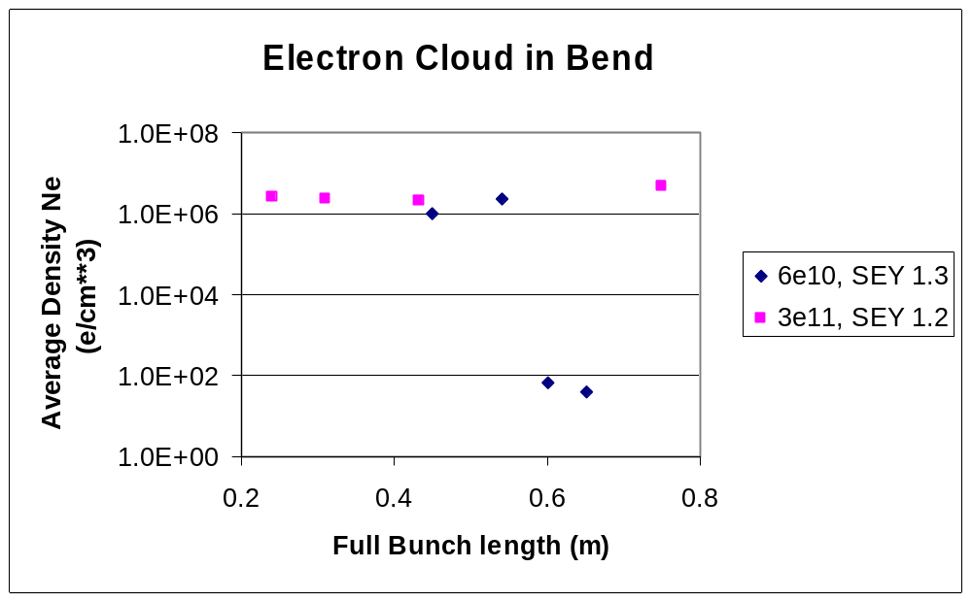
Figure 3. With normal MI elliptical vacuum chamber and within bend magnets, at proton bunch intensity of 6e10, the electron cloud threshold for the bunch length of 0.54m, which means electron cloud happens during ramping and transition crossing where bunch length becomes shorter.
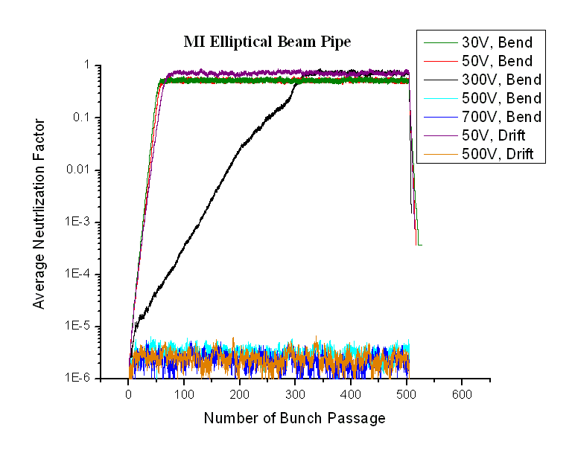
Figure 4. Above electron cloud can be suppressed by the 500V clearing electrode in the beam pipe.

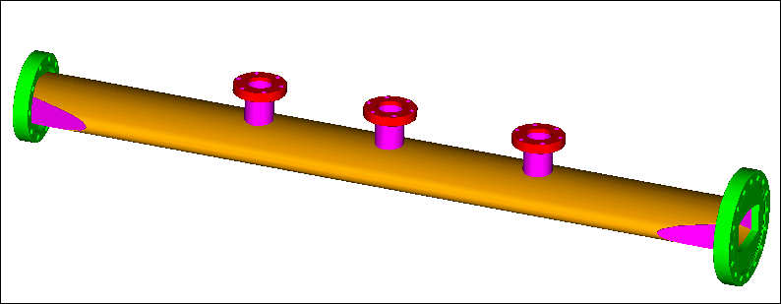

Figure 5. The MI type elliptical beam pipe insertion installed at Tevatron B48. The graph shows the RFA port, vacuum gauge port and ion pump port.

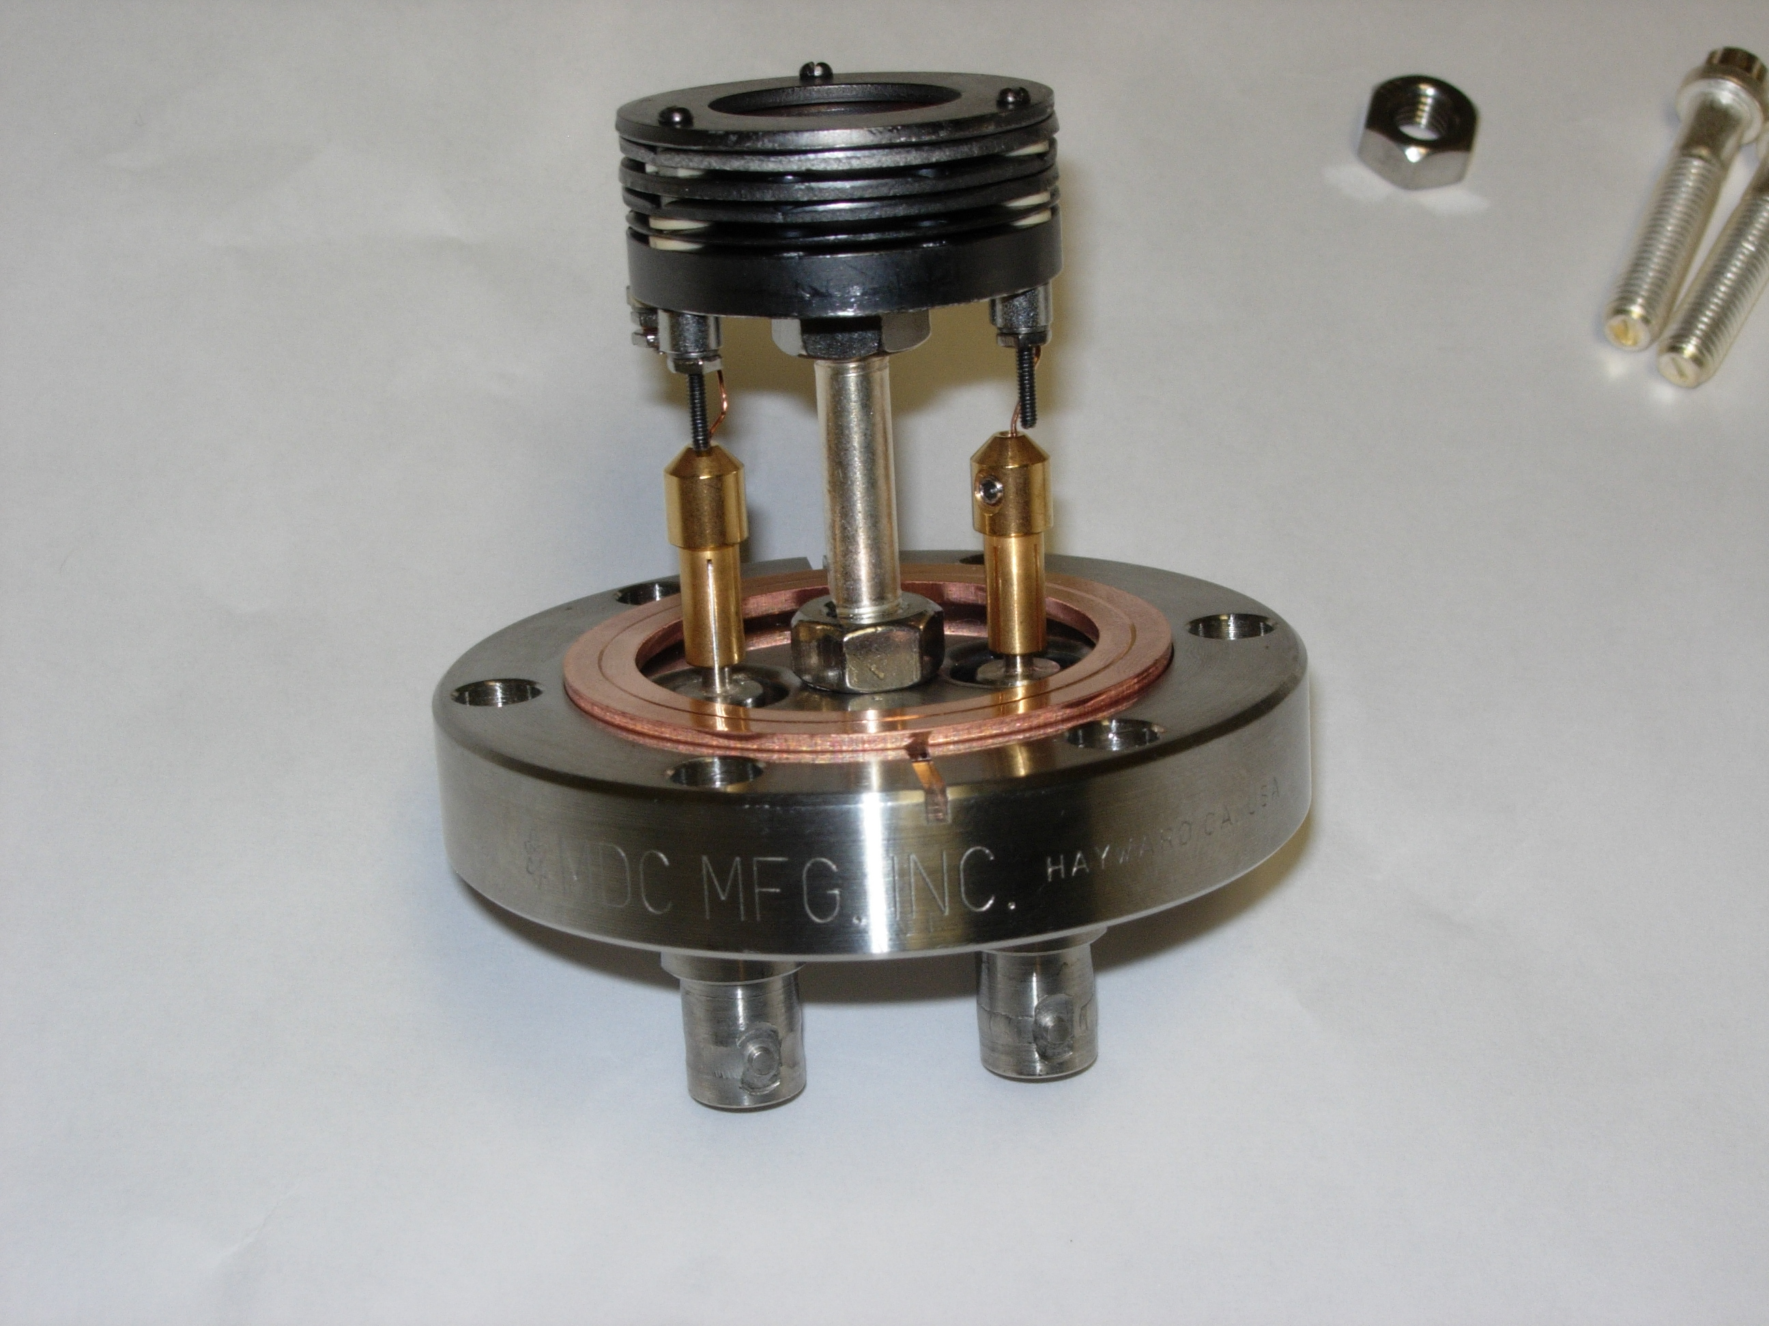

Figure 6. The RFA from ANL installed in Tevatron and MI, courtesy of R. Rosenberg and K. Harkay

