f Fermilab
Doc Number: Beams-doc-2287
Version: 1.0
Type: Note

Mechanical Design of MI8 Collimators

Vladimir Sidorov, Mechanical Support Department
Al Legan, Controls Department
Bruce C. Brown, Main Injector Department
Accelerator Division
Fermi National Accelerator Laboratory*
P.O. Box 500
Batavia, Illinois 60510

13 June 2006

*Operated by the Universities Research Association under contract with the U.S. Department of Energy

Mechanical Design of MI8 Collimators

Abstract

A collimation system for the Booster to Main Injector transfer line (MI8 line) has been designed and installed at MI-836 and MI-838. This system will remove particles in the beam halo from 8 GeV Booster beam before it arrives at the Main Injector. A pair of 5 ton collimators, with horizontal and vertical motion, is installed between the gradient magnets in half-cell 836 and an identical system is placed one cell away (about 90º in phase advance) at 838. A description of the mechanical structure of the collimator, including the support and motion control is provided. The vacuum, loss monitor (LM), beam position monitor (BPM), and thermocouple monitoring systems are briefly described.

Introduction

In expectation of increased beam intensity requirements associated with operation of the NuMI beamline, Residual radiation around the Main Injector tunnel was examined prior to the 2004 Fermilab facility shutdown¹. A small but significant contributor to the residual radiation was losses of beam due to tails of the Booster beam which were not accelerated but were scraped around the Main Injector at locations which had only very little less aperture than other similar lattice locations. By providing a more defined beam from the Booster, we will reduce the losses from these tails which will reduce substantially the number of hot locations in the MI Ring. Collimation in the MI8 Line can provide this improved beam to the Main Injector². Tails from the Booster Beam may contribute residual radiation at other, as yet unidentified Main Injector locations. In addition to more general sources of beam tails, measurements of the beam motion induced by changes in the beam trajectory through the Booster Extraction Septum (MP02) suggest that non-uniformity of the fields in this bending magnet (including quadrupole and skew sextupole terms) may be sufficient to create halo from some of the extracted Booster beam³. The design concept for this collimator system is based on the Booster Beam Collimation system⁴. The difference between circulating and single pass beam collimation requires additional collimators. For symmetric collimation, it will be useful and perhaps sufficient to remove only a small fraction of the beam. Beam motion will cause asymmetric scraping of a more intense part of the beam nearer the core. An autotune scheme will be used to minimize the motion. Since four collimators are required, a compact design using 5 tons per collimator was selected despite its lower capacity for shielding beam loss in order to reduce the demands on the motion system. A marble shield surrounds the steel collimator. It is much less susceptible to activation and provides shielding for the MeV gamma rays emitted by activated iron, resulting in a much lower exposure from residual radiation for personnel working in the tunnel. With this design choice, the radiation induced in the tunnel walls and surrounding materials limits the operational loss capability due to radiation which can be extracted into the surface waters. Loss limitations from other criteria are less restrictive.

MI8 Collimator Layout
.
The MI8 Collimators will intercept the beam in stainless steel vacuum boxes (part of the MI8 vacuum system) surrounded by massive steel absorbers with an external marble shield. As in the Booster collimation system, the motion system will be external to the entire collimator system. A pair of these remotely positioned collimators will be placed in a 5.2 m (200”) open space in an MI8 half-cell in which the focusing is provided by gradient magnets. One collimator will provide scraping on one horizontal and one vertical edge (bottom and outside, for example) while the next will scrape the other sides (e.g. top and inside). They will be followed by a fixed collimation mask which will protect the downstream magnet. In order to scrape large emittance particles which happen to be at small displacement but large angle at the 836 location (initial collimator), a second collimator-mask set will be placed two half cells downstream at 838 (about 90 degrees phase advance). The four collimators are of the same design and each can be used to provide scraping on one side or any corner.
The following table is extracted from the new lattice description of the MI8 Line.
Type | Device | Distance from MI101 | Distance from MP02
 |  | meters | meters
Bend | MP02 | -754.366 | 0
Bend | PGD_836A | -257.768 | 496.598
Trim | HT836 | -253.574 | 500.792
SWIC | MW836 | -253.069 | 501.297
BPM | HP836 | -252.599 | 501.767
Bend | PGD_836B | -252.282 | 502.084
BPM | VP836 | -247.824 | 506.542
Marker | COL836A | -247.367 | 506.999
Marker | COL836B | -246.681 | 507.685
BPM | HP837 | -245.665 | 508.701
Bend | PGD_837A | -243.126 | 511.24
Trim | VT837 | -238.932 | 515.434
BPM | VP837 | -237.589 | 516.777
Bend | PGD_837B | -237.271 | 517.095
Bend | PGD_838A | -228.115 | 526.251
Trim | HT838 | -223.921 | 530.445
BPM | HP838 | -222.578 | 531.788
Bend | PGD_838B | -222.261 | 532.105
BPM | VP838 | -217.803 | 536.563
Marker | COL838A | -217.346 | 537.02
Marker | COL838B | -216.66 | 537.706
BPM | HP839 | -215.644 | 538.722
Bend | PGD_839A | -213.105 | 541.261
Marker | MQ101U | 0 | 754.366

Collimator Design, Input to Mechanical Design

Preliminary calculations examined the radiation implications of a 12 ton collimator, finding that a more compact design was suitable. After an intermediate design round, the following concept was provided as input to the mechanical design. The collimators as built replace some marble with iron needed for support.
Conceptual design of the MI-8 Collimator is based on the Booster Collimator design. A 2”x2” aperture is surrounded by a 0.75” stainless steel primary absorber (3.5”x3.5” outside by 47.5” long). The bulk of the collimator consists of 35” long iron absorber which is 26” wide by 20” high. This is surrounded by 4 layers of marble which is 3 cm thick (4.72 inches). It was planned to use 1.25” marble which would have provided 5” thickness and 45” length. The marble is held in place by a frame of 1.5” aluminum channels.

Nominal Collimator Components
Material | Horizontal  Edge | Vertical  Edge | Horizontal  Thickness | Vertical  Thickness | Length | Weight  Lbs
Vacuum | 1” | 1” |  |  | 47.5” | 0
Stainless Steel | 1.75” | 1.75” | 0.75” | 0.75” | 47.5” | 125
Steel | 13” | 10” | 11.25” | 8.25” | 35” | 5750
Marble (side) | 17.72” | 14.72” | 4.72” | 4.72” | 35” | 2802
Marble (2 ends) | 18” | 15” | 16.25” | 16.26” | 4.72” | 2802

The final design included: Support plate 36”x40”x1.75” – weight 700 Lbs
Base plate 38”x 45”x 1.5” – weight 600 Lbs.
Weight to lift: ~9300 Lbs.
Total weight: ~ 10000 Lbs.

Collimator Design, Overview

Four lifting jacks mounted on the base plate (item 1) provide vertical motion. Travel nuts for these jacks are bolted to the support plate (item 2). THK linear bearing systems mounted onto a support plate permit horizontal movement. The motor, gear box, and 2 ton Uni-Lift Jacks supply the horizontal motion of +/- 1.00” for the vacuum liner (item 3) surrounded with steel absorber (item 4) and marble (item 5). The vertical movement of the collimator from the center of the beam line is +/- 1.00” also. A short bellows (items 6) is joined to the beam pipe (upstream and downstream) and a long bellows (item 7) is installed between two collimators to make a collimation system pair (See Fig.2). Note that no additions to the MI8 vacuum pumping or monitoring were required.
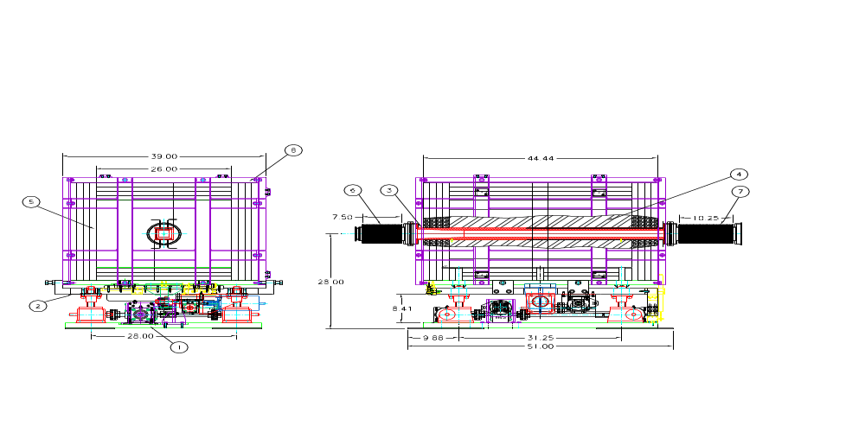 Fig.1. Collimator Assembly.
1- Base Plate Assembly; 2 - Support Plate Assembly; 3 - Vacuum Liner Weldment; 4 - Steel Shielding Block Assembly; 5 - Marble plates; 6 - 7.5” Bellows Weldment; 7 - 10.25” Bellows Weldment; 8 – Aluminum Frame.
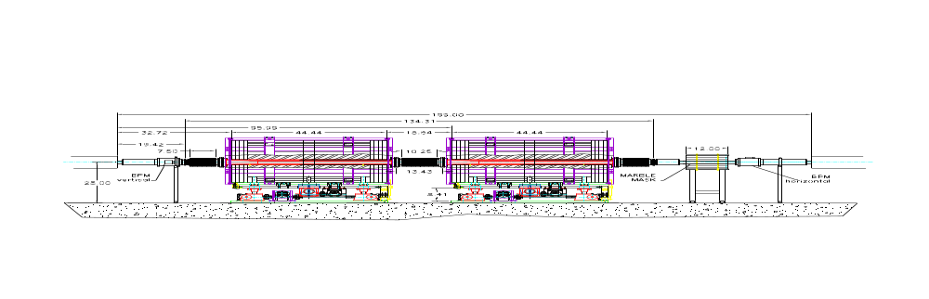
Fig.2 Collimation system layout in 8 Gev line tunnel at MI836 and MI838.

The marble mask surrounds the Recycler-style elliptical beam pipe in the down stream end of the collimation system. Two BPMs are welded into beam line, vertical upstream and horizontal downstream (See Fig.2). Two of the standard gas-filled loss monitors will be employed with each collimator but their placement will be established operationally. The channels I:LM8C1 and I:LM8C2 are assigned to the monitors at 836 while I:LM8C3 and I:LM8C4 are for the 838 monitors.
On a console parameter page, these loss monitor devices appear as follows:
I:LM8C1 LOSSMON @ 836 COLL SYS1
I:LM8C2 LOSSMON @ 836 COLL SYS2
I:LM8C3 LOSSMON @ 838 COLL SYS1
I:LM8C4 LOSSMON @ 838 COLL SYS2

Vacuum Liner

The Vacuum liner is welded from two tapered 304 stainless steel blocks (item 2), circular upstream (item 4) and down stream (item 3) end plates and standard 6” BOOSTER QD Flanges (item 1). The steel blocks create a device with a 2” square vacuum aperture and a 3.5” square surface which is 47” long. The connection to the upstream and downstream vacuum system consists of a 6” adaptor plate and a spool to connect to a 4” bellows with a 4” quick disconnect at the ends of the bellows.

The vacuum liner serves as the primary absorber. It is designed to provide an impact point for the intercepted beam with low outscattering. A tapered portion is provided at the upstream end to increase the penetration of intercepted particles. This chamfer is 8.94” long with a taper of 2.56º. We expect the beam which strikes the collimator to be most intense at the downstream end of this chamfer. The wall thickness of 0.75” in the body is only 0.35” at the upstream end. Particles parallel to the collimator axis will strike the chamfer at 45 milliradian angle.

Two grooves of 0.125” width are cut in the top and bottom of the absorber block at 0.75” left and right of the centerline for mounting thermocouples. These grooves extend from the downstream end to within 19.84” of the upstream end which places them 10.9” downstream of the end of the tapered portion. For each collimator, we will instrument two channels of thermocouple readout with the other two devices available as spares.

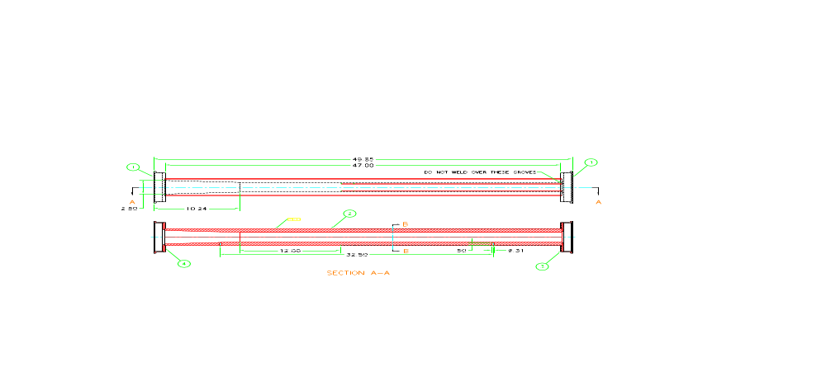

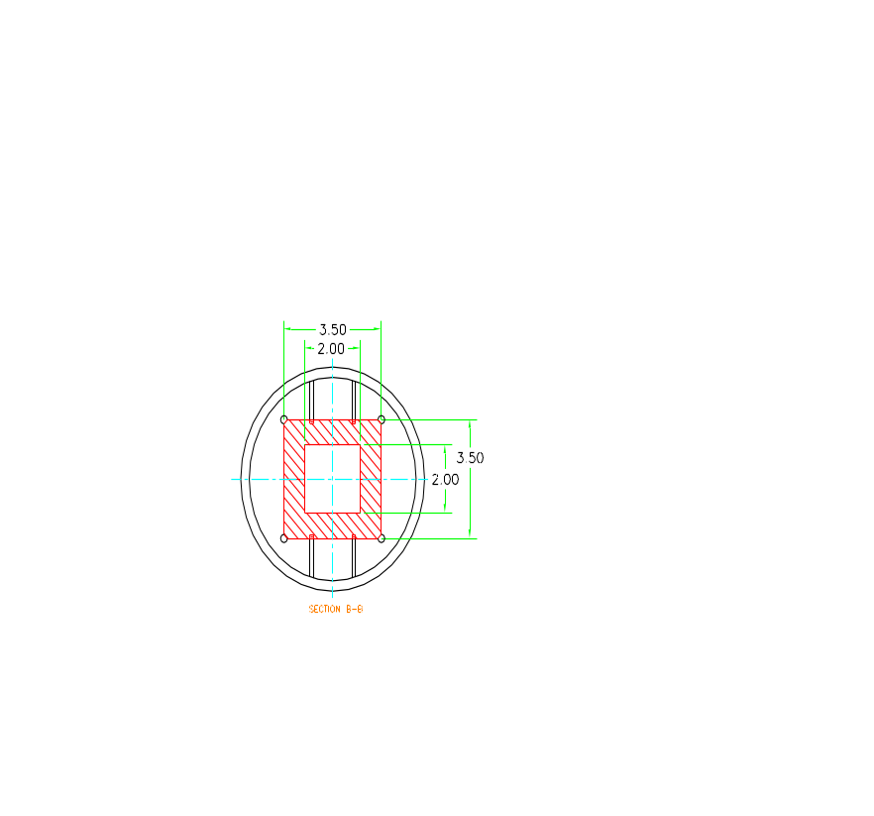
Fig.3 Stainless Steel Vacuum Liner

- 6” Booster QD Flange; 2 – Tapered Block; 3 – End Plate DS; 4 – End Plate – US.

Vertical Motion System.

The vertical motion system is mounted on the collimator base plate.
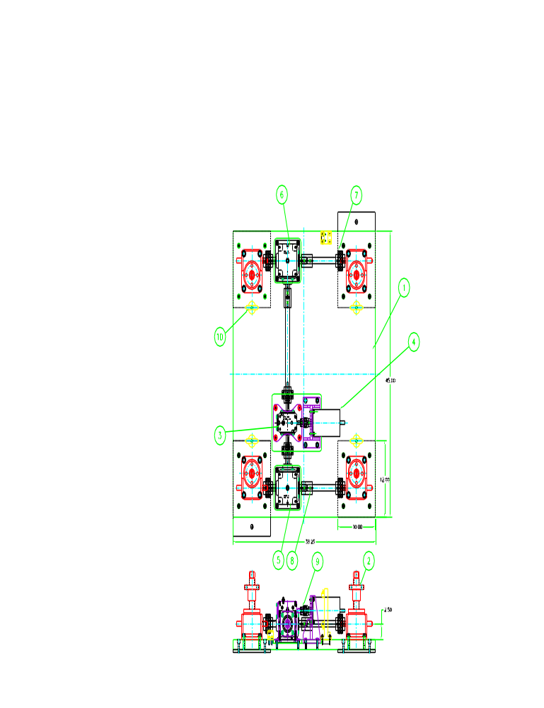
Fig. 4 Vertical Motion System.

1 – Base Plate; 2- Jack J5; 3 – Hub City 211 Gear Box, 40:1; 4 - Empire Magnetics U-42 Motor; 5 - Hub City 150A Gear Box; 6 - Hub City 150B Gear Box; 7 – Chain Coupling Assembly; 8 – Boston CR-16 Coupling; 9 – FC15 Coupling Assembly; 10 – 1.25 ton Swivel Hoist Ring.

Four J5 – five ton capacity jacks (item 2) are bolted to the base plate and connected to the drive system by couplings (items 7, 8, 9) and 1” diameter shafts. The drive system consist of Empire Magnetic U-42 step motor (item 4) and Hub City gear boxes model 211, ratio 40:1, (item3), model 150A (item 5) and model 150B (item 6) ratio 1:1. The step motor provides
71in-lb starting torque (series connection) and 48 in-lb parallel connection. Royal Purple Industrial oil SYNFILM 68 is used in all gear boxes for the lubrication

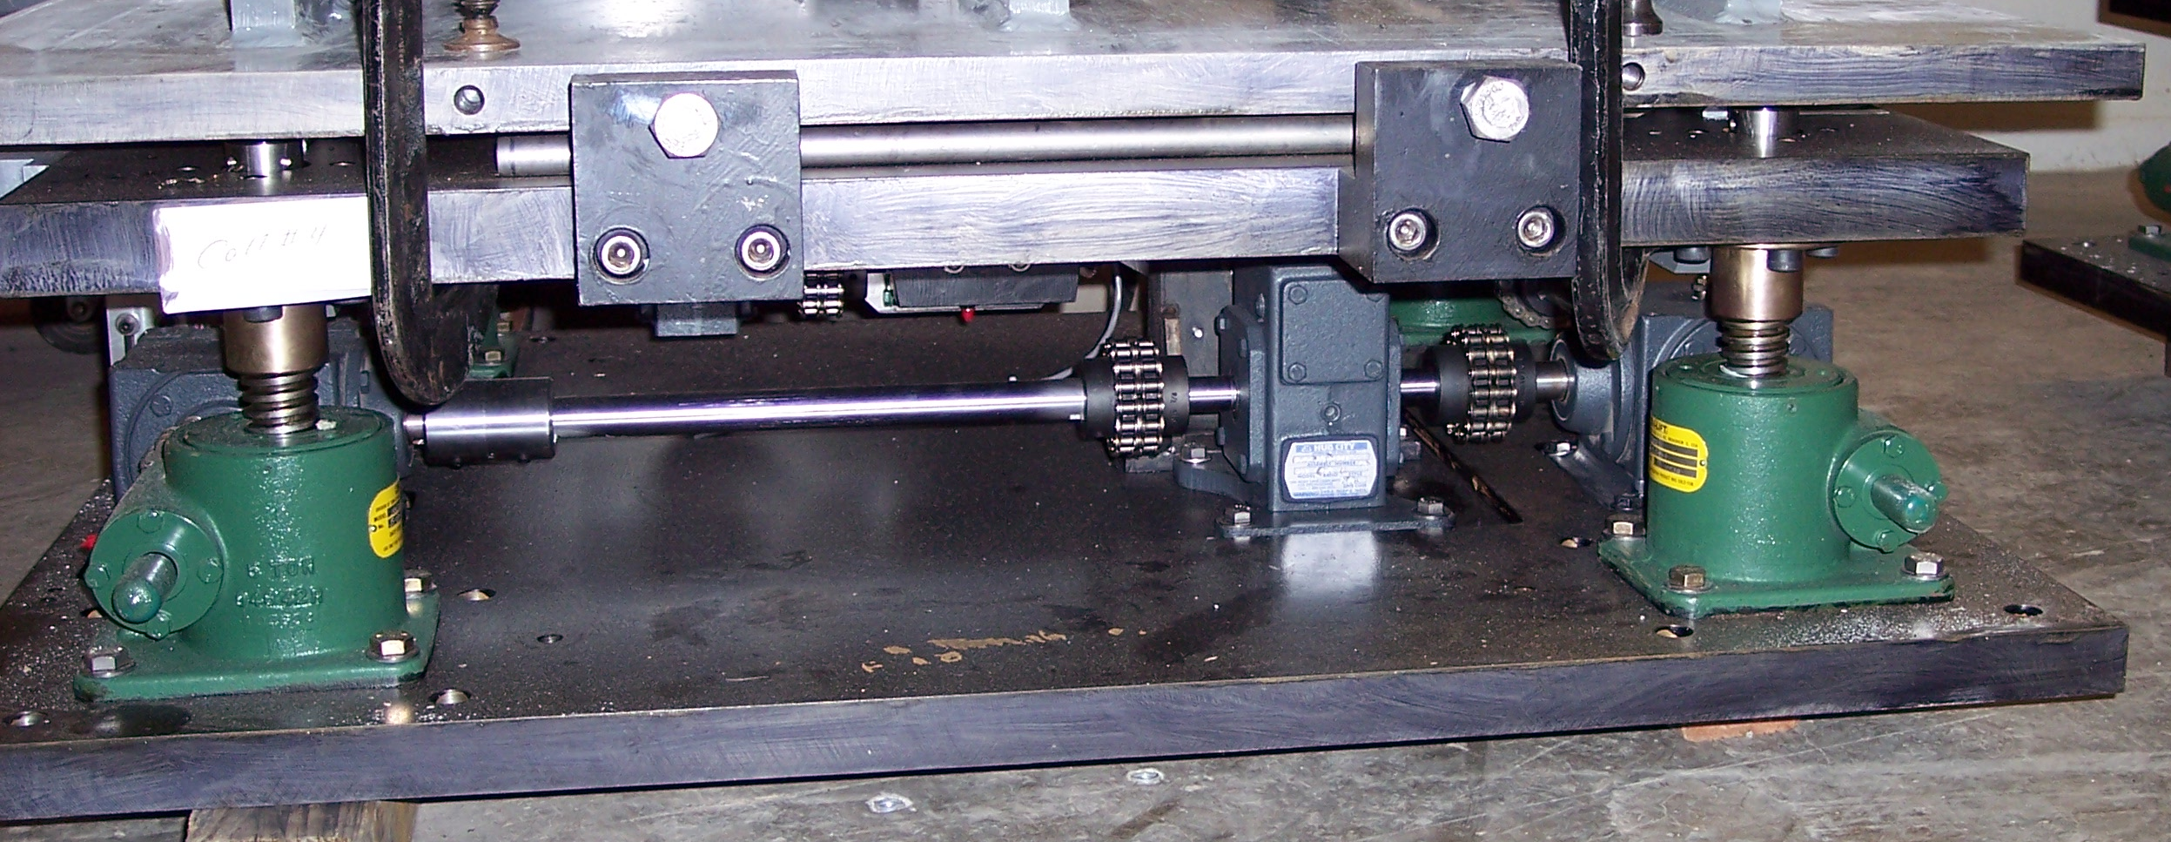

Fig. 5 Vertical Motion System, pictures.

Horizontal Motion System

The horizontal motion system is mounted on the support plate (item 1).
The support plate is bolted to the J5 vertical motion system jacks and holds a collimator absorber with vacuum liner (see fig.7). The push- pull force is provided by two ton capacity UNI-LIFT jack, J2 (item 2). The movement is plus-minus 1” from center of the beam. The torque is transferred from the motor U42 to the jack through Hub City gear box model 131, ratio 15:1.
2.7 ton capacity THK ball bearings (item 8, fig.7) are sitting on the rails (item 8, fig. 6) and are used for horizontal movement. The coefficient of friction between ball bearing block and rail is 0.05.

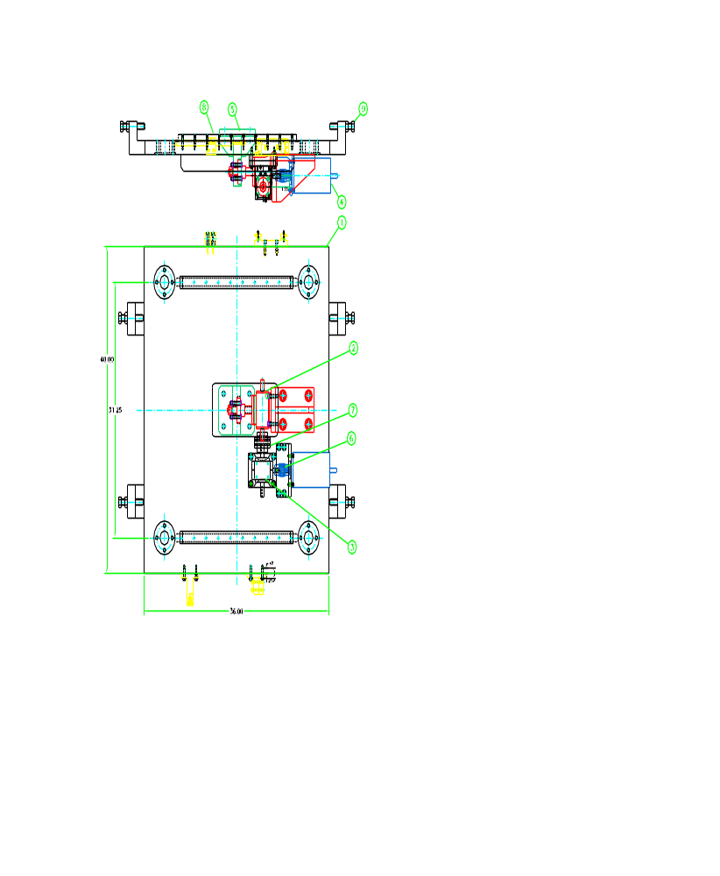
Fig. 6 Horizontal Motion System.

1 – Support Plate; 2- Jack J2; 3 – Hub City 131 Gear Box, 15:1; 4 - Empire Magnetics U-42 Motor; 6 – FC15 Coupling Assembly; 7 – Chain Coupling Assembly; 8 – THK Rail, 9 – Hard limit screw.

Steel Absorber with vacuum liner and ball bearings.

The steel absorber is assembled from steel blocks (items 2,3,4,5) that are bolted to each other and to absorber plate weldment (item1). The vacuum liner (item 6) is surrounded by steel blocks. Four thermocouples (item 7) are glued into the vacuum liner thermocouples slots (see below). Total weight steel absorber with vacuum liner is 5750 lb.
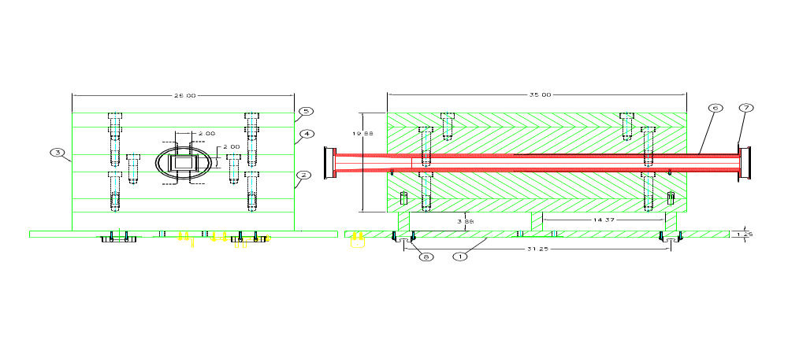 Fig. 7 Steel Absorber with THK ball bearing blocks.

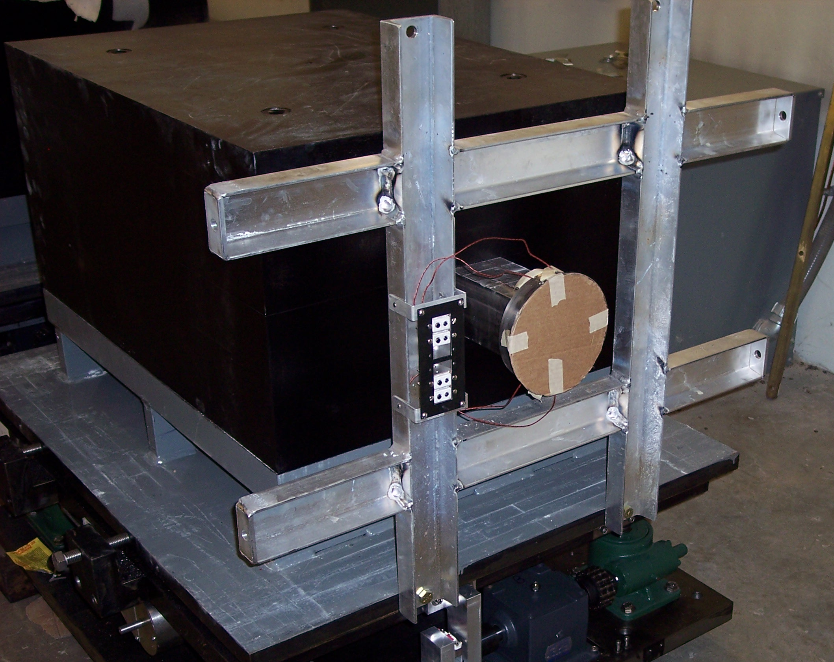
Fig. 8 Steel Absorber with thermocouples connector panel.

Marble absorber

Four layers of the marble plates 30mm (1.18”) thick are placed on the absorber plate weldment and on the top of the steel absorber. Three layers of marble are inserted into the absorber plate weldment. The successful bidder provided marble from Carrara, Italy. An aluminum frame holds the marble in a place around the steel absorber. Total marble weight is 2802 lb.

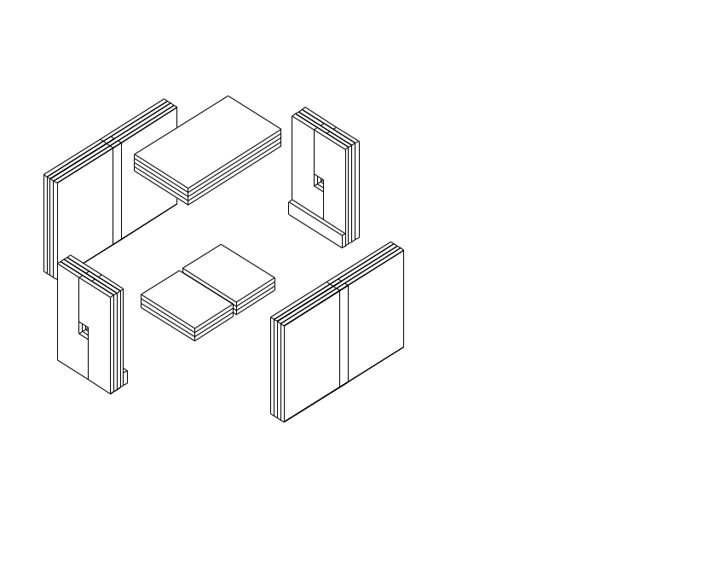
Fig. 9 Marble plates.

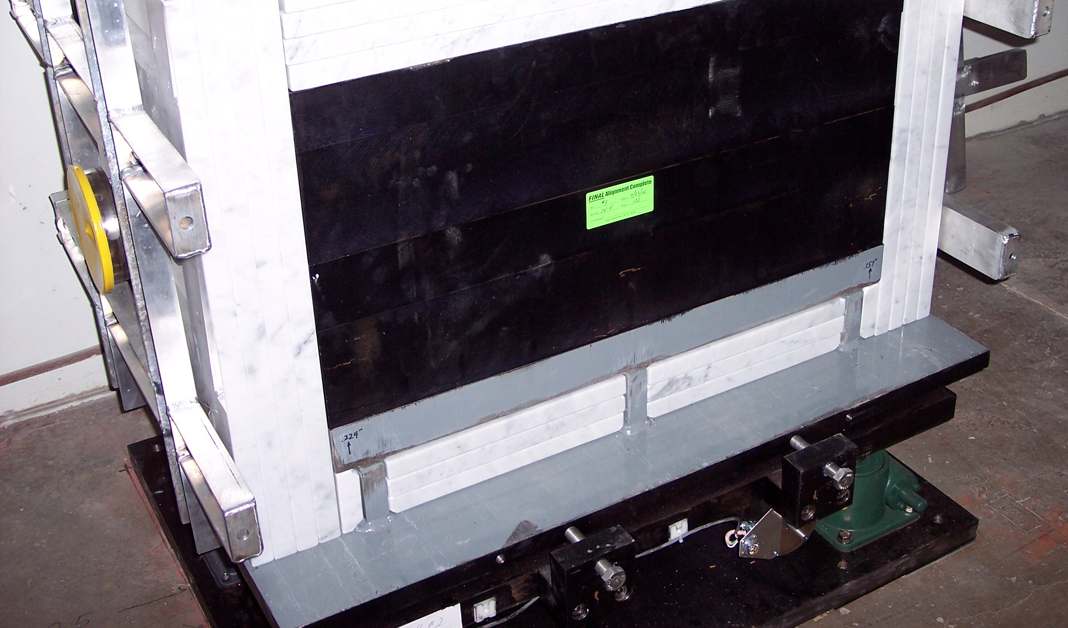

Fig. 10 Marble plates are inserted into absorber weldment.

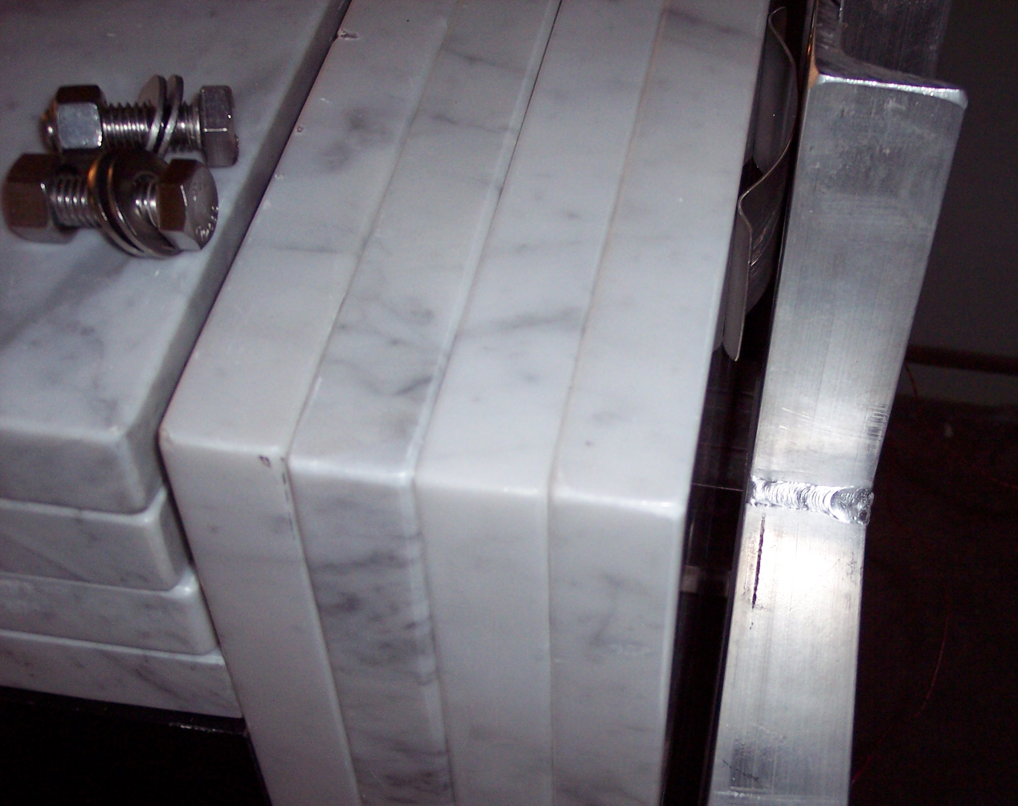

Fig.11 In order to hold marble, stainless steel flat springs are installed
between marble and frame.

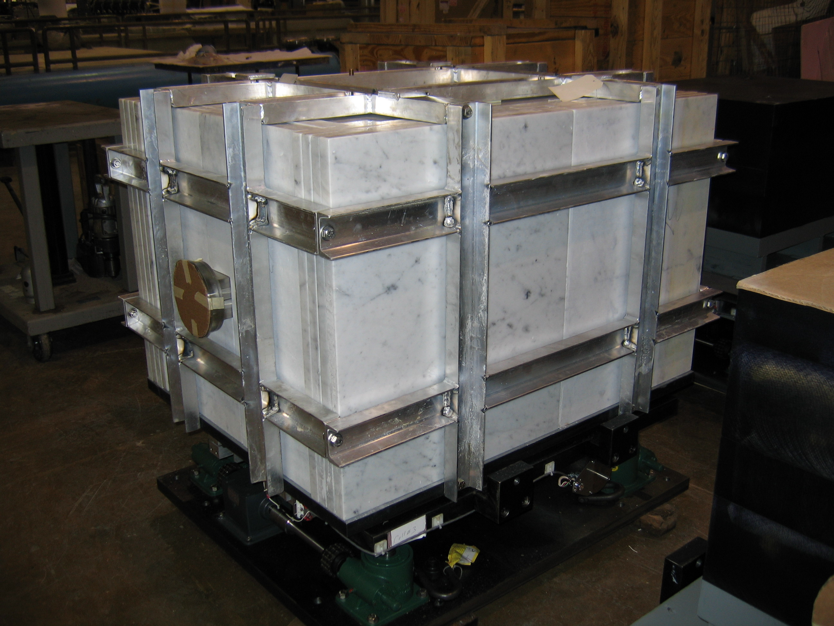
Fig. 12 Assembled marble with aluminum frame.
Collimators location
Collimators are installed into 8-Gev line in pairs. The first pair of collimators (C1 and C2) is installed in an area between 836-837 magnets. The second pair (C3 and C4) is installed between 838-839 magnets.

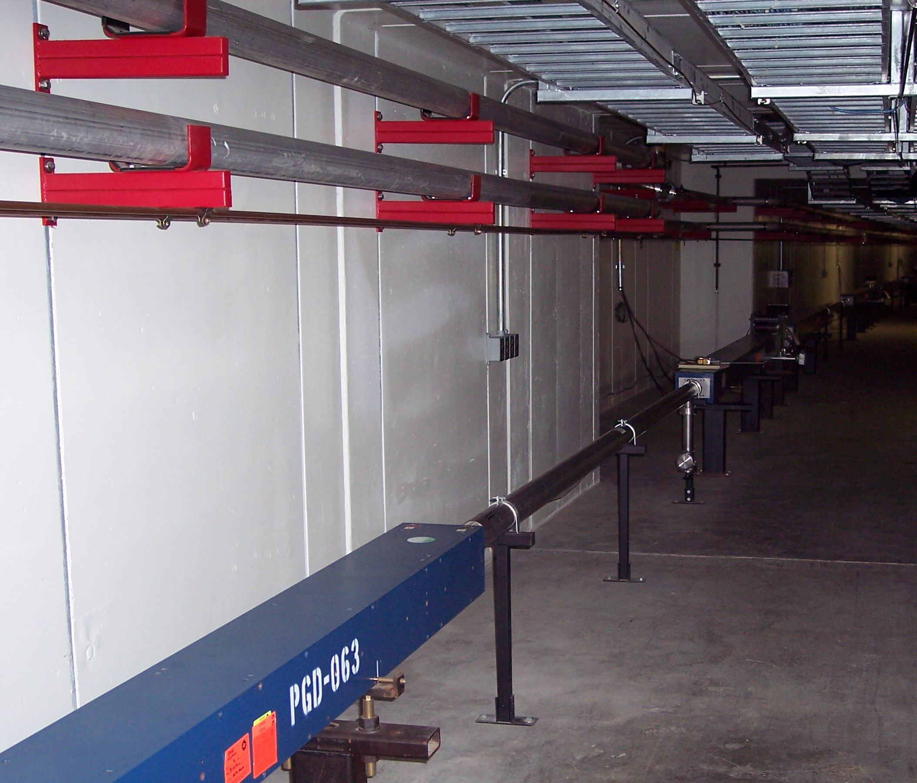
Fig.13. First pair of collimators location.

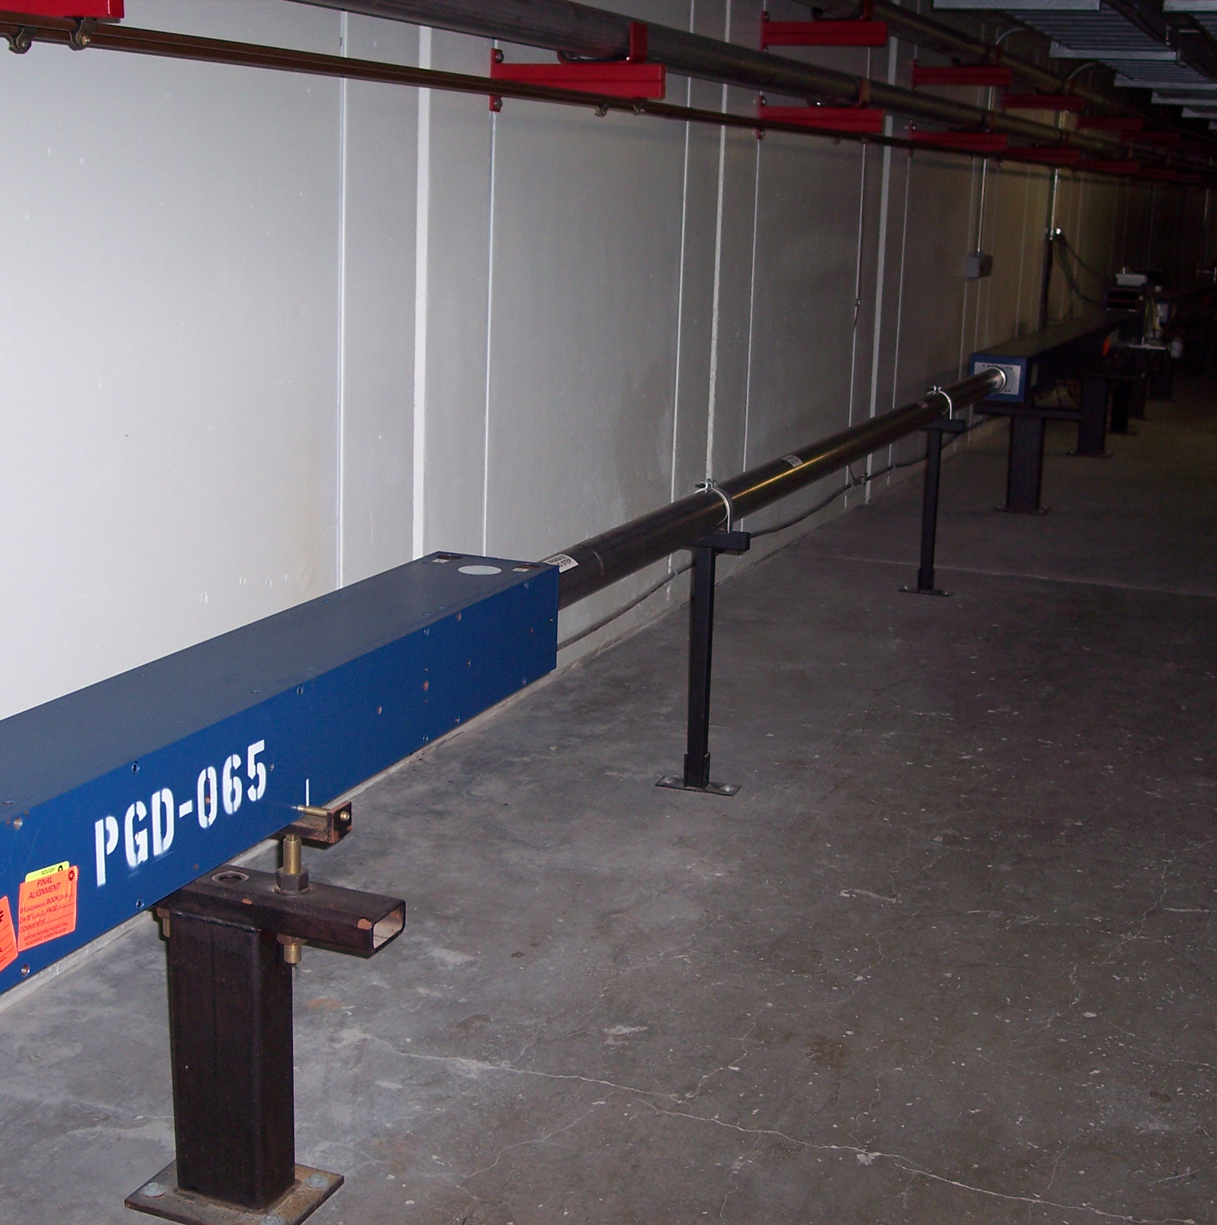
Fig.14. Second pair of collimators location.

Collimators installation

175 inches of vacuum pipe is cut to prepare a space for collimators.

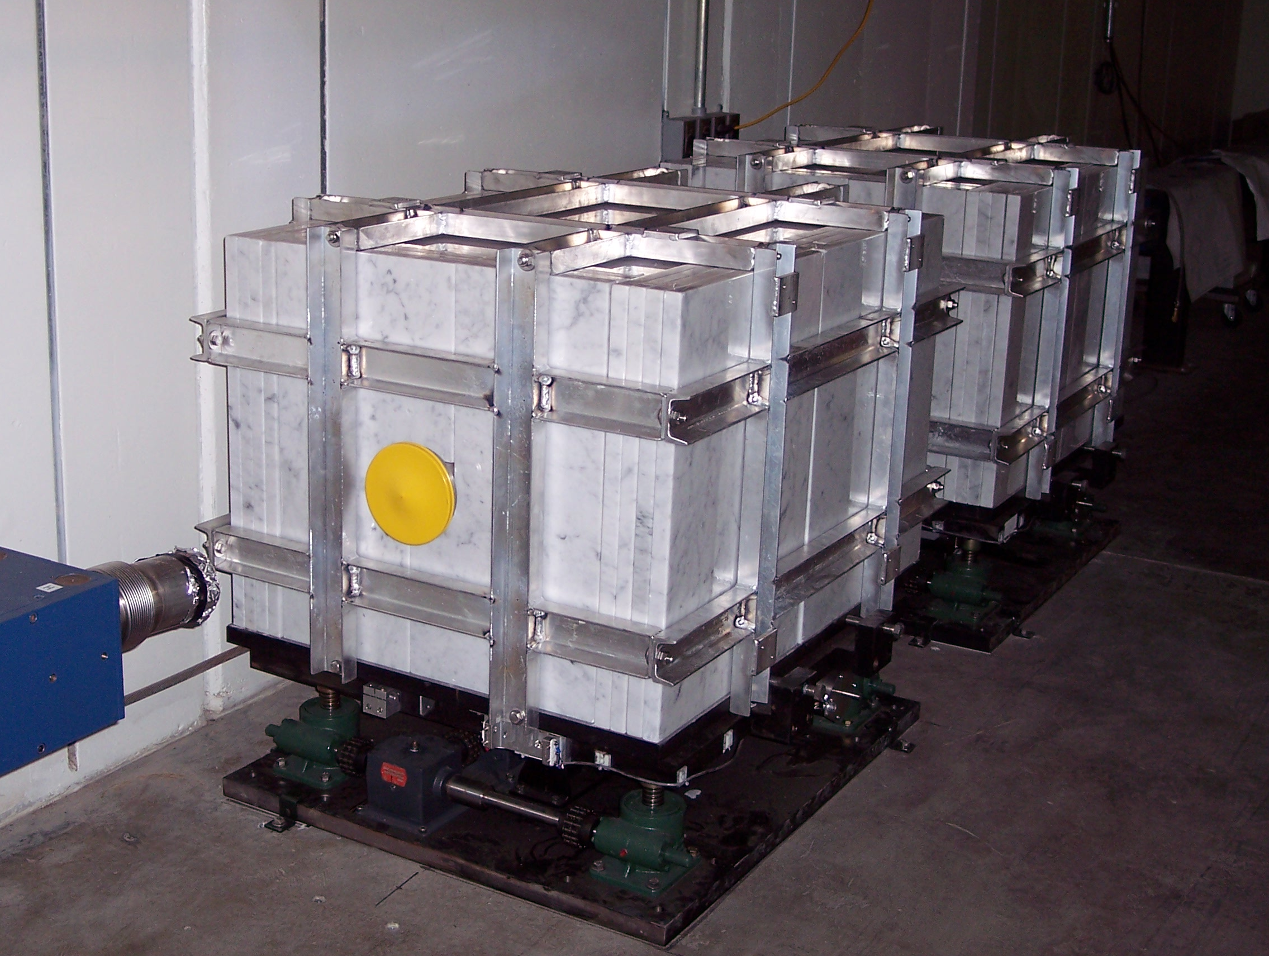

Fig.15 Pair of collimators is installed into beam pipe cut out.

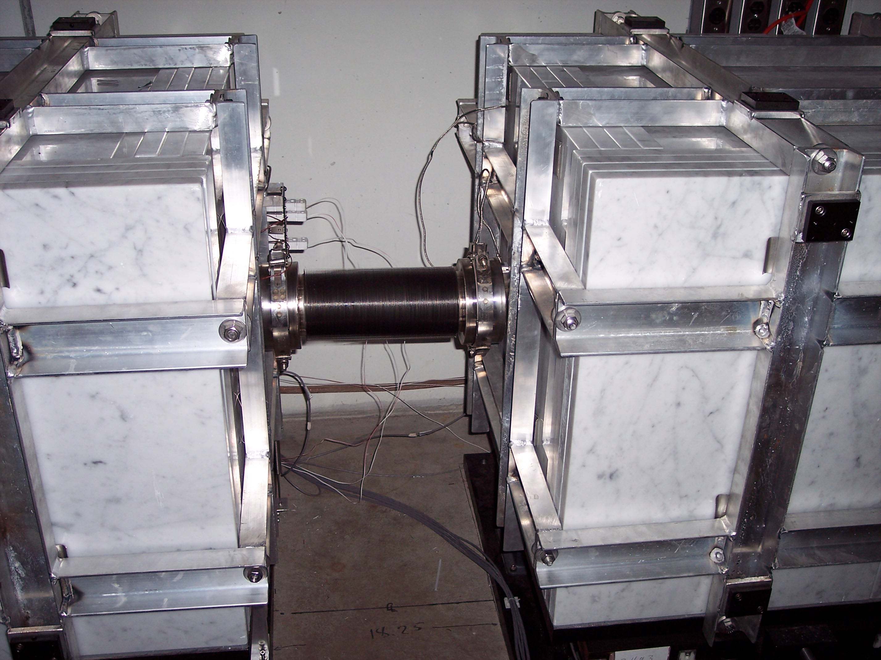

Fig. 16 Four inch diameter STANDARD welded bellows, 10.25” long joints both collimators in pair with BOOSTER 6” diameter quick release clamps.

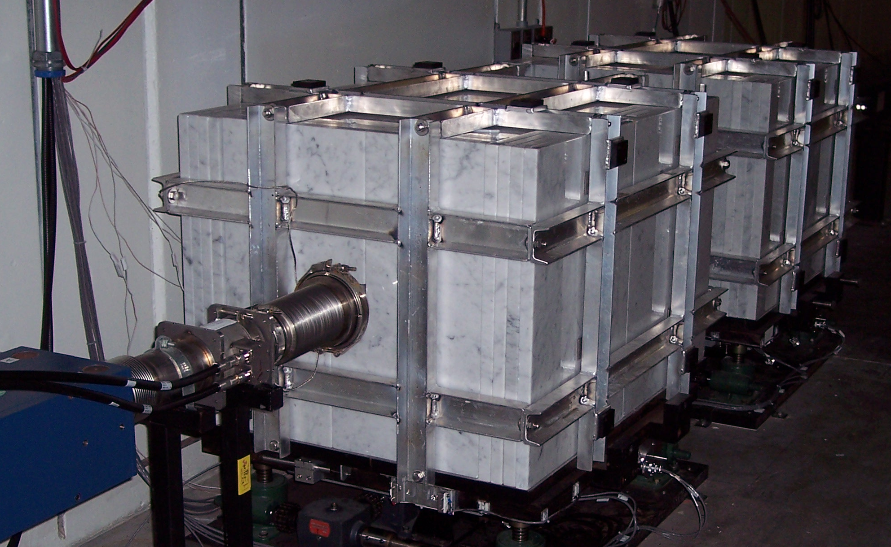

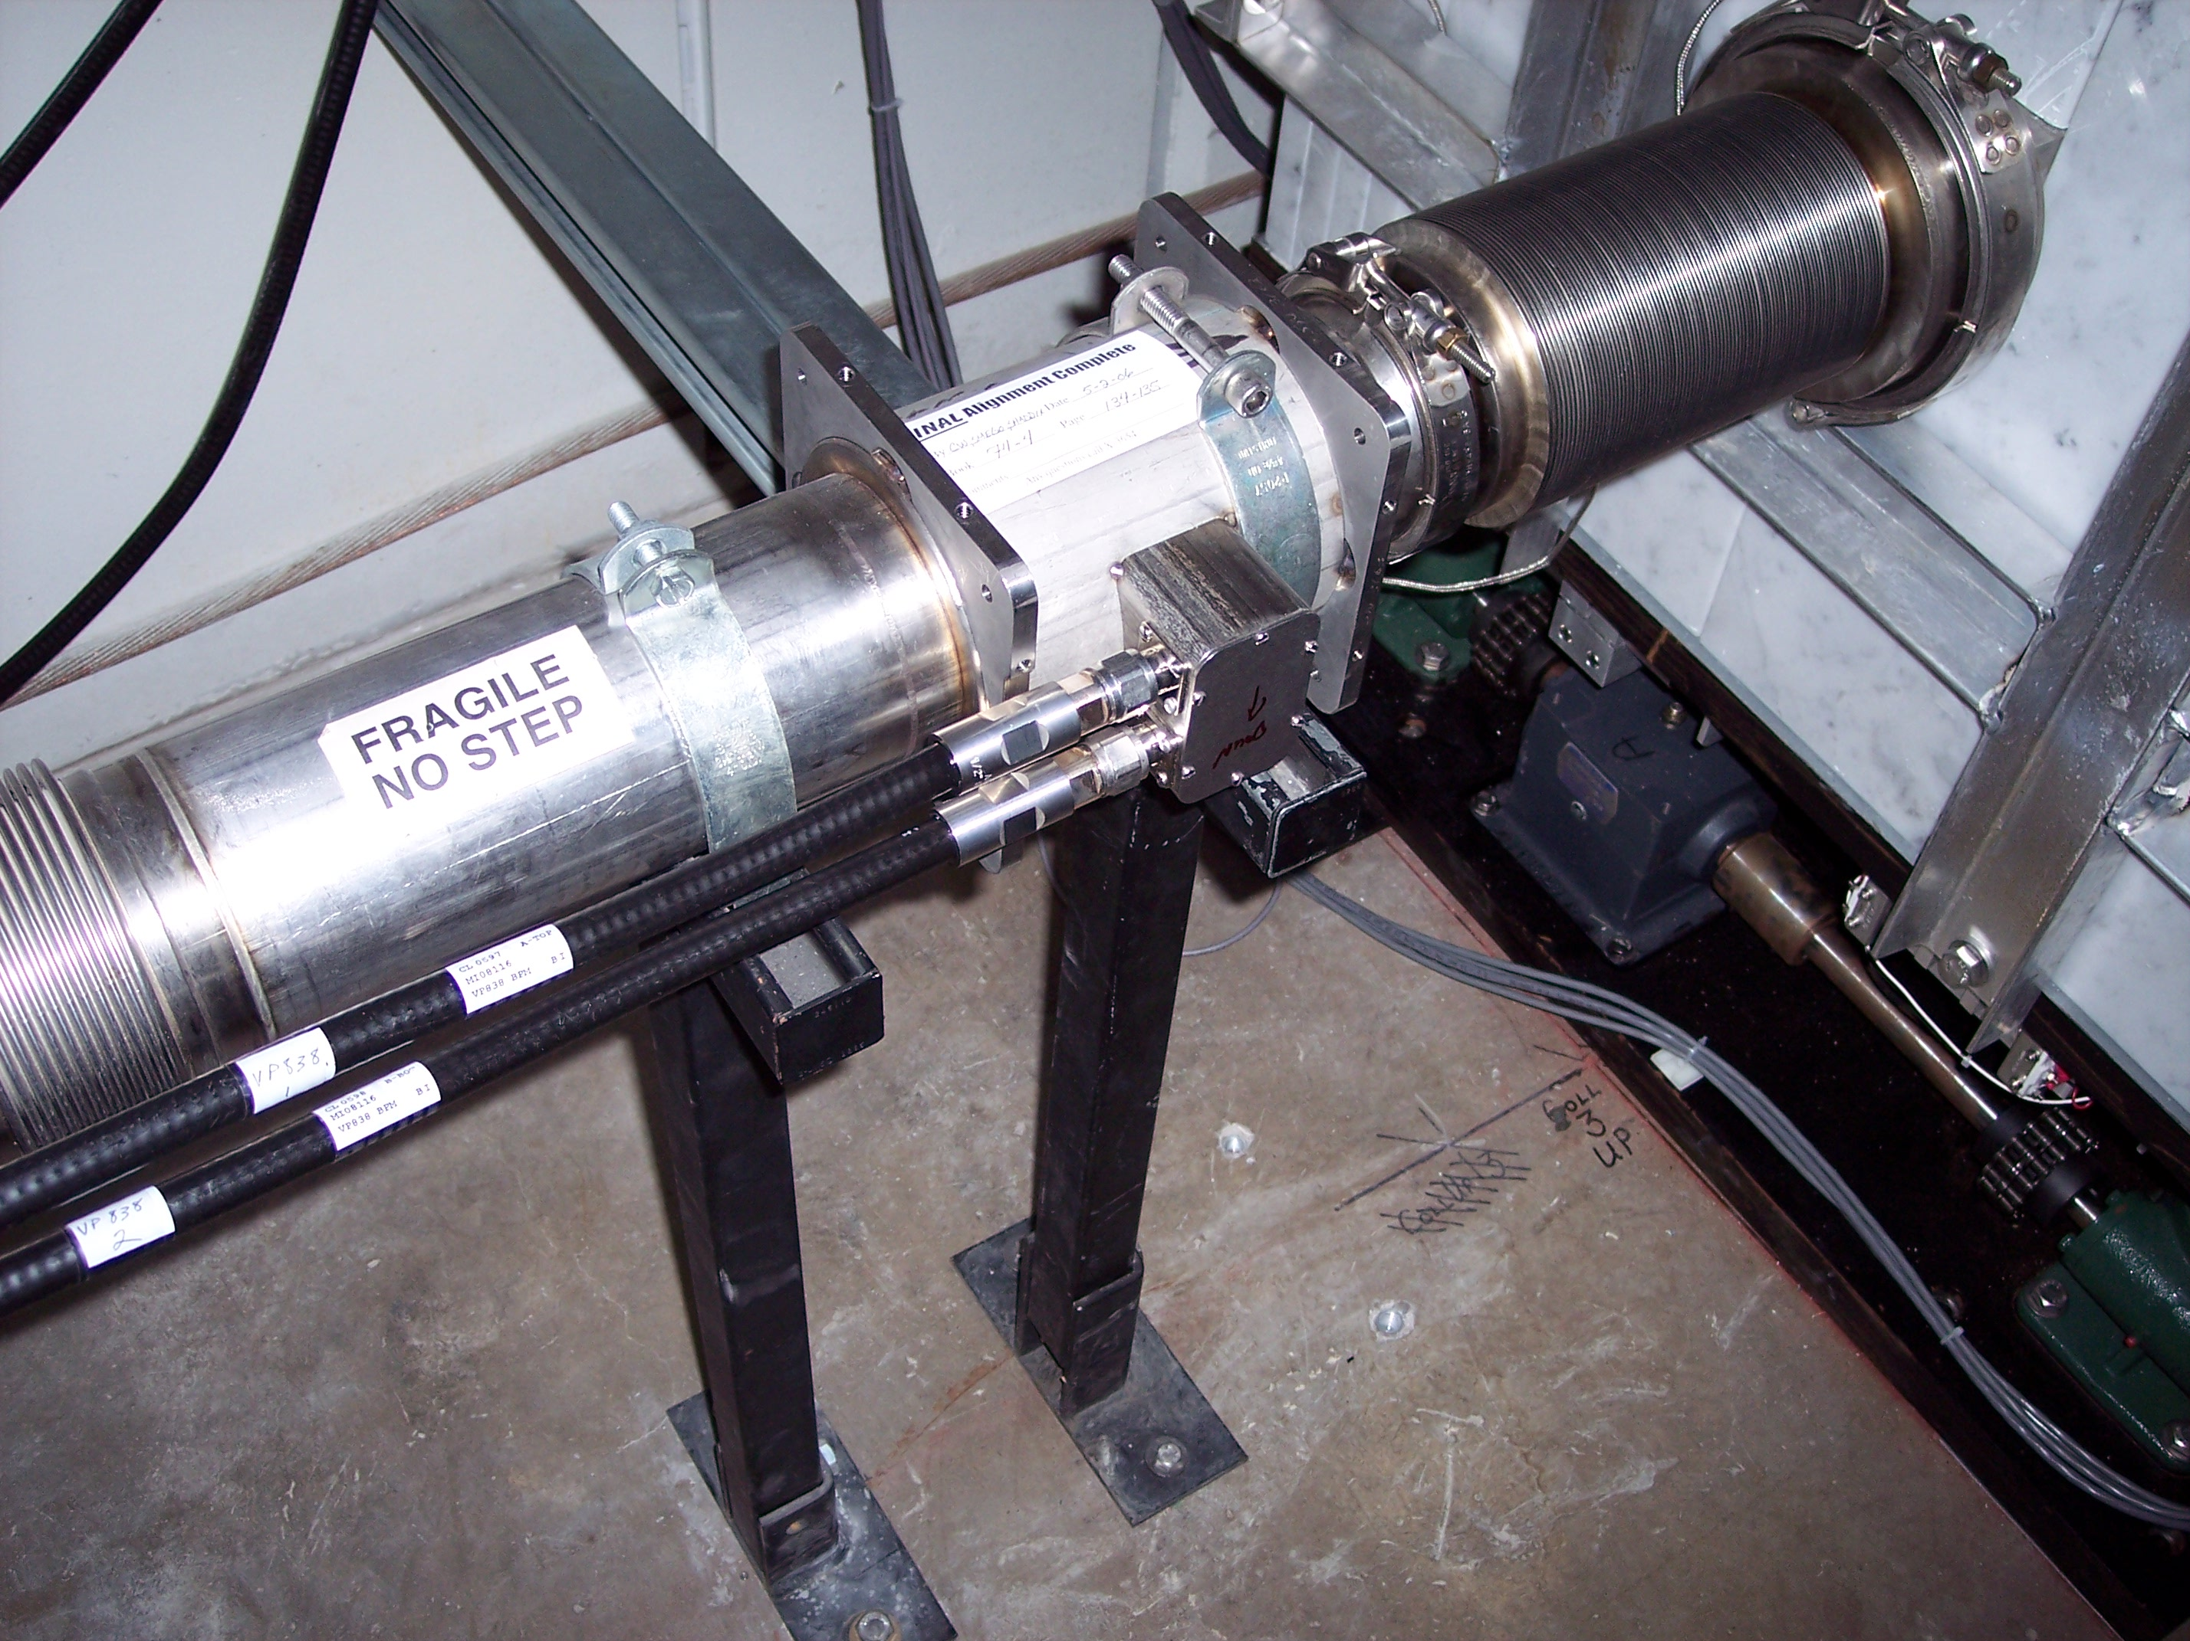

Fig. 17 Vacuum line in the upstream end of collimators.
The vertical BPM is welded into the vacuum pipe in the upstream end of the collimation system. STANDARD 4” welded bellows 7.5” long is connected to the BPM and collimator with BOOSTER quick release clamps (see Fig.17)
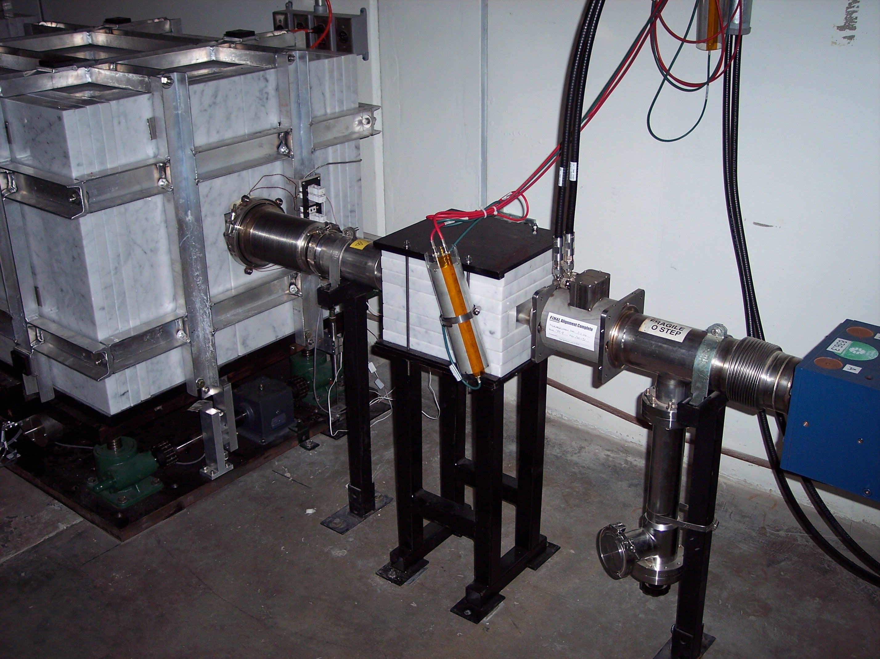

Fig. 18 Vacuum line in the down stream end of collimators
The marble mask is installed in the down stream end of the collimation system. The horizontal BPM is welded into the beam line downstream of the marble mask. STANDARD 4” welded bellows, 7.5” long is connected to the vacuum pipe and collimator with BOSTER quick release clamps. A beam loss monitor is clamped to the aisle side of the marble mask (see Fig. 18) and another is on the wall nearby. Final BLM placement will be established operationally.
Marble mask

The marble mask is assembled from six marble plates 9”x 12” x 1.25” (item2) and four bars 2” x 12” x 1.25” (item 3). Marble plates surround the Recycler-style elliptical beam pipe (item 6) and clamp to the stand (item 1) with the top plate (item 4) and threaded rods (item 5), see Fig.19.

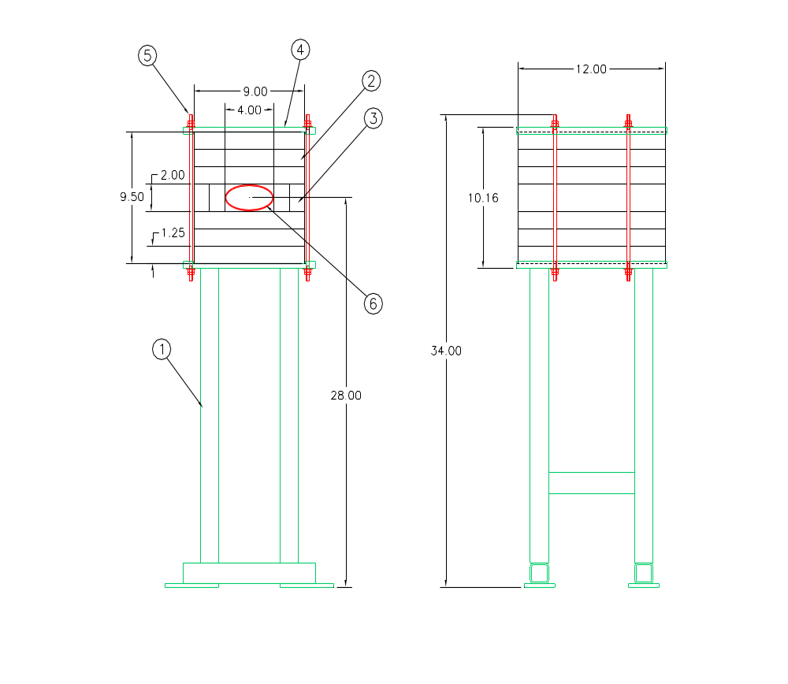
Fig.19 Marble mask assembly

Thermocouple Monitoring System

Four thermocouples (item 7 - OMEGA part #: XCIB- J -4 -3 -10) are glued into the vacuum liner thermocouple slots (see Fig.7). Upstream ends of thermocouples are located ~12” down stream from a collision point. Down stream ends of thermocouples are connected to ceramic OMEGA connectors that mounted into the panel in the down stream end of the collimator. An additional thermocouple (OMEGA part #: 5TC-GG-J -24-36) is installed for each collimator. It is initially mounted on the wall side of the vacuum liner upstream of the marble. Following thermal studies, one or more of these thermocouples may be mounted on an upstream magnet to monitor tunnel temperature. From the OMEGA connector, thermocouple wire is installed to the rack in the MI8 service building. Assignment of the OMEGA connectors is uniform for the four collimators.

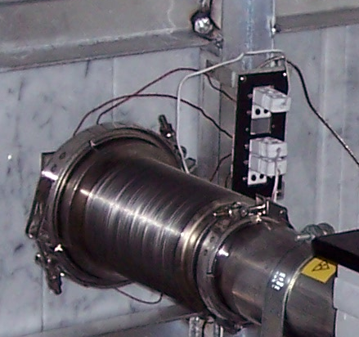

Fig.20 Thermocouple connectors panel.

Fig.21 Front vacuum liner thermocouple.

Temperature read back

Type J thermocouples are being read by using a INOR brand # APAQ-LC Thermocouple Signal conditioner DIN rail type modules (See FIG.22) using the 10 mV input for Type J. This means the output will go to 200 Deg C. Maximum. This is the finest resolution this device offers. If studies require measurement of higher temperature, we can select a less sensitive range. The signal conditioners are then wired into the controls system CAMAC MADC system using Channels #48 – 59.
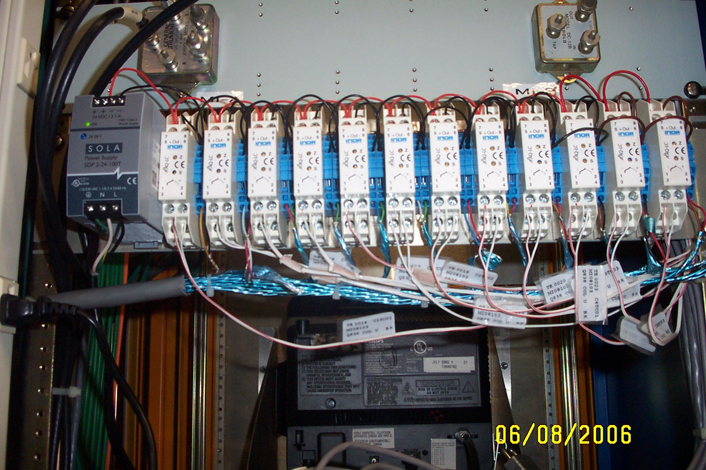

FIG.22 – 12 Channels of Thermocouple Couple Signal Conditioner.
3 Channels for each Collimator.

Thermocouple Placement and Assigned Channels
OMEGA  Connector | Thermo-  couple | Collimator 1  (836US) | Collimator 2  (836DS) | Collimator 3  (838US) | Collimator 4  (838DS)
1 | Upstream | C1TC03 | C2TC03 | C3TC03 | C4TC03
2 | Top/Wall | C1TC01 | C2TC01 | C3TC01
3 | Top/Aisle |  |  |  | C4TC01
4 | Bottom/Aisle | C1TC02 | C2TC02 | C3TC02
5 | Bottom/Wall |  |  |  | C4TC02

On a console parameter page, these devices appear as follows:
I:TC36AT Thermocouple 36A Top
I:TC36AB Thermocouple 36A Bottom
I:TC36AU Thermocouple 36A Upstrm
I:TC36BT Thermocouple 36B Top
I:TC36BB Thermocouple 36B Bottom
I:TC36BU Thermocouple 36B Upstrm
I:TC38AT Thermocouple 38A Top
I:TC38AB Thermocouple 38A Bottom
I:TC38AU Thermocouple 38A Upstrm
I:TC38BT Thermocouple 38B Top
I:TC38BB Thermocouple 38B Bottom
I:TC38BU Thermocouple 38B Upstrm
They are currently displayed on parameter page I59 <22>.

Collimator Motion Control Hardware

The following Hardware description is associated with the 4 MI-8 Collimator motion control and position readback. The motion controls as well as the position read backs are VME based using a Motorola Power PC and various Industry Pack (IP) modules for all controls and position monitoring there is also one interface chassis and 1 interface card. The electronics is installed in rack MI08103.

The complete motion system consists of the following hardware:

- 1 – VME based Motorola Power PC module – MVME2430. (Front-End) Connected to Accelerator Controls Network (Acnet). Ethernet Node name is ‘MI8CL1’ (Fig. 25)
- 1 – IP 16ADC – 16 Channel 16 bit A/D Module from SBS Technologies
- 4 – IP-STEPPER - Dual Channel Stepper Module from SBS Technologies
- 1 – IP-UCD – Fermi Universal T-Clock Decoder. (FermiLab built)
- 2 – VME based IP carrier board, the first carrier board holds – 1 ‘IP-UCD’ and 1 – 16 Channel A/D – ‘IP-16ADC’, the second board holds 4 IP-STEPPER modules. (Fig. 25)
- 1 – 16 Ch. Motion Controls interface Chassis. (FermiLab built) (Fig. 28)
- 1 – VME interface PC board that will allow analog inputs into the IP 16ADC module. (Fig. 31)
- 8 – LVDT – from Macro sensors ‘HAS 750-1000’
- 8 – LVDT Din Rail Mounted Signal Conditioners – from Schaevitz. ‘LDM-1000’ (Fig. 29)
- 1 – 8 channel ACS (Advanced Control Systems) Step/Pak type chassis with 8 – SPD6B Bipolar DC Stepper motor Controller modules – 6 Amps @ 48 Volt. (Horizontal and Vertical motion) (Fig. 26)
- 1 – ACS SPT-8R Motor Power Transformer 48 VAC nominal (Fig. 27)

Motors Types and Specifications
- Empire Magnetics – Model #RH-U42 (radiation hardened). These motors have been tested and proven to withstand >109 RADS gamma radiation for prolonged periods. (See Web Article) http://www.empiremagnetics.com/articles/rad_intensive.htm
- Motors are controlled using bipolar type drive units.
- Motors are configured with 8 wires (4 windings). Vertical motors are wired in a Series configuration to get the maximum torque output. Horizontal motors are wired in a Parallel configuration.
- The vertical motors run at a speed of 2 Revolutions per Second (RPS) which will obtain ~1300 Oz. In. of torque @ 48 Volts.
- The horizontal motors will run at a speed of 4 RPS which will obtain ~700 Oz. In. of Torque @ 48 Volts.
- Motor resolution is based on the gear reductions of the Jack Screws and other associated gear boxes. All of the motors run in half step mode / 400 Steps per Revolution.
- Each collimators vertical resolution: .001” = 576 motor steps
- Each collimators horizontal resolution: .001” = 192 motor steps.

Limit Switches
- Honeywell 2HT1 High temperature Limit Switches.
- Limit switches are wired using the normally closed contacts.
- Switches are wired through the Fermi 16 Ch. Motion Control Chassis and into the IP-Stepper modules. The Switches prevent the motors from moving, when the limit switch is opened, unplugged, or have broken wires.
- Switches are made of Aluminum and ceramic. All materials inside and outside of these switches are radiation resistant materials. (see Fig.23)
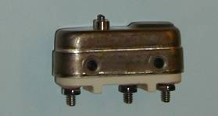

FIG.23
A hard limit on the vertical motion is provided by the nuts at the top and bottom of the jack screws. Bolts to limit the horizontal motion can be inserted in available threads on the support plate.

Position read back

- 8 - LVDT’s are used for position read backs. They have a maximum stroke of 2.00” (See Fig.24).
- LVDT’s are read back using a Schaevitz LDM-1000 LVDT signal conditioner. The Signal conditioners produce a 0-10 VDC output signal linear to the position of the transformers core. Each signal conditioner is calibrated then connected into an analog channel in the ‘MI8CL1’ Front-end using one of its available 16 A/D channels. (See Fig.29)

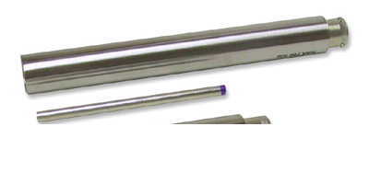

Fig.24 - LVDT

Motion Control Relay Rack Front View.

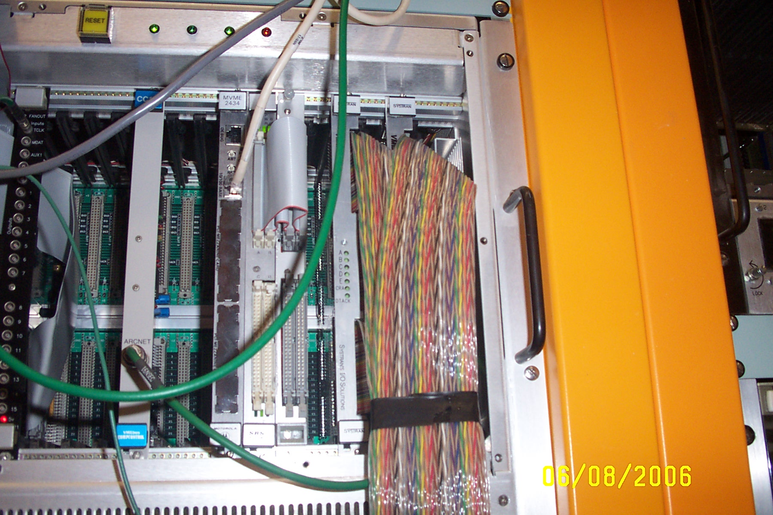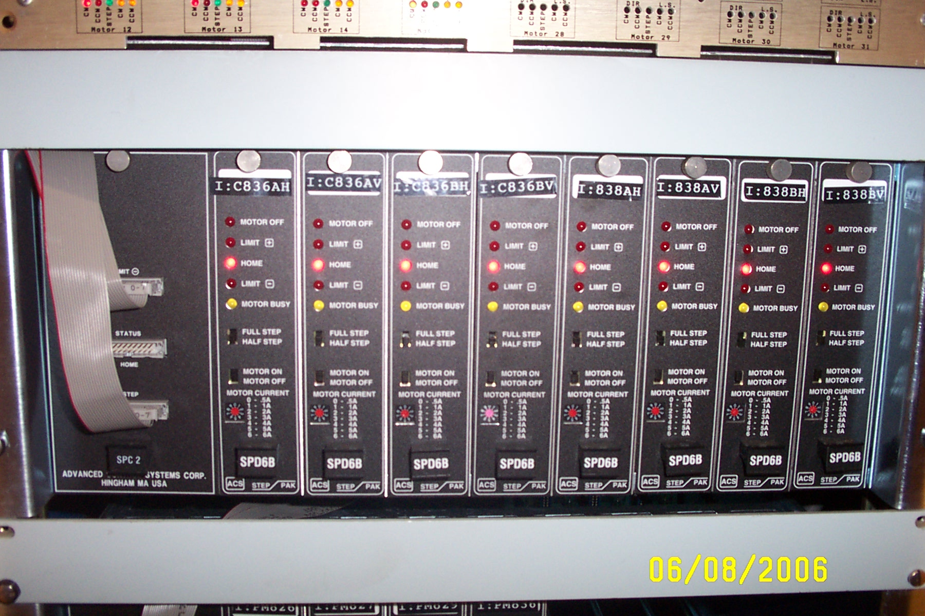
Fig.25 - VME Crate with all Support Fig.26 – ACS Stepper Motor Controller
Cards Chassis – 8 Channels

Front View of Relay Rack

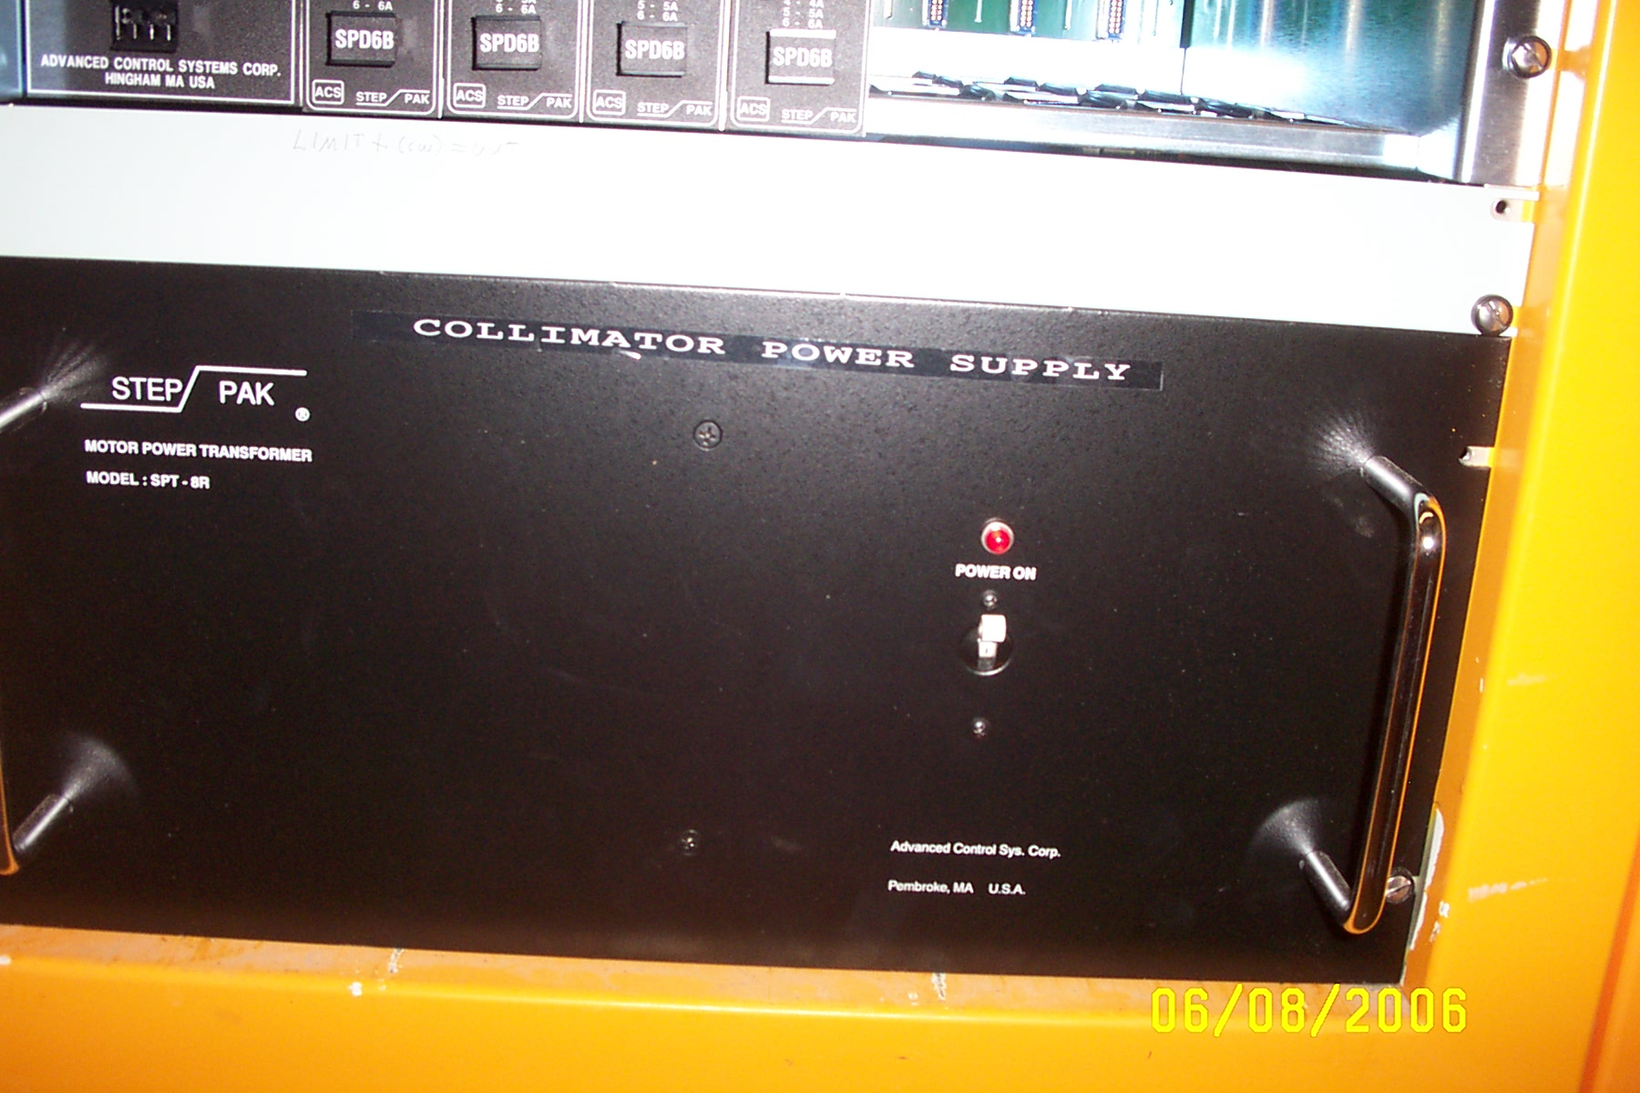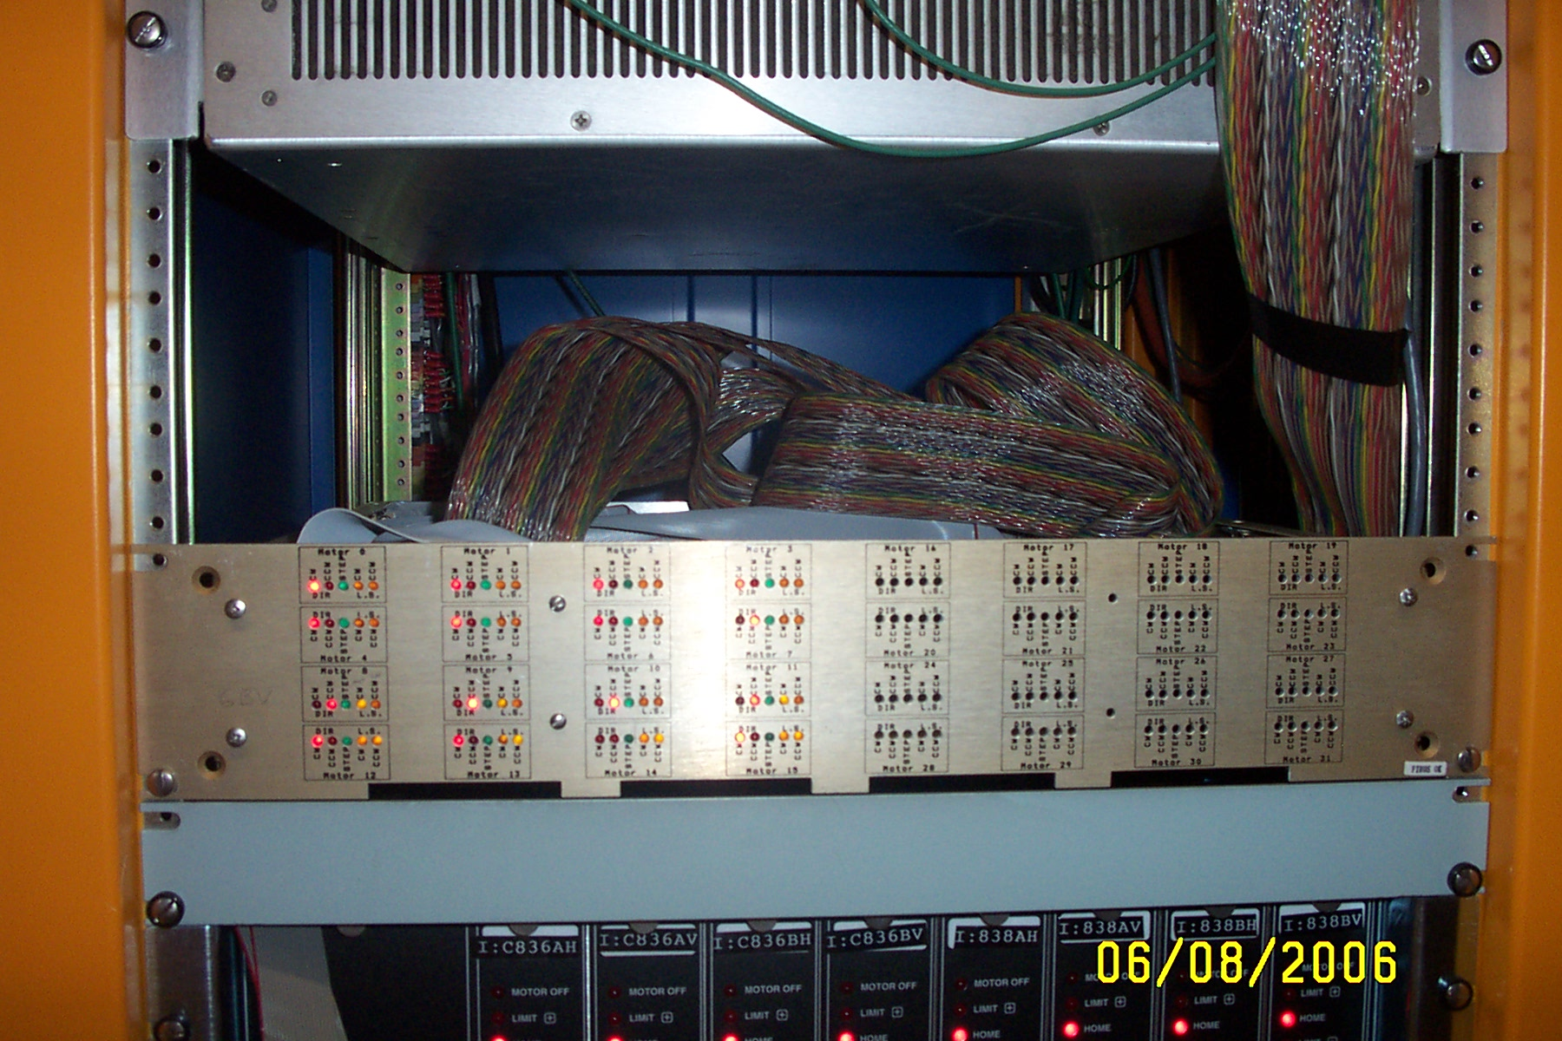

Fig.27 – 48 Volt Motor Power Supply Fig.28 – Motor Controller Interface

Motion Control Relay Rack Back View.

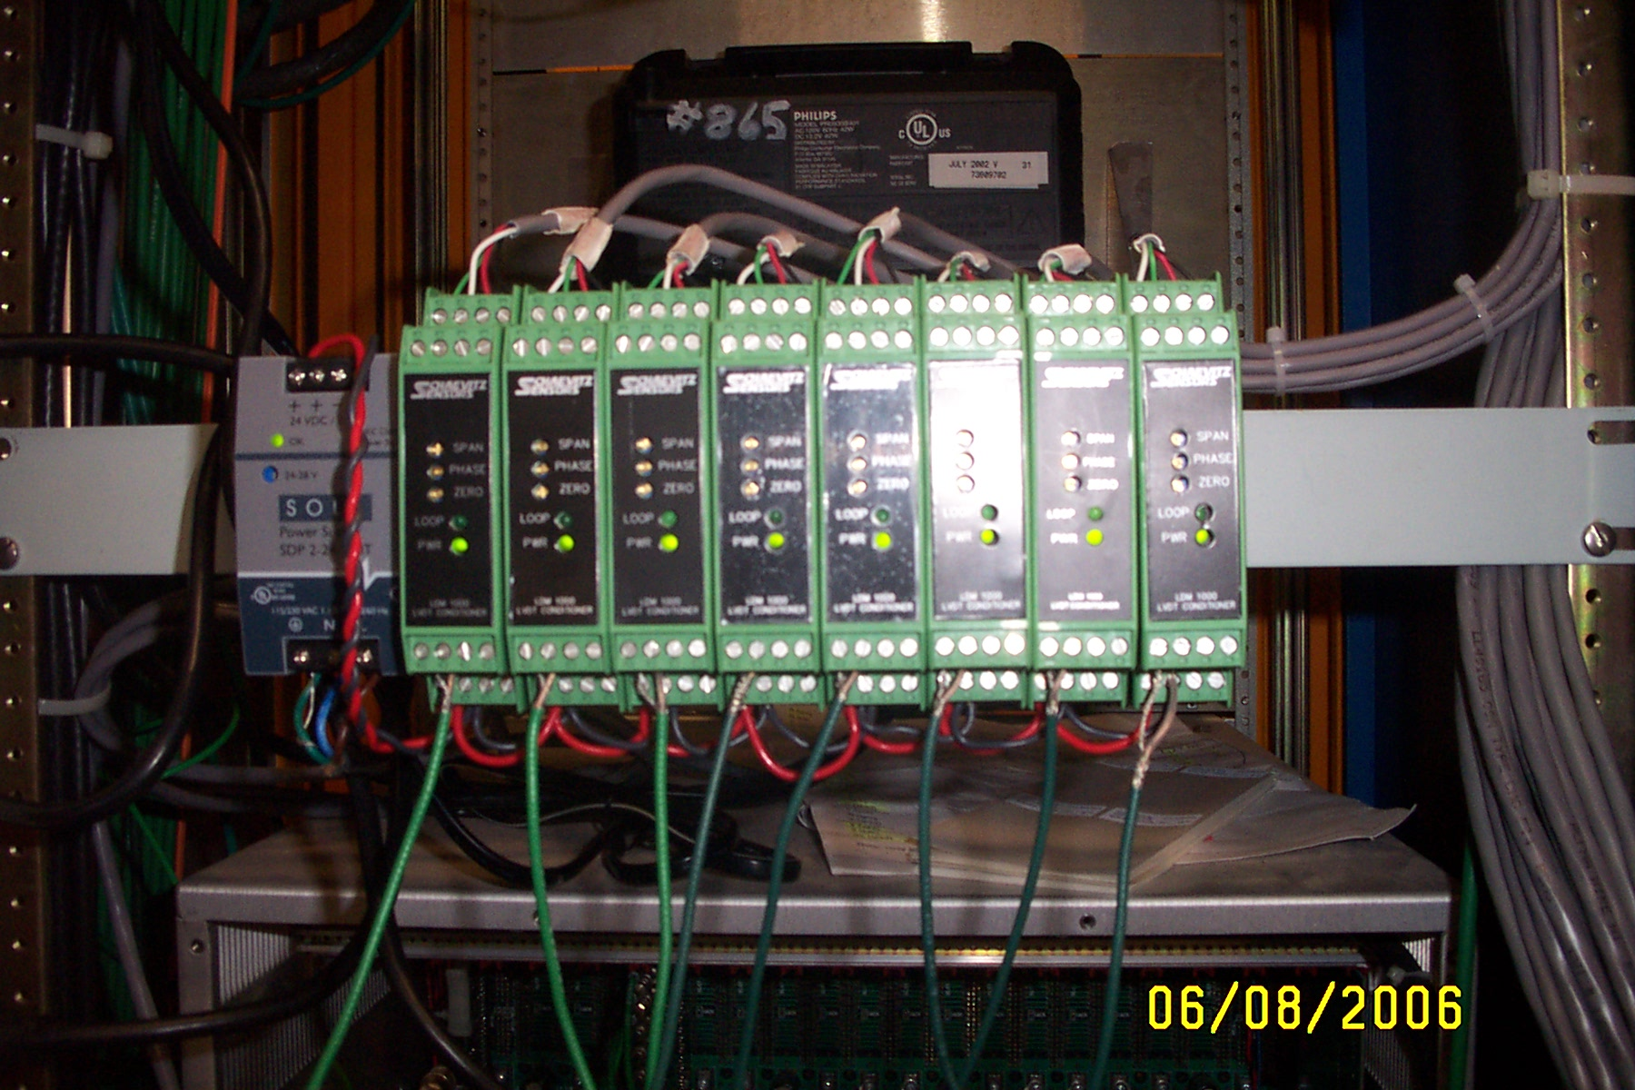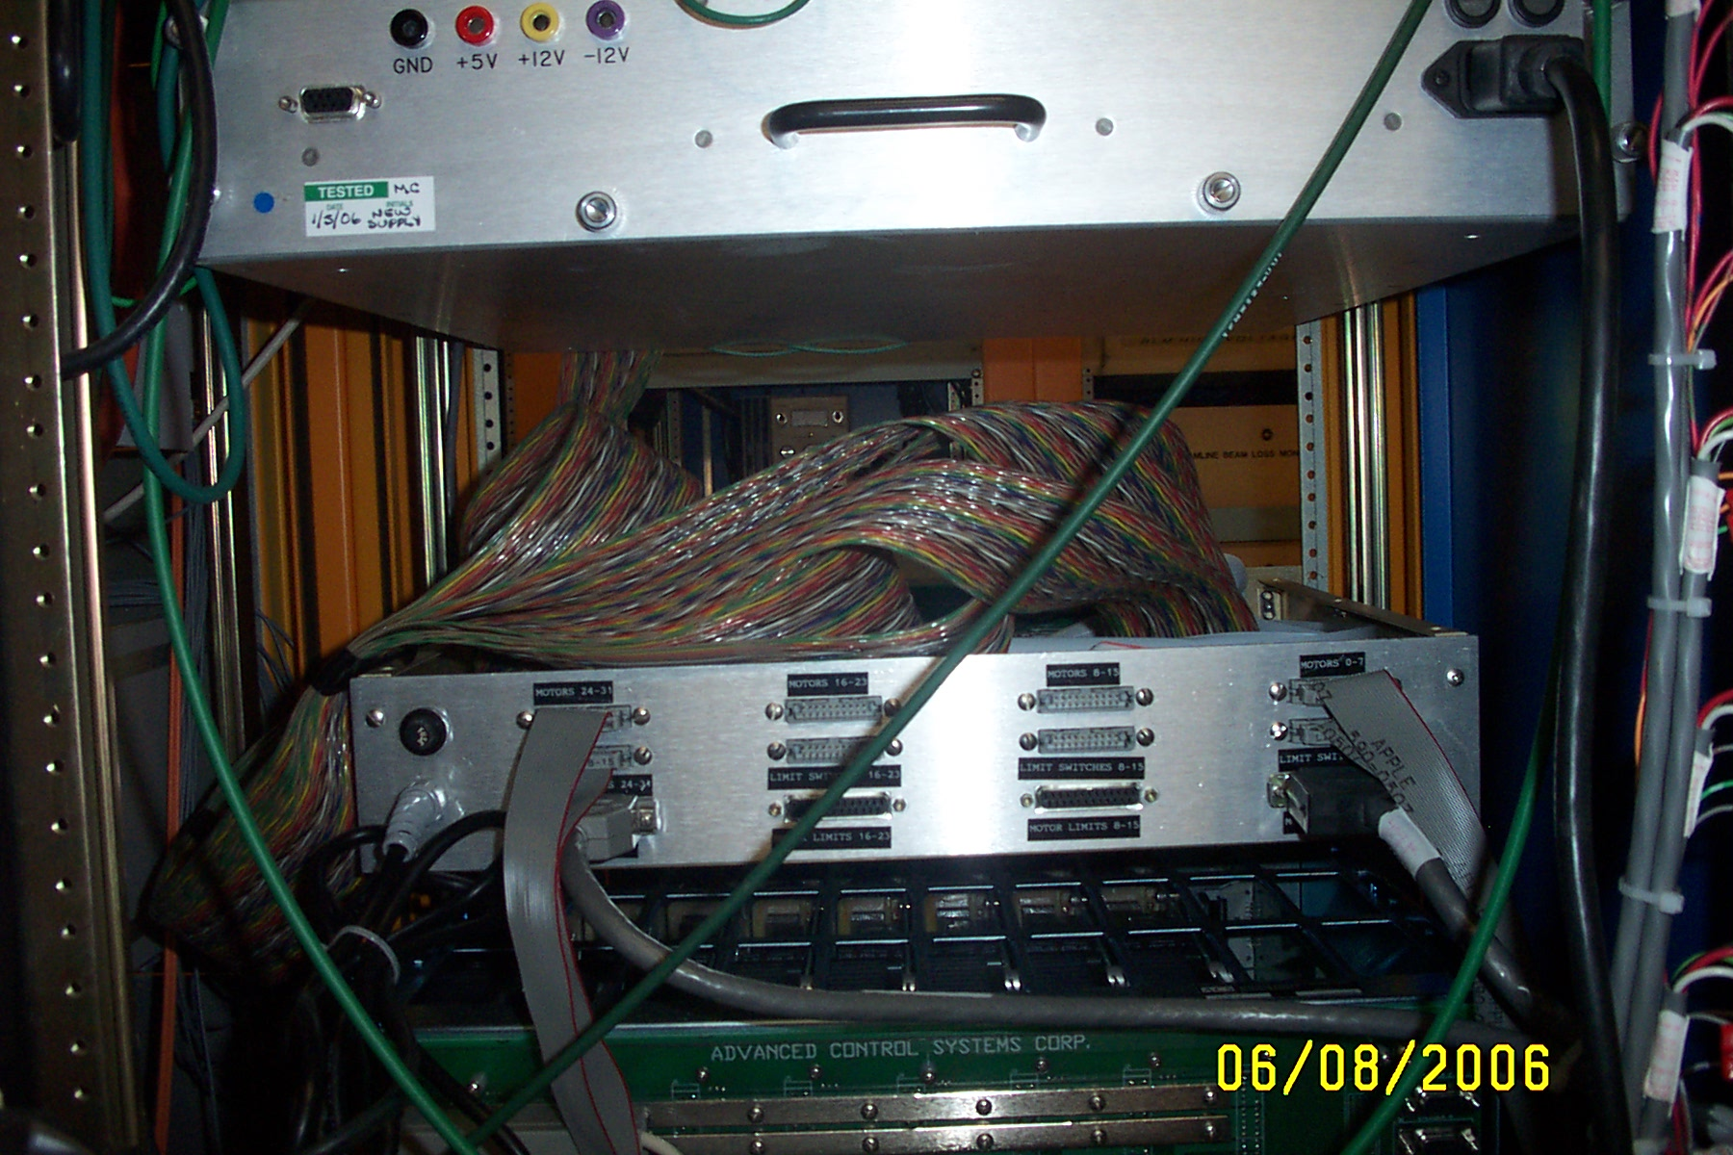

Fig.29 – LVDT Signal Conditioners Fig.30 – 16Channel Interface Chassis.
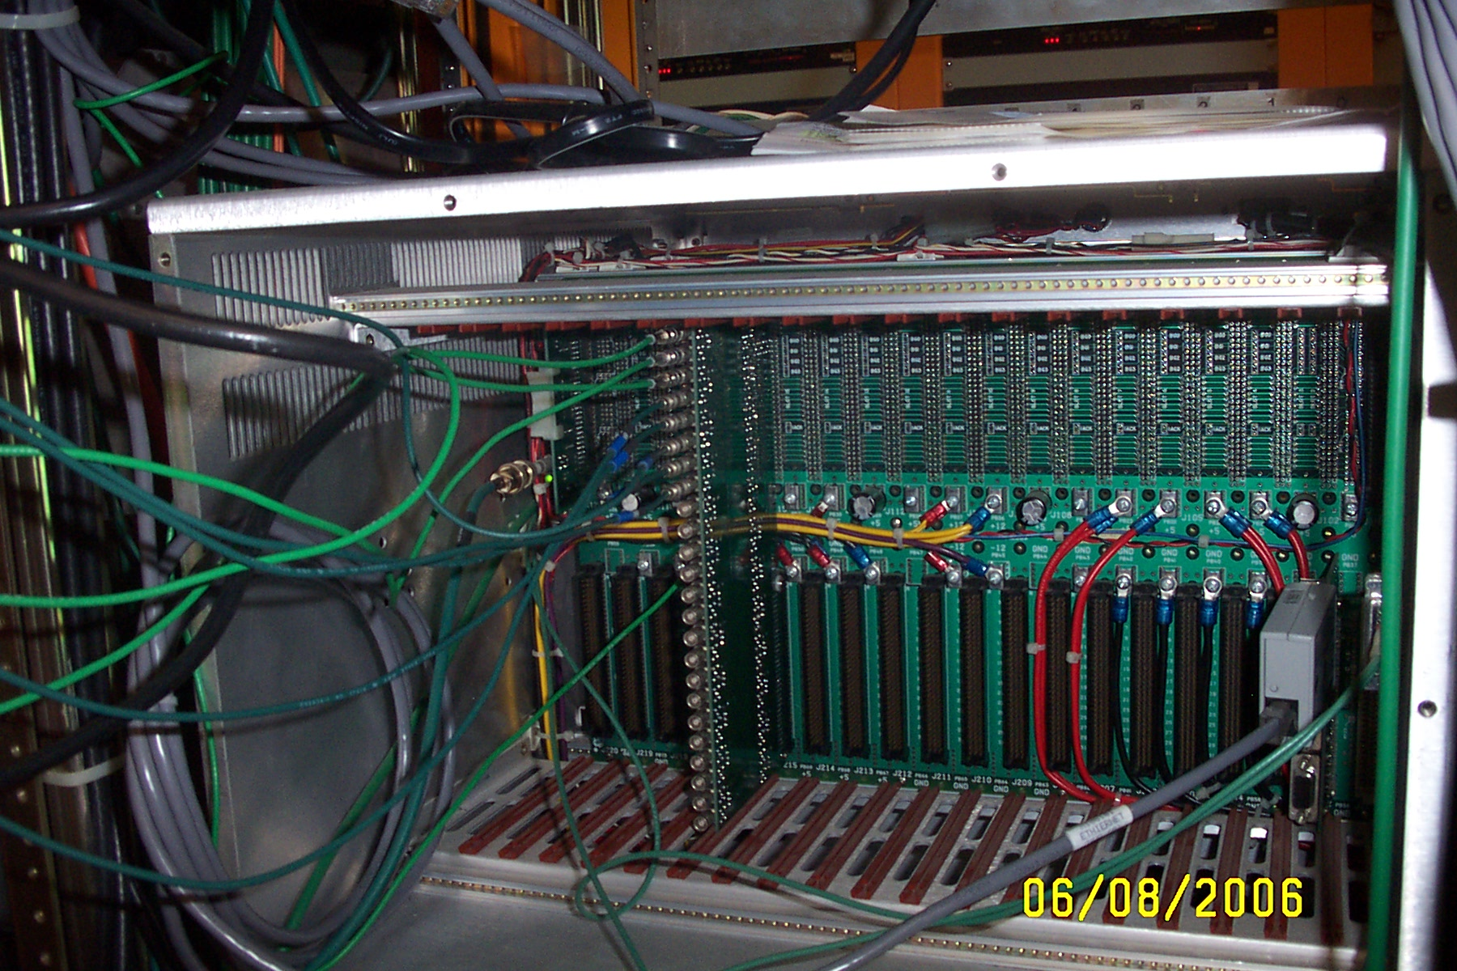

Fig.31 – A/D input Interface Board.

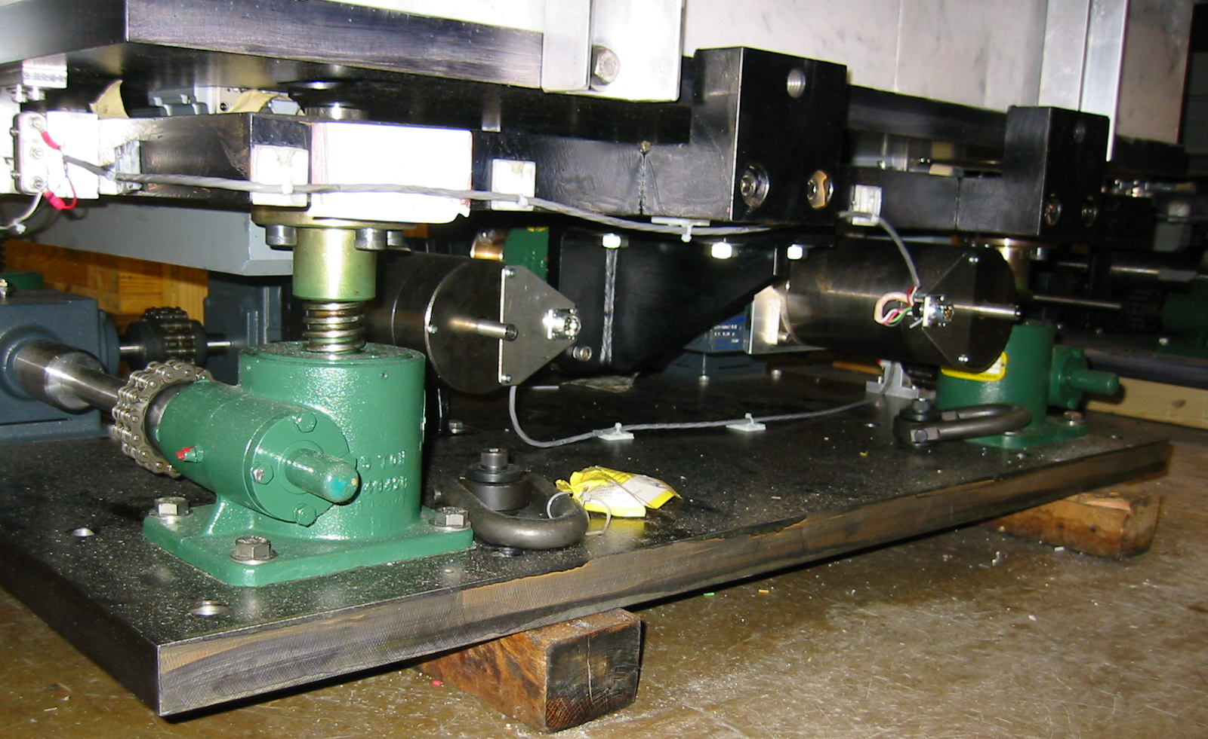

Fig.32 Vertical and horizontal motion systems motors.

 |  |  | MI-8 Collimator Motion Data
ACNET  Name | Motor # | Direction | Steps  Per  Mil | Total  Pulses / 2" | Total Mils LS to LS | Backlash in Steps | Backlash in Mils | Pulses to Center
I:C836AH | 0 | Horizontal | 192 | 374,840 | 1,952 | 384 | 2 | 187,804
I:C836AV | 1 | Vertical | 576 | 1,137,746 | 1,975 | 1,900 | 3.3 | 570,773
I:C836BH | 2 | Horizontal | 192 | 376,219 | 1,959 | 384 | 2 | 188,493
I:C836BV | 3 | Vertical | 576 | 1,137,708 | 1,975 | 2,468 | 4.2 | 571,322
I:C838AH | 4 | Horizontal | 192 | 379,724 | 1,977 | 1,456 | 7.5 | 191,318
I:C838AV | 5 | Vertical | 576 | 1,136,854 | 1,973 | 2,080 | 3.6 | 570,507
I:C838BH | 6 | Horizontal | 192 | 374,835 | 1,952 | 494 | 2.5 | 187,911
I:C838BV | 7 | Vertical | 576 | 1,146,373 | 1,990 | 2,877 | 5 | 576,063

BPM system

The MI8 line BPM system includes a position monitor at each half cell. Horizontal detectors are installed at the 836 and 838 cell boundaries and vertical detectors at the 837 and 839 locations. These are of the design known as 8GeV-Line BPM (Drawing 9502.000-MB-337360-A) (A description and some measurement data for NuMI are available in Beams-doc-1412 [6]). The mechanical design employs a tube with a diagonal cut to provide sensitivity in one plane. The installation orientation determines the plane of sensitivity. The inside diameter of these BPM’s is 3.870”. To assure our knowledge of the beam position through the collimators, we include a BPM to measure the vertical beam position at the upstream end of the collimation space and one at the downstream end to measure the horizontal position. The complement of beam position measurements now consists of HP836, VP836(new), HP837(new), VP837, HP838, VP838(new), HP839(new), VP839. The electronics for the MI8 Line beam position is being replaced following the Spring 2006 shutdown and these new devices are temporarily being read by a test crate of the new electronics. When the electronics upgrade is complete, the full complement of position information will be available for use in an auto-tune program to limit position drift. In a separate upgrade of the MI8 Line during this shutdown, new “Texas” multiwire beam profile monitors were installed. The MI836 multiwire is now of this new type.

Fig.33 BPM in the vertical position, upstream end.

Fig.34 BPM in the horizontal position, down stream end.

Alignment

Precision knowledge of the collimator location is provided by referencing the top and side surfaces of the vacuum liner. Using this reference, the collimators were aligned to the MI8 design centerline. Since those surfaces will be difficult to access do to interference from the aluminum frame which holds the marble, alignment reference plates were installed on the aluminum frame. Four are attached the collimator top and four on the aisle side (see photo in Figure 17). These plates will be available for future precision alignment. For quick confirmation of the alignment, measurements between fixed and movable portions of the collimator system were made using rulers and stick micrometers (vertical) or electronic calipers (horizontal).

References

[1] Bruce C. Brown, “Residual Radiation Hints for Aperture and Alignment Issues in the Main Injector”, Beams-doc-1382.

[2] Bruce C. Brown, “Reducing Losses in Main Injector by MI8 Line Scraping”, Beams-doc-1926.

[3] Ming-Jen Yang, “Multipole fields in Booster extraction septum MP02”, Beams-doc-1573.
[4] N.V. Mokhov, et al., “Fermilab booster beam collimation and shielding”, FERMILAB-CONF-03-087, May 2003. 4pp.
Presented at Particle Accelerator Conference (PAC 03), Portland, Oregon, 12-16 May 2003.

[5] Vladimir Sidorov, “MI-8 Collimation System”, Engineering Note #MSDM-ME-000068.

[6] James A. Fitzgerald, "Numi BPM Test Stand Measurements”, Beams-doc-1412

