1. Introduction 2
2. Normal Operating Conditions 2
3. Best Stacking 3
4. JAS and AIDA files 4
5. Compare Current Stacking to “Best Stacking” 6
• Beam Intensity JAS Plots 6
i. D:BPI708 vs M:Tor109 7
ii. D:BPI712 vs M:Tor109 9
iii. D:IC728 vs M:Tor109 10
iv. D:BPI734 vs M:Tor109 11
v. D:INJFLX vs M:Tor109 12
vi. D:BPI10D vs M:Tor109 13
vii. D:BPI10D/M:Tor109 vs M:Tor109 14
viii. D:PRDCTN vs M:Tor109 15
ix. A:IBMINJ vs. M:Tor109 16
• Accumulator JAS Plots 17
i. A:PRDCTN vs A:STCKRT 18
ii. A:STCKRT vs A:IBEAM 19
iii. A:PRDCT vs A:IBEAM 20
iv. A:STCKRO vs A:IBEAM 21
v. A:EMT3HN vs A:EMT3VN 23
vi. A:EMT3HN vs A:IBEAM 24
vii. A:EMT3VN vs A:IBEAM 25
6. Online Pbar Tuning Guide 26
7. References and Useful Links 26

Introduction

The purpose of the Pbar Online Baseline is to compare recent stacking performance with that of our “Best Stacking” conditions inside of a dynamically updating web interface. In order to achieve that goal, I will discuss documenting “normal” operating conditions, determining a “best stacking” period, and comparing that “best stacking” period with current stacking conditions using web-based plots generated by Java Analysis Studio.

Normal Operating Conditions

Before each major shutdown, significant effort is put into documenting the running conditions of the Pbar Source. This documentation is intended to document as many Pbar systems as possible, which is a complex undertaking. Documentation includes devices associated with the P1 line, P2 line, AP1 line, Target Station, AP2 line, Debuncher, D to A line, Accumulator, and AP3 line. Data from diagnostics such as BPMs, BLMs, SEMs, and Toroids are collected. Signals from Oscilloscopes, Spectrum Analyzers, Network Analyzers, and Vector Signal Analyzers are captured. Read backs and data from power supplies, vacuum, RF systems, and Stochastic Cooling systems are collected as well. Data often must also be collected separately for different Pbar operating modes including stacking, reverse protons, and shot setup.

In order to organize this effort, I constructed an online index that has links to the running conditions documentation taken prior to the Fall 2003, Fall 2004 and Winter 2006 shutdowns. The index can be found in the Pbar Online Tuning guide at http://www-drendel.fnal.gov/TuningGuide/RunningConditions/Pbar-Running-Conditions2.htm.

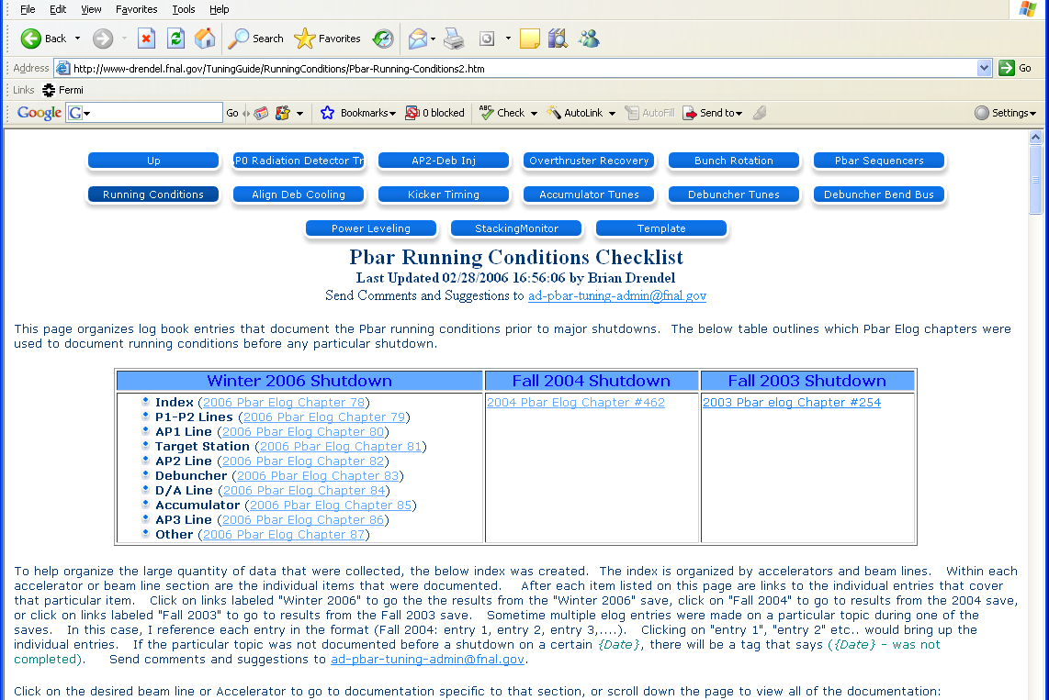
Figure 1: Pbar Running Conditions Documentation.

Some of the data collected is not easily reproducible through the data loggers or not examined regularly when we are stacking well. This makes this data valuable for troubleshooting systems when stacking is not as good as it can be.

Best Stacking

In the last section we showed how our “running conditions” documentation helps us troubleshoot when something is not working well in the Pbar source. Once we have our systems working properly, we will want to find ways to optimize our current Pbar operational conditions. When in stacking mode, this means stacking as fast and efficiently as possible. To determine if our current stacking is up to par, we will chose a period of “best stacking” to compare with. To help determine this “best stacking” period, I focused on our maximum daily stack rates. Paul Derwent publishes a web page that lists the best stack rate during each 24 hour period at http://www-bdnew.fnal.gov/pbar/AEMPlots/besthours.txt. I took this table and sorted it on Pbars accumulated column to get our “Top 10” stacking days (see Table 1).

Top 10 | Date | Best hour of stacking
1 | 10-Feb-06 | 20.12 | mA/hr | at | Fri Feb 10 01:36:29 CST 2006
2 | 23-Feb-06 | 19.73 | mA/hr | at | Wed Feb 22 20:52:52 CST 2006
3 | 11-Feb-06 | 19.44 | mA/hr | at | Fri Feb 10 09:39:43 CST 2006
4 | 24-Sep-05 | 19.27 | mA/hr | at | Fri Sep 23 06:55:31 CDT 2005
5 | 22-Feb-06 | 18.99 | mA/hr | at | Wed Feb 22 05:10:50 CST 2006
6 | 12-Feb-06 | 18.73 | mA/hr | at | Sat Feb 11 15:36:12 CST 2006
7 | 13-Feb-06 | 18.63 | mA/hr | at | Sun Feb 12 23:02:50 CST 2006
8 | 14-Feb-06 | 18.6 | mA/hr | at | Tue Feb 14 01:45:34 CST 2006
9 | 7-Feb-06 | 17.67 | mA/hr | at | Tue Feb 07 02:44:35 CST 2006
10 | 8-Feb-06 | 17.53 | mA/hr | at | Wed Feb 08 02:50:38 CST 2006
Table 1: This table shows peak stack rate, and the table is sorted to show the “top 10” days. Yellow rows are days that fall between 00:00 February 10, 2006 and 00:00 February 15, 2006. Five of the top 10 days fall inside of this range.

Examining Table 1, the five day stretch from February 10, 2006 through February 14, 2006 has five of the top eight peak stacking hours. Lumberjack plots verify that the period produced very good stacking. As a result, for the purpose of this document, I am defining the “Best Stacking” period as 00:00 February 10, 2006 to 00:00 February 15, 2006.

JAS and AIDA files
In the last section, we chose a “best stacking” period. We will next chose a tool to build some dynamically updating web pages that compare current stacking conditions with the conditions taken during the “best stacking” period.

Java Analysis Studio (“JAS” for short) is a free tool (see http://jas.freehep.org/jas3/) that allows users to plot data from Abstract Interfaces of Data Analysis (“AIDA” for short) files. What is so special about AIDA files? To quote from the AIDA website (http://aida.freehep.org/) “The goal of the AIDA project are to define abstract interfaces for common physics analysis objects, such as histograms, ntuples, fitters, IO etc.. The adoption of these interfaces should make it easier for physicists to use different tools without having to learn new interfaces or change all of their code.”

In short, JAS allows the user to make nice looking data plots. In addition, the AD\Controls department has adopted AIDA as a supported file type. Data files, such as the SuperTable, are now exported in AIDA format in addition to their Excel and HTML versions. Timofei Bolshakov also built plug-ins for JAS that allow a user to import Lumberjack and SDA data directly into JAS. Combine this with the ability of making data cuts on your plots, provides more plot flexibility than D44 Lumberjack plots or plots generated from Excel data.
It did not take long to determine that we could make useful Pbar data plots from the datalogger data. The fact that we could make “cuts” on the data gave us some additional power. A good example of this is shown in Figure 2, which is plot of D:IC728 vs M:Tor109 sampled at various times. The red and blue data points are from the same lumberjack data. The red data has a cut with I:VMDT56 equal to either 3, 7, or 17 - indicating single batch stacking. The blue data has a cut I:VMDT56 equal to 5, 14, or 28 indicating slip stacking. The ability to make this cut allows us to easily separate out the slip stack versus non-slip stacking data. That is something that is not easy to do using D44.

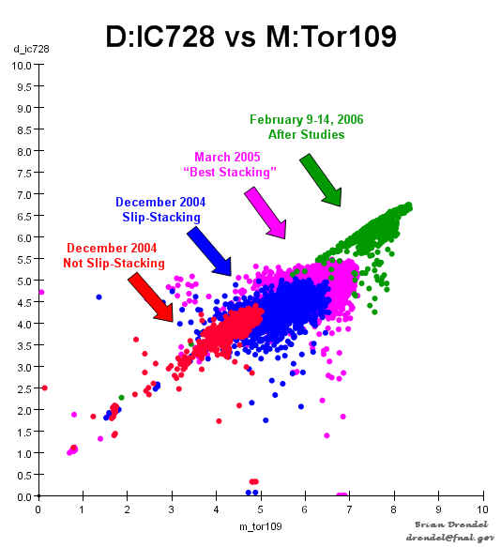
Figure 2: Sample JAS plot showing AP2 beam intensity at IC728 verses AP1 beam intensity at Tor109 taken at various times since 2004. We can see that as we have increased beam on target, the beam increases in the AP2 line similarly.

I started to generate a number of different JAS plots, which can be viewed at http://www-drendel.fnal.gov/OnlineBaseline/online_baseline-stacking.htm. The largest problem with these JAS plots is the time commitment needed to generate the plots.

Compare Current Stacking to “Best Stacking”

In the last section, we chose JAS as our plot generating tool and showed how we could use this tool to make useful Pbar plots based on Datalogger data. It quickly became clear that these types of plots could be useful if we could use them to compare current stacking conditions with our “best stacking” conditions. The time overhead in creating these plots manually everyday would be substantial. It was obvious if we wanted to keep the plots up-to-date, then we needed a way to automate them.

Timofei Bolshakov from AD\Controls was able to help. He was able to setup a controls server to automatically generate my most useful JAS plots on a daily basis and publish them on a web page. These plots were setup to compare current stacking conditions with our “best stacking” period as determined in Section 3 of this document. There are two separate sets of plots. The first set of plots focuses on beam intensity starting in the AP1 line and ending in the injection orbit of the Accumulator. The second set of plots focus on beam parameters in the Accumulator. Both sets of plots are published on web pages that are updated daily and compare “best stacking” with each individual day of stacking as well was each week and each month of stacking. AIDA files are available for all plots so that the ambitious reader can make his/her own custom JAS plots using the same data.

We will now outline how our Beam Intensity and Accumulator JAS plots are setup, how to access them, and how to use them.

Beam Intensity JAS Plots
The purpose of the Beam Intensity JAS plots is to provide intensity plots that compare “best stacking” with “current stacking” from the AP1 line to the Accumulator Injection orbit. These plots can be viewed at
http://www-bd.fnal.gov/SDA_Viewer/stacking_rate_catalog_ds2.jsp. The interface is fairly straight forward as shown in Figure 3.

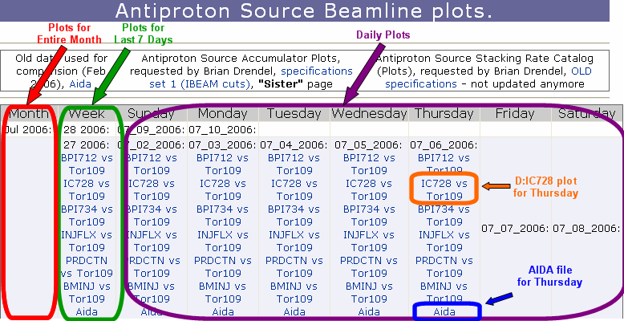
Figure 3: The web interface for the Pbar Beam Intensity JAS plots. We can select to look at beam over the last month, beam over the last week or beam from any individual day.

At the end of each month, plots links are generated in the first column, which is the month column. Notice that in this screen capture there is not a monthly plot for July. That will be generated on August 1st. Plots in the month column compare the current month of stacking with “best stacking.” The second column is the week column. This column contains plots that compare the last seven days of stacking with “best stacking.” The next seven columns contain plots for each individual day of the current week with best stacking. The bottom link in each cell is an AIDA file that was used to build the plots.

Now that we understand the web interface, we will now turn our attention to each of the plots. We have nine beam intensity JAS plots. Each plot compares current stacking conditions with “best stacking” conditions defined as 00:00 February 10, 2006 to 00:00 February 15, 2006.

D:BPI708 vs M:Tor109

The first plots looks at D:BPI708 vs M:Tor109. BPI708 is a BPM intensity reading from early in the AP2 line, and Tor109 is our standard toroid intensity reading for AP1 line beam just prior to the target. The weakness of BPI708 is that the AP2 BPMs periodically have their gains adjusted, which changes their reading. Also, all of the AP2 line BPMs had their preamps changed over the shutdown. The result is the BPM scaling may be different between current stacking and our “best stacking” period. Experts are working to get scale factor differences on this and other AP2 BPM intensity readings, so that I can rescale my plots appropriately.

x-axis
Device | Plot Limits |  | Datalogger
Device | Lower | Upper | Datalogger
M:Tor109 | 0 | 10 | PbarEH, $81, 500ms
y-axis
Device | Plot Limits |  | Datalogger
Device | Lower | Upper | Datalogger
D:BPI708 | 0 | 150000 | E_864, $90, 1000ms
Data Cuts
Cut 1 | Cut 2 | Cut 3 | Cut 4
V:APSMOD ==7 | 12 > M:TOR109 > 0 | 26 > A:STCKRT > 0 | 30 > A:PRDCTN >0
Figure 4: JAS Plot setup for D:BPI708 vs M:Tor109

Figure 4 shows the plot setup parameters and cuts, and Figure 5 is an example plot comparing stacking on June 10, 2006 with our “best stacking.”

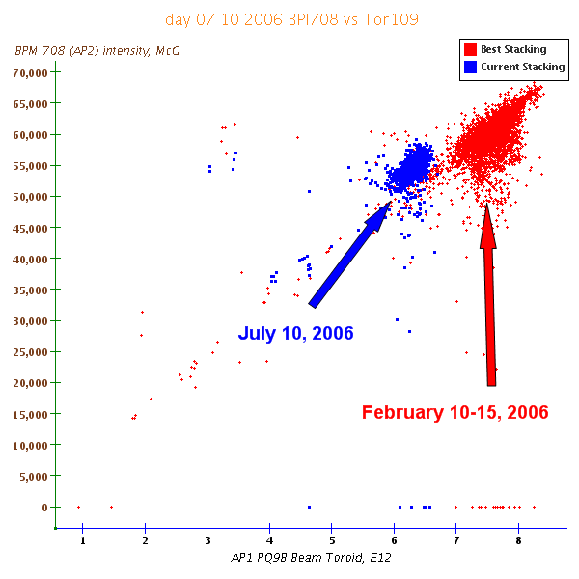
Figure 5: D:BPI708 vs M:Tor109. We need to be careful when interpreting this plot since the BPM scaling may be different for the two data collection periods.

D:BPI712 vs M:Tor109

The next plot looks at D:BPI712 vs M:Tor109. BPI712 is a BPM intensity reading from the AP2 line prior to the left bend. The scaling issues mentioned above for BPI708 also apply to BPI712.

x-axis
Device | Plot Limits |  | Datalogger
Device | Lower | Upper | Datalogger
M:Tor109 | 0 | 10 | PbarEH, $81, 500ms
y-axis
Device | Plot Limits |  | Datalogger
Device | Lower | Upper | Datalogger
D:BPI712 | 0 | 100000 | E_864, $90, 1000ms
Data Cuts
Cut 1 | Cut 2 | Cut 3 | Cut 4
V:APSMOD ==7 | 12 > M:TOR109 > 0 | 26 > A:STCKRT > 0 | 30 > A:PRDCTN >0
Figure 6: JAS Plot setup for D:BPI712 vs M:Tor109

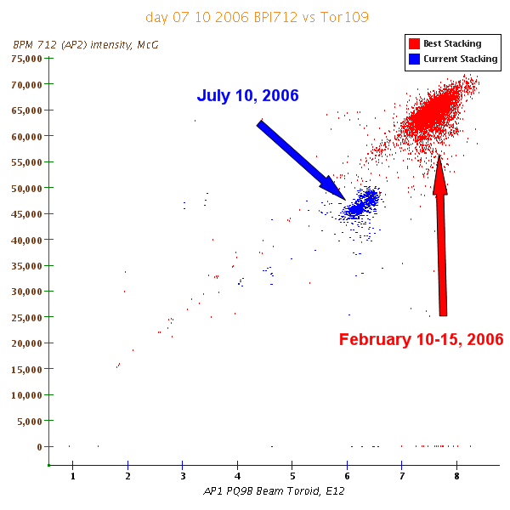
Figure 7: D:BPI712 vs M:Tor109. We need to be careful when interpreting this plot since the BPM scaling may be different for the two data collection periods.

Specs on this plot are as follows.

D:IC728 vs M:Tor109

The third plot looks at D:IC728 vs M:Tor109. D:IC728 is an ion chamber near the end of the AP2 line, before the D:V730 downward bend toward the Debuncher. This plot has been used as a standard measure of target performance and is well known.

x-axis
Device | Plot Limits |  | Datalogger
Device | Lower | Upper | Datalogger
M:Tor109 | 0 | 10 | PbarEH, $81, 500ms
y-axis
Device | Plot Limits |  | Datalogger
Device | Lower | Upper | Datalogger
D:IC728 | 0 | 8 | Pbar EH, $81, 500ms
Data Cuts
Cut 1 | Cut 2 | Cut 3 | Cut 4
V:APSMOD ==7 | 12 > M:TOR109 > 0 | 26 > A:STCKRT > 0 | 30 > A:PRDCTN >0
Figure 8: JAS Plot setup for D:IC728 vs M:Tor109

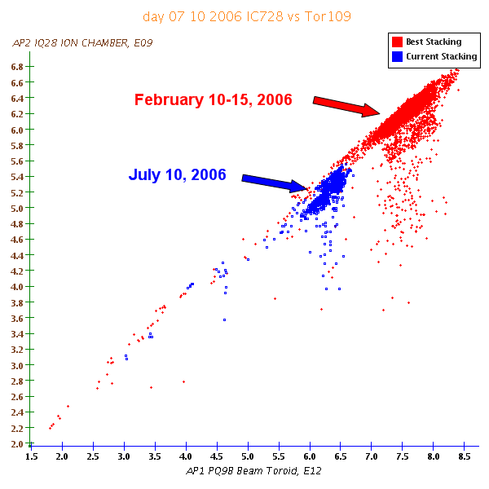
Figure 9 D:IC728 vs M:Tor109. Performance of beam to IC728 on July 10th is similar, though maybe a bit lower, for the beam on target as compared to best stacking.

D:BPI734 vs M:Tor109

The fourth plot looks at D:BPI734 vs M:Tor109. BPI734 is a BPM intensity reading from the AP2 line just prior to injection into the Debuncher. The scaling issues mentioned above for BPI708 also apply to BPI734.

x-axis
Device | Plot Limits |  | Datalogger
Device | Lower | Upper | Datalogger
M:Tor109 | 0 | 10 | PbarEH, $81, 500ms
y-axis
Device | Plot Limits |  | Datalogger
Device | Lower | Upper | Datalogger
D:BPI734 | 0 | 150000 | E_864, $90, 1000ms
Data Cuts
Cut 1 | Cut 2 | Cut 3 | Cut 4
V:APSMOD ==7 | 12 > M:TOR109 > 0 | 26 > A:STCKRT > 0 | 30 > A:PRDCTN >0
Figure 10: JAS Plot setup for D:BPI734 vs M:Tor109

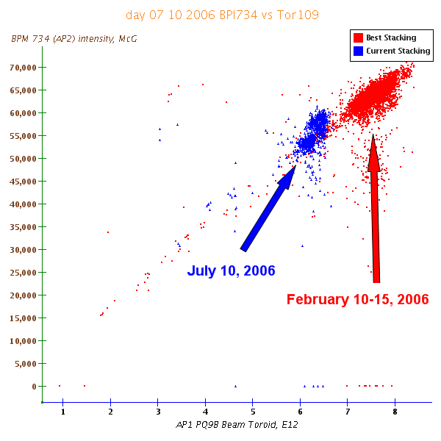
Figure 11: D:BPI734 vs M:Tor109. We need to be careful when interpreting this plot since the BPM scaling may be different for the two data collection periods.

D:INJFLX vs M:Tor109

The fifth plot looks at D:INJFLX vs M:Tor109. INJFLX is first turn beam in the Debuncher from the Flux Capacitor scope.

x-axis
Device | Plot Limits |  | Datalogger
Device | Lower | Upper | Datalogger
M:Tor109 | 0 | 10 | PbarEH, $81, 500ms
y-axis
Device | Plot Limits |  | Datalogger
Device | Lower | Upper | Datalogger
D:INJFLX | 0 | 26 | Pbar EH, $81, 500ms
Data Cuts
Cut 1 | Cut 2 | Cut 3 | Cut 4
V:APSMOD ==7 | 12 > M:TOR109 > 0 | 26 > A:STCKRT > 0 | 30 > A:PRDCTN >0
Figure 12: JAS Plot setup for D:INJFLX vs M:Tor109

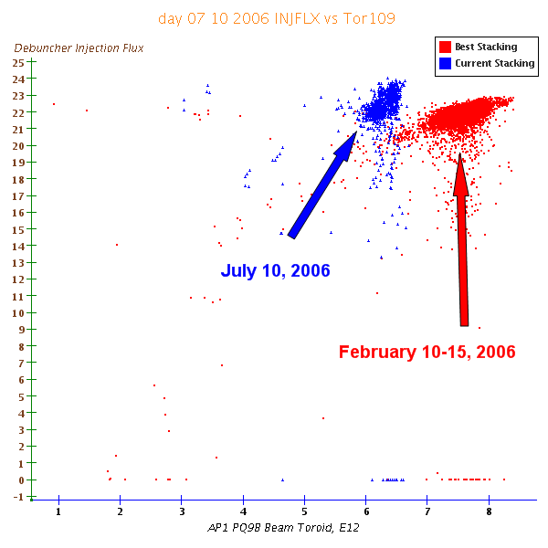
Figure 13: D:INJFLX vs M:Tor109.

D:BPI10D vs M:Tor109

The sixth plot looks at D:BPI10D vs M:Tor109. BPI10D is a BPM intensity reading representing circulating beam in the Debuncher. The scaling issues mentioned above for BPI708 also apply to BPI10D. In addition components in the BPI10D system were changed over the shutdown. Experts are working to determine scale factor differences so that I can rescale these plots appropriately.

x-axis
Device | Plot Limits |  | Datalogger
Device | Lower | Upper | Datalogger
M:Tor109 | 0 | 10 | PbarEH, $81, 500ms
y-axis
Device | Plot Limits |  | Datalogger
Device | Lower | Upper | Datalogger
D:BPI10D | 0 | 20000 | Pbar2, $80, 0ms
Data Cuts
Cut 1 | Cut 2 | Cut 3 | Cut 4
V:APSMOD ==7 | 12 > M:TOR109 > 0 | 26 > A:STCKRT > 0 | 30 > A:PRDCTN >0
Figure 14: JAS Plot setup for D:BPI10D vs M:Tor109

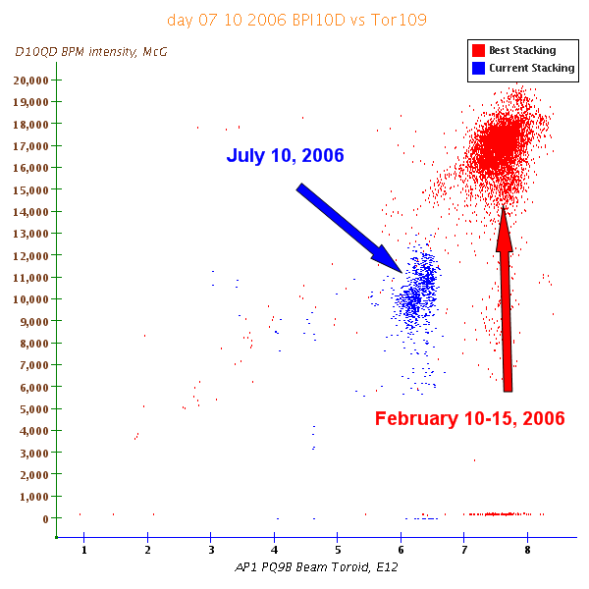
Figure 15: D:BPI10D vs M:Tor109. We need to be careful when interpreting this plot since the BPM scaling may be different for the two data collection periods.

D:BPI10D/M:Tor109 vs M:Tor109

Some experts like to look at D:BPI10D/M:Tor109 vs M:Tor109. This plot was added by request.

x-axis
Device | Plot Limits |  | Datalogger
Device | Lower | Upper | Datalogger
M:Tor109 | 0 | 10 | PbarEH, $81, 500ms
y-axis
Device | Plot Limits |  | Datalogger
Device | Lower | Upper | Datalogger
D:BPI10D/  M:Tor109 | 0  0 | 20000  10 | Pbar2, $80, 0ms  PbarEH, $81, 500ms
Data Cuts
Cut 1 | Cut 2 | Cut 3 | Cut 4
V:APSMOD ==7 | 12 > M:TOR109 > 0 | 26 > A:STCKRT > 0 | 30 > A:PRDCTN >0
Figure 16: JAS Plot setup for D:BPI10D/M:Tor109 vs M:Tor109

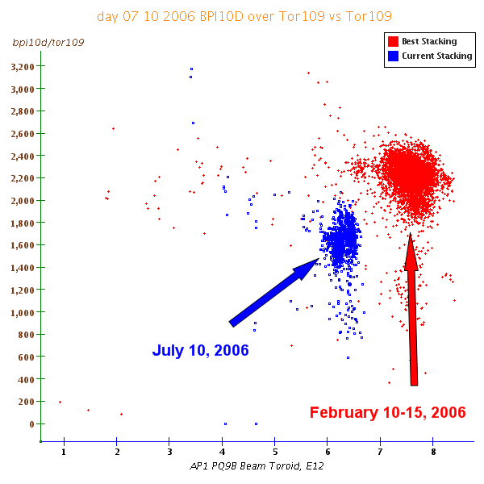
Figure 17: D:BPI10D/M:Tor109 vs M:Tor109. We need to be careful when interpreting this plot since the BPM scaling may be different for the two data collection periods.

D:PRDCTN vs M:Tor109

The eighth plot looks at D:PRDCTN vs M:Tor109. D:PRDCTN is a measure of production efficiency to the Debuncher. It is calculated by looking at D:IBEAMV. D:IBEAMV has an offset that wanders over time. In order to step the drifting offset from impacting the PRDCTN calculation, the offset value is corrected every switchyard $21 event. If no $21 is in the timeline, then care must be taken when using this parameter.

x-axis
Device | Plot Limits |  | Datalogger
Device | Lower | Upper | Datalogger
M:Tor109 | 0 | 10 | PbarEH, $81, 500ms
y-axis
Device | Plot Limits |  | Datalogger
Device | Lower | Upper | Datalogger
D:PRDCTN | 0 | 26 | PbarEH, $00, 0ms
Data Cuts
Cut 1 | Cut 2 | Cut 3 | Cut 4
V:APSMOD ==7 | 12 > M:TOR109 > 0 | 26 > A:STCKRT > 0 | 30 > A:PRDCTN >0
Figure 18: JAS Plot setup for D:PRDCTN vs M:Tor109

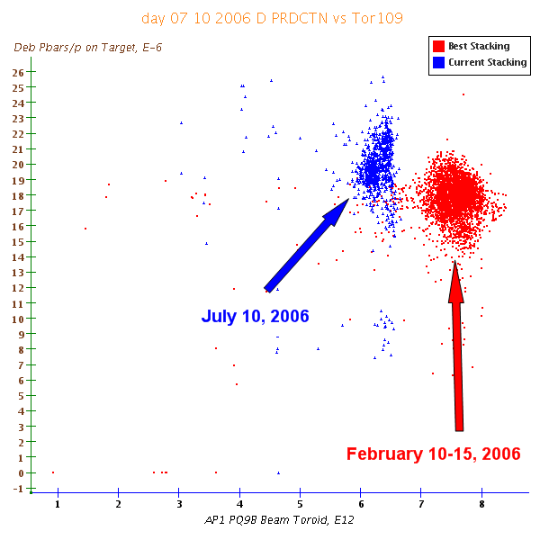
Figure 19: D:PRDCTN vs M:Tor109.

A:IBMINJ vs. M:Tor109

The last beam intensity plot looks at A:IBMINJ vs M:Tor109. A:IBMINJ is a measure of beam injected in the accumulator as determined by the Stacking VSA.

x-axis
Device | Plot Limits |  | Datalogger
Device | Lower | Upper | Datalogger
M:Tor109 | 0 | 10 | PbarEH, $81, 500ms
y-axis
Device | Plot Limits |  | Datalogger
Device | Lower | Upper | Datalogger
A:IBMINJ | 0 | 26 | E_760, $90, 0ms
Data Cuts
Cut 1 | Cut 2 | Cut 3 | Cut 4
V:APSMOD ==7 | 12 > M:TOR109 > 0 | 26 > A:STCKRT > 0 | 30 > A:PRDCTN >0
Figure 20: JAS Plot setup for A:IBMINJ vs M:Tor109

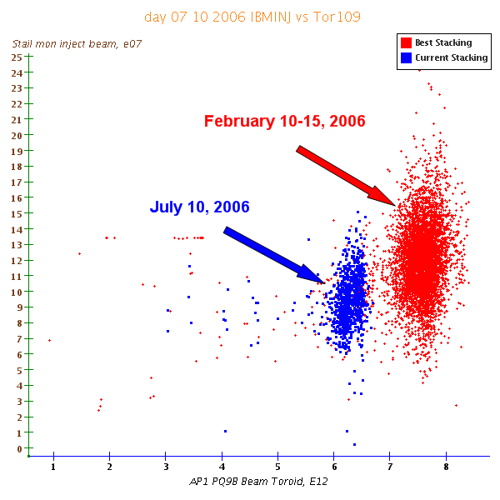
Figure 21: A:IBMINJ vs M:Tor109.

Accumulator JAS Plots

In the last section we covered all of the Beam Intensity JAS plots that cover beam from the AP1 line all the way to the Accumulator Injection orbit. The second set of JAS plots focuses on beam in the Accumulator and can be viewed at http://www-bd.fnal.gov/SDA_Viewer/stacking_rate_catalog_ds1.jsp.

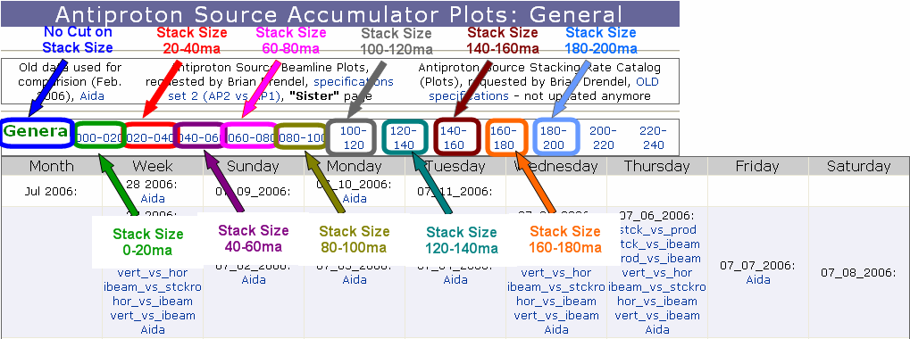
Figure 22: The Accumulator JAS plot allow you to select a cut on stack size.

Figure 22 shows that the interface is similar to the Beam Intensity JAS plots, with one additional feature. Above the plot links is a row that allows the user to select a cut on stack size. Selecting “General” says to look at all stack sizes, selecting “000-020” says to only show data between 0 and 20ma, selecting “020-040” says to only show data between 20 and 40ma, and so on. The default plot state is to look at all stack sizes.

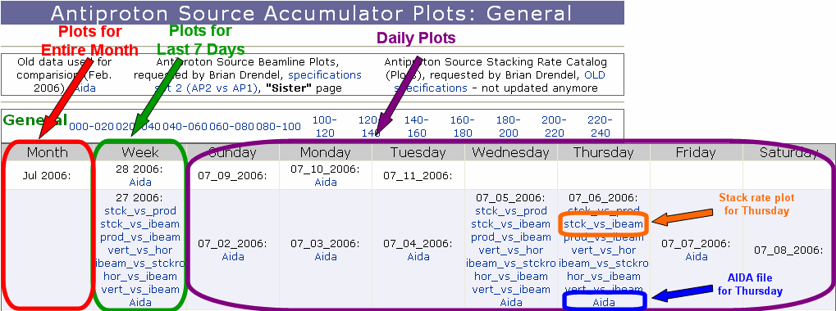
Figure 23: The web interface for the Pbar Accumulator JAS plots. Once we select our cut on stack size, we can select to look at beam over the last month, beam over the last week or beam from any individual day.

We will now turn our attention to each of the plots. We have seven Accumulator JAS plots. Each plot compares current stacking conditions with “best stacking” conditions defined as 00:00 February 10, 2006 to 00:00 February 15, 2006.

A:PRDCTN vs A:STCKRT

The first plot shows the Accumulator Production versus Stack Rate. Both the production and stack rate parameters are calculated parameters and have been updated in recent weeks. Earlier this year, test parameters A:STAKRT and Z:PRDTMP were implemented to improve the stack rate and production calculations. These new versions better handle missed beam pulses, one shots, etc.. and give more consistent readings. As of July 7, the temporary parameters were moved to the operational parameters A:STCKRT and A:PRDCTN. In order to maintain consistency in the plots, any plot data before July 7th uses A:STAKRT and Z:PRDTMP, while any plot data after July 7th users A:STCKRT and A:PRDCTN. The same will be true for any of the upcoming plots that use these two parameters.

x-axis
Device | Plot Limits |  | Datalogger
Device | Lower | Upper | Datalogger
A:STCKRT  (A:STAKRT) | 0 | 24 | E_760, $00, 2000msec
y-axis
Device | Plot Limits |  | Datalogger
Device | Lower | Upper | Datalogger
A:PRDCTN  (Z:PRDTMP) | 0 | 28 | E_760, $00, 2000msec
Data Cuts
Cut 1 | Cut 2 | Cut 3 | Cut 4
V:APSMOD ==7 | 26 > A:STCKRT > 0 | 30 > A:PRDCTN >0 | 300 > A:IBEAM > 0
Figure 24: JAS Plot setup for A:PRDCTN vs A:STCKRT

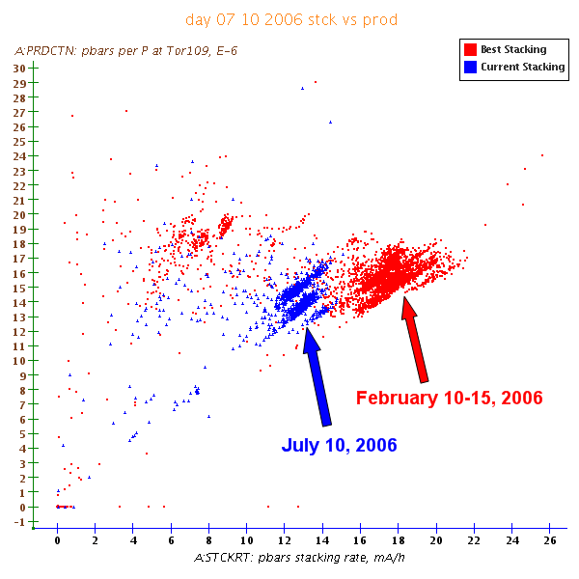
Figure 25: A:PRDCTN vs A:STCKRT. Comparing current stacking to “best stacking” it looks like stack rate is a little low per given production.

A:STCKRT vs A:IBEAM

The second plot shows the Accumulator Stack Rate versus Stack Size. This is long been a favorite plot of Pbar experts.

x-axis
Device | Plot Limits |  | Datalogger
Device | Lower | Upper | Datalogger
A:IBEAM | 0 | 200 | Pbar1, 1Min
y-axis
Device | Plot Limits |  | Datalogger
Device | Lower | Upper | Datalogger
A:STCKRT | 0 | 24 | E_760, $00, 2000msec
Data Cuts
Cut 1 | Cut 2 | Cut 3 | Cut 4
V:APSMOD ==7 | 26 > A:STCKRT > 0 | 30 > A:PRDCTN >0 | 300 > A:IBEAM > 0
Figure 26: JAS Plot setup for A:STCKRT vs A:IBEAM

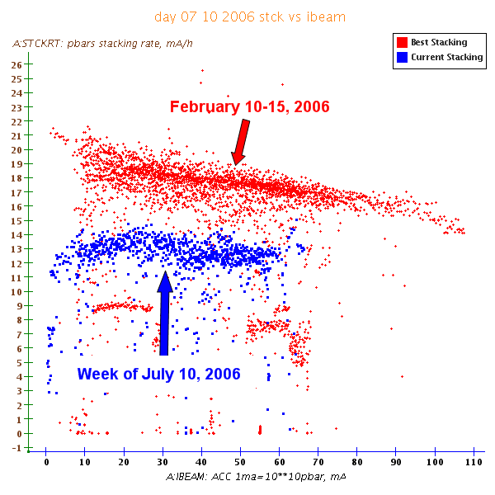
Figure 27: A:STCKRT vs A:IBEAM. Current stack rate for a given stack size is down. At least some of this is due to less beam on target.

A:PRDCT vs A:IBEAM
The third plot shows the Accumulator Production versus Stack Size.

x-axis
Device | Plot Limits |  | Datalogger
Device | Lower | Upper | Datalogger
A:IBEAM | 0 | 200 | Pbar1, 1Min
y-axis
Device | Plot Limits |  | Datalogger
Device | Lower | Upper | Datalogger
A:PRDCTN | 0 | 28 | E_760, $00, 2000msec
Data Cuts
Cut 1 | Cut 2 | Cut 3 | Cut 4
V:APSMOD ==7 | 26 > A:STCKRT > 0 | 30 > A:PRDCTN >0 | 300 > A:IBEAM > 0
Figure 28: JAS Plot setup for A:PRDCTN vs A:IBEAM

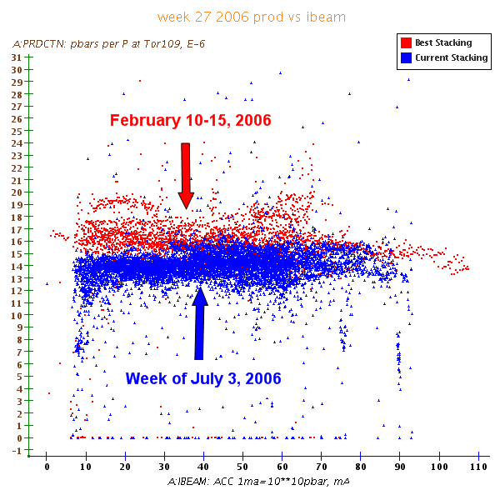
Figure 29: A:PRDCTN vs A:IBEAM. Current production efficiency for a given stack size is down.

A:STCKRO vs A:IBEAM

The fourth plot shows A:STCKRO versus Stack Size. A:STCKRO is the ratio of the average time between stacking events divided by the expected time between stacking events for a given stack size. 100% means that we are stacking at exactly the expected cycle time. When A:STCKRO is greater than 100% it means that we have more time between stacking cycles than expected, and when A:STCKRO is less than 100% it means that we have less time between stacking cycles than expected. Large values of A:STCKRO may be an indication of not pushing stacking hard enough or problems with stacking.

x-axis
Device | Plot Limits |  | Datalogger
Device | Lower | Upper | Datalogger
A:IBEAM | 0 | 200 | Pbar1, 1Min
y-axis
Device | Plot Limits |  | Datalogger
Device | Lower | Upper | Datalogger
A:STCKRO | 0 | 200 | PbarEH, $00, 0msec
Data Cuts
Cut 1 | Cut 2 | Cut 3 | Cut 4
V:APSMOD ==7 | 26 > A:STCKRT > 0 | 30 > A:PRDCTN >0 | 300 > A:IBEAM > 0
Figure 30: JAS Plot setup for A:STCKRO vs A:IBEAM

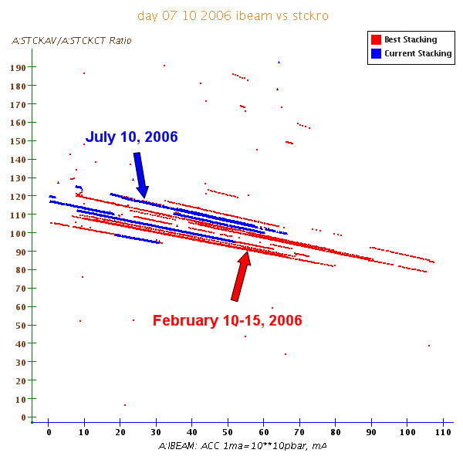
Figure 31: A:STCKRO vs A:IBEAM. Current values of A:STCKRO for a given stack size may be slightly larger. Given the fact that production efficiency is also lower and there is less beam on target, may hint that there is a problem.

A:EMT3HN vs A:EMT3VN

The fifth plot shows the Accumulator horizontal emittance versus the vertical emittance. Since A:IBEAM is not included in this plot, this is one plot that can benefit from selecting cuts on Accumulator stack size. We will only show the data that does not segment stack size.

x-axis
Device | Plot Limits |  | Datalogger
Device | Lower | Upper | Datalogger
A:EMT3HN | 0 | 2.6 | Pbar1, 1Min
y-axis
Device | Plot Limits |  | Datalogger
Device | Lower | Upper | Datalogger
A:EMT3VN | 0 | 2 | Pbar2, 1Min
Data Cuts
Cut 1 | Cut 2 | Cut 3 | Cut 4
V:APSMOD ==7 | 26 > A:STCKRT > 0 | 30 > A:PRDCTN >0 | 300 > A:IBEAM > 0
Figure 32: JAS Plot setup for A:EMT3HN vs A:EMT3VN

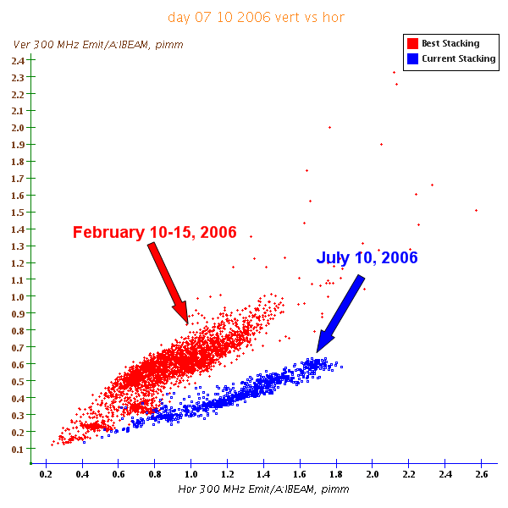
Figure 33: A:EMT3HN vs A:EMT3VN. We can see that the emittance behavior is very different compared to before the shutdown.

A:EMT3HN vs A:IBEAM

The sixth plot shows the Accumulator horizontal emittance versus the stack size. This plot was added by Pbar expert request.

x-axis
Device | Plot Limits |  | Datalogger
Device | Lower | Upper | Datalogger
A:IBEAM | 0 | 200 | Pbar1, 1Min
y-axis
Device | Plot Limits |  | Datalogger
Device | Lower | Upper | Datalogger
A:EMT3HN | 0 | 2.6 | Pbar2, 1Min
Data Cuts
Cut 1 | Cut 2 | Cut 3 | Cut 4
V:APSMOD ==7 | 26 > A:STCKRT > 0 | 30 > A:PRDCTN >0 | 300 > A:IBEAM > 0
Figure 34: JAS Plot setup for A:EMT3HN vs A:IBEAM

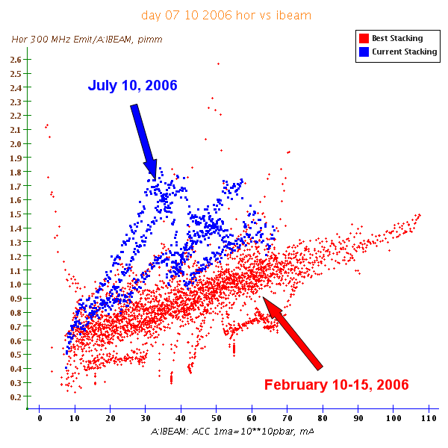
Figure 35: A:EMT3HN vs A:IBEAM. We can see that the horizontal emittance for a given stack size is larger than it was before the shutdown.

A:EMT3VN vs A:IBEAM

The last plot shows the Accumulator vertical emittance versus the stack size. This plot was added by Pbar expert request.

x-axis
Device | Plot Limits |  | Datalogger
Device | Lower | Upper | Datalogger
A:IBEAM | 0 | 200 | Pbar1, 1Min
y-axis
Device | Plot Limits |  | Datalogger
Device | Lower | Upper | Datalogger
A:EMT3VN | 0 | 2 | Pbar2, 1Min
Data Cuts
Cut 1 | Cut 2 | Cut 3 | Cut 4
V:APSMOD ==7 | 26 > A:STCKRT > 0 | 30 > A:PRDCTN >0 | 300 > A:IBEAM > 0
Figure 36: JAS Plot setup for A:EMT3VN vs A:IBEAM

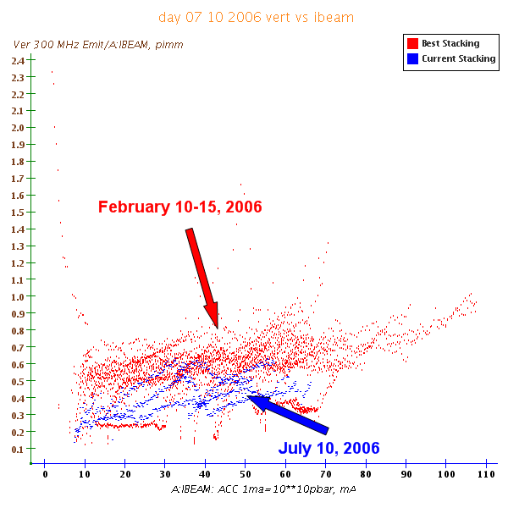
Figure 37: A:EMT3VN vs A:IBEAM. We can see that the vertical emittance for a given stack size is smaller than it was before the shutdown.

Online Pbar Tuning Guide

One may be able to use the JAS plots in the last two sections to provide guidance on what areas need the most work. The next step is to tune-up beam to try to surpass the “best stacking” conditions. The Online Pbar Tuning guide is a tool that we can use to assist the tuning process.

The tuning guide starts with the Tuning Goals outlined by the Stacking Rapid Response team. This lists some generic beam goals that should be obtained in all of the accelerator chain. This list can be viewed at http://www-drendel.fnal.gov/TuningGuide/Tuning-Goals/Goals.htm.

A more detailed treatment of the Pbar tune-up is covered in the Pbar 15 Minute Check-Up which can be viewed at http://www-drendel.fnal.gov/TuningGuide/15MinuteTune/15MinuteTuneup.htm. This document is intended to give an outline of what tuning tasks should be completed each shift.

The actual tuning procedures for each Pbar subsystem can then be accessed through the Pbar Tuning Guide, which can be viewed at http://www-drendel.fnal.gov/TuningGuide/tuning-guide.htm. Browse through the navigation structure of this web page to access the various documents.

The tuning guide is a fluid and actively updating set of documents. Pbar experts and operators are encouraged to contribute material to keep the tuning guide up-to-date.

References and Useful Links

  - Java Analysis Studio Download, http://jas.freehep.org/jas3/
  - Fermilab Datalogger and SDA Plug-ins for JAS, Timofei Bolshakov, http://www-bd.fnal.gov/SDAMisc/Jas3/index.html
  - Daily Best Stacking Hour, Paul Derwent, http://www-bdnew.fnal.gov/pbar/AEMPlots/besthours.txt

