DYNAMIC ALIGNMENT IN PRESENCE OF GROUND MOTION & TECHNICAL NOISE
V. Ivanov
FNAL, Batavia, IL 60510, USA

The ground motion (GM) and technical noise are the important limiting factor in the performance of modern linear colliders. They continuously misalign the elements of accelerating structure and beam delivery system. It needs the efficient dynamic alignment procedure to preserve the transversal emittance and to optimize the luminosity factor of the linear collider. The GM model implemented by A. Seryi for the LIAR code is used to provide some simulations for the ILC project with using the experimental data obtained at the Aurora site and compare them with the results published before. The one-to-one steering algorithm is used to study the performance of various subsystems of ILC. One of the goals of this work was to embed the GM model to the CHEF code developed at FNAL. For that the original Fortran algorithms have been rewritten in C++.

inTRODUCTION
The importance of GM for the luminosity and emittance preservation of modern linear colliders is more than evident now. The code CHEF [1] is developed at FNAL Computing Division to provide the optics calculation in ILC project. It uses high level graphical interface to facilitate the exploitation of lower level tools incorporated into a hierarchy of C++ class libraries on a UNIX machine. The code performs the particle tracking for linear colliders with taking into account space charge effects. Its algorithms based on the aberrational theory and differential algebra including Jet, Mapping and Lie operators. The optical tract can consist of different types of accelerating (cavities) and focusing elements (dipole correctors, quadruple, sextuple etc. lenses). The aims of this work are:
- Develop the C++ version of the GM model [2] implemented before by A. Seryi in Fortran [3];
- Provide benchmarks for different types of GM spectra [4];
- Incorporate the GM model into CHEF;
- Implement the dynamic steering algorithm [5] under GM perturbations;
- Study the stability and efficiency for the steering algorithm with GM.

Ground motion model
The original methodics is described at the publications [2]-[4], but here we give a brief description for fundamental conceptions only. Let us introduce a two-dimensional power spectrum for the displacement 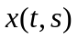 as
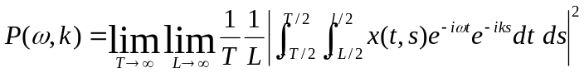
(1)

where is measurement time, is the distance between the probes, 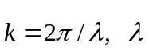 is a spatial period of displacements, and frequency 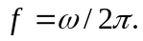
The 2-D spectrum contains the information about both relative and absolute motion, but it could not be measured directly unlike the two-dimensional relative power spectrum
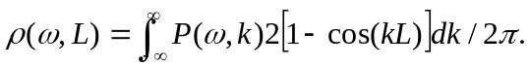
(2)
This power spectrum can be approximated by different ways for low and high frequencies

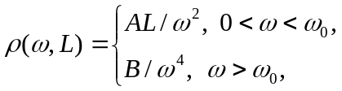 (3)
where discrimination frequency 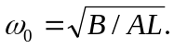
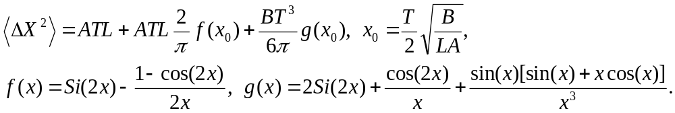The variance of the relative misalignment corresponding to (1) – (3) is given by formulae

(4)

Here 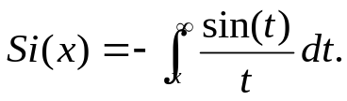
Thus the spectrum approximation can be represented by two coefficients: A – linear term, and B – cubic one.

Dynamic alignment algorithm

The original version of one-to-one dynamic alignment of the magnetic focusing elements of linear colliders have been suggested by V. Balakin et al. in 1996 [5]. Let our beam delivery system (BDS) includes a chain of N quads with a corrector and beam position monitor (BPM) on each of them, and A_{i} is as BPM read for i-th element. The iterative algorithm uses 3-element pattern to evaluate the need shift for i-th corrector
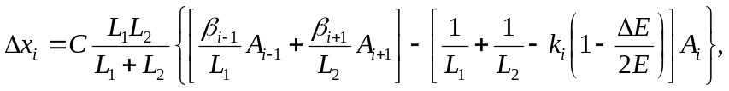
(5)

where L₁ – distance to the previous element, L₂ – distance to the next element, ΔE/E – beam energy spread, k_{i} – inverse focusing distance of the element, β_{i} – coefficient, which takes into account the differences of the real quad of length l_{i} from the thin lens approximation 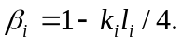
Consecutive application the algorithm (5) to each triple element set one can make the alignment for all focusing elements. Static alignment consists of iterative using this procedure up to convergence with pre-defined accuracy. Coefficient 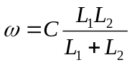 in (5) determines the rate of convergence. Static alignment should be done once for a long period, but dynamic alignment is performing continuously. The repetition rate for ILC bunch-train is 5Hz. It means that we get BPM read each 0.2 s, then we should make correction (5) for each element of BDS.
Theory of single Bunch stability and beam dynamics in linacs with wakefields and misalignment have been presented by G. Guingard and J. Hagel in publication [6].

numerical results for 4 different sites
Publication [4] presents 4 typical models of GM spectra characterized by different set of parameters obtained from experimental measurements at different sites. Model 1 (Protvino, VLEPP) has most aggressive spectrum (A=10⁻¹⁶, B=10⁻¹⁵), but model 3 (CERN, LEP) represents most quiet site (A = B = 10⁻¹⁸). Two other models represent intermediate cases: SLAC, SLC (A=10⁻¹⁶, B=10⁻¹⁸) and HERA,DESY (A=10⁻¹⁷, B=10⁻¹⁵). We used these 4 typical models as a benchmark for our algorithms. In our simulation we used a chain of N=100 quads with the distance L=34 m between them, energy spread ΔE/E = 1%, and random BPM error 1 nm. The GM profile and beam steering results versus time are given at Fig. 1.
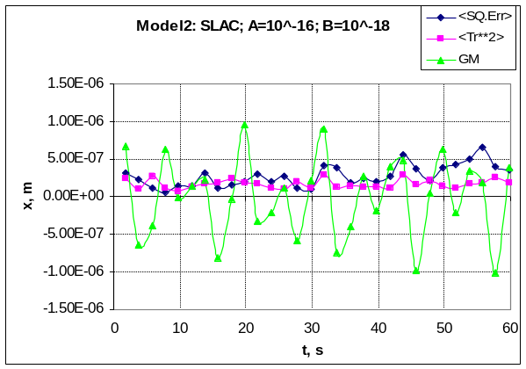
Model1: Protvino, VLEPP; A=10^-16; B=10^-15
-1.50E-06
-1.00E-06
-5.00E-07
0.00E+00
5.00E-07
1.00E-06
1.50E-06
2.00E-06
2.50E-06
0
10
20
30
40
50
60
t, s
x, m
<SQ.Err>
<Tr**2>
GM
- b)
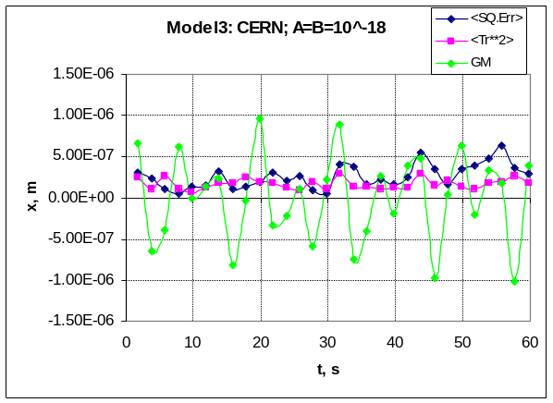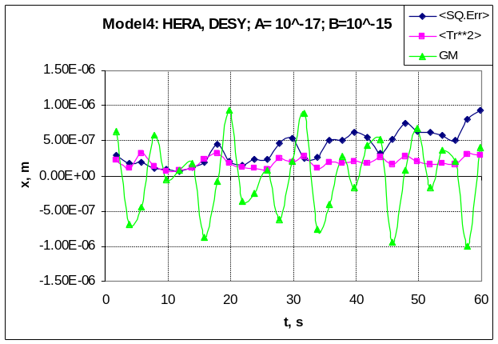
- d)
Figure 1. Beam steering with GM for different sites: a) Protvino; b) SLAC; c) CERN; d) DESY. Green lines represent the GM at some particular point of the structure; blue lines correspond to the misalignment variance over all elements of structure; red lines show beam steering – to the variance of trajectory offset.

Next Fig. 2 shows the spatial distribution of the GM and trajectories for these sites. All these data corresponds to the optimal value of the coefficient C≈0.02. The analysis of these data shows the steering stability area is much more narrow for the aggressive spectrum (Model 1) then for quiet site (Model 3).
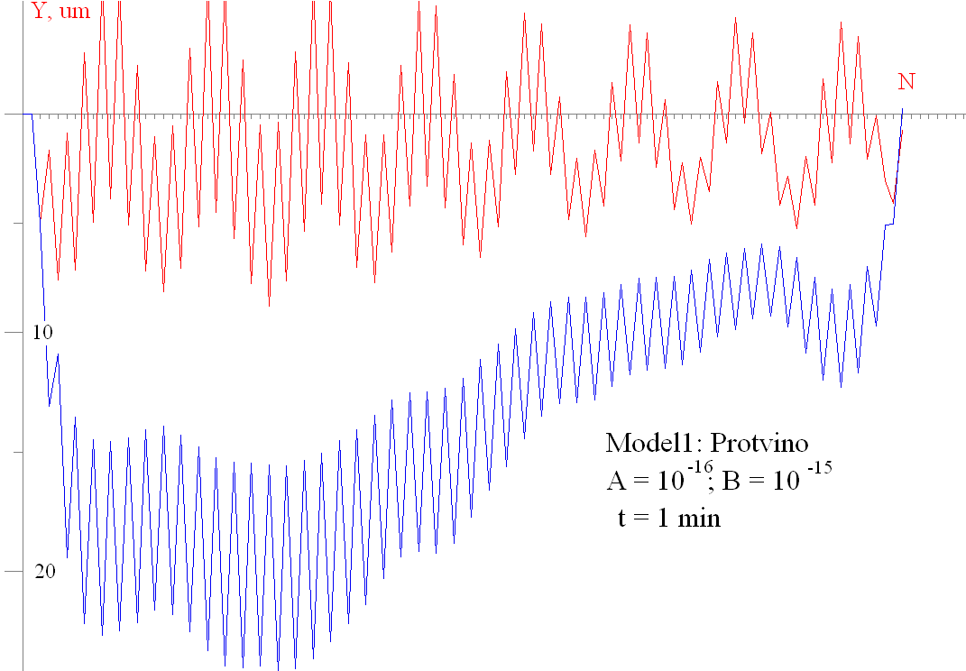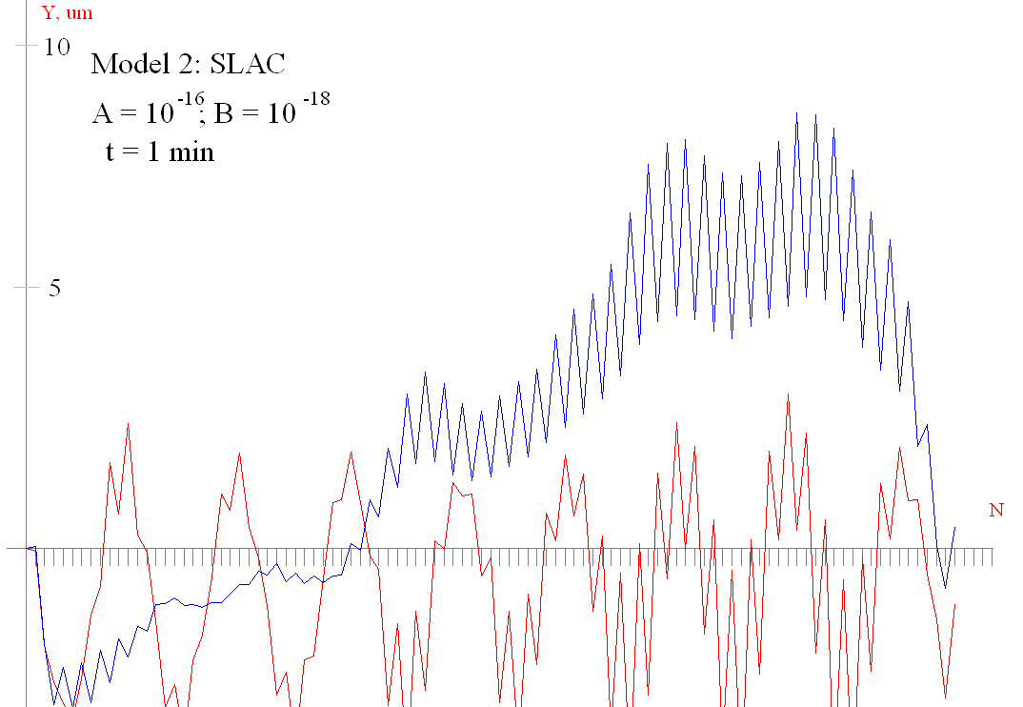
- b)
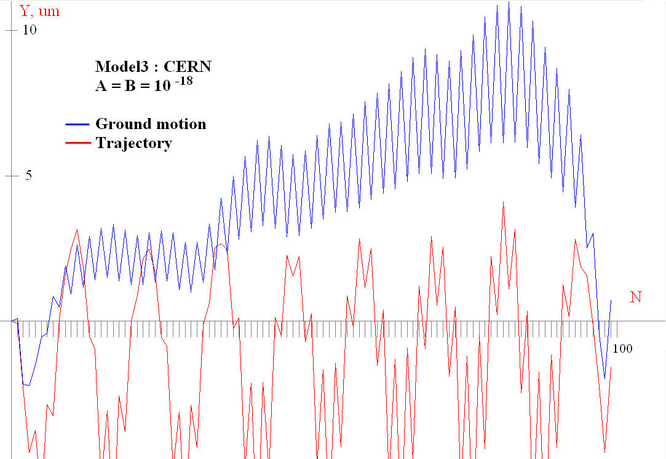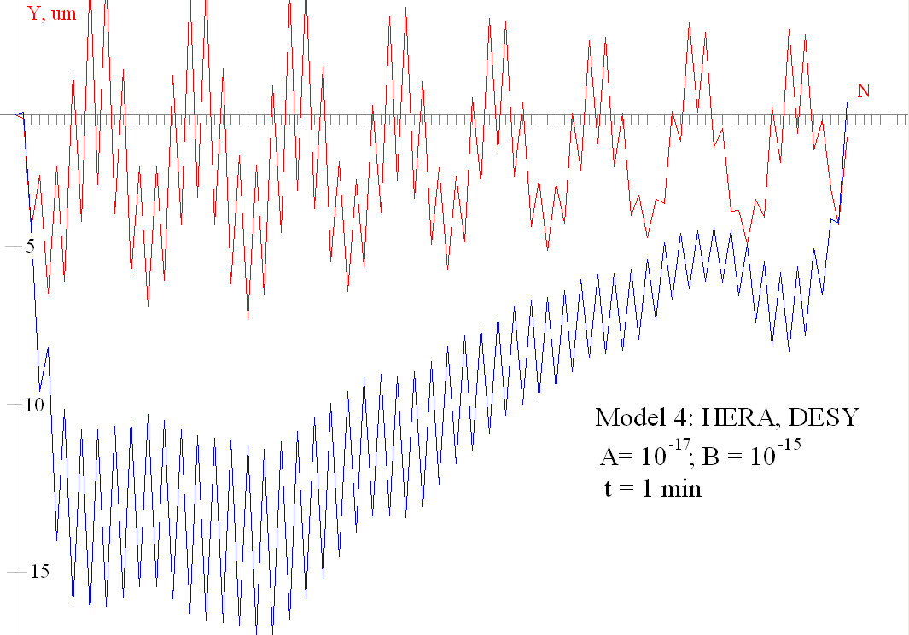
- d)
Figure 2. Spatial distribution of GM (blue lines) and beam trajectories (red lines) for different type spectra.

experimental & numerical data for fnal site
Similar simulations have been done for FNAL sites. The results are given at Fig.3. Coefficients A and B represent these spectra have been obtained from experimental data provided by V. Shiltsev and S. Signatulin. These data

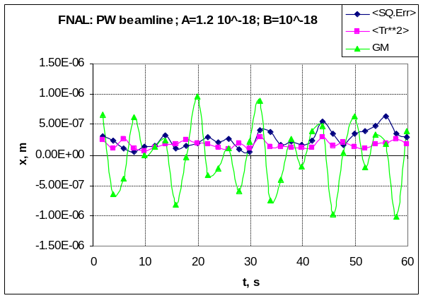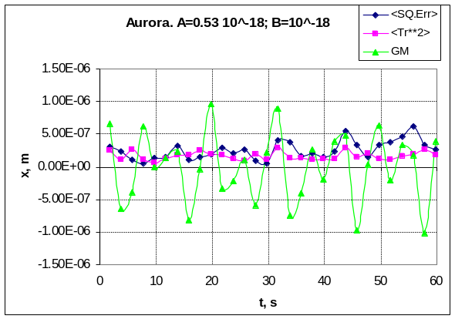

Figure 3. Beam steering with GM for FNAL sites: PW beamline and Aurora (100 m underground mine).

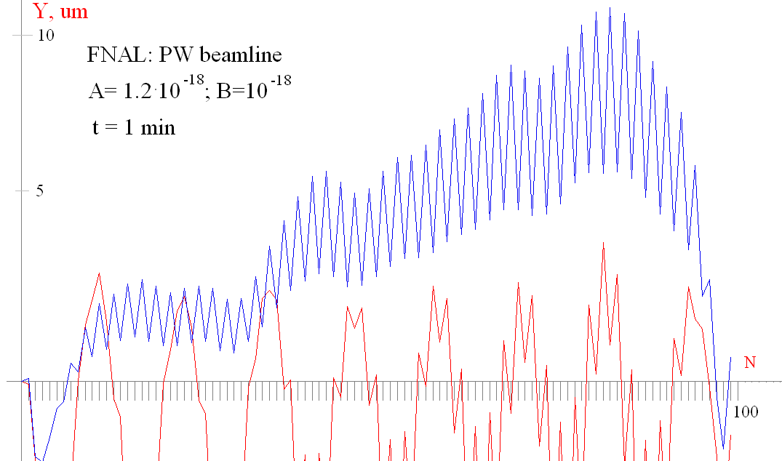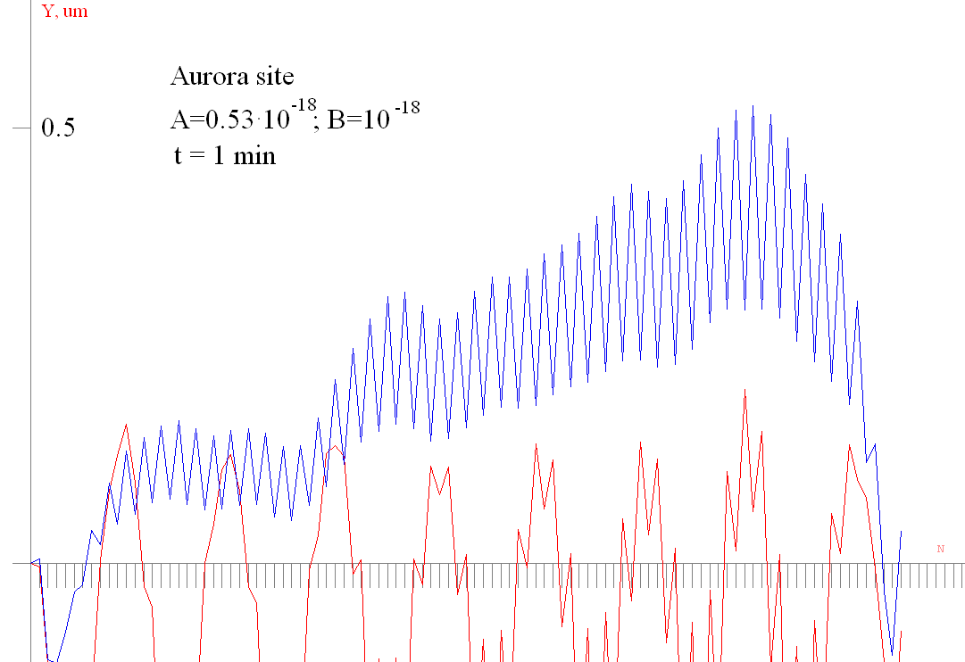
- b)
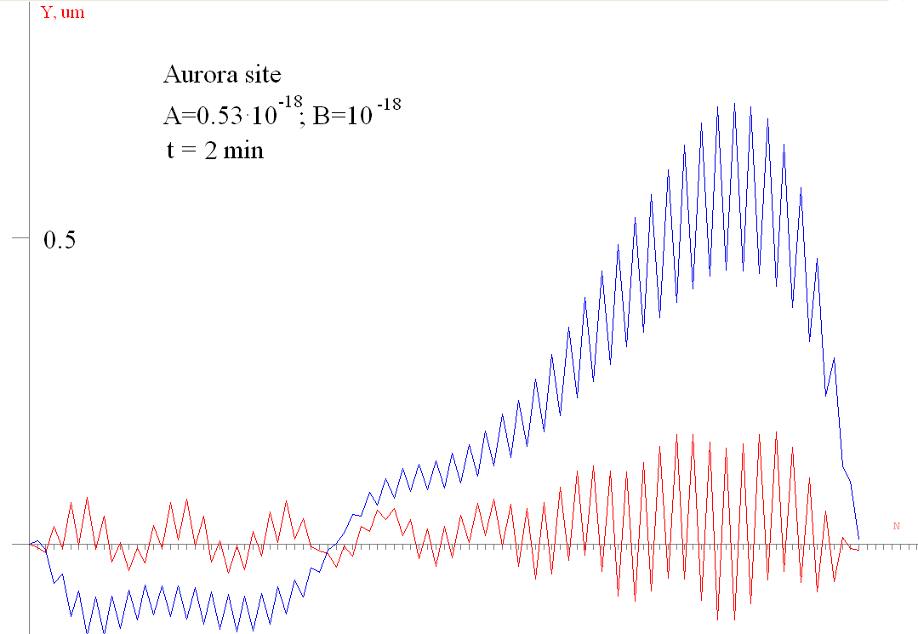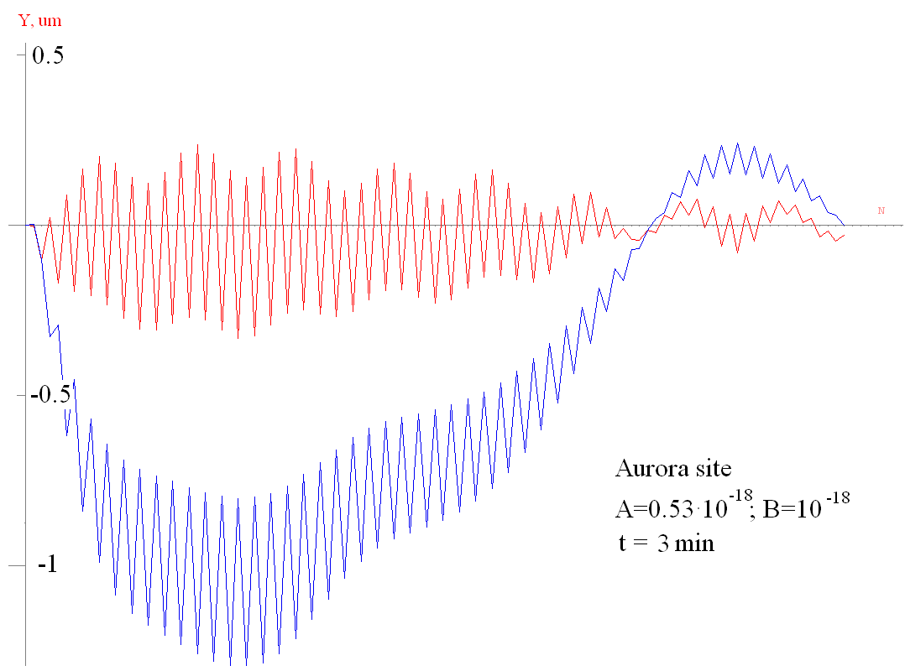
- d)

Figure 4. GM spatial distribution and beam trajectories for FNAL sites at different time moments.
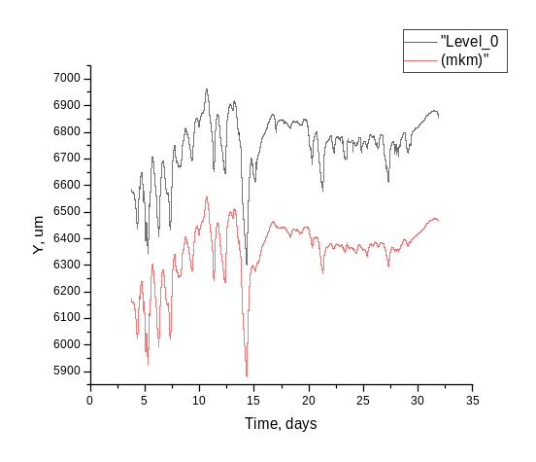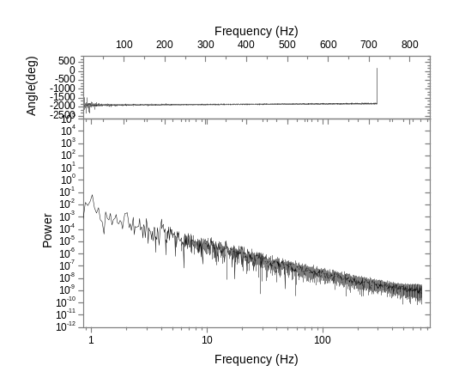

a) b)
Figure 5. a) GM signals from 2 different probes; b) spectrum for PW beamline.
Similar comparison for GM effects at 20 different sites has been done in publications [7] – [9].

Ackowledgments
The author wish to thank A. Seryi for the help with GM algorithm, N. Solyak for the help with the steering problem formulation, V. Shiltsev, S. Signatulin for their experimental data.
References
[1] Michelotti L., Ostiguy J.-F., CHEF: An Interactive Program for Accelerator Optics, Proc. of PAC’05,
May 16-20, 2005. Knoxville, Tennessee.
[2] A. Seryi, Ground Motion Study with Respect to Linac Performance, Proc. of XVIII Int. Conf. LINAC’96,
26-30 Aug., 1996, Geneva, Switzerland.
[3] A. Seryi, A. Mosnier, Spectral Analysis of Correction Techniques for Linear Colliders, Phys. Rev. E, 56, 3, 1997.-pp.3558-3571.
[4] A. Seryi, L. Hendrikson, P. Raimondi, T. Raubenheimer, P. Tenenbaum, Simulation Study of the NLC with Improved Ground Motion Models, Proc. XX Int. Linac Conf., August 21 - 25, 2000, Monterey, California.
[4] A. Seryi, O. Napoly, Influence of Ground Motion on the Time Evolution of Beam in Linear Colliders, Phys. Rev. E, 53 (1996) 5.
[5] A. Alexandrov, V. Balakin, A. Lumin, Experimental tests of the adaptive alignment of the magnetic elements of
Linear Collider. Proc. Of the LINAC’96 Conf., p.255, Geneve (1996).
[6] G. Guinard, J. Hagel, Theory of Single Bunch Stability and Dynamics in Linacs with Strong Wakefields and
Misalignments, CERN-SL-99-006 AP, CLIC Note 385.
[7] R. Amirikas, A. Bertolini, W. Bialwons, H. Ehrlichmann, Ground Motion & Comparioson of Various Sites,
EUROTeV-Report-2005-023-1.
[8] W. Bialowons, H. Ehrlichmann, Ground Vibration Measurements at the Proposed ALBA Site in Barcelona,
TESLA Report 2005-10.
[9] W. Bialowons, R. Amirikas, A. Bertolini, D. Kruecker, Measurements of Ground Motion in various Sites,
EUROTeV-Report-2006-33.

