Tevatron and Main Injector Sampled Bunch Displays

a.k.a. SBD

Randy Thurman-Keup
AD / Instrumentation Deptartment

BEAMS-DOC-3043-V1

Abstract
This document contains a brief description of the present Sampled Bunch Displays (SBDs) for the Tevatron and Main Injector. It describes the hardware and software at a relatively high level, and provides a description of the longitudinal emittance algorithm. The core of each SBD is a wall-current monitor connected to a 2GHz oscilloscope, the output of which is used to determine longitudinal bunch parameters.

Introduction
The Sampled Bunch Display (SBD) is a device for measuring the longitudinal parameters of beam bunches. The raw data consists of the intensity of the passing bunch as a function of time. These parameters may include the intensity, the centroid phase, the RMS bunch length in ns, the emittance in eV·s, and dp/p in units of 10⁻⁴. In the Tevatron, the skew and kurtosis of the time distribution is also presented.

Physical System

Hardware
The SBD works by digitizing the output from a wide-bandwidth resistive wall-current monitor (RWCM) [1]. A RWCM consists of a gap in the beampipe wall across which is placed a cylindrically symmetric collection of resistors. As the beam passes these resistors, the image current in the beampipe wall is forced to traverse the resistors producing a voltage which travels along a 7/8” heliax cable to the service building where it is available for use by various front-ends.
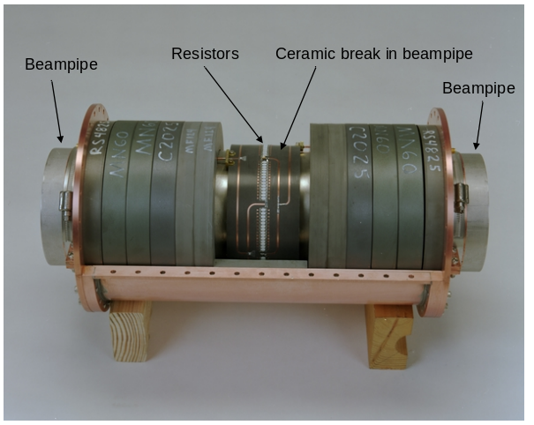
Figure
1: Resistive Wall Current Monitor.
In the service building, the signal for the SBD is split and connected to channels 2 and 3 of a Lecroy Waverunner 6200 oscilloscope running some version of Windows. One of these channels has low gain, while the other has high gain, providing a wider dynamic range than a single 8-bit channel. The scope has a 2 GHz analog bandwidth and digitizes the data at a rate of 5 GHz. After acquisition, the scope data is read by the front-end Power Mac running LabVIEW and processed to obtain the longitudinal bunch parameters. The scope acquisition is controlled by the front-end via a TCP/IP communication link.
Table
1: Networked SBD devices and their physical locations.
Hardware | Nodename | Location
MI SBD Computer | SBDMI.FNAL.GOV | Computer Room XGC-108
MI SBD Scope | SBDMISCOPE.FNAL.GOV | MI-60; RR MI60118
TEV SBD Computer | SBDTEV.FNAL.GOV | Computer Room XGC-108
TEV SBD Scope | SBDTEVSCOPE.FNAL.GOV | F0; RR F0107 (bottom)
Hot Spare Computer | INSTEST.FNAL.GOV | Computer Room XGC-108
Hot Spare Scope | SBDSPARESCOPE.FNAL.GOV | F0; RR F0107 (top)
MI Timing Board | MISBDTRIG.FNAL.GOV | MI-60; RR MI60119
MI Timing Spare | MISBDTRIG.FNAL.GOV | MI-60; RR MI60119

Tevatron Acquisition and Timing
In the Tevatron (TEV), the oscilloscope collects 32 single turn samples and averages them together. The triggers for the scope are generated by a custom NIM module that passes through the proper number of $AA markers which come directly from the RF system. The NIM module settings are controlled by a small LabVIEW executable running on the scope which communicates with the module through the parallel port of the scope. After the requisite number of acquisitions have been accumulated and averaged, the data is transferred from the scope to the front-end LabVIEW program where it is further processed and the cycle repeats. The acquisition cycles happen continuously regardless of whether or not there is beam in the Tevatron.
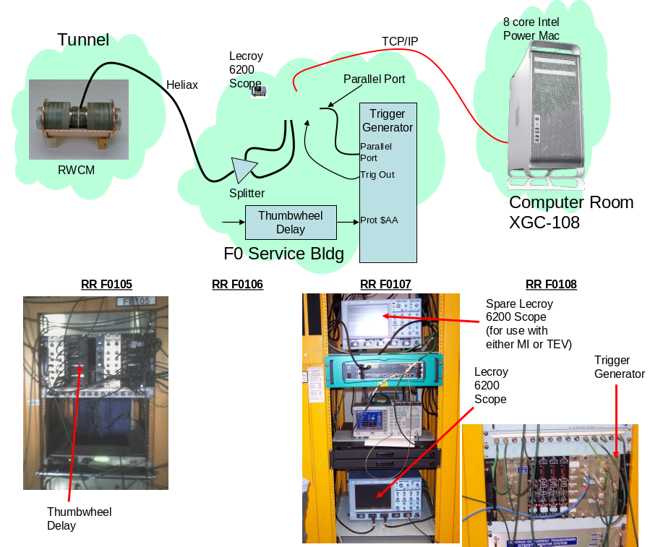
Figure
2: Tevatron SBD system components and connections.

Main Injector Acquisition and Timing
In the Main Injector (MI), the oscilloscope collects N acquisitions where N depends on the type of MI cycle currently running. Each type of MI cycle has a predefined list of acquisition times referenced to a specified clock event. In addition, some cycles require averaging over a number of samples spaced evenly over the synchrotron period to provide a more reliable emittance measurement. The combination of these two numbers determines how many actual triggers are collected by the scope. The triggers to the scope are generated by a NIM module containing FPGA firmware that listens for 2 clock events specified by the front-end, and then passes through specified $AA markers which arrive directly from the . The specifications are written to the module by the front-end using a telnet connection. The status of the board can be read to determine when the acquisition sequence is finished. At that time, the front-end pushes the data taken by the scope to internal scope memory to await readout by the front-end. This allows the next cycle of triggers to occur while the previous data is being transferred to the front end.
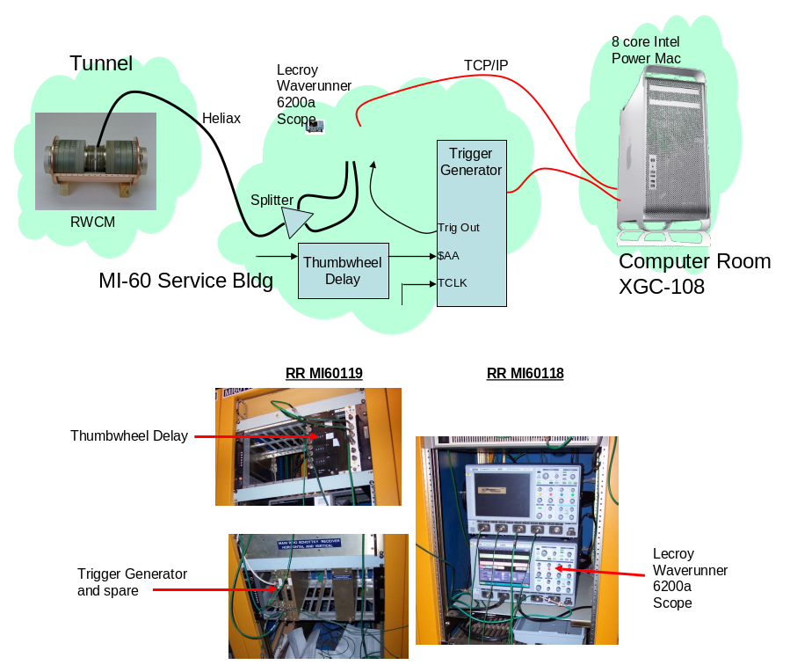
Figure
3: Main Injector SBD system components and connections.

Front-end Processing
Once all the triggers are collected, the data is read out over Ethernet by the front end. The current front end is a 3GHz Intel-based PowerMac with dual 4-core CPUs. The computers are running LabVIEW as the data acquisition software. LabVIEW has a slight advantage as far as the multiple processor cores go, since it has parallel processing capabilities built into its infrastructure. After processing, the measured bunch lengths, intensities, etc… are made available via ACNet. The code is setup in such a way that there are a small number of VI’s that concurrently run continuously. Each of these is a separate thread of execution.
The code has a version number N.NMMM that consists of the user code version, N.N, and the LabVIEW version it was developed for, M.MM. The code is archived in //beamssrv1.fnal.gov/inst.bd/Instruments/SBD/ where there are MI and TEV folders, each with a LabVIEW Code folder where the zip files for all the versions are stored.

MI SBD Threads
All threads are initiated from the top level VI, after some initialization stuff. There are 5 main threads: 3 data processing and 2 communications related. Figure 4 contains a high-level VI diagram for the main threads.
- DAQ
The DAQ thread is responsible for setting up and arming the hardware. It also monitors changes to ACNet settings and implements them. It arms the timing board and scope and, once the cycle is complete, initiates a transfer of the scope data to internal memory and fetches information from the timing board. At this point it rearms the scope and notifies the ScopeReadLoop thread that there is data waiting to be read.
- ScopeReadLoop
This threads only purpose is to fetch the data from the scope and put it into a LabVIEW message queue for processing by SBDMIMainNew. This thread and the DAQ thread share oscilloscope access time via a semaphore.
- SBDMIMainNew
This is the largest thread and is responsible for all of the actual processing of the scope data. It pulls data out of the message queue, does trace averaging if requested, does the baseline subtraction and cable dispersion and calculates all the longitudinal bunch parameters. It makes use of parallel processing by farming out each acquisition time to a separate instance of the analysis VI. Notification of new data is accomplished via a states device, V:ISBDRD.
- Acnet
This thread is responsible for all ACNet communication. It is used in virtually all LabVIEW applications in the Instrumentation department.
- Dispatcher
This thread handles communication with the TCport application which runs on one of the controls machines in the computer room and is used for direct front-end to front-end data access. ACNet information is usually pushed to or pulled from a front-end, but this TCport link allows the front-end to pull from or push to another front-end through the TCport application.
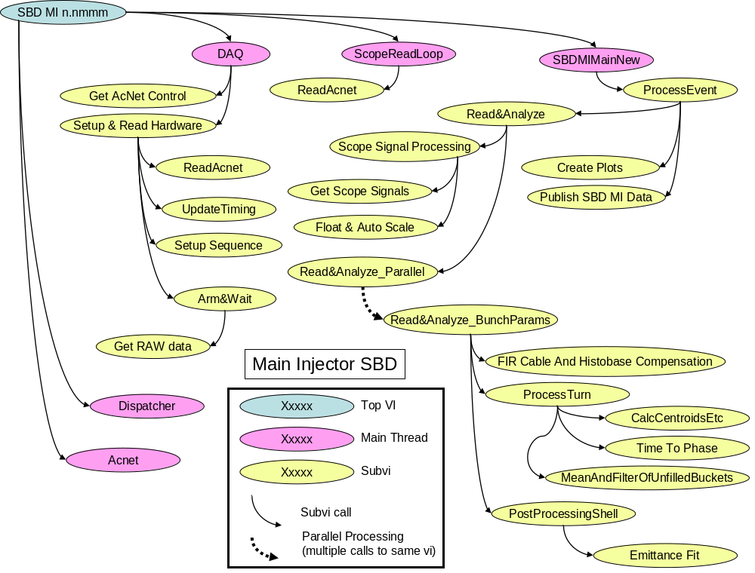
Figure
4: High-level VI diagram for the main threads of the MI SBD code. The arrows indicate VI calls. Not all VI’s are indicated here. The parallel process arrow indicates that there is more than one call to that VI and that they are in parallel. The called VI must of course be declared reentrant to take advantage of the parallel processing.

TEV SBD Threads
All threads are initiated within one VI from the top level. There are 4 main threads: 2 data processing and 2 communications related. Figure 5 contains a high-level VI diagram for the main threads.
- Scope DAQ
The DAQ thread is responsible for setting up and arming the hardware. It runs repetitively independent of any clock events.
- Data Processing
This is the largest thread and is responsible for all of the actual processing of the scope data. It does the baseline subtraction and cable dispersion and calculates all the longitudinal bunch parameters. It calculates parameters not only for the bunch, but also for some of the satellites. Notification of new data is accomplished via a states device, V:TSBDRD.
- Acnet
This thread is responsible for all ACNet communication. It is used in virtually all LabVIEW applications in the Instrumentation department.
- Dispatcher
This thread handles communication with the TCport application which runs on one of the controls machines in the computer room and is used for direct front-end to front-end data access. ACNet information is usually pushed to or pulled from a front-end, but this TCport link allows the front-end to pull from or push to another front-end through the TCport application.
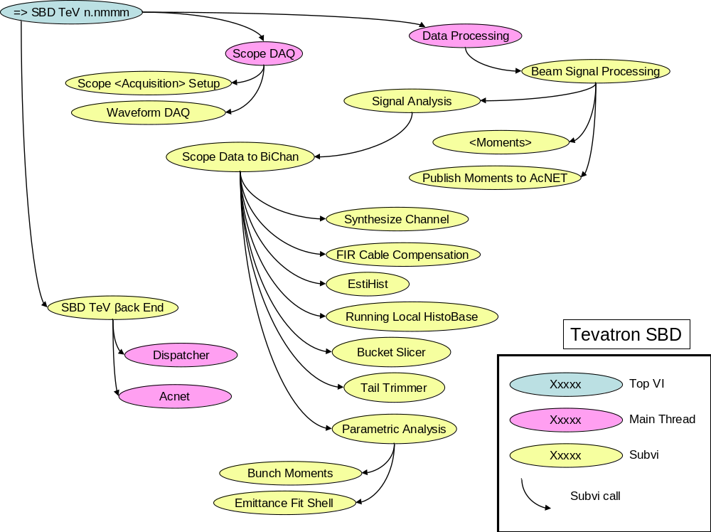
Figure
5: High-level VI diagram for the main threads of the TEV SBD code. The arrows indicate VI calls. Not all VI’s are indicated here.

Algorithms

Emittance
Discussions about the emittance fitting can be found in Reference [2]. The basics of this method are to divide longitudinal phase space into concentric regions for which the density of particles would be the same for an equilibrium bunch and use the projections of these regions onto the time axis as a set of fitting functions for the actual time distribution of the bunch. A major assumption in this method is the equilibrium nature of the bunch. For the Tevatron, this is a really, really good assumption. For the Main Injector, it is not so good, depending on how many synchrotron periods have passed since the last manipulation of the beam. We can get around that problem at some level by averaging over multiple samples evenly spaced throughout the synchrotron period.

Theory
From Edwards and Syphers, Eqn. 2.45,
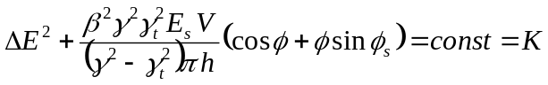
E_{s} = ring energy in eV
V = RF voltage in Volts
h = harmonic number
φ_{s} = synchronous phase (assume to be zero for non-accelerating beam and negligible synch radiation losses)
K = phase space contour
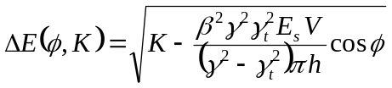
Now let
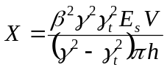
and shift φ so that it goes from –π to π giving us
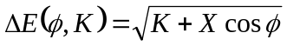
K can be written as FX where F = [-1,1] with -1 being zero emittance and 1 being the separatrix
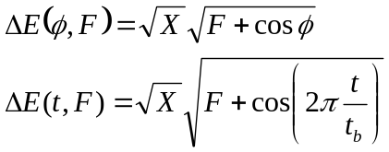
where t_{b} is the bucket period.
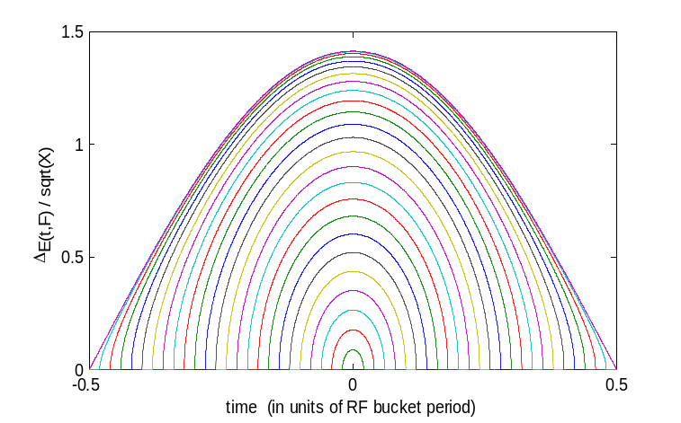
Writing this in discrete matrix form we have
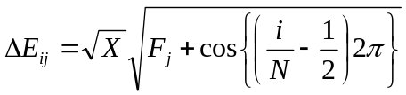
where N is the number of data points on the time axis and F_{j} is the F value of the j^{th} contour.
Here is F_{j} for a number of scenarios (j = 1..M):
- Uniform increments in maximum t (see plot above)
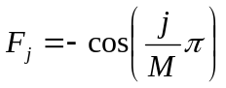
- Uniform increments in maximum ΔE
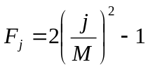
- Uniform increments in phase space area (need to solve for F_{j})
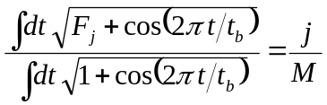

Emittance Fit
The projected phase space P(t,F) in the annulus between F and F + ΔF is
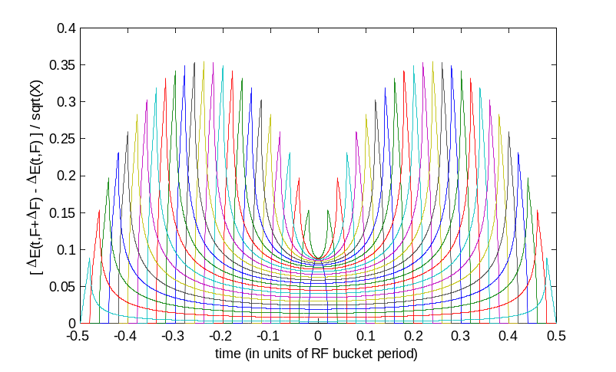
or in discrete matrix form
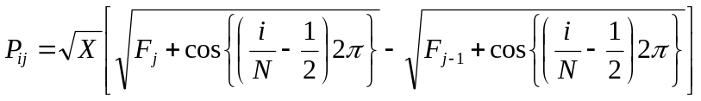
We can now construct a fitting function as a sum of the P_{ij} fitting functions with coefficients to be determined
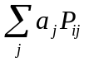
The a_{j} coefficients can be determined by a least squares method
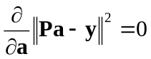
where we have N beam intensity points in time, y_{i,} corresponding to the N fitting function points resulting in the solution
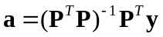
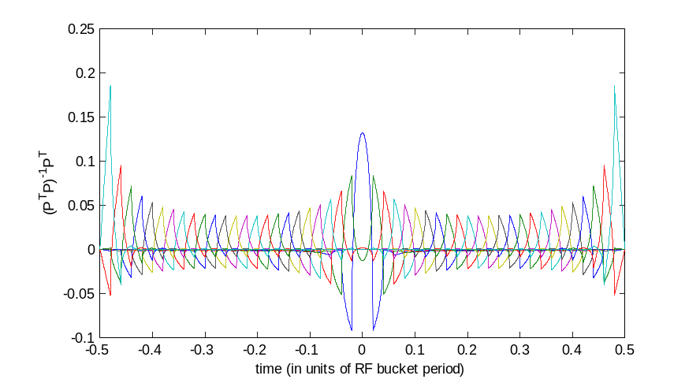

The coefficients, a, tell us the unnormalized relative particle densities in each annulus.
To obtain an emittance, we must first determine the region containing the desired fractional particle count (e.g. 95%) by integrating over the relative particle densities of each annulus until we reach the desired particle count. The relative particle count in a annulus is a product of the relative particle density and the phase space area for that annulus.
The phase space area of an annulus is
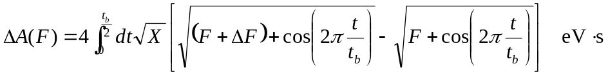
or in semi-discrete form
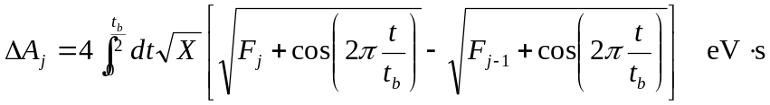
which is an elliptic integral.
Combining with the coefficients, we obtain the cumulative fractional particle count through annulus m
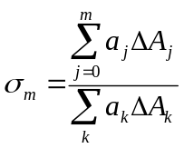
To determine the nn% emittance, one needs to determine the m value, m_{o}, where σ_{m} = 0.nn.
The σ_{m} distribution can be interpolated to allow m_{o} to be a fractional number.
The emittance is then given by
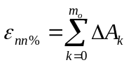
where again, the ΔA_{k} can be interpolated to obtain the value at the possibly fractional m_{o}.

Momentum Dispersion
A measurement of the RMS(p) of the particles in the bucket starts with the 2nd moment formula where we use a(F) to represent the unnormalized relative particle density in annulus F (this is the continuous variable version of the coefficients):
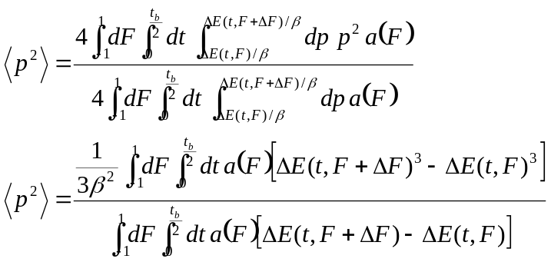
where we have made use of the fact that p = ΔE/β (the β relationship is inverted because these are energy and momentum differences). In discrete terms this is
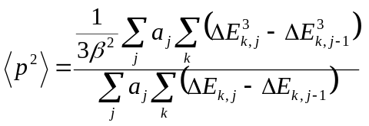
and dp/p is
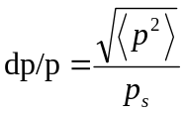

Code Implementation

Tevatron
In the TEV SBD code there are 5 arrays used in the emittance fits. Here they are matched with the corresponding functions from above (the XXX is either 150 or 980 depending on what energy the beam is currently at).
- fit XXX
This is (P^{T}P)⁻¹P^{T} with P_{ij} defined as above.
- s_fit XXX
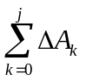
- dels XXX
ΔA_{j}
- psq XXX
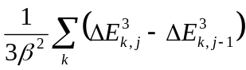
- norm XXX
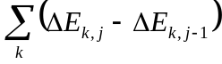
These arrays are generated at either 150 GeV or 980 GeV with an RF voltage of 1.11 × 10⁶ V. For each acquisition, the RF voltage is read and a correction is applied based on the difference between the actual voltage and the nominal voltage (1.11 MV).

Main Injector
Since the conditions of the Main Injector differ greatly depending on the type of cycle, the emittance algorithm does not have fixed fitting arrays as in the TEV. Instead there is a master array of fit functions, sampled at 0.1˚ in phase, from which the desired array is generated by interpolation. The details of will be described in more detail in the next version of this document.

Acknowledgements
Many people have worked to bring the TEV and MI SBD systems to their present state, including (but probably not limited to) Alan Hahn, Willem Blokland, Chandra Bhat, Brian Fellenz, and most recently Bob Flora, who rewrote much of the Labview code, Stephen Pordes, Alvin Tollestrup, and Adam Para.

References

- B. Fellenz and J. Crisp, BIW 98 An improved Resistive Wall Monitor & AIP Conf. Proceedings 451 pp. 446-453.
- A.V. Tollestrup, BEAMS-DOC-541, 548, 658, and 881.
- B. Flora, BEAMS-DOC-1117 and BEAMS-DOC-1269.
- S. Pordes, PAC05, BEAMS-DOC-1818.

The Tevatron scope runs Windows 2000, while the Main Injector scope runs Windows XP.

