Summary of Buncher 1 Conditioning

Robyn Madrak
Sep 23, 2009

Status
As of 09/09/09, Buncher 1 was fully conditioned to operate at 6 kW with a 3ms pulse length at 2 Hz. The nominal buncher power is 5.5 kW. The cavity was operated at this level for 8 hours without incident. During this time, the vacuum pressure with ion pump and turbo pump was about 6.6E-07 torr as measured by the ion gauge, and 5.4E-07 torr as measured by the ion pump power supply. (When not being powered, the pressure was ~3.3e-07). The cavity was able to run for this time without tripping.

Baking
The buncher cavities are not baked. This is to avoid any possible problems with the thin copper plating.

Vacuum
Since this cavity was not baked, the pressure was higher than in the RTCH cavities. Because of this, both the ion pump and the turbo pump were always used during conditioning.

Settings
- No water cooling was used during conditioning
- During the final six hours of conditioning, the cavity frequency ranged from 325.036 MHz (low power) to 325.000 MHz (high power, running for 6 hours). This was as measured by minimizing reflected power. The cave temperature ranged from 78F at the beginning of the day to 81.5F at the end of the day. According to JPAW documents, frequency dependence is 6 kHz/deg C, which we have verified at temperatures near room temperature. See Figure 2.

Other Anomalies
- The cavity probe had to be replaced. It was working during the initial network analyzer measurements, but the loop came unsoldered after that (after connecting to high power RF system but before any substantial amount of power (<100W peak) was applied). The probe was replaced with a spare.
- Since the cavity coupling loop is large, it is necessary to add 12 dB attenuators on its output.
- It was not discovered until the conditioning of Buncher 2 on 9/22 that the motor spec on the buncher tuner motors is 2 A, as opposed to the 1 A for the RTCH cavity tuner motors. For buncher 2, the motor controller was switched to 2 A.

Details

- 08/31/09: Started at low power, 100us pulse width, 0.5 Hz and conditioned to 6.3kW
- 09/01/09: Continued conditioning to 3ms, 2Hz, 6.3kW. Only a handful of small spikes in large reflected power were observed. We tripped off on these.
- 09/03/09: Timergali replaced the broken monitor with a he spare. The monitor which had broken had been modified at FNAL to decrease the size of the loop (coupling was too large).
- 09/04/09: Continued to condition at 3ms, 2Hz, 5.8kW. Saw some multipacting around 425 W. No problem at 5.7kW.
- 09/09/09: Conditioned for six hours at 3ms, 2Hz, 6kW. There was no multipacting, sparking or any other incident
- Further details may be found at http://www-hins-crl.fnal.gov/hins/Index.jsp
- Figure 3 shows the measured resonant frequency for various tuner positions.

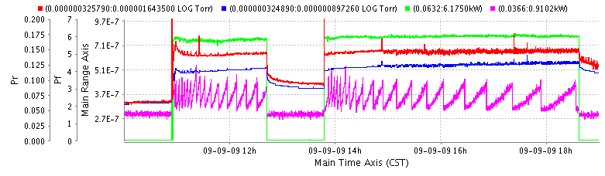

Figure 1: Forward and reverse power (kW) (green and magenta), and pressure (blue = ion pump, red = ion gauge) during the final 8 hours of conditioning.

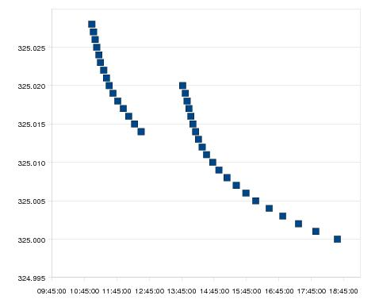
Figure 2: Cavity frequency vs. time at full power. Frequency was measured by minimizing reflected power. Frequency dependence according to JPAW document is 6kHz/deg C. The temperature in the cave at the beginning/end of the day was 25.5/27.5 C. The total frequency change above is 28 KHz.

 | IB4 | MDB
temp (deg C) | 21 | 25.5
tuner all the way out | 324.97 | 324.945
tuner all the way in | 325.42 | 325.397
nominal* | 325.05 | 325.03

Figure 3: Measured frequency(MHz) (low power) vs. tuner position. *Nominal is the tuner position when the cavity was delivered to MDB.

