Summary of Buncher 2 Conditioning

Robyn Madrak
Oct 19, 2009

Status
As of 09/24/09, Buncher 2 was fully conditioned to operate at 6.6 kW with a 3ms pulse length at 2 Hz. The nominal buncher power is 5.5 kW. The cavity was operated at this level for 5 hours without incident. During this time, the vacuum pressure with ion pump and turbo pump was about 2E-06 torr as measured by the ion gauge. The higher pressure is due to the fact that we began conditioning a short time after the initial pump down. (When not being powered, the pressure was ~1.0e-06). The cavity was able to run for this time without tripping. By 10/26/09, when the cavity was moved to the storage room, the pressure had improved to 2.36e-07.

Baking
The buncher cavities are not baked. This is to avoid any possible problems with the thin copper plating.

Vacuum
Since this cavity was not baked, the pressure was higher than in the RTCH cavities. Because of this, both the ion pump and the turbo pump were always used during conditioning.

Settings
- No water cooling was used during conditioning
- During the final five hours of conditioning, the cavity frequency ranged from 325.016 MHz (low power) to 324.988 MHz (high power, running for 5 hours). This was as measured by minimizing reflected power. According to JPAW documents, the frequency dependence is 6kHz/deg C, which we have verified at temperatures near room temperature. See Figure 2.

Settings
- It was not discovered until the conditioning of Buncher 2 that the motor spec on the buncher tuner motors is 2 A, as opposed to the 1 A for the RTCH cavity tuner motors. For buncher 2, the motor controller was switched to 2 A.

Details

- 09/23/09: Started at low power, 100us pulse width, 0.5 Hz and conditioned to 6.3kW, 2ms, 1Hz. We observed some multipacting around 2-3 kW.
- 09/24/09: Continued conditioning to 3ms, 2Hz, 6.6kW, with no spikes in reverse power or trips. Figure 1 shows the progress.
- Further details may be found at http://www-hins-crl.fnal.gov/hins/Index.jsp
- Figure 3 shows the measured resonant frequency for various tuner positions.

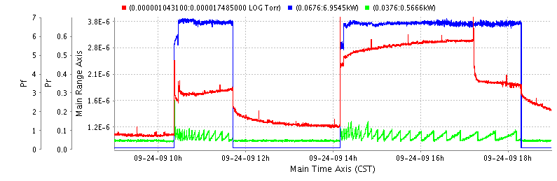
Figure 1: Forward and reverse power (kW) (blue and green), and pressure (red) during final conditioning. At some between 14:00 and 17:00 the ion pump had tripped off. It was turned back on at 17:00. This explains the higher pressure during that time.

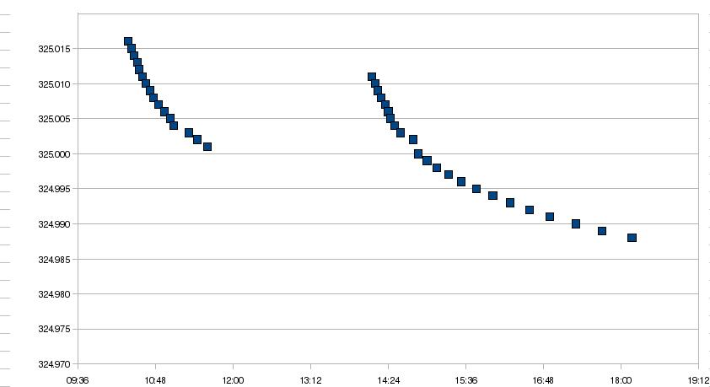
Figure 2: Cavity frequency vs. time at full power. Frequency was measured by minimizing reflected power. Frequency dependence according to JPAW document is 6kHz/deg C.

 | IB4 | MDB
temp (deg C) | ? | 25.8
tuner all the way out | 324.95 | 324.947
tuner all the way in | 325.4 | 325.4
nominal* | 325.05

Figure 3: Measured frequency(MHz) (low power) vs. tuner position. *Nominal is the tuner position when the cavity was delivered to MDB.

