Summary of RTCH1 Conditioning

Robyn Madrak
Oct 20, 2009

Status
As of 4/9/09, RTCH1 was fully conditioned to operate at 5.6 kW with a 3.5 ms pulse length at 2 Hz. This is somewhat larger than 120% of the nominal 3.14 kW (power to be dissipated in the cavity). The cavity was operated at this level for 7.5 hours with no incident. The cavity was also operated at 3.7 kW for 0.5 hours.
Note: CH1 had previously been conditioned in September ’07. It was reconditioned as documented here after being sent back to Technical Division for tuner upgrades.

Baking
- In the interest of time this cavity was not baked.

Vacuum
- The eight hour test was done running with both the ion and turbo pumps (since the cavity was not baked and the pressure was higher). The final cavity pressure at the end of the test was ~1E-7; base pressure with no RF was 7E-8. By 4/14, when the cavity was removed from the test stand, the pressure was 2.2E-08.

Settings
- During conditioning the tuner was moved to stepper motor position 900. Position 0 corresponds to near mid-range position as shipped from technical division. Position -7950/8127 corresponds to the tuner plunger being all the way in/out.
- With cooling water hooked up, at low power, f was 325.075. At the end of the 8 hour test f was 325.060. This was measured by adjusting the frequency on the RF generator to minimize reflected power.

Other Anomalies – Deformation during vacuum pumping
- When the cavity arrived at MDB, we measured the frequency to be 325.028 MHz.
- After two days, the cavity was moved to the test stand and pumped.
- When we began conditioning, the reflected power was extremely large.
- We remeasured the resonance frequency to be at 318 MHz under vacuum. When let up to atmosphere, f was 317 MHz.
- The cavity was returned to Technical Division for inspection.
- Upon inspection, it was determined that both copper end walls had deformed inwards leaving a very small gap between the drift tubes. Gaps 1 and 4 were very small; gaps 2 and 3 were unaltered. The current theory is that this happened due to a large change in pressure during rough pumping. To prevent this in the future, an orifice was installed in the pump setup to limit pumping speed during pumping and venting. See Figure 1.
- The cavity was mechanically deformed back to f = 324.85 MHz (not under vacuum) with tuner at mid range.
- Cavity was shipped back to MDB for conditioning.
- Under vacuum, at low power (without cooling water connected), we measured f = 325.188 MHz with tuner at mid range (stepper motor position = 0) and T=18 C.

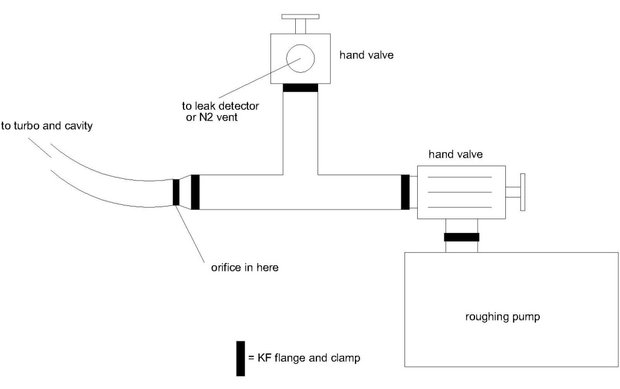
Figure 1: Pump setup with orifice to limit rough pumping/venting speed.
Details
- 4/08/09: Started at low power, 100 us pulse width, 2 Hz and conditioned to 5.28 kW, 3.5 ms, 2 Hz. Some multipacting in the coupler was observed.
- 4/09/09: Continued to condition with a 3.5 ms pulse width at 2 Hz, 5.6 kW. Conditioned for eight hours with no incident. See Figure 2.
- 4/14/09: Cavity was filled with nitrogen and stored in crate near the 325 MHz test cage, as to be available for low level RF testing.
- Further details may be found at http://www-hins-crl.fnal.gov/hins/Index.jsp

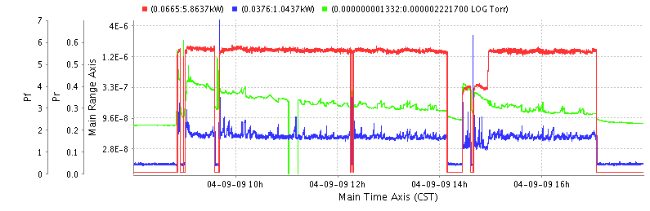
Figure 2: Forward and reverse power (red and blue), and pressure(green) during the final 8 hours of conditioning.

