Summary of RTCH9 Conditioning

Robyn Madrak
Oct 21, 2009

Status
As of 4/01/09, RTCH9 was fully conditioned to operate at 27.7 kW with a 3.5 ms pulse length at 2 Hz. This is somewhat larger than 120% of the nominal 20.78 kW (power to be dissipated in the cavity). The cavity was operated at this level for 5 hours, and at 21.5 kW for 3 hours.

Baking
- The cavity was baked per usual procedure to 150 C.

Vacuum
- Running on the ion pump alone with the turbo valved out, the final cavity pressure was 9.0 E-8; base pressure with no RF was 2.6 E-8.

Settings
- During conditioning, the cavity frequency feedback loop (PID1) was used.

Details
- 03/23/09: Started at low power, 100 us pulse width, 1 Hz and conditioned to 20 kW, 3.5 ms, 2 Hz.
- 03/24/09: Continued to condition with a 3.5 ms pulse width at 2 Hz, 25.4 kW. Some multipacting was observed in the coupler (this diminished later in the day), and a spark was observed occasionally.
- 04/01/09: The cavity was run for eight hours at 3.5ms, 2Hz. For three hours the power was set to 21.5 kW and for five hours it was set to 27.7 kW.
- Further details may be found at http://www-hins-crl.fnal.gov/hins/Index.jsp

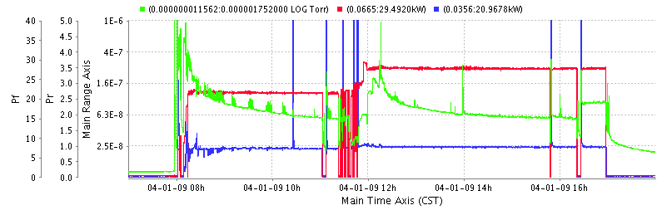
Figure 1: Forward and reverse power (red and blue), and pressure (green) during the final 8 hours of conditioning.

