Ground Motion studies at Fermilab 2009
Alexey Naumov, James T Volk
September 2009

- Introduction.
Modern high energy physics accelerators required more and more beam energy for new research; hence it requires much large accelerators with high alignment accuracy of accelerator elements. In this case ground motion makes a problem for scientists, because deviation of several ground points may be from 10µm to 1000µm and more per month. It depends from site, where points are placed. Displacement of two points 100m or more can be much more. For quad displacement it is big values, it can be cause of big loss of energy and dispersion. Therefore it is important to understand nature of slow ground motion and make the same forecast of displacement for any site.
- Experimental setup.
For monitoring slow ground motion at Fermilab several types of sensors are used. These are ultra sonic sensors, tilt-meters, seismometers and capacitive sensors (fig. 1). The last one is common at Fermilab, because it is simple and not expensive; also they accumulate data with acceptable precision (~1-6 µm). This sensor measure distance of air gap between water surface and electrode on bottom of electronic module. Electronic module contains a generator and oscillatory circuit. Oscillatory circuit consists of an inductive coil and capacitor. One side of capacitor is water surface and other side is electrode. The circuit estimates the value of capacitance by signal, which it receives from oscillatory circuit; hence it can compute distance between water surface and electrode.
The Hydrostatic Level Sensors (HLS) system consists of several capacitive sensors connected by water and air pipe system. Experimental setup represents the system of communicating vessels. Sensors placed on north-south or east-west direction can determine deviation of the tilt. Each sensor records the temperature of the water pool. It can determine deviation of two points there are placed sensors by compute water level in the same sensors.
HLS service connects with PC by HLSInterface programs, developed in Budker institute of Nuclear Physics. This software gets data from HLS system by Ethernet cable. It also contains calibration for each sensor and shows for user relative and absolute levels in sensors. They accumulate data by “.lev” files.

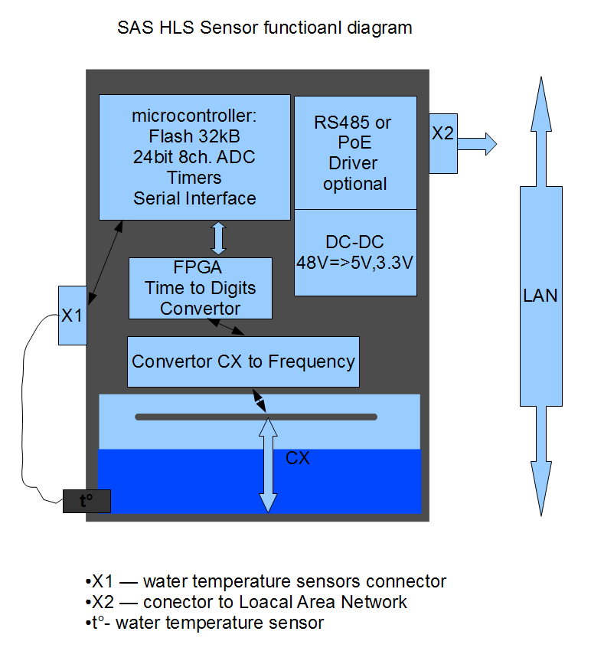

Figure 1.
At Fermilab there are several systems at different sites.
- 9 Budker sensors on the low beta quads at each interaction region
- 204 Tevatron style sensors one on each Tevatron quadrupole
- 5 Budker sensors in the LaFarge mine North Aurora Illinois
- 7 Budker sensors in the near MINOS hall Fermilab
- 11 Tevatron style sensors on floor in NMS hall photo injector test
- 6 sensors various types stability test at MP-8 Fermilab
- 12 PoE and 3 Capacitive “hot” spares at MP-8

3. ATL law.
This is an empirical rule that describes the relative displacement between two points. The RMS of two points located at distance L, for a time T is given as:
The value of order for A constant is. It’s depending on site. ATL law describes low frequency ground motion generated by local sources such as variation of temperature and pressure, wind, ground water etc.
- Experimental software.
Experimental software contains several programs. It is HLSInterface described above, Postgras database with simple web GUI for adding and extracting data, written on Python and small C++ program for compute average, sigma, double difference and “A” constant for a chosen time interval. Also it can compute correlation between any functions.

- How the “HLS program” works.
HLS program write in C++. It is software that takes data from Postgres database. The database contains time stamped data in rows from HLS system, at MINOS and Aurora Mine site. After extracting “HLS program” writes files with such information, see below:
- Average for installed time interval
- Sigma for same time interval
- Average for double difference at same time interval
Also the program can estimate “A” constant for ATL law and correlation coefficient between simple difference (two choose sensors) and average of temperatures in same sensors.
The program needs connect to fnal.gov domain through flix02 branch. <flix02.fnal.gov>
Before starting, the program needs to install environment variables. For setup variables you need type in terminal window:
source setup_env.sh
Clear all compiled program before.
make clear
It need compile and link t1 file type in terminal window
make t1
Program starts by “t4” file. To compile and link this file type in terminal window
make t4
To run the program you must type
t4
Program’s Shell is very simple. After start you need (fig. 2):
- choose database (MINOS or Aurora mine)
- choose “Estimate correlation coefficient”, if you need
  - If you set this option, you must choose two sensors. Between witch differences ant temperatures you want estimate correlation coefficient. Type only numbers of sensors!
- Set a year, month and time interval, which will be averaged all data.
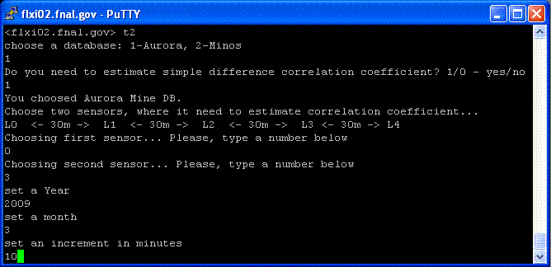
Figure 2.
When program is finished you can see any empty row in data base (if it’s exists). Also program show A constants and correlation coefficient (fig 3).
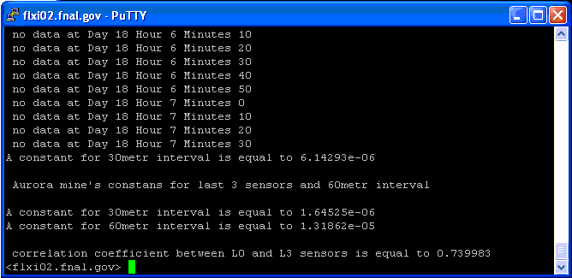
Figure 3.
Average data, Sigma and Average of double difference you can see in “.txt” files with same names and dates. They contain same values for each sensor by level and temperature. Pressure measured by one sensor, hence it’s alone for all sensors. File names and examples see below:
Example for compute data at August 2009 on Aurora mine site (increment is equal to 10 minutes):
For average: Average_”Site”_”Increment”_”Month”_”Year”.txt 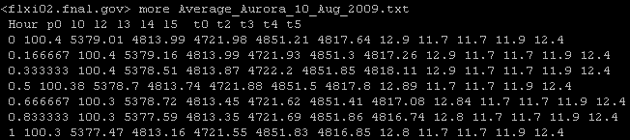

For sigma: Sigma_”Site”_”Increment”_”Month”_”Year”.txt
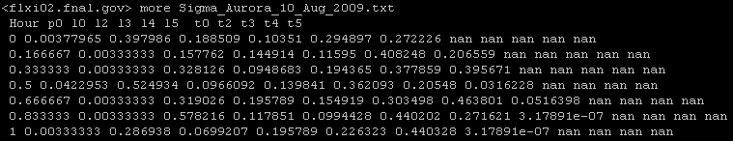
For average of double difference: AverageDoubleDiff30_”Site”_”Increment”_”Month”_”Year”.txt
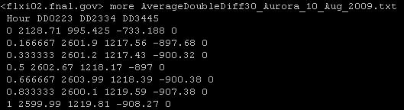

For “A” constants and correlation coefficients: Constants_”Site”_”Increment”_”Month”_”Year”.txt
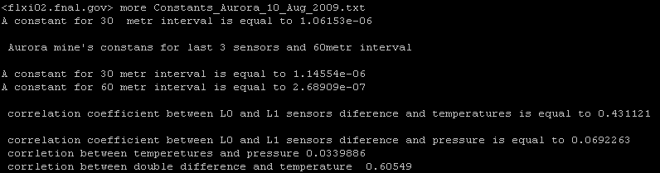

- Programs test.
C++ program was tested by estimating “A” constant and correlation for MINOS and Aurora site. In first time all computing was checking by manual computation of same parameters. And tests give satisfactory results for “A” constants and correlation coefficient also.

