Fermilab HINS Program 2.5 MeV Beam

Design, Operations, and Safety Assessment

Bob Webber
December 4, 2009

Introduction
This document outlines plans, configuration, safety issues, and hazard mitigations for 2.5 MeV beam operation in Meson Detector Building as a part of the Fermilab HINS R&D program.

Specifically and exclusively, HINS 2.5 MeV beam operation is defined as that scope of activities related to commissioning and operation of a proton or H- ion beam in the "initial HINS 2.5 MeV configuration” as referenced in letter (Appendix 1) from Dr. Joanna M. Livengood, DOE Fermilab Site Manager, to Dr. Bruce Chrisman, Fermilab COO, and dated April 27, 2009.

The purpose of HINS 2.5 MeV beam operation is to verify the functionality of the HINS Radio Frequency Quadrupole (RFQ) as an accelerator and to make initial measurements of its output beam parameters.

Subsequent HINS operations with additional accelerating structures beyond the RFQ are outside the scope of this document and will be covered in a full, yet to be written, HINS Safety Assessment Document (SAD). HINS activities that may be progressing concurrently with 2.5 Mev beam operations are likewise beyond the scope of this document.

Beams-doc-2616, “HINS R&D Overview”, describes the general broad context for HINS operations. Since the April 2008 version of that document, the HINS schedule has slipped and the HINS program has been de-scoped such that the maximum beam energy now will be 30 MeV or less. Nevertheless, the 2.5 MeV beam operation, described herein, is a subset of the overall HINS scope as described there.

HINS 2.5 MeV beam operation activities shall, at all times, meet all applicable Fermilab FESHM and FRCM requirements and conditions stated in the Livengood letter, and abide by Accelerator Division beam operations practices.

Scope of HINS 2.5 MeV Beam Operation

Operational Overview
The “initial HINS 2.5 MeV configuration” provides for beam acceleration through the HINS RFQ, transport through a diagnostic beam line and finally disposal into a suitably designed absorber with no acceleration beyond the RFQ.

The HINS ion source supplies 50 keV protons or H- ions through the Low Energy Beam Transport (LEBT) section to the RFQ. The ion beam accelerates in the RFQ and then propagates through the 2.5 MeV transport/diagnostic line without focusing into the beam absorber. The fundamental design of the HINS RFQ establishes and sharply limits the maximum beam energy to nominally 2.5 MeV.

Beam operates in a pulsed mode with the technical possibility of beam pulse lengths up to 3.0 milliseconds and pulse repetition rates up to 2.5 Hz, but not exceeding a combined duty factor of 1%. The maximum technically possible, pulsed beam current in 2.5 MeV beam operation is 50 mA. It is not physically possible to obtain all of these maximum possible parameters simultaneously. Ultimately, the ion source capability, RFQ design, and available RF power limit maximum possible beam.

Normal 2.5 MeV beam operation shall be constrained, by controls described later in this document, to 1.6E14 particles per second with individual pulses no longer than one millisecond, e.g. ≤25 mA at 0.1% duty cycle (1 ms pulse at 1Hz).

At all times, reduced beam power operation shall be possible by adjustment of ion source beam current, beam pulse length, and beam repetition rate.

Two qualified persons, including one qualified HINS Klystron Operator, shall be physically present in the Meson Detector Building and in immediate communication with one another at all times during 2.5 MeV beam operation. Qualified persons are identified on a list approved by the HINS program manager.

The estimated duration of HINS 2.5 MeV beam operations is two to three calendar months, depending on problems encountered during commissioning.

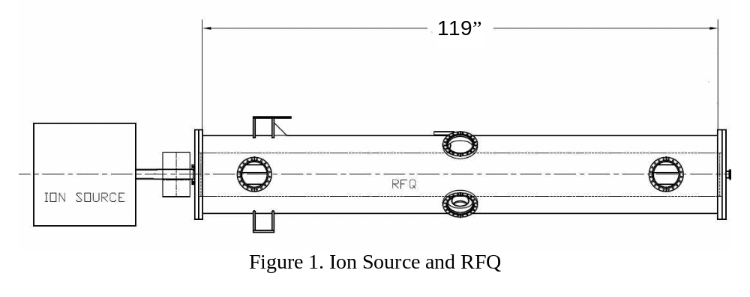
Manually Operated Vacuum Gate Valve

2.5 MeV Beam Line Configuration Detail
Figures 1 and 2 show the “initial HINS 2.5 MeV configuration”. Figure 1 shows the accelerating section comprising the ion source, the LEBT section, and the RFQ followed by a manually operated beam line vacuum gate valve. Figure 2 shows, in detail, the transport/ diagnostic line and absorber that are located immediately downstream of the RFQ and the vacuum valve. The distance from the end of the RFQ through the diagnostic line to the face of the absorber is approximately 90 inches.

The transport/diagnostic line contains two button-type beam position monitors, one beam current transformer, three single-wire scanners, and vacuum pumping ports. These components are fabricated primarily of stainless steel with a short ceramic section near the beam current monitor.

The design avoids exposing fixed surfaces containing Li, V, Mn, FE and Cu to the beam where beam loss is normally expected. Some isotopes of these materials reveal rather low neutron production thresholds–less than 2.5 MeV. In particular, a thin sheet of aluminum lines the 21.6 inch (55 mm) section of stainless steel beam pipe immediately upstream of the absorber box where the beam size is largest. Nothing but the thin tungsten wires of the wire scanners intercepts any of part of the central beam in normal operation; this occurs only while performing beam profile measurements.

Any change in beamline layout or introduction of different materials requires evaluation and approval by the Accelerator Division Radiation Safety Officer.
Figure 2. 2.5 MeV Transport/Diagnostic Line and Beam Absorber Design Layout
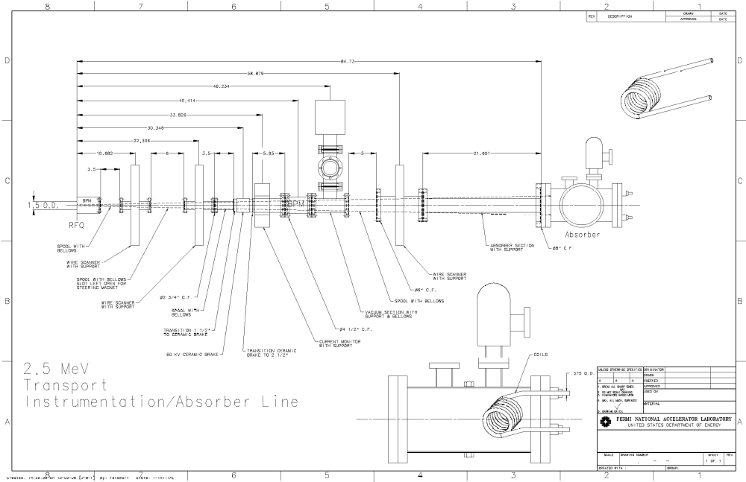

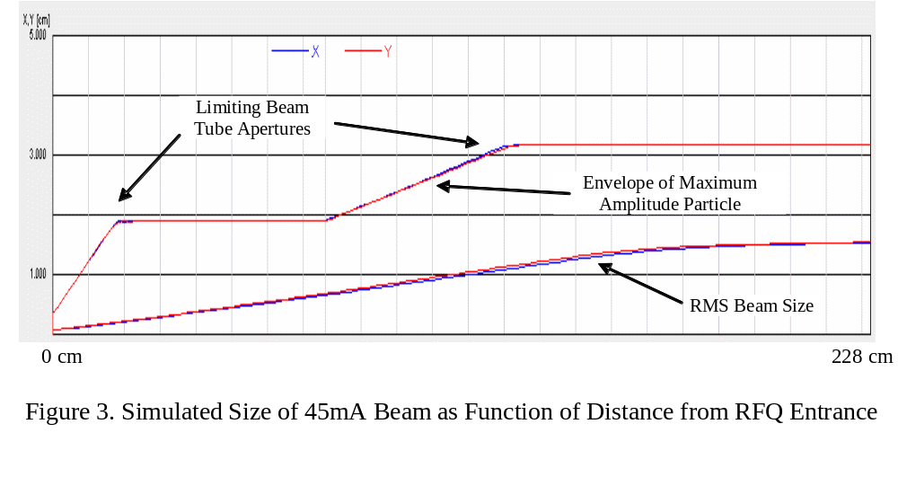Beam Transport to 2.5 MeV Absorber
By design, the beam size in the transport/diagnostic line downstream of the RFQ grows without focusing. This is to simplify the system and to reduce the peak beam energy density applied to the absorber.

Results of the TRACK particle tracking simulation code, shown in Figure 3, give the predicted beam size for a beam current of 45 mA. Figure 2 also shows the full-size beam envelope as dashed lines. Particles at the edges of the beam hit the beam tube and are lost. This appears in Figure 3 as regions of relatively constant beam size as a function of distance along the line. The Hazards section below discusses the implications of this beam loss.

2.5 MeV Beam Absorber
The 2.5 MeV beam absorber design and construction details and engineering calculations are contained in Beams-doc-3514, “HINS Aluminum Coil Beam Absorber Heating Analysis”.

That document recommends not exceeding 150 C temperatures in the aluminum absorber material. For 2.5 MeV operations, this temperature limit is consistent with operation at 25 mA beam current, one millisecond pulse length, and 1 Hz pulse rate

Low conductivity water flows through the absorber coil to dissipate the heat deposited by the average beam power. The system shall include a water flow interlock to inhibit accelerated beam in the case of insufficient water flow and thereby to protect the absorber from damage due to loss of cooling.

2.5 MeV Beam Operation Hazards
Hazards associated with 2.5 MeV beam operation include non-beam as well as beam-related hazards.

Non-Beam Hazards
Among the non-beam hazards are the ion source hydrogen gas system, high voltage electrical equipment, high-power 325 MHz RF energy, and possible x-rays generated within the RFQ.

Throughout RFQ RF conditioning activities, the Accelerator Division Radiation Safety Officer has verified that x-rays produced by high-power excitation of the RFQ do not create a radiation hazard.

Documents addressing the other non-beam hazards are:
- Beams-doc-3514 - HINS Test Facility at Meson System Overview of Hazards
- Beams-doc-3505 - HINS MDB Ion Source Safety Documents

Hazards Specific to Beam Operation
Beam-related hazards include the possibility of component damage due to excessive beam energy deposition and the possibility of ionizing and nuclear radiation.

Component Damage Hazards
Components subject to damage by beam heating in 2.5 MeV beam operation are limited to the beam absorber itself and the wires of the wire-scanner diagnostics. These devices are wholly contained within the vacuum system and their failure, undesirable as it is, will not constitute a personnel safety hazard. Scanner wires can overheat and break, rendering the device unusable. Absorber damage could result in a water leak into the vacuum; this would render beam operations physically impossible. The 2.5 MeV Beam Absorber section above identifies acceptable absorber operating conditions.

Procedural and administrative controls spelled out in commissioning plan and operations documentation and, in some cases, hardware equipment protection interlocks shall be employed to establish beam conditions that will avoid component damage. The HINS program has precedent for this in protecting wire scanners from damage during operations to measure profiles of the ion source beam.

Radiation Hazards
The primary, and nearly exclusive, energy loss mechanism of the 2.5 MeV proton or H- beam is ionization. The 2.5 MeV proton range is approximately 30 microns in stainless steel and 60 microns in aluminum. The maximum energy the ionizing proton can transfer to an electron is approximately 5 keV (T_{max} in Bethe-Block equation). In the case of H- ions, the energy carried by each electron is 1.25 keV. The vacuum chamber walls quickly and completely absorb these electrons from either source without producing penetrating photons.

Low-cross section neutron production in some materials is also possible, even at these low beam energies.

Nikolai Mokhov has looked at the level of neutron production due to beam losses within the RFQ itself using the loss distribution in the HINS RFQ taken from Ostroumov et al. paper “Application of a New Procedure for Design of 325MHz RFQ”, 2006 JINST 1 P04002”. Nikolai has written:

As described in my message of April 17(2009), the neutron production x-section on Cu-65 (30% of natural copper) drops by three orders of magnitude for 3.5-MeV protons down to the cutoff at 2.07 MeV. Neutron production in the 2.07-2.5 MeV region is about 3.e-8 neutrons per proton.

Losses are calculated as % of 1.56e15 p/s that corresponds to 25 mA at the RFQ entrance. Fig. 15 of the above JINST paper shows that losses take place predominantly in the middle of the RFQ where proton energy is about 1 MeV and loss rate is 9.4e11 p/s. There is no neutron production at this energy, but one would need a screen to protect against X-rays generated in that region. The loss rate in the RFQ region which corresponds to the 2.07-2.5 MeV energy range is about 7.8e10 p/s.
This results in neutron flux at 1 meter of about 0.02 n/cm^2/s with mean neutron energy of 150 keV. This roughly corresponds to the neutron dose of 8.e-4 mrem/hr, that requires no shielding against neutrons.

The conclusion is that neutron production due to beam loss within the RFQ is not significant.

Nikolai Mokhov and Igor Rakhno also considered radiation in the 2.5 MeV transfer/diagnostic line. Beams-doc-3164, “Radiation Shielding for 2.5 MeV Beam HINS Operations” describes the situation and includes results of a MARS simulation for 2.5 MeV protons on stainless steel. That document puts forth recommendations as follows:

With the uncertainties involved in the estimate, we recommend the following:
• Proceed with the beam pipe made of pure aluminum. Select a vendor that provides the lowest amount of admixtures in the aluminum.
• Avoid the materials for the beam pipe, beam windows and upstream end of the absorber which contain Li, V, Mn, Fe and Cu [4]. Some isotopes of the materials reveal rather low neutron production thresholds–less than 2.5 MeV.
• Perform measurements of a neutron production rate around the beam pipe in order to estimate the amount of neutrons generated on admixtures in the aluminum beam pipe as well as assure any further related developments in the region. The ES&H has agreed to perform such measurements this fall.

Designs and procedures in the “initial HINS 2.5 MeV configuration” relative to the specific recommendations are:

Proceed with the beam pipe made of pure aluminum – beam pipes are be stainless steel; however, the final 21 inch tube section where beam is expected to hit the walls (see Figure 4 below) is lined with aluminum.

Avoid the materials for the beam pipe … – surfaces exposed to the beam will be stainless steel and aluminum; no lithium, vanadium or copper is exposed. The beam absorber is fabricated of aluminum.

Perform measurements of a neutron production rate… – The DOE Exclusion letter, the AD RSO and the HINS 2.5 MeV Beam Operation Commissioning Plan all require verification of radiation levels during commissioning.

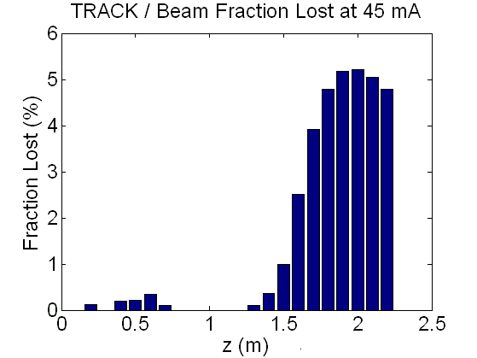

Figure 4. TRACK simulation showing 2.5 MeV transfer/diagnostic line beam losses at 45mA beam current; one-third of all particles are lost on the beam tube walls, 95% of those in the final 60 cm upstream of the absorber.

Operational Beam Limits and Controls
Necessary Conditions and On/Off Control
Four necessary conditions must be met simultaneously in order to physically allow the possibility of accelerated beam:
- The ion source must be running with the accelerating voltage very near to 50 kV.
- The Low Energy Beam Transport line (LEBT) beam stops must be open.
- The RFQ must be energized with approximately 400 kW RF power.
- The relative timing of the pulsed ion source and the pulsed RFQ RF power must coincide.

Timing triggers and pulse widths set in the HINS control system control individually the ion source and the RFQ RF pulse repetition rates, pulse lengths, and relative timing. The shorter of the two pulse widths determines the maximum length of the 2.5 MeV beam pulse and the slower repetition rate determines the maximum beam pulse rate.

Eliminating any of the four necessary conditions will result in no accelerated beam and are acceptable means of beam control, however two “beam off” modes are specifically defined:
- “Beam Shut Down” – This mode is established when the LEBT beam stops are fully inserted and the ion source high voltage supply is locked off.
- “Beam Switch Off” – This mode is established when the relative timing of the ion source and RFQ RF pulses are set to not overlap in time.

“Beam Switch Off” is the normal control for enabling and disabling beam during active commissioning operations.

“Beam Shut Down” is the required control state whenever qualified personnel are not present and actively pursuing commissioning activities.

Operating Limits
Beams-doc-3164, “Radiation Shielding for 2.5 MeV Beam HINS Operations”, as well as Beams-doc-3514, “HINS Aluminum Coil Beam Absorber Heating Analysis”, take 50 mA beam current at 2.5 MeV and 1% duty cycle as a reference operating point. These parameters equate to 3.125E15 particles per second and 1.25kW average beam power.

Normal 2.5 MeV operations will be limited to ~5% of that reference level, that is, 1.6E14 particles per second with individual pulses no longer than one millisecond. Typical operation with be at or below 25 mA at 0.1% duty cycle (e.g. 1 ms pulse at 1Hz). The ability to achieve commissioning and operational 2.5 MeV beam goals, the desire the desire to minimize potential radiation, and the desire to place minimal heating stress on the beam absorber all indicate operation within these bounds.

Pertinent commissioning and operating documents establish specific limits on beam current, pulse length, and repetition rates. Regardless of the specific conditional operating limits, absolute system limits on RFQ RF power pulse length (1.0 millisecond) and repetition rate (1 Hz) are fixed within the controls system database, and where possible in hardware, to limit the maximum beam duty factor to 0.1%.

Integrated beam operation time shall be no more than that necessary to achieve stated commissioning and operating goals. During active commissioning and operation, average beam current and pulse rates shall be set as low as reasonably achievable consistent with obtaining those goals.

Accident Conditions
Two credible radiation accident conditions are noted:
- Beam is accelerated through the RFQ with the downstream vacuum closed, possibly creating unacceptably high radiation levels.
  - Provisions will be made for the valve to be locked in the ‘open’ position with an RSO lock.
  - Alternatively, if required, the valve can be removed and replaced with a spool piece.
- After initial commissioning measurements, the 2.5 MeV transport/diagnostic beam line is knocked seriously out of alignment; beam strikes the stainless steel beam tube creating unacceptably high radiation levels.
  - The Rakhno/Mokhov MARS calculation suggests that radiation levels of order hundreds of mr/hr are possible at the wall of a 3” beam pipe for 50 mA, 1% duty factor beam. At one foot from that pipe, the rate is lower by a 1/R factor of 1.5/13.5 or 11%. Planned operation is constrained to 5% of the beam rate assumed in the calculation. The accident rate at one foot from the beam pipe is then 0.5% of the possible hundreds of mr/hr, that is, it will be in the low single mr/hr range.

Personnel Radiation Safety for 2.5 MeV Beam Operations
Consistent with the provisions of Livengood letter that the machine not create a radiological area, radiation monitoring and verification during startup is required to assure that the configuration meets this condition.

Radiological controls consistent with the Fermilab Radiological Control Manual and the guidance of the Accelerator Division RSO shall be established and maintained.

No beam line configuration changes are permitted without Radiation Safety Officer approval.

2.5 MeV Beam Commissioning and Subsequent Operation
Beams-doc-3514, “Fermilab HINS Program - 2.5 MeV Beam Commissioning Plan”, establishes the 2.5 MeV beam commissioning steps and procedures; it also spells out the conditions that constitute completion of commissioning including the write-up and approval of operational documents. Therefore, transition from the commissioning phase to a subsequent operational phase shall not occur before the appropriate operational documents are available.

Appendix 1
Letter from Dr. Joanna M. Livengood, DOE Fermilab Site Manager, to Dr. Bruce Chrisman, Fermilab COO, and dated April 27, 2009



