Beams-doc-3669

Bunch coalescing study at low energy

- Yagodnitsyna

Novosibirsk State University, Russia

September 9, 2010

Fermi National Accelerator Laboratory
P.O. Box 500, Batavia, IL 60510

Contents
1 Introduction 3
2 Theoretical background 3
2.1 Longitudinal dynamics 3
2.2 Bunch coalescing 6
2.3 Bunch coalescing for low and high energy beams 8
3 Bunch coalescing simulations at low energy 8
3.1 Rotation at 2.5 MHz bucket 8
3.2 Fast rotation at 53 MHz bucket 9
3.3 Rotation at unstable fixed point 10
3.4 Bunch coalescing parameters 18
4 Beam longitudinal emittance measurement after the beam injection 18
5 Adiabatic dumping experimental study 20
6 Conclusion 22

Introduction

Project X is a proposed high-intensity proton accelerator complex that could provide beam for variety of physics projects. The proposed facility would provide particles at different energies to various experiments. The intensity of the beam would be 5-6 times higher than present. Since the Main Injector will accelerate protons with injection energy of 8 GeV, we have to study high intensity beam space charge effect. Hence, the new system for high intensity beam generation at low energy is required.
The goal of this work is bunch coalescing study at low energy (8GeV) and simulation of this process for 5 bunches with 0.1 eVs emittance to achieve 85% coalescing efficiency. The study was performed using bunch coalescing simulation program written in C++.

Theoretical background

Longitudinal dynamics

Acceleration of particles to high energies involves the use of high frequency resonant cavities. We assume that an “ideal” particle arrives to acceleration gap at the same phase and receives the same increment of energy. Let be the time interval between passages through the rf cavity gaps for the ideal particle. If C is circumference of accelerator, and v is the particle speed, then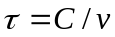.
Assume a particle arrives at cavity gap at nth turn with energy 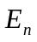and phase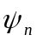. After (n+1) st turn the phase of the particle would be
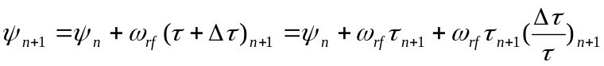
Since the ideal particle always arrives at the acceleration cavity at the same phase, it is convenient to switch to an angular variable which reflects this circumstance. We can define as 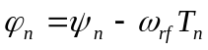, where 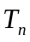 - is a time of entrance to the nth turn.
Then we can rewrite equation for the phase change as
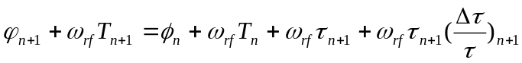
But 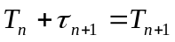 and so
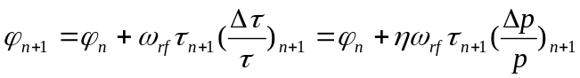
Here we used that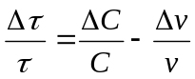, and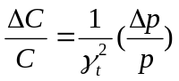, and 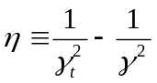 - so called “slip factor”.
The particles in a synchrotron with synchronous energy 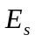 are accelerated each time they transverse the rf cavity gaps at a phase 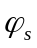 by voltage 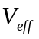 = V*sin where V – the maximum rf cavity voltage. Assume, that energy of the “ideal” particle after n turns is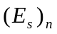, then its energy after n+1 turns will be:
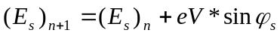
There are other particles with another energy 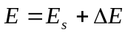, which arrive to the rf cavity gaps a little earlier or later, so their phase 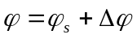. For those particles the corresponding equation will be:
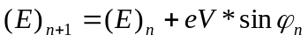
So the difference in energy between the particle in question and an ideal particle,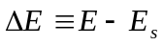, must satisfy
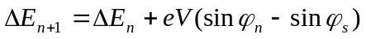
Since 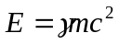 and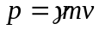, one can show that
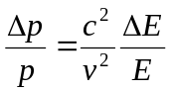,
And so two difference equations for the motion of the particles with respect to that of the ideal particle are:
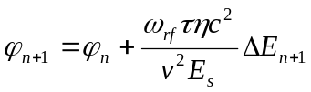 (1)
(2)

Figure 1 shows the result of a few iterations for a number of particles with different 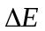 and 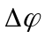 on the first turn. It is easy to see that particles closest to the ideal particle appear to remain close to the ideal particle as time develops. But particles with largest value of phase or energy are departing from neighborhood of the ideal particle. There is well defined boundary between stable and unstable motion called separatrix. The area within the separatrix called bucket, and the particles which populate certain bucket called bunch.
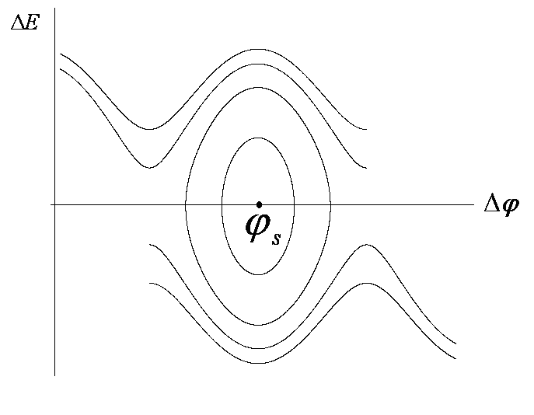
Figure 1 Application of the difference equations for synchrotron motion for several particles with different initial energy and phase

Combining equations (1) and (2), one can find the expression for contours describing particle motion in 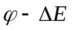phase space:
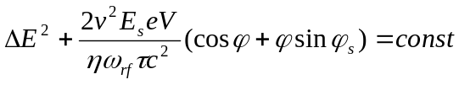
The angular frequency of synchrotron oscillations is 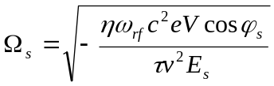(3)

Bunch coalescing

Bunch coalescing is a process in which several bunches are added together to form high intensity bunch. Bunch coalescing is performed by using 2 different harmonic numbers rf cavities.
In standard operation, there are the following four steps:
Step 1:
Five to seven bunches are circulation while captured by an RF system with a frequency of 53 MHz and a voltage of 1.1 MV. The bunch shape matches to the 1.1 MV RF bucket.
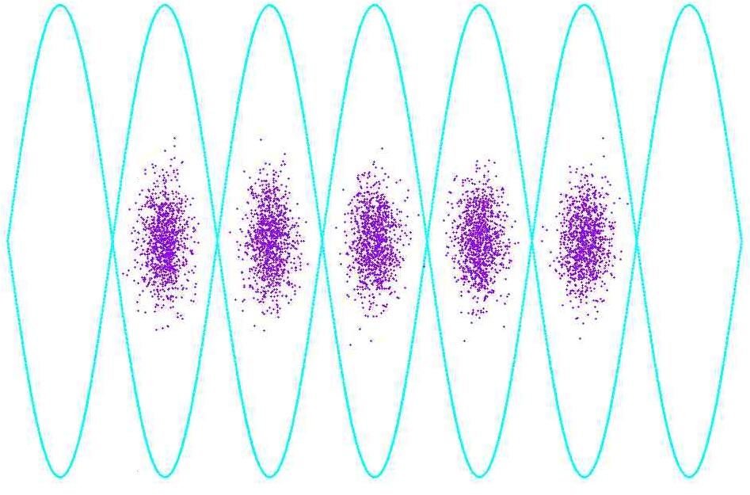
Figure 2 Bunch coalescing. Step 1
Step 2:
The voltage is decreased suddenly, so the bunches start rotating in phase space. After a quarter of synchrotron period, the momentum spread is at minimum.
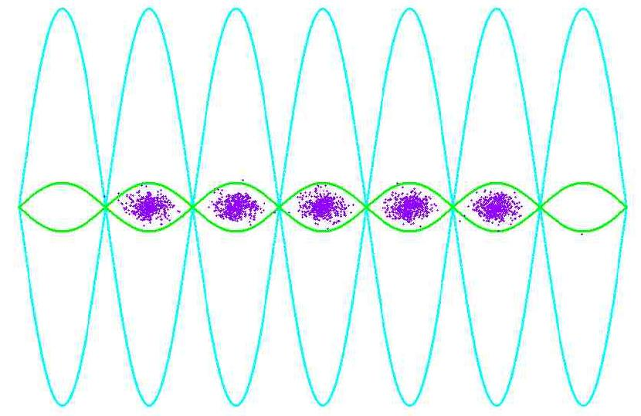
Figure 3 Bunch coalescing. Step 2
Step 3:
The 53 MHz RF voltage is changed to 0 V. At the same time, a 2.5 MHz RF system with a voltage of 75 kV is brought on. Bunches start rotating in the 2.5 MHz bucket. After a quarter of synchrotron period the bunch length is at minimum.
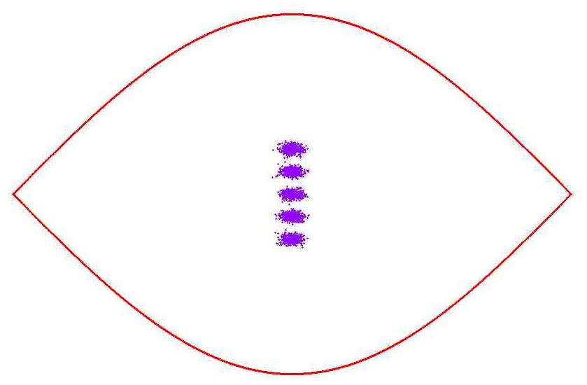
Figure 4 Bunch coalescing. Step 3

Step 4:
The 2.5 MHz RF voltage is changed to 0 V. At the same time, the 53 MHz voltage is increased to 1.1 MV and captures the coalesced bunch.
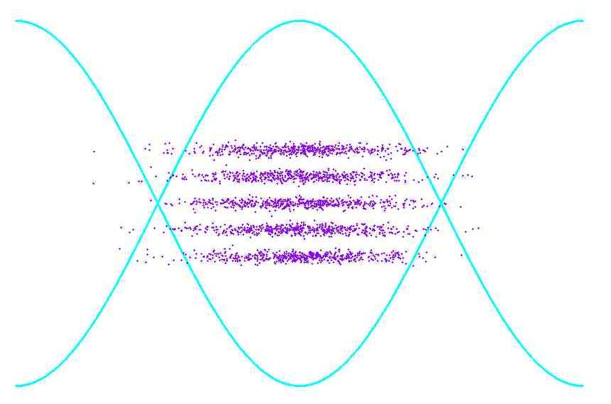
Figure 5 Bunch coalescing. Step 4

Bunch coalescing for low and high energy beams

According to formula (3) and assuming that 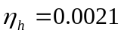 (index h means high energy beam – 150 GeV) and 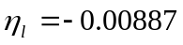 (index l means low energy beam – 8GeV) we can estimate synchrotron oscillation frequency for both cases:
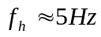
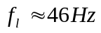
It means that in the case of low energy the particles in the bunch oscillates faster and we have to have better time resolution for coalescing system.
Moreover, if particles distribution before coalescing at low and at high energies is the same, the ratio of the bunch time spread after a quarter of synchrotron period rotation at 2.5 MHz would be:
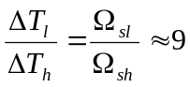
This means that we have to reduce energy spread of bunch at low energy dramatically before capture with 2.5 MHz cavities.

Bunch coalescing simulations at low energy

Rotation at 2.5 MHz bucket

Figure 6 presents a plot of bunch coalescing efficiency as a function of initial particle distribution at phase-energy space from simulations. The voltage of 2.5 MHz cavity was 75 kV. The first plot represents a case when initial time distribution was equal to 1 ns, the second one accords with a 9ns time distribution at the bunch.
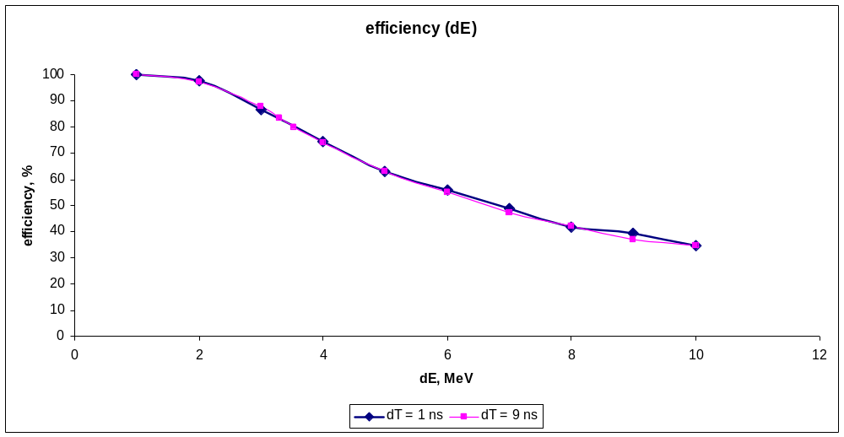
Figure 6 Bunch coalescing efficiency as a function of initial particle distribution

It is easy to see that coalescing efficiency doesn’t depend on initial length of bunches. According to this plot to achieve 85 % coalescing efficiency 3 MeV energy spread is required before coalescing.

Fast rotation at 53 MHz bucket

Initial conditions used in simulations are dE = 13.38 MeV, dT = 2.4 ns, emittance 0.1eVs, so they match 1 MV bucket. The voltage was reduced adiabatically. Figure 7 shows the plot of energy distribution in the bunch after voltage decrease as a function of voltage.
The plot ends at 20 kV because 10 kV bucket area is less then 0.1eVs.
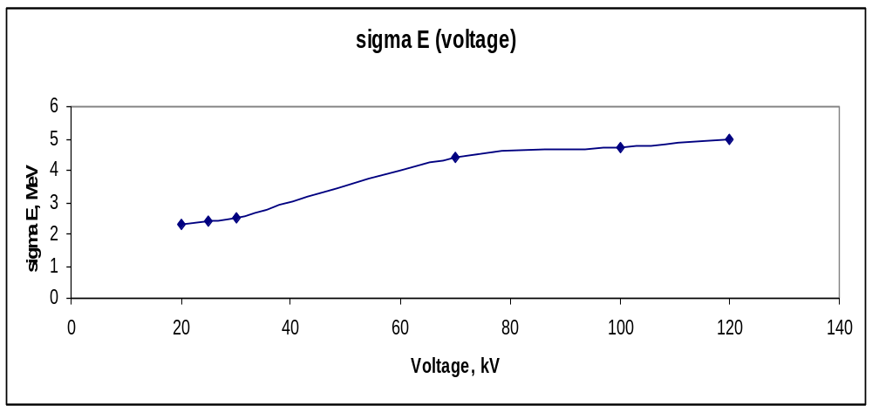
Figure 7 Energy distribution as function of Voltage of 53 MHz bucket
Here we can see that the smallest energy spread we can achieve is 2.3 MeV at one sigma, that means dE = 2*sigma E = 4.6 MeV. But this is larger than required 3 MeV for the 2.5 MHz rotation, so we need to make the energy spread smaller before coalescing.

Figure 8 shows the plot of adiabatic time as function of voltage.
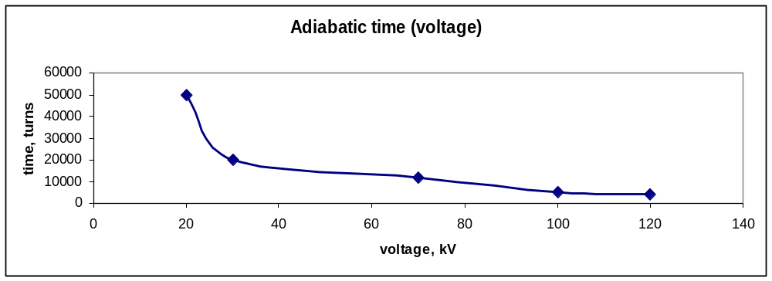
Figure 8 Adiabatic time

Rotation at unstable fixed point

To reduce the bunch energy spread the following technique was applied. At certain point of bunch rotation at 2.5 MHz bucket the voltage phase was changed to, so the beam was stretched. To increase the length of linear voltage region a voltage of 2 times higher harmonic number frequency was applied by factor -0.15.
In order to optimize an angle and time length for stretching simulations were performed. Initial conditions dE = 3.54 MeV and dT = 9ns were applied. Figure 9 shows a plot of coalescing efficiency as a function of stretch angle (rotation time before voltage phase change). Stretch time was set to 50 turns.
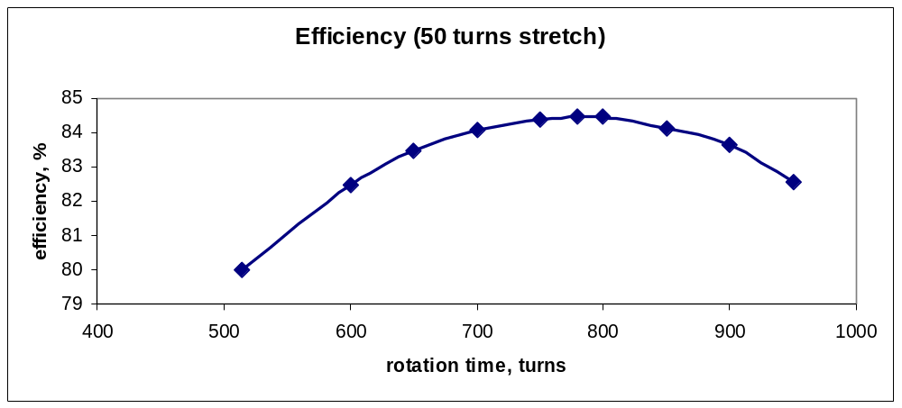
Figure 9 Coalescing efficiency as function of stretching angle
Worth noting, that the shape of graph slightly depends on stretching time.
The efficiency with different stretch time (for 800 rotation turns before stretching) is shown on Figure 10.
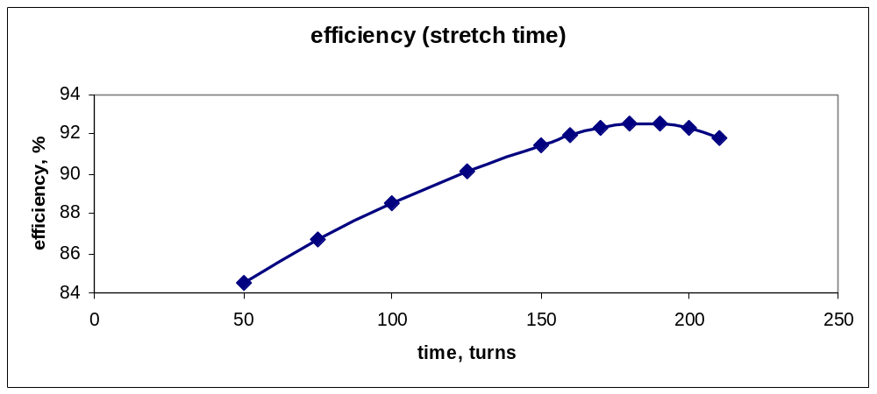
Figure 10 Coalescing efficiency as function of stretching time

Combining the two results, bunch rotation at 2.5 MHz, bunch stretching and coalescing were simulated with different initial conditions (dE). Below dependency of efficiency for initial energy distribution in the bunch is shown on the Figure 11.
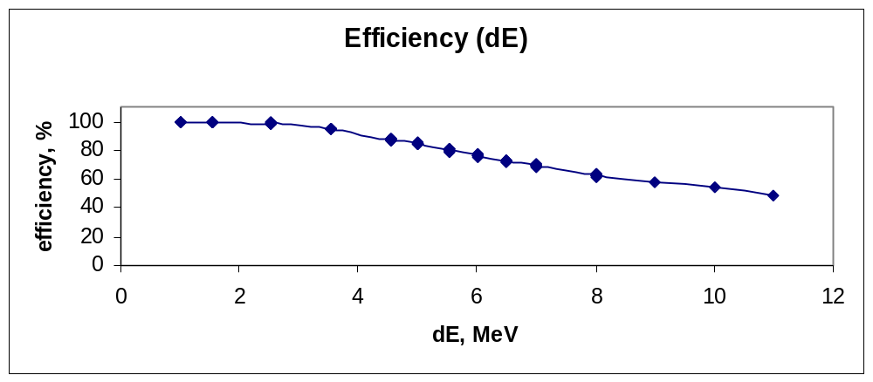
Figure 11 Coalescing efficiency as function of energy spread
According to this plot, the maximum energy spread in the bunch to achieve 85 % bunch coalescing efficiency is 5 MeV.
Taking into account all the results, we have shown that if we have initial particle distribution matched to the 1MV bucket with 0.1 eVs emittance, we can achieve coalescing efficiency 85%.

Below all steps for 5 bunches are presented.
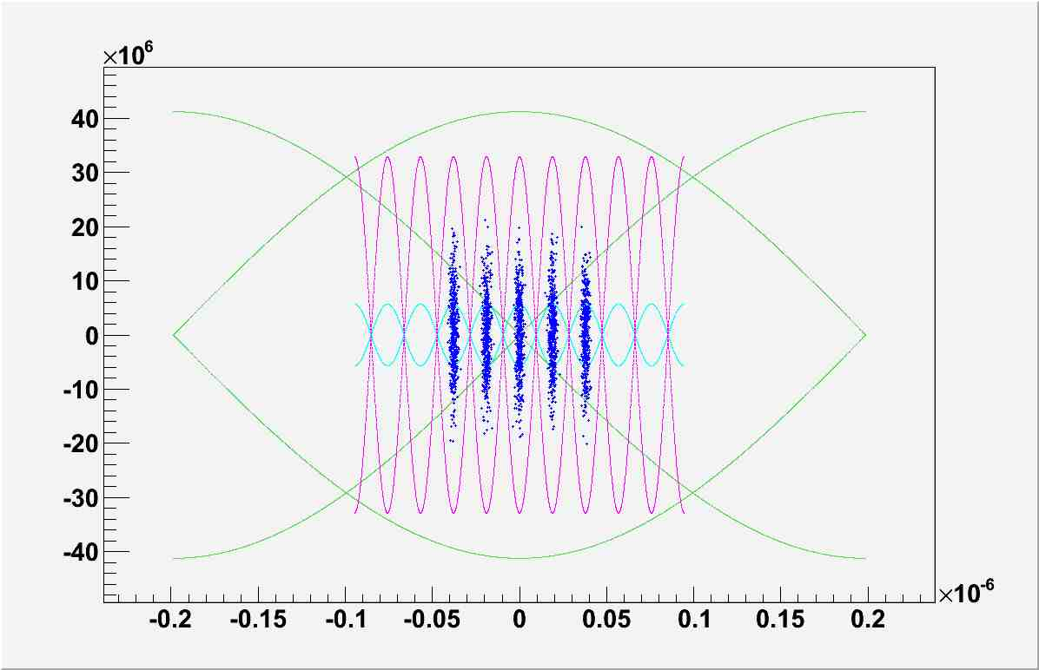
Figure 12 initial particle distribution. Green - 2.5 MHz separatrix, magenta - 1 MV separatrix
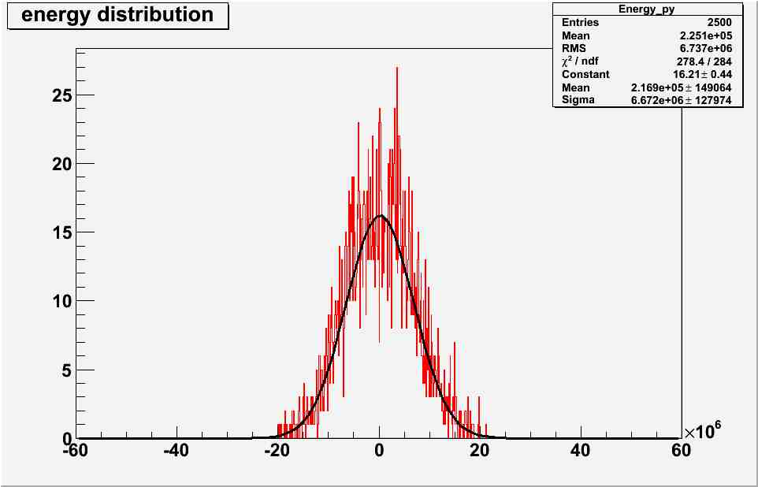
Figure 13 initial energy spread

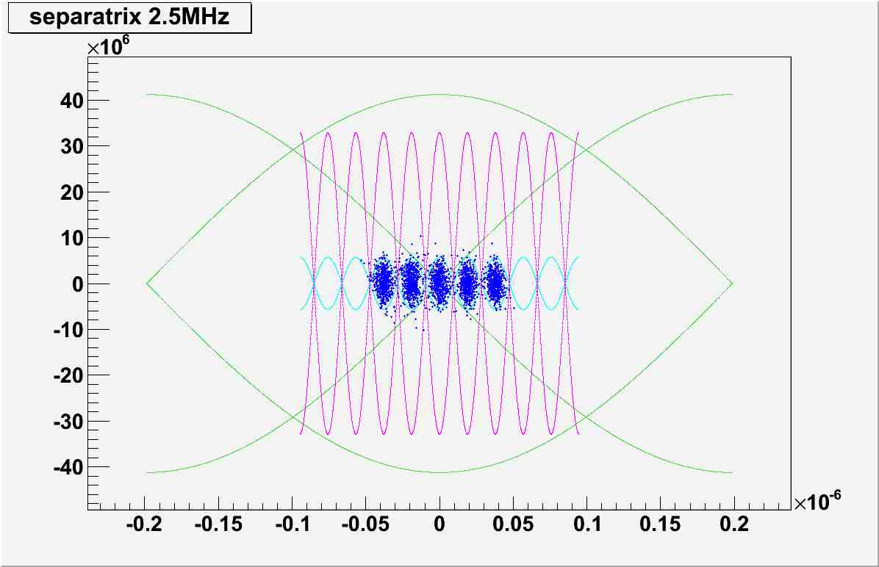
Figure 14 particles after voltage decrease to 30 kV
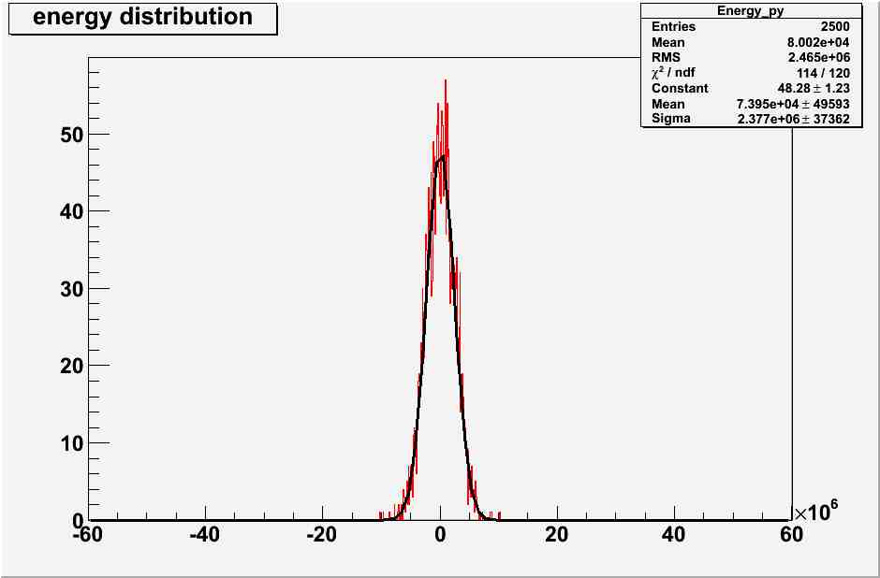
Figure 15 energy spread after voltage decrease to 30 kV
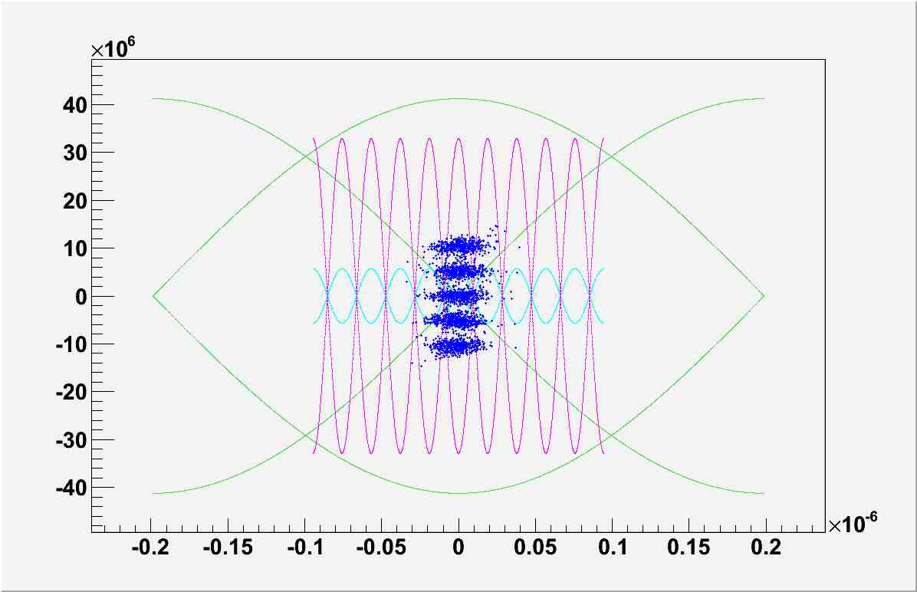
Figure 16 bunch rotation at 2.5 Mhz bucket
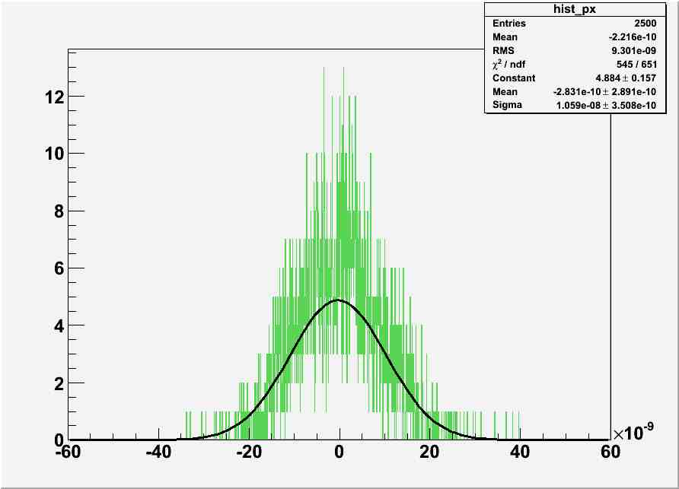
Figure 17 time spread after a quarter of period at 2.5 MHz bucket

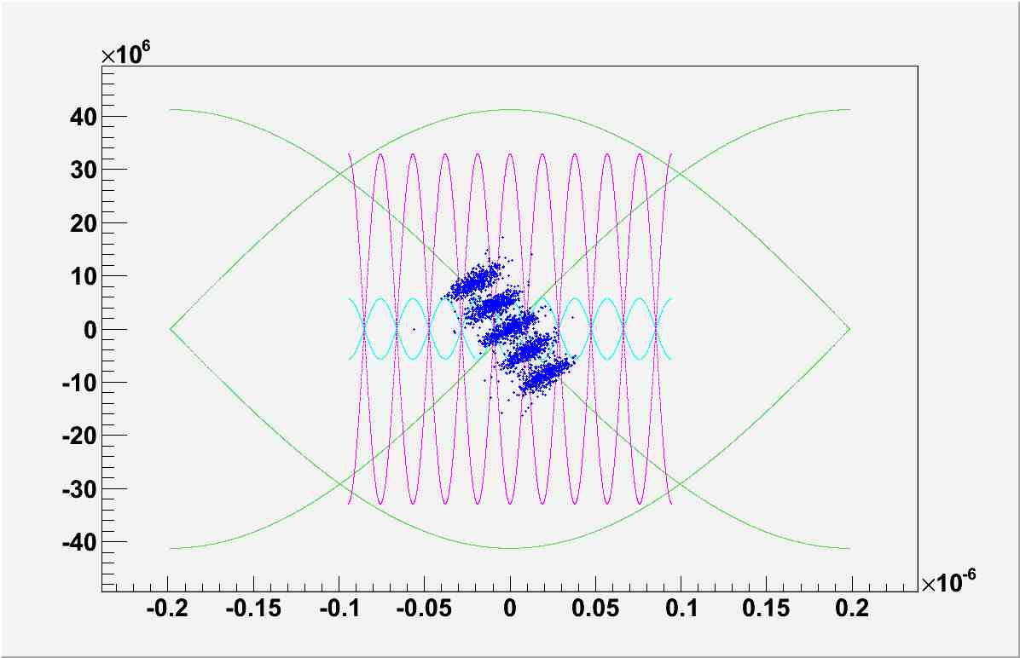
Figure 18 particles position at 2.5 MHz bucket before stretching
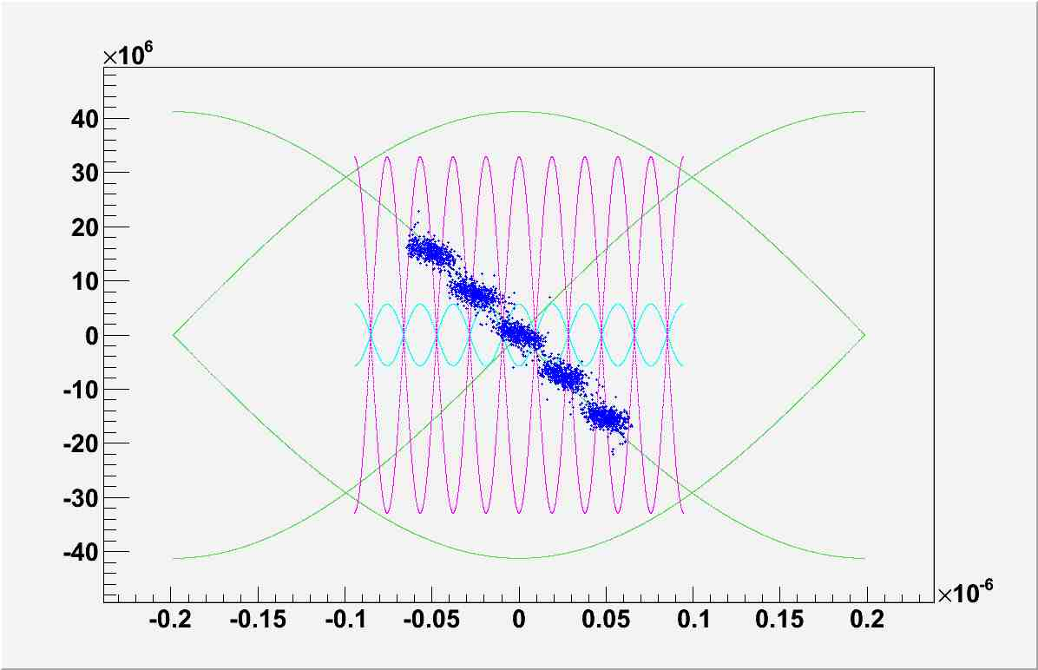
Figure 19 bunches after 230 turns stretching
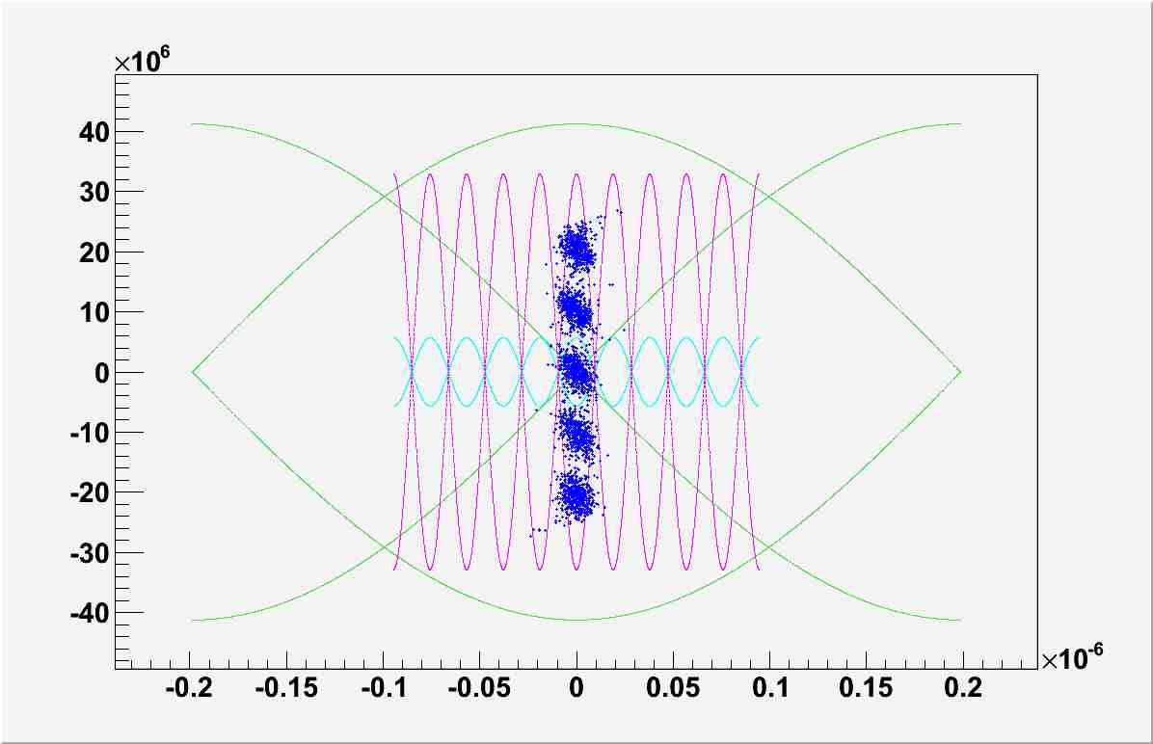
Figure 20 particles after all operations
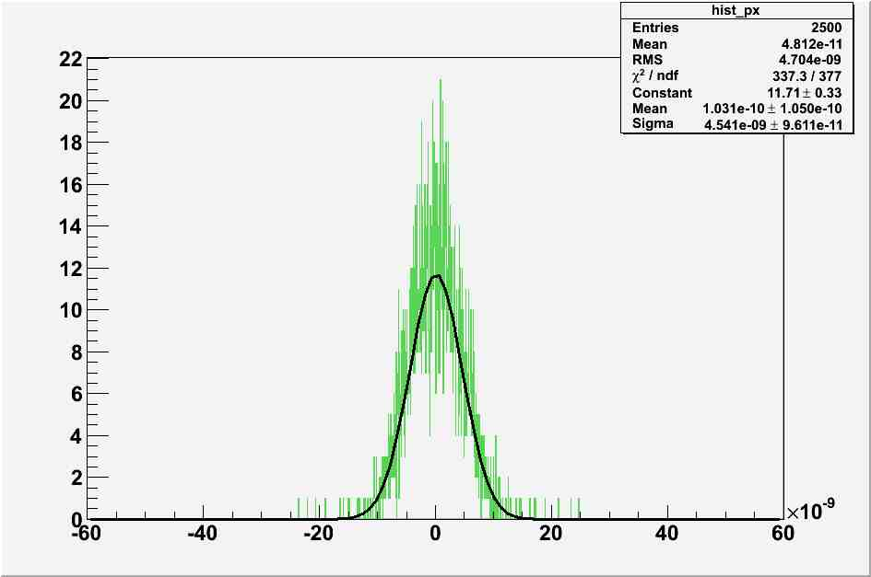
Figure 21 Final time spread of coalesced bunch

Bunch coalescing parameters

During simulations all parameters for bunch coalescing were optimized. Below is a table of the parameters.

Process | Parameters
Adiabatic dumping | Adiabatic time = 0.02 s  Vinitial = 1MV ,Vfinal = 30 kV
Bunch stretching | Stretching time = 2.5 ms±0.05ms
Rotation at 2.5 MHz | Voltage = 75 kV.  Time before stretching 7.7±0.5ms, time after stretching 17.4±0.05ms ms

The simulations showed that the time resolution required for bunch coalescing is 0.1 ms (10 turns). But now the system is working with frequency 750 Hz (which means, that we have time resolution 1.33 ms). Hence, the system frequency optimization is required to achieve a better time resolution.

Beam longitudinal emittance measurement after the beam injection

Beam emittance before coalescing at 8 GeV at the Main Injector was measured. Bunches were captured by 53 MHz cavities with different voltages, so the shape of bucket did not math the shape of bunch and bunch rotated.
Here are oscilloscope plots of voltage as function of turns and time.

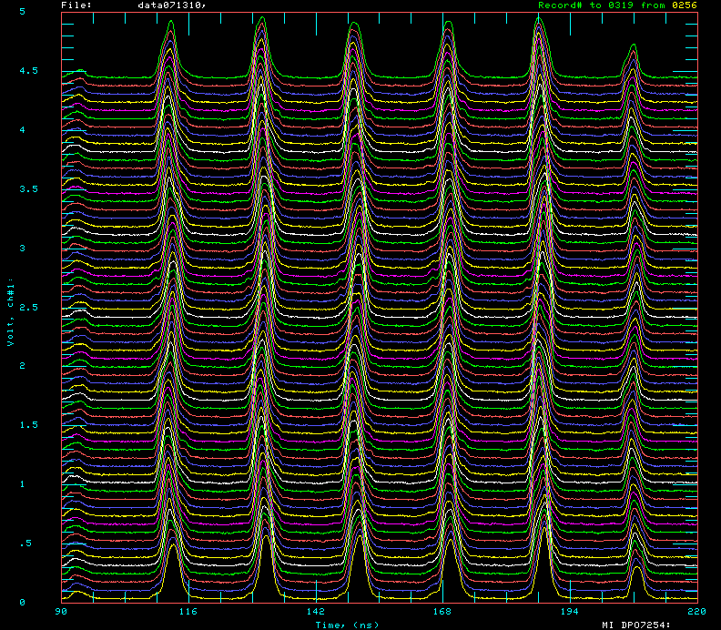
Figure 22 Oscilloscope plot, V = 1.2 MV

Below is the plot of bunch length as function of number of turns.
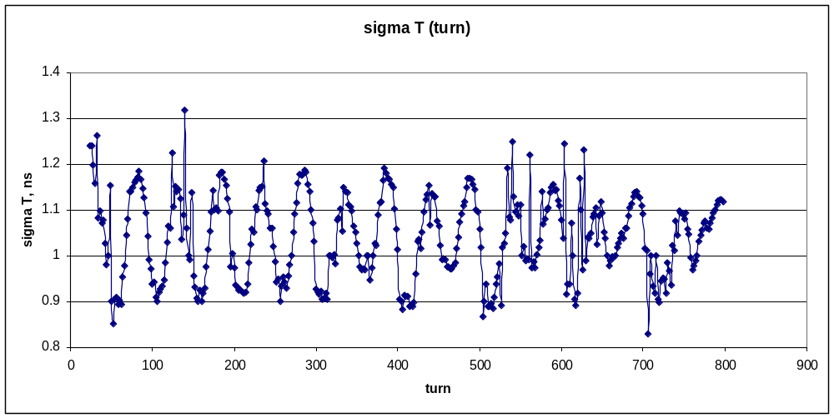

Figure 23 Sigma T (number of turn). Intensity = 10 booster turns. V = 1.1 MV

Emittance for bunch was calculated using the next formula:
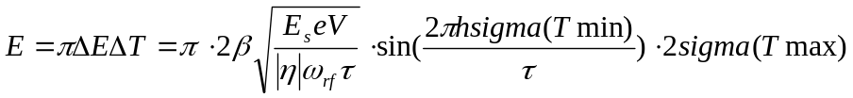
The numbers for energy spread and emittance for different voltages are presented in the Table 1:
Table 1 Bunch coalescing parameters
Beam intensity | Voltage, MV | sigma Tmax, ns | sigma Tmin, ns | delta Emin, MeV | delta Emax, MeV | Emittance1, eVs | Emittance2, eVs
10 BT | 1.1 | 1.3 | 1.1 | 12.5 | 14.6 | 0.1 | 0.1
8 BT | 1.05 | 1 | 1 | 11.1 | 11.1 | 0.07 | 0.07
4 BT | 0.95 | 1.05 | 0.9 | 10.1 | 11.1 | 0.07 | 0.07

Adiabatic dumping experimental study

Beam adiabatic dumping was studied at 8GeV energy with different intensities. After the injection bunches were matching 53MHz buckets with initial voltage. The voltage was reduced adiabatically (adiabatic parabolic function) to 30 kV during 0.2s.

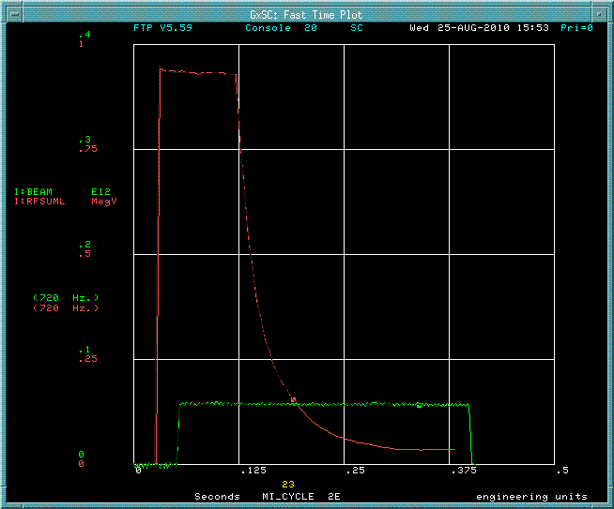
Figure 24 Adiabatic dumping voltage (red line)

The results of bunch energy spread after the adiabatic dumping were compared with simulations results at low and high intensity. It was shown that experimental data agree with simulations. Below are plots of bunch energy spread as a function of time.
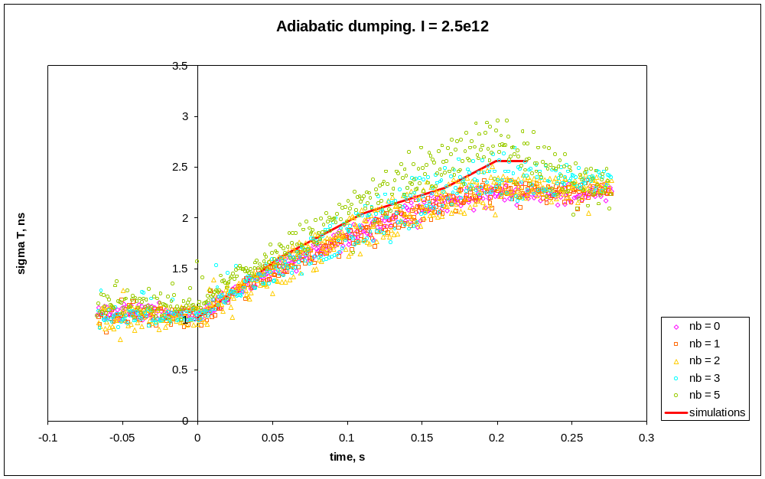
Figure 25 Adiabatic dumping. 10 BT. Vinitial = 1.1 MV

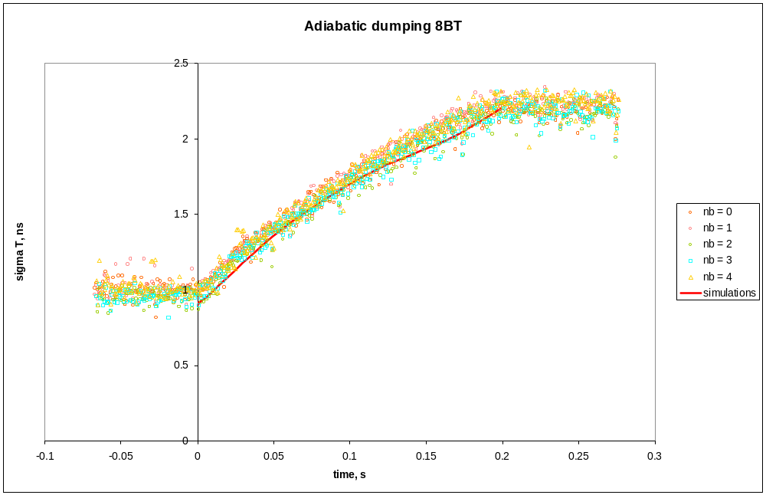
Figure 26 Adiabatic dumping. 8 BT. Vinitial = 1.05 MV

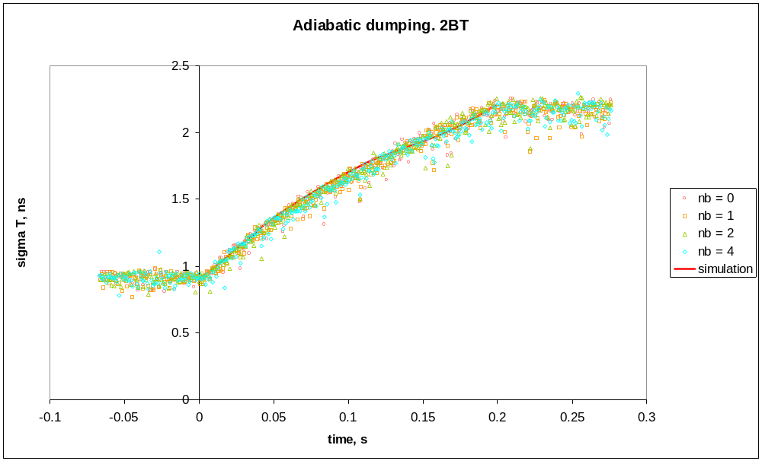
Figure 27 Adiabatic dumping. 2 BT. Vinitial = 2 BT

Conclusion

The simulation of bunch coalescing at low energy was performed. It was shown that for 85% coalescing efficiency bunch stretching is required. The parameters for bunch coalescing were optimized. The required time resolution for the coalescing process is 0.1 ms. Thus, the system working frequency optimization is required. The adiabatic dumping was performed experimentally with different beam intensities. The experimental data agree with simulations.

