1.3 GHz Phase Averaging Reference Line for NML
Brian Chase, Ed Cullerton
A 1.3 GHz phase averaging reference line is being developed for Fermilab’s NML accelerator. The reference line outlined in this paper will provide a phase stable 1.3 GHz reference signal to all the necessary systems that require phase accuracy. In this paper, simulations of the reference line are presented.
The source for the phase stable 1.3 GHz signal is the master oscillator[1], which will be located in a temperature controlled room at the front end of the accelerator. A ten watt amplifier, located in the same rack as the master oscillator, will amplify the 1.3 GHz signal and send it down the reference line. The reference line is fed back to the master oscillator to maintain an absolute phase reference point. A diagram of the NML reference line is shown in figure 1. The reference line will provide a phase stable signal to the following systems: laser source, electron gun, CC1, CC2, CM1, CM2, CM3, and two points along the reference line will provide for instrumentation.
The design concept of the NML reference line design is to send an RF signal down a length of coaxial cable with a short circuit at the end of the line. Using dual directional couplers, the forward and reflected signals are coupled out of the line at specific points along the line, and then summed together to realize an averaged phase that is not sensitive to variations in cable, such as flexing or temperature drift. To increase phase accuracy, phase feedback is used to hold the phase constant at the short circuited end of the line. The concept described above is similar to a scheme presented in [2].
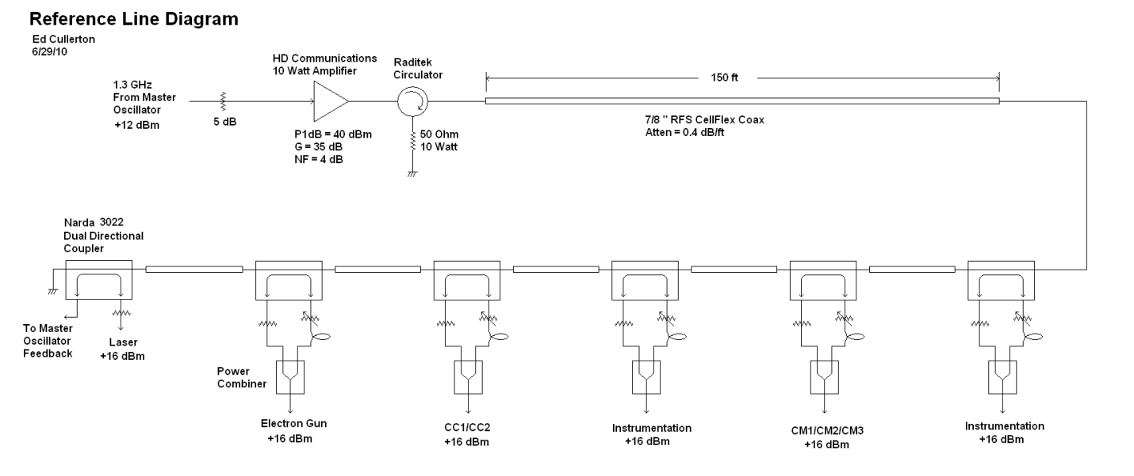
Fig 1. Diagram of the 1.3 GHz NML Reference Line
The components of the reference line have been carefully selected to minimized added phase noise and maximize phase stability. The 10 Watt amplifier is specified with a low noise figure and a low ripple power supply to minimize added phase noise to the signal. A plot of the residual phase noise of the amplifier is shown in figure 2. There is a calibration factor of -62 dB that is added to the numbers seen in the plot. The worst case is –139.8 dBc/sqrt(Hz) at 852 Hz. The very low frequency data (<100 Hz) is unreliable due to power supply ground loops that cause error in the measurement.
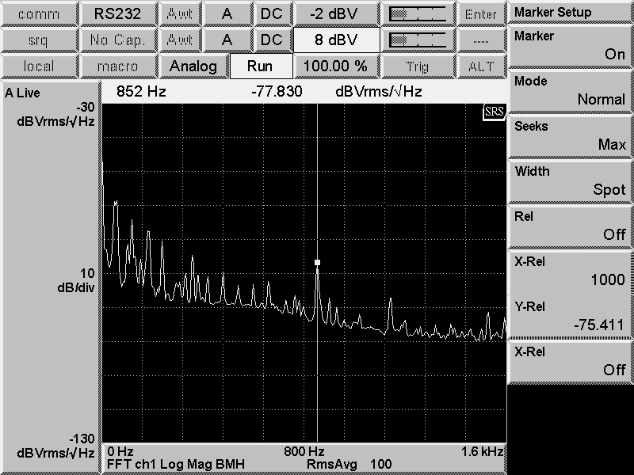
Fig 2. Residual phase noise of the 10 Watt amplifier.
The phase accuracy of the reference line is most dependent on reflections within the reference line, the directivity of the couplers, the phase stability of the coaxial cable between couplers, and the phase stability of the cables used to sum the signals together.
The main source of reflections within the line is from impedance mismatches between the couplers and the 7/8” coaxial cable. The Narda 3022 20dB coupler was chosen because it has good VSWR (<1.05) and good directivity(>35 dB). A plot of typical coupler return loss is shown in figure 3. RFS CellFlex 7/8”coaxial cable was chosen for the cable between the couplers because of its excellent temperature stability, and a plot of its temperature characteristics is shown in figure 4. Times Microwave Phasetack 210 cable was chosen for the summing cables because of its excellent temperature stability, and a plot of its temperature characteristics are shown in figure 5.
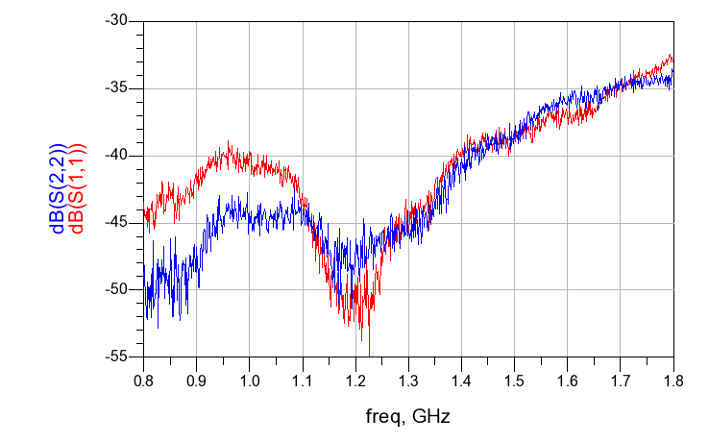
Fig. 3. Narda 3022 20dB Coupler typical return loss.
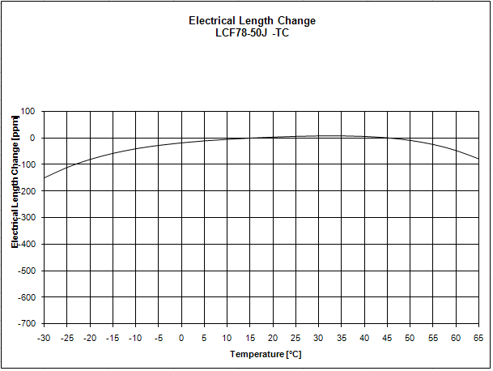
Fig 4. RFS Cable Electrical Length vs Temperature
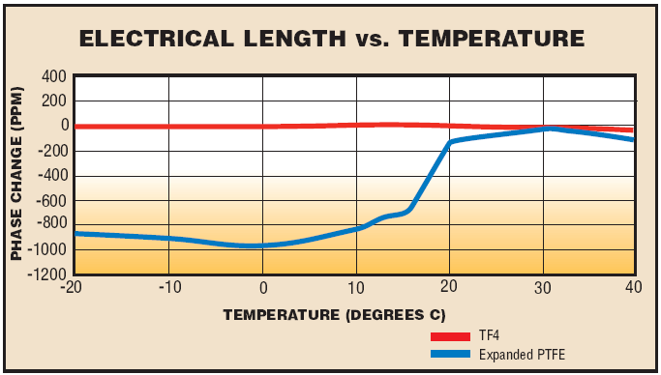
Fig. 5. Phasetrack-210 cable electrical length vs temperature.
Simulations have been performed to measure phase accuracy and also to generate a procedure for building the reference line while minimizing phase errors caused by internal reflections. The Narda couplers have been measured using a network analyzer and the s-parameter data is used in the simulations. A model for the RFS cable has also been developed for simulation. The simulations were done using Agilent ADS and the simulation schematic is shown in figure 6. Results of the simulation will be shown after the design procedure is explained below.
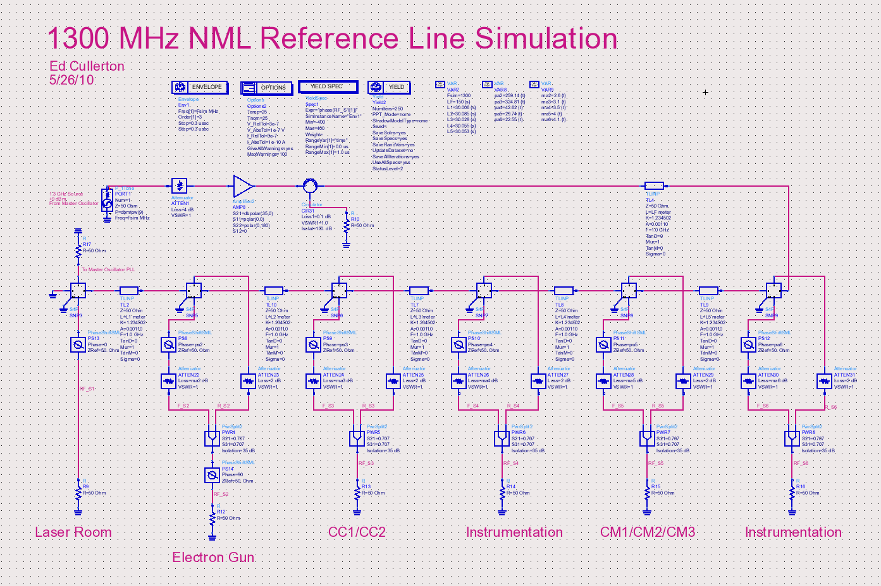
Fig. 6. Agilent ADS simulation schematic.
A design procedure has been developed to minimize phase errors caused by internal reflections by properly adjusting the length of cable between couplers. The goal of the procedure is to adjust the cable lengths between couplers so that the change in averaged phase of the forward and reflected signals is minimized with respect to change in cable length. A simulation schematic of the first step in the design procedure is shown in figure 7. The design procedure starts at coupler 2 nearest the shorted end of the reference line, and is used to determine the optimum cable length between couplers 1 and 2. The simulation calculates S21 and S31, which correspond to the forward and reflected signals at the output of the second coupler. Starting with an arbitrary length of 30 meters, the results of the simulation are shown in figure 8. A broad frequency sweep is used so that the phase may be flattened using electrical delay. Once the electrical delay is adjusted to flatten the phase, the circuit is again simulated with a more narrow frequency sweep so that the peak phase can be seen, which is shown in figure 9.
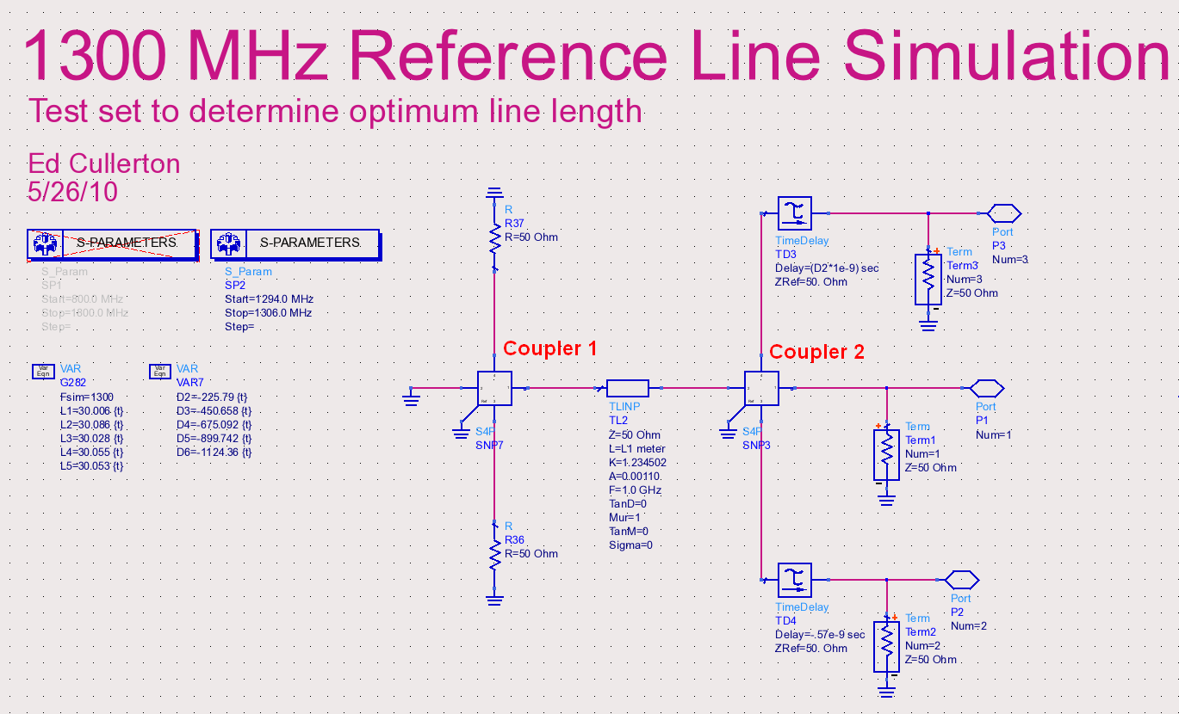
Fig. 7. Simulation to find optimum cable length between coupler 1 and coupler 2.
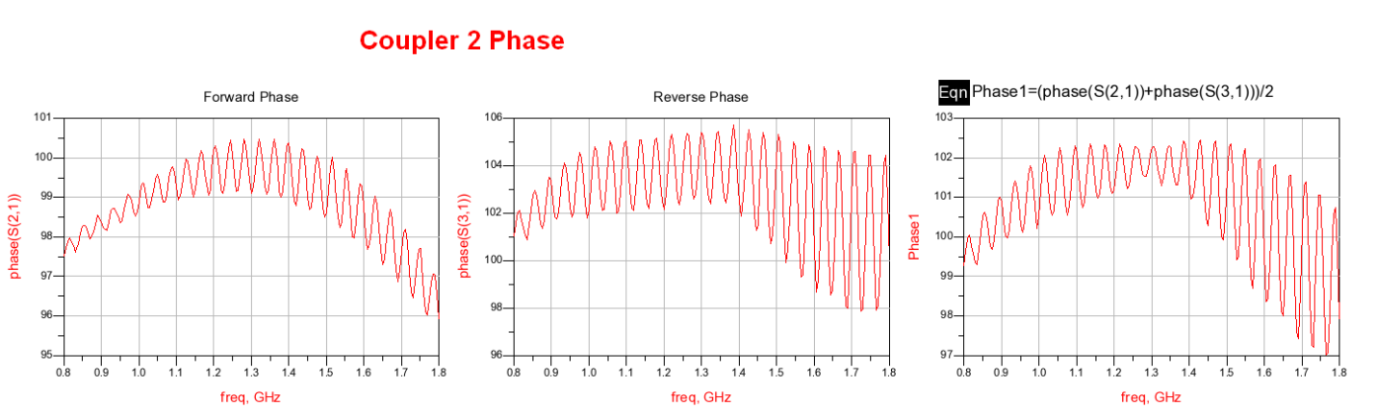
Fig. 8. Broad frequency sweep simulation used to flatten the phase using electrical delay.
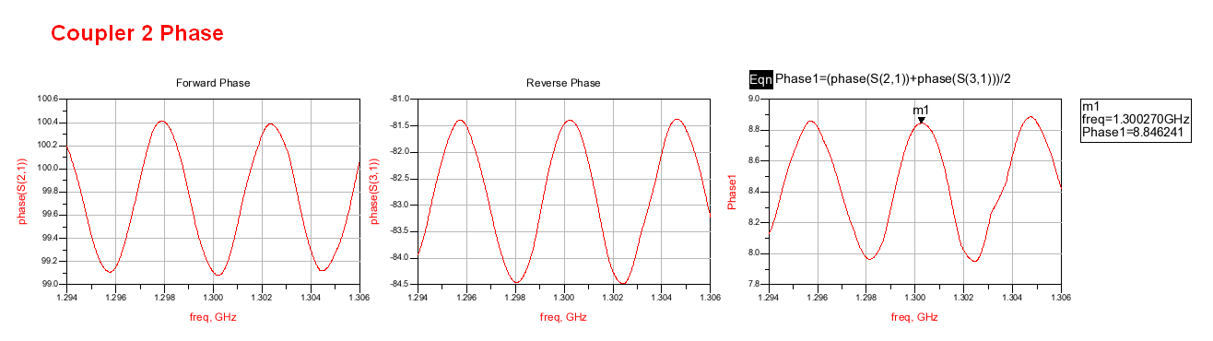
Fig. 9. Forward, reflected, and averaged phase at coupler 2 before cable length adjustment.
It is seen from figure 9 that the average phase has a peak at 1.30027 GHz, which means the cable length must be adjusted so that the peak is at exactly 1.3 GHz. This will satisfy the condition of minimum phase change versus change in cable length Each time the cable length is adjusted, the electrical delay must also be adjusted so that the phase is flat. The final adjustment to the cable was made and a plot of the simulation results is shown in figure 10. It is seen that the average phase is at a peak exactly at 1.3 GHz.
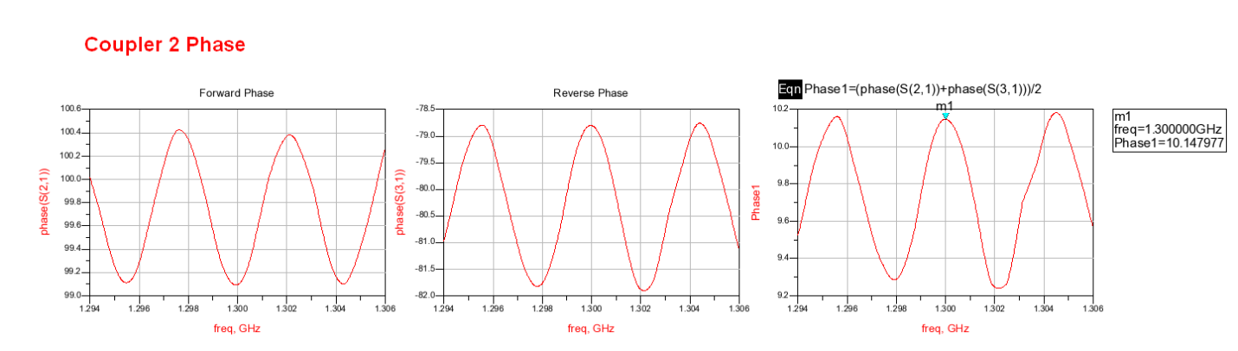
Fig. 10. Forward, reflected, and averaged phase from coupler 2.
The procedure continues with the next coupler down the line. The simulation schematic for coupler 3 is shown in figure 11. As seen in figure 12, the s21 and S31 phase measurements show more ripple due to the additional reflections caused by adding another coupler in the line. It is also seen that the ripples are more narrow in frequency, which leads to increased phase error due to changes in cable length. This characteristic will limit the amount of couplers that can be added to the line given a specified phase error for the line. The procudure was repeated for the remaining couplers and all line lengths have been determined. The final simulation results for all the couplers, after adjusting cable lengths, is shown in figure 13.
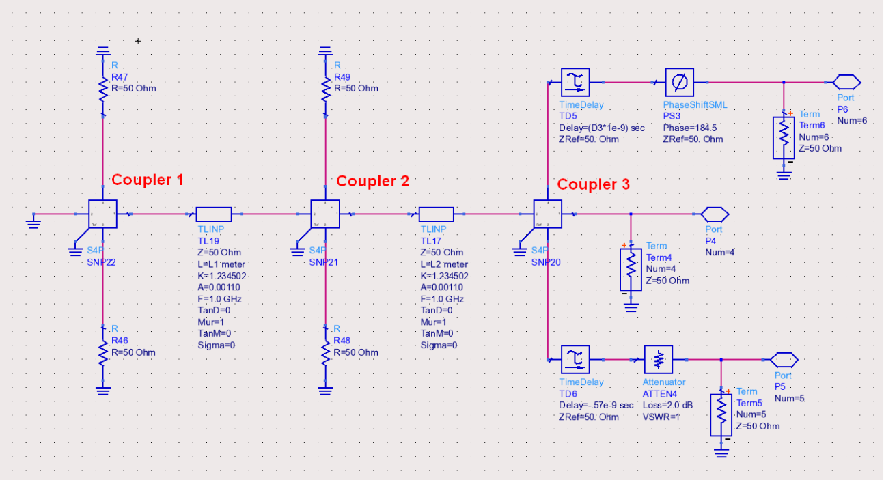
Fig. 11. Simulation to find optimum cable length between coupler 2 and coupler 3.
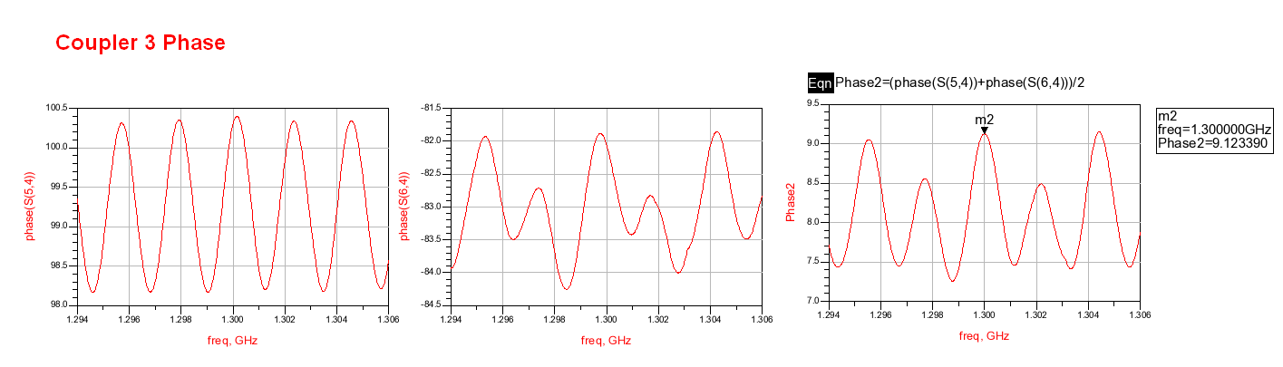
Fig. 12. Forward, reflected, and averaged phase from coupler 3.
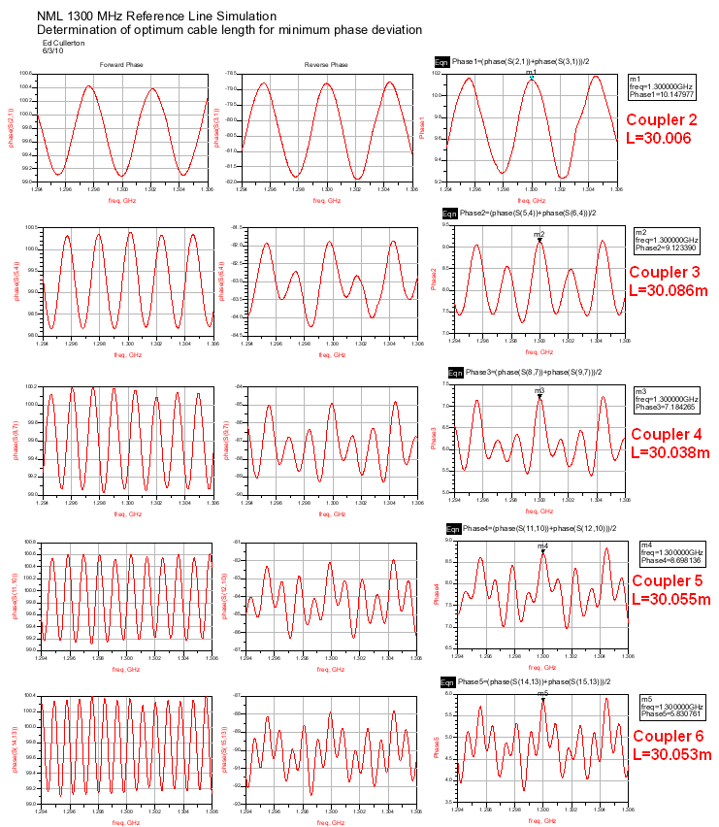
Fig. 13. Final simulation results for all cable length adjustments.
The adjusted line lengths were then entered into the complete reference line simulation schematic (figure 6) and simulated 250 times. Each simulation varies each cable between the couplers randomly with a gaussian distribution that represents a +/- 20 degree C temperature change. The standard deviation of the error between station 1 and all other stations is plotted in figure 14. The phase deviation is less than 9 millidegrees for any 1 station.
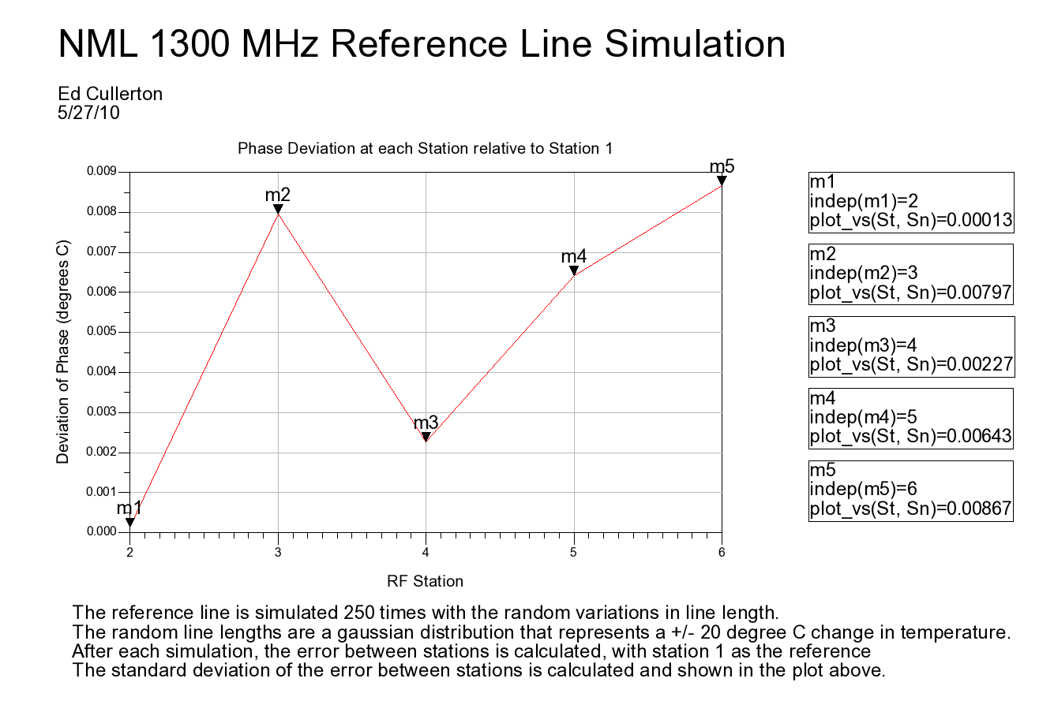
Fig. 14. Simulation results showing the phase errors of the complete reference line.

References
[1] Julien Branlard, “NML Master Oscillator”, Fermilab docDB, Accelerator Division, 3674-v1.
[2] Josef Frisch, David Brown, Eugene Cisneros, “ The NLC RF Phase and Timing Distribution System”, May 17, 2000

