Superconducting Main Injector
Preliminary Construction & Utilization Cost Estimate
Henryk Piekarz
Accelerator Physics Center, Fermilab
September 27, 2010
- Basic assumptions about the Superconducting Main Injector and construction cost estimate

The Main Injector (MI) ring length is 3.3 km. The MI accelerator magnets use about 2960 m of the ring length, or about 90%. There are 364 dipoles of 6.1 m length, 128 dipoles of 4.1 m length and 80 quads of 2.75 m (average) length. For the purpose of the Superconducting Main Injector (SMI) construction and utilization cost estimate we assume the MI magnet count and length. We assume the SMI magnets will be powered by a superconducting transmission-line cable. Such approach facilitates the application of a combined function dipole for the arc main magnet with the support provided only by a multi-function corrector. The proposed combined function dipole and corrector magnet parameters for a 120 GeV SMI beam are given in Table 1.

Table1. Basic parameters of main arc and multi-function corrector magnets for 120 GeV SMI

Combined function dipole length [m] | 6
Beam gap (vertical x horizontal) [mm x mm] | 50 x 100
Dipole B-field [T] | 1.4
Dipole gradient @ 1.4 T [T/m] | 3.2
Multi-function corrector length [m]  V or H dipole [T]  Quadrupole [T/m]  Sextupole [T/m²] | 1  0.5  2.4  1.2
SMI cycle time [s] | 1.3 - 2
Combined function dipole dB/dt [T/s] | 1.4 – 2.2

We consider two superconductor options for the magnet power cable: (1) LTS (NbTi) and (2) HTS (344C-2G). The 1.4 T field in a 50 mm magnet gap requires 50 kA –turns. For both, NbTi and 344C-2G it leads to 200 strands per magnet coil with strand I_{C} = 1 kA @ 5 K, and I_{t} = 50% of I_{C}. For the 3.3 km circumference of the SMI accelerator the total length of the superconductor strand required for construction of transmission-line dipole cable is 1,320,000 m. The corrector magnet requires 30 kA-turns thus using 2400 m of strand per magnet. Assuming 100 correctors the required total length of the correctors is 240000 m. A detailed cost estimate was performed recently for the LBNE beam line [1] and the Tevatron Stretcher [2] based on the transmission-line superconducting magnets with the properties matching closely those of the Main Injector ones. We modify these estimates to account for the 1.4 T (instead of 1.7 T) B-field of the combined function SMI dipole and the required number of dipoles and correctors for the SMI ring. The SMI construction cost which includes M&S and Labor is estimated at 27 M$ and 64 M$ for magnet ring using the LTS or the HTS superconductor cable, respectively. This cost estimate includes: magnetic cores (Fe3%Si), superconductor cables, cable cryogenic support within the SMI ring, the magnet power supplies and the vacuum support and quench protection systems. This cost estimate does not include the construction of the cryogenic plant or the construction of cryogenic transfer lines to the SMI ring from the Tevatron plant, if it was designated for the SMI accelerator use.

- Projected cryogenic and wall powers for the SMI accelerator

The fast-cycling magnets powered by the LTS superconducting cable have been extensively studied [3, 4] while a possible use of the HTS power cable for such application has been only recently considered [5]. Using the data [3, 4] and the studies [5] we present in Table 2 projected power losses for the SMI magnet operating at 1.4T/s and 2.2 T/s sweeping magnetic fields, respectively.

Table 2 Projected SMI main arc magnet cryogenic power losses at 1.4 T/s and 2.2 T/s

dB/dt  [T/s] | LTS  [W/m] | HTS  [W/m]
1.4 | 6.0 | 0.6
2.2 | 9.4 | 1.0

The static heat load of the transmission-line cable is about 0.22 W/m leading to 1.3 kW for the SMI accelerator (2960 m). The projected total required cryogenic power for the SMI main arc magnets with LTS or HTS power cables is given in Table 3.

Table 3 Projected total cryogenic power loss for the SMI accelerator

dB/dt  [T/s] | LTS  [kW] | HTS  [kW]
1.4 | 19.1 | 3.0
2.2 | 29.1 | 4.3

Using the Carnot factor of 70.43 (300 K -> 4.2 k), the Carnot factor efficiency (0.28)⁻¹ and the overcapacity factor 1.3 the projected wall power for the SMI cryogenic system with the LTS and HTS magnet cables is given in Table 4. For comparison we also present the LCW cooling power of the MI accelerator (NC) [6].

Table 4 Projected required wall power for the SMI accelerator cryogenic system

dB/dt  [T/s] | LTS  [MW] | HTS  [MW] | NC  [MW]
1.4 | 6.3 | 1.0 | 16.2
2.2 | 9.6 | 1.4 | 25.3

For the fast cycling accelerator a considerable electric power is required to ramp magnetic field. This power depends on the overall inductance of the accelerator magnet string. The estimated inductance for the 6 m long SMI transmission-line magnet is about 24 µH, including the magnetic core space for the power cable. The total inductance of the SMI accelerator magnet string is then 11.84 mH. For the SMI transmission line power cable we need to add the inductance of the magnetic core free section: 340 m x 1.2 µH/m = 1.48 mH. The total SMI ring inductance is then about 13.3 mH. With the magnet peak current of 50 kA the voltage rise/fall is 1022 V and 665 V, for the 1.3 s and 2 s cycles, respectively. The transmission-line cable can withstand very well this voltage rise/fall, but the MSI magnet string requires ramping peak power of 51 MVA and 33 MVA, respectively for the 1.3 s and 2 s cycles. This is to be compared to the 120 MVA peak power of the MI accelerator operating at 1.5 s cycle.

- Comparison of LTS and HTS power cable options for the SMI magnets

The LTS power cable will produce about an order of magnitude higher cryogenic power losses than those of the HTS power cable while its allowable operational temperature margin is order of magnitude smaller. The studies of the state-of-art NbTi cables for fast cycling magnets
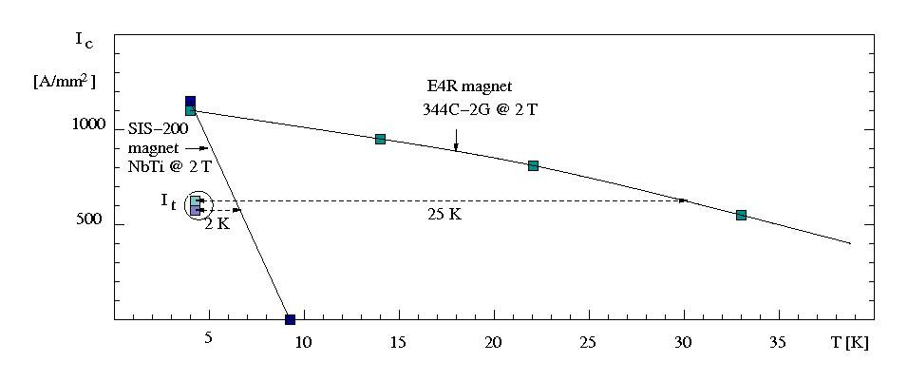
Fig. 1 Temperature dependence of critical currents for NbTi and 344C-2G magnet power cables

[3, 4] have shown that the practical operational temperature margin is actually less than 0.5 K, thus making their application in a larger scale accelerator impossible. Contrary to above, the HTS power cable allows for the operational temperature margin of (25-30) K with the same critical and operational currents as the LTS ones [5]. Consequently, although the cost of the LTS type cables is much lower than those of the HTS ones this option cannot be considered for the SMI accelerator construction.

- Electric power for the fast ramping magnetic field of SMI accelerator

For the fast ramping accelerator a considerable electric power is required to ramp magnetic field of a long accelerator magnet string. This power depends on the overall inductance of the magnet string, power cable current and the applied cycling rate. The faster the cycling rate of magnet current the higher is the voltage rise in a cycle (ΔU = L dI/dt). For a 50 kA magnet current cycled at 1.3 s and 2 s the voltage rise is 1023 V and 665 V, respectively. The required peak electric power for the magnet power supply is 51 MVA (1.3 s) and 33 MVA (2 s), to be compared to 120 MVA ramping power supply of the Main Injector at 1.5 s cycle.

- Conclusions

The SMI accelerator based on the HTS power cable offers comfortable temperature margin for the fast-cycling operations making them possibly quench-free. The cooling cryogenic power is very low (4.3 kW @ 1.3 s cycle) requiring 1.4 MW of electric wall power, in a sharp contrast to 25 MW LCW cooling power of the MI accelerator. In addition, due to much lower inductance of the SMI accelerator magnet string, the magnetic field ramping power is also reduced from 120 MVA for the MI at 1.5 s cycle to 50 MVA for the SMI at 1.3 s cycle.

References

[1] H. Piekarz, “Preliminary Consideration of LBNE Beam Line with Superconducting Transmission-Line Magnets”, Beams-doc-3651-v1, 2010
[2] H. Piekarz, “Superconducting Transmission-line Magnet Ring in Tevatron Tunnel”, Beams-doc-3652-v1, 2010
[3] M.N Wilson et al., “Measured and calculated losses in a dipole for GSI’s Heavy Ion Synchrotron”, IEEE Appl. Superconductivity, 14, 2004
[4] V. Zubko et al., “Stability of Fast0Cycling Dipole for the SIS300 Ring”, EPAC 2004, 1756
[5] H. Piekarz, J. Blowers, S. Hays, Y. Huang and V. Shiltsev, “Design Study and Test Arrangement of HTS Transmission-Line Power Cable for Fast-Cycling Accelerator Magnets”, IEEE Transactions on Applied Superconductivity, Vol. 20, No 3, p 1304007, 2010
[6] J.A. Satti, “The Fermilab Main Injector Dipole and Quadrupole Cooling Design and Bus Connections”, IEEE, p 1343-1345, 1996

