Linac Beam Velocity/Energy Measurement
Craig Drennan
June 24, 2011

Contents
Figures ii
I. Introduction 1
II. The Griffin Detector Beam Pickups 1
III. Beam Velocity Measurement and Debuncher 805 MHz Phase Measurement 4
IV. Application of the Griffin Detector Measurements 8
IV.1 Computations Used 12
IV.1.1 Spreadsheet Equations 12
IV.1.2 An Evaluation of Sensitivity for 10 Degree Phase Difference 12

Figures
Figure II.1 Photo of the Griffin Detector in the 400 MeV line. 2
Figure II.2 Griffin Detector locations relative to the other beamline devices. 3
Figure III.1 Block diagram of the measurements. 6
Figure III.2 The phase detector circuit assemblies. 7
Figure IV.1 Scope display of the Linac velocity. 8
Figure IV.2 Cabling layout for “Griffin to Griffin” and “Griffin to 805 MHz” phase signals. 10
Listing IV.1 Sensitivity calculation spreadsheet 11

Introduction
The optimal settings of a number of timing parameters are impacted by changes in the velocity/energy of the particles injected into the Booster at the beginning of the acceleration cycle. A time-of–flight particle velocity measurement, using the Griffin stripline detectors in the 400 MeV transport line between the Linac and the Booster, was assembled to monitor this critical “initial condition” for the Booster acceleration process. The objective of the measurement is not a precisely calibrated energy measurement, but is intended to be a stable and repeatable relative measurement. The measurement provides an oscilloscope display of this parameter showing both offsets from the nominal reference velocity and relative variation over the duration of the injected beam pulse. Additionally, the average velocity over the injected beam pulse is fed back to front-end computer processors in the Linac to regulate this beam parameter.
The current Griffin Phase Detector was assembled and calibrated by Bill Pellico and Rich Meadowcroft.

The Griffin Detector Beam Pickups
The Griffin detector is a wide bandwidth RF pickup. The signals produced provide a detailed representation of the structure of the bunched beam passing through the detector. There are two Griffin detectors in the 400 MeV beam transport line between the Linac and the Booster. These detectors are space 50 meters apart. The upstream detector is just downstream of the Chopper. The downstream detector is downstream of Q12, before the Debuncher. Figure II.1 is a photo of the Griffin Detector. Figure II.2 shows the relative location of the detectors in sections taken from the “Booster Accelerator Vacuum & Component General Schematic”, drawing number 0340-LE-282247. The detector provides four ports.
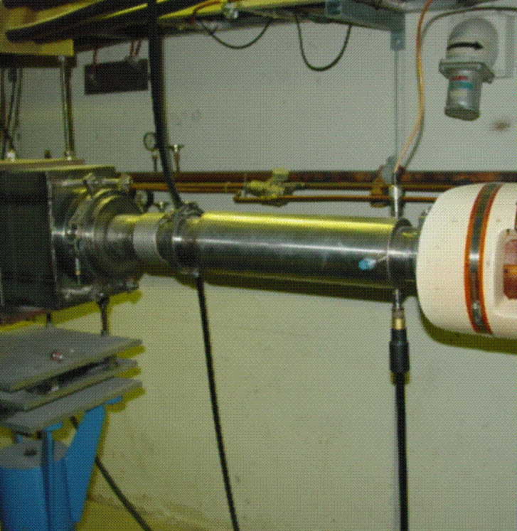
Figure II.1 Photo of the Griffin Detector in the 400 MeV line.

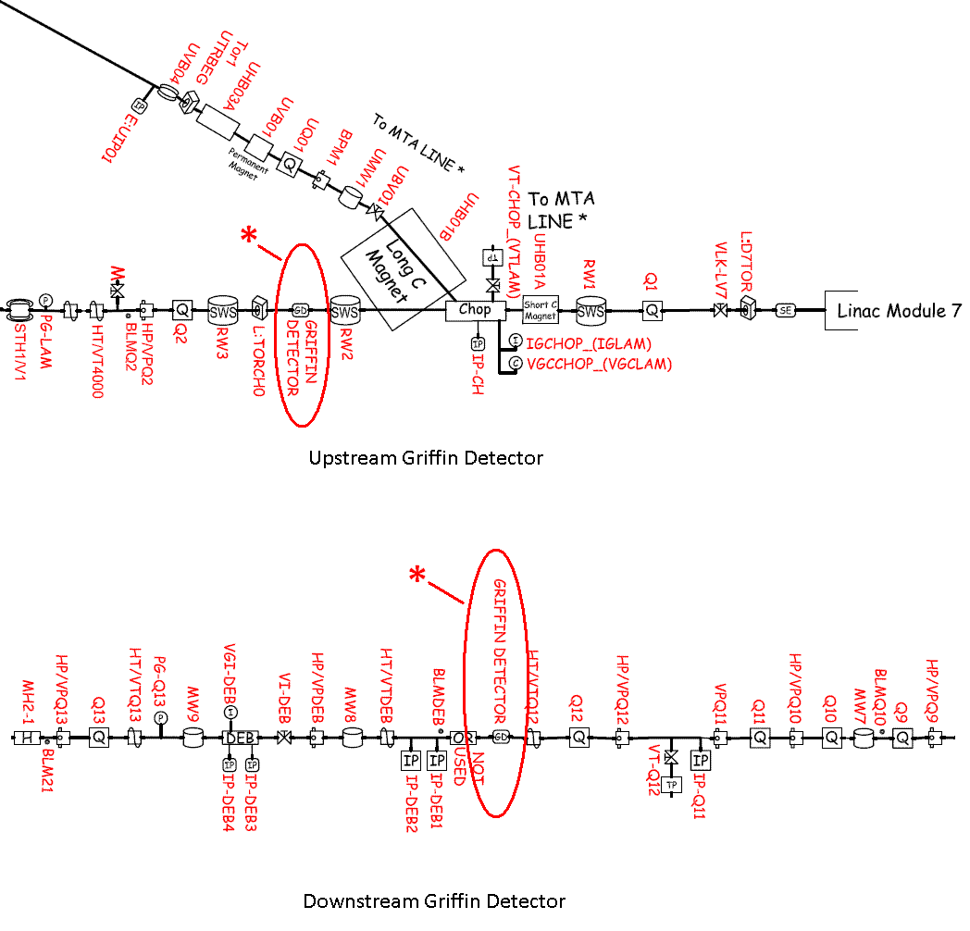
Figure II.2 Griffin Detector locations relative to the other beamline devices.

Beam Velocity Measurement and Debuncher 805 MHz Phase Measurement
The particle packet structure of the Linac beam produces signals out of the Griffin detectors with strong 201 MHz and 805 MHz frequency components. The beam velocity measurement is made by measuring the phase difference between the 201 MHz signal of the upstream and downstream Griffin detectors, and determining the time-of-flight, $T$,between the detectors from this. The upstream and downstream Griffin detectors are 50 meters apart.
$$T=\frac{1}{201E6} \left(\frac{second}{cycles}\right) ∙ \frac{1}{360} \left(\frac{cycle}{degrees}\right) ∙Phase \left(degrees\right)$$
$$T=13.82E-12 \left(\frac{seconds}{degree}\right) ∙Phase\left(degrees\right)$$
The particle velocity is then,
$Velocity=T\left(seconds\right)$ /$50 (meters)$
The phase is measured using a RF mixer. The mixer multiplies the two Griffin detector RF signals according to the following trigonometric identities.
$$Cos\left(α+β\right)=Cos\left(α\right)∙Cos\left(β\right)- Sin\left(α\right)∙Sin\left(β\right)$$
$$Cos\left(α-β\right)=Cos\left(α\right)∙Cos\left(β\right)+ Sin\left(α\right)∙Sin\left(β\right)$$
Adding the two equations above gives
$$2∙Cos\left(α\right)∙Cos\left(β\right)=Cos\left(α-β\right)+Cos\left(α+β\right)$$
If we apply this to the two 201 MHz RF signals from the Griffin detectors we get
$$A_{1}∙Cos\left(2π∙201E6∙t+ θ_{1}\right) ∙ A_{2}∙Cos\left(2π∙201E6∙t+ θ_{2}\right)=\frac{1}{2} ∙ A_{1}∙A_{2}\left[Cos\left(θ_{1}-θ_{2}\right)+ Cos(2π∙402E6∙t+ θ_{1}+ θ_{2}\right]$$
The mixer output shown in the equation above has a 402 MHz component that when filter by a low-pass filter leaves the baseband signal which is our phase difference.
$$Phase Volts Out=\frac{1}{2} ∙ A_{1}∙A_{2}∙Cos\left(θ_{1}-θ_{2}\right)$$
Note that the amplitude of the Griffin detector RF signals, $A_{1}$ and $A_{2}$, scale the phase difference voltage output. The signal amplitude is determined by the Linac beam intensity which is accepted to be nearly constant. Measurement of the electronics has been found to produce an amplitude error of approximately 0.09 Volts per dB of beam intensity.
Alternate phase detectors that employing RF limiters could be used to force the signal amplitudes to fixed values to eliminate this source of error. However, the trade-off comes in that limiters produce noise when a signal is not present, when there is no beam passing through the Griffin detectors. The mixer only approach provides a zero volt output on the scope display. The use of limiters requires additional gating signals and electronics.
A phase difference measurement is also made between the 805 MHz component of the Linac beam structure and the 805 MHz reference frequency used in the Debuncher Klystron. This phase difference measurement is made using the same approach as the velocity measurement.
Figure III.1 is a block diagram of the electrical measurements being made. Figure III.2 is a drawing showing how the circuits were assembled and the components that went in to them. Combinations of additional BNC Bullet and Barrel adapters were used as timing elements to establish the initial phase relationship (zero on the oscilloscope display) of the RF signals into the phase difference measurements. It is the variations of the phase differences that are monitored in the operation of the Linac and Booster accelerators.
In adjusting the initial phase difference using the BNC bullet and barrel adapters the following relationships were found
Phase Calibration:
360 degrees = 1.5 meters @ 201 MHz
1 inch = 0.0254 meters
1 Bullet + 1 Barrel = 2.125 inches
1 Bullet + 1 Barrel = 12.954 degrees @ 201 MHz
1 Bullet + 1 Barrel = 0.216 Volts change on the mixer output
2 Bullet + 2 Barrel = 0.404 Volts change on the mixer output
A change in 0.100 Volts corresponds to a change of 5.997 degrees

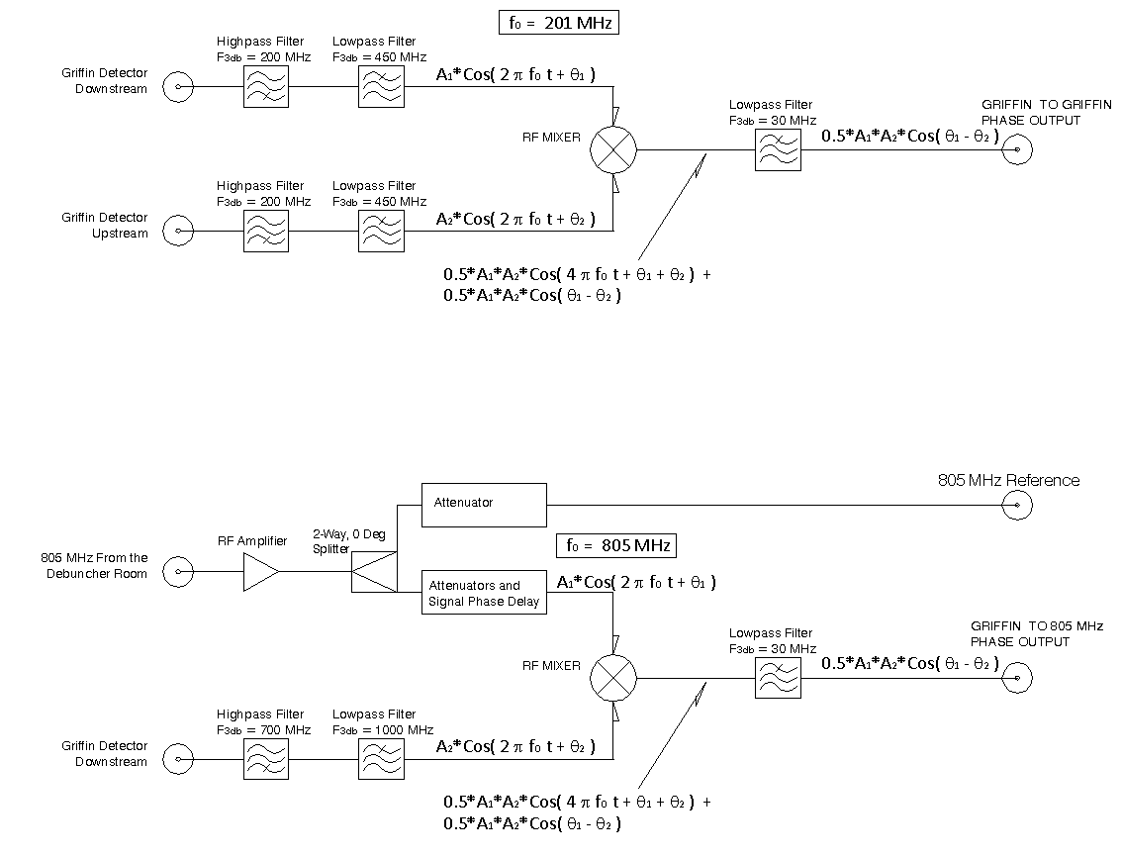
Figure III.1 Block diagram of the measurements.

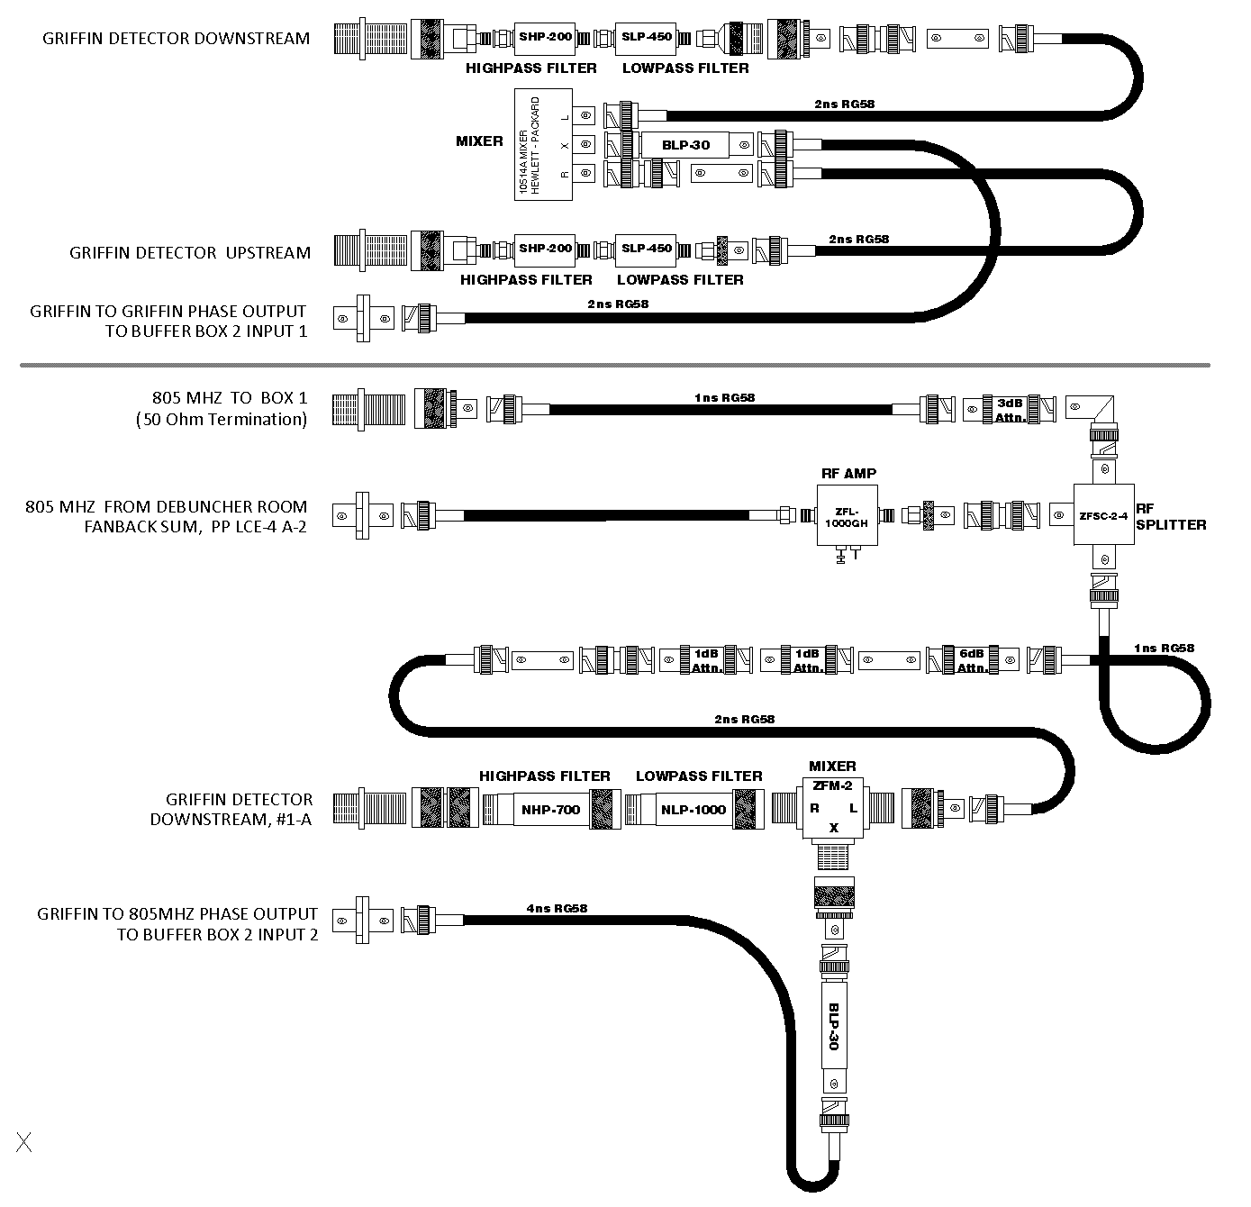
Figure III.2 The phase detector circuit assemblies.

Application of the Griffin Detector Measurements
The output phase difference voltage of the Linac beam velocity is monitored on an oscilloscope display assigned to Channel 17 on the controls cable TV network. This voltage is also applied in a control system front-end processor, IRM node 061E (a.k.a. LIP61E), to modulate the phase of Linac Tank 7 and hence the beam velocity / energy out of the Linac. Figure IV.2 is a block diagram showing how the cabling for the signals is routed between racks in the West Booster Gallery.
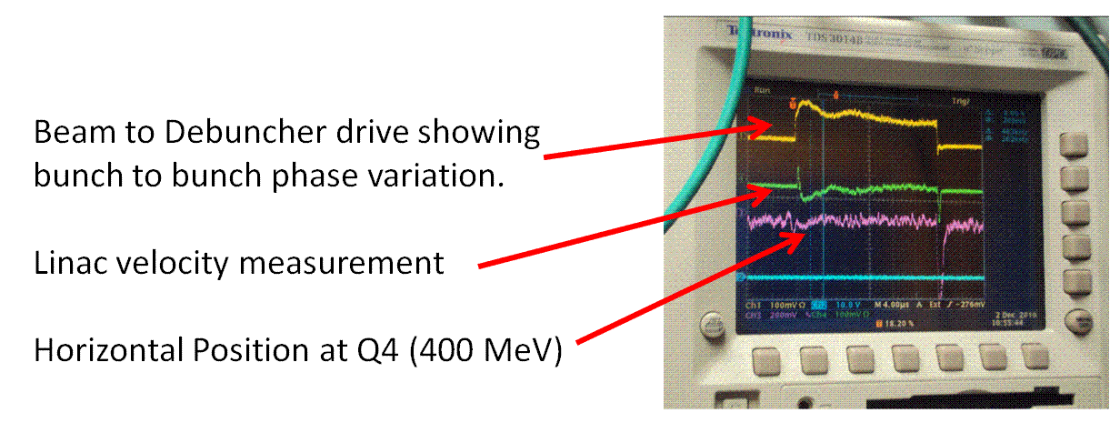
Figure IV.1 Scope display of the Linac velocity.
The velocity regulation is described in two notes written by Robert Goodwin, “Beam Velocity Regulation, Local Application VELO”, Nov. 2, 2009, and “BPM Waveform Averaging, Local Application BPMR”, Feb. 20, 2009. The feedback is fairly simple. The thing to note is that feedback adjustments to Linac Tank 7 are only made when a “valid” velocity measurement is available from the previous beam cycle. The logic is that the BPMR application scans a fixed length portion of the beam intensity waveform, counting how many points (out of the current 160) are found above a small threshold. The VELO calculation is done if at least ten points qualify. At a 10MHz sample rate, this means a beam pulse width of at least 1 microsecond above threshold.
There are also limits on the size of the adjustment that can be made after a beam cycle.
ACNET parameters associated with the velocity measurement and regulation are
L:D4VELO Average Velocity Deviation from nominal.
L:D4VELS Sigma of the Velocity Deviation from nominal.
L:D4VGN1 VELO application loop gain.
Listing IV.1 is a snapshot of a spreadsheet showing the computation of other physics parameters to show the sensitivity of the measurement to Linac beam energy and momentum.
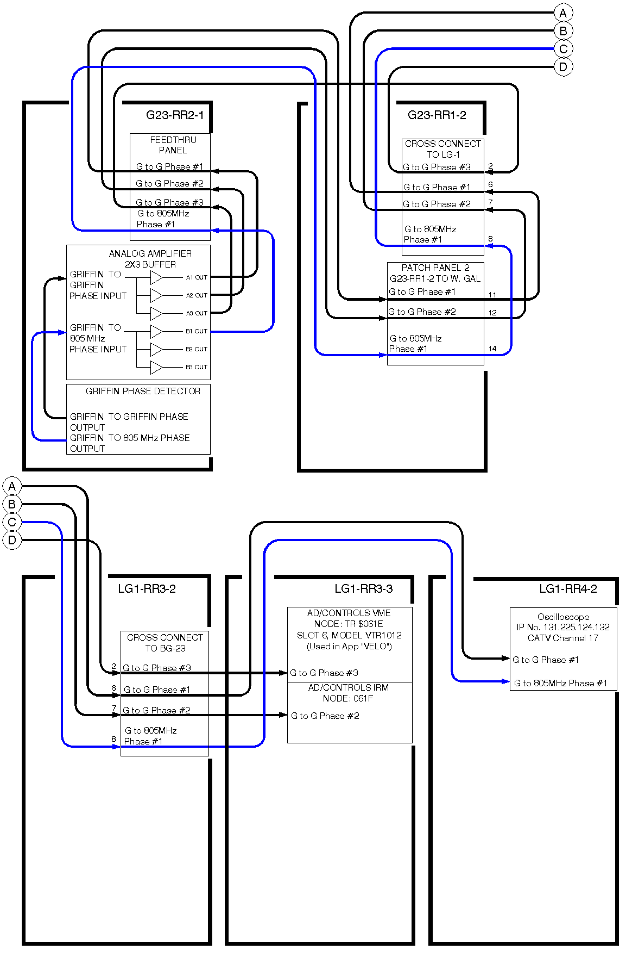
Figure IV.2 Cabling layout for “Griffin to Griffin” and “Griffin to 805 MHz” phase signals.
Nominal KE  = 400 Mev | Rest Energy,  Eo = mo*c^2 | Gamma,  g = [KE(t) + Eo]/Eo | Beta,  B = sqrt[1 - g^(-2)] | Velocity,  vo = B*c  (meters / s) | Distance Between Detectors  = 50 meters | Baseline  Time-of-Flight  = dist. / velocity | Baseline Phase | Baseline Volts  Conversion  = 0.1 Volts / 5.997 deg | Baseline Momentum, c*po
4.00000E+08 | 9.38E+08 | 1.426439 | 0.713116 | 213792093 | 50.0 | 2.34E-07 | 0.00 | 0.000 | 9.54149E+08
Kinetic Energy, KE(t) | Rest Energy,  Eo = mo*c^2 | Gamma,  g = [KE(t) + Eo]/Eo | Beta,  B = sqrt[1 - g^(-2)] | Velocity,  v = B*c  (meters / s) | % Change in Velocity | Delta T =  Baseline - (dist/v) | Deg. Phase =  Delta T *201E6*360 | Volts Out =  Deg. Phase *0.016675 | Momentum  c*p = Eo*sqrt[g^2 - 1] | % Change in Momentum
4.00020E+08 | 9.38E+08 | 1.426461 | 0.713126 | 213795250 | 0.001476% | 3.45E-12 | 0.25 | 0.004 | 9.54177E+08 | 0.003004%
4.00040E+08 | 9.38E+08 | 1.426482 | 0.713136 | 213798270 | 0.002889% | 6.76E-12 | 0.49 | 0.008 | 9.54205E+08 | 0.005879%
4.00060E+08 | 9.38E+08 | 1.426503 | 0.713147 | 213801358 | 0.004333% | 1.01E-11 | 0.73 | 0.012 | 9.54233E+08 | 0.008818%
4.00080E+08 | 9.38E+08 | 1.426525 | 0.713157 | 213804446 | 0.005778% | 1.35E-11 | 0.98 | 0.016 | 9.54261E+08 | 0.011757%
4.00100E+08 | 9.38E+08 | 1.426546 | 0.713167 | 213807533 | 0.007222% | 1.69E-11 | 1.22 | 0.020 | 9.54289E+08 | 0.014696%
4.00120E+08 | 9.38E+08 | 1.426567 | 0.713178 | 213810621 | 0.008666% | 2.03E-11 | 1.47 | 0.024 | 9.54317E+08 | 0.017635%
4.00140E+08 | 9.38E+08 | 1.426588 | 0.713188 | 213813708 | 0.010110% | 2.36E-11 | 1.71 | 0.029 | 9.54345E+08 | 0.020575%
4.00160E+08 | 9.38E+08 | 1.426610 | 0.713198 | 213816795 | 0.011554% | 2.70E-11 | 1.96 | 0.033 | 9.54373E+08 | 0.023514%
4.00180E+08 | 9.38E+08 | 1.426631 | 0.713208 | 213819882 | 0.012998% | 3.04E-11 | 2.20 | 0.037 | 9.54401E+08 | 0.026453%
4.00204E+08 | 9.38E+08 | 1.426657 | 0.713221 | 213823648 | 0.014759% | 3.45E-11 | 2.50 | 0.042 | 9.54435E+08 | 0.030038%
4.00220E+08 | 9.38E+08 | 1.426674 | 0.713229 | 213826055 | 0.015885% | 3.71E-11 | 2.69 | 0.045 | 9.54457E+08 | 0.032330%
4.00240E+08 | 9.38E+08 | 1.426695 | 0.713239 | 213829141 | 0.017329% | 4.05E-11 | 2.93 | 0.049 | 9.54485E+08 | 0.035269%
4.00260E+08 | 9.38E+08 | 1.426716 | 0.713250 | 213832228 | 0.018773% | 4.39E-11 | 3.18 | 0.053 | 9.54513E+08 | 0.038208%
4.00280E+08 | 9.38E+08 | 1.426738 | 0.713260 | 213835314 | 0.020216% | 4.73E-11 | 3.42 | 0.057 | 9.54541E+08 | 0.041147%
4.00300E+08 | 9.38E+08 | 1.426759 | 0.713270 | 213838399 | 0.021659% | 5.06E-11 | 3.66 | 0.061 | 9.54569E+08 | 0.044086%
4.00320E+08 | 9.38E+08 | 1.426780 | 0.713280 | 213841485 | 0.023103% | 5.40E-11 | 3.91 | 0.065 | 9.54598E+08 | 0.047024%
4.00340E+08 | 9.38E+08 | 1.426802 | 0.713291 | 213844570 | 0.024546% | 5.74E-11 | 4.15 | 0.069 | 9.54626E+08 | 0.049963%
4.00360E+08 | 9.38E+08 | 1.426823 | 0.713301 | 213847656 | 0.025989% | 6.08E-11 | 4.40 | 0.073 | 9.54654E+08 | 0.052902%
4.00380E+08 | 9.38E+08 | 1.426844 | 0.713311 | 213850741 | 0.027432% | 6.41E-11 | 4.64 | 0.077 | 9.54682E+08 | 0.055840%
4.00400E+08 | 9.38E+08 | 1.426866 | 0.713322 | 213853825 | 0.028875% | 6.75E-11 | 4.89 | 0.081 | 9.54710E+08 | 0.058779%
Listing IV.1 Sensitivity calculation spreadsheet

Computations Used

Spreadsheet Equations
The spreadsheet in Listing IV.1 runs through a small range of energies for the Linac beam delivered to the Booster through the 400 MeV beam transport line. The relationships between the velocity, momentum and energy were taken from C. Bovet, et.al. ,”A Selection of Formulae and Data Useful for the Design of A. G. Synchrotrons”, CERN/MPS-SI/Int. DL/70/4, April 1970.
Kinetic Energy, KE: Given
Rest Energy, Eo: 938 MeV
Gamma, γ (g): (KE + Eo)/Eo
Momentum, $c∙p$: $E_{O}∙\sqrt{γ^{2}-1}$
Beta, β (B): $\sqrt{1-γ^{-2}}$
Speed of Light, c: 299,792,458 meters/second
Velocity, V: $β∙c$

An Evaluation of Sensitivity for 10 Degree Phase Difference
This is included here for reference.
The nominal γ and $β$ at 400 MeV beam is
$$γ=\frac{938+400}{938}=1.426$$
$$β=\sqrt{1-γ^{-2}}=\sqrt{1-{\left(\frac{938}{938+400}\right)}^{2}}=0.713$$
To write the momentum sensitivity as a function of the change in velocity we use the following relationships
$$I. \frac{dβ}{β}=\frac{1}{γ^{2}}∙\frac{dp}{p}$$
$$dβ=β∙\frac{1}{γ^{2}}∙\frac{dp}{p}$$
$$II. dV=dβ∙c$$
$$I.→II. dV=β∙c∙\frac{1}{γ^{2}}∙\frac{dp}{p}$$
$$\frac{dp}{p}=\frac{γ^{2}}{β∙c}∙dV$$
The change in the Time-of-Flight from the reference TOF is
$$∆TOF=\frac{50 \left(meters\right)}{V_{0}\left(meters/second\right)}-\frac{50 \left(meters\right)}{V_{1}\left(meters/second\right)}$$
$$∆TOF=50∙\left(\frac{V_{1}-V_{0}}{V_{1}∙V_{0}}\right)=50∙\left(\frac{dV}{V_{1}∙V_{0}}\right)$$
The change in Velocity associated with the change in Time-of-Flight is
$$dV=V_{1}∙V_{0}∙\left(\frac{∆TOF}{50}\right)=\left(V_{0}+dV\right)∙V_{0}∙\left(\frac{∆TOF}{50}\right)$$
$$dV=V_{0}∙\frac{V_{0}∙\left(\frac{∆TOF}{50}\right)}{1-V_{0}∙\left(\frac{∆TOF}{50}\right)}$$
The change in Time-of-Flight associated with the change in the phase difference at frequency F is
$$∆TOF=∆Phase \left(degrees\right)∙\left(\frac{1}{F}\right)\left(\frac{seconds}{cycle}\right)∙\left(\frac{1}{360}\right)\left(\frac{cycles}{degree}\right)=∆Phase∙\left(\frac{2.778E-3}{F}\right)$$
$$\frac{∆TOF}{50}=∆Phase∙\left(\frac{55.556E-6}{F}\right)$$

So, the change in Velocity associated with the change in the phase difference at 201 MHz is
$$dV=V_{0}∙\frac{V_{0}∙∆Phase∙\left(\frac{55.556E-6}{F}\right)}{1-V_{0}∙∆Phase∙\left(\frac{55.556E-6}{F}\right)}$$
$$dV=β∙c∙\frac{β∙c∙∆Phase∙\left(\frac{55.556E-6}{F}\right)}{1-β∙c∙∆Phase∙\left(\frac{55.556E-6}{F}\right)}$$
Substituting this $dV$ into the equation for the momentum sensitivity we get
$$\frac{dp}{p}=γ^{2}∙\frac{β∙c∙∆Phase∙\left(\frac{55.556E-6}{F}\right)}{1-β∙c∙∆Phase∙\left(\frac{55.556E-6}{F}\right)}$$
Substituting in for $γ$, $β$ and $c$ at 400 MeV Linac output and F=201 MHz we have
$$\frac{dp}{p}={\left(1.426\right)}^{2}∙\frac{\left(0.713\right)∙\left(299.8E6\right)∙∆Phase∙\left(276.40E-15\right)}{1-\left(0.713\right)∙\left(299.8E6\right)∙∆Phase∙\left(276.40E-15\right)}$$
$$\frac{dp}{p}=\frac{2.0335∙∆Phase}{16,926-∆Phase}$$

For a change in phase difference of 2.5 degrees we have
$$\frac{dp}{p}=0.0003=0.030\%$$
For reference we consider the result for F=805 MHz and a 10 degree change
$$\frac{dp}{p}={\left(1.426\right)}^{2}∙\frac{\left(0.713\right)∙\left(299.8E6\right)∙10∙\left(69.014E-15\right)}{1-\left(0.713\right)∙\left(299.8E6\right)∙10∙\left(69.014E-15\right)}$$
$$\frac{dp}{p}=0.000289=0.029\%$$

