Configuring the LLRF System for Testing New Frequency and Phase Control Components

Craig Drennan
December 1, 2009

Table of Contents

I. Introduction 3
II. Overview of System to be Tested 4
III. Test Electronics Installation Details 7
III.1 Cable Delays to Manage 7
III.2 Physical Layout 9
III.3 Proposal for Installation of New Hardware. 13

Table of Figures

Figure II.1 The existing system under consideration for replacement. 4
Figure II.2 Connection of the new electronics for testing through RF switches. 5
Figure II.3 The addition of new phase detectors for implementing MI phase-lock in the new module. 6
Figure II.4 The final configuration of the LLRF controls using the new module. 6
Figure III.1.1 Matching the delay in the two paths between the LLRF Source and the Phase Detector. 8
Figure III.1.2 Signal delays to be managed. 9
Figure III.2.1 Interconnections we are concerned with. 10
Figure III.2.2 Layout of rack BLLRF-4 with signal cables indicated. 11
Figure III.2.3 Photos of rack BLLRF-4, front and rear. 12
Figure III.3.1 Signal cabling with the new DDS Source and RF switches. RF Switch NIM Module has an equivalent delay of 2 nanoseconds. 13
Figure III.3.2 Layout of rack BLLRF-4 after the addition of the new DDS LLRF Source and the RF switch modules. 14

Introduction
A new module is being developed to replace the Booster’s current LLRF frequency source. The new module will eliminate the need for the analog phase shift modules currently implemented in the radial position control loop and the A cavity RF/B cavity RF beam capture paraphasing functions. The new module will do this by implementing multiple DDS RF signal synthesizers tied together by a common frequency digital word and manipulated individually by independent phase digital words. In addition, the module will be programmed to perform the procedures for phase locking to the Main Injector RF and replace the set of modules currently used for this purpose.
The advantages we expect to achieve with the new system are:
- A reduction in the number of hardware modules we must maintain and the amount of cable congestion in the racks.
- Greater flexibility to control the Main Injector phase-lock process.
- More precise and flexible control of RF phase.
- Greater flexibility in testing modifications to the control algorithms.
Initially the controls, curves, triggers and settings for the new system would be similar to the current system if not exactly the same. Specification for the new system are being captured in another document, “Requirements for the Booster LLRF DDS Module”, Beams-doc-2828.
The Booster is currently in operation and needs to remain running at its highest throughput and efficiency even as a new system is tested and brought on-line. The general procedure for doing this is to run both the current system and the new system in parallel for an extended period of time. When the new system is deemed ready it can be switched into active control of the Booster on a single low intensity cycle, while the old system continues to control the other Booster cycles.
The new electronics can be integrated in stages. It can first be tested as the replacement for the frequency source only and afterwards replacing the phase shifting components also. At any point in the testing, a new process for achieving Main Injector phase-lock can be tested, with or without implementing a new frequency source and or new phase control.
The Booster LLRF controls will be configured so that the new system can be tested alongside the existing, running LLRF controls. This document captures many details for the installation of the control modules and testing hardware.

Overview of System to be Tested
The electronics under consideration are the main elements of two control loops. The first is a phase lock loop that maintains a controlled phase relationship between the beam bunch structure and the LLRF source output. The second control loop manipulates the phase of the LLRF out to the beam accelerating cavities to control the radial position of the beam. Figure II.1 provides a block diagram of this portion of the LLRF controls for which we are intending to build and test new electronics.

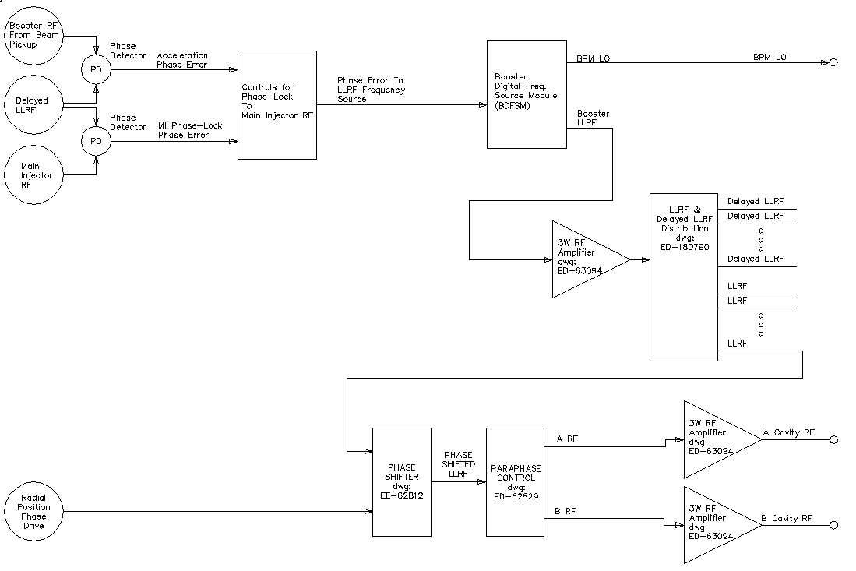
Figure II.1 The existing system under consideration for replacement.

Figure II.2 shows the connection of RF switches to the existing system and the new Four Channel DDS LLRF VME Module. In the simplest test, the new DDS VME module would replace the Booster Digital Frequency Source. The Phase Shifter and Paraphase Control modules could be left in the system. DDS Channel 1, LLRF, and DDS Channel 2, BPM LO, would be programmed to mimic the function of the Booster Digital Frequency Source.
The next step would be to employ DDS Channel 3 and DDS Channel 4 to provide the phase shifted LLRF signals for the A accelerating cavities and the B accelerating cavities, respectively. The new module would respond to the PSDRV, phase drive, signal from the Radial Position Phase Controller by shifting the phase of both the A RF and B RF together with respect to the LLRF from DDS Channel 1. Additionally the new module would manipulate the A RF and B RF phase individually to perform the function of the Paraphase Controller.
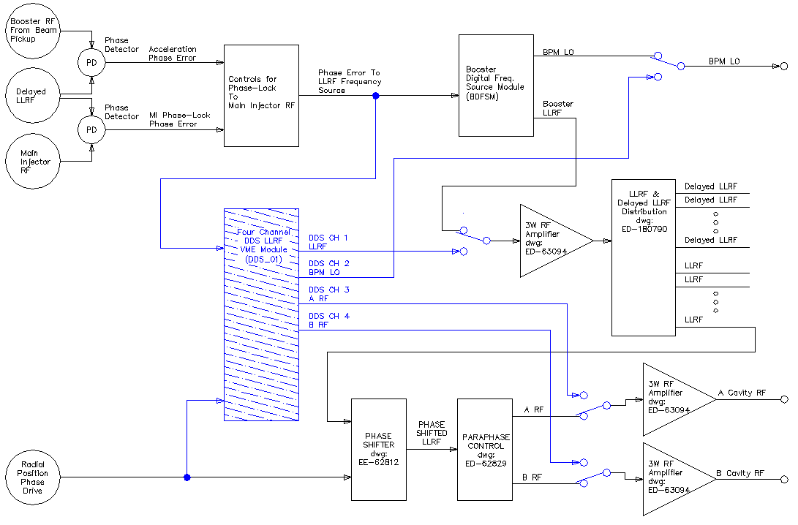
Figure II.2 Connection of the new electronics for testing through RF switches.
The new DDS module would also be capable of replacing the Main Injector phase-lock controls. The initial trials will employ a new set of phase detectors. The connection of these new phase detectors are indicated in Figure II.3. A new Main Injector phase-lock scheme could be implemented by generating a new phase error output from the new module and using this signal with the current Booster Digital Frequency Source, Phase Shifter and Paraphase Control. The ultimate configuration of new electronics would replace the phase detectors for the acceleration and Main Injector phase-lock, the two other modules that make up the current controls for Main Injector phase-lock, the Booster Digital Frequency Source Module, the Phase Shifter and the Paraphase Controller along with the VXI Paraphase Curve Generator.
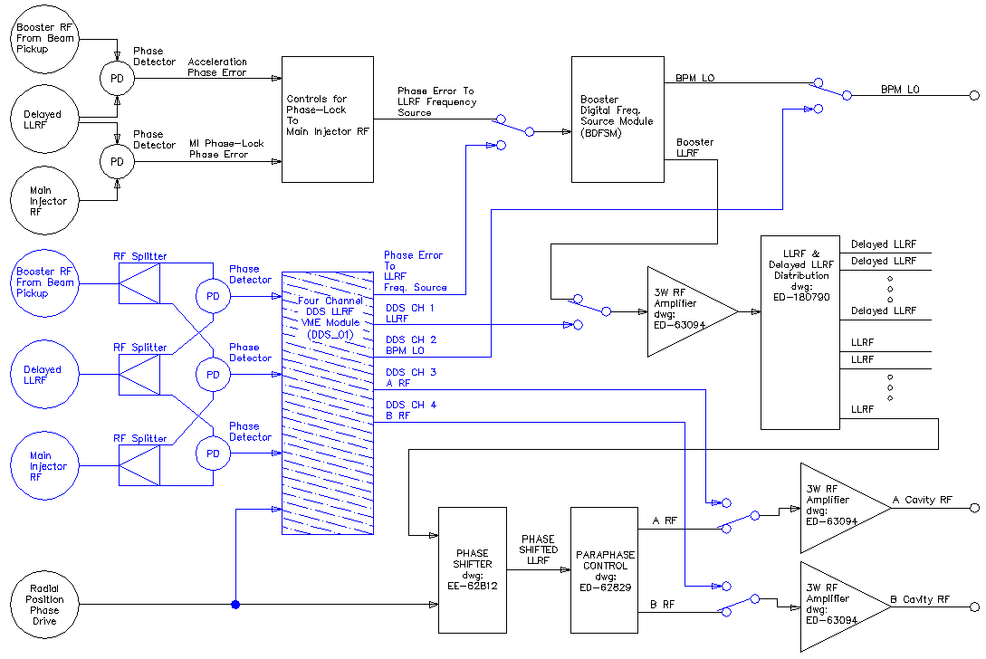
Figure II.3 The addition of new phase detectors for implementing MI phase-lock in the new module.

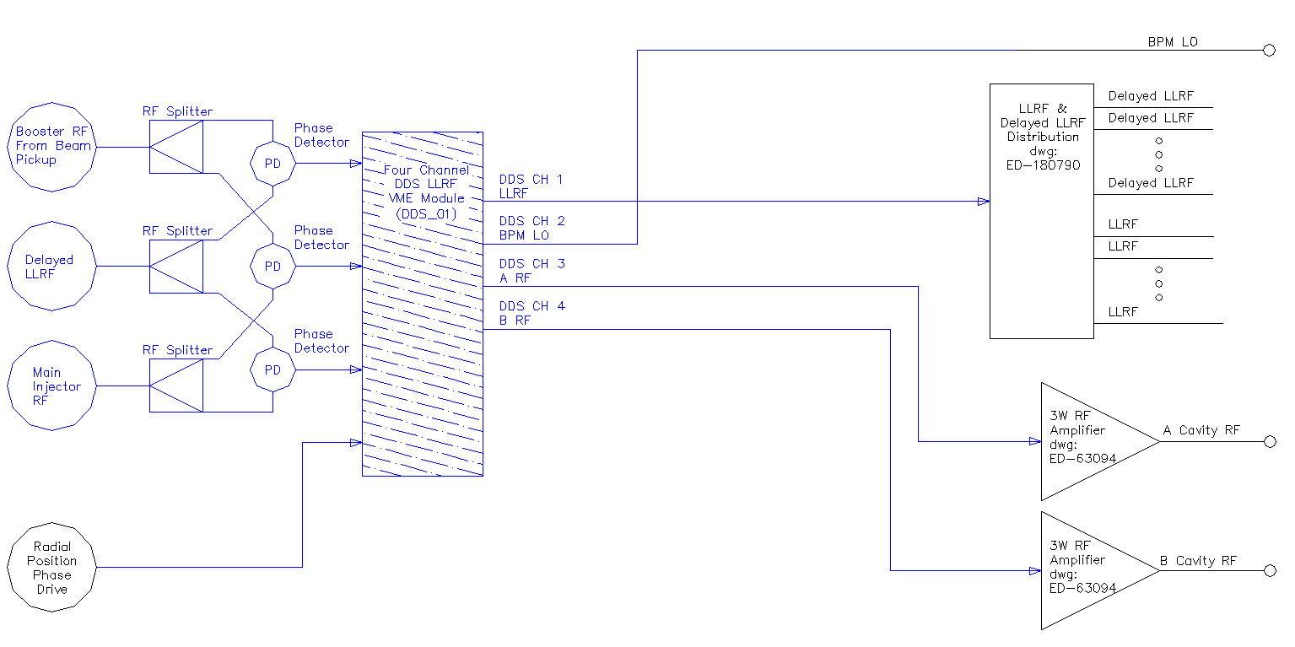
Figure II.4 The final configuration of the LLRF controls using the new module.

Test Electronics Installation Details

III.1 Cable Delays to Manage
The LLRF control signal is distributed over long runs of cable between the Frequency Source and the accelerating cavities. It is the RF at the accelerating cavities that impacts the frequency structure and phase of the beam bunches. Hence, when the LLRF phase is compared to the Booster RF from the beam pickup in the tunnel a delayed version of the LLRF is used. The effects of the cable delays are significant since the frequency of the RF is ramped from approximately 37 MHz to 52.8 MHz over the acceleration cycle. The amount of phase shift introduced by a cable of length ‘L’ is dependent on the signal frequency.
$$∆Phase\left(degrees\right)= \frac{L(meters)∙f\left({cycles}/{second}\right)\left({360 deg}/{cycle}\right)}{Velocity of Propagation\left({meters}/{second}\right)}$$
The velocity of propagation for RG58 cable is 0.66 x c (speed of light). The conversion for RG58 becomes
$$∆Phase\left(degrees\right)= \left(1.8194E-6\right)∙\left(\frac{degree∙second}{cycle∙meter}\right)∙L(meters)∙f\left(\frac{cycles}{second}\right)$$
The delayed LLRF (“Delayed VCO” as it is listed in Booster LLRF Block diagrams and schematics) is established by running the LLRF signal through reels of cable mounted to the ceiling in the LLRF Room. The delay through this cable and other associated interconnects must be adjusted to match the delay between the frequency source and the effected Booster bunch frequency and phase at the input to the Phased Detector. Figure III.1 illustrates the delay paths we are now considering.
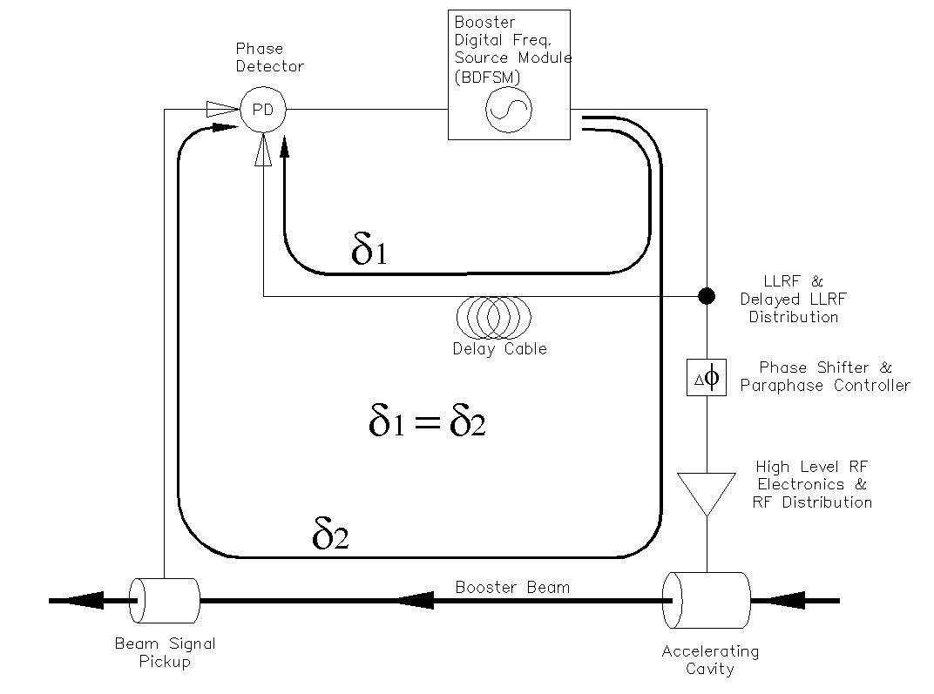
Figure III.1.1 Matching the delay in the two paths between the LLRF Source and the Phase Detector.

The installation of the RF switches that will be used to transfer Booster control between the old and new systems will impact this delay matching. In installing the RF switches, and the new electronics for testing, we want to maintain the existing cables delays. So, we will identify sections of interconnecting cable that can be replaced by equivalent lengths of switch plus cable. The RF switches are to go onto the LLRF output of the BGDSM and the A RF and B RF outputs of the Paraphase Controller. Fortunately these outputs exist close together in LLRF Rack 4. Also the existing cable lengths in this rack have sufficient slack to accommodate the addition of the switches.
Figure III.2 illustrates the delay issues associated with the addition of the switches and new frequency source module. As before, we must maintain the relationship
$$δ_{1}=δ_{2}=δ_{A}+δ_{B}+δ_{C}+{2∙δ}_{SW}$$
Where $δ_{SW}$ is the delay through the RF switch. Additionally, since all 4 DDS outputs of the new DDS Frequency Source are expected to be updated with the same frequency word simultaneously, appropriate delay needs to be added to the A RF and B RF outputs ($δ_{3}$ ).
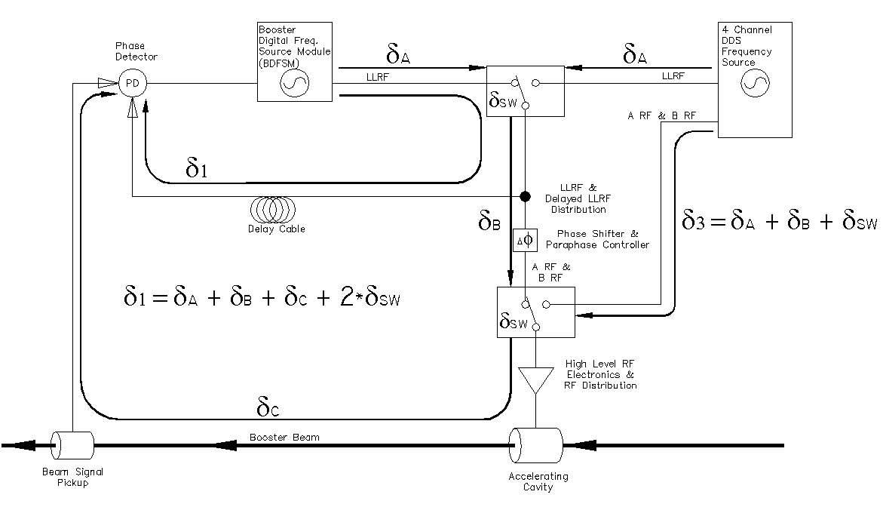
Figure III.1.2 Signal delays to be managed.

III.2 Physical Layout
Fortunately, most of the cables and electronics involved with attaching and testing the new modules resides in rack BLLRF-4. The signals that we are putting switches in are the LLRF output and the BPM LO output of the Booster Digital Frequency Source Module, and the A RF and B RF outputs of the Paraphase controller. Figure III.2.1 shows the actual connections and cable length of the interconnections involved. This figure does not, however, indicate rack layout. Figure III.2.2 illustrates the current rack layout. The cables for the signals of interest are indicated on this drawing. For reference, Figure III.2.3 and Figure III.2.4 are composite photos of the rack BLLRF-4, front and rear, respectively.

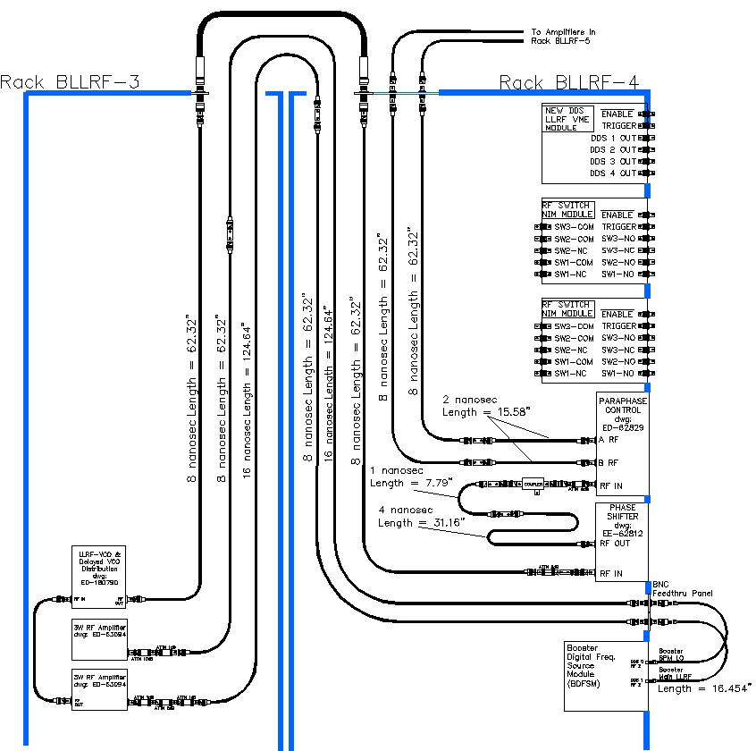
Figure III.2.1 Interconnections we are concerned with.

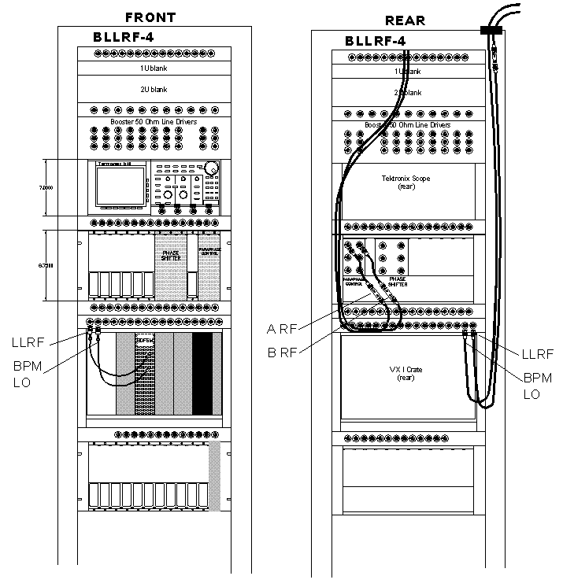
Figure III.2.2 Layout of rack BLLRF-4 with signal cables indicated.

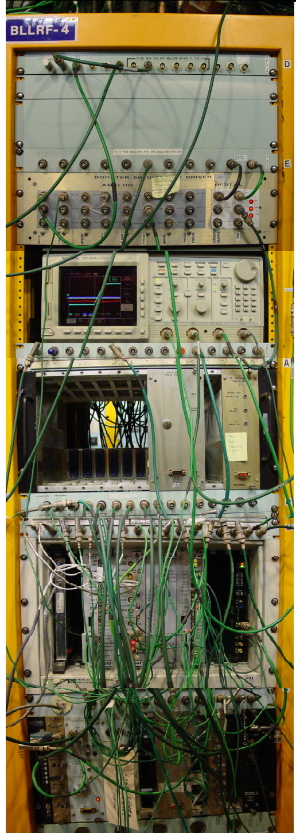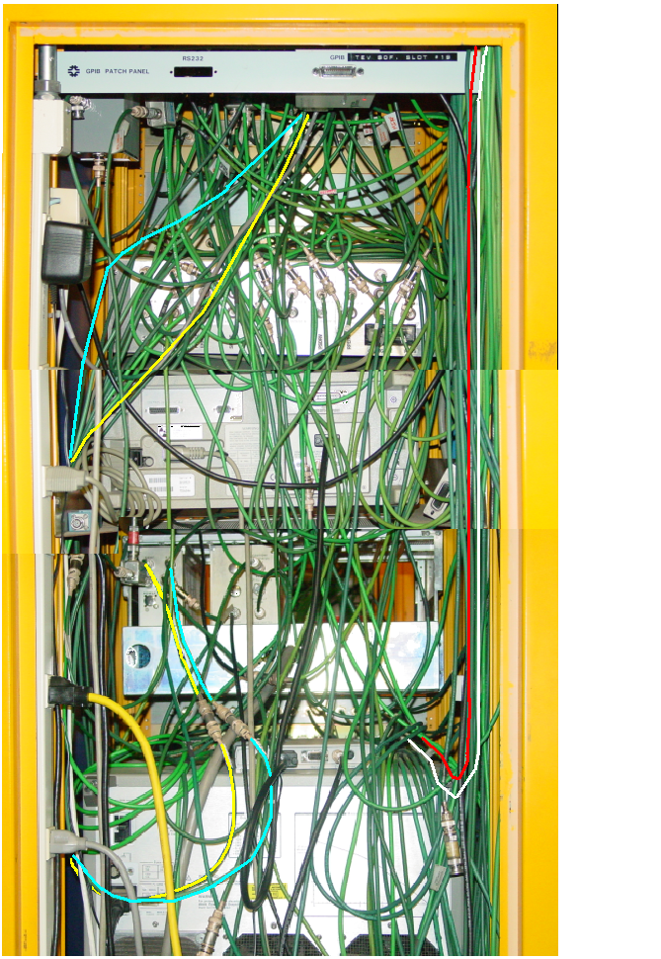
Figure III.2.3 Photos of rack BLLRF-4, front and rear.

III.3 Proposal for Installation of New Hardware
The RF switches and the new LLRF DDS Module need to be physically installed near the path of the LLRF signal and the A RF and B RF signals to take advantage of the available slack in these cables to maintain the current signal delays. RF Switch NIM Module is built to have an equivalent delay of 2 nanoseconds (15.58 inches of RG58 cable).

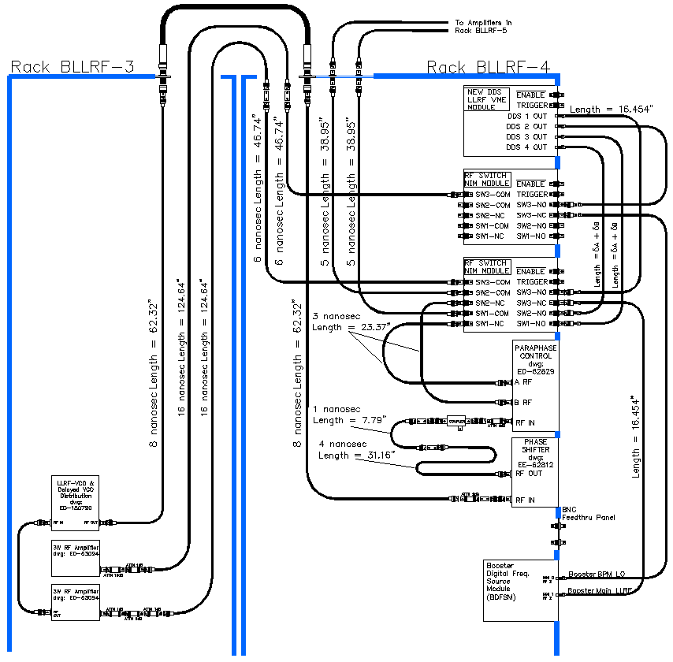
Figure III.3.1 Signal cabling with the new DDS Source and RF switches. RF Switch NIM Module has an equivalent delay of 2 nanoseconds.

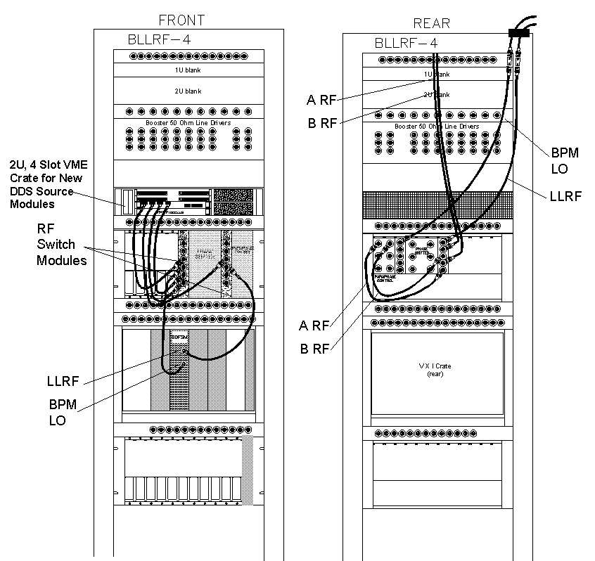
Figure III.3.2 Layout of rack BLLRF-4 after the addition of the new DDS LLRF Source and the RF switch modules.

