**A Review of the RFQ Based Pre-injector for the Fermilab Linac** September 1, 2011, FNAL

***Reviewers:***

Eric Prebys, FNAL (chair)

George Krafczyk, FNAL,

John Lyles, LANL,

Deepak Reparia, BNL,

Vic Scarpine, FNAL,

Chuck Schmidt, FNAL,

Bob Webber, FNAL,

Bob Zwaska, FNAL

***Presenters:***

Dan Bollinger, Mary Convery, Bill Pellico, Elmie Peoples-Evans, Vic Scarpine[1], Cheng-Yang Tan, FNAL

This review[2] was organized at the request of Bill Pellico to evaluate the status and plans for the installation of a new RFQ based pre-injector (ions sources, low energy beam transport, an RFQ, and medium energy beam transport) to replace the existing ion sources and Cockcroft-Walton Preaccelerators currently being used. At the time of this writing, the RFQ itself and a prototype ion source have been built and are being tested. The designs are complete for all other beam components, which are in various stages of delivery and construction.

The current plan is to assemble and test the ion source, Low Energy Beam Transport (LEBT), and RFQ in the linac test area over the next few months, and then install them, along with the Medium Energy Beam Transport (MEBT) and buncher, into the LINAC during the NOvA shutdown. That shutdown will nominally begin in March 2012 and last 9 months. Installation and commissioning of the RFQ pre-injector is scheduled to take three months, with the expectation that beam must be available to NTF during the third month.

No official charge was given, so the committee agreed to set the following charge for itself:

1. Given the advanced state of the project, can you identify any significant flaws which would call into question its potential success?
2. Are there any proposed modifications which would improve the performance or allow easier commissioning?
3. Are there any suggested modifications to the commissioning plan?
4. Comment on the schedule and budget as presented.

In response to the first and most important question, we find that the design is for the most part very conservative, with the pre-injector itself based on a Brookhaven pre-injector that has been supplying H- beams of the same energy and bunch structure to a very similar linac for over 20 years. The major components, a circular-aperture H- magnetron ion source and a RFQ are well established in the BNL design. We therefore have little reason to believe that the design will not work.

The one innovative part of the design is the use of an Einzel lens as a beam chopper. While the SNS uses an Einzel lens to chop the beam by deflecting it laterally, this implementation actually sets up a potential barrier to reflect the beam back along its path. There are some risks associated with this plan;however, it is felt there are backup options if it does not work as well as envisions.

As far as the second and third questions, we feel strongly that that the pre-installation tests should be expanded to include at least the magnetic components of the MEBT, understanding that implementing the buncher in the test area would take a great deal of work. Given the uncertainty in the optics of the first linac tank, we feel that it’s important to have a very good understand of the transverse parameters of the beam at the end of the MEBT.

With regards to the final issue, the committee felt that the assembly and test schedule lacked sufficient detail and was overly ambitious in term of the schedule. In particular, given the importance of restoring beam to the NTF, it’s vital to test the system as thoroughly as possible prior to final installation. It’s likely that the NOvA shutdown will be delayed, and the RFQ installation does not have to begin immediately when it does occur. We recommend that the team determine the minimum time before the *end* of the NOvA shutdown at which they could confidently begin the installation.

No information was presented on the budget for the project, so we do not comment on it.

## Findings

### Design

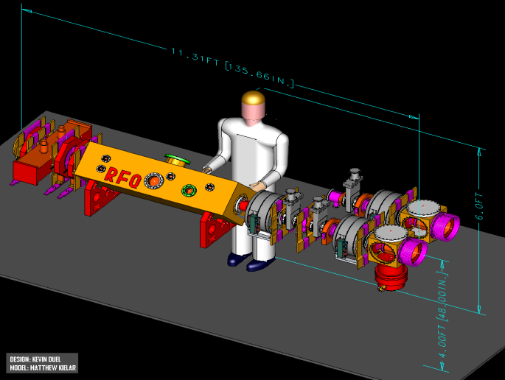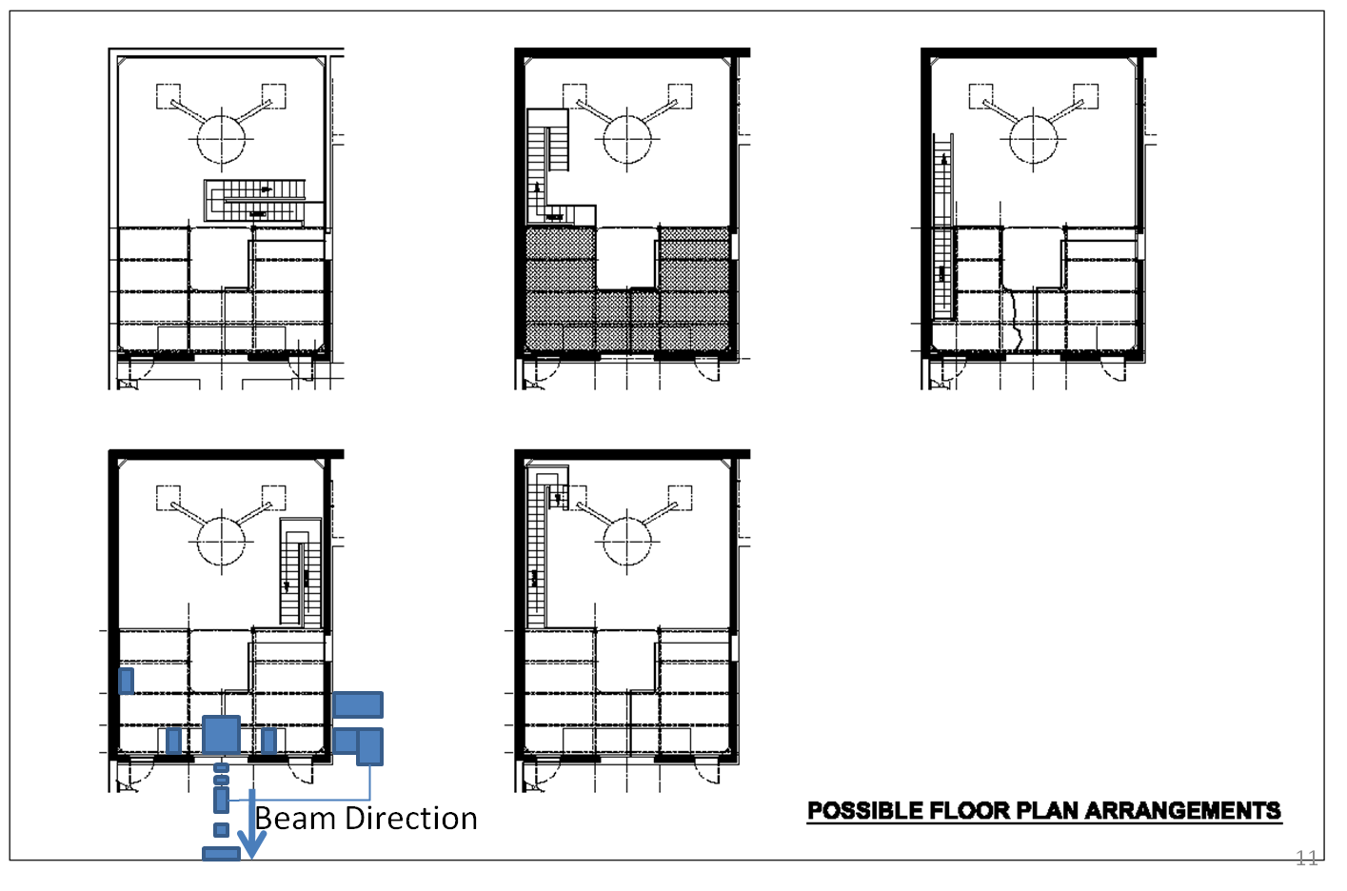

Figure 1: Layout of the ion sources, LEBT, RFQ and MEBT (left) along with proposed installation location (right)

At the time of this review, the design of the RFQ was complete, the RFQ itself delivered, and the remaining components in various stages of construction and assembly. Therefore, significant changes can only be considered if a true “show stopper” is identified.

Figure 1 shows the layout of the proposed 750 keV RFQ-based injection system. Two 35 keV magnetron ion sources are mounted on a track, such that the standby source can be tested in situ and then moved into place quickly. These are followed by a LEBT which uses solenoid focusing and employs low pressure Xe for space charge neutralization. The RFQ itself accelerates the beam to 750 keV, after which a MEBT consisting of two quadrupole double pairs performs the matching to the first Linac tank. The MEBT also contains a two gap buncher for longitudinal matching. This design is largely based on the BNL pre-injector, which has been successfully operating for over 20 years. Though BNL and FNAL RFQ design energies are same (35 keV input, 750 keV output), the lengths differ by 40 cm. Also, FNAL RFQ is four-rod type while BNL RFQ is four-vane type.

The general installation plan is to leave the I- dome in place, but to build a platform around it and remove the column, as shown on the right of Figure 1. The entire source assembly will be mounted to the rear flange of Linac tank 1, supported on a platform which is cantilevered through the opening in the I- enclosure left by the removal of the column assembly. Access to the ion sources will be from inside the enclosure, while access to the RFQ itself will be from outside, just downstream.



Figure 2: Operation of the pulse Einzel Lens

A unique feature of the design is pulsing the Einzel lens in the LEBT to create a longitudinal field to act as a beam chopper, as illustrated in Figure 2. To our knowledge, this has never been done before. The design relies on two high-speed solid state switches in a push pull configuration to control the required 37 kV pulse.

### Status

The RFQ has arrived, and a prototype ion source is being tested. Other components are in various stages of construction and assembly. It’s planned to assemble the ion source, LEBT and RFQ in the Linac lower gallery ion source test area and to test them extensively there. There is currently no plan to test the MEBT until the final installation.

Installation is planned to coincide with the “NOvA” shutdown. This shutdown is currently scheduled to begin in March and continue for nine months, although there is a strong likelihood the start will be delayed. The pre-injector installation and commissioning is expected to take 3 months from the time the beam is shut off until it is again accelerated in the Booster, with beam available to NTF within two months. This last constraint is important in that it affects whether or not the NTF will lay off staff.

We were told of plans to reduce beam-off time required for installation by completing construction of the platform in the I- room while still operating the Linac with the H- Cockcroft-Walton.

## Comments

The pre-injector design is very similar to that at Brookhaven, which has been working reliably for over 20 years, so there is reason to be reasonably confident of success.

The only new feature is the use of the Einzel Lens to create a longitudinal field serving as a beam chopper. As far as we know, this has never been done before. In addition to the possibility of problems with the high speed pulser, the ion beam which is reflected may affect the Xe space charge neutralization, possibly resulting in subtle changes to the beam.

Because a small portion (3 microsec) of the 30 to 60 microsec Linac beam to the Booster is adversely affected by the Linac RF Stations and must be dumped , the committee was not convinced of the stringent rise and fall times (tens of nanoseconds) placed on the Einzel Lens pulser.

Very few details were given about the remaining assembly and test schedule, but the overall time scale struck the committee as rather ambitious.

The committee was concerned whether the quantity of documentation needed to satisfy safety requirements and to obtain operational permits is adequately understood and whether the time required to generate, review, and receive approval of that documentation is adequately considered in the schedule.

One of the stated goals of the RFQ project is to reduce the Linac beam emittance. There is presently a transverse beam emittance monitor at the downstream end of Linac Tank 1 in an unknown state of repair. The committee feels it would be useful to characterize the transverse beam properties at that location prior to switching to the RFQ injector to serve as a reference for what will be observed after the RFQ is installed. This device would provide a quantitative measure of the emittance before and after.

## Recommendations

1. The committee feels that it’s important to test the magnetic elements of the MEBT prior to installation. In an ideal world, one would like to test the buncher as well, but we realize that this would require a great deal of effort and could easily delay the project. On the other hand, setting up the magnetic elements and characterizing the transverse beam parameters should be fairly straightforward, and the information gathered will be useful later in matching to the Linac.
2. Write up a more detailed test and qualification plan, with specific and quantitative acceptance criteria. We recommend a short readiness review prior to start of installation.
3. We consider it possible that the assembly and test schedule will push the installation date past the beginning of the NOvA shutdown, even if the latter is delayed. The team should therefore evaluate how late in the shutdown one could begin the installation of this project while still not putting the restart of the complex at risk.
4. There needs to be a specific backup plan if the current Einzel Lens pulsing scheme doesn’t work due to high speed pulsing or neutralization problems. Neutralization with Xe should be studied early to check for subtle issues during the turn on
5. We recommend identifying all the documentation that will ultimately be required to receive approval to operate and incorporating generation, review, and approval of this documentation into the project schedule.
6. We recommend ‘rehabilitating’ the Tank 1 output emittance probe to serve as an instrument to measure transverse 10 MeV beam parameters before and after switching to the new injector system.

1. The fact the Vic Scarpine was both a presenter and a reviewer was something of an oversight; however, given the rather informal nature of the review, we did not view this as a significant conflict.
2. The review agenda, background material, and presentations can be found at <https://indico.fnal.gov/conferenceDisplay.py?confId=4665>