Proposal to Create a Tomoscope Application for the Fermilab Main Injector
Jerry Cai
Elliott McCrory
November, 2011

Introduction
It is helpful to be able to see a particle density distribution in longitudinal phase space, especially to reveal how it evolves over time for critical beam processes. As we explore the intensity frontier, it may become important to understand possible non-linear longitudinal processes caused by space-charge. Therefore, we propose to develop a Tomoscope application suite for the Main Injector to measure, publish and display the longitudinal phase space of the proton beam using tomography techniques. This suite is to include an open-access front end that collects data and calculates the tomograms. This server can be used online in MI studies in the Main Control Room, and it can host tomography data for heads-up displays in the MCR and for the data logger.
In this note, we give an introduction to tomography techniques and how they can be applied to the construction of longitudinal phase space in a synchrotron. Then, we present our initial proposal for the implementation of the suite. Finally, we suggest personnel for completing this project in a timely manner.

Tomography and the Tomoscope
Tomography refers to using mathematic algorithms to reconstruct cross-sectional images of an object from projection data collected by illuminating the object from many different angles. For example, the well-known Computed Tomography (CT) directs X-rays from multiple orientations and measures the resultant X-rays attenuation, from which the CT image is created. Reconstructing the tomogram from these many projections is a complex mathematical challenge.
This mathematical problem was first addressed by Johann Radon in 1917. In the 1970s Allen Cormack developed more advanced algorithms to solve this problem. Then, Godfrey Hounsfield invented the first X-ray computed tomography scanner using Cormack’s algorithms. The impact of these nondestructive techniques for visualizing the interior of the human body in medical diagnosis has been revolutionary. Cormack and Hounsfield shared the 1978 Nobel Prize in Medicine for this work. Since then, tomography has become a very broad topic with wide applications in such fields as materials science, biology, geophysics, oceanography, and even astrophysics.
Today, a wealth of algorithms for tomographic reconstruction is available. The most common categories of tomography algorithms are the filtered backprojection and iterative reconstruction. In general, the filtered backprojection is faster, but it has more artifacts. (See, for example, http://www.dspguide.com/ch25/5.htm.)

CERN’s Tomoscope
In 1998, Steve Hancock applied tomography techniques to construct the longitudinal phase space for a beam in the Proton Synchrotron (PS) at CERN (see http://cdsweb.cern.ch/record/363824/files/ps-98-030.pdf?version=1). He used a series of one-dimensional bunch profile data from an oscilloscope, connected to a wall current monitor, as the projection data. Hancock realized that this bunch profile data set, accumulated as the beam passes repeatedly through the diagnostic, was analogous to a projection data set, accumulated from different angles around an object, in CT scanner. The algorithm he used for image reconstruction was a modified algebraic iterative algorithm, in which the particle tracking is used to take the beam dynamics into account. We have seen the success and the popularity of the Tomoscope program in CERN Control Center.
The software architecture of the CERN Tomoscope is an amalgam of components written in FORTRAN, Mathematica, and C/Motif. It uses a FORTRAN program for the actual tomography calculation, Mathematica for data analysis and C/Motif for the GUI display/operations application, requiring three people for maintenance. In 2008, the Control Department at CERN asked the LAFS (LHC Accelerator/Fermilab Software) team to come to CERN to discuss how to upgrade their Tomoscope program with modern tools and techniques. Several detailed and useful discussions were conducted. However, the plan was abandoned in 2009 because the Control Department and the PS Department (Hancock) could not reach an agreement on how to proceed.

A short glossary
We present a short glossary to ensure clarity.
Tomography – The mathematical algorithms, and the process of using these algorithms, that generate a tomogram from multiple projections through an object. Some sources refer to this concept with the term “tomographic reconstruction.” For an interesting summary of this word, see http://en.wikipedia.org/wiki/Tomography.
Tomoscope – A device that creates a tomogram.
Tomogram – A collection of 2-dimensional, cross-sectional images of an object, created using the techniques of tomography. Sometimes the tomogram is represented as the collection of the cross-sections in a three-dimensional chart.
Daemon – A computer process that runs continuously in the background and performs a useful service. It has no direct user interface.

The MI Tomography Suite
We propose to build a software suite to calculate and display tomograms based on particle tracking and beam projection signals from a wall-current monitor in the Main Injector. The primary deliverables of this effort will be software components. It is possible that there will also be secondary items that are developed or improved because of this project.

Primary Deliverables
- A daemon process (open-access server, OAS) that collects data from the MI longitudinal pickup, calculates the tomogram, and republishes these data to the rest of the control system. This daemon process runs all the time.
- An operations GUI for displaying the tomograms from the daemon.
- An operations application (possibly distinct from number 2) for enabling configuration changes to the daemon.
- A mechanism for permanent storage of the tomograms.

Secondary Benefits
- Improved longitudinal diagnostics for the MI.
- A demonstration of a more sophisticated Java operations application at Fermilab, fashioned on the type of applications in use at the LHC.
- A demonstration of the publication of structures on ACNET, rather than simple scalar or vector values.
- A demonstration of the ability to save complex structures (for example, the tomogram itself) to Lumberjack, or some other permanent storage.
These deliverables and benefits are suggestions that are based on our experience. A full and official set of requirements for this suite will be developed in conjunction with MI personnel.

Implementation Ideas
Although implementation details will be developed after we gain a thorough understanding the objectives of this project, there are a few pieces of the implementation that are clear.
We propose to implement this software suite entirely in the Java programming language. Through our five years of experience writing applications in Java for the LHC at CERN, we have gained substantial experience with Java—experience which we would like to utilize here. There are several substantial advantages to Java:
- The GUI elements of Java are very well developed and rich
- Java’s implementation of multithreading is very robust
- AD/Controls has expressed a strong interest in developing more complex Java software, fashioned after the sort of software currently in use at the LHC.
- We will be able to use many of the techniques that we utilized for LAFS software projects at the LHC. We may even be able to use some of these elements directly.
We further propose that the Tomography Suite be implemented as a three-tier system: The front end, the open access server (“daemon”) process and the graphical user interface(s).
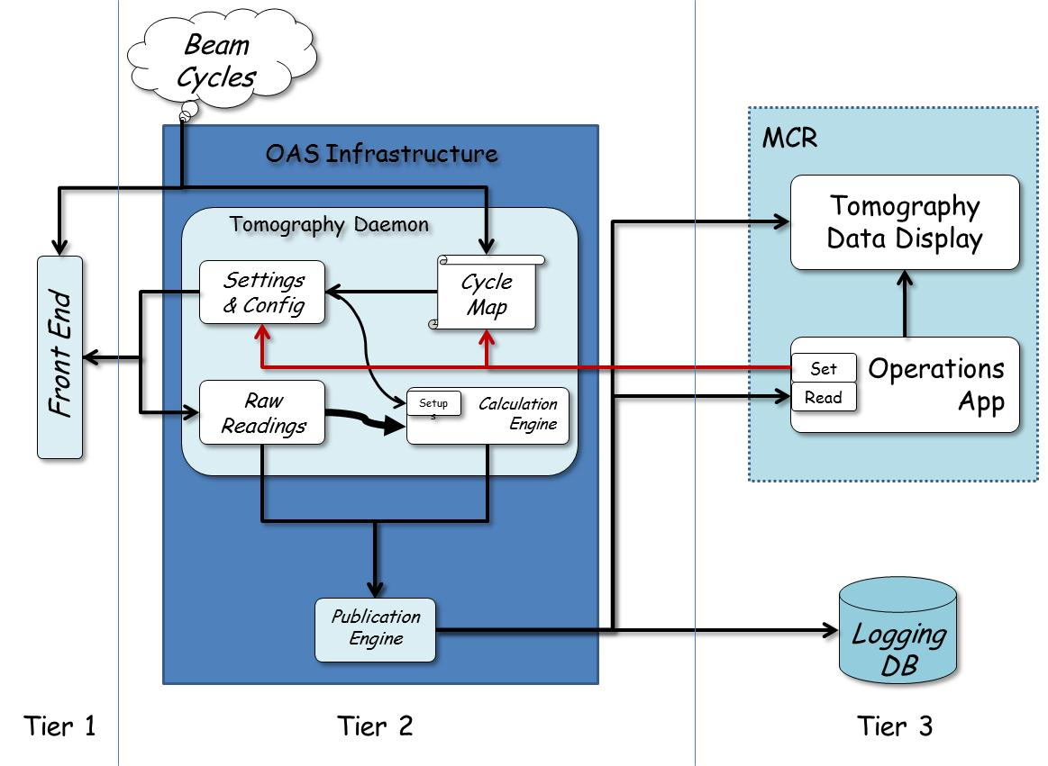
The front end, which is probably connected to an oscilloscope, is responsible for setting the oscilloscope based on the request from the user. It also tracks the bunch through the specified number of turns, acquires profile data and publishes it.
The daemon server is to run continuously as a process within the open-access infrastructure in AD/Controls. It listens for the changes in the configuration from any potential user and for machine timing event. Also, it gathers data from front end and from other ACNET devices. The daemon process also performs the tomography calculations of the longitudinal phase space, and it publishes the tomograms. These data should include any other relevant parameters, like the RF voltage, harmonic number, dipole magnetic field and its time derivative, etc.
We expect the daemon to have at least two basic running modes:
- Taking longitudinal profile data and calculating the tomograms only when requested.
- Continuously taking longitudinal profile data of pre-determined machine event(s) and calculating the tomograms.
The algorithm for tomography reconstruction to get longitudinal phase space is the most critical part of the project. We propose to follow Hancock’s algorithm in our implementation. However, the details of this implementation, including ideas on how to optimize these algorithms, are under consideration.
It is important to consider the speed at which the tomograms can be calculated. The CERN Tomoscope uses High Performance FORTRAN (see http://en.wikipedia.org/wiki/High_Performance_Fortran) with parallelization capability running on a dual-processor computer—this is indeed quite fast. But this implementation creates a system with two distinct components that have no simple means for inter-communication. We believe it would be better to have the whole system in Java. To that end, we have developed a proof-of-principle tomoscope in Java that replicates the tomography reconstruction used in the PS. The preliminary results of our tests are encouraging: It takes about 30 second to build one image set for a profile data set of 58 bunches with each of 500 points (a typical data set). This seems acceptable, but there is plenty of room for improvement. We are well aware that the computing speed depends on many things, most notably the power of the processor. We will work with AD/Controls on this.

Expert Assistance
We realize this is a complicated project. We face a series of challenging issues to complete this project, and we will certainly need assistance from experts in the relevant departments within the Accelerator Division.
Data acquisition is the one of the most crucial aspects of this project. We will need assistance from experts in the Accelerator Control Department and in the Instrumentation Department on this.
Personnel from the Main Injector Department will be the most important users of the tomography suite. Initially, we would like to consult with the Department in order to understand the features and measurements that are required for this suite. Once this has been established, we would like to have a “customer” from MI identified to work with us to develop this suite. This person can be a “guide”, who suggests directions for the suite, or this person could be a hands-on contributor to the software—whichever makes more sense.
The tomoscope software suite is to be built within the Open-Access Server infrastructure in the Accelerator Controls Department. We will need assistance from this department to build this daemon process.
Kiyomi Seiya has used many manual measurements of the longitudinal phase space of the MI beam for slip-stacking studies. Since she has very relevant experience, we hope she can help us.
In summary, here is a list of the effort we expect and need for this project:
Person | Role | Department | Effort
Jerry Cai | Project leaders/Software developers | AD/RF | 50%
Elliott McCrory |  | AD/HQ | 50%
TBD, by Ioanis Kourbanis | General support from MI Department | AD/MI | TBD
TBD, by Manfred Wendt | Hardware support | AD/Instrumentation | TBD
TBD, by Jim Patrick | Software support | AD/Controls | TBD
Kiyomi Seiya | Consultation and advice | AD/Proton Source | TBD

A full reckoning of the time it will take to complete this project will be developed in the next stage of this project.
We wish to have our first meeting soon in order to establish the scope and the basic requirements of this project. We can start to work on this project after this meeting, based on the advice from our experts.

