Beam Loading Numerical Simulation

for µ2e Experiment

*APC, Fermilab, P.O. Box 500, Batavia, IL 60510*

V.I. Balbekov and L.G. Vorobiev

*Abstract*

We have studied numerically a heavy beam loading and instabilities in the 8 GeV Fermilab Accumulator ring in frames of the µ2e (muon-to-electron conversion) experiment. A numerical model based on Fourier expansion of the beam current has been introduced and beam dynamics during tens thousands turns in the Accumulator were simulated. A cross-checking of beam loading has also been done with other codes and with analytical formulae, demonstrating an excellent agreement. The results of simulations put limitations on the cavity shunt impedance and the RF time wave-form to ensure the necessary bunch quality for µ2e research program.

**1. Introduction**

In the µ2e (muon-to-electron conversion) experiment an intense proton beam from the Fermilab Booster goes through the Recycler Ring to the Accumulator ring. The batches, consisting of a train of bunches are being placed consequently on three different orbits in the Accumulator (with the difference of 5 MeV).

After that an RF ramp of the 2.5MHz cavities (harmonic number 4) converts these three batches, each nearly the whole accumulator ring long, into four bunches. Each of those resulting bunches then ejected into the Debuncher ring and then to the µ2e transport line, consisting of solenoids, targets and detectors. The protons hit the target and produce muons, which then are analysed in µ2e apparatus. A structure of the extracted beam at the detector area is shown in Fig. 1. More details of the accelerator setup for µ2e may be found in [1].

It is mandatory for the whole project to provide for µ2e detectors the so-called “inter-bunch extinction” interval [2, pp. 20-23], to minimize the background effect from the strayed muons. Otherwise the collected data will be corrupted, jeopardizing the experiment. See Fig.1 for illustration.



Fig. 1 A sketch of a proton bunch time structure at the final stage, near µ2e detector (a snapshot of Fig. 2.3 from [1].

A creation of the extinction interval at the final stage, assumes that upstream, all RF systems provide a high-quality proton beam bunching. The RF manipulations in the Accumulator ring must suppress all possible instabilities and to ensure four isolated resulting bunches without strayed particles in between.

A computational model was based on inclusion of additive Fourier coefficients, representing the beam current, to the principal RF voltage in the longitudinal equation of motion. Since the cavities, used for the bunching are working on a frequency 4× $f_{rev}$, it is accurate enough to retain in the motion equations the Fourier coefficient only with indices of 4th multiples.

Numerical experiments have been conducted and the longitudinal beam structure analyzed for different scenarios (with a linear, a parabolic RF voltage ramps and with RF generator “OFF”) suggesting the acceptable beam current and RF cavity parameters: a time-dependent wave-form and shunt impedance ranges.

**2. Bunching without beam-loading.**

In the beginning of our studies, we performed numerical experiments in the absence of beam loading, to benchmark our data and the algorithm with other previous results.

The original batch, i.e., a train of bunches (84 bunches minus some 3-4 bunches required for the extraction notch) from the Fermilab Booster is injected into the Recycler and then is sent to the Accumulator ring. The original parameters of the Booster beam are the following: a harmonic number is h=84, an RF frequency is 53MHz, the proton energy is 8GeV. Ultimately, all three batches are placed into the Accumulator ring, each batch with energy offset: -0.0125, 0, +0.0125 GeV correspondingly, as demonstrated in Fig. 2.

These three momentum-stacked batches in the Accumulator are the starting point in our numerical studies. Further bunching occurs for these three batches simultaneously, operating under 2.5MHz cavities RF ramp, which lasts during approximately 17500 turns, or 0.0267 s, with the voltage amplitude varying from zero up to 170 kV. Since the harmonic number becomes h=4, there will be 4 resulting bunches after the ramp.

We made cross-checking of our results with the model without beam loading, of C.Bhat and M. Syphers [3], who were using ESME code [4] for their simulations.

We made our simulations for three momentum stack batches (totally of 25000 macro-particles), initially distributed, as shown in Fig. 2, with Guassian standard deviation for each batch $σ_{dE}=0.0015$ [GeV] and batches medians of -0.0125, 0, +0.0125 [GeV]. In azymuthal direction we assumed a randomly uniform distribution, instead of 80-84 micro-bunches.

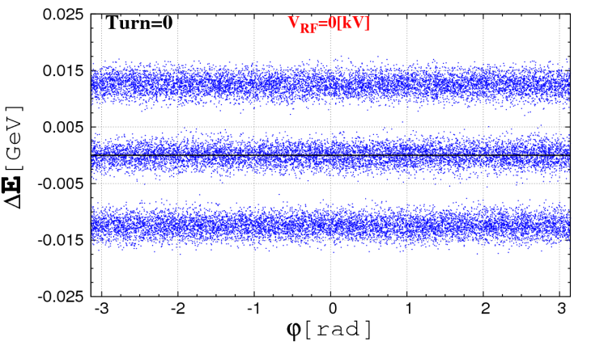 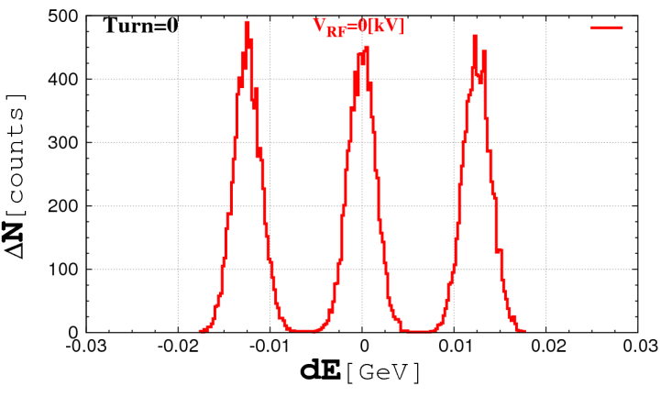

Fig. 2. Three momentum-stacked batches with Gaussian-like (3-sigma) initial distribution $\left({Δφ}_{k},{ΔE}_{k}\right), k=1, …, 25000$ (left), and a corresponding histogram (right).

In the Accumulator ring with the circumference of 474.09 m an 8 GeV proton beam has a revolution frequency of 0.625MHz. We need to form four separate bunches, so we need a 4x0.625=2.5MHz RF generator. The assumption is that during $N_{max}=$ 17500 turns, or the time of 0.0267 s (=17500×1.53 μs), the amplitude of RF voltage is changing as: $V_{RF}\left(n\right)=n^{2}V_{max}/N_{max}^{2}$ ( $n≤N_{max}$). After the ramp, $V_{RF}(n)=V_{max}=$ 170 kV ( $n>N_{max}$).

In [3] the shape of the function $V_{RF}$ was suggested (see Fig. 3, left). It is not analytical and it’s shape was found to minimize the number of the particles between RF buckets. We have approximated $V_{RF}$ by a simplified RF wave forms: a linear and a parabolic ones. See Fig. 3, right.

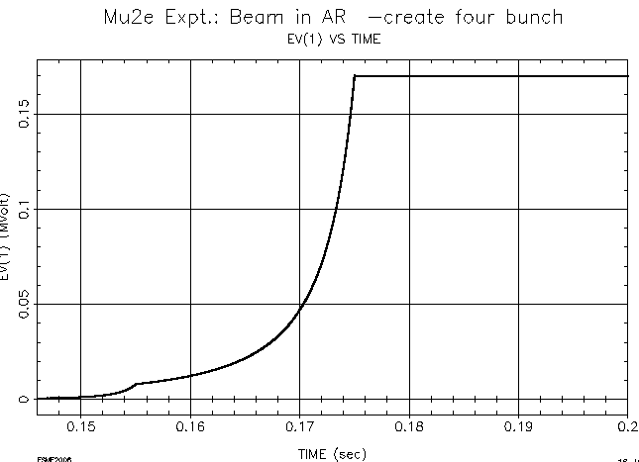 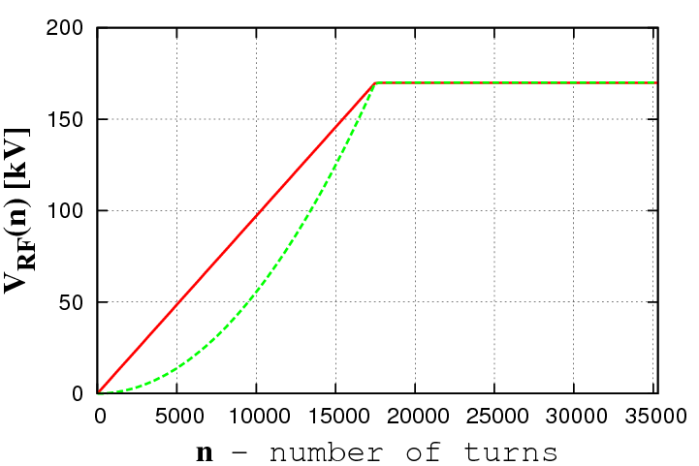

Fig. 3 **Left:** RF voltage as a function of time (1.53µs corresponds to one turn), from [3]. **Right:** Linear $V_{RF}\left(n\right)=nV_{max}/N_{max}$ (solid) or a parabolic (dashed) $V_{RF}\left(n\right)=n^{2}V_{max}/N_{max}^{2}$ RF voltage during 17500 turns. For ${n>N_{max} , V}_{RF}\left(n\right)=170$ [kV].

In Figs. 3 one can see the results of beam tracking for different RF wave-forms, during the RF ramp, when three original batches from Fig.2 are adiabatically bunched into four separate bunches. The longitudinal coordinates are shown along with the growing RF voltage.

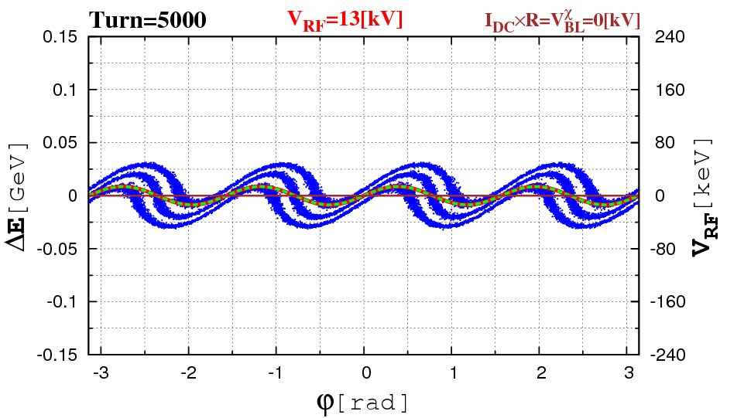 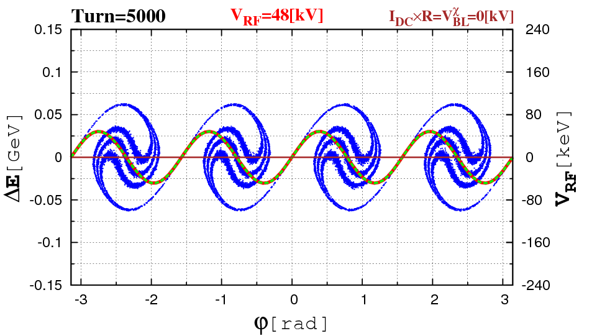

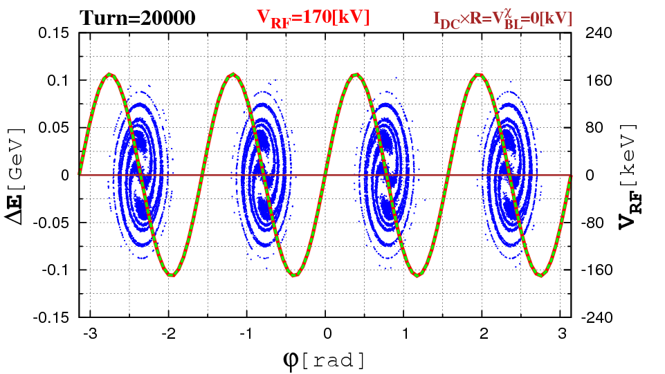 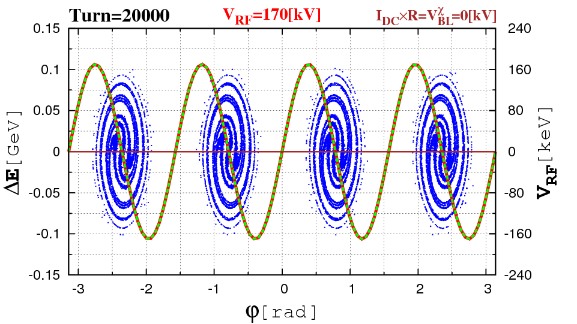

Fig. 4a Beam coordinates $\left({Δφ}_{k},{ΔE}_{k}\right), k=1, …, 25000$, during the momentum stack bunching for parabolic (left) and linear RF voltage growth (right) for 5000, 10000, 20000 turns.

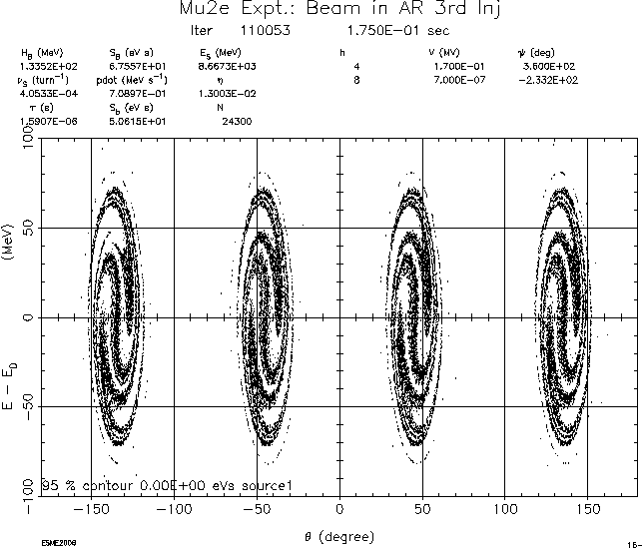

Fig. 4b Beam longitudinal coordinates after RF bunching with the RF voltage growth shown in Fig. 2 (left), from [3].

The RF ramp voltage shown ijn Figs. 4a by a red solid (overlapped by dashed green) lines.

The difference is noticeable for 5000 and 10000 turns, and is becoming undistinguishable for more than 15000 turns, although the microscopic structure of bunches differ. The final simulation agree well with C.Bhat and M.Syphers results in [3]. All three pictures from 4a (bottom left, right) and Fig.4b are very much alike.

**3. Model for beam loading**

When passing RF cavities a beam induces a potential there, regardless if these cavities were either “ON” or “OFF”. This beam loading potential $V_{BL}$ corresponds to the total energy loss. A voltage, induced in the RF cavity due to beam loading, may be written as:

$V_{BL}\left(t\right)=-\int_{0}^{t}{K\left(t-t^{'}\right)\tilde{I}\left(t^{'}\right)dt^{'}=-}\int_{0}^{t}{K\left(t\right)\tilde{I}\left(t-t^{'}\right)dt^{'}}$ (1)

where the $\tilde{I}$ is the beam current and the wake function $K\left(t\right)$ is

$$K\left(t\right)=\frac{Rω_{0}}{Q}e^{-\frac{ω_{0}t}{2Q}}\left(\cos{ω_{r}t-\frac{\sin{ω_{r}t}}{2\sqrt{Q^{2}-1/4}}}\right)$$

with $Q$ standing for the quality factor, $R$ as a shunt impedance, $C$ as a capacitance and L as inductance:

$$ω_{0}=\frac{1}{\sqrt{LC}}, Q=R\sqrt{\frac{C}{L} } , ω_{r}=ω_{0}\sqrt{1-\frac{1}{4Q^{2}}}$$

For large quality factors $Q≫1$

$$K\left(t\right)≅\frac{Rω_{0}}{Q}e^{-\frac{ω_{0}t}{2Q}}\cos{ω_{0}t}$$

Then if the beam current $\tilde{I}$ in the ring is quasi-periodic, it may be represented, as a finite Fourier sum of $M$ complex summands:

$$\tilde{I}(t)≅\sum_{m=0}^{M}{\left[{{\tilde{s}}_{m}\sin\left(mΩt\right)+\tilde{c}}_{m}\cos\left(mΩt\right)\right]}$$

with $φ=Ωt$ ( $Ω$ is a revolution frequency) and the expansion coefficients $\{{\tilde{s}}_{m},{\tilde{c}}_{m}\}$, derived from the inverse Fourier transform.

Substituting $\tilde{I}$ into (1), the potential $V_{BL }$ becomes:

$$V_{BL}\left(t\right)=-\frac{Rω_{0}}{Q}\sum_{m}{\int_{0}^{t}{e^{-\frac{ω_{0}tʹ}{2Q}} cos{ω_{0}t}'[s_{m}\left(t-t^{'}\right)\sin{mΩ\left(t-t^{'}\right)}}}$$

$$+c_{m}\left(t-t^{'}\right)\cos{mΩ\left(t-t^{'}\right)]}dt^{'}$$

Therefore, the loss of the beam energy in the cavity $V_{BL}\left(t\right)$ is proportional to the beam current $\tilde{I}$, i.e. proportional to expansion coefficients $\{{\tilde{s}}_{m},{\tilde{c}}_{m}\}$. Generally, all Fourier coefficient contribute to $V_{BL}\left(t\right)$, especially, in the very beginning of the ramp, however, since the Accumulator is operating with the harmonic number 4, only those terms with indices multiples of four will remain noticeable during the bunching.

$$V_{BL}(t)≅-\frac{Rω_{0}}{Q}[s_{4}\left(t\right)\sin\left(4ω_{0}t\right)+c_{k}\left(t\right)\cos{{(4ω}_{0}t)]}\int_{0}^{t}{e^{-\frac{ω_{0}t'}{2Q}}dt^{'}}$$

$$≅R[s_{4}\left(t\right)\sin\left(4ω_{0}t\right)+c_{k}\left(t\right)\cos{{(4ω}_{0}t)]}$$

Using a notation for the longitudinal phase $φ=Ωt$, we can rewrite the last expression:

$$V_{BL}(t)=R[s_{4}\left(t\right)\sin\left(4φ\right)+c_{4}\left(t\right)\cos{(4φ)]}$$

The energy kick from the particle “*k*” , with the phase $φ_{k}$, the effect of beam loading may be included into standard longitudinal motion equation of the *k-th* particle:

$$E_{k}=E_{k}+eV_{RF}(t)\sin\left(4φ_{k}\right)- {eV}_{BL}[s_{4}\left(t\right)\sin\left(4φ_{k}\right)+c_{4}\left(t\right)cos\left(4φ_{k}\right)]{ }$$

The term *VBL* is supplementary to the nominal $V_{RF}(t)$, the RF-generator voltage, resulting in additional phase shifts (cosine contributions) and the RF amplitude variations (sine contributions) in the motion equations.

The physical meaning of beam loading voltage is a product of beam current and the cavity shunt impedance *IDC*×*RΣ*. Let us work with real numbers for the illustration. In the Accumulator ring the shunt impedance of a single RF cavity is 40 kΩ. There are 7 cavities, so the total shunt impedance is *Σ* =280 kΩ. The total number of protons is *Np* =1.5x1013, and the revolution time is *Trev* =1.53x10-6 s. Therefore, *Σ* = *eNp / Trev*= 1.5 A is the total beam current. A product *Σ* = *Σ*×*Σ* =425 kV is the total voltage, induced in the cavities for the maximum design parameters.

The magnitude of *Σ* is large, exceeding the voltage amplitude of the RF generator itself (we have been considering $\max_{t}{V_{RF}}(t)=$ 170 kV). This is why for design studies it is necessary to deal with a fractions of *Σ* : *VBL* =χ×*Σ* ,. An auxiliary scaling parameter χ , is a dimensionless beam loading factor, varying within [0, *χmax*]:

(2)

In numerical studies below we have been taking different χ from the interval [0, χmax=1] and were analyzing the beam dynamics:

$χ=1, 0.1, 0.05 and 0.01 …$, correspond to *VBL* ==425, 42, 21, and 4.2 kV, $…$ (3)

as it will be used in our calculations below.

The goal is to find the upper limit of $χ$ which still guarantees the quality bunching and this threshold will put limitations on the product *IDC*×*RΣ* (=*VBL =*), limiting the beam current and the shunt impedance of the cavities in each specific case. Ideally, for $χ$ =1, if the bunching is appropriate, we approach the design parameters: *Σ* = *Σ*×*Σ* =425 kV.

The Fourier coefficients after normalization:

$$c_{m}=\frac{{\tilde{c}}_{m}}{{\tilde{c}}_{0}}, s_{m}=\frac{{\tilde{s}}_{m}}{{\tilde{c}}_{0}}$$

are plotted in the Figs. 5a, 5b for the beam loading with $I_{DC}×R_{Σ}=25.5$ kV.

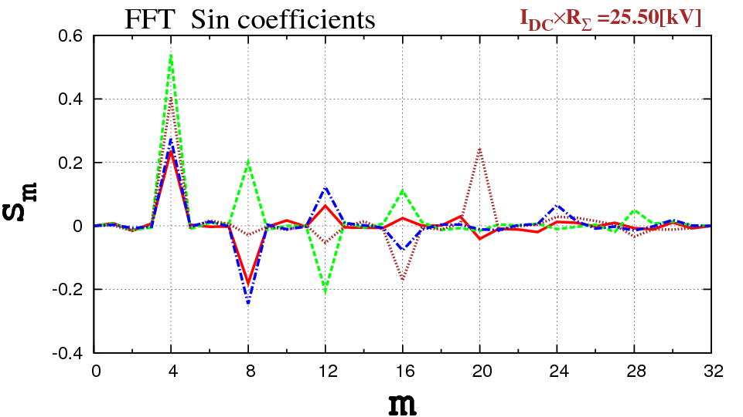 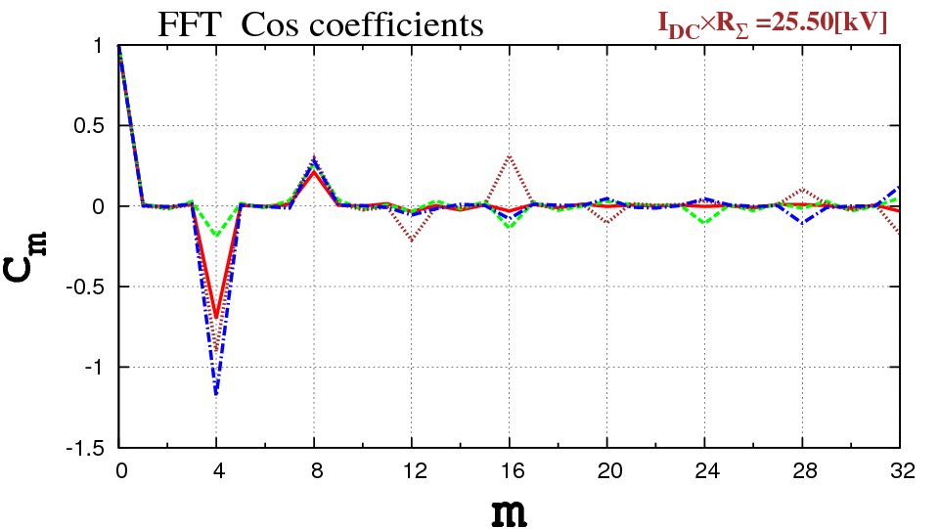

Fig.5a Normalized Fourier coefficients *si(χ,n)* (left), *ci(χ,n)* (right), *i*=1,…,16 for the beam loading factor *χ*=0.06 ($I_{DC}×R_{Σ}=25.5$), depending on the number of turns: *n*=2500 turns (solid red), 5000 (dashed green), 10000 (dotted brown), 20000 (dash-dot blue).

One can see the steady growth of all 4th multiple harmonics, during the formation of 4 bunches in the Accumulator. And Fig. 5b shows *s4* (*n*) (blue), *c4* (*n*) (red) for *n*=1,…,20000 turns.

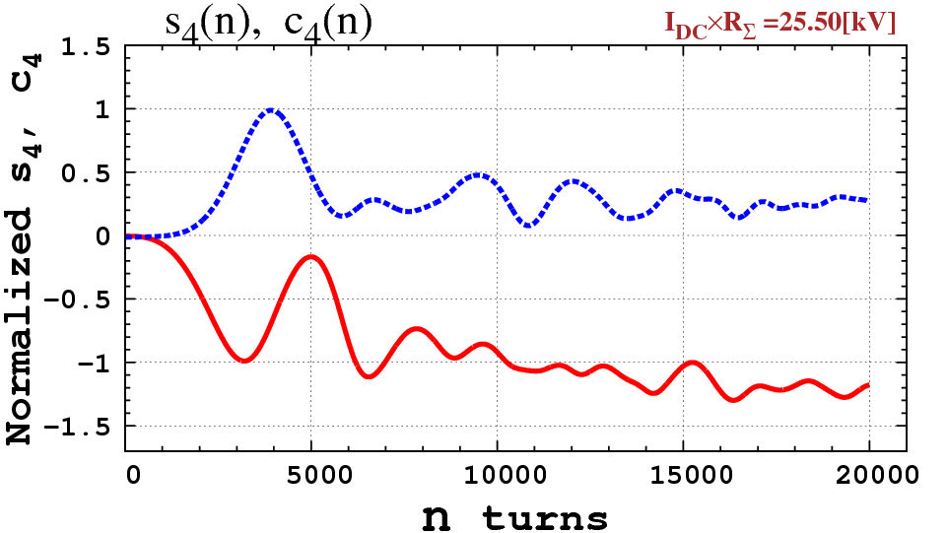

Fig. 5b Normalized Fourier coefficient *s4* (blue), *c4* (red) for n=1,…,20000 turns for the beam loading factor *χ*=0.06 ($I_{DC}×R_{Σ}=25.5$).

**4. Numerical studies: bunching with linear RF ramp**

An upper “ $\overline{χ}$” limit can be derived from the simulations for different *χ* within the interval [0, χmax], and checking the gap between bunches. We conducted a series of experiments with *χ*=0.1, 0.06, 0.04 and 0.02, with results shown in Fig. 6.

From now on all phase pictures, demonstrating longitudinal beam dynamics will include the plots of RF generator voltage $V_{RF}\left(t\right)$ (red solid), the beam loading voltage $V_{BL}\left(t\right)$ (brown solid) and the total resulting voltage $V_{RF}\left(t\right){-V}_{BL}\left(t\right)$ (dashed green) with the dimensions shown on the right vertical scales.

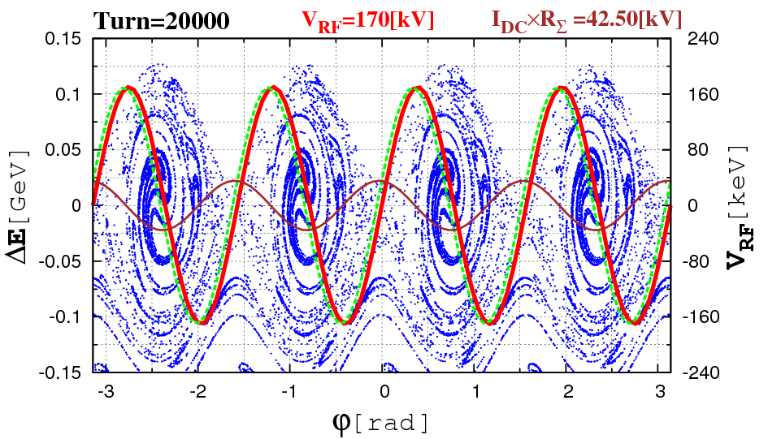 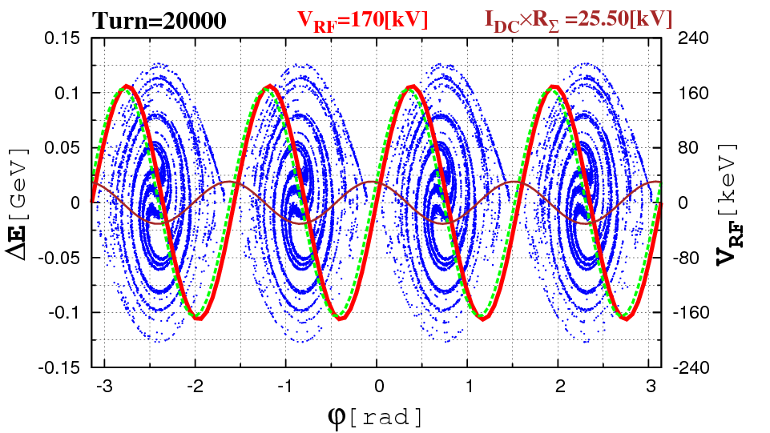

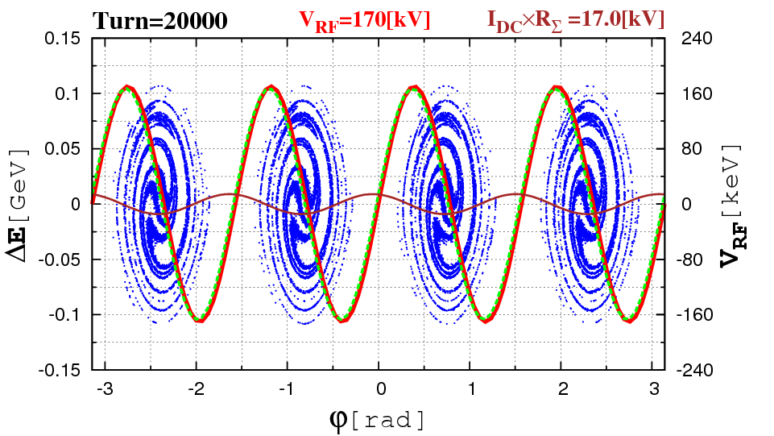 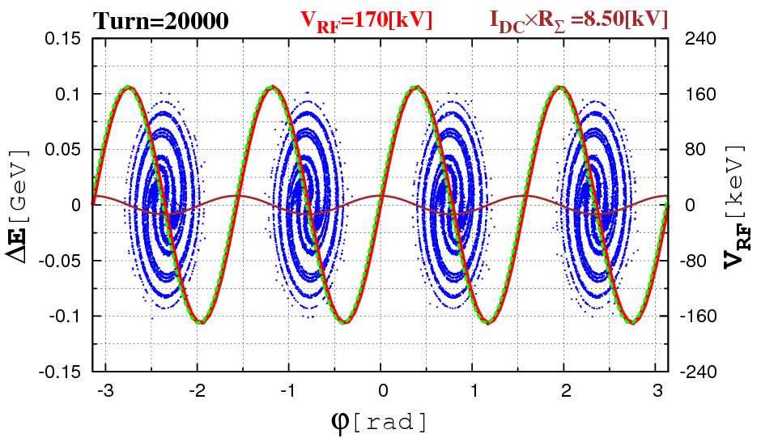

Fig. 6 $\left({Δφ}_{k},{ΔE}_{k}\right), k=1, …, 25000$ after 20000 turns, for different beam loading factors $I_{DC}×R_{Σ}=42.5, 25.5, 17, 8.5$ [kV], corresponding to 10%, 6%, 4%, 2% from the design magnitude ${\overline{I}}_{DC}×{\overline{R}}_{Σ}$ =425 [kV].

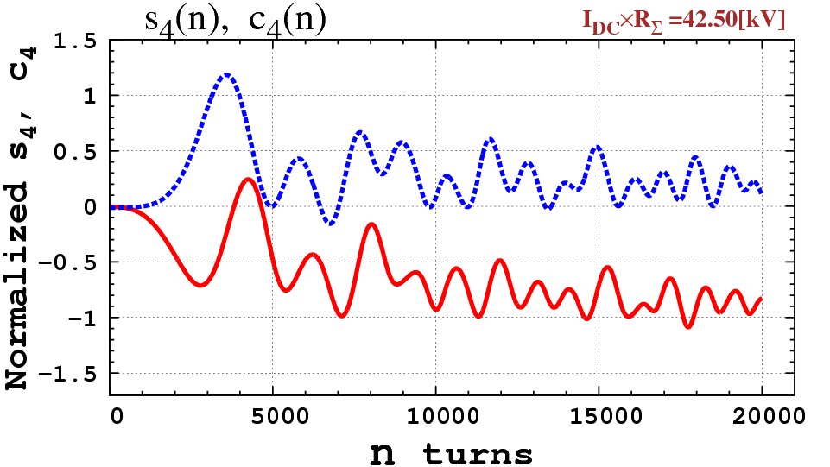 

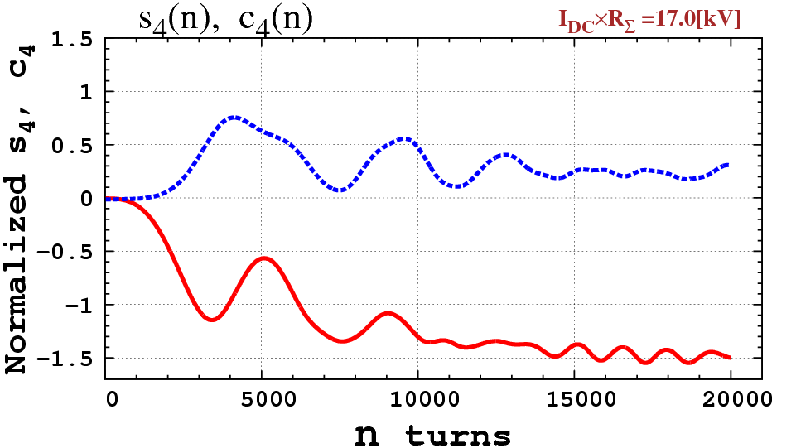 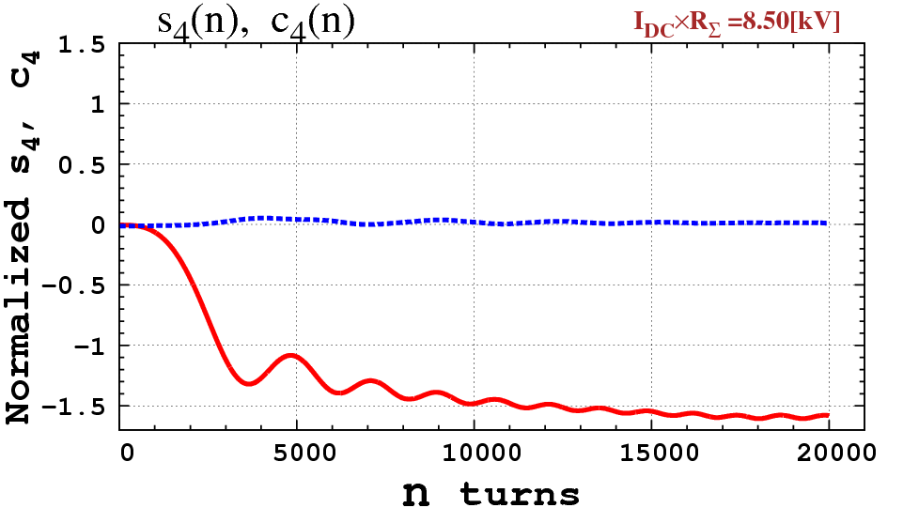

Fig.7 Normalized Fourier coefficients *s4* (blue), *c4* (red) for n=1,…,20000 and $I_{DC}×R_{Σ}=42.5, 25.5, 17, 8.5$ kV, corresponding to 10%, 6%, 4%, 2% from the design magnitude ${\overline{I}}_{DC}×{\overline{R}}_{Σ}$ =425 kV.

The values of χ=0.04 and 0.02 ($I_{DC}×R_{Σ}=8.5$) produce the acceptable quality of bunching.

**6. Feedforward**

The results of calculations in Fig. 6, demonstrated that the beam loading effect is extremely strong. For the beam loading of ${V_{BL}\left(t\right)=I}_{DC}×R_{Σ}≤42$ kV (10% from the nominal 425 kV) we observed a complete longitudinal smear, without bunching at all.

The acceptable level of beam loading voltage which keeps the quality bunching should not exceed $I_{DC}×R_{Σ}≤8.5$ kV, that corresponds only to 2% from the nominal design parameters of 425 kV. To meet these requirements, we have to decrease either beam current or the shunt impedance, or their product by the factor of 50.

A feed-forward compensation scheme is one of the remedies how to accommodate the higher beam loading, still maintaining the appropriate bunching. It is based on inclusion (actually, a subtraction) of the preprocessed beam loading voltage $V_{BL}^{FF}(t)$ into the RF generator voltage $V_{RF}\left(t\right)$ (the abbreviation “FF” stands for feedforwarding), that presumably will compensate the effect of beam loading.

Let us consider the normalized Fourier coefficients, calculated for the case, when beam loading is excluded from the motion equations. In fact, we are doing only the Fourier analysis of beam current, without applying $V_{BL}(t)$. See Fig. 8.

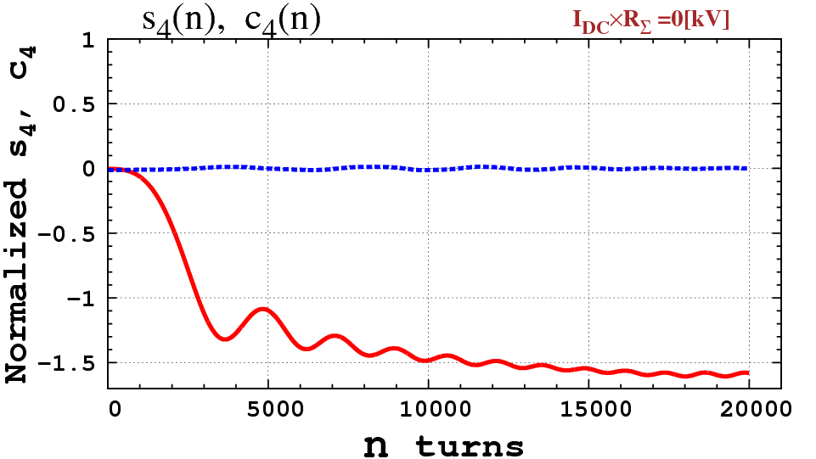

Fig. 8 Normalized Fourier coefficients $s_{4}$ (*n*) (blue), $c_{4}$ (*n*) (red) for n=1,…,20000 and ${\overline{I}}_{DC}×{\overline{R}}_{Σ}$ =425 [kV], when the beam loading is excluded from motion equations.

The sine coefficient $s_{4}^{FF}$ in Fig. 8 is very close to zero. The cosine $c_{4}^{FF}$ is essentially non-zero and always negative. Now, we introduce the “preprocessed” ${-s}_{4}^{FF}\left(t\right), {-c}_{4}^{FF}\left(t\right)$ into (2), as the following:

$$E_{k}=E_{k}+eV_{RF}\left(t\right)\sin\left(4φ_{k}\right)-χ×e{\overline{V}}_{Σ}\left\{\left[s_{4}\left(t\right)-s_{4}^{FF}\left(t\right)\right]\sin\left(4φ_{k}\right)+\left[c_{4}\left(t\right)-c_{4}^{FF}\left(t\right)\right]cos\left(4φ_{k}\right) \right\}{ }$$

(2)ʹ

The beam dynamics with FF-compensation is improving drastically, as shown in Fig.9

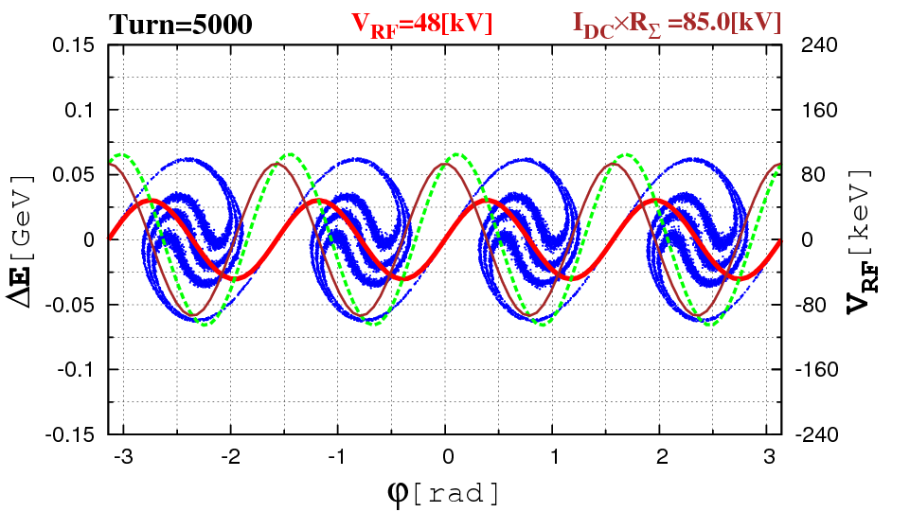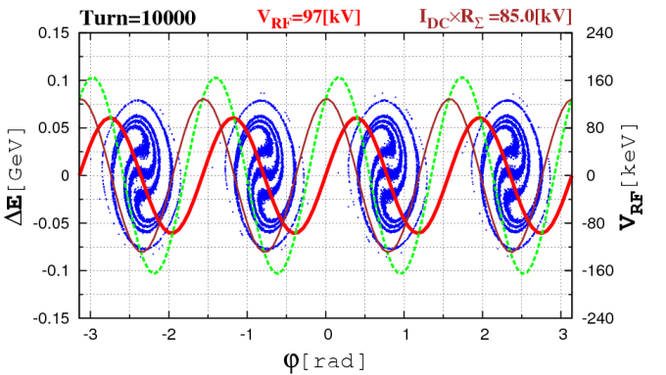

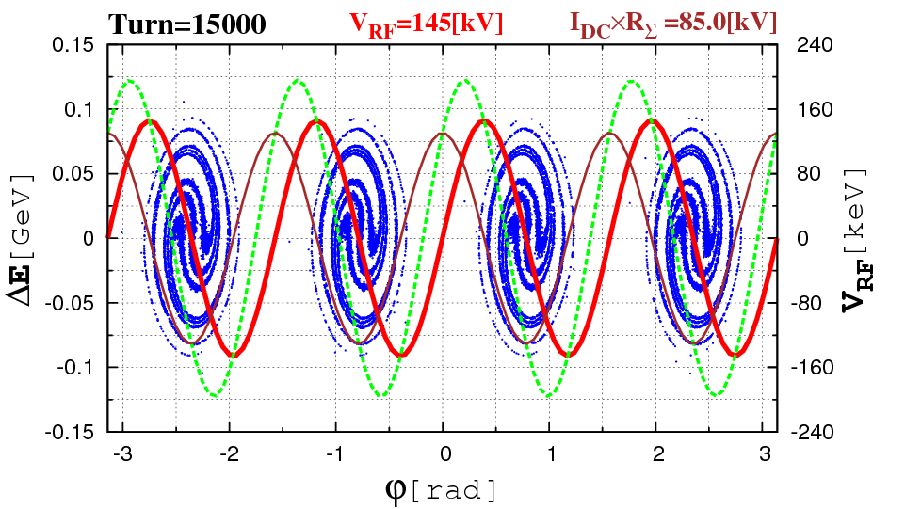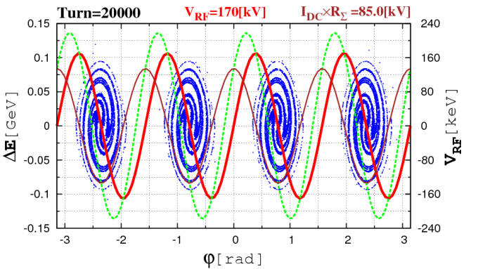

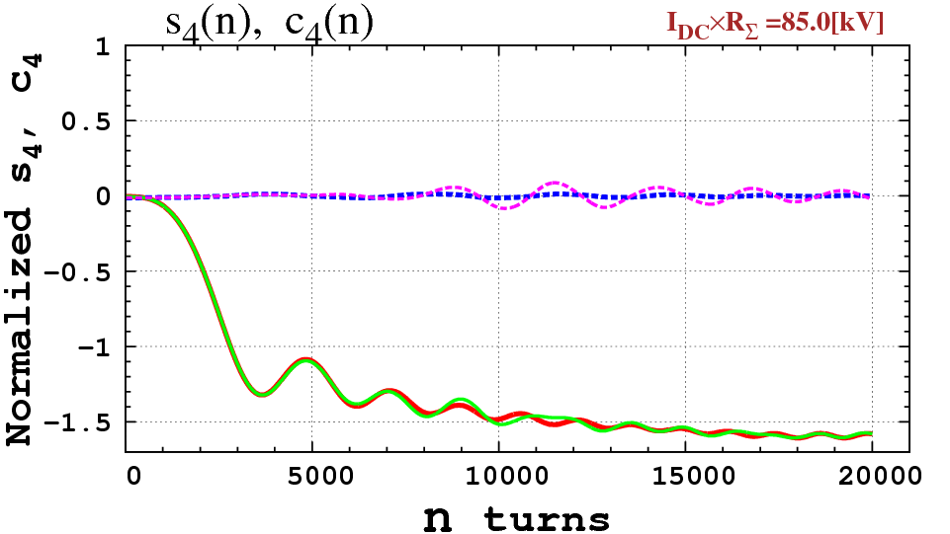

Fig.9 Feedforward algorithm. Longitudinal coordinates $\left({Δφ}_{k},{ΔE}_{k}\right), k=1, …, 25000$ after 20000 turns and normalized Fourier coefficients *s4* (blue), *c4* (red) for n=1,…,20000 and $I_{DC}×R_{Σ}=85$ [kV], corresponding to 20% from the design magnitude. The preprocessed Fourier coefficients $s_{4}^{FF}\left(t\right)$ and $c_{4}^{FF}\left(t\right)$ are plotted with magenta and green lines correspondingly.

One can see $s_{4}(t)$ and $c_{4}(t)$ behavior is pretty much the same, as the preprocessed $s_{4}^{FF}\left(t\right)$ and $c_{4}^{FF}\left(t\right)$. However, further increase of the beam loading result in instabilities. See Fig. 10.

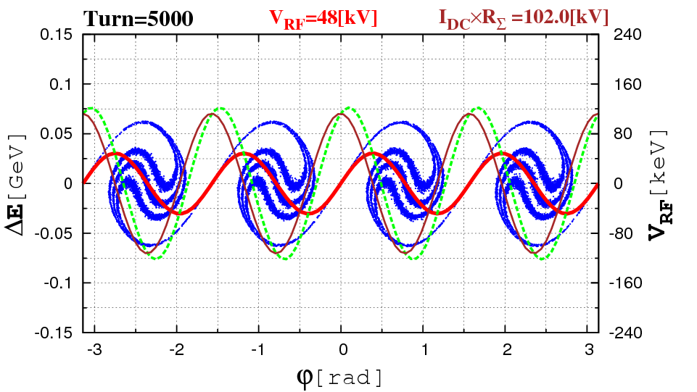 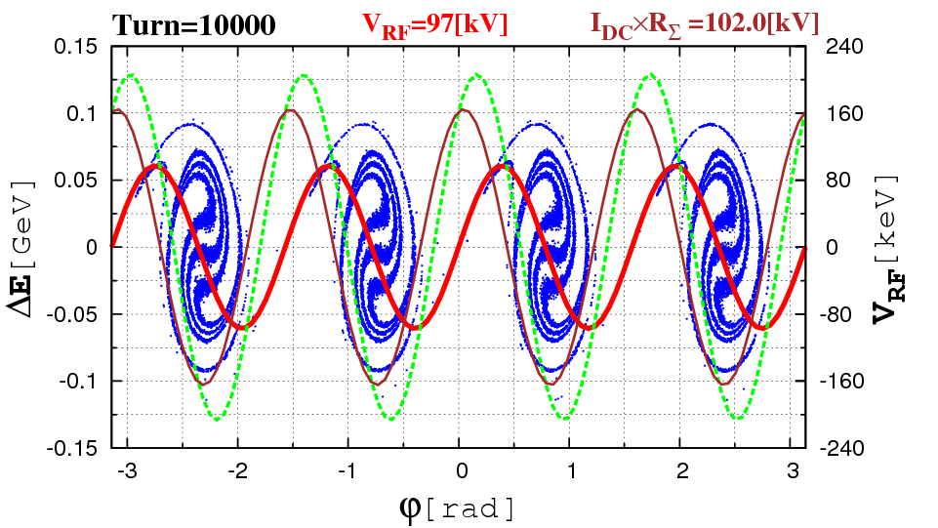

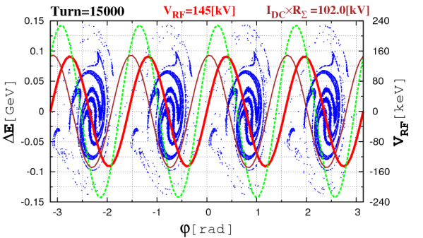 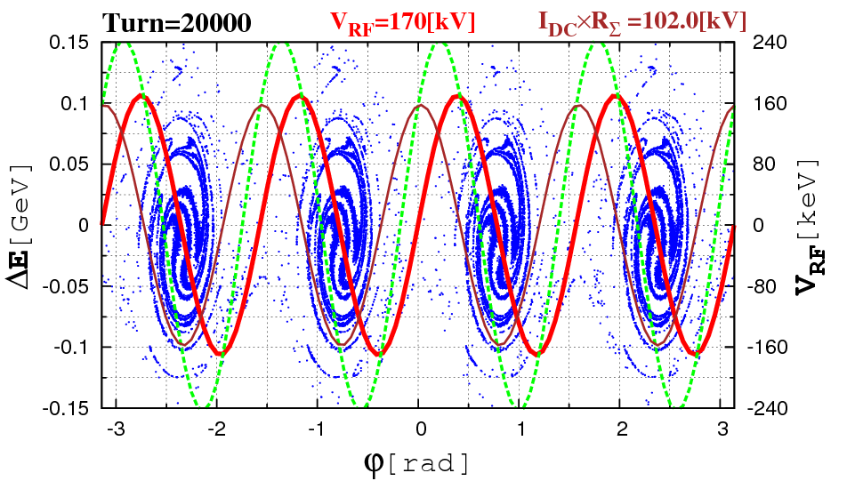

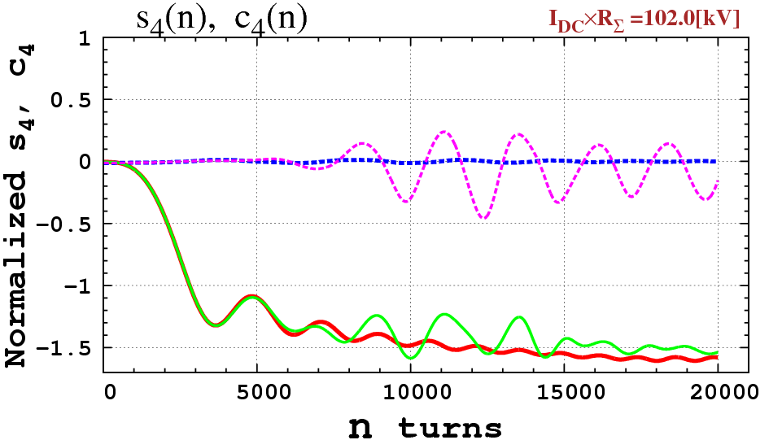

Fig.10 Feedforward algorithm. Longitudinal coordinates $\left({Δφ}_{k},{ΔE}_{k}\right), k=1, …, 25000$ after 20000 turns and normalized Fourier coefficients *s4* (n) (blue), *c4* (n) (red) for n=1,…,20000 and $I_{DC}×R_{Σ}=102$ [kV], corresponding to 25% from the design magnitude ${\overline{I}}_{DC}×{\overline{R}}_{Σ}$ =425 [kV]. The preprocessed Fourier coefficients $s_{4}^{FF}\left(t\right)$ and $c_{4}^{FF}\left(t\right)$ are plotted with magenta and green lines correspondingly.

Beam loading compensation with feedforward apparently stops working because of instabilities, emerging after 7000-10000 turns. Accordingly, $s_{4}(t)$ and $c_{4}(t)$ behavior differ significantly from $s_{4}^{FF}\left(t\right)$ and $c_{4}^{FF}\left(t\right)$ after that.

Let us study instabilities due to beam loading, when the RF generator is “OFF”.

**7. Instabilities with RF generator “OFF”**

When the beam circulates long enough in the ring in the absence of, or for low enough RF voltage, the beam loading force may result in longitudinal instabilities. For example, let us consider the beam dynamics during 20000 turns, when the RF is “OFF”.

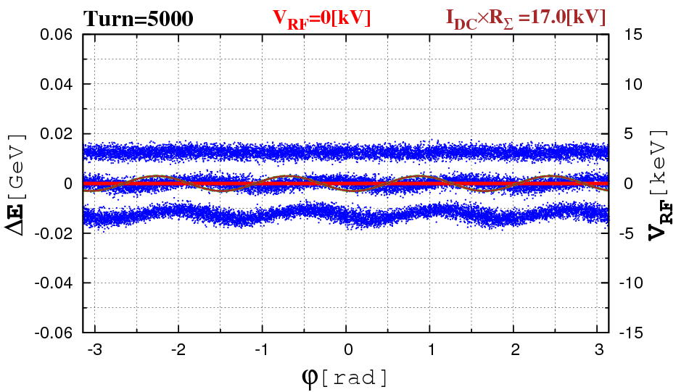 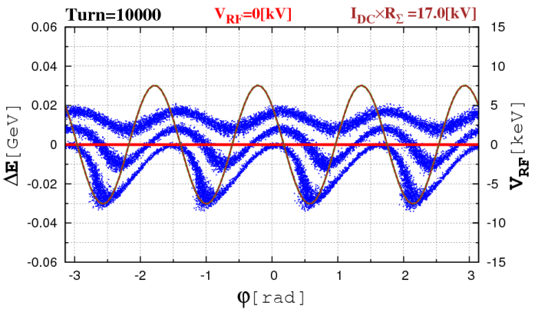

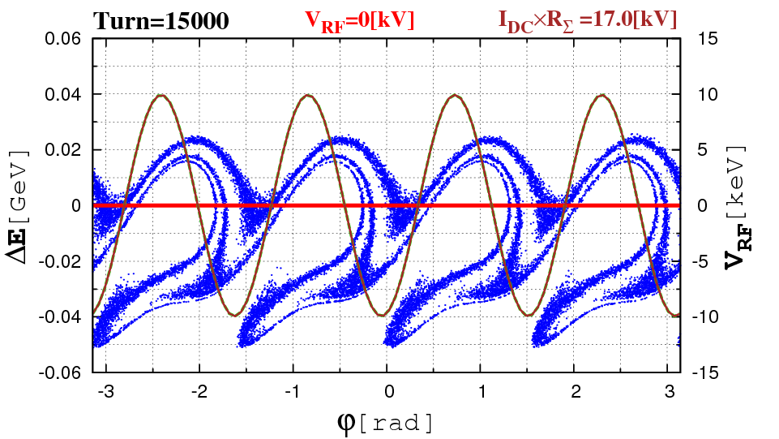 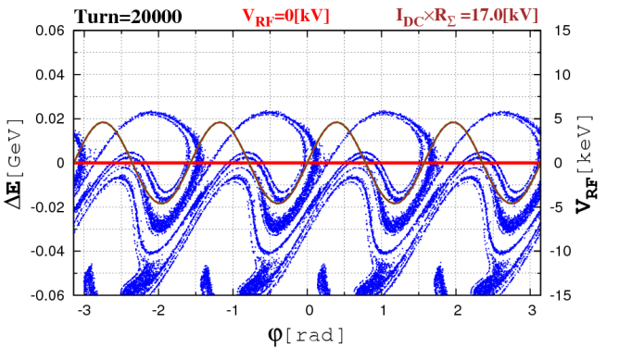

Fig. 8a $\left({Δφ}_{k},{ΔE}_{k}\right), k=1, …, 25000$ after 5000, 10000, 15000 and 20000 turns, for the beam loading factor of $I_{DC}×R_{Σ}=17 [kV]$, corresponding to 4% from the design magnitude ${\overline{I}}_{DC}×{\overline{R}}_{Σ}$ =425 [kV].

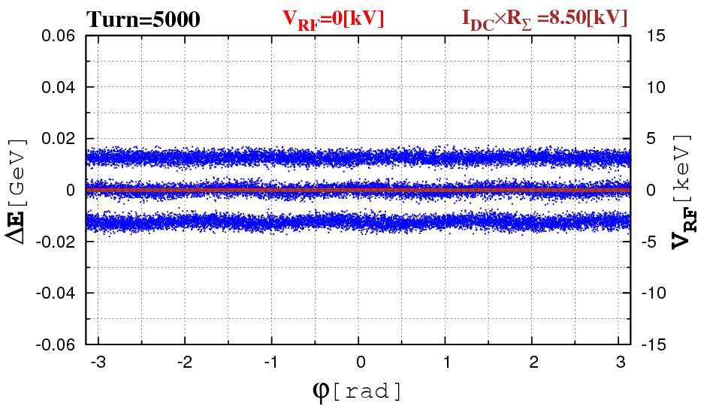 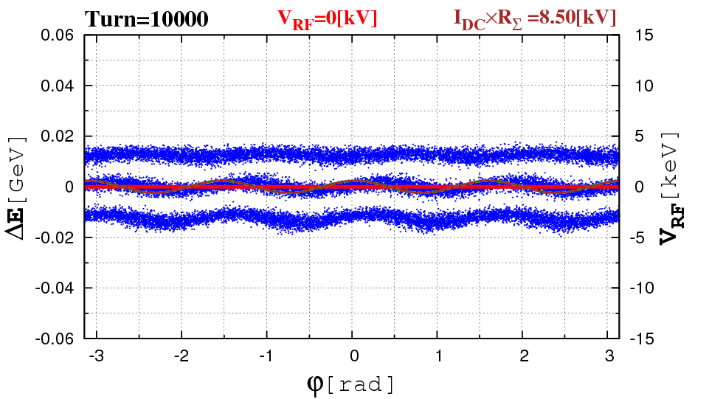

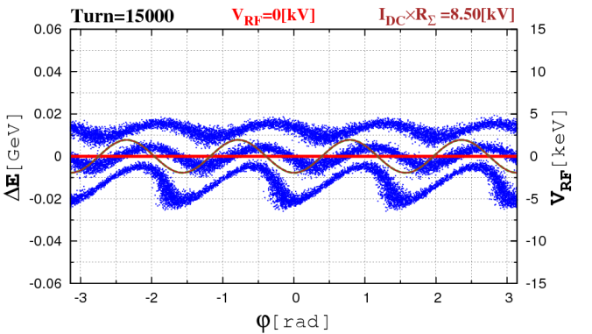 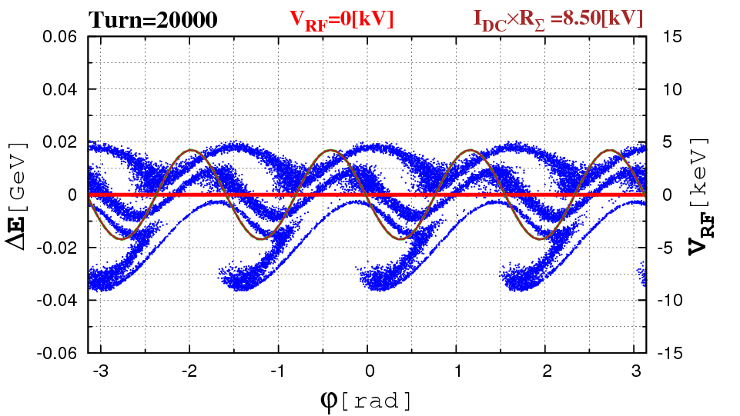

Fig. 8b $\left({Δφ}_{k},{ΔE}_{k}\right), k=1, …, 25000$ after 5000, 10000, 15000 and 20000 turns, for the beam loading factor of $I_{DC}×R_{Σ}=8.5 [kV]$, corresponding to 2% from the design magnitude ${\overline{I}}_{DC}×{\overline{R}}_{Σ}$ =425 [kV].

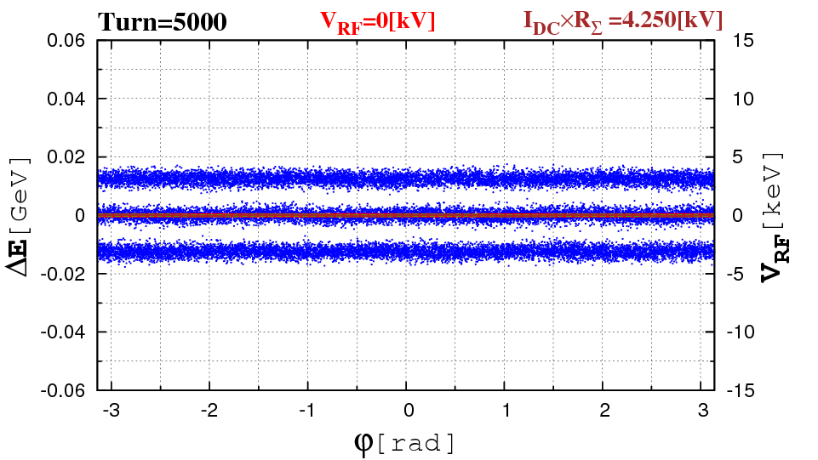 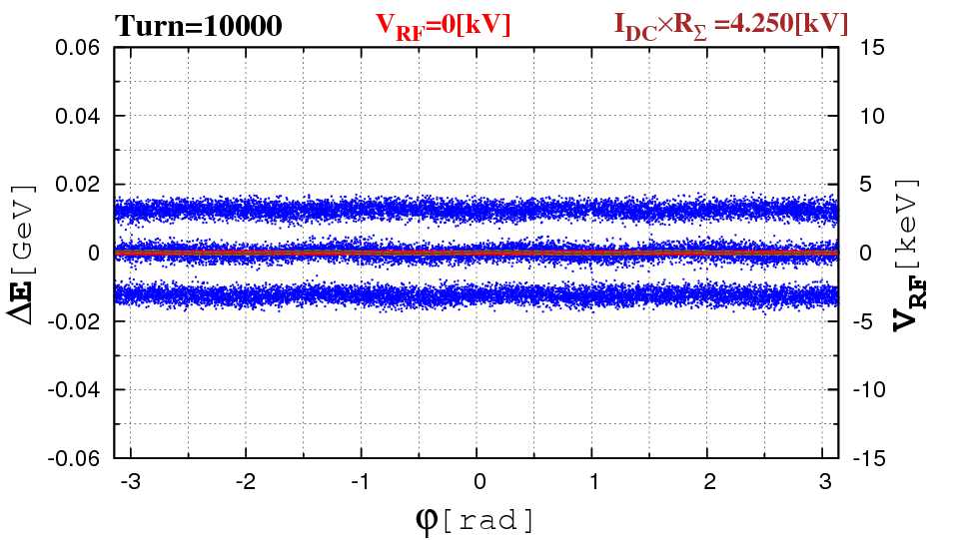

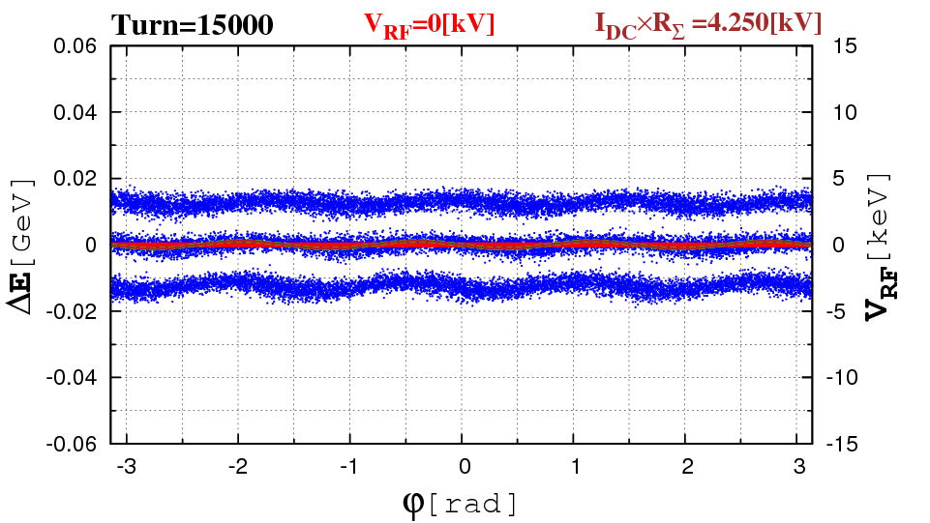 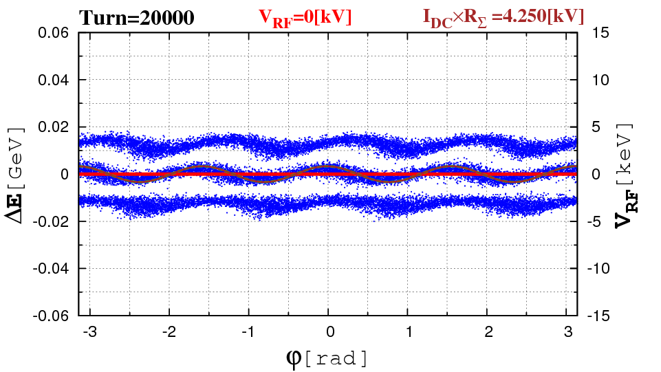

Fig. 8c $\left({Δφ}_{k},{ΔE}_{k}\right), k=1, …, 25000$ after 5000, 10000, 15000 and 20000 turns, for the beam loading factor of $I_{DC}×R_{Σ}=4.25 [kV]$, corresponding to 1% from the design magnitude ${\overline{I}}_{DC}×{\overline{R}}_{Σ}$ =425 [kV].

This instability is persistent and occures for lower and lower beam loading factors. A threshold was found 0.1%. The instability growth rates, depending on χ from turn to turn are:

$$η(χ,n)=\log{\sqrt{s_{4}^{2}(χ,n)+c_{4}^{2}(χ,n)}}$$

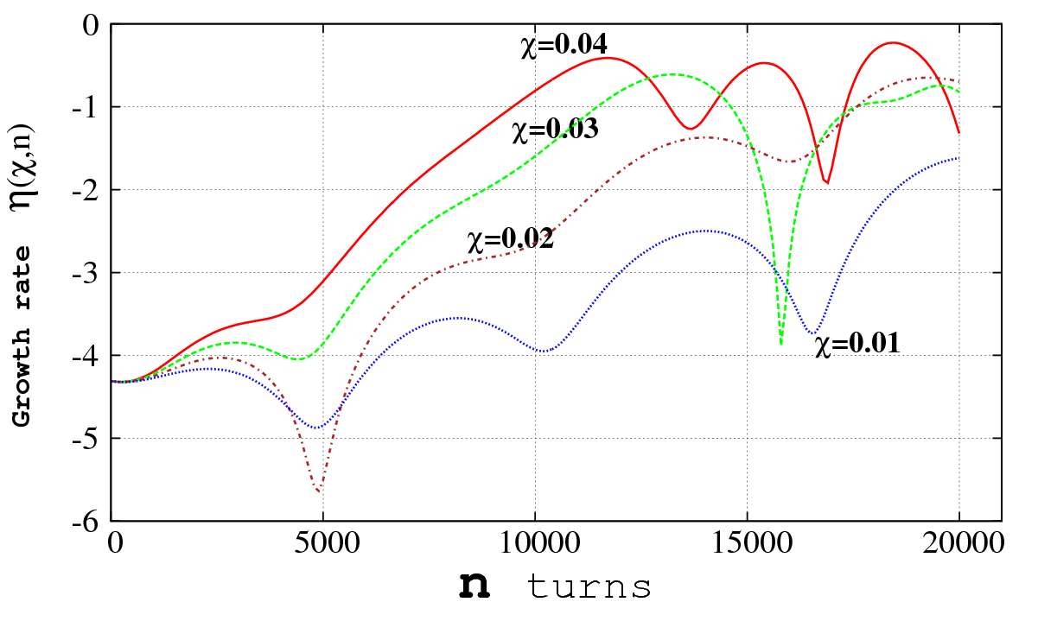

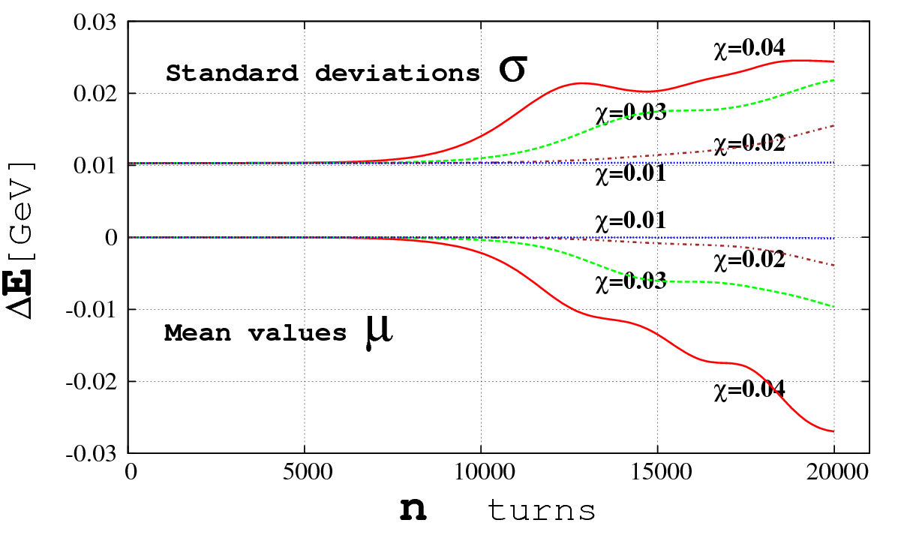

Fig. 9 The growth rates $η(χ,n)$ (top) and the moments (bottom) plots, as functions of turns, for the feedback factors $I_{DC}×R_{Σ}=17, 12.75, 8.5, 4.25 kV$, corresponding to 4%, 3%, 2% and 1% from the design level ${\overline{I}}_{DC}×{\overline{R}}_{Σ}$ =425 [kV].

One can see that the total mean value $μ(n)$ of the beam trends downward due to the beam loading, the butches loose the energy and.

**8. Other beam loading compensation schemes. Quasy-Feedback**

Feedforward (FF) compensation demonstrated a very high efficiency, when the upper limit $\overline{χ}$ corresponded to 20% of the nominal design values ${\overline{I}}_{DC}×{\overline{R}}_{Σ}$ =425 [kV]. When RF generator is not working, the FF is not applicable. One needs a Feedback (FB) compensation.

In this paper we made an heuristical approach to the FB system, trying to include into the model the effect of dynamic correction of beam loading. Although it is extremely simplified approach, it gives an estimate of FB delays range, appropriate for the correction.

**RF Generator ”OFF”, FB Delay 100 turns**

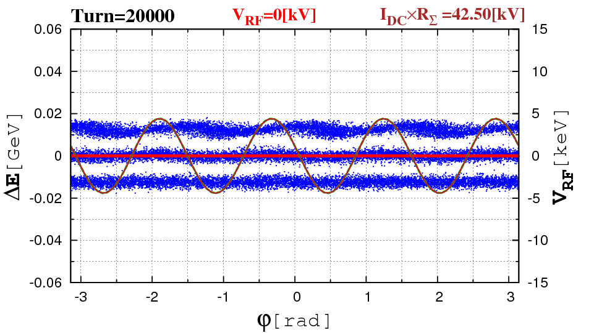 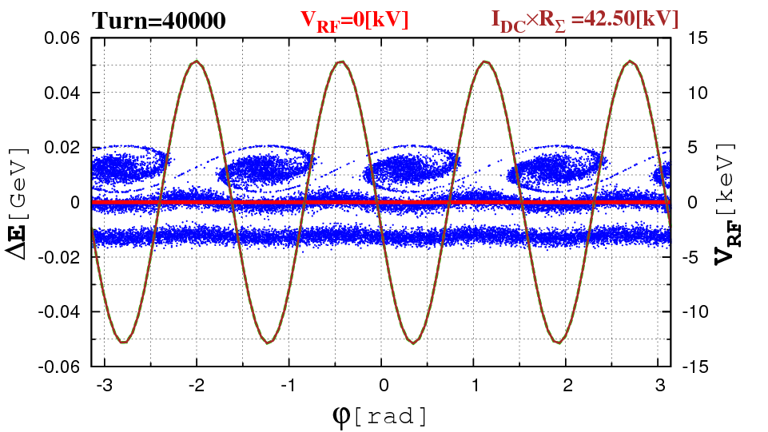

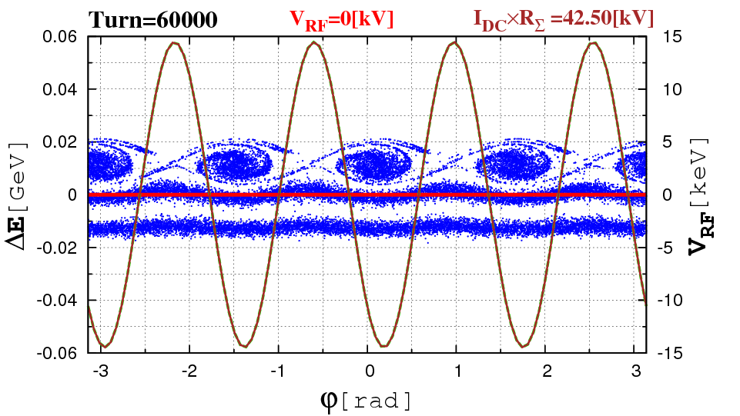 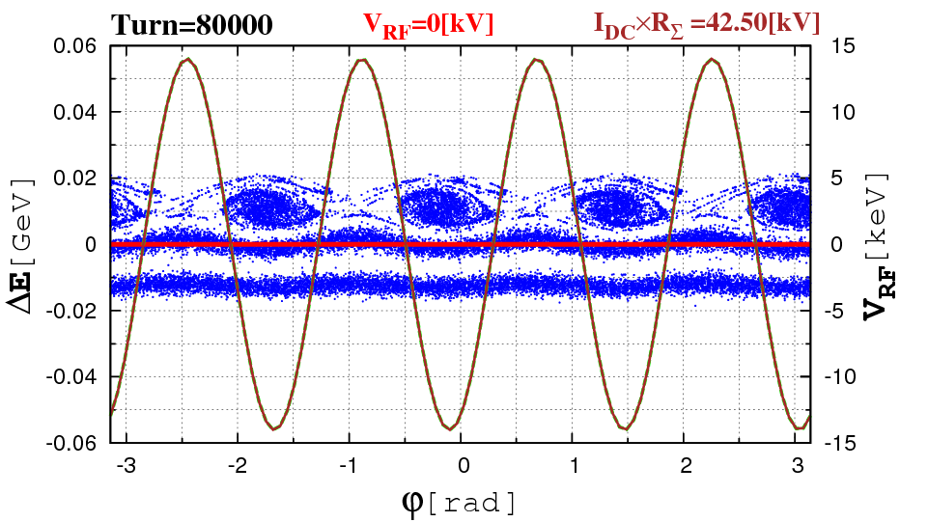

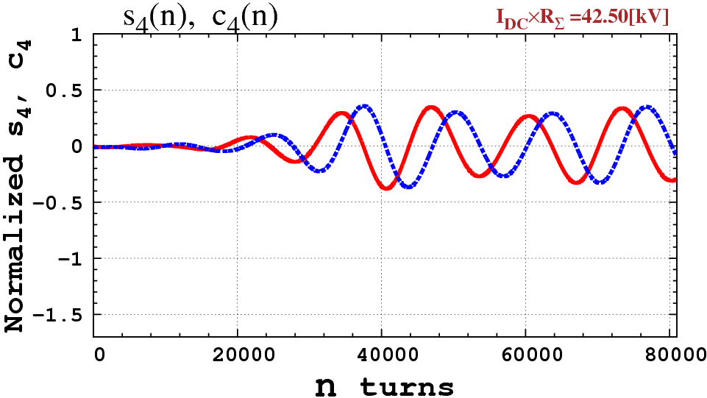

Fig.10 Feedback delay of 100 turns. $\left({Δφ}_{k},{ΔE}_{k}\right), k=1, …, 25000$ after 5000, 10000, 15000 and 20000 turns, and for the beam loading factor of $I_{DC}×R_{Σ}=42.5 kV$ and normalized Fourier coefficients *s4* (n) (blue), *c4* (n) (red) for n=1,…,20000, corresponding to 10% from the design magnitude ${\overline{I}}_{DC}×{\overline{R}}_{Σ}$ =425 [kV].

**RF Generator ”OFF”, FB Delay 50 turns**

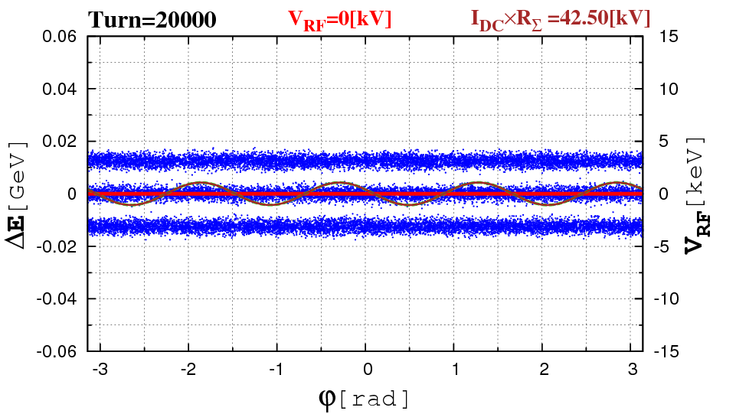 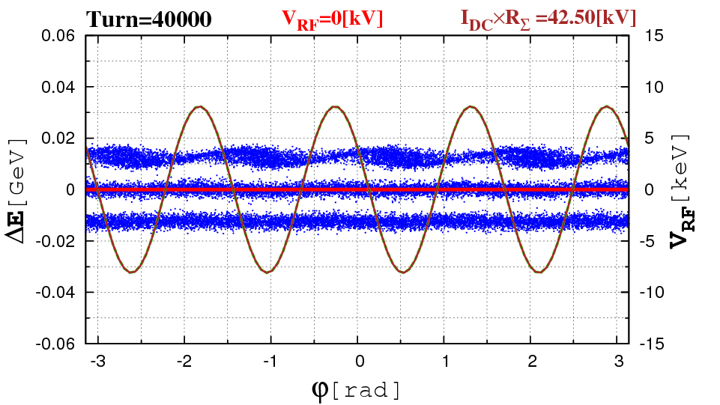

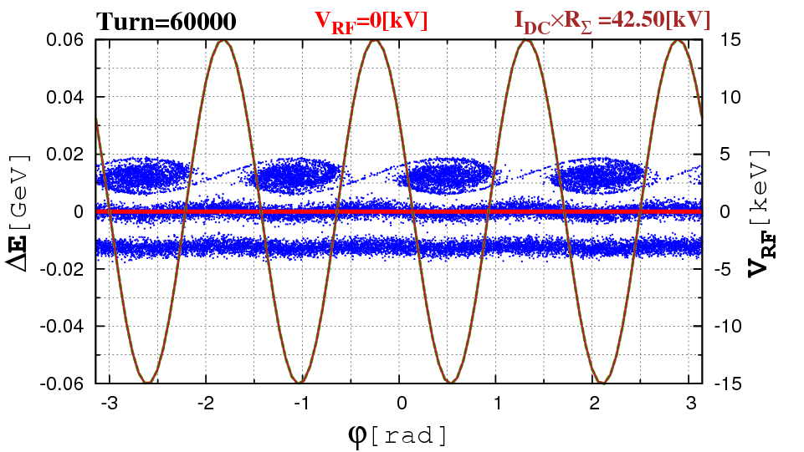 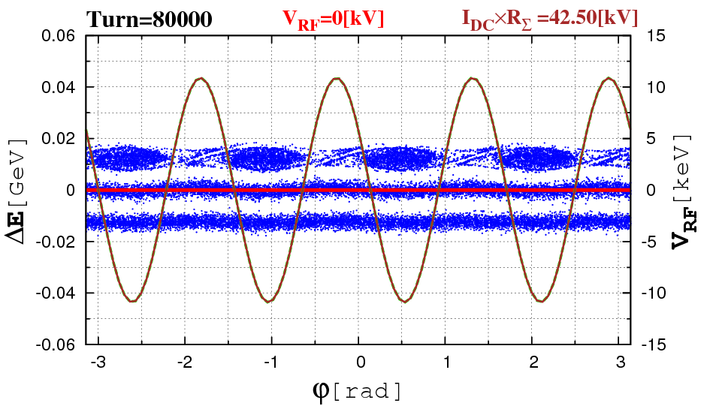

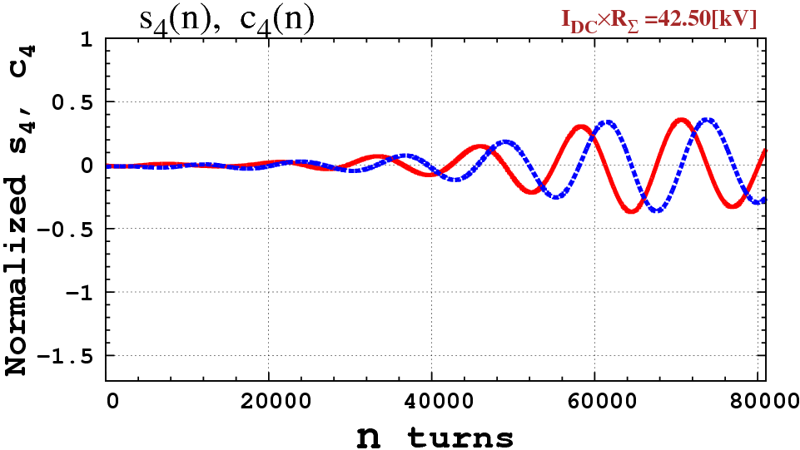

Fig.11 RF generator “OFF”. Feedback delay of 50 turns. $\left({Δφ}_{k},{ΔE}_{k}\right), k=1, …, 25000$ after 5000, 10000, 15000 and 20000 turns, and for the beam loading factor of $I_{DC}×R_{Σ}=42.5 kV$ and normalized Fourier coefficients *s4* (n) (blue), *c4* (n) (red) for n=1,…,20000, corresponding to 10% from the design magnitude ${\overline{I}}_{DC}×{\overline{R}}_{Σ}$ =425 [kV].

**RF Generator ”OFF”, FB Delay 20 turns**

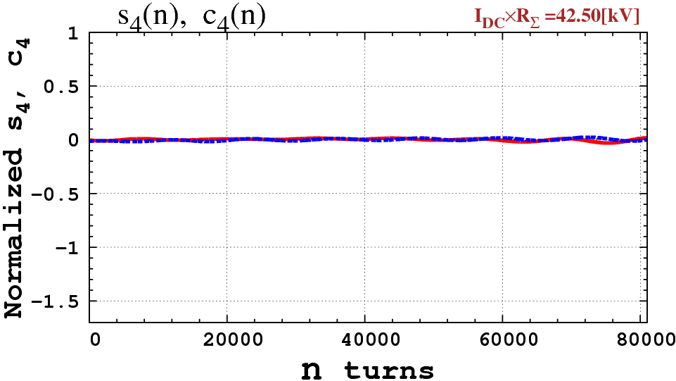

Fig.12 RF generator “OFF”. Feedback delay of 20 turns. $\left({Δφ}_{k},{ΔE}_{k}\right), k=1, …, 25000$ after 5000, 10000, 15000 and 20000 turns are as those for no beam loading (not shown), for the beam loading factor of $I_{DC}×R_{Σ}=42.5 kV$ and normalized Fourier coefficients *s4* (n) (blue), *c4* (n) (red) for n=1,…,20000, corresponding to 10% from the design magnitude ${\overline{I}}_{DC}×{\overline{R}}_{Σ}$ =425 [kV].

**RF Generator with Linear Ramp, FB Delay 500 turns**

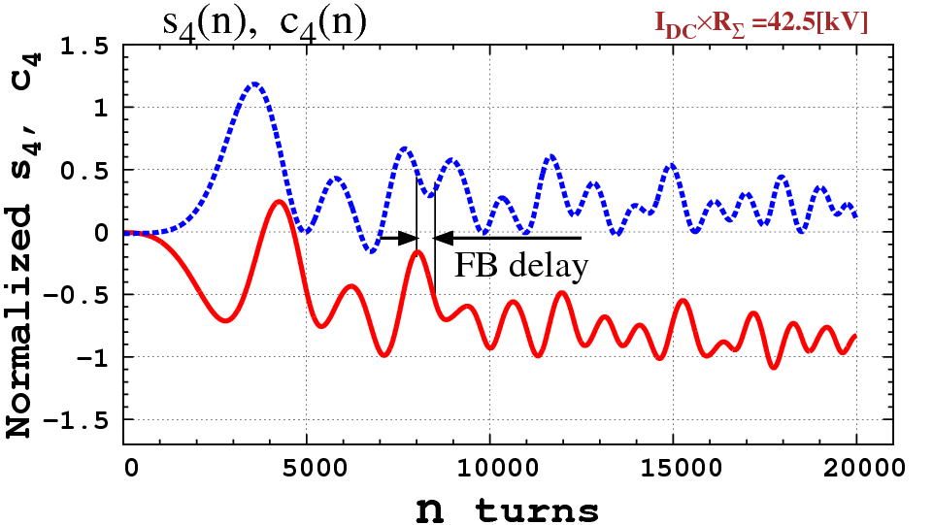 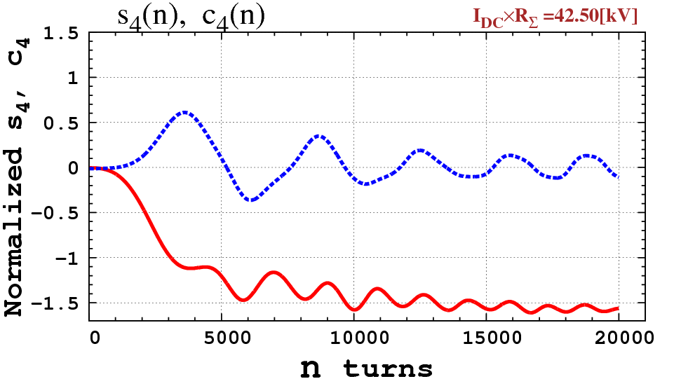

Fig. 13a. Before BL compensation (left) and after (right).

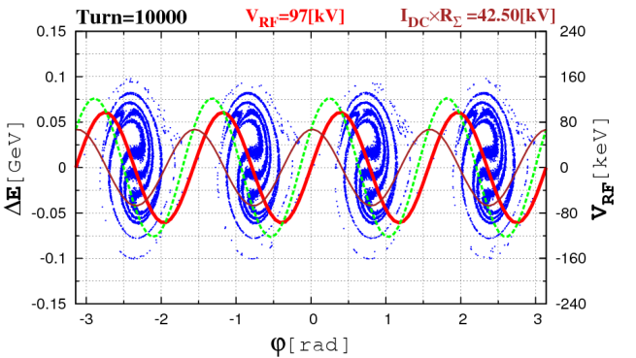 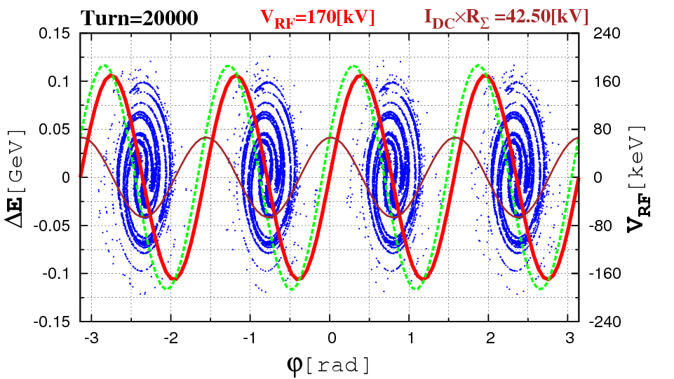

Fig.13 Linear RF ramp. Feedback delay of 500 turns. $\left({Δφ}_{k},{ΔE}_{k}\right), k=1, …, 25000$ after 5000, 10000, 15000 and 20000 turns, and for the beam loading factor of $I_{DC}×R_{Σ}=42.5 kV$ and normalized Fourier coefficients *s4* (n) (blue), *c4* (n) (red) for n=1,…,20000, corresponding to 10% from the design magnitude ${\overline{I}}_{DC}×{\overline{R}}_{Σ}$ =425 [kV]. Compare to Fig.5.

**RF=Linear Ramp, FB Delay 100 turns**

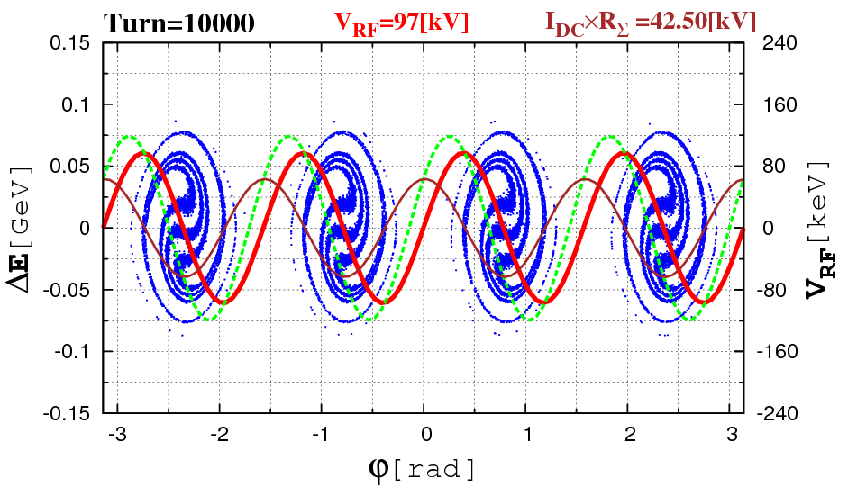 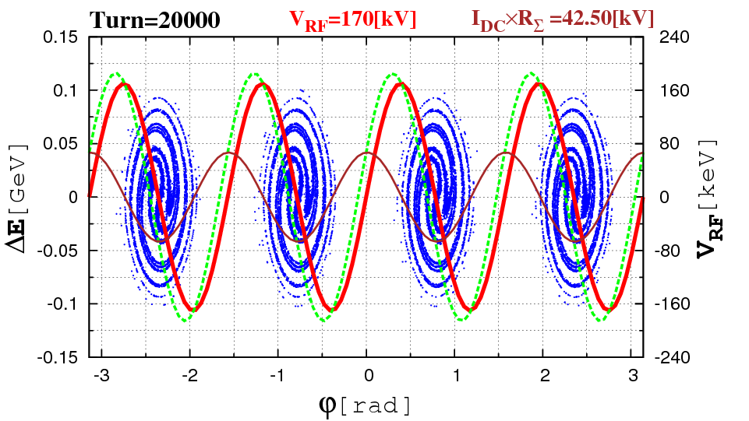

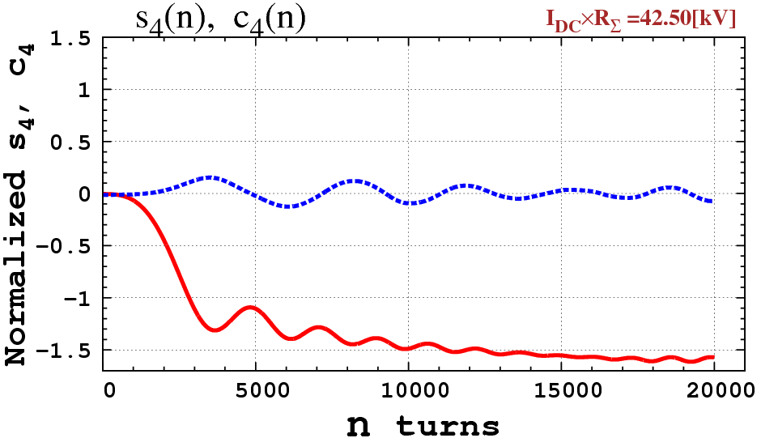

Fig.14 Linear RF ramp. Feedback delay of 100 turns. $\left({Δφ}_{k},{ΔE}_{k}\right), k=1, …, 25000$ after 5000, 10000, 15000 and 20000 turns, and for the beam loading factor of $I_{DC}×R_{Σ}=42.5 kV$ and normalized Fourier coefficients *s4* (n) (blue), *c4* (n) (red) for n=1,…,20000, corresponding to 10% from the design magnitude ${\overline{I}}_{DC}×{\overline{R}}_{Σ}$ =425 [kV].

A good bunching achieved with the Fourier coefficients close to those from Fig.8.

**9. Discussion and Conclusion**

* Beam loading effect is critical. Without precautions the appropriate bunching is feasible only for ${\overline{I}}_{DC}×{\overline{R}}_{Σ}≤8.5$ kV, that is only 2% from the design parameters.
* When RF is “OFF” the instabilities develop even for smaller beam loading ${\overline{I}}_{DC}×{\overline{R}}_{Σ}≤2.1$ kV (0.5% from the design parameters).
* Feedforward improves the beam bunching quality significantly, accommodating up to 20% level of the design parameters.
* Feedback may help a lot, increasing the level ${\overline{I}}_{DC}×{\overline{R}}_{Σ}$ up to the design parameters level.

An important note is, that taking into account all three batches, as a starting point of beam dynamics simulation (see Fig.2), we may overestimate the effect of instabilities.

The further plans are:

* A more realistic injection scheme into the Accumulator to be implemented.
* Developing a new computational model for beam loading in a time domain.
* The implementation of a realistic feedback system to be done.

The algorithm, described in this paper, may put in the form of a standard module in the computer package ORBIT, largely used in accelerator rings design [5].

**References.**

1. The muon-to-electron conversion experiment at Fermilab: [http://mu2e.fnal.gov](http://mu2e.fnal.gov/)

2. R.M.Carey et al. “Proposal to search for *μ─N→e─N* with a Single Event Sensitivity Below 10─16”, FERMILAB-PROPOSAL-0973, October 10, 2008. DOE Contract DE-AC02- 07CH11359.

3. Chandra Bhat, Mike Syphers, March 2010.

4. J.A.MacLachlan. “ESME code”, 1987.

5. J.D. Galambos, J.A. Holmes, D.K.Olsen, A. Luccio, J. Beebee-Wang, ORBIT, 1999.