August 12, 2012
Prepared By: David B. Augustine
Description: Analysis of Booster Turbo Pump Manifolds

The Booster Accelerator uses Sargent Welch turbo pumps, back by roots blowers, to pump the magnet strings from atmosphere to ion pump starting pressure. In 2009, all of the Booster Correction magnets were upgraded to a larger correction magnet. This drove the need to redesign the turbo pump manifold. This new design incorporated a method to connect a different turbo molecular pump. The turbo pump chosen to test was the Oerlikon Leybold Turbovac 151 pump. This was based upon the previous success in the Tevatron, when used as a replacement for the 3120 Sargent Welch pump. The rated speed of the Leybold 151 is 145 l/s nitrogen. The rated speed of the Sargent Welch is 160 l/s nitrogen.
The Sargent Welch turbo pumps are obsolete. At this point in time it is very difficult to obtain repair parts for these pumps. We are looking to replace all of the turbo pumps in the Booster tunnel. The conductance analysis of the new manifold is necessary to determine the effective pumping speed to the Booster vacuum system. Once this is known, the correct pumping speed turbo can be selected.

Photograph of original turbo pump installation, location is Period 13 ( photo taken in Nov 2008)
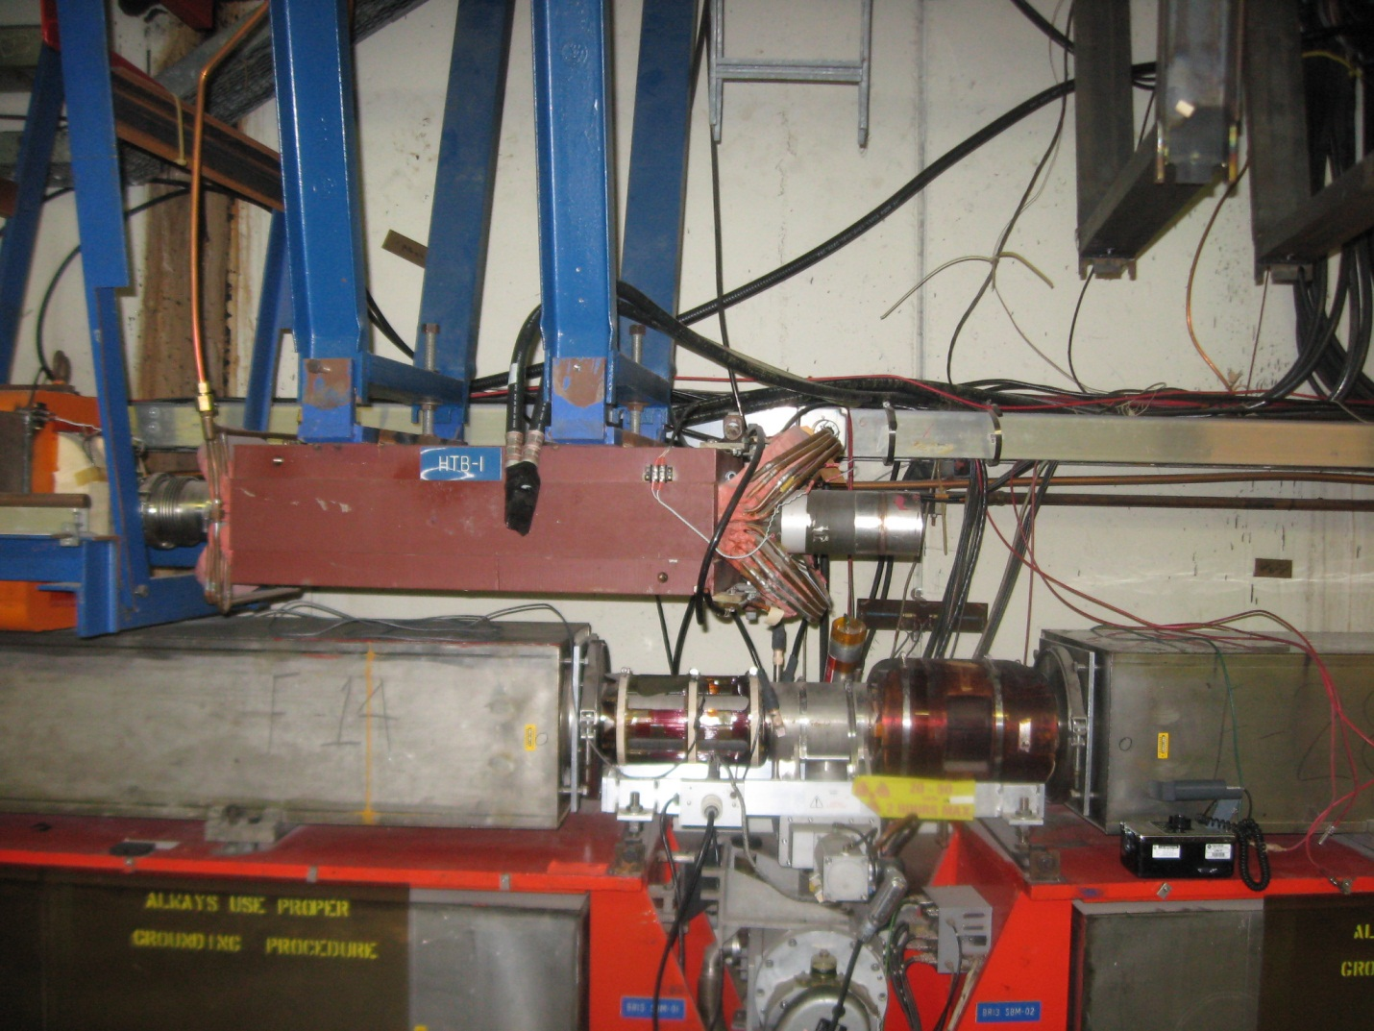
The Turbo manifold in this photo, although hard to see, is as follows. All tubing is 3.250 inch OD stainless steel. Item 1 connection from turbo to valve 6 inches long; item 2, valve, 3.5 inches long; item 3, connection from valve to beam tube 3 inches long.

History
The Booster vacuum system was completed by Dec. 14, 1970. The first coasting beam was Jan. 23, 1971. The first accelerated beam was Feb. 6, 1971. It is important to note that each girder set of gradient magnets were baked at 150⁰ F for two weeks prior to installation and intergration to the vacuum system. This was due to the epoxy used to assemble the gradient magnet. The mechanical pumps in Booster have not functionally changed since that time. High vacuum pumping is provided by 600 l/s ion pumps. The intermediate pumping was provided by the Sargent Welch 160 l/s turbo pumps. The roughing stations were each (4) 157 cfm roots blower backed by an 88 cfm roughing pump. The design of the original vacuum system indicates pump down to 200 millitorr in 15 minutes. Then, pump down to 10⁻⁵ Torr where the 600 l/s ion pumps could be started. This process was stated to take 5 hours from atmosphere with the caveat that the magnets were in operation for the previous 1.5 months and they were vented with dry nitrogen. The maximum achievable vacuum pressure then was low 10⁻⁶ to mid 10⁻⁷ Torr. We enjoy mid to low 10⁻⁸ Torr today.
Conductance calculation of original manifold.
List of objects.
All outside diameters are 3.250 inch-065 wall stainless tube
Item 1- connection from turbo pump to valve 6 inches
Item 2-valve 3.5 inches
Item 3- connection from valve to beam tube 3 inches
Summation of lengths
Turbo to valve 6 inches
Valve 3.5 inches
Valve to beam tube 3 inches
Total length 12.5 inches
Short tube Conductance
C=KAa’ dimensions in centimeters, speed in liters per second
K = flow constant for a specific gas 11.56 L/s-cm2 for air at 20 degrees C, 14.68 for H2O, 44.03 for H2.
A = the cross sectional aperture area cm2
a’ = transmission probability

Calculate a’
=(4*id/(3*Length))/(1+4*id/(3*length)
=(4*7.93/(3*31.75))/(1+4*7.93/(3*31.75)
a’ = .249
Calculate Area and convert to sqcm
A=πr²
3.125/2=1.562
(1.562)²=2.441
2.441*3.1416=7.6 sqin
7.6*6.4516=49.48 sqcm
Calculate Conductance for Air
K=11.56
a’=.249
A=49.48
11.56*.249*49.48=142.89 liters/second
Calculate Effective Speed to System using a Sargent Welch 3120 Turbo Pump
Note: the original turbo pumps were belt drive. They were modified over time to direct drive.
The pumping speed of a Sargent Welch 3120 is 160 liters/second for nitrogen
Effective Speed=( tube cond.*speed of pump)/(tube cond.+speed of pump)
( 142.89*160)=22862.40
(142.89+160)=302.89
22862.40/302.89= 75.48 liters/second effective speed to system

Photograph of location Short 16 in the Booster Tunnel (taken 8/9/12). This is a photographic representation of the new manifold. No new turbo is installed at this location.
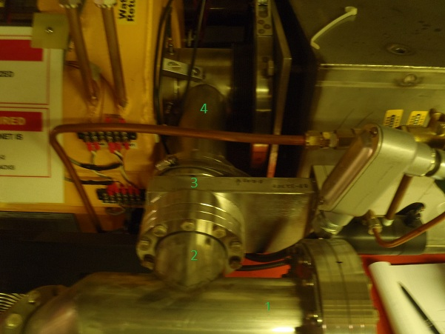
The parts in the photograph are numbered. Dimensions taken are as follows. Item 1- 3 inch tee, 5.5 inches long from flange face to center run. Item 2- 3 inch tee center run 2 inches long to flange face. Item 3- gate valve 2.5 inches flange to flange. Item 4- 3 inch OD tube , 8.5 inches long flange to beam tube.

Conductance calculation of new manifold.
List of objects.
All outside diameters are 3 inch-0.065” wall stainless tube
Item 1- leg of tee 5.5 inches
Item 2-center run of tube to flange 2 inches
Item 3- 3 inch vacuum gate valve 2.5 inches long flange to flange
Item 4- tube flange to beam tube 8.5 inches long
Convert 90 degree angle of tee to straight tube
Effective Length L_{e}=( L1+L2)+1.33*(Angle/180)*inside diameter
(5.5+2)+1.33*(90/180)*2.875=9.4 inches
Summation of length of objects
Tee 9.4 inches
Valve 2.5 inches
Tube 8.5 inches
Total 20.4 inches
Short tube Conductance
C=KAa’ dimensions in centimeters, speed in liters per second
K = flow constant for a specific gas 11.56 L/s-cm2 for air at 20 degrees C, 14.68 for H2O, 44.03 for H2.
A = the cross sectional aperture area cm2
a’ = transmission probability

Calculate a’
=(4*id/(3*Length))/(1+4*id/(3*length)
=(4*7.3/(3*51.8))/(1+4*7.3/(3*51.8)
a’ = .158
Calculate Area and convert to sqcm
A=πr²
2.875/2=1.437
(1.437)²=2.06
2.06*3.1416=6.47 sqin
6.47*6.4516=41.75 sqcm
Calculate Conductance for Air
K=11.56
a’=.158
A=41.8
11.56*.158*41.8=76.4 liters/second
Calculate Effective Speed to System using a Leybold Turbovac151 Turbo Pump
The pumping speed of a Leybold turbovac 151 is 145 liters/second for nitrogen
Effective Speed=( tube cond.*speed of pump)/(tube cond.+speed of pump)
( 76.4*145)=11078
(76.4+145)=221.4
11536.4/221.4=50.03 liters/second effective to system
Calculate Effective Speed to System using a Leybold Turbovac 361 Turbo Pump
The pumping speed of a Leybold turbovac 361 is 345 liters/second for nitrogen
Effective Speed=( tube cond.*speed of pump)/(tube cond.+speed of pump)
( 76.4*345)=26358
(76.4+345)=421.4
26358/421.4=62.5 liters/second effective speed to system

Effective Speed Difference.
50.03/62.5=.80 or a 20% increase in effective pumping speed if a Turbovac 361 is used, instead of a Turbovac 151.
Cost
A recent quote from Oerlikon for 12 Turbovac 361 and 12 Turbovac 151 nets the individual cost of a fan cooled turbo pump, 210 foot cable, and a classic power supply with RS 485 communication port, at $9755.55 for the Turbovac 361, and $7,444.20, for the Turbovac 151. This is a difference of $2,311.35. There are 24 turbo pumps in the Booster tunnel. This would be a projected cost increase difference of $55,472.40 to use the Turbovac 361 vs the Turbovac 151.

Pump down comparison
In summer shutdown of 2009, two Oerlikon Leybold Turbovac 151 turbo pumps were purchased. It was planned to install these during that shutdown. The installation was done in a manner that allowed us to compare the pumpdown rate and time for the Sargent Welch and the Oerlikon Leybold turbo pump. Period 18 was selected to be tested. The test was as follows. The period was to be pumped out and leak checked. Then the ion pumps were started and vacuum stabilized. The period was vented with nitrogen. The system was pumped out with the Sargent Welch turbo pumps. The ion pumps were started and the vacuum stabilized. The pumpdown time was recorded at specific times. The period was vented again. The pumpdown down was done with the Oerlikon Leybold turbos. The time was recorded at specific times. The period was then vented again. The pump down was then performed with both turbo pumps on. The following is a picture of the test set up and the graphs that reflect the test.

Photograph of Booster Short 18. This is the installation to test each turbo. There are two sets of these in period 18.
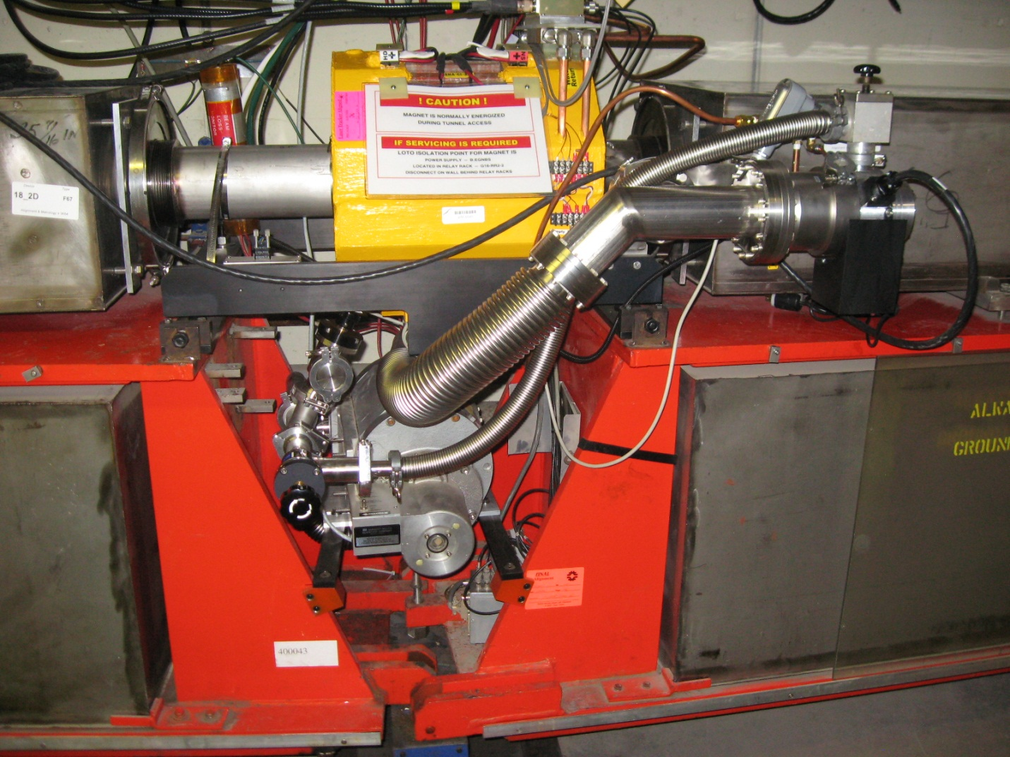

Conclusion
Based upon analysis and testing, the Oerlikon Leybold Turbovac 151 performs equally well as the Sargent Welch 3120. My conclusion is that the pumping speed gained by the Leybold Turbovac 361 is not enough to justify the amount of cost increase.
Acknowledgement
The author would like to thank those who contributed in making the design, fabrication, assembly and tests a success. In particular I would like to thank Terry Anderson, Joel Misek, Ben Ogert Jr., Jason Kubinski, and Justin Briney. I appreciated very much the discussions with Alex Zuxing Chen and Lucy Nobrega.

References
- The Village Crier Vol. 3 No. 22, June 3, 1971
- Vacuum System for the NAL Booster Synchrotron
- Foundations of Vacuum Science and Technology
- Turbo pump comparison tests July/August 2009
- Turbo Pump Data Leybold Turbovac 151
- Turbo Pump Data Leybold Turbovac 361
- Turbo Pump Data Sargent Welch 3120

