Linac 805 MHz Frequency system

Linac BPM Electronics Upgrade

Elliott McCrory

August 23, 2012

Each of the new Linac BPM electronics modules need an 805MHz signal that is a copy of the 805 MHz that drives the RF. These signals must be provided at about -10dBm to each BPM module. There are 6 modules in the low-energy half of the Linac, distributed throughout the stations there. There are 30 modules in the Diagnostics Room, so distribution is a bit easier. And, finally, there will be 30 modules in the 400 MeV line that need this signal; these modules are in three different locations.

The rack locations and module distribution is specified in [the spreadsheet, here](OAC%20Device%20names%20and%20arrangement%20with%20Master.xlsx). A copy is presented here:



# Low-Energy Linac 805 MHz Distribution System

There exists an RF distribution system at 172MHz, which has been used by the BPM system in the low-energy half of the Linac to beat down the raw signal from the Linac beam to approximately 28MHz, where the existing position modules operate. We will reuse that system to distribute the 805MHz RF signal to the new BPM modules.

Here is a cartoon of the system as it stands now.

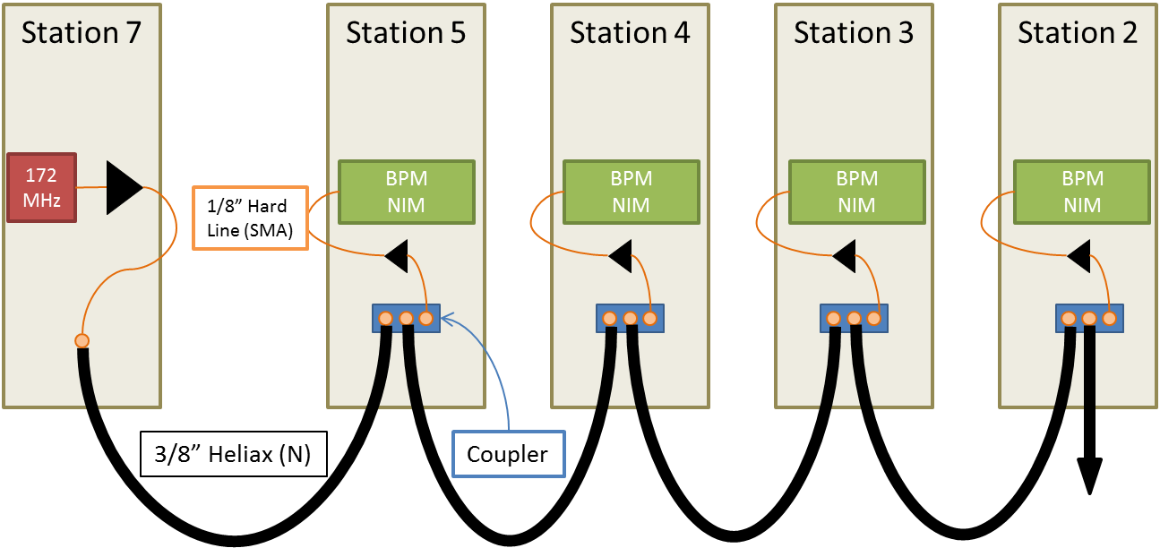

The existing system was installed in the days of the 200MeV Linac, so the signal had to be distributed upstream and downstream of the RF source. Station 6 was the original location (I think), but the source is at Station 7 now.

We propose to replace the minimum number of components in order to use the Heliax runs at 805MHz. The 805MHz source will be taken from Station 2, where there is already an available signal. Here is a proposed layout of the new system.

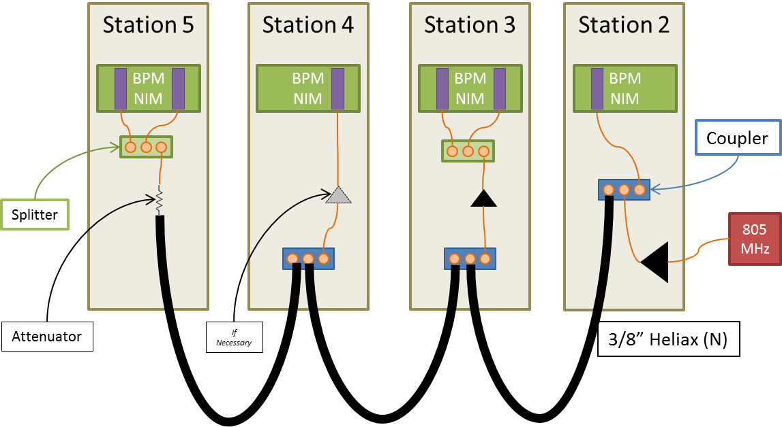

The existing Heliax cables do not need to be changed, nor do the hard lines inside the racks.

The amplifiers within Stations 3, 4 and 5 may need to be replaced, depending on the signal levels we get there. If they are to be replaced, we propose the following:

|  |  |  |  |  |  |  |  |
| --- | --- | --- | --- | --- | --- | --- | --- |
| Model |  | Quantity | Freq Range | Gain | Pmax | DC power | Specs |
| *ZHL-1A-S* | *Existing* | *8* | *1-500 MHz* | *+16dB* | *28dBm* | *24V, 0.6A* | [*Click*](http://www.minicircuits.com/pdfs/ZHL-1A.pdf) |
| ZHL-2-S | Proposed | 31 | 10-1000 MHz | +16dBm | 29dBm | 24V, 0.6A2 | [Click](http://www.minicircuits.com/pdfs/ZHL-2.pdf) |

The new 805MHz amplifiers are plug-compatible with the existing 172MHz amplifiers.

*Note 1: It might be possible to eliminate the amplifier at Tank 4.*

*Note 2: The power supply chassis at the NIM crates for the BPMs include a power supply for that old NIM crate, which we are not using anymore. A new, smaller crate could be constructed, or we can simply reuse the existing one.*

The couplers will also need to be replaced:

|  |  |  |  |  |  |  |
| --- | --- | --- | --- | --- | --- | --- |
| Model |  | Quantity | Freq Range | Coupling | Loss | Specs |
| *ZDMC-20-1* | *Existing* | *8* | *25-400 MHz* | *21 dB* | *0.35 dB* | [*Similar*](http://www.minicircuits.com/pdfs/ZDC-20-1.pdf) |
| ZFDC-20-4L | Proposed | 3 | 10-1000 MHz | 20 dB | 0.7 dB | [Click](http://www.minicircuits.com/pdfs/ZFDC-20-4L.pdf) |

There will need to be an 805 MHz amplifier at the beginning of the line.

|  |  |  |  |  |  |  |
| --- | --- | --- | --- | --- | --- | --- |
| Model |  | Freq Range | Gain | Pmax | DC power | Specs |
| *ZHL-1A* | *Existing* | *1-500 MHz* | *+16dB* | *28dBm* | *24V, 0.6A* | [*Click*](http://www.minicircuits.com/pdfs/ZHL-1A.pdf) |
| ZHL-2-S | Proposed | 10-1000 MHz | +16dB | 29dBm | 24V, 0.6A | [Click](http://www.minicircuits.com/pdfs/ZHL-2.pdf) |

There will also need to be a small 2-way power splitter at stations 3 and 5 to drive two modules at these stations.

|  |  |  |  |  |
| --- | --- | --- | --- | --- |
| Model |  | Type | Freq Range | Specs |
| *ZMSC-4-3* | *Existing* | *4-way power splitter* | *0.25-250 MHz* | [*Click*](http://www.minicircuits.com/pdfs/ZMSC-4-3.pdf) |
| ZX10-2-20-S+ | Proposed | 2-way power splitter | 200-2000 MHz | [Click](http://www.minicircuits.com/pdfs/ZX10-2-20+.pdf) |

# High-Energy Linac 805 MHz Distribution System

There are 30 BPM modules for the high-energy half of the Linac, which are all installed in the Linac Diagnostics Room. Here is a proposal for the distribution system:

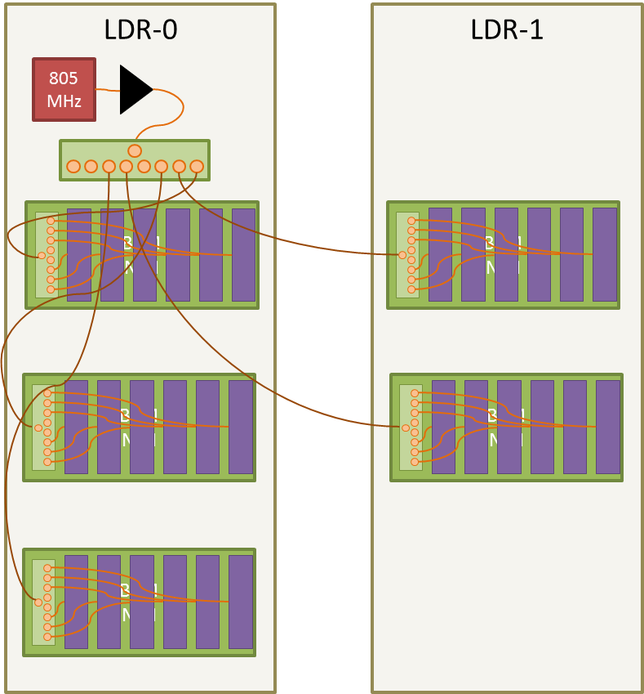

The amplifier already exists. The components needed are:

* 8-way splitters: ZB8PD-1-S, 800-960MHz, <http://www.minicircuits.com/pdfs/ZB8PD-1.pdf>; already on hand.

# 400-MeV Line 805 MHz Distribution System

The 400 MeV line BPMs modules are located in three different places in the Booster Gallery. They are approximately laid out like this:

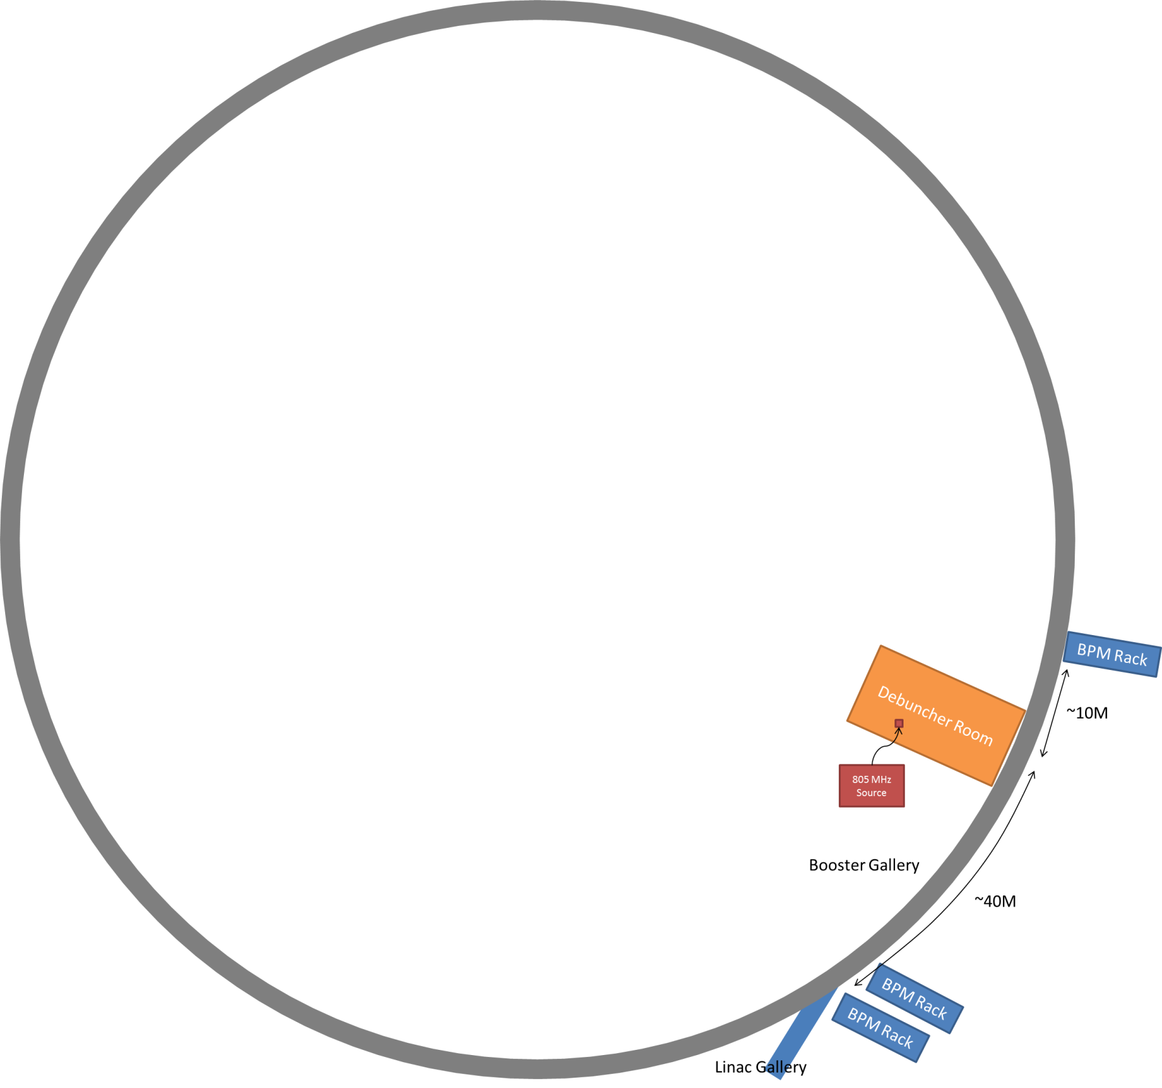

The two racks in the 400 MeV line closest to the Linac Gallery look like this:

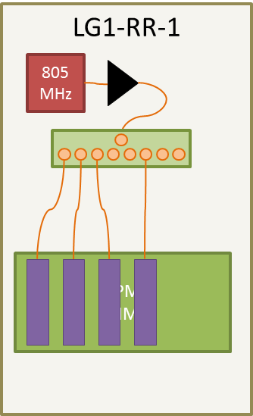

Then, the bulk of the modules, 50m from the Linac Gallery, just down from the Debuncher room, look like this:

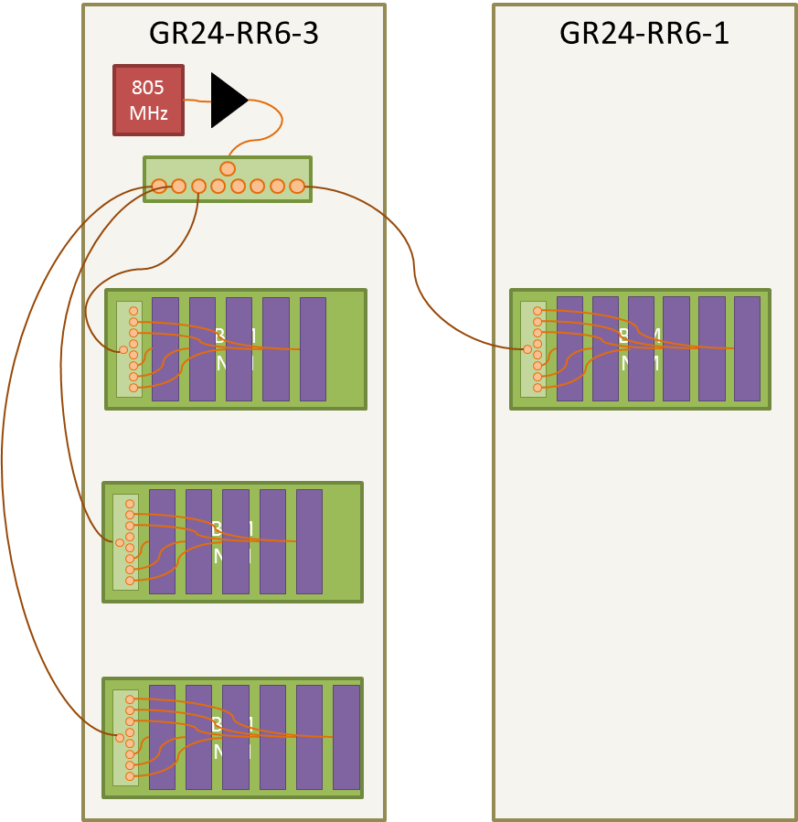

The source of the 805MHz signal is in the Debuncher room. A heliax cable will need to be pulled from the Debuncher room to the other two racks. The layout will look like this.

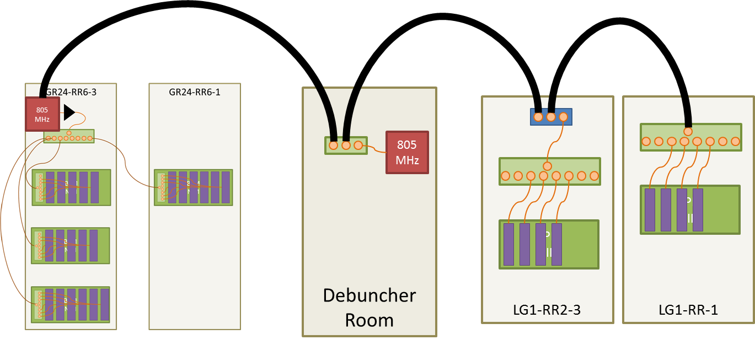

# Analysis of Signal Level

***TO DO! Something along these lines ...***

805 MHz signals have been pulled to all the locations. Here are the signal levels that are needed at the entry to the rack(s) in question.



# Summary of Components needed System



Of course, more of these components, aside from the 8-way splitters, may be available from folks in AD at no cost. The power supplies for the amplifiers are available from old Linac BPM NIM crates and can be liberated. Mountings will need to be constructed for these, and for the 8-way splitters in the NIM crates. The unused ports in the 8-way splitters should be terminated in 50Ω.

# Cable Runs

With these layout assumptions, here are the cables that are needed for these installations.

