Applications for Linac BPMs
Elliott McCrory
January 29, 2013
Several Java applications have been released for the new, 2013 Linac BPM electronics modules. This document provides a basic outline of each application so that someone in Operations can launch these apps and roughly understand what it is supposed to do. For this document, it is more important to be brief than to be complete.
The applications are launched in the normal way for Java applications: Visit http://www-bd.fnal.gov/appix/ and search for the application name, as indicated in the section below. These are all on the “L” index page. Then click on the launch button, which looks like this:
Say “Yes” or “RUN” to all the popups. Note that you must have a valid Kerberos ticket available in order to run any of these applications (or be on a console computer). These applications are compiled for Java 6.
Each of these applications should be terminated through the “Exit” menu choice from the “File” menu. Otherwise, DAQ processes on the server may not be stopped properly.
As of this writing, all of the programs are in development—it is likely that you are going to find problems with them at some level. Please report the problems you find back to the author.

General Notes
In many places within these applications, there will be a button that looks like this:
This button launches a time chart of the data from that scalar parameter. Clicking it again will cause the chart to be hidden (as will clicking on the “close” button normally found on the upper-left corner of the window).
The charts in this application are implemented through the CERN JDataViewer package. For the reader who is not yet familiar with this package, here are some key features:
- Zoom in by dragging a rectangle within the chart.
- Zoom out by right-clicking within the chart.
- Use the “Views” drop-down menu to select another set of data to display. For example, some of the charts that are displayed by clicking the “#” button, above, have a time plot and a histogram—select the histogram from the Views menu.
- A spreadsheet of the numbers in a chart can be seen by first selecting the chart and then clicking on the “More” pull-down menu and then selecting “Table.”

Linac BPM Expert
This program gives you access to all of the internal workings of each BPM module. The screen will look like this when it starts:
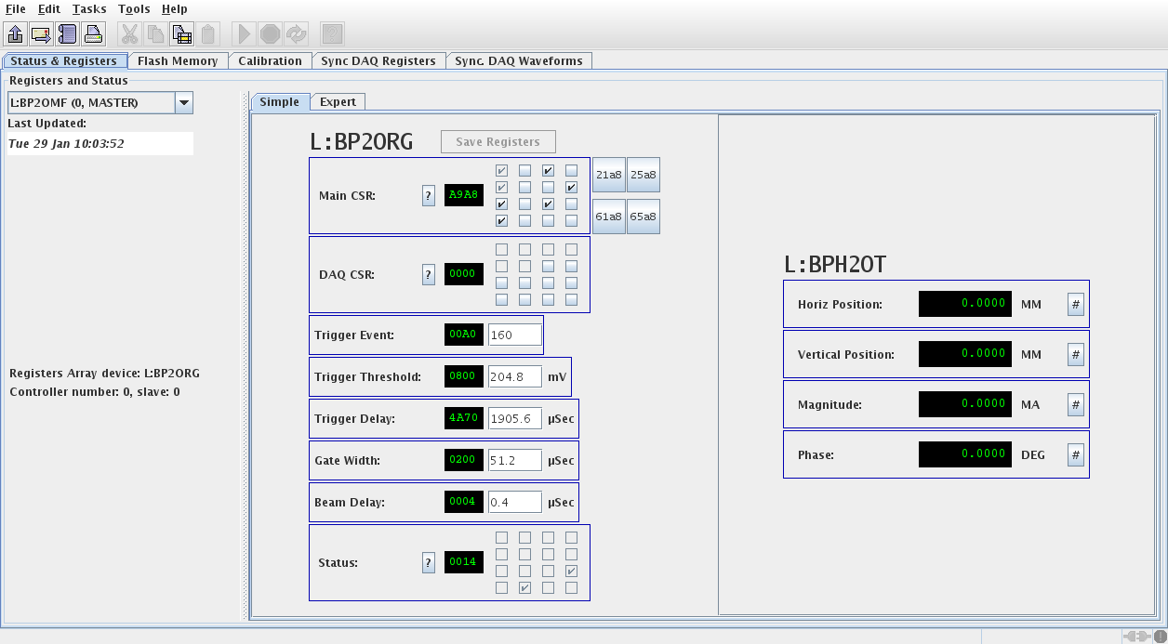
This view allows you to change the most important (in the judgment of the author) registers in each module. Click on the “Expert” tab to see, and to be able to change, all the registers. Click on the pull-down menu on the left (under the words “Registers and Status”) to select another module.
The other main tabs give you the following functionalities:
- Flash Memory – See the contents of the flash memory on the module
- Calibration – Allow you to turn on the “cal tone” in order to debug the DAQ within the module.
- Sync DAQ Registers – Allows you to see and to modify the contents of the registers that have been set up to perform the so-called “Synchronous DAQ” among all the modules in the system. In other words, to get each module to capture the position, magnitude and amplitude waveforms in each of the modules on a very specific clock event. [As of this writing, this functionality is not completely tested.]
- Sync DAQ Waveforms – Show the waveforms that result from the synchronous DAQ.

BPM Simple Display
This program provides a simple display of the BPM data. It is a prototype for a future Java application and is not ready for full operations. However, comments are welcome. The initial screen looks like this:
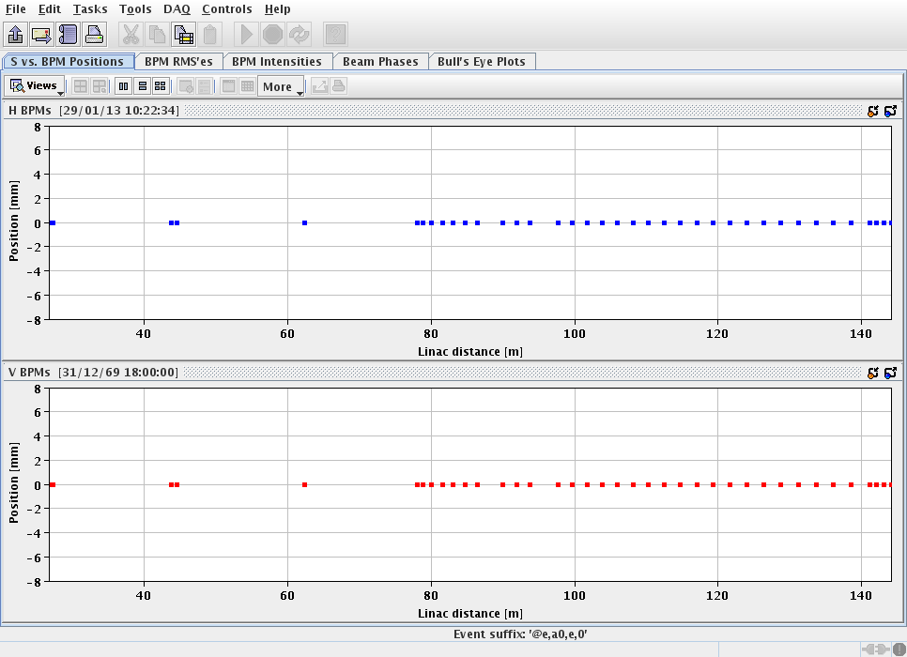

Linac BPM Expert Summary
This application provides much of the same information as “Linac BPM Expert”, but attempts to show the same information for all of the modules at the same time.
The initial screen looks like this:
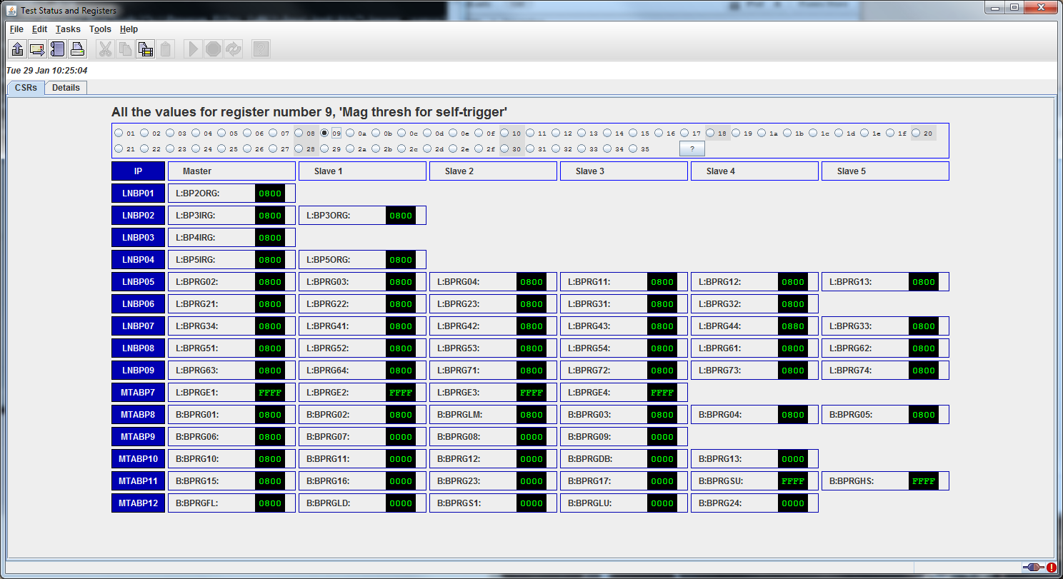
This screen shows the value of all of the registers, in this case, the first register (the Control Status Register, or CSR), for all of the modules. Other registers can be chosen through the radio buttons across the top. Click on the “?” button to see a list of the registers.
The “Details” button shows the 15 most important registers for all of the modules at once.
Usually, a value of “FFFF” indicates that this module is not responding to the data request.
At this time, no settings are implemented.

Linac BPM Multiplex Waveform Control
This program allows for the control and display of the multiplexed waveforms that are available through the Linac BPM OAC.
The OAC looks at eight channels, L:BPMXCn, to determine which BPMs to read for the array data (waveforms) that are presented in the eight matching waveform channels, L:BPMWFn. The 32-bit code is not particularly readable—it represents the node address of the module that contains this waveform, and the memory location within that module.
The initial screen of this application looks like this:
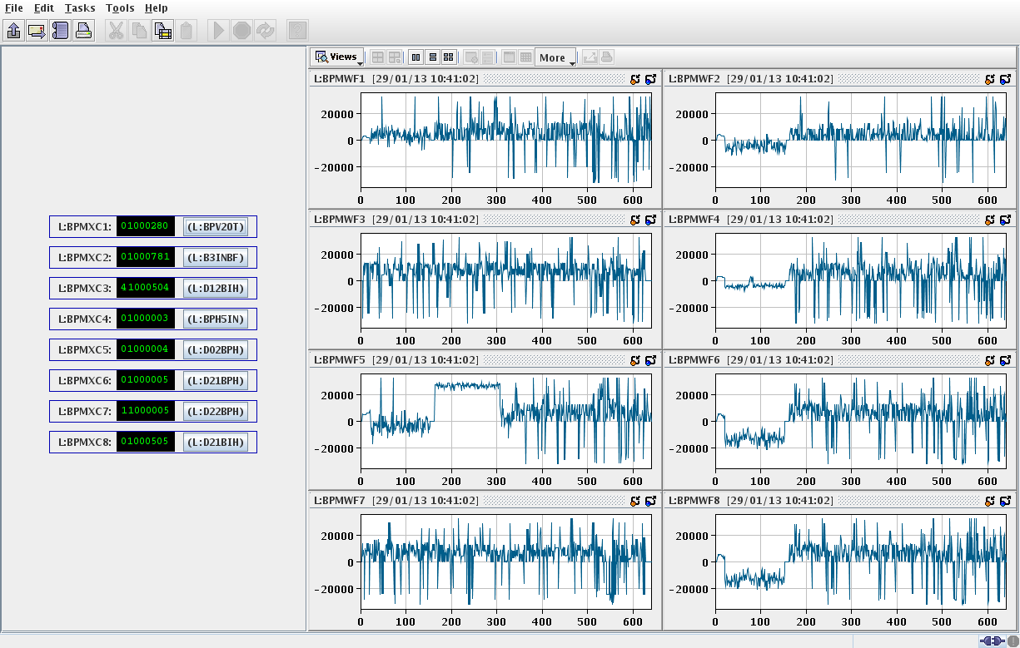
The display of the waveform is included for completeness. It is assumed that the real display will come from another application, like D27.
Click on the button on the left side of the display, just to the right of the green-on-black hex number field. A pull-down menu will pop up and allow you to select the BPM for which you want to display. You can display the X, Y, Magnitude (“I”) or Phase (“F”) of any BPM.
These multiplexed devices all begin with “L:” although the Booster 400 MeV-line BPMs are available for these devices, too.

