Tevatron Run-II Collimator Beam-Based Alignment1

**D. Still* and J. Annala**

Fermilab, P.O. Box 500, Batavia, IL 60510, USA

Abstract: The Tevatron implemented a 2 stage collimator system for the Collider II Run that operated from 2001 to 2011. During that period it was nescessary to conduct a beam-based alignment of all the secondary collimators to ensure proper operation.

Keywords: Tevatron, Collimation System, collimator alignment.

1 Work supported by Fermi Research Alliance, LLC under Contract No. DE-AC02-07CH11359 with the US Department of Energy

* corresponding author: *E-mail*: [still@fnal.gov](mailto:still@fnal.gov)

Contents

1. Introduction 1

2. Collimator Alignment Procedure 3

1. Introduction

The Tevatron Collider II Halo removal system is designed to be a 2 stage collimation system [1] which was an upgraded system from Collider Run I. It was commissioned at the beginning of the Run II in June of 2001 and operated until the end of Tevatron operations in Sept 30, 2011. The halo removal system utilized beam loss monitor and beam intensity feedback to automatically place the collimators through the Tevatron sequencer software for each collider store or fill [2][3]. The system employs “L” shaped primary collimator consisting of a 5-mm thick tungsten wing that is used to scatter particles which are then intercepted with 2 secondary collimators placed at appropriate phase advance. The primary collimator is placed 5 and the secondary collimators are placed at 6 from the beam. Secondary collimators are 1.5m in length and made of stainless steel also “L” shaped. Figure 1 is an example of the placement of the collimators in the 2 stage collimator system.

2stage

**FIGURE 1.** Placement of the target and secondary collimators to produce a 2-stage collimator system.

The Tevatron Collider II halo removal system requires 12 collimators of which there are 4 primary collimators or targets and 8 secondary collimators. The collimators are arranged in 4 sets: 2 proton and 2 antiproton sets and are installed around the Tevatron ring as shown in Figure 2. Placement of collimators in the Tevatron is limited to a few locations since there is limited warm space and the proton and antiproton beams are on helical orbits. Figure 3 shows how the proton and antiproton beams are orientated on the helix at the E0 tunnel location. The helical orbits are created by electrostatic separators which are necessary to prevent the proton and antiproton beams from multiple collisions since the beams are in the same beam pipe. The “L” shaped collimator design was chosen to allow a collimator to interact with only a single beam.

overview

Figure 2. Tevatron Collider Run II Halo Removal Collimator Layout. CDF and D0 detectors are located at B0 and D0 respectively.

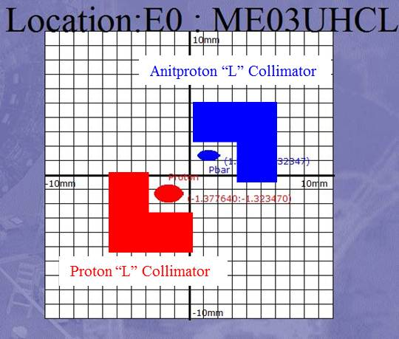

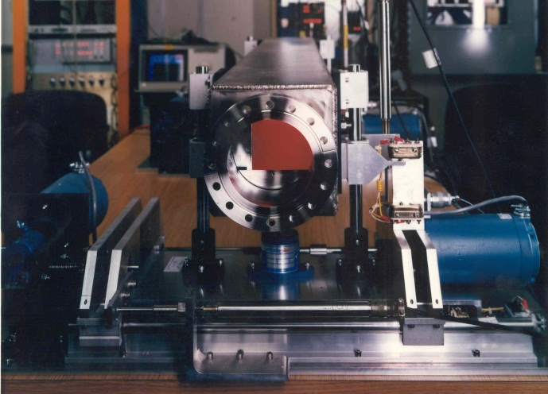

Figure 3. Picture of Tevatron “L” shaped 1.5m secondary collimator (Left). Cartoon depicting proton and antiproton beams at location E0 with corresponding “L” shaped collimators (Right).

Collimation was employed just after the proton and antiproton beams were brought into collision after reaching a flattop energy of 980Gev. The collimator system was designed to remove the beam halo to caused large background signals for the B0 and D0 detectors. The collimators are retracted for injection, acceleration and the lowbeta squeeze.

1. Collimator Alignment Procedure

A large amount of time at the beginning of the Collider Run II was devoted to commissioning the collimator system. Since the main motivations of upgrading the collimator system for collider II was to make the insertion of the collimators automated so that the process took as little time as possible with increased reliability and repeatability of placement of the collimators much of the commissioning effort was dedicated to initial setup of the collimators and alignment of the collimators. The alignment of the collimator system ideally is thought of as two main alignment topics.

1. Aligning a collimator set to ensure the correct relationship for the target and secondary collimators.
2. The alignment of a secondary collimator to ensure that it is parallel to the beam.

Details on the beam loss monitor and beam intensity feedback system can be found in [3].

Alignment and Operation of a Collimator Set

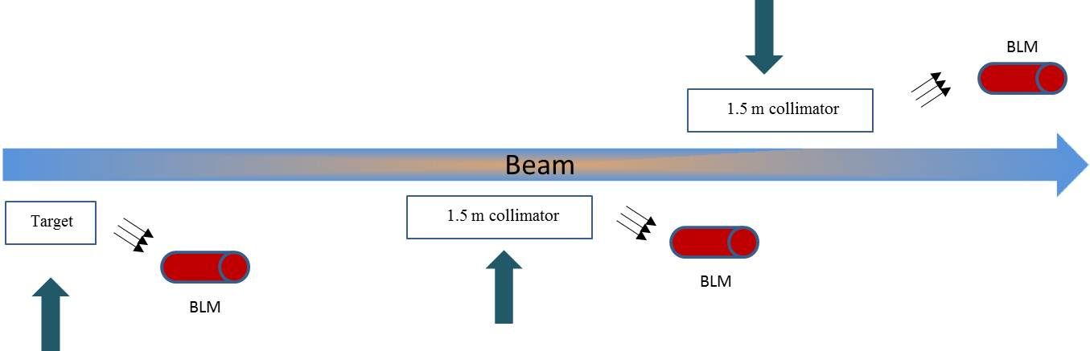

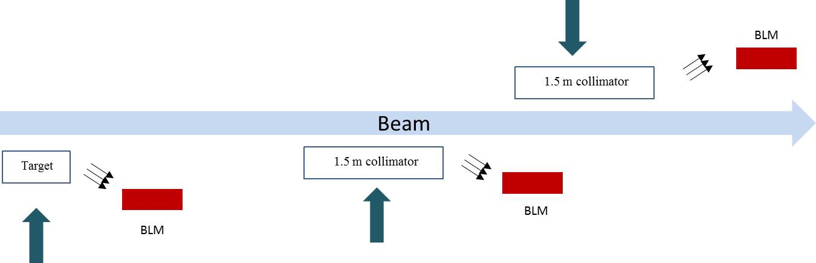

Alignment of a Secondary Collimator Parallel to the Beam

The original collimator system proposal [1] investigated the increased loss rates in the Roman POT detectors. Roman POT detectors were used to study low angle collisions on each side off the interaction region at CDF and typically were placed at 8 to 9  from the beam. The conclusion of the paper found that alignment errors at small angles of +/- 0.12mrad would produce large increases in loss rates for the POT detectors   Therefore, it was necessary during commissioning to align the secondary collimators to be parallel to the beam. Figure 4 demonstrates this type of alignment error.

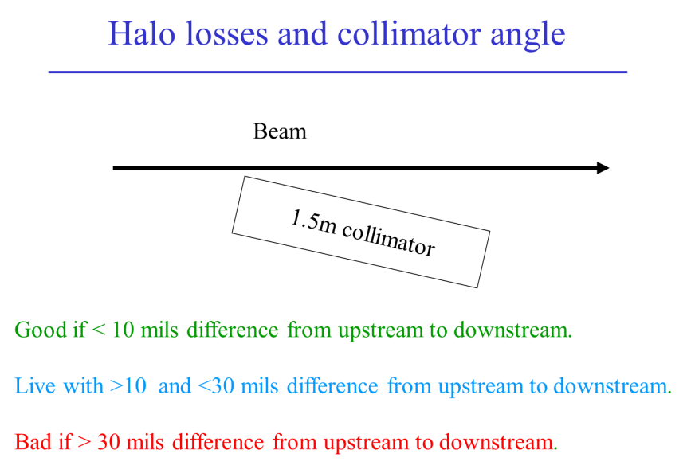

Figure 4. Secondary collimator (1.5m) showing misalignment to the beam.

Each secondary collimator was aligned parallel to the beam during the commissioning run. This procedure was conducted manually. Since each end of a collimator is independently controlled by separate motors, it is possible to align the collimator in both planes (horizontal and vertical) so that it is parallel to the beam. The collimator can move in 2 basic modes. The first mode is that either the horizontal or vertical plane can be moved with the motors “locked”. This mode allows the collimator to move as one unit with synchronized steps. The second mode is “unlocked”. This mode allows each motor to be independently moved allowing for different angles between the collimator face and beam to be achieved. The minimum motor step is 1 mil per step (40 mils = 1mm). It is noteworthy to mention that while moving the collimator in the unlocked mode there is a small consideration that must be made since the supporting screw jacks that hold collimator in the stand have fulcrums that are not centered about the length of the collimator. Small compensations to the number of step sent to the motor must be made when moving the motors independently. An example of the support can be seen in Figure 5.

The procedure to align the collimator parallel to the beam is to inject beam into the Tevatron during a dedicated study period. The beam was accelerated to 980 Gev and the low beta squeeze was initiated to ensure that same orbit was present for the test as for the real halo removal case. Later in the collider run when much experience had been gained these studies were performed at the end of colliding beam store with the CDF and D0 turned off. Typically, uncoalescesd protons were injected for the study with intensity of ~ 3E11 protons. Studies that were used at the end of store had ~ 9E12 protons and ~ 3E12 antiprotons. Next, a single collimator was inserted into the beam in the “locked” mode until the beam touch position was achieved. The collimator is then “unlocked” and each end is moved into the beam until losses are recorded on a downstream beam loss monitor (BLM). Once a loss is detected the opposite end of the collimator is moved into the beam until a similar loss is detected on the BLM. This procedure is repeated until a minimum steps between the 2 ends can be achieved. This process is demonstrated as a cartoon in Figure 6.

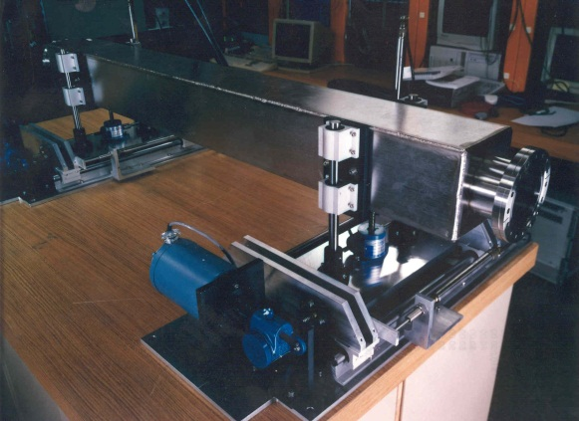

1.5 m collimator

Collimator screw jack supports

Figure 5. Secondary collimator (1.5m) showing screw jack supports for collimator motion.

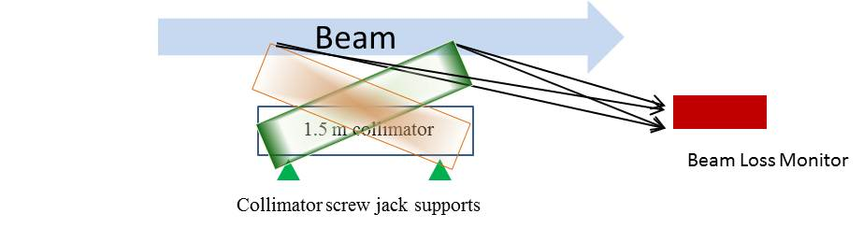

Figure 6. Alignment process to ensure secondary collimator (1.5m) is parallel to the beam.

This procedure in practice only needed to be completed about every 1 year during the collider run or if there was a reason to believe a collimator was misaligned. This determination could be made by either higher unexpected halo losses (either proton or antiproton halo losses) or by statistics on collimator positions. A data gathering process ran after each store and tracked collimator positions and angles. This data was analyzed periodically to determine if a collimator was out of its expected range (just to be clear – this process is different than the collimator position being in alarm due to a problem).

The reproducibility from store to store over a year was on the order of misalignments of 0.16 to 0.5mrad. Errors greater than 0.5 mrad were found to contribute to halo losses at both the B0 and D0 IP’s. However, alignment errors less than 0.5 mrad appeared not to contribute much in increased halo losses even though the original estimates from reference [1] predicted increased loss rates for misalignment errors on the order of +/- 0.12 mrad. This procedure took about 30 min per plane per 1.5 m collimator to perform. Targets only are 6” long in total length and the tungsten portion that interacts with the beam is only 5mm long. Therefore, targets are too short to align in this manner.

References

1. N. Mokhov et.al, “Tevatron Run-II Beam Collimation System”, Proc. PAC 1999, Fermilab-Conf -99/059.
2. N. Mokhov et.al, “Tevatron Beam Halo Collimator System: Design, Operational Experience and New Methods”, JINST 6 (2011) T08005, Fermilab-Pub-11-378-APC.
3. D. Still et.al, “The Tevatron Collider Run II Halo Removal System”, AIP Conf. Proc. 693 (2004) 176-179.