SeaQuest NM3 Beam Cherenkov Proposal
V 2.0 6/25/13
David Christian, Michael Geelhoed, and Paul Reimer
Abstract
Experiment E906, SeaQuest, is requesting to place a Beam Cherenkov in the NM3 enclosure. This instrumentation device will be used to provide a bucket by bucket beam signal for analysis. The signal will be used for multiple purposes such as triggering dead time, DAQ live time, and basic proton normalization.
Location
SeaQuest requests that there are two prerequisites to install the Cherenkov. The first geographical constraint is that the location needs to be relatively close to the E906 target and detector apparatus. Second the ideal location must be easily accessible in case of component replacement.
NM3 could be broken down into two sections the upstream section and the downstream section. The transition between those two sections is a beam pipe flange that reduces from four feet to four inches in diameter. This flange is approximately 100 feet upstream of the target table. In Figure 1 is an image of the flange installed in NM3. This location would be ideal for the constraints and operational considerations needed for the Beam Cherenkov.
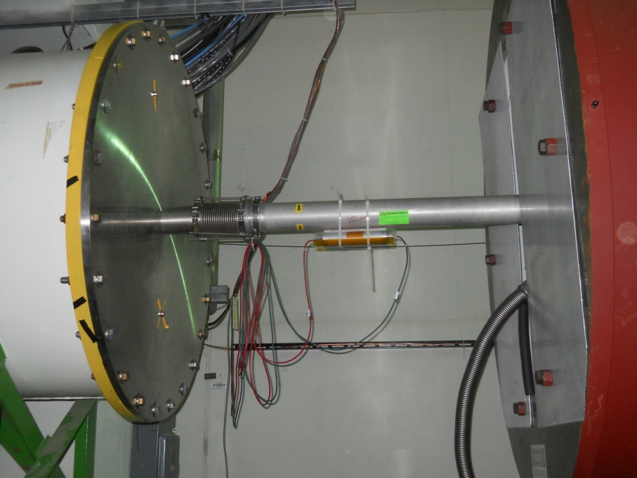
Figure 1 Upstream and downstream section of NM3. The 4 feet to 4 inch flange
The Setup
In order to make room for the Beam Cherenkov, we will install a vacuum bypass line just downstream of the large flange. However unlike those vacuum bypass lines in other similar enclosures of G2 and NM2, this bypass gap will have an attached pipe. Figure 2 is an example of one vacuum bypass with an attached pipe.
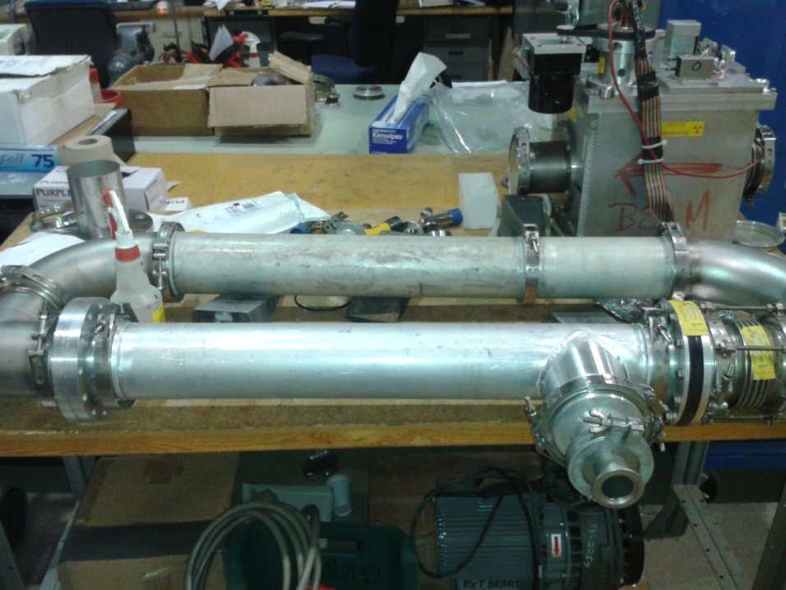
Figure 2 Bypass with Cherenkov pipe installed
The Beam Cherenkov
The Beam Cherenkov is a 27 and 3/8th inch long pipe with a diameter of four inches. Both ends of this pipe will have clamps identical to that of the surrounding Titanium windows, completing the vacuum separation. The pipe will be filled with 1 atmosphere of standard 80/20 split of Argon CO2 gas. This pipe has four ports. One port wedded at the bottom and downstream section to install the PMT can, another port on the top to install a photon blocker, and two smaller ports on the side to connect a gas flow system.
An Internal component of the Cherenkov will be an aluminized Mylar window angled at 45 degrees to the beamline. This window will be attached to the PMT can and installed as one unit. Once in place it can be bolted together. Once this can is connected, nitrogen will be able to properly flow to its proper pressure.
Upstream of that window will be another window made out of black paper. This black paper will reduce the number of photons seen by the PMT per spill. Figure 3 is the proposed Beam Cherenkov pipe drawing.

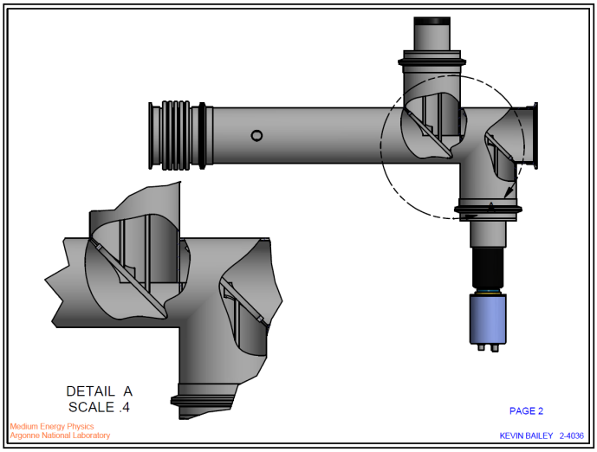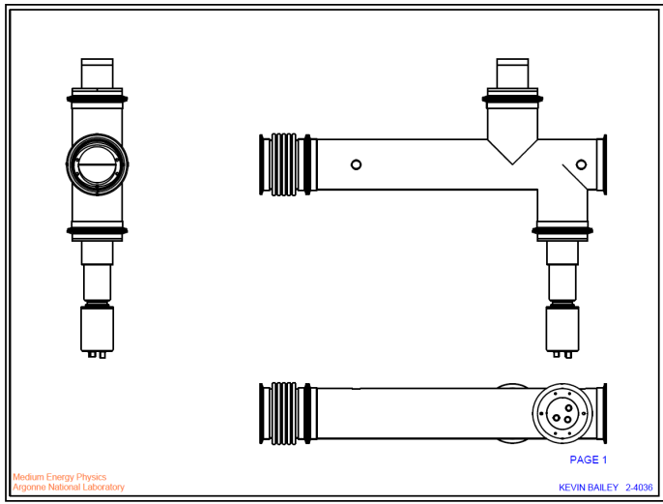
Figure 3 Drawings of the Beam Cherenkov
Activation of Cherenkov
With this instrumentation device, we will be creating a known loss point at this particular location in the beamline. The amount and types of materials described earlier, Table 1 shows that the interaction length of this device is 0.299% of an interaction length, for the worst case scenario using a 0.02” thick Al-Mylar window.
Nitrogen Pipe with Titanium Windows & Mirror |  | Argon | CO2 | Ti | Ti | Paper | Al-Mylar | Total
density (g cm-3) | ρ | 1.66E-03 | 1.84E-03 | 4.54 | 4.54 | 1.42 | 2.40
thickness (inches) | l | 24.3 | 6.075 | 0.003 | 0.003 | 0.01 | 0.02
thickness (cm) | l | 61.72 | 15.43 | 0.00762 | 0.00762 | 0.025 | 0.051
Nuclear interaction length (gm cm⁻²) | λ_{I} | 119.7 | 88.9 | 126.2 | 126.2 | 84.4 | 84.9
Interaction Lengths = Thickness/(λ_{I}/ρ) |  | 0.086% | 0.032% | 0.027% | 0.027% | 0.043% | 0.084% | 0.299%
Table 1 Calculation of combined interaction length of nitrogen Mylar mirror and titanium windows
A very conservative, order of magnitude estimate of the resulting dose rate at saturation, (after one day of shutdown, assuming all decays produce 1 MeV gammas) indicated about 31 mrem/hr at one meter from the center of aluminum Mylar inside of the assembly. At one foot the corresponding dose rate could be as high as 327 mrem/hr.
A MARS simulation was performed to get an expected dose rate from the window. Figure 4 is the setup of the Beam Cherenkov in MARS and Figure 5 is the output. Initial conditions for MARS were running an average of 1.67E+11 protons per second and a low energy neutron cutoff of 1E-12 Gev. The on contact residual dose of the window is 4.5E+04 mrem/hr, for 30 days running and 1 day of cool off. At one foot this residual dose is calculated to be 50 mrem/hr at one foot.
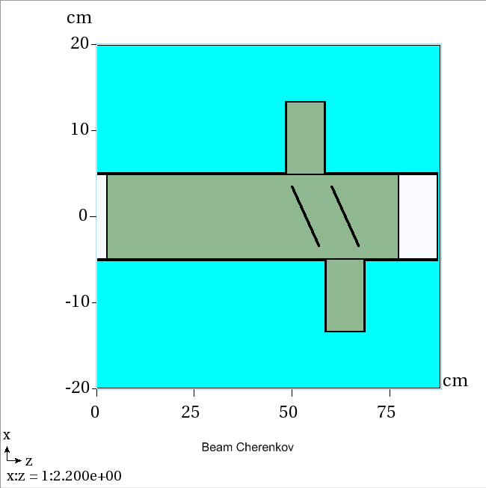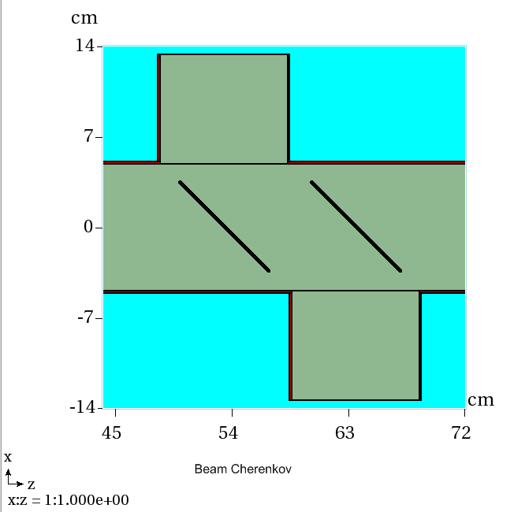
Figure 4 MARS input of Beam Cherenkov and zoomed in figure on paper/mirror
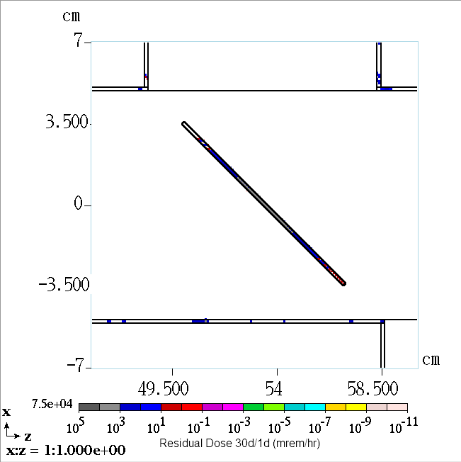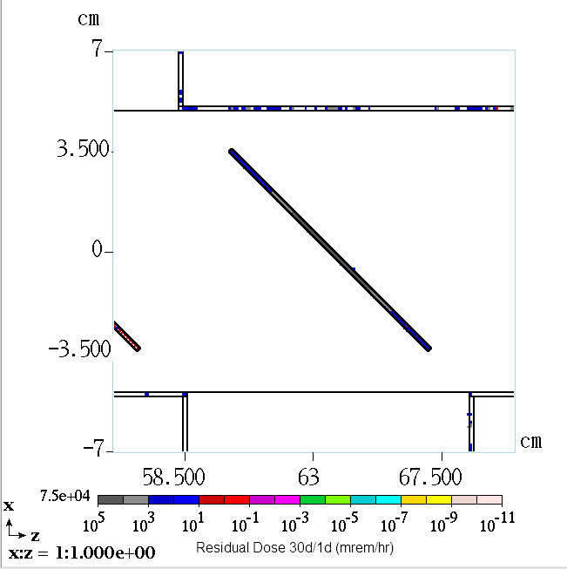
Figure 5 Residual Dose 30 days running and 1 day of cool off (mrem/hr)
Shielding in Proposed Location
Transversely in NM3, the current shielding has 21.2 effective feet of dirt, or e.f.d. and longitudinally there are 21.3 e.f.d. For a category 4B in the shielding assessment for accident conditions, beam loss on a pipe, the required amount of e.f.d. is 10.0. Both transversely and longitudinally there is an adequate amount of shielding for a loss on a pipe. Since this Cherenkov will be in the path of the beam under normal operating conditions an additional required shielding amount is calculated. Equation 1 calculates the additional e.f.d based on the Coissart Category. This amount is scaled from the dose rate limits of the category 4B. Table 2 summarizes this.
Thickness = -3.38 log(100/500) = 2.36 e.f.d
Equation 1 Additional shielding for normal running conditions
 | Cossairt Category | Current Shielding (e.f.d.) | Normal Running  Required  (e.f.d.) | Difference  (ft)
Transverse | 4B | 21.2 | 12.36 | 8.84
Longitudinally | 4B | 21.3 | 12.36 | 8.94
Table 2 Shielding requirements for NM3 Normal Running and adequate shielding
Summary
Experiment E-906 desires to measure bucket-by-bucket beam intensity using a nitrogen Beam Cerenkov counter. Fermilab Accelerator Division Mechanical Support has titanium windows in stock and available beam pipe in old enclosures that are easy to assemble in NM3 to make this bypass section. With the responsibility to fabricate the Cherenkov’s internal components with PPD, the additional instrumentation will be beneficial to the experiments
data tracking ability and provide the ability for a better duty factor.
References
N.V. Mokhov, "The MARS Code System User's Guide", Fermilab-FN-628 (1995);
N.V. Mokhov, O.E. Krivosheev, "MARS Code Status", Proc. Monte Carlo 2000 Conf., p. 943, Lisbon, October 23-26, 2000; Fermilab-Conf-00/181 (2000);
N.V. Mokhov, "Status of MARS Code", Fermilab-Conf-03/053 (2003);
N.V. Mokhov, K.K. Gudima, C.C. James et al, "Recent Enhancements to the MARS15 Code", Fermilab-Conf-04/053 (2004); http://www-ap.fnal.gov/MARS

Private communication Kamran Vaziri
Neutrino Muon Shielding Assessment
FRCM Table 2-6

