Booster Longitudinal Dampers

Module Settings and Functional Checks.
February 19, 2014
Craig Drennan

Introduction
This is a working document, meaning that not only is it in perpetual DRAFT state waiting for input from others, but will be added to as time permits.
This document contains three sections. The first simply list references discussing why and how the Booster Longitudinal Dampers operate and some history on what has been tried in the past and why the damping methods have changed.

References:
[1] C.M. Ankenbrandt, J.E.Griffin, R.P. Johnson, J. Lackey and K. Meisner, “Longitudinal Motion of the Beam in the Fermilab Booster,” IEEE Trans. Nucl. Sci. NS-24 1449 (1977).
[2] D. Wildman and K. H ar kay, “ HOM R F Cavity Dampers for Suppressing Coupled Bunch Instabilities in the Fermilab Booster,” 1993 PAC Proc. Washington, DC., p.3528A.
[3] K. Cecelia Harkay “A Study of longitudinal Instabilities and Emittance Growth in the Fermilab Booster Synchrotron.” FERMILAB-THESIS-1993-65 (Dec 1993) 211p.
[4] J.P. Shaw, D. McGinnis, and R. Tomlin, “Reducing the Coupled-Bunch Oscillation in the Fermilab Booster by Optimizing RF Voltage,” 1993 PAC Proc. Washington, DC. ,p.3787
[5] J.M. Steimel and D. McGinnis, “Damping in The Fermilab Booster,” 1993 PAC Proc. Washington, DC., p. 2100
[6] D.A. Herrup, D. McGinnis, J. Steimel, and R. Tomlin, “Analog Dampers in the Fermilab Booster,” 1995 PAC Proc. Dallas, Texas, p.3010.
[7] W.A. Pellico, D.W. Wildman, “Booster’s Coupled Bunch Damper Upgrade,” 2003 PAC Proc. Portland, OR, p.3177.

Other References
Fermi Accelerator Division Operations, “Booster Rookie Book,” p.39,
http://www-bdnew.fnal.gov/operations/rookie_books/Booster_V4.1.pdf
D.K. Weaver, “A Third Method of Generation and Detection of Single-Sideband Signals,” Proc. of the IRE, vol. 44 issue 12, p.1703

System Drawings
Booster Longitudinal Damper Block Diagram, 0323.00 - ED - 282391, W. Pellico, C. Drennan 2/19/2014
Booster Front End Damper Module, 0323.00 - EC - 282390, W. Pellico, C. Drennan 2/19/2014
Tracking Narrow Band Filter, 0323.00 - ED - 282392, D. McGinnis, G. Golinski 8/1996

Appendix A: Compute the DIP Switch Settings for the DDS on the “Tracking Narrow Band Filter” Modules.
There are two configurations for the Longitudinal Damper systems. One provides a DDS clock at 8x the LLRF reference frequency and takes the Beam signal directly, and the second provides a DDS clock at 2x the LLRF reference frequency and downconverts the mode frequencies on the beam signal before sending to the Tracking Narrow Band Filter modules.
The input to the DDS, besides the clock, is a digital word that represents the desired frequency of its sinewave output. The input bits can be considered as bits (30 ... 1) of a 32-bit frequency setting, FW(31 ... 0).
$$FW\left(31..0\right)=2^{32}∙\frac{F_{OUT}}{F_{CLK}}$$

System Using the x8 Clock.
For the first damper system we will use a DDS reference clock, $F_{CLK}$, that will be 8 times higher than the LLRF Reference Frequency, $f_{o}$. The DDS output frequency, $F_{OUT}$, is to be the frequency of the mode we wish to damp $f_{mode}$.
$$f_{mode}=f_{0}+f_{0}∙\frac{m}{84}, for m=1⋯83$$
Therefore we can determine the frequency setting as
$$FW=2^{32}∙\frac{\left(1+\frac{m}{84}\right)∙f_{o}}{8∙f_{o}}=2^{32}∙\frac{\left(1+\frac{m}{84}\right)}{8}$$

Example 1:
Setup DDS for the Mode 1 Damper, (m=1).
$$FW=2^{32}∙\frac{\left(1+\frac{1}{84}\right)}{8}=2^{32}∙0.126488=543,262,232$$
The 32-bit binary version of this number is
$$FW\left(31 .. 0\right)=0010 0000 0110 0001 1000 0110 0001 1100$$
The DDS Input bits are bits (30 .. 1)
$$Switch Settings \left(30 .. 1\right)=010 0000 0110 0001 1000 0110 0001 110$$

Example 2:
Setup DDS for the Mode 50 Damper, (m=50).
$$FW=2^{32}∙\frac{\left(1+\frac{50}{84}\right)}{8}=2^{32}∙0.199405=856,436,931$$
The 32-bit binary version of this number is
$$FW\left(31 .. 0\right)=0011 0011 0000 1100 0011 0000 1100 0011$$
The DDS Input bits are bits (30 .. 1)
$$Switch Settings \left(30 .. 1\right)=011 0011 0000 1100 0011 0000 1100 001$$

System Using the Front End Damper Module and the x2 Clock.
For the second damper system we will use a DDS reference clock, $F_{CLK}$, that will be 2 times higher than the LLRF Reference Frequency, $f_{o}$, and we will downconvert the mode frequencies in the beam pickup signal using this ${2∙f}_{o}$clock. The DDS output frequency, $F_{OUT}$, is to be the downconverted mode frequency of the mode we wish to damp ${f_{mode}}^{*}$.
$${f_{mode}}^{*}=2∙f_{o}-f_{mode}=2∙f_{o}-\left(f_{0}+f_{0}∙\frac{m}{84}\right)=f_{0}-f_{0}∙\frac{m}{84} , for m=1⋯83$$
Therefore we can determine the frequency setting as
$$FW=2^{32}∙\frac{\left(1-\frac{m}{84}\right)∙f_{o}}{2∙f_{o}}=2^{32}∙\frac{\left(1-\frac{m}{84}\right)}{2}$$

Example 3:
Setup DDS for the Mode 47 Damper, (m=47).
$$FW=2^{32}∙\frac{\left(1-\frac{47}{84}\right)}{2}=2^{31}∙0.440476=945,915,416$$
The 32-bit binary version of this number is
$$FW\left(31 .. 0\right)=0011 1000 0110 0001 1000 0110 0001 1000$$
The DDS Input bits are bits (30 .. 1)
$$Switch Settings \left(30 .. 1\right)=011 1000 0110 0001 1000 0110 0001 100$$

For the modes currently damped using this configuration we have the following switch settings.
Mode 47 : $Switch Settings \left(30 .. 1\right)=011 1000 0110 0001 1000 0110 0001 100$
Mode 51 : $Switch Settings \left(30 .. 1\right)=011 0010 0100 1001 0010 0100 1001 001$
Mode 52 : $Switch Settings \left(30 .. 1\right)=011 0000 1100 0011 0000 1100 0011 000$

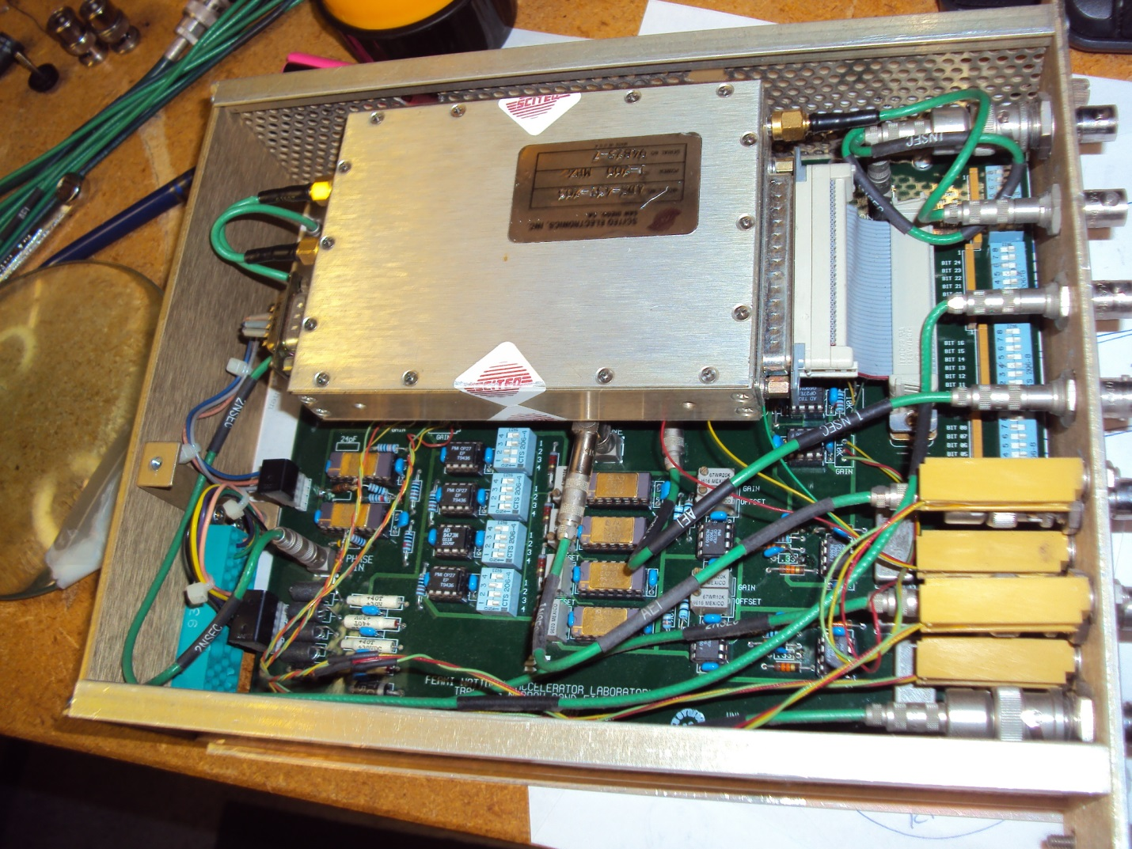
Figure A.1 Tracking Narrowband Filter Module.
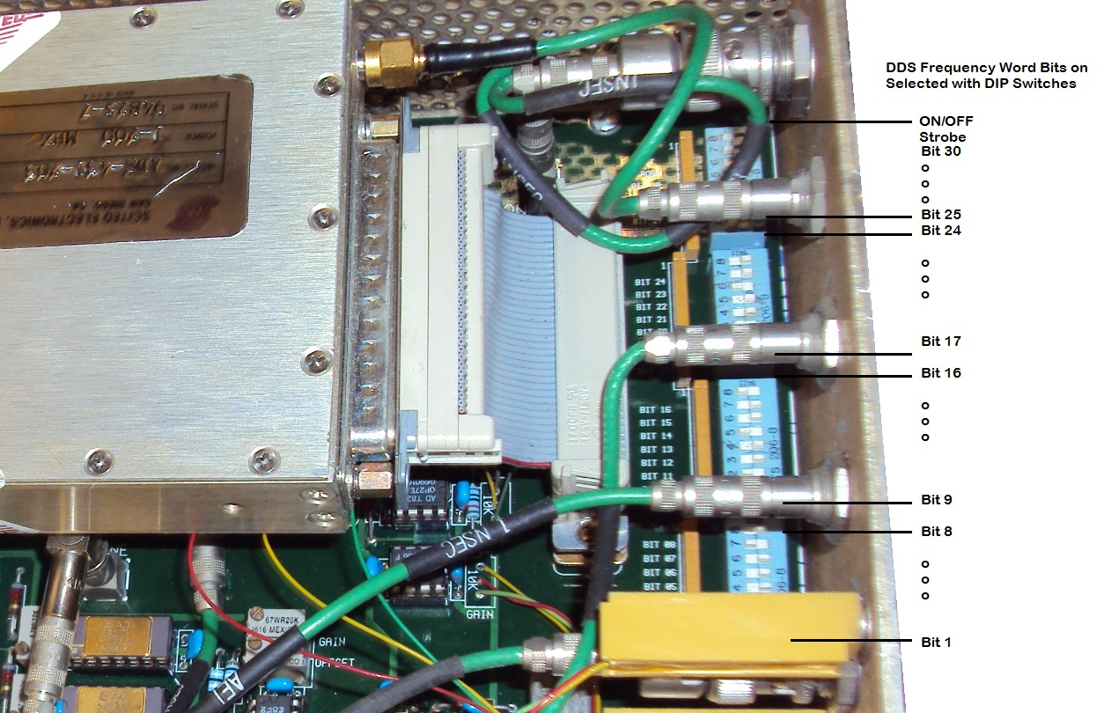
Figure A.2 Location of the DDS Frequency Word selection DIP switches.

Appendix B: Tracking Narrow Band Filter Functional Checks
The following test is meant to test the basic function of the mode dampers. There are two versions of the damper modules. One is provided a DDS clock at 8x the LLRF reference frequency and takes the beam pickup signal directly, and the second provides a DDS clock at 2x the LLRF reference frequency and downconverts the mode frequencies on the beam pickup signal before sending to the Tracking Narrow Band Filter modules.
Table B.1 lists the frequencies of the currently damped modes given points through the Booster LLRF reference frequency sweep.
Table B.1 Input Beam Frequencies of Interest, MHz
 | Mode
Fllrf | 1 | 2 | 47 | 48 | 49 | 50 | 51 | 52
37 | 37.440 | 37.881 | 57.702 | 58.143 | 58.583 | 59.024 | 59.464 | 59.905
38 | 38.452 | 38.905 | 59.262 | 59.714 | 60.167 | 60.619 | 61.071 | 61.524
39 | 39.464 | 39.929 | 60.821 | 61.286 | 61.750 | 62.214 | 62.679 | 63.143
40 | 40.476 | 40.952 | 62.381 | 62.857 | 63.333 | 63.810 | 64.286 | 64.762
41 | 41.488 | 41.976 | 63.940 | 64.429 | 64.917 | 65.405 | 65.893 | 66.381
42 | 42.500 | 43.000 | 65.500 | 66.000 | 66.500 | 67.000 | 67.500 | 68.000
43 | 43.512 | 44.024 | 67.060 | 67.571 | 68.083 | 68.595 | 69.107 | 69.619
44 | 44.524 | 45.048 | 68.619 | 69.143 | 69.667 | 70.190 | 70.714 | 71.238
45 | 45.536 | 46.071 | 70.179 | 70.714 | 71.250 | 71.786 | 72.321 | 72.857
46 | 46.548 | 47.095 | 71.738 | 72.286 | 72.833 | 73.381 | 73.929 | 74.476
47 | 47.560 | 48.119 | 73.298 | 73.857 | 74.417 | 74.976 | 75.536 | 76.095
48 | 48.571 | 49.143 | 74.857 | 75.429 | 76.000 | 76.571 | 77.143 | 77.714
49 | 49.583 | 50.167 | 76.417 | 77.000 | 77.583 | 78.167 | 78.750 | 79.333
50 | 50.595 | 51.190 | 77.976 | 78.571 | 79.167 | 79.762 | 80.357 | 80.952
51 | 51.607 | 52.214 | 79.536 | 80.143 | 80.750 | 81.357 | 81.964 | 82.571
52 | 52.619 | 53.238 | 81.095 | 81.714 | 82.333 | 82.952 | 83.571 | 84.190
53 | 53.631 | 54.262 | 82.655 | 83.286 | 83.917 | 84.548 | 85.179 | 85.810
 | F mode = F llrf + mode*(Fllrf/84)

Table B.2 lists the downconverted mode frequencies used in the x2 Clock version of the damper modules.
Table B.2 Downconverted Mode Frequencies, MHz
 | Front End Damper Module Output
 | Fclk = | F mixer out | Down Converted Mode
Fllrf | 2 x F llrf | Fclk - F llrf | 1 | 2 | 47 | 48 | 49 | 50 | 51 | 52
37 | 74.000 | 37.000 | 36.560 | 36.119 | 16.298 | 15.857 | 15.417 | 14.976 | 14.536 | 14.095
38 | 76.000 | 38.000 | 37.548 | 37.095 | 16.738 | 16.286 | 15.833 | 15.381 | 14.929 | 14.476
39 | 78.000 | 39.000 | 38.536 | 38.071 | 17.179 | 16.714 | 16.250 | 15.786 | 15.321 | 14.857
40 | 80.000 | 40.000 | 39.524 | 39.048 | 17.619 | 17.143 | 16.667 | 16.190 | 15.714 | 15.238
41 | 82.000 | 41.000 | 40.512 | 40.024 | 18.060 | 17.571 | 17.083 | 16.595 | 16.107 | 15.619
42 | 84.000 | 42.000 | 41.500 | 41.000 | 18.500 | 18.000 | 17.500 | 17.000 | 16.500 | 16.000
43 | 86.000 | 43.000 | 42.488 | 41.976 | 18.940 | 18.429 | 17.917 | 17.405 | 16.893 | 16.381
44 | 88.000 | 44.000 | 43.476 | 42.952 | 19.381 | 18.857 | 18.333 | 17.810 | 17.286 | 16.762
45 | 90.000 | 45.000 | 44.464 | 43.929 | 19.821 | 19.286 | 18.750 | 18.214 | 17.679 | 17.143
46 | 92.000 | 46.000 | 45.452 | 44.905 | 20.262 | 19.714 | 19.167 | 18.619 | 18.071 | 17.524
47 | 94.000 | 47.000 | 46.440 | 45.881 | 20.702 | 20.143 | 19.583 | 19.024 | 18.464 | 17.905
48 | 96.000 | 48.000 | 47.429 | 46.857 | 21.143 | 20.571 | 20.000 | 19.429 | 18.857 | 18.286
49 | 98.000 | 49.000 | 48.417 | 47.833 | 21.583 | 21.000 | 20.417 | 19.833 | 19.250 | 18.667
50 | 100.000 | 50.000 | 49.405 | 48.810 | 22.024 | 21.429 | 20.833 | 20.238 | 19.643 | 19.048
51 | 102.000 | 51.000 | 50.393 | 49.786 | 22.464 | 21.857 | 21.250 | 20.643 | 20.036 | 19.429
52 | 104.000 | 52.000 | 51.381 | 50.762 | 22.905 | 22.286 | 21.667 | 21.048 | 20.429 | 19.810
53 | 106.000 | 53.000 | 52.369 | 51.738 | 23.345 | 22.714 | 22.083 | 21.452 | 20.821 | 20.190
 |  |  |  | Mode Frequencies Passed by the Output Filter

Checkout Procedure
- An RF sinewave signal source is setup for 400 MHz, 0 dBm. This is approximately 8x the final Booster LLRF Frequency (50.0 MHz). This signal is connected to the DDS Clock input of the device under test (DUT).

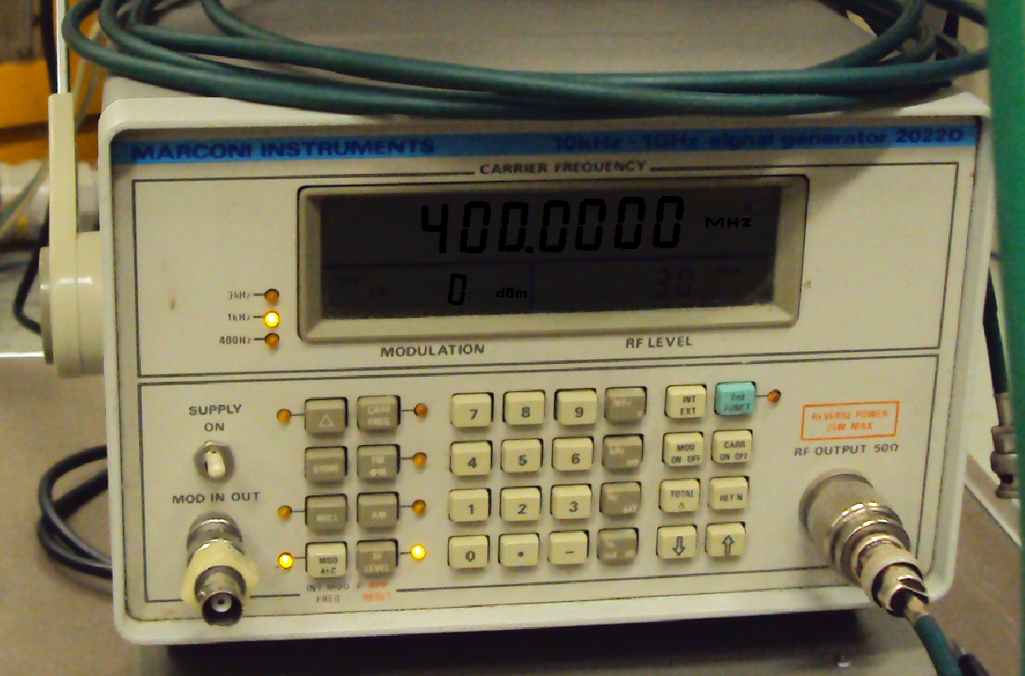

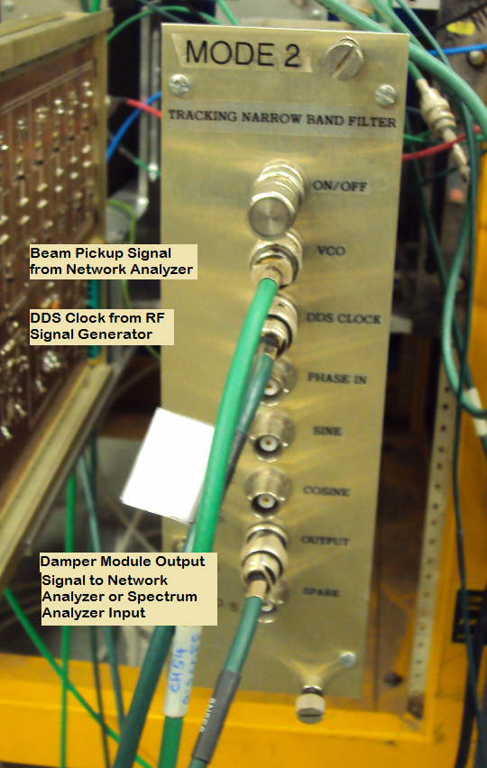

- A Network Analyzer is setup to produce the Beam Pickup signal. This network analyzer output is connected to the Beam In or VCO input connection on the Damper Module.

x8 Clock Version: The network analyzer frequency is set to sweep through the mode frequency at which the module has been setup to damp.
If it is not apparent which mode the module has been setup for, recall the method for determining the DIP switch settings in Appendix A and work back through the equations
$$\left(FW∙\frac{8}{2^{32}}-1\right)∙84=mode$$
Recall that the 32-bit frequency word is the Switch Settings(31 .. 1) with zero’s attached at either end for bit 32 and bit 0.

X2 Clock Version: The network analyzer frequency is set to sweep through the downconverted mode frequency at which the module has been setup to damp. Refer to Table B.2 for this frequency.
Again, to determine the mode the module is setup for work back using the appropriate method in Appendix A.
$$\left(1-FW∙\frac{2}{2^{32}}\right)∙84=mode$$
Recall that the 32-bit frequency word is the Switch Settings(31 .. 1) with zero’s attached at either end for bit 32 and bit 0.

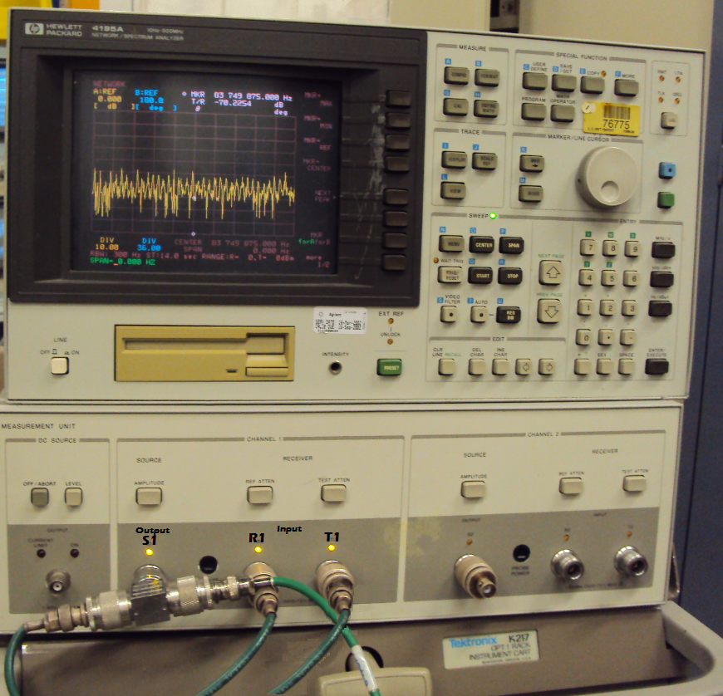

- The network analyzer should show a peak near the mode frequency (or downconverted mode frequency). By centering the display on this peak and reducing the frequency “Scan” width to approximately 20 kHz, we hope to see a display similar to that in Figure B.1 below.

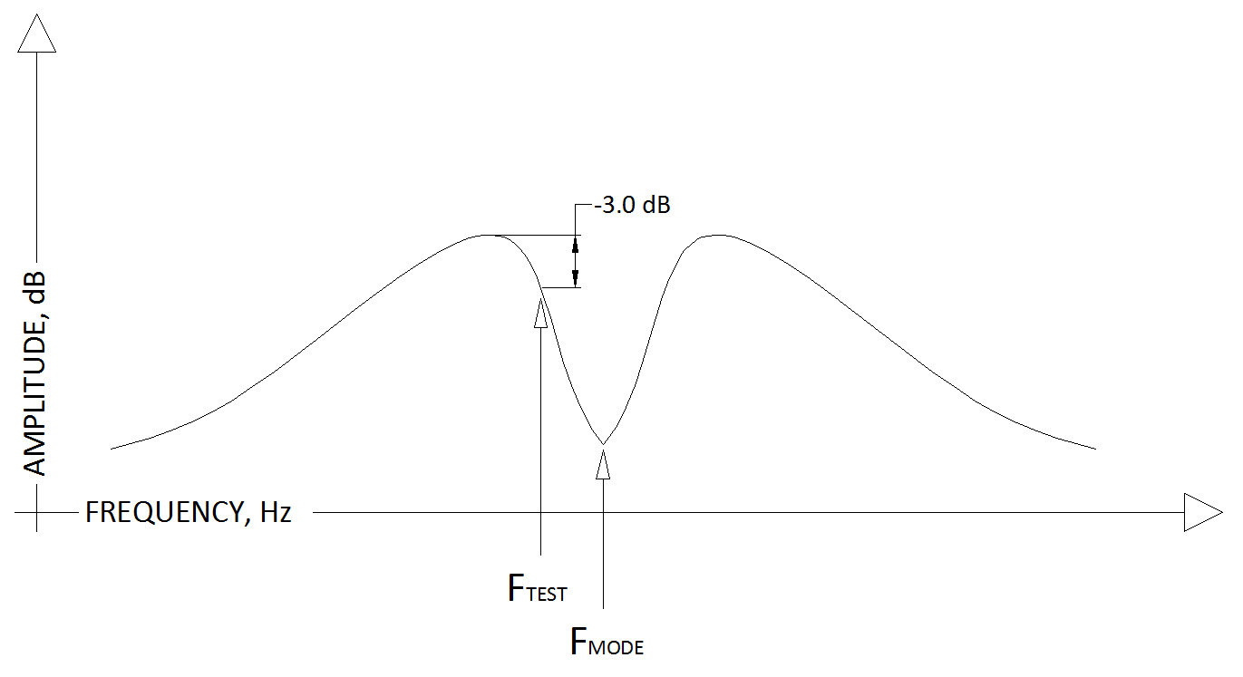
Figure B.1 Network Analyzer Display.

- Determine the frequency of FTEST as indicated in Figure B.1. Center the network analyzer at this frequency then set the frequency span to 0 Hz. This will drive a constant frequency (CW) signal into the damper module.
- Remove the output of the damper module from the T1 input of the network analyzer and connect to a spectrum analyzer.
- Adjust the spectrum analyzer to find and display something similar to Figure B.2. Note the expected location of FTEST .

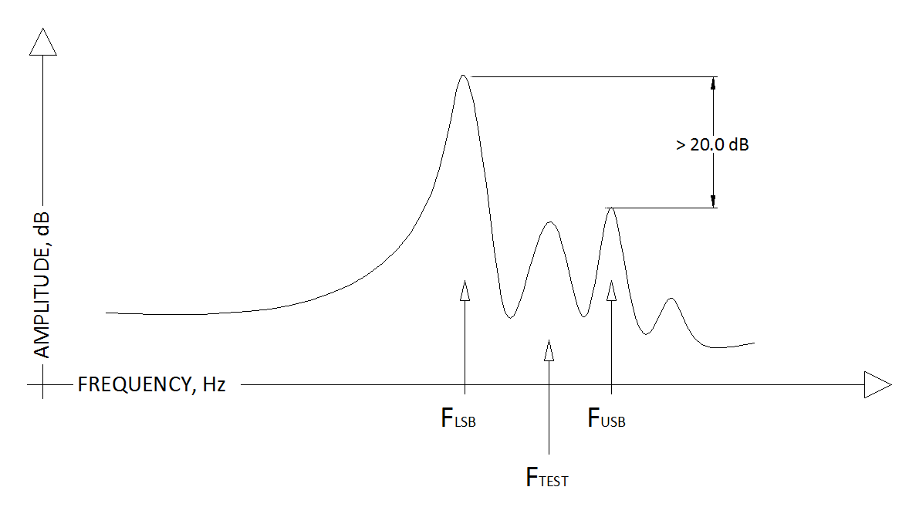
Figure B.2 Spectrum Analyzer Display

- Under normal operation the mode frequency will be modulated by the oscillations we wish to damp. This modulation would appear as sidebands on either side of the fundamental mode frequency. The damper module is designed to select the lower side band (FLSB) to produce the feedback to damp the oscillation.

In this test, higher order mixer products generated by the downconversion stage in the damper module are used to examine the adjustment of the circuit and probe the filtering in place of the modulation sidebands.

The lower side band amplitude should be 20 dB greater than the upper side band at FUSB.

