NM4 Prompt Dose Investigation
2/4/14
Michael Geelhoed
Introduction
The Neutrino Muon Beamline operated for a month and a half prior to the yearlong shutdown of 2012-2013. During this time radiations levels in the NM4 Experimental Hall were not an issue for normal running conditions. Since start-up, the radiation levels in the hall have restricted the maximum intensity delivered to the SeaQuest experiment.
Setup
Figure 1 is a datalogged plot from April 2012 of eight straight hours of running through an intensity range from above 2.0E11 to below 2.0E12 on the G2 SEM (S:G2SEM). This also shows that the chipmunks in the hall on the west ledge (G:RD3163) and the north roll up door (G:RD3164) increase with intensities during this time. The series of orange dots at the bottom is the voltage read back of a loss monitor nearest to the four foot to four-inch flange (LNM344). The highest readback on a pulse of beam is 0.003 volts.
Also on the plot are two other loss monitors, F:LNM2EU and F:NM2D1, near upstream limiting apertures in enclosure NM2. These loss monitors show that no significant beamloss is happening uring the this time.
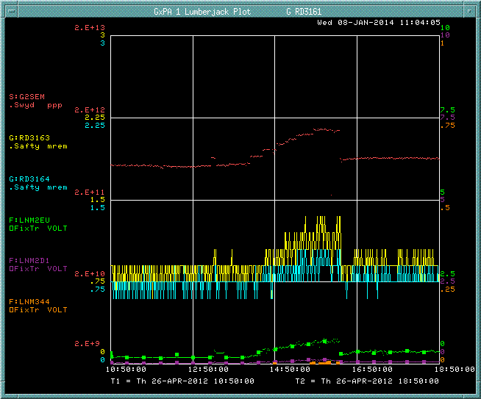
Figure 1 Neutrino Muon Beamline running in April 2012
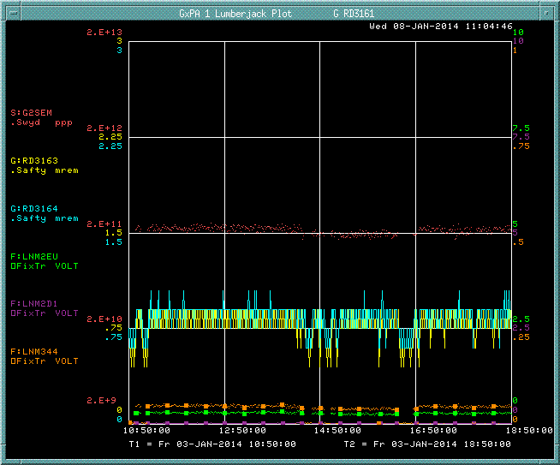
Figure 2 Neutrino Muon Beamline running in January 2013
Figure 2 is the same-scaled plot that shows that the chipmunks in the hall on the north roll up door and the west ledge have remained higher with intensities around 2.0E11 protons per pulse. Once again, the orange line at the bottom is the voltage read back of a loss monitor nearest to the four foot to four-inch flange (LNM344). The highest readback on a pulse of beam is 0.05 volts.
Both data samples during this time have the same configuration in regards to beamline components placed in the preceding enclosure. Such as the same Ion Chamber and SWICs towards the target area.
One difference is the installation of the NM3 Beam Cherenkov during the yearlong shutdown near the four foot to four inch flange seen in Figure 3. This Cherenkov provides the SeaQuest Experiment the splat block signal for their detector, an essential component for running at a high efficiency. SeaQuest requested that there are two prerequisites to install the Cherenkov. The first geographical constraint is that the location needs to be relatively close to the E906 target and detector apparatus. In addition, the ideal location must be easily accessible in case of component replacement. Therefore, this location was chosen.
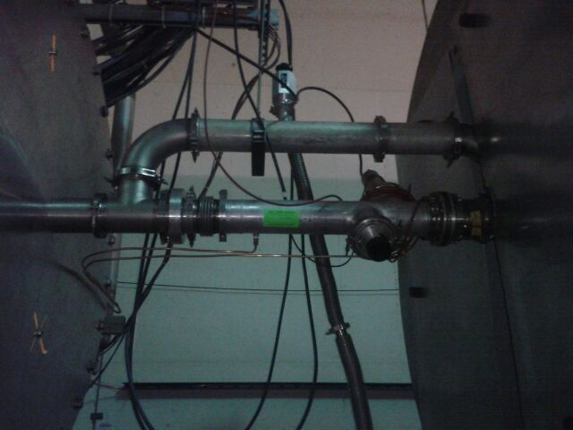
Figure 3 SeaQuest's Beam Cherenkov
Investigation
To investigate this prompt dose rate required two stages. The first stage is to begin by removing the Cherenkov out of the beamline. The removal happened on Jan 7th. AD Mechanical Support vented the NM3 beamline, removed all components of the Cherenkov and replace the area with a straight spool piece seen in Figure 4. Once completed the beamline pumped back down, and beam was delivered with varing intensities from 2.0E+11 to 6.0E+11 protons per pulse. Figure 5 shows the result of that test.
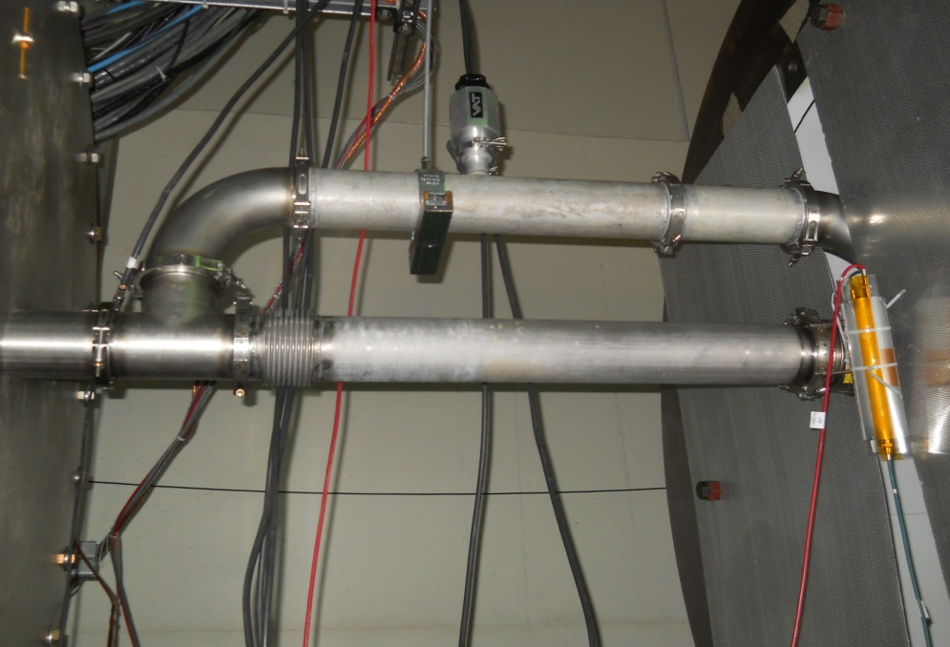
Figure 4 Spool piece installed
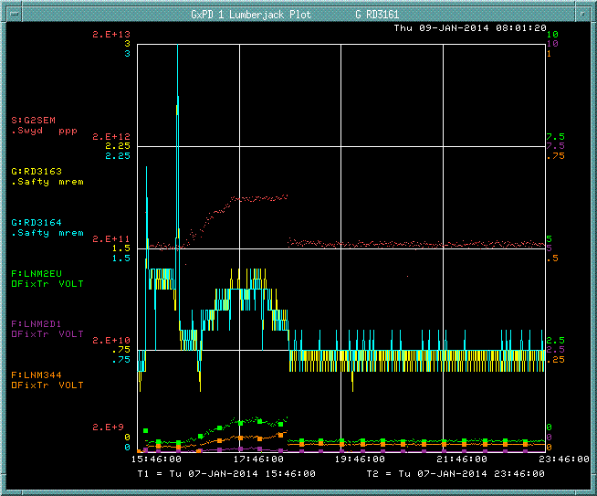
Figure 5 Plot of NM4 Chipmunk during beam with removed Cherenkov
Prior to running without the Cherenkov, the Main Injector department changed the tune of the slow extraction process towards Switchyard. Efforts were made prior to running to SeaQuest by retuning the slight position and angle changes made in switchayrd. Once beam was stable and consistant, beam was re-established to NM4. Shown in Figure 5 the most efficient running was towards the end of this run. Based on is run, the location of the Cherenkov is a contributor to the prompt dose in the NM4 Hall.
Solution
The next stage was to find a new location for the Cherenkov. In this stage we procured aluminum foil equal to the thickness of the Cherenkov with respect to its interaction length. In this case the Cherenkov is 0.228% of an interaction length while 33 mills of aluminum is close to its equivalent at 0.211%. Calculations are shown in Table 1.
Towards the downtream end of NM3 is the Air SWIC and Ion Chamber that reports position of the beam, and intensity delivered. With additional air gaps between the instruments this will be our test location for the foil.

Beam Cherenkov versus Aluminum Foil |  | Argon | CO2 | Ti | Ti | Paper | Mylar | Total | Al
density (g cm-3) | ρ | 1.66E-03 | 1.84E-03 | 4.54 | 4.54 | 1.42 | 1.4 |  | 2.7
thickness (inches) | l | 24.3 | 6.075 | 0.003 | 0.003 | 0.01 | 0.003 |  | 0.033
thickness (cm) | l | 61.722 | 15.430 | 0.008 | 0.008 | 0.025 | 0.008 |  | 0.091
Nuclear interaction length (gm cm⁻²) | λ_{I} | 119.7 | 88.9 | 126.2 | 126.2 | 84.4 | 84.9 |  | 107.2
Interaction Lengths = Thickness/(λ_{I}/ρ) |  | 0.086% | 0.032% | 0.027% | 0.027% | 0.043% | 0.013% | 0.228% | 0.211%
Table 1 Interaction lengths between Cherenkov and Aluminum foil
Accelerator Division Mechanical Support group contructed a frame and placed the calibrated foil between the downstream SWIC and Ion Chamber near the Helium bag, and delivered beam through the intensity range as mentioned earlier. Figure 6 is the constructed foil frame and Figure 7 is the resulting plot.
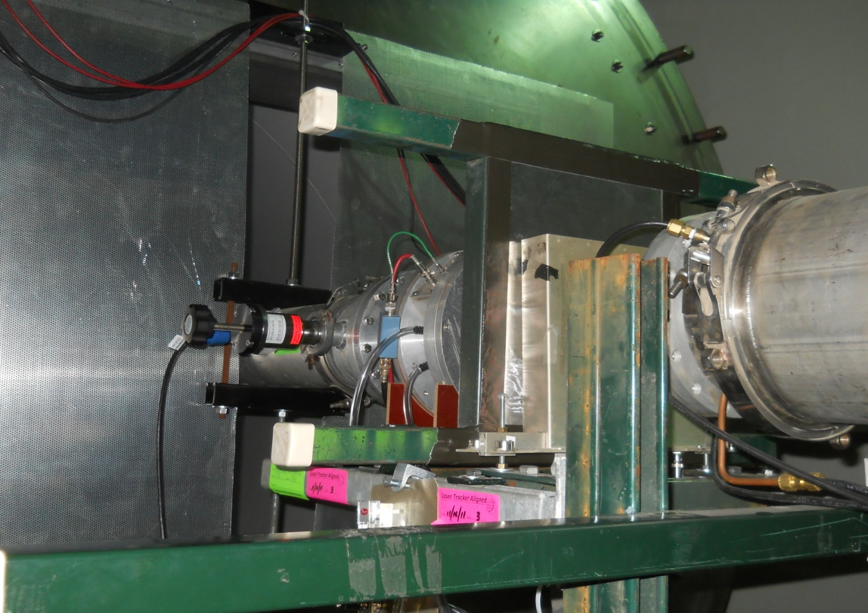
Figure 6 Foil Frame inserted in Instrumentation package
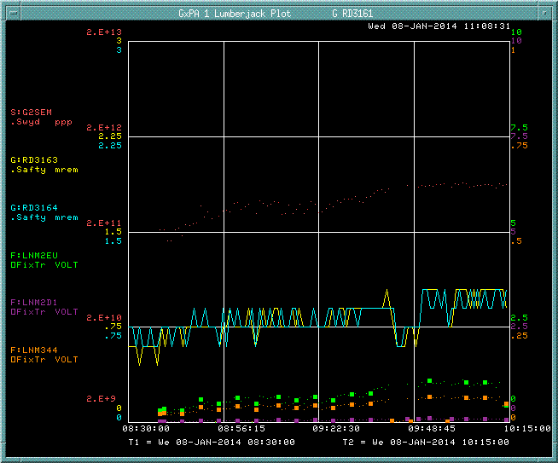
Figure 7 Plot of NM4 Chipmunk during beam with insert Foil
Analysis
There were four configurations of the beamline to compare against each other. One intensity scan run in April of 2012, and three runs in January of 2013. Of the three in January one was with the Cherenov installed, one with the spool piece installed, and the last was with the calibrated foil installed. In Figure 8 you can see the trends of all radiation rates (mrem/proton) and prompt dose rates (mrem/hr) compared to each other.
Unfortunately there were some small differences beyond the preceding enclosure that are differing from the 2012 and 2013 configurations. During the year-long shutdown two additional quadrupole magnets were installed, and the SWIC in the NM1 enclosure was fixed in its “in “ positioned. However for the three configurations in January 2013 these two factors remained controlled.

Figure 8 Prompt Dose rate vs. Intensity

Figure 9 Prompt Dose rate vs. Intensity

Figure 10 Prompt Dose vs. Intensity

Figure 11 Prompt Dose vs. Intensity
The NM4 chipmunks showed little change from when beam was delivered with no Cherenkov versus the calibrated foil. The chipmunks RD3163 and RD3164 prompt dose rates per proton were varying as high as 6.0% when intensities were varing by 2.2%.
G2SEM protons per pulse
Spool piece installed | Foil Installed | Spool / Foil
2.09E+11 | 2.07E+11 | 100.61%
2.31E+11 | 2.26E+11 | 102.15%
5.54E+11 | 5.50E+11 | 100.65%
6.17E+11 | 6.24E+11 | 98.91%
RD3163 Prompt Dose Rate
1.87E-10 | 1.99E-10 | 93.98%
1.98E-10 | 2.04E-10 | 97.28%
9.91E-11 | 1.03E-10 | 96.20%
9.92E-11 | 9.81E-11 | 101.10%
RD3164 Prompt Dose Rate
1.95E-10 | 2.07E-10 | 94.13%
2.11E-10 | 2.13E-10 | 99.40%
9.75E-11 | 1.01E-10 | 96.15%
9.48E-11 | 9.23E-11 | 102.68%
Table 2 Varying Dose rates from varying Intensities
Recommendation
From these results, there is no significant difference in prompt dose rates on the two chipmunks RD3163 and RD3164 when the Cherenkov is removed from the beamline and when the calibrated foil was inserted into the NM3 instrumentation package. Higher intensities will still result in higher prompt dose, however the relocation of the Cherenkov will initially reduce prompt dose rates at current operating intensities. Fabrication of a new Cherenkov should be considered with materials in Table 3 and as shown in Figure 12.
New Beam Cherenkov with paper and Al-Mylar window |  | Argon | CO2 | Ti | Ti | Paper | Mylar | Total
density (g cm-3) | ρ | 1.66E-03 | 1.84E-03 | 4.54 | 4.54 | 1.42 | 1.4
thickness (inches) | l | 9.6 | 2.4 | 0.01 | 0.003 | 0.005 | 0.003
thickness (cm) | l | 24.384 | 6.096 | 0.0254 | 0.00762 | 0.0127 | 0.00762
Nuclear interaction length (gm cm⁻²) | λ_{I} | 119.7 | 88.9 | 126.2 | 126.2 | 84.4 | 84.9
Interaction Lengths = Thickness/(λ_{I}/ρ) |  | 0.034% | 0.013% | 0.091% | 0.027% | 0.021% | 0.013% | 0.199%
Table 3 New Cherenkov Interaction length calculation
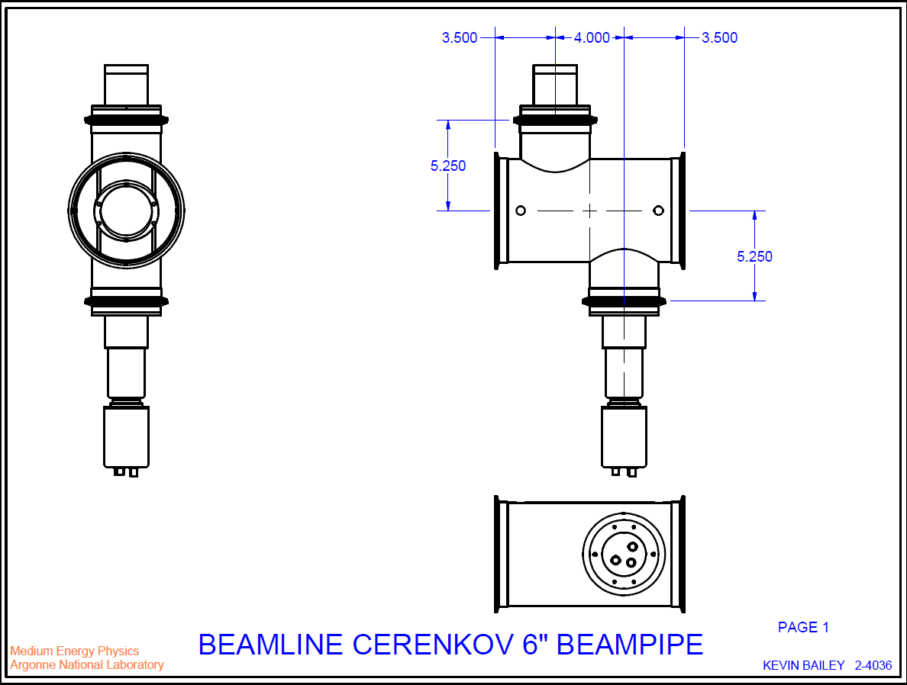
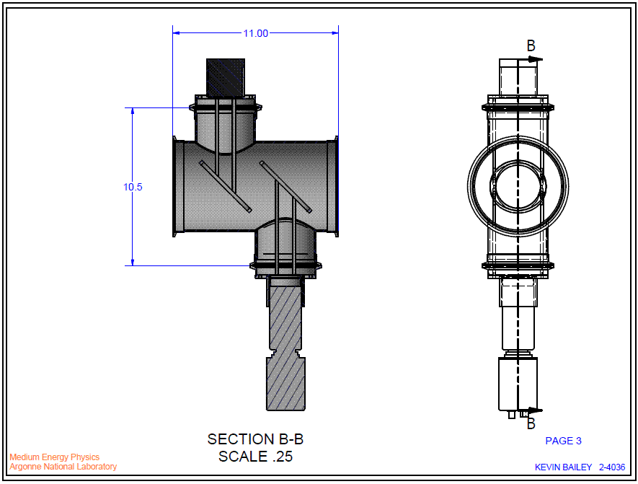
Figure 12 New Beam Cherenkov design
New Cherenkov Installed
On January 29th, AD Mechanical Support was able to remove the old Cherenkov from its location and install the new Cherenkov, shown in Figure 12, in the recommended location. A high intensity run was performed for the experiemnt as shown in Figure 13. Intensity ranged from 2.0E+11 to 2.0E+12 protons per pulse.
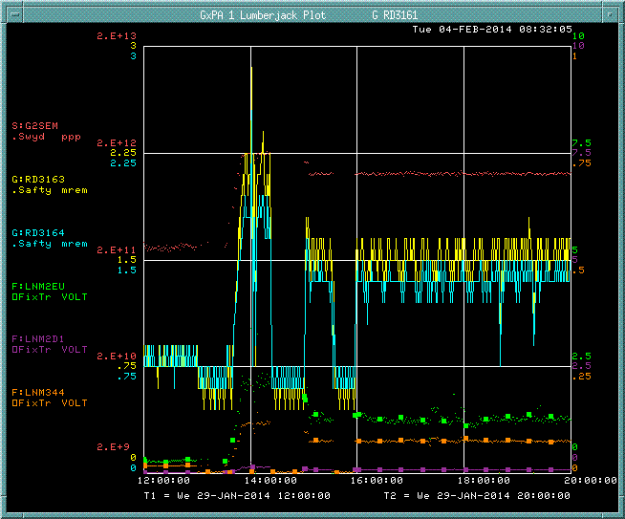
Figure 13 High Intensity run with New Cherenkov in new position
New Cherenkov Analysis
The results were as expected from the calibrated foil run, as seen in Figures 14 through 17. Currently the only large difference between current running and 2012 running is the NM1 Box SWIC locked in its in position due to a bad pivot pin. AD Instrumentation, PPD AMG, and Mechanical Support are working on building a new SWIC for this location.

Figure 14 Prompt Dose rate vs. Intensity

Figure 15 Prompt Dose rate vs. Intensity

Figure 16 Prompt Dose vs. Intensity

Figure 17 Prompt Dose vs. Intensity

