Measurements of Static Magnetic Properties of AL-800 Material

To correctly evaluate losses in a tunable RF cavity, one must have static magnetization curve of YIG material. This note describes a setup for measurement of the static magnetization and results of attempts to synthesize a magnetic saturation curve that would fit the data obtained by the measurements.

AL-800 material sample is placed inside existing solenoid designed by V. Kashikhin and A. Makarov for RF tuners at AD. A sketch of the setup is shown in Fig. 1.

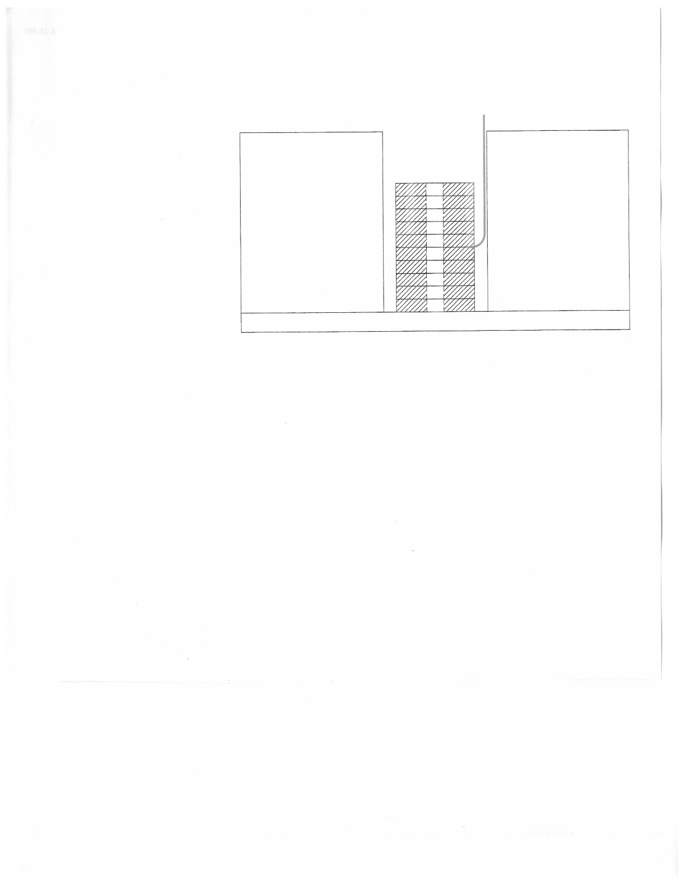

Fig. 1. Setup concept for measurements of static magnetization.

Main dimensions and other parameters of the solenoid are as following: the length of the coil is 177.8 mm, inner diameter is 100.0 mm, and the outer diameter is 305.0 mm. The number of turns in the coil **N = 112**. The magnet was designed with the flux return built using CDM-10 ferrite, but at least part of the flux return used G4 material instead; the difference in the materials does not play significant role though. The inner diameter of the flux return is 320 mm, thickness is 20 mm, and the diameter of the hole in the top plate is 105 mm.

Magnetic properties of the CDM-10 ferrite are shown in the table below and illustrated by corresponding figure. The material was formulated to have higher permeability at higher field.

|  |  |
| --- | --- |
| B (G) | mu |
| 10 | 550 |
| 20 | 570 |
| 100 | 650 |
| 300 | 950 |
| 1000 | 1750 |
| 2000 | 2500 |
| 2700 | 2950 |
| 3000 | 2980 |
| 3300 | 2950 |
| 4000 | 1800 |
| 5000 | 200 |
| 6000 | 20 |
| 10000 | 1.75 |

Fig. 2. Magnetic properties of CMD-10 material

The material sample is assembled of ten discs made of AL-800 material and placed symmetrically inside the solenoid. The geometry of the sample is shown in Fig. 3.

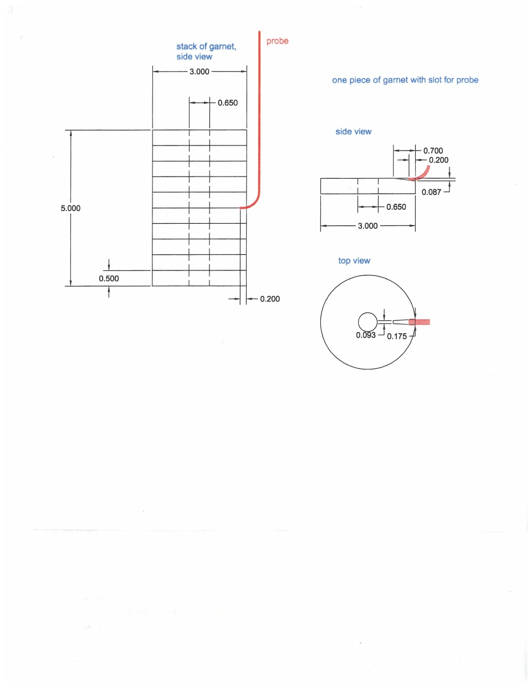

Fig. 3. Geometry of the material sample.

Main dimensions of the material sample are as follows:

Inner diameter is 16.51 mm, outer diameter is 76.2 mm, thickness of one disc is 12.7 mm.

Saturation magnetization of the YIG material Ms = 63662[A/m] (800 Oe).

Static magnetization curve of the sample material is found using iterative process, so initial assumption is used to start the iterations. For example, this “zero iteration” function can look like shown in Fig. 4.

B(T) mu_static

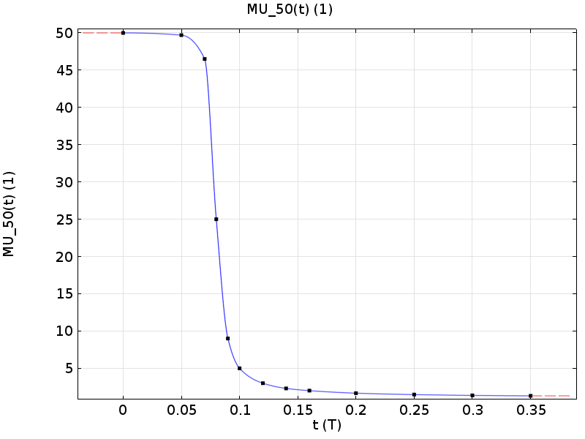

0 50

0.05 49.7

0.07 46.5

0.08 25

0.09 9

0.1 5

0.12 3

0.14 2.3

0.16 2

0.2 1.66

0.25 1.47

0.3 1.36

0.35 1.3

Fig. 4. Assumed zero-iteration magnetic properties of the AL-800 material

This curve was obtained by using maximum initial permeability (B = 0) of ~50 (found in publications) and using a theoretical RF permeability for B > 800 G. Between zero and 800 G, the curve is essentially imagined. The goal of the measurements is to get a curve closer to reality by gradually changing the assumed magnetization curve.

Three magnetometers were available for the measurement; they were cross-calibrated in the magnet in the current range from 0 to 80 A. Three Hall probes were installed: in the center of the solenoid, between the rings #1 and #2, and between the rings #9 and #10. Readings of the probes were taken at several current levels. Results of the measurements were compared with modeling using iterative approach: the magnetization curve was gradually changed starting with low current. At each current level the changes were made until the modeling result properly reflect the measurement data.

Three attempts of extracting the magnetization curve out of data obtained by measurements were made. During the first attempt (end of January 2015), the readings of the AphaLab magnetometer (calibrated by the vendor on January 26) were used as the reference; readings of other two magnetometers were adjusted correspondingly by using cross-calibration. This resulted in some correction for the number of turns in the coil: 110 instead of 112. This correction was not welcomed by the designer of the magnet though as he claimed that the number of turns is 112 or even a bit higher (112.5).

Next, an attempt to calibrate the magnetometers was made using existing (in IB-1) magnet. As a base for the calibration a Hall probe magnetometer was used that was considered sufficiently precise. The data obtained during the first measurement session was recalculated – it resulted in the increase of the number of turns to 113, which was a good sign. Nevertheless, the attempt to find the sample material magnetization curve was not tremendously successful as the attempts to fit high current data led to deterioration of the fit for the low current area. So, the process did not converge as desired.

At this point it was decided to repeat the measurements using a better quality set of the rings, assuming N = 112, and using our magnetic system as a calibration stand. Readings of the three magnetometers were adjusted based on calculated values of the field at the location of the probes. This calibration resulted in the following correction factors for the used magnetometers

(k = reading/modeling):

For the Cryomagnetics meter k1 = 1.075;

For the AlphaLab magnetometer k2 = 1.016;

For the DELL magnetometer k3 = 0.94.

After applying the coefficients, comparison of the readings and the modeling at several currents is shown in Fig. 5. Corresponding set of data is shown below.

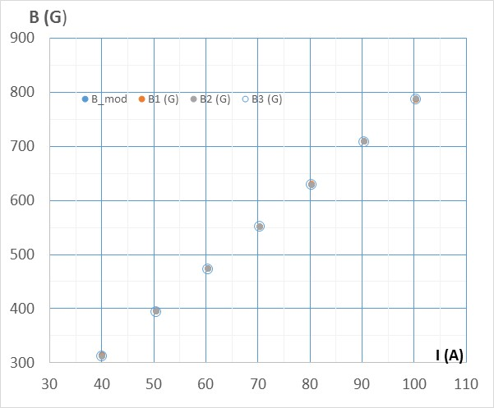 

Fig. 5. Reading of the probes after application of the correction coefficients.

During the measurement, the sample was installed in two positions:

**Position 1**: data with the probes installed as flowing:

Cryomagnetics magnetometer at the bottom;

AlphaLab magnetometer in the middle;

DELL magnetometer at the top.

**Position 2**: data with the probes installed as following

Cryomagnetics magnetometer at the top;

AlphaLab magnetometer in the middle;

DELL magnetometer at the bottom.

Data collected in the two positions is shown below:

 

1. b)

Fig. 6. Readings of the probes during the current scan: a) position 1; b) position 2.

As in the two positions the probes of different magnetometers exchange their locations, after application of the correction factors, the adjusted readings for the same location must coincide. This is reflected by the two tables below:

 

The difference in the corrected readings is less than 1% for all the probes.

Averaged values will be used for further work. It is illustrated by a graph and a table below:

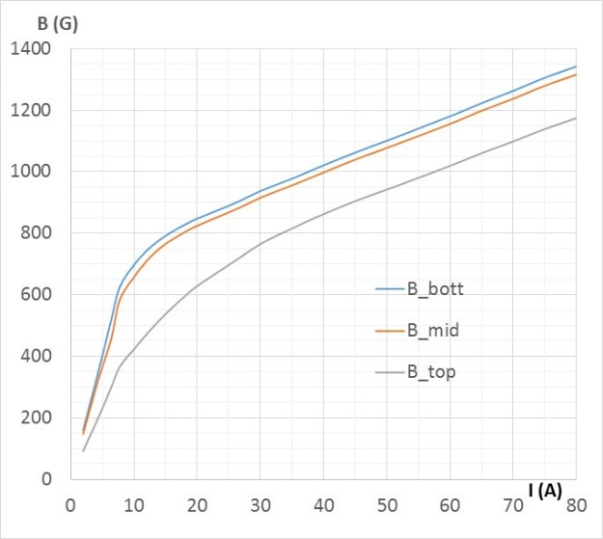 

Fig. 7. Readings of the probes at the bottom, in the middle and at the top of the sample.

Modeling shows that at small current (up to I ≈ 5 A) permeability is constant everywhere (50 for the “zero” iteration (see Fig. 8), so we can use a constant value to check how it fits to the results. Measuring the field in the gap at low current and choosing the value of mu in the model that gives the same field value allows obtaining the value of initial permeability µinit.

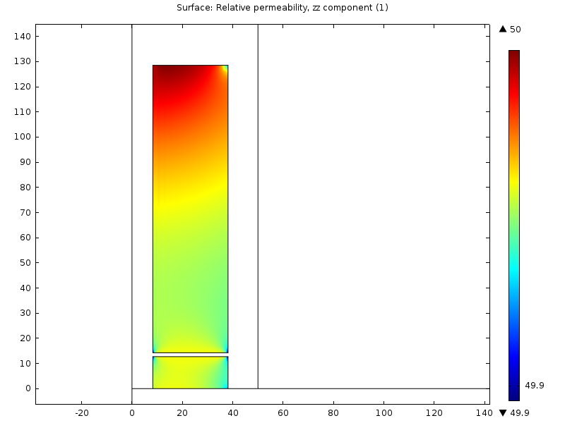

Fig. 8. Permeability of the sample at low current

The presence of the gaps makes significant impact on the field distribution. Figure below compares the field at the same current (2.5 A) along the line R = 23 mm without any gaps and with three gaps. The gaps were carefully measured and 1.37 mm gap width was accepted during this modeling session.

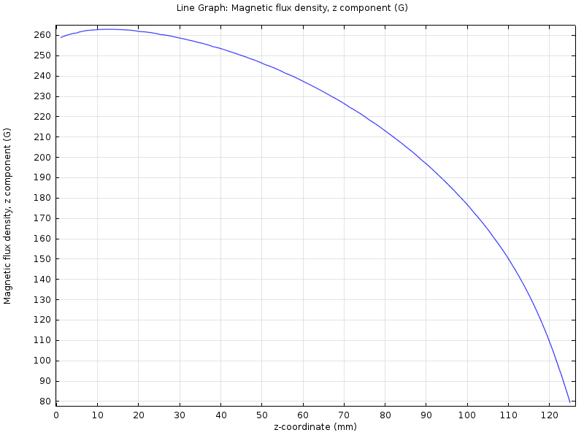 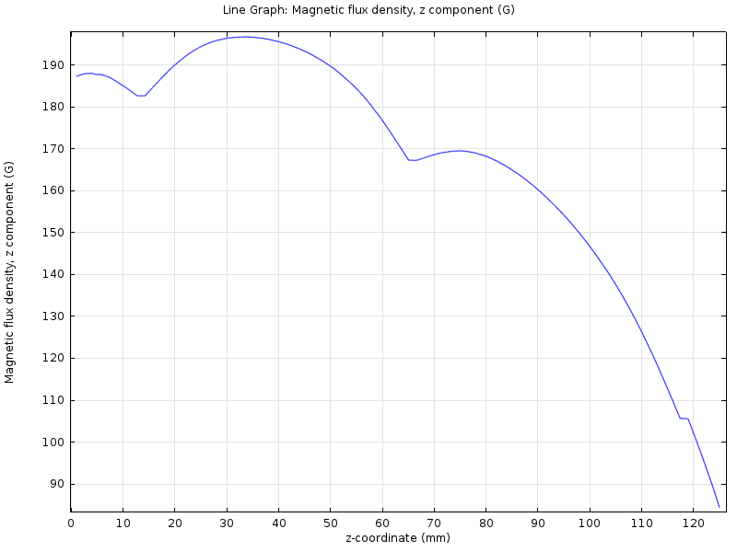

Fig. 9. The impact of the gaps in the sample.

After a number of iterations of the fitting process a permeability curve was found (Figures 10 and 11) that satisfactory fits all the measurement data. Corresponding data tables are also shown below.

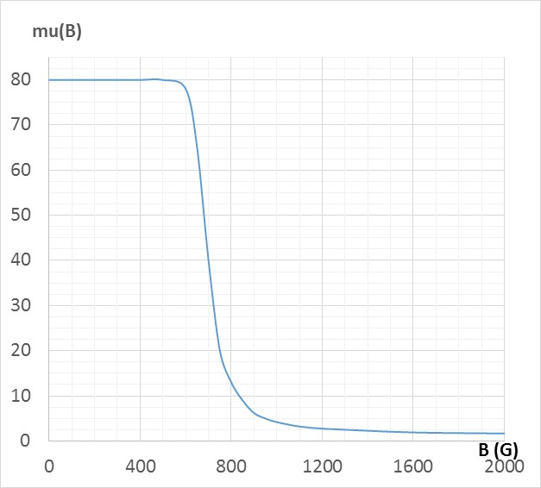 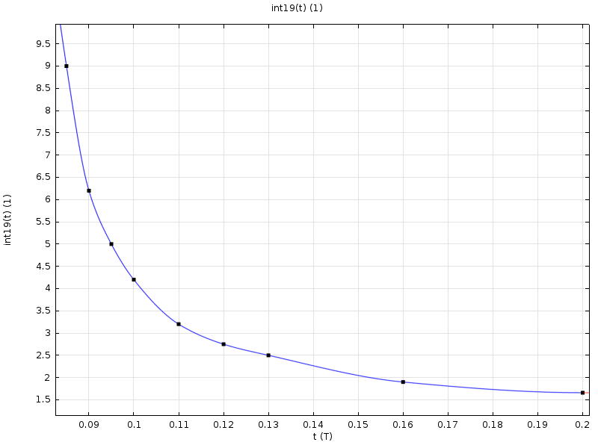

Fig. 10. Magnetization curve in the form µ(B)



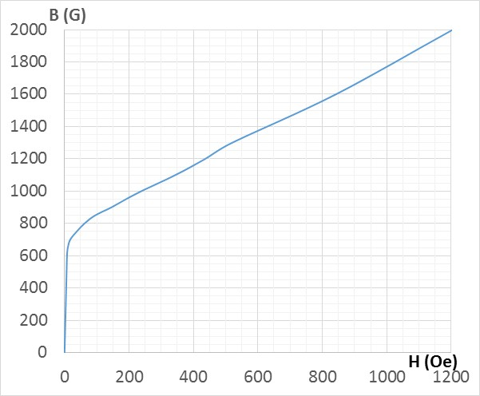 

Fig. 11. Magnetization curve in the form B(H)

A table that compares the measured and the modeled values of the Hall probe readings is shown below.

|  |  |  |  |  |  |  |
| --- | --- | --- | --- | --- | --- | --- |
| I (A) | bott_model | bott_meas | mid_model | mid_meas | top_model | top_meas |
| 4.41 | 363.3 | 353.2 | 330.6 | 326.7 | 206.6 | 202.5 |
| 7.76 | 628.8 | 625.8 | 572.4 | 583.7 | 358.4 | 365.9 |
| 10.07 | 705.2 | 698.4 | 663.2 | 659.1 | 428.4 | 424.5 |
| 12.22 | 746.1 | 747.3 | 714.4 | 714.6 | 480 | 476.6 |
| 16.13 | 807.5 | 806.0 | 782 | 780.6 | 563.3 | 559.7 |
| 19.88 | 846.1 | 846.4 | 826.2 | 823.48 | 626.8 | 626.6 |
| 30.25 | 935.5 | 939.5 | 918.5 | 917.5 | 759.5 | 768 |
| 40.07 | 1016.5 | 1021.66 | 1001.1 | 998.3 | 850 | 863 |
| 50.69 | 1096.6 | 1106.1 | 1081 | 1082.7 | 931.5 | 947.3 |
| 60.81 | 1182.5 | 1187.1 | 1164.5 | 1162.4 | 1007 | 1025.8 |
| 80.39 | 1356.4 | 1345.5 | 1336.8 | 1319.1 | 1156 | 1177.4 |

This table is illustrated by the graph in Fig. 12.

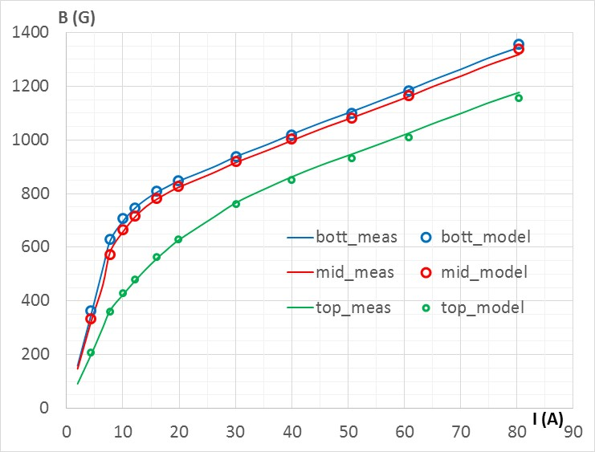

Fig. 12. Comparison of the data obtained by the measurements with that obtained by the modeling using the found magnetization curve.