Magnetic Field Measurements in the BnB 25 Meter Absorber
M. Backfish, R. Tayloe, R. Van De Water

Three sets of Magnetic Field Measurements were taken during the 25 Meter absorber SWIC Installation. These sets will be referred to as round 1 (taken Nov 22, 2014), round 2 (taken Nov 25, 2014), and round 3 (taken Dec 11, 2014). The magnetic field probe used was a Group3 model DTM-133 digital Teslameter, which is a 1 dimensional hall probe used with a 30 meter cable. The coordinate system used in this analysis is: beam direction or North is +Z, beam left or West is +X, and +Y is up. The first round of measurements was taken using a different method than rounds 2 and 3. The initial probe design was too thick to fit between the absorber steel thus experts carefully oriented the probe for these measurements with no protection for the chip. This initial run prompted changes to the design. The magnetic field probe configurations shown and described in Figure 1 were used for the remainder of the measurements. Measurements were made in orientation 1 with a straight tube. This allowed the measurement of magnetic field in the X direction (Bx) and magnetic field in the Z direction (Bz). Next a pipe bender was used to bend a 90 degree angle in the pipe to put it in orientation #2 for measuring magnetic field in the Y direction (By).
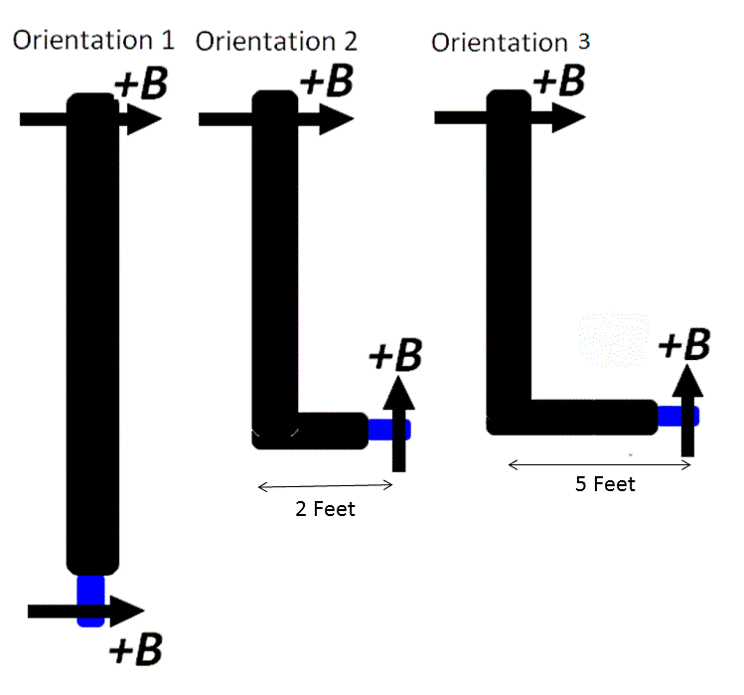

Figure 1 Shows orientations of the hall probe. The black represents the 7/16 inch stainless steel tubing used as a 20 foot long probe handle. The blue is the plastic tube of an ink pen that fit within the inner diameter of the stainless steel tubing and provided protection for the chip. The chip was stabilized with play dough. A wooden arrow was placed on the top of the tubing pointing in the direction of a positive magnetic field as measured through the chip in orientation 1.

ROUND 1
The first magnetic field data was taken Nov 22, 2014.
The data can be found at: https://iu.app.box.com/s/mpoqf2y027doxnayzyz4
Based on these measurements, the estimate of overall field direction/magnitude at the downstream end of the 25 meter absorber is:
(Bx,By,Bz)=(+2.5,-2.5,+1.5) Gauss [1]

ROUND 2
Orientation 1 was used to determine the 0 offsets. For example, in orientation 1 at a depth of 13 feet +1 Gauss was measured for +Z and 0 Gauss for –Z, the 180 degree opposite orientation. The zeroed probe value is obtained by subtracting an offset of .5 from each. The yellow shaded portions of the remaining tables use this method to account for the probe offset.
Table 1 data using orientation 1, as shown in Figure 1, for the downstream SWIC. Non shaded data is as read from the probe while the shaded region corrects for a zero offset using a measurement and the same measurement 180 degrees rotated. Depth is below the top surface of the steel absorbers.
Direction Of Pointer | Depth 13 ft | Depth 13 ft after correcting for Offset
+Z | +1 | +.5
-X | +1 | +.5
-Z | 0 | -.5
+X | 0 | -.5

Table 2 data using orientation 2, as shown in Figure 1, for the downstream SWIC. Non shaded data is as read from probe while the shaded region corrects for the offset using data from Table 1. Depth is below the top surface of the steel absorbers. Note orientation 2 has a 2 foot extension at 90 degrees.
Direction Of Pointer | Depth 13 ft | Depth 14 ft | Depth 13 ft after Correction | Depth 14 ft after Correction
+Z | -1 | -1.5 | -1.5 | -2.0
-X | -1 | -1.5 | -1.5 | -2.0
-Z | -1 | -1.5 | -1.5 | -2.0

ROUND 3
  - Orientation 2
At the start of round 3 the magnetic field sensing chip was removed from its protective cover and placed in a zero gauss magnetic shield in order to zero out the hall probe. This is the method used for removing the offset from 0 in Tables 3 and 4.

Table 3 uses orientation 2 (Figure 1) at the downstream SWIC position. Note orientation 2 can only measure the magnetic field in the Y axis. A positive value in this table means the magnetic field is pointing straight up while a negative value means the field is pointing straight down.
Direction of Pointer | Depth  2 ft | Depth  4 ft | Depth  6 ft | Depth 8 ft | Depth 10 ft | Depth 11 ft | Depth 12 ft | Depth 13 ft | Depth 14 ft | Depth 15 ft
+Z (cent) |  |  |  |  | -2.5 | -2.5 | -2.5 | -2.0 | -1.5 | -1.5
-X (BL) | 0 | -3.5 | -1 | 1 | -1 | -1.5 | -1.5 | -1.5 | -1.5 | -1.5
-Z (cent) |  |  |  |  | -2.5 | -2.5 | -2.5 | -2.5 | -2.5 | -2.5
+X

Table 4 uses orientation 2 (Figure 1) for the upstream SWIC position. Note orientation 2 can only measure the magnetic field in the Y axis. A positive value in this table means the magnetic field is pointing straight up while a negative value means the field is pointing straight down.
Direction of Pointer | Depth  2 ft | Depth  4 ft | Depth  6 ft | Depth 8 ft | Depth 10 ft | Depth 11 ft | Depth 12 ft | Depth 13 ft | Depth 14 ft | Depth 15 ft
+Z (cent) |  |  |  |  | -2.5 | -2.5 | -2.5 | -2.5 | -2.5 | -2.5
-X (BL) | -1.5 | 0 | 0 | -1.5 | -2.5 | -2.5 | -2.5 | -2.5 | -2.5 | -2.5
-Z (cent) |  |  |  |  | -2.5 | -2.5 | -2.5 | -2.5 | -2.5 | -2.5
+X

  - Orientation 1
To get from orientation 2 back to orientation 1 (see Figure 1) experts had to straighten the 7/16 inch tubing. In orientation 1 the offset from 0 can be determined by measuring the field in an orientation and then rotating the probe 180 degrees to measure what should be the negative of that same field. This was the method used for zeroing the probe in this section.
Table 5 uses Orientation 1 (Figure 1) with the upstream SWIC.
Direction of Pointer | Depth  2 ft | Depth  4 ft | Depth  6 ft | Depth 8 ft | Depth 10 ft | Depth 11 ft | Depth 12 ft | Depth 13 ft | Depth 14 ft | Depth 15 ft
+Z | 0 | 0 | -1.5 | -1 | -1 | -1.5 | -1.5 | -1.5 | -1.5 | -1.5
-X |  |  |  |  | -1.5 | -1.5 | -1.5 | -1.5 | -1.5 | -1.5
-Z |  |  |  |  | -2.5 | -2.5 | -2.5 | -2.5 | -2.5 | -2.5
+X |  |  |  |  | -2.5 | -2.5 | -2.5 | -2.5 | -2.5 | -2.5
Corrected
+Z |  |  |  |  | 1 | .5 | .5 | .5 | .5 | .5
-X |  |  |  |  | .5 | .5 | .5 | .5 | .5 | .5
-Z |  |  |  |  | -.5 | -.5 | -.5 | -.5 | -.5 | -.5
+X |  |  |  |  | -.5 | -.5 | -.5 | -.5 | -.5 | -.5

Table 6 uses orientation 1 (Figure 1) for the Downstream SWIC.
Direction of Pointer | Depth  2 ft | Depth  4 ft | Depth  6 ft | Depth 8 ft | Depth 10 ft | Depth 11 ft | Depth 12 ft | Depth 13 ft | Depth 14 ft | Depth 15 ft
+Z |  |  |  |  | -1.5 | -1.5 | -1.5 | -1.5 | -1.5 | -1.5
-X | -1.5 | 1 | -1.0 | -1.5 | -1.5 | -1.5 | -1.5 | -1.5 | -1.5 | -1.5
-Z |  |  |  |  | -2.5 | -2.5 | -2.0 | -1.5 | -1.5 | -1.5
+X |  |  |  |  | -2.5 | -1.5 | -1.5 | -1.5 | -1.5 | -1.5
Corrected
+Z |  |  |  |  | .5 | .25 | .125 | 0 | 0 | .5
-X |  |  |  |  | .5 | .25 | .125 | 0 | 0 | .5
-Z |  |  |  |  | -.5 | -.75 | -.375 | 0 | 0 | -.5
+X |  |  |  |  | -.5 | .25 | .125 | 0 | 0 | -.5

  - Orientation 3
For orientation 3, shown in Figure 1, the 7/16 inch tubing had to once again be bent 90 degrees to allow for measurement of the Y axis. This orientation allowed a 5 foot transverse extension. The system was difficult to manage. Mechanical experts were not able to insert the probe in the downstream SWIC position due to spatial restrictions. After some manipulation the probe was inserted in the upstream position. The process of inserting the probe resulted in a broken plastic pen used to protect the chip. The fact that the chip was exposed to more forces just to get it into position likely changed the zero of the probe itself. With this in mind larger errors should be associated with these measurements. The measurements in this orientation are consistent with the rest of the measurements thus the field gradient is likely small in the vicinity of the upstream SWIC.
Table 7 uses orientation 3 (Figure 1 ) in the position of the upstream SWIC. The tubing was re-bent to achieve a 5 foot extension. The extension was pointed in the –Z direction.
Direction of Pointer | Depth  2 ft | Depth  4 ft | Depth  6 ft | Depth 8 ft | Depth 10 ft | Depth 11 ft | Depth 12 ft | Depth 13 ft | Depth 14 ft | Depth 15 ft
+Z
-X |  |  |  |  | -2.5 | -2.5 | -2.5 | -2.5 | -2.5 | -2.5
-Z

Results and Error
There are three sources of systematic errors which are listed in the user’s manual for the Group 3 DTM-133 Digital Teslameter: probe accuracy, temperature influence on calibration and temperature influence on the zero offset. The probe accuracy is +-.9% and the error due to temperature fluctuations is small in comparison to this. The error due to zero drift is listed as .18 Gauss per degree C. This error can be accounted for by measuring the same field in the 180 degree orientation. The vectors should read as the same magnitude with opposite sign. The offset between equal magnitudes determines the zero drift thus alleviating this source of error. Total systematic error for the measurement system is then on the order of .9 Gauss. The total error is found using statistical methods of error determination combined with the .9 Gauss systematic error. The results are listed below.

Center of the Decay Pipe Upstream SWIC Position

Note: the Total Field Value below adds all three axes in quadrature to achieve the Random error contribution. The Optimistic Y Axis Dominated error is calculated using just the Y axis error because the field contribution from the other two axes is small.
Axis | Field (G) | Random Error (+/- G) | Systematic Error (+/- G)
Bx | -0.5 | 0.3 | 0.9
By | -2.5 | 0.3 | 0.9
Bz | +0.5 | 0.3 | 0.9
Total Field  Y Axis Dominated | 2.6 +/- 1.6 (G)  2.6 +/- 1.0 (G)

Center of the Decay Pipe Downstream SWIC Position
Axis | Field (G) | Random Error (+/- G) | Systematic Error (+/- G)
Bx | +1.3 | 0.9 | 0.9
By | -2.0 | 0.4 | 0.9
Bz | +0.8 | 0.5 | 0.9
Total Field  Y Axis Dominated | 2.5 +/- 1.9 (G)  2.5 +/- 1.4 (G)

Conclusion
Any magnetic field in the BnB decay pipe will steer the Proton beam according to the total integrated magnetic field. The total field in the upstream position was measured as 2.6 Guass +/- 1.6 Gauss and the downstream measured 2.5 Gauss +/- 1.9 Gauss.
The "Y Axis Dominated" value assumes the systematic error is dominated by the y-axis measurement, since the y-axis measurement dominates the total B-field measurement. This better addresses the question of whether or not there is a magnetic field in the beam pipe. Averaging the upstream and downstream measurements gives 2.6 +/- 1.2 G. Thus at the approximated three sigma level, there is a weak magnetic field in the decay pipe. To thoroughly understand the implications, a field map of the entire decay pipe is needed.

Bibliography
[1] R. Tayloe (personal communication November 23, 2014)
[2] “Group 3 DTM-133 Digial Teslameter with Serial Communications User’s Manual” Group 3 Technology Ltd. Avondale New Zealand

