Cogging Test Switch Module

Plus BDOT Interval Time Measurement

Craig Drennan

June 23, 2016

The Cogging Test Switch Module currently has two functions. The first is used for testing an alternate Cogging controller during Booster operation. The module supports switching between Primary and Alternate sets of 4 digital output signals and a Primary and Alternate analog signal (+/- 5 Volts). This first function is active when a 50 Ohm terminator is installed at input SW2.
When a Booster event trigger pulse is seen at the “Alternate I/O Select” input of the module (SW1), the 4 alternate digital signals and the alternate analog signal are switched onto the outputs of the module for 40 milli-seconds. Otherwise, the primary 4 digital signals and the primary analog signal appear at the outputs. Figure 1 indicates the connections on the front and rear of the module.
The module is a modified Dual Phase Detector Module Version 2 (phasedet2). Figures 2 to 5 show the circuit modifications. Beams-doc-3922-v2 can be referred to for the other details of the module.
The analog signals through the module can be calibrated with gain and offset adjustment set using the USB – PC interface (DLP). A screenshot of this interface is shown in Figure 6.
The second function is to provide an analog output that represents the deviation from the nominal time interval between the BDOT trigger pulses from the GMPS system. This function is active when the SW2 input is left open or set to a logic High voltage ( >2.8 V ). The input SW2 is pulled High internally for convenience. This second function only requires a BDOT trigger pulse on input T4. The analog output can be monitored on the rear of the module at AOUT 1.
The BDOT interval measurement is made by counting the number of 10 MHz clocks that occur between BDOT pulses. This count is subtracted from the nominal count (666,666) and the difference is scale by 32 times and output onto a 16 bit +/- 10V DAC.
The FPGA logic that controls these functions is shown in Figure 7 and Listing 1.
“A pictures worth a thousand words”, Arthur Brisbane.

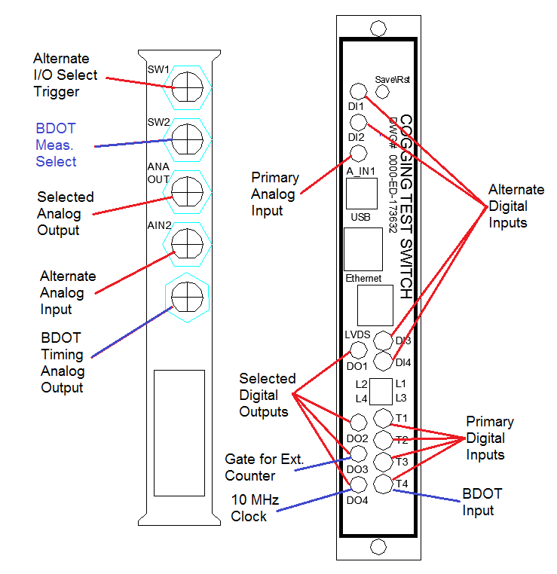
Figure 1.

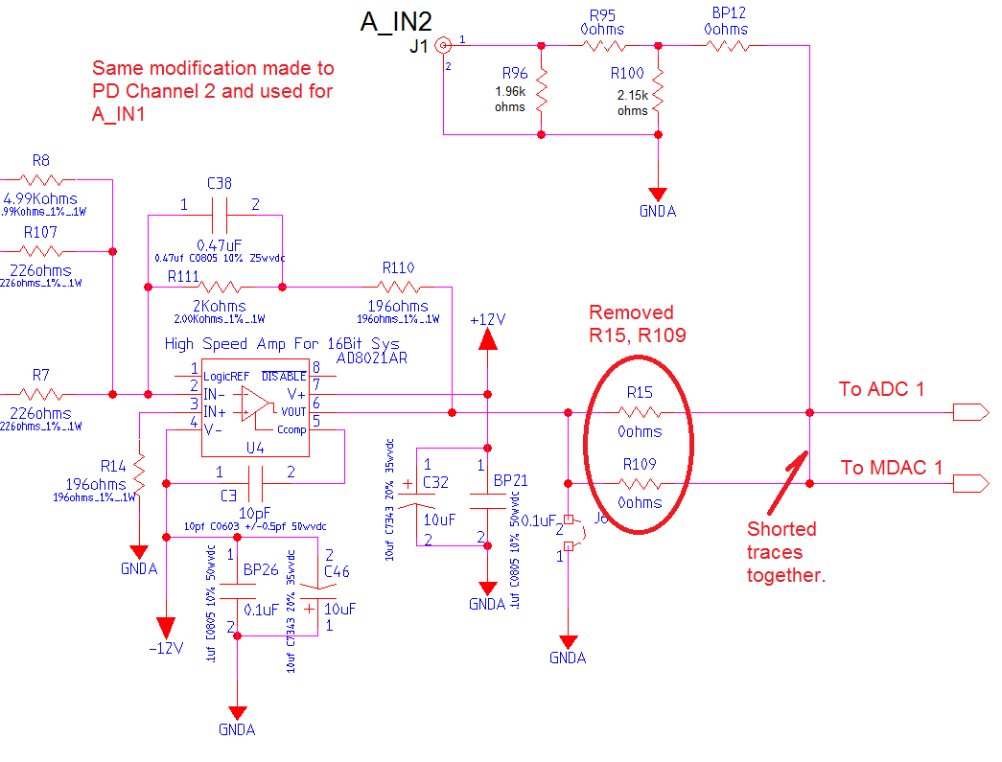
Figure 2

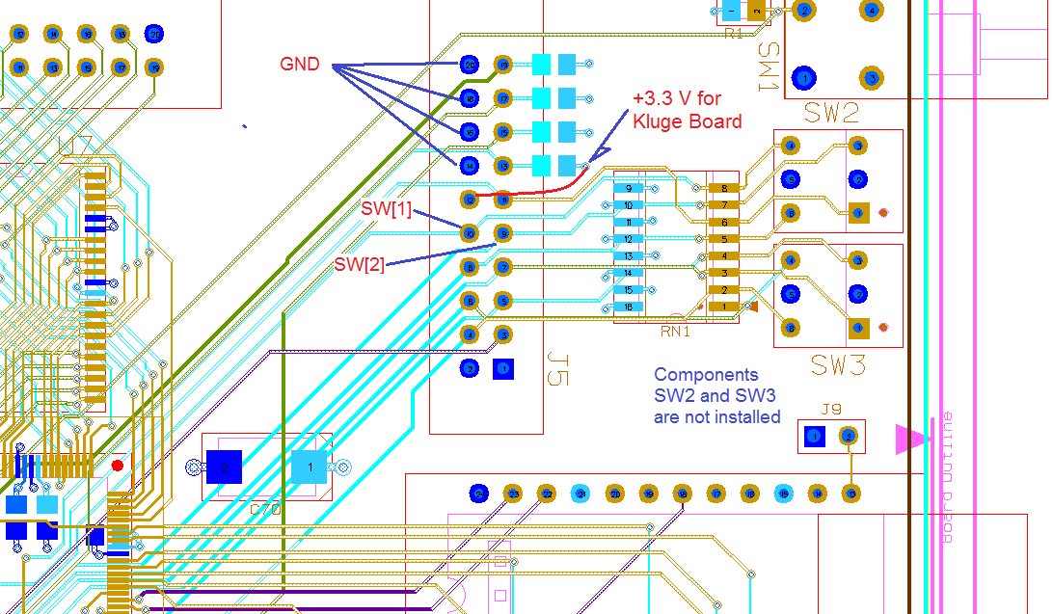
Figure 3

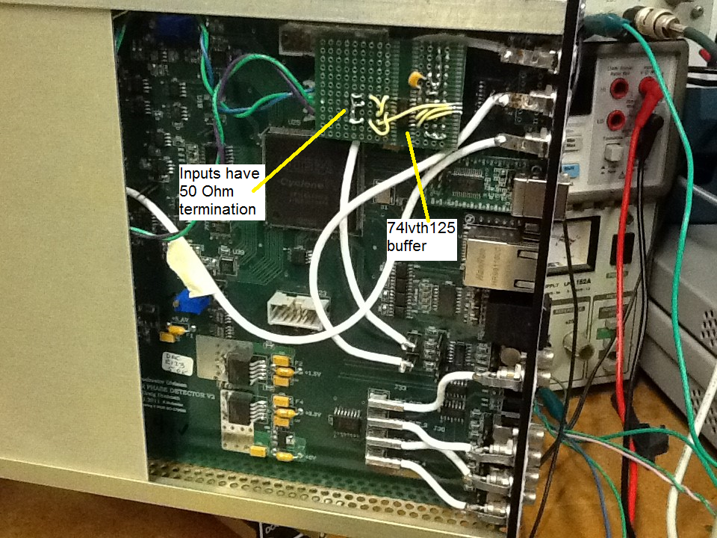
Figure 4
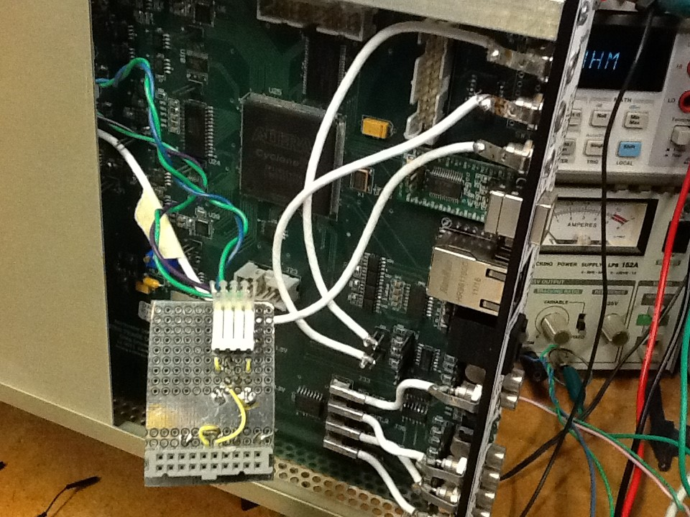
Figure 5
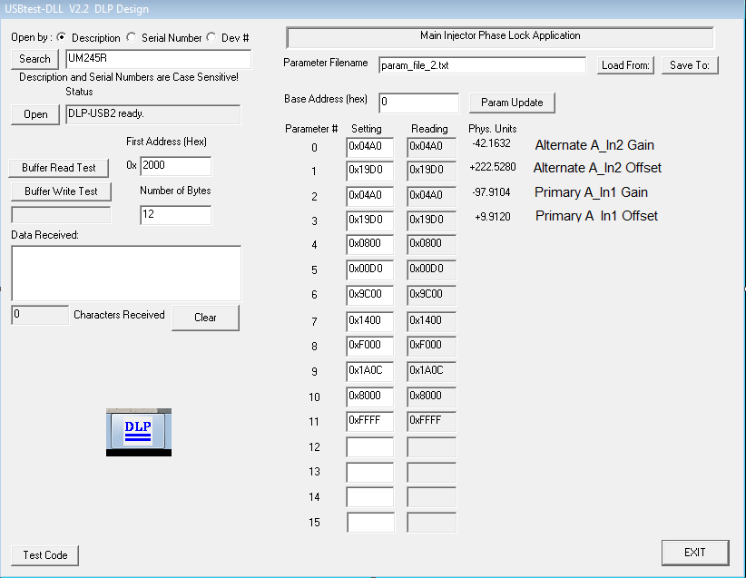
Figure 6.
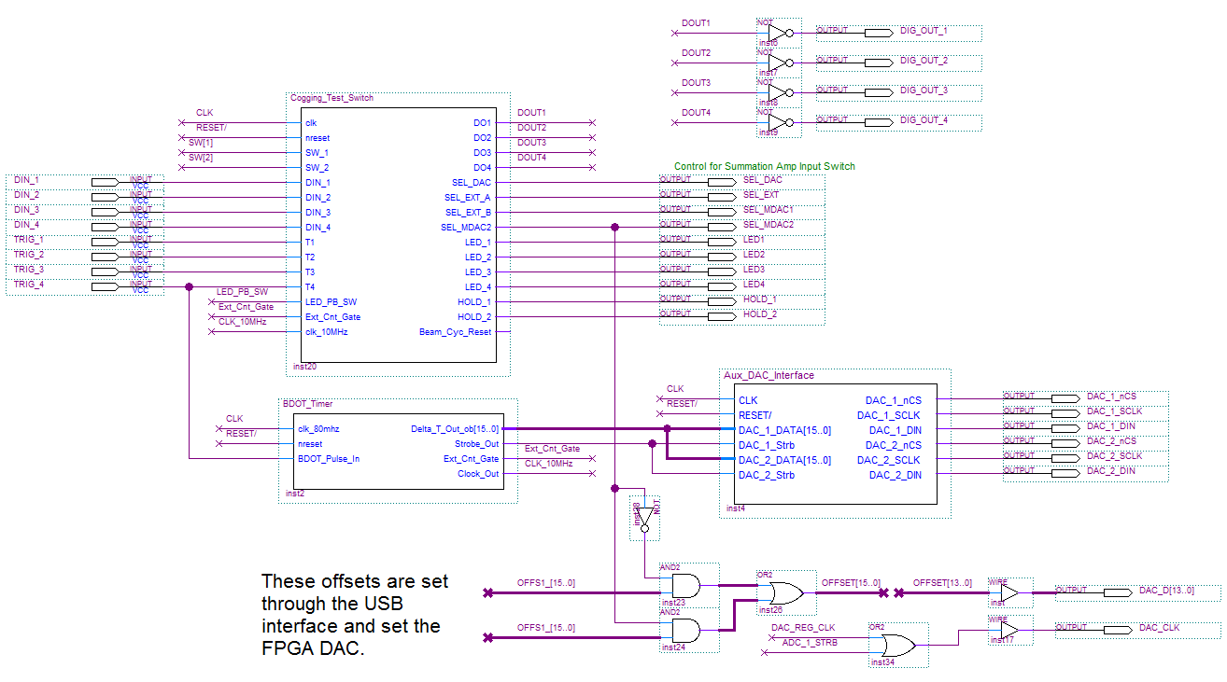
Figure 7

Listing 1

Library IEEE;
USE IEEE.std_logic_1164.all;
USE IEEE.std_logic_arith.all;
USE ieee.std_logic_unsigned.all;

-- My Definitions --------------------------------------------------
USE work.pkg_081006.all; -- my definitions and entities

--Version 4 breaks the EXTERNAL / MADC1 Switch logic out from the
-- Accel_PL_Ena and Start / Stop logic.

entity Cogging_Test_Switch is
port(clk : in std_logic;
nreset : in std_logic;
SW_1 : in std_logic; -- momentary trigger runs mode for 40ms
SW_2 : in std_logic; -- A High logic level sets BDOT timer mode
-- until returned to a Low logic level
DIN_1 : in std_logic;
DIN_2 : in std_logic;
DIN_3 : in std_logic;
DIN_4 : in std_logic;

T1 : in std_logic;
T2 : in std_logic;
T3 : in std_logic;
T4 : in std_logic;

LED_PB_SW : in std_logic;
Ext_Cnt_Gate : in std_logic;
clk_10MHz : in std_logic;

DO1 : out std_logic;
DO2 : out std_logic;
DO3 : out std_logic;
DO4 : out std_logic;

SEL_DAC : out std_logic;
SEL_EXT_A : out std_logic;
SEL_EXT_B : out std_logic;
SEL_MDAC2 : out std_logic;

LED_1 : out std_logic;
LED_2 : out std_logic;
LED_3 : out std_logic;
LED_4 : out std_logic;

HOLD_1 : out std_logic;
HOLD_2 : out std_logic;

Beam_Cyc_Reset : out std_logic
);
end Cogging_Test_Switch;

architecture main of Cogging_Test_Switch is

signal sel_alternate : std_logic;
signal sel_bdot_timer_mode : std_logic;

signal timer : std_logic_vector(23 downto 0);
signal timer_ena : std_logic;

signal alt_IO_mode : std_logic;
signal cycle_reset : std_logic;

-- State Machine declarations ------------------------------------
type STATE_TYPE is
(idle, switched, send_reset, bdot_timer_mode);
signal CS, NS : STATE_TYPE;

-- ## MAIN ##############################################################
begin
EDGE_ON_TEST_SELECT_TRIGGER: led
port map(sig_in => SW_1, clk => clk, clrn => nreset, pls_out => sel_alternate);

SELECT_BDOT_TIMER_MODE: process(clk, nreset, SW_2)
begin
if (nreset = '0') then sel_bdot_timer_mode <= '0';
elsif rising_edge(clk) then
if (SW_2 = '1') then sel_bdot_timer_mode <= '1';
else sel_bdot_timer_mode <= '0';
end if;
end if;
end process;

PROCESS_TIMER: process(clk, nreset, timer_ena, timer)
begin
if (nreset = '0') then timer <= (others => '0');
elsif rising_edge(clk) then
if (timer_ena = '0') then timer <= (others => '0');
else timer <= timer + 1;
end if;
end if;
end process;

----------------------------------------------------------
sm_reg: process (clk, nreset)
begin
if(nreset='0') then CS <= idle;
elsif(clk'event and clk='1')then CS <= NS;
end if;
end process; -- sm_reg

sm_combinatorial:
process (CS, timer, sel_alternate, DIN_1, DIN_2, DIN_3, DIN_4,
T1, T2, T3, T4,
sel_bdot_timer_mode, Ext_Cnt_Gate, clk_10MHz)
begin
-- default outputs --
timer_ena <= '1'; -- not enabled only when in idle state
cycle_reset <= '0';

DO1 <= T1; -- Normal Digital Inputs to Outputs
DO2 <= T2;
DO3 <= T3;
DO4 <= T4;

case CS is
when idle =>
timer_ena <= '0';
if (sel_alternate = '1') then NS <= switched;
elsif(sel_bdot_timer_mode = '1') then NS <= bdot_timer_mode;
else NS <= idle;
end if;

when switched =>
if (timer = X"30D400") then NS <= send_reset; -- time out at 40 ms
else NS <= switched;
end if;

DO1 <= DIN_1;
DO2 <= DIN_2;
DO3 <= DIN_3;
DO4 <= DIN_4;

when send_reset => NS <= idle;
cycle_reset <= '1';

when bdot_timer_mode =>
timer_ena <= '0';
DO3 <= Ext_Cnt_Gate;
DO4 <= clk_10MHz;

if (sel_bdot_timer_mode = '1') then NS <= bdot_timer_mode;
else NS <= idle;
end if;

when others => NS <= idle;
end case;

end process;

----------------------------------------------------------
SWITCH_CONTROL: process(clk, nreset, sel_alternate, cycle_reset)
begin -- THIS ACTS AS AN SR-FLIP FLOP
if (nreset = '0') then alt_IO_mode <= '0';
elsif rising_edge(clk) then
if (sel_alternate = '1') then alt_IO_mode <= '1';
elsif(cycle_reset = '1') then alt_IO_mode <= '0';
end if;
end if;
end process;

Beam_Cyc_Reset <= cycle_reset;

SEL_DAC <= '1';
SEL_EXT_A <= '0';
SEL_EXT_B <= alt_IO_mode;
SEL_MDAC2 <= not alt_IO_mode;

LED_1 <= SW_1;
LED_2 <= LED_PB_SW;
LED_3 <= not alt_IO_mode;
LED_4 <= SW_2;

HOLD_1 <= '0';
HOLD_2 <= '0';

end main;

Library IEEE;
USE IEEE.std_logic_1164.all;
USE IEEE.std_logic_arith.all;
USE ieee.std_logic_unsigned.all;

-- My Definitions --------------------------------------------------
USE work.pkg_081006.all; -- my definitions and entities

--This Module counts the number 10 MHz clocks between BDOT inputs.
-- It then subtracts the count from the nominal count (666,666) and
-- puts the difference out as the top ten bits of a +/- 15 bit DAC

entity BDOT_Timer is
port(
clk_80mhz : in std_logic;
nreset : in std_logic;
BDOT_Pulse_In : in std_logic;

Delta_T_Out_ob : out std_logic_vector(15 downto 0);
Strobe_Out : out std_logic;
Ext_Cnt_Gate : out std_logic;
Clock_Out : out std_logic
);
end BDOT_Timer;

architecture main of BDOT_Timer is

signal cnt_A : std_logic_vector(31 downto 0);
signal cnt_A_ena : std_logic;
signal cnt_A_rst : std_logic;

signal cnt_B : std_logic_vector(31 downto 0);
signal cnt_B_ena : std_logic;
signal cnt_B_rst : std_logic;

signal bdot : std_logic;

signal get_cnt_A : std_logic;
signal get_cnt_B : std_logic;

signal latched_cnt : std_logic_vector(31 downto 0);
signal delta_cnt_2s : std_logic_vector(31 downto 0);
signal delta_cnt_ob : std_logic_vector(31 downto 0);

signal delta_out_ob : std_logic_vector(31 downto 0);

signal clk_div : std_logic_vector(2 downto 0);
signal clk : std_logic;

component addsub32signed
PORT
(
add_sub : IN STD_LOGIC ;
dataa : IN STD_LOGIC_VECTOR (31 DOWNTO 0);
datab : IN STD_LOGIC_VECTOR (31 DOWNTO 0);
result : OUT STD_LOGIC_VECTOR (31 DOWNTO 0)
);
end component;

-- State Machine declarations ------------------------------------
type STATE_TYPE is
(count_on_a, latch_cnt_a, reset_cnt_a,
count_on_b, latch_cnt_b, reset_cnt_b );
signal CS, NS : STATE_TYPE;

-- ## MAIN ##############################################################
begin
EDGE_ON_BDOT_PULSE_IN: led
port map(sig_in => BDOT_Pulse_In, clk => clk, clrn => nreset, pls_out => bdot);

DIVIDE_CLOCK: process(clk_80mhz, nreset, clk_div)
begin
if (nreset = '0') then clk_div <= (others => '0');
elsif rising_edge(clk_80mhz) then clk_div <= clk_div + 1;
end if;
end process;
-----------------------------------------------------
clk <= clk_div(2); -- 80 MHz divided by 8 = 10 MHz
Clock_Out <= clk;
-----------------------------------------------------

PROCESS_TIMER_A: process(clk, nreset, cnt_A_ena, cnt_A_rst, cnt_A)
begin
if (nreset = '0') then cnt_A <= (others => '0');
elsif rising_edge(clk) then
if (cnt_A_ena = '1') then cnt_A <= cnt_A + 1;
elsif(cnt_A_rst = '1') then cnt_A <= (others => '0');
end if;
end if;
end process;

PROCESS_TIMER_B: process(clk, nreset, cnt_B_ena, cnt_B_rst, cnt_B)
begin
if (nreset = '0') then cnt_B <= (others => '0');
elsif rising_edge(clk) then
if (cnt_B_ena = '1') then cnt_B <= cnt_B + 1;
elsif(cnt_B_rst = '1') then cnt_B <= (others => '0');
end if;
end if;
end process;

DAC_COUNT_LATCH: process(clk, nreset, get_cnt_A, get_cnt_B, cnt_A, cnt_B)
begin
if (nreset = '0') then latched_cnt <= (others => '0');
elsif rising_edge(clk) then
if (get_cnt_A = '1') then latched_cnt <= cnt_A;
elsif(get_cnt_B = '1') then latched_cnt <= cnt_B;
end if;
end if;
end process;
----------------------------------------------------------
COMPUTE_DELTA: addsub32signed
PORT MAP (
add_sub => '0',
dataa => X"000A2C2A", -- 666666
datab => latched_cnt,
result => delta_cnt_2s
);

delta_cnt_ob(31 downto 0) <= (not delta_cnt_2s(31)) & delta_cnt_2s(30 downto 0);

LIMIT_DELTA_TO_10_BITS:
process(delta_cnt_ob)
begin
if (delta_cnt_ob > X"800003FF") then delta_out_ob <= X"800003FF";
elsif(delta_cnt_ob < X"7FFFFC01") then delta_out_ob <= X"7FFFFC01";
else delta_out_ob <= delta_cnt_ob;
end if;
end process;

----------------------------------------------------------------------------------------------
Delta_T_Out_ob(15 downto 0) <= (not delta_out_ob(10)) & delta_out_ob(9 downto 0) & "00000";

Ext_Cnt_Gate <= cnt_A_ena;
----------------------------------------------------------
sm_reg: process (clk, nreset)
begin
if(nreset='0') then CS <= count_on_a;
elsif(clk'event and clk='1')then CS <= NS;
end if;
end process; -- sm_reg

sm_combinatorial:
process (CS, bdot)
begin
-- default outputs --
cnt_A_ena <= '0';
cnt_A_rst <= '0';
cnt_B_ena <= '0';
cnt_B_rst <= '0';
get_cnt_A <= '0';
get_cnt_B <= '0';
Strobe_Out <= '0';

case CS is
when count_on_a =>
cnt_A_ena <= '1';
if (bdot = '1') then NS <= latch_cnt_a;
else NS <= count_on_a;
end if;

when latch_cnt_a => NS <= reset_cnt_a;
cnt_B_ena <= '1';
get_cnt_A <= '1';

when reset_cnt_a => NS <= count_on_b;
cnt_B_ena <= '1';
cnt_A_rst <= '1';
Strobe_Out <= '1';

when count_on_b =>
cnt_B_ena <= '1';
if (bdot = '1') then NS <= latch_cnt_b;
else NS <= count_on_b;
end if;

when latch_cnt_b => NS <= reset_cnt_b;
cnt_A_ena <= '1';
get_cnt_B <= '1';

when reset_cnt_b => NS <= count_on_a;
cnt_A_ena <= '1';
cnt_B_rst <= '1';
Strobe_Out <= '1';

when others => NS <= count_on_a;
end case;
end process;
end main;

Listing 2

BDOT Interval Measurement
23-Jun-16
Signal  Generator, ms | Delta ms | External  Counter | Delta  Count | DAC  AOUT 1, V
Column1 | Column2 | Column3 | Column4 | Column5
66.66667 | 0.00117 | 666655 | 11 | 0.161 |  | Linest | delta_cnt = m Volts + b
66.66767 | 0.00017 | 666665 | 1 | 0.0635 |  | m | b
66.66867 | -0.00083 | 666675 | -9 | -0.034 |  | 102.3428 | -5.74425
66.66967 | -0.00183 | 666685 | -19 | -0.132
66.67167 | -0.00383 | 666705 | -39 | -0.327 |  | Linest | Volts = m delta_cnt + b
66.67267 | -0.00483 | 666715 | -49 | -0.424 |  | m | b
66.67667 | -0.00883 | 666755 | -89 | -0.814 |  | 0.009771 | 0.056128
66.68267 | -0.01483 | 666815 | -149 | -1.401
66.69067 | -0.02283 | 666895 | -229 | -2.1828 |  | Linest | Delta_ms=m Volts + b
66.70667 | -0.03283 | 666995 | -329 | -3.159 |  | m | b
66.72067 | -0.05283 | 667195 | -529 | -5.112 |  | 0.010234 | -0.0005
66.74067 | -0.07283 | 667395 | -729 | -7.065
66.76067 | -0.09283 | 667595 | -929 | -9.018 |  | Linest | Volts = m delta_ms + b
66.66567 | 0.00217 | 666645 | 21 | 0.259 |  | m | b
66.66467 | 0.00317 | 666635 | 31 | 0.3605 |  | 97.71083 | 0.049288
66.66267 | 0.00517 | 666615 | 51 | 0.556
66.66067 | 0.00717 | 666595 | 71 | 0.751
66.65667 | 0.01117 | 666555 | 111 | 1.141
66.65067 | 0.01717 | 666495 | 171 | 1.728
66.64067 | 0.02717 | 666395 | 271 | 2.705
66.63067 | 0.03717 | 666295 | 371 | 3.683
66.62067 | 0.04717 | 666195 | 471 | 4.66
66.61067 | 0.05717 | 666095 | 571 | 5.637
66.59067 | 0.07717 | 665895 | 771 | 7.592
66.57067 | 0.09717 | 665695 | 971 | 9.543

