Kicking the Booster Neutrino Beam Off Target

  - Thomas R. Kobilarcik
  - 21 January 2016

ABSTRACT
Even during 6+6 slip stacking to NuMI and 5 Hz to the Short Baseline, the Booster will not run at 15 Hz. However, if the Booster Neutrino beam could be steered rapidly off target, the additional beam could the sent to the 50 m absorber. This paper explores the possibility of rapidly steering (kicking) the beam off target.
Introduction
The present Booster Neutrino Beamline [BNB] horn is designed to run at a maximum repetition rate of 5 Hz average; with 6+6 slip stacking to NuMI, the Booster will run at 9 Hz average. Thus, there will be, on average, 1 Hz “left over”. See figure 1.
In 2015, BNB ran in “off-target” mode, that is, the primary beam was steered such that it went between the top of the target and below the inner wall of the target tube, and into an absorber located 50 m from the target. This required an approximately 7.5 mm vertical change in beam trajectory. In this mode, the horn was not pulsed.
The final focusing triplet in BNB focuses the beam onto the target in both plane, that is, it acts as a thick focusing lens in each plane. If the beam were kicked at the upstream focal point, this would translate to a parallel movement downstream of the lens (all para-axial rays converge to a single point, by definition of a thin focusing lens; then run the system backwards).
The Booster operates at 15 Hz. Thus, any kicker magnet would need to rise/fall in about 1/30 second (at present, all BNB magnets, except the initial switch magnet, operate DC).
Thus, if a kicker can be located at the upstream focal point, the beam can be steered off target.
Beamline Optics
A calculation using the transfer matrix of the triplet, and confirmed using TRANSPORT, indicates that the upstream vertical focal point is 10.5 m upstream of the first triplet quadrupole (Q873). If located at this point, a 0.0240 T*m kick would move the beam 7.5 mm above the target. The present LEP correctors are capable of a 0.0211 T*m (DC) kick, indicating that 0.0240 T*m is a reasonable strength.

Magnet Selection
Table 1 shows several candidate magnets and their associated parameters. In addition to strength, the magnet must have a low enough inductance so that it can be ramped, and adequate aperture. A good choice is an NDB type magnet. EE support should be consulted regarding this choice.
Beamline Optics Two – Harsh Reality Rears it’s Ugly Head
Unfortunately, the focal point is at the upstream face of the last bend in the vertical dogleg (V8721). Additionally, real magnets have bellows and other things hanging off them. Nonetheless, we modify the beamline model to have an NDB upstream of V8721, with 30 cm separation. The beam is no longer parallel when exiting the triplet – it has a 0.073 mr pitch, which would result in a 3.8 mm (as opposed to 7.5 mm offset) at the 50 m absorber, and a -32 mm offset at the MiniBooNE detector.
Control of the Magnet
Because the magnet would kick when the horn is off, the kicker and horn require different events. One possibility is to re-task the “beginning of pulse train” ($B0) and “end of pulse train” ($B1) events to “BNB Horn Fire” and “BNB Kicker Fire”, respectively. These events could be broadcast synchronously with a $1D. An advantage of this scheme is no other systems (MBEX, multiwires, lossmonitors) would be affected.
Conclusion
Assuming an offset of -32 mm (as opposed to 7.5 mm) at the MiniBooNE detector is acceptable, it is possible to steer the beam off the target for individual pulses using a single existing kicking magnet.

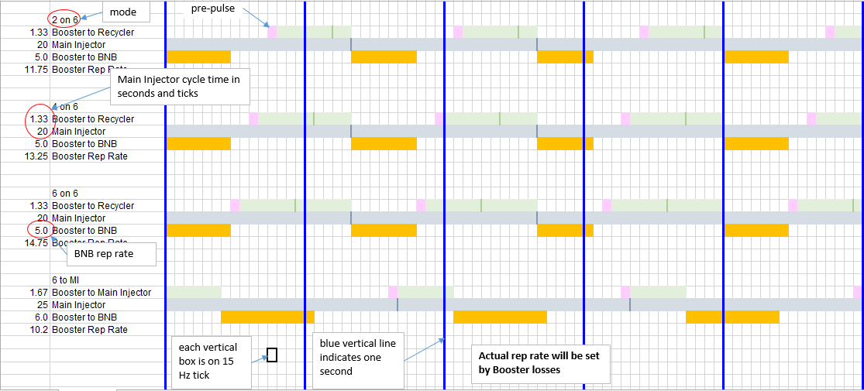
Figure 1. Slip stacking and BNB scenarios.

Type | s | x | g | I_{max} | R | L | BL
 | [m] | [T*m/A] | [m] | [A] | [ohm] | [H] | [T*m]
MCH | 0.400 | 0.0130 | 0.102 | 2.5 | 10.2 | 23.0 | 0.02113
MCV | 0.400 | 0.0085 | 0.199 | 2.5 | 21.8 | 9.3 | 0.02113
MCHB | 0.400 | 0.0042 | 0.102 | 2.5 | 2.1 | 1.1 | 0.02113
MCVB | 0.400 | 0.0033 | 0.199 | 2.5 | 2.8 | 1.5 | 0.02113
HDC | 0.305 | 0.0072 | 0.051 | 15.0 | 2.2 | 1.1 | 0.02113
VDC | 0.305 | 0.0032 | 0.127 | 15.0 | 2.4 | 0.9 | 0.02113
NDB | 0.508 | 0.0018 | 0.143 | 20.0 | 0.7 | 0.3 | 0.02400
NDA | 0.203 | 0.0016 | 0.114 | 19.0 | 0.8 | 0.3 | 0.02400
NDB | 0.508 | 0.0018 | 0.143 | 20.0 | 0.7 | 0.3 | 0.02529

Type | dI | dt | V=L*dI/dt | V=I*R | V_{T} | notes
 | [A] | [s] | [V] | [V] | [V]
MCH | 1.63 | 0.033 | 1121.3 | 16.6 | 1137.8 | voltage too high
MCV | 2.50 | 0.033 | 693.8 | 54.5 | 748.3 | voltage too high
MCHB | 5.03 | 0.033 | 164.5 | 10.6 | 175.1 | gap marginal
MCVB | 6.40 | 0.033 | 284.2 | 17.6 | 301.8
HDC | 2.95 | 0.033 | 97.4 | 6.5 | 103.9 | gap too small
VDC | 6.69 | 0.033 | 180.5 | 16.0 | 196.5
NDB | 13.50 | 0.033 | 120.7 | 10.1 | 130.8 | looks good
NDA | 14.96 | 0.033 | 153.0 | 12.3 | 165.3
NDB | 14.22 | 0.033 | 127.1 | 10.6 | 137.8 | TRANSPORT value
Table 1. Parameters of various candidate magnets.

