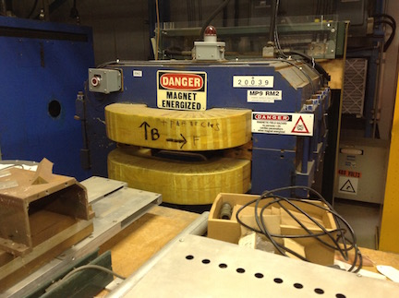

Is it the best way to test parameters of a garnet specimen?

Need to make the following:

1. Model fields of a cylinder sample in the magnet with different excitation coil placement.
2. A sample inside a solenoid

Required magnet field in the solenoid when my = 1.5:

B = Ms + H 🡪 mu = 1 + Ms/H = 1.5 🡪 H = Ms/0.5 = 2 Ms

With Ms = 800 Oe, required H = 1600 Oe 🡪 0.16/12.5E-7 = 128000 A/m =

H*L = I 🡪 **J = H = 1280 A/cm**

Tuning the modeling file with I = 5 A:

1. Geometry with a 5 mm gap at the coil:

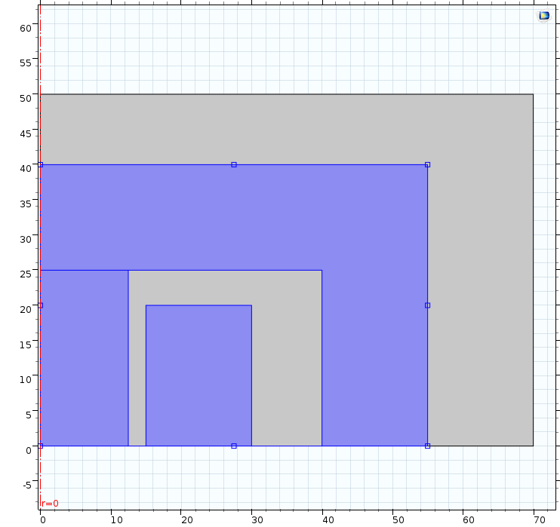 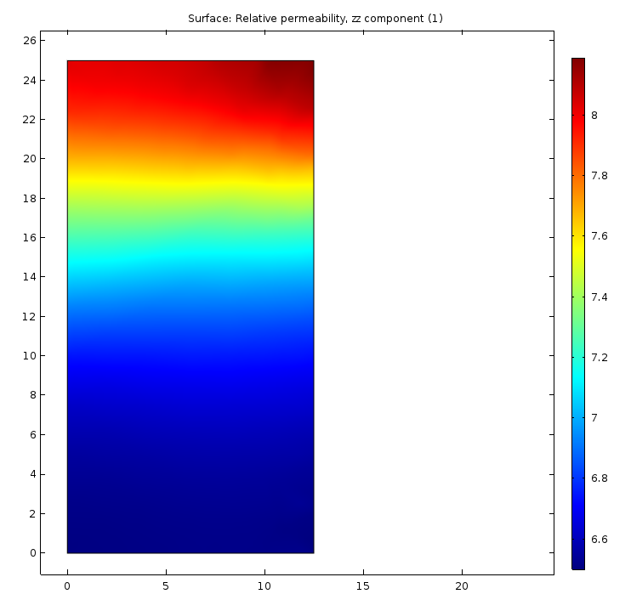

1. Geometry with a 2.5 mm gap at the coil:

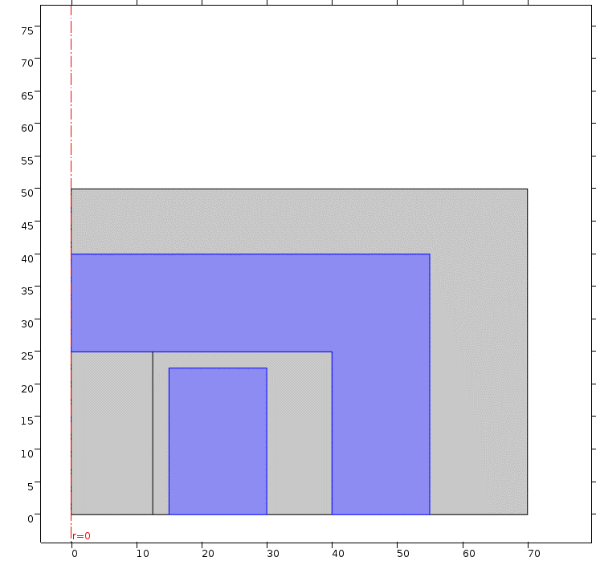 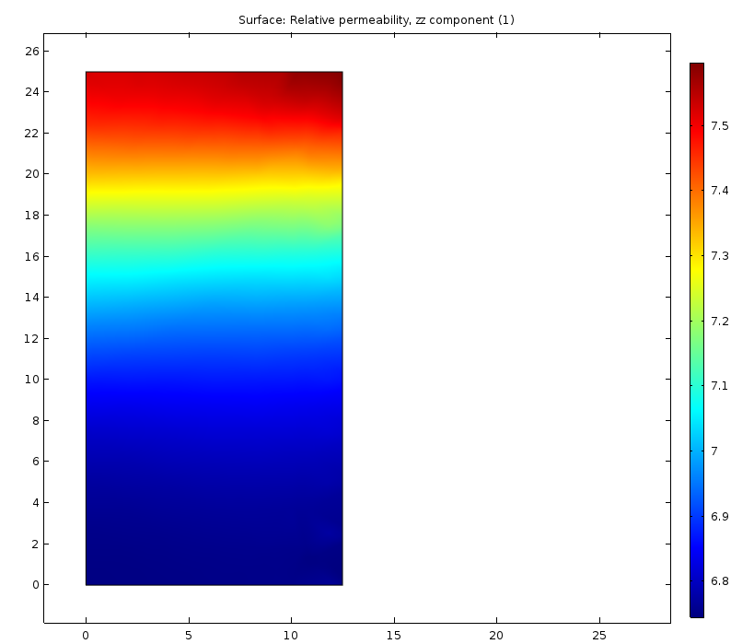

1. Geometry with a zero gap at the coil:

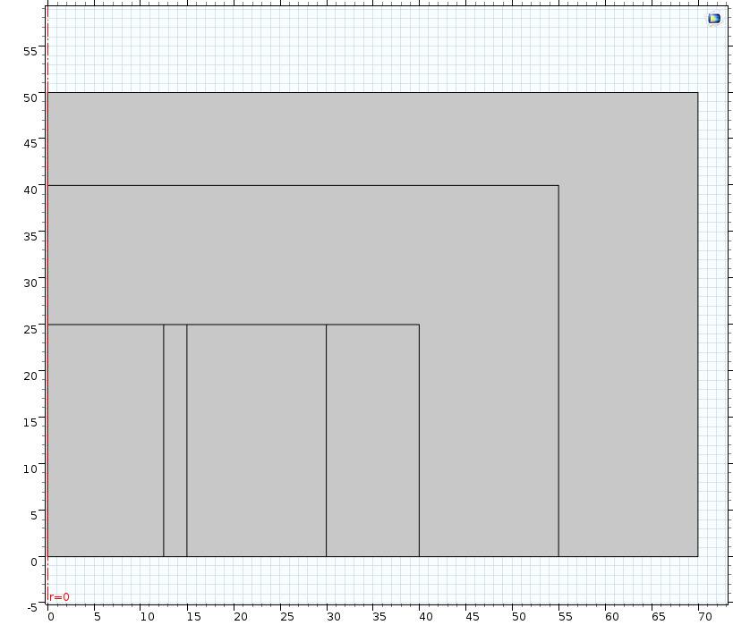 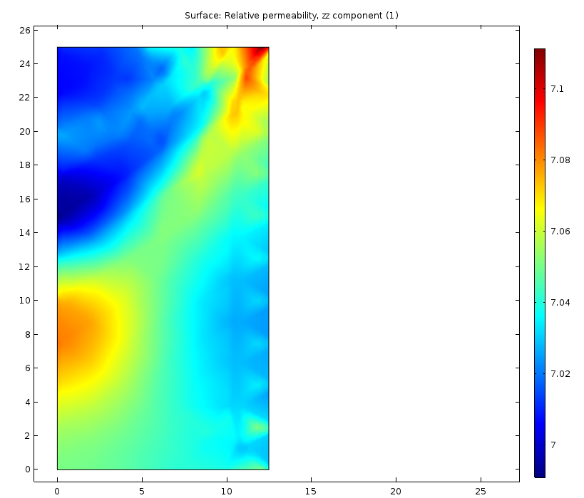

So, to get good results, **the coil must fill all the space**

How does the radial placement of the coil come in the game? Let’s use smaller current: I = 1 A

R0 = 15 mm

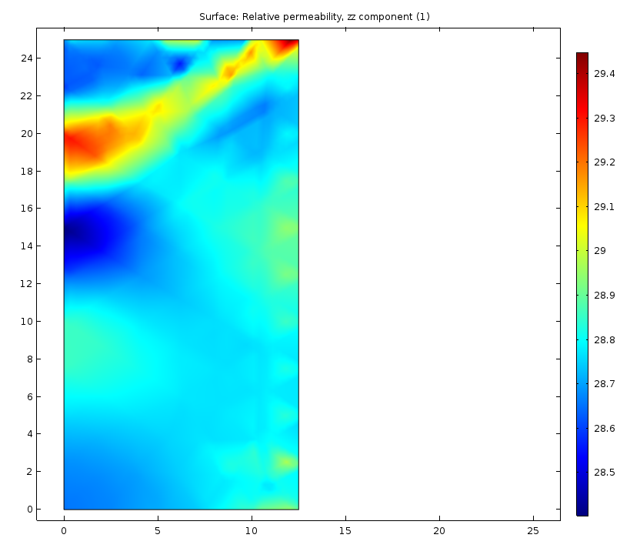

🡪 R = 24 mm

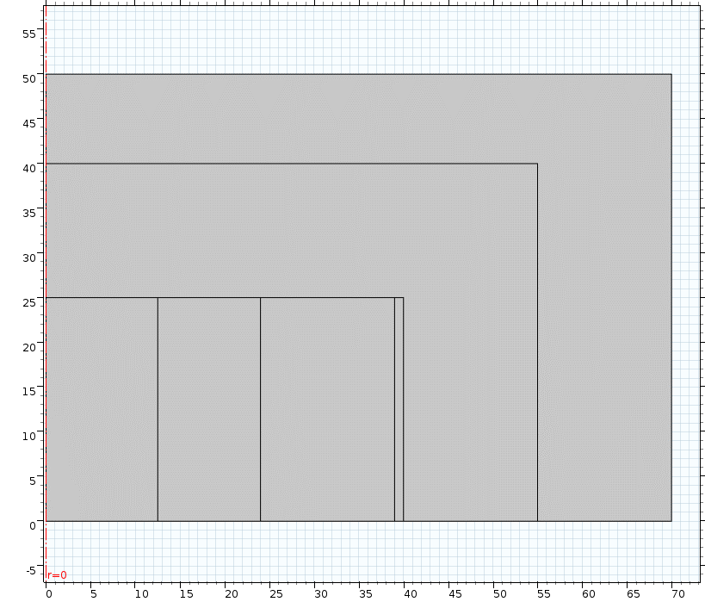 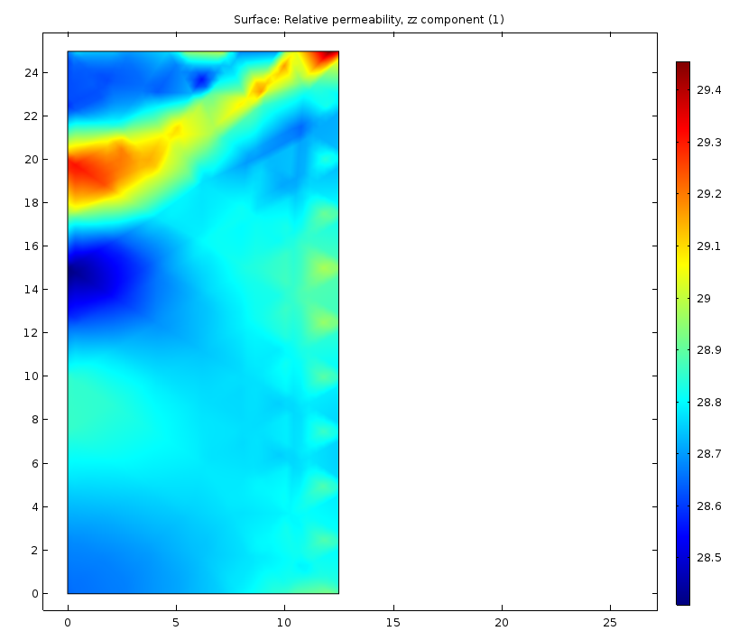

Practically there is no difference.

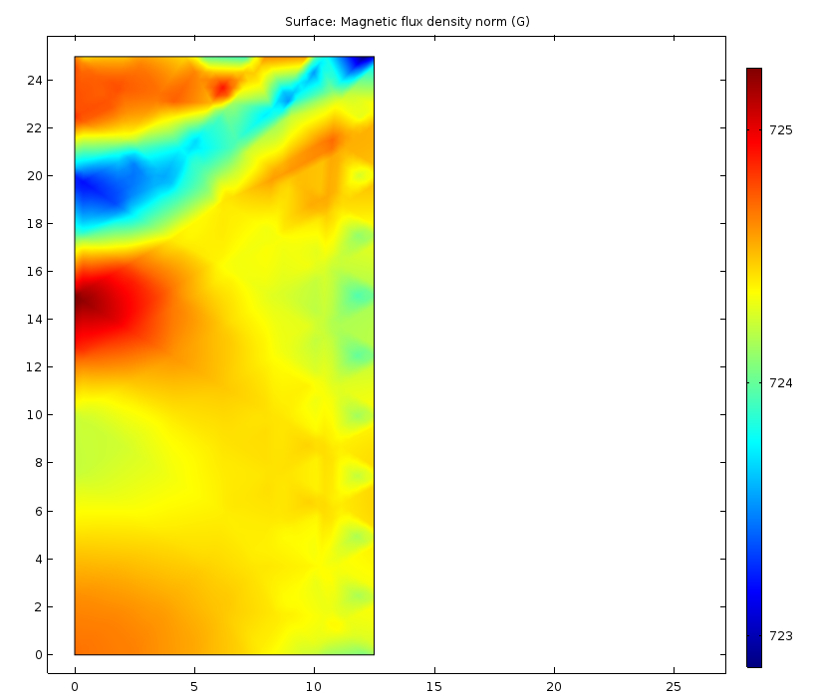 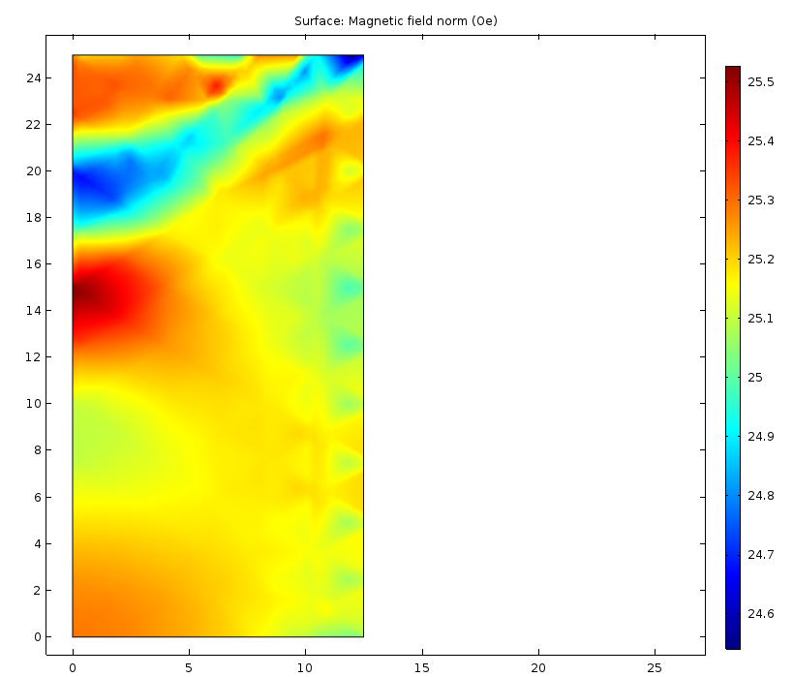

How does the permeability of the magnet core come in the game? It was 5000 Let’s make it 1000 🡪

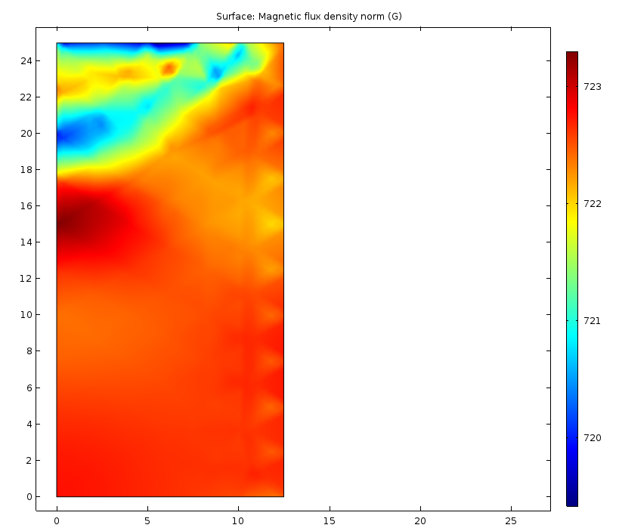 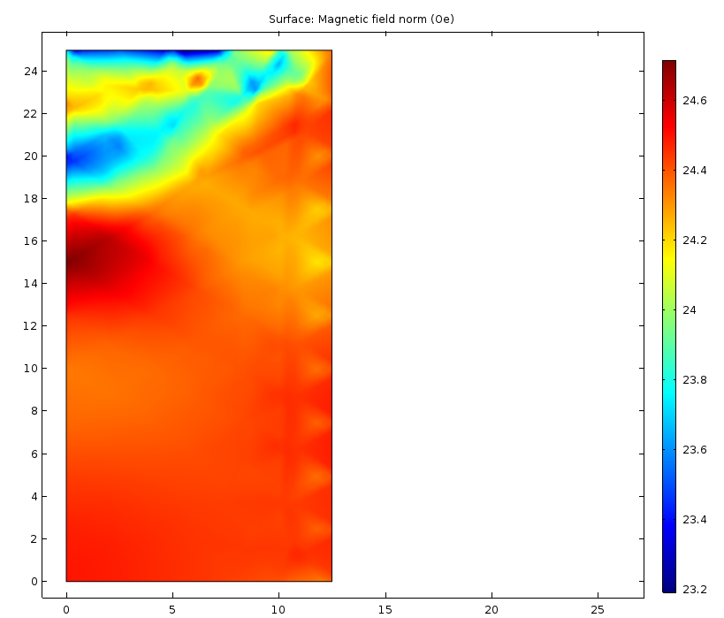

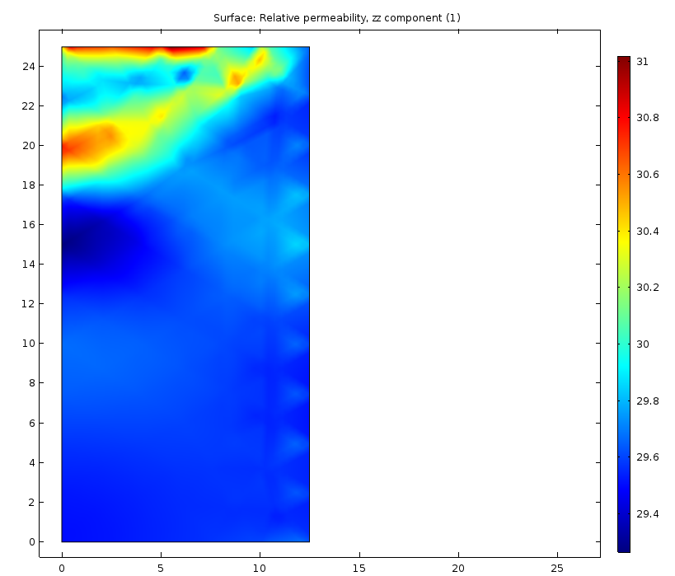

We get smaller field due to the lower permeability of the core 🡪 a bit higher permeability of the garnet. Nevertheless, the spread did not change much – it was ~1 and now ~1.5 which seems OK.

What is we have yoke with mu = 500 ?

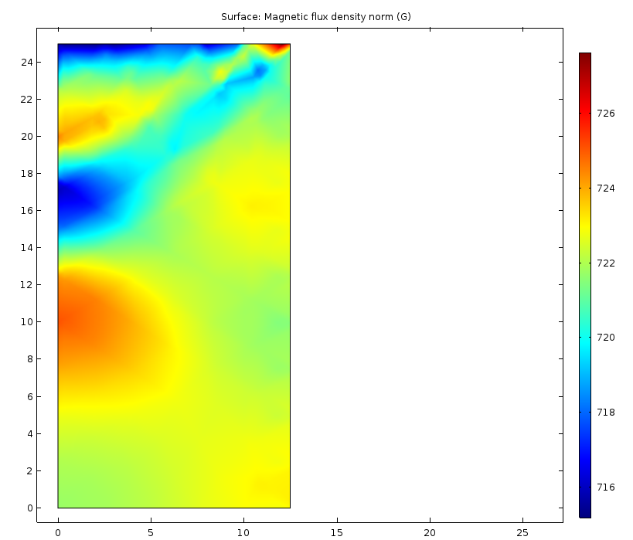 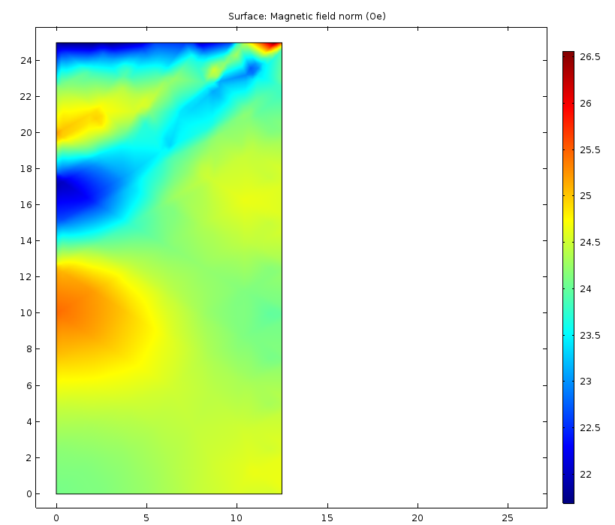

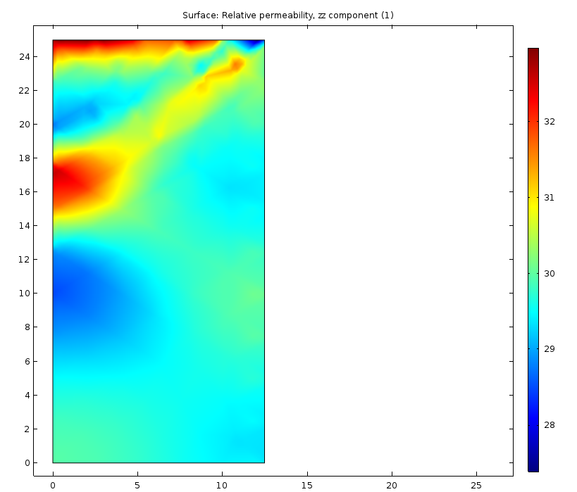

Spread in permeability became more significant ~6

So, material of the yoke must be good 🡪 good ferrite with mu >= 5000 or soft (1006) steel.

Let’s use **mu = 1000** and go from small current to the high one and record the fields, the permeability, and the flux in the garnet.

I = 0.1 A 🡪

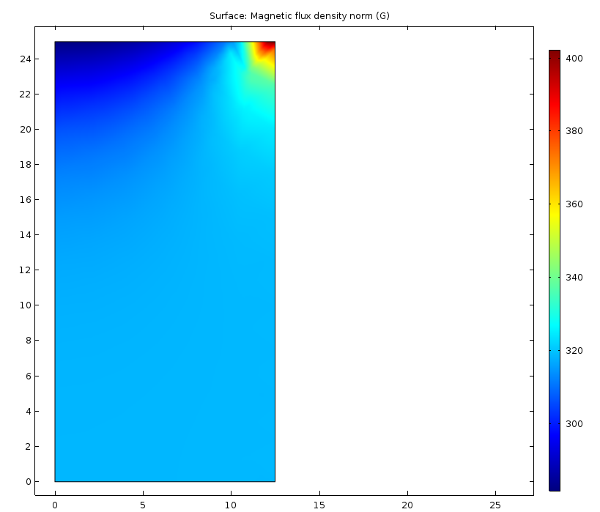 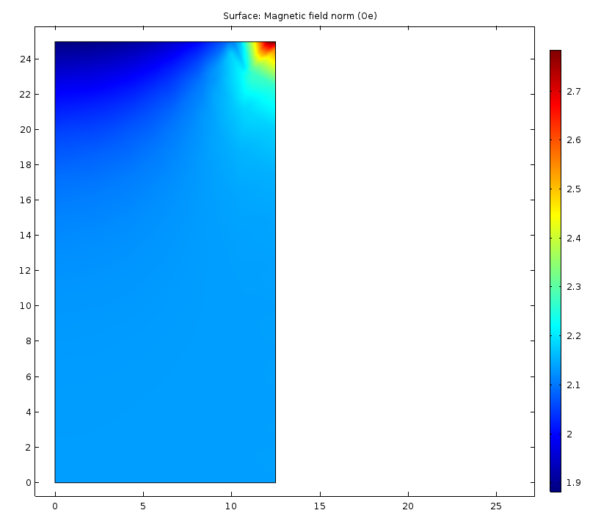

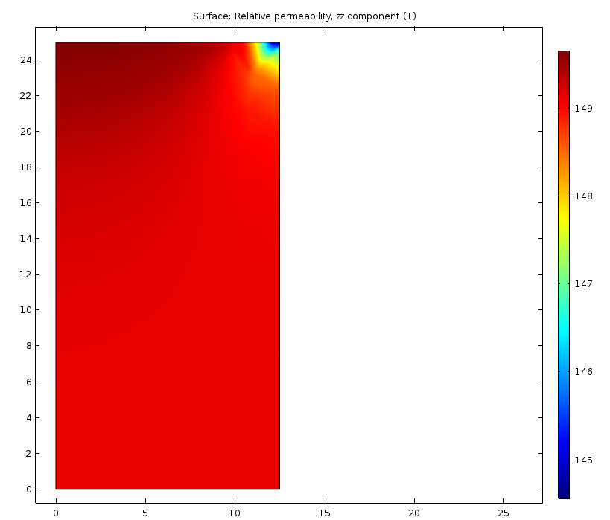

So, there is an increase in the field and the reduction in the permeability in the corner of the garnet 🡪 can a pole tip help ??

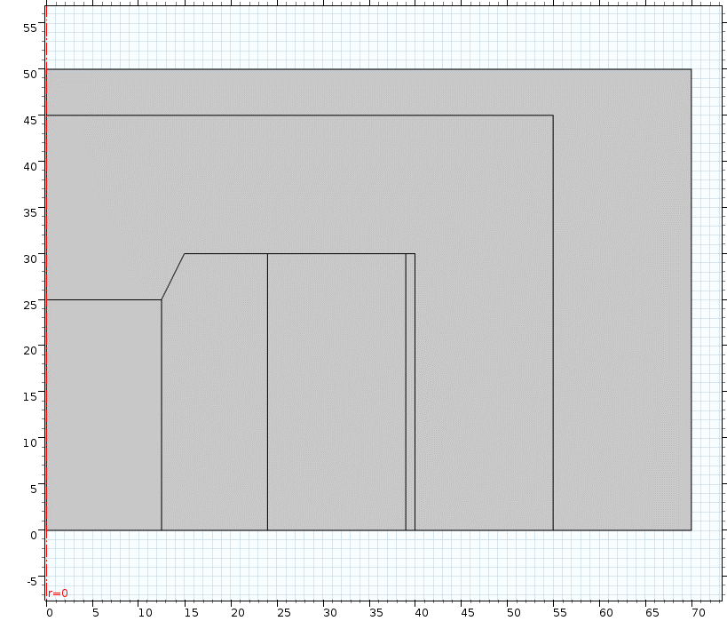

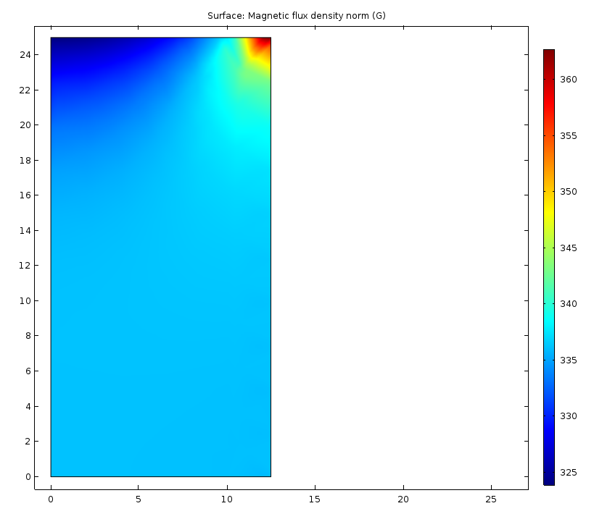 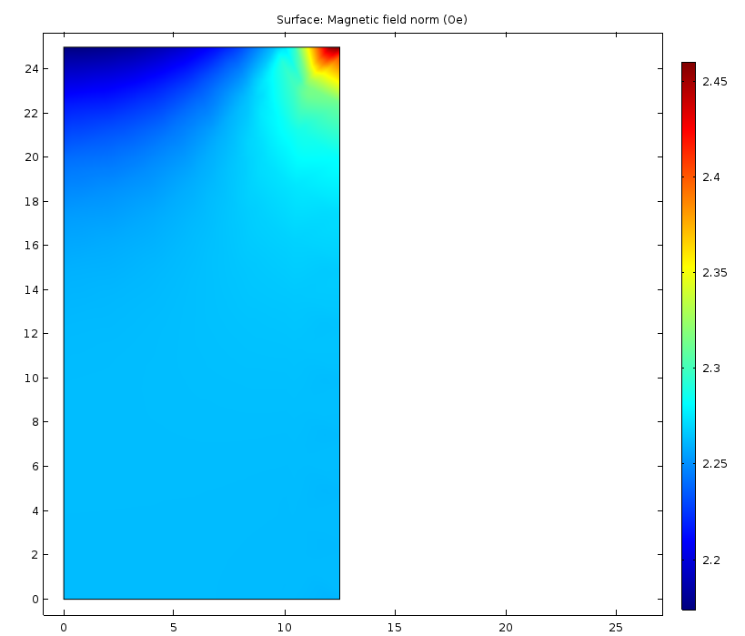

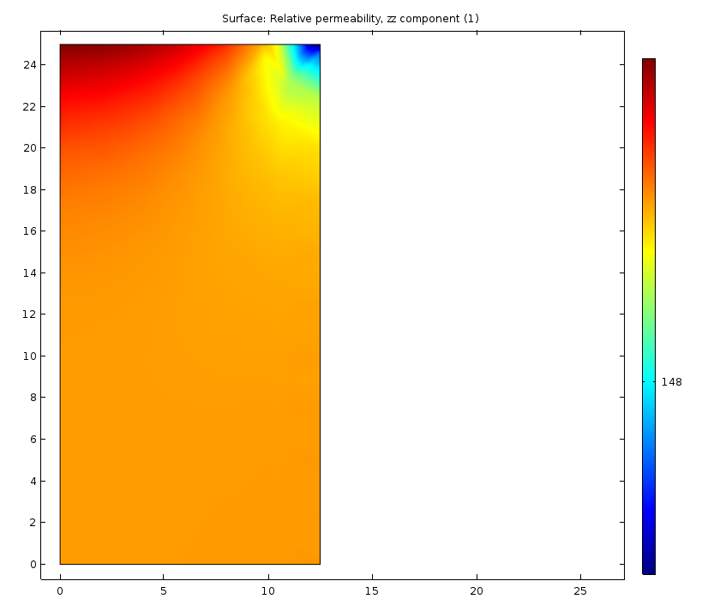 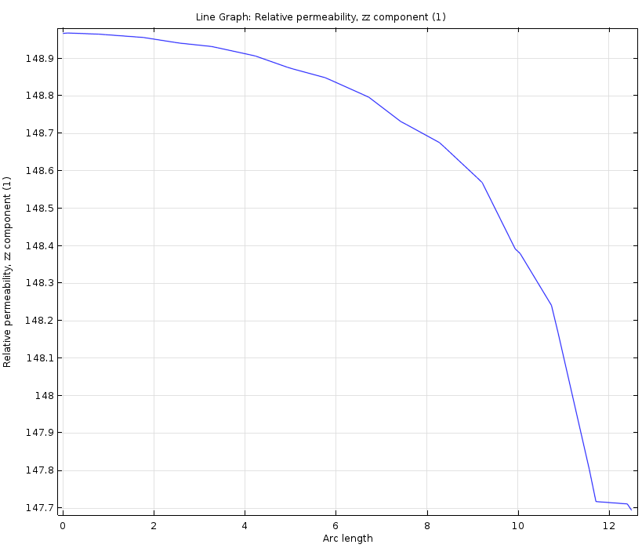

The field is more uniform now. Line graph is along the top portion of the garnet.

|  |  |  |  |  |  |  |
| --- | --- | --- | --- | --- | --- | --- |
| I (A) | **B_min (G)** | B_max (G) | **H_min (Oe)** | H_max (Oe) | mu | Flux (T*m2) |
| 0.1 | **325** | 362 | **2.15** | 2.45 | 147.7 - **150** | 1.650e-5 |
| 0.15 | **453** | 493 | **3.27** | 3.76 | 131.3 – **138.2** | 2.2865e-5 |
| 0.2 | **537** | 572 | **4.42** | 5.15 | 111 – **121.5** | 2.685e-5 |
| 0.25 | **587.5** | 615 | **5.6** | 6.7 | 93.5 - **105** | 2.914e-5 |
| 0.3 | **617** | 642 | **6.7** | 9.1 | 71 - **90** | 3.034e-5 |
| 0.35 | **632.5** | 653.5 | **8.2** | 10.5 | 63 – **77.5** | 3.105e-5 |
| 0.4 | **644** | 665 | **9.3** | 11.9 | 57 - **69** | 3.16e-5 |
| 0.45 | **655** | 679 | **11.1** | 13.7 | 50 - **62** | 3.215e-5 |
| 0.5 | **665** | 687.5 | **11.8** | 15 | 45.8 – **56.7** | 3.264e-5 |
| 0.55 | **674.5** | 692.3 | **13** | 16 | 43.5 - **52** | 3.31e-5 |
| 0.6 | **682** | 699 | **14.2** | 17.3 | 40.3 – **48.3** | 3.347e-5 |
| 0.7 | **695** | 721 | **16.5** | 23.7 | 31.2 – 42.1 | 3.41e-5 |
| 0.8 | **703** | 730 | **18.7** | 27.3 | 26.9 – 38.5 | 3.46e-5 |
| 0.9 | **713** | 748 | **21** | 36.5 | 20.5 – 34.3 | 3.50e-5 |
| 1.0 | **720** | 757 | **23.2** | 40.8 | 19.5- 31 | 3.53e-5 |
| 1.5 | **743** | 797 | **34** | 60 | 13.3 – 21.8 | 3.65e-5 |
| 2.0 | **769** | 833 | **46** | 82 | 10.2 – 16.8 | 3.77e-5 |
| 2.0* | **769** | 833 | **46** | 82 | 10.2 – 16.6 | 3.78e-5 |
| 2.0** | **771** | 792 | **47** | 57.3 | 13.8 – 16.4 | 3.78e-5 |
| 5** | **866** | 896 | **109** | 142 | 6.35 – 7.92 | 4.29e-5 |
| 10** | **965** | 1055 | **212** | 287 | 3.65 – 4.61 | 4.88e-5 |
| 20** | **1180** | 1350 | **415** | 575 | 2.35 – 2.86 | 6.084e-5 |

Procedure of extracting the static permeability (B/H) is as following:

1. We consider the yoke of high permeability
2. Static permeability µµ0 = B/H; B = Φ/S; H = Iwcoil /*L* 🡪 µ = Φ*L*/µ0SIwcoil
3. Flux Φ is found by integration of the voltage induced in the loop during current ramp around the sample (V = wloop*dΦ/dt, 🡪 Φ = 1/wloop *∫Vdt)
4. So, µ = *L*/(µ0SIwcoilwloop)*∫Vdt

In our case, using the table above, we can find dΦ/dI 🡪 integrate it to find Φ.

We will have µ = Φ*L*/µ0SIwcoil

As the current increases, more spread in the field, and permeability is seen.

This is because the field from the pole is trapped in the sample:

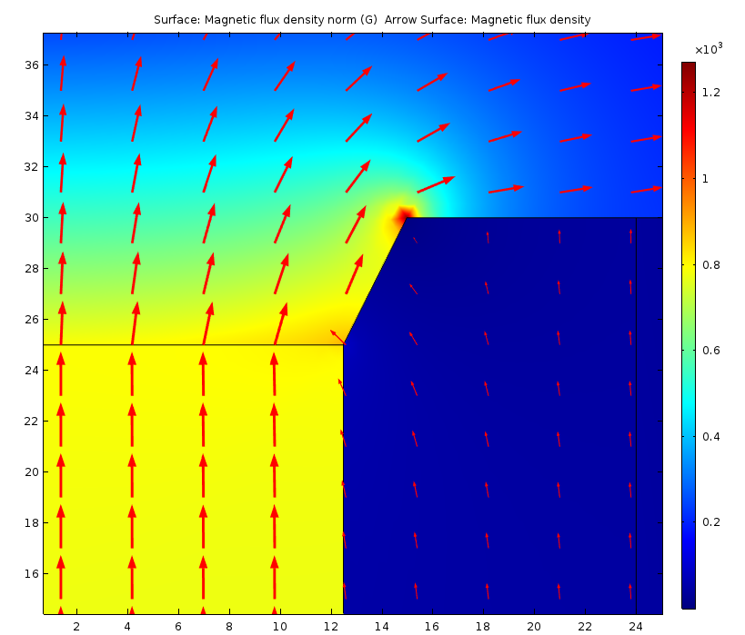

Closer location of the coil does not change anything (see the line 2A*).

What if to make a pole profile that takes the field out of the garnet 🡪 see line 2A**

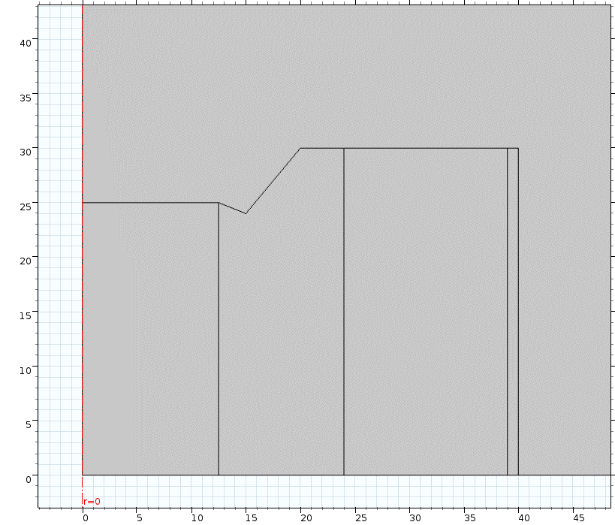 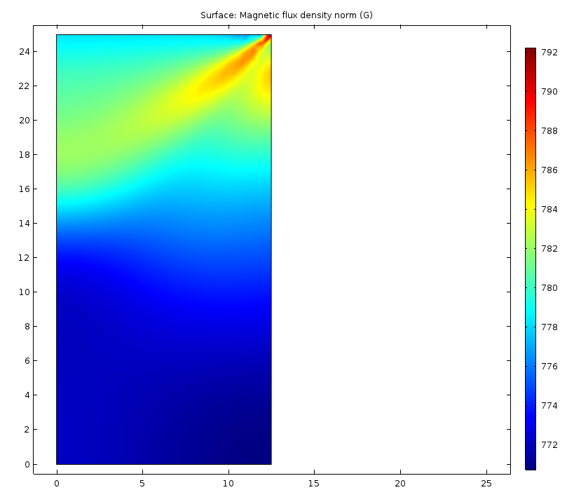

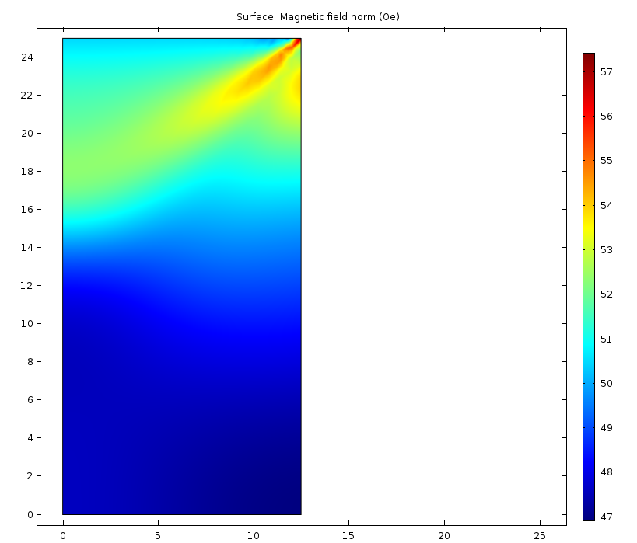 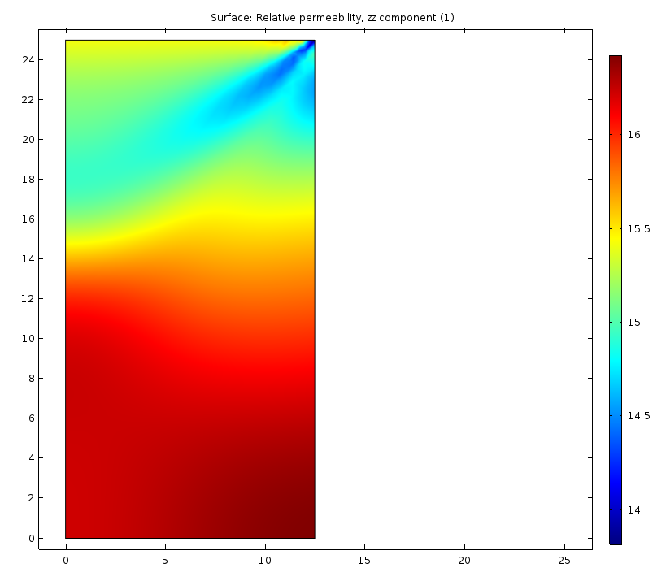

So, this profiling works well.

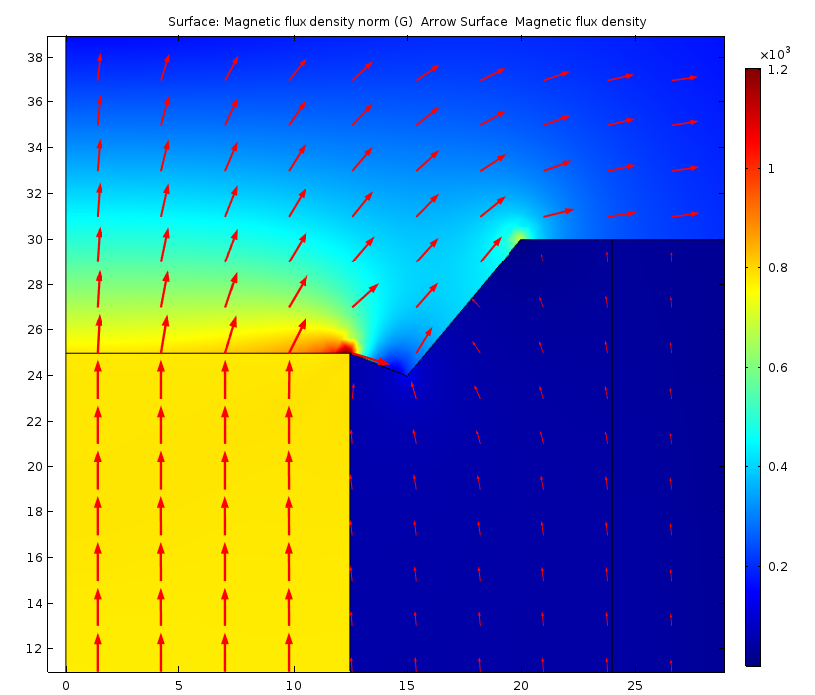

At 20 A near the top:

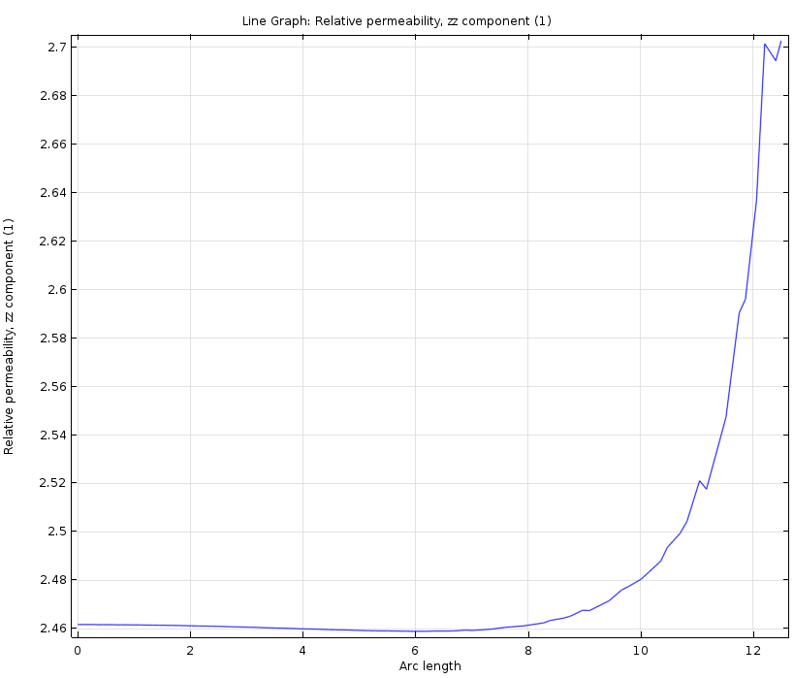 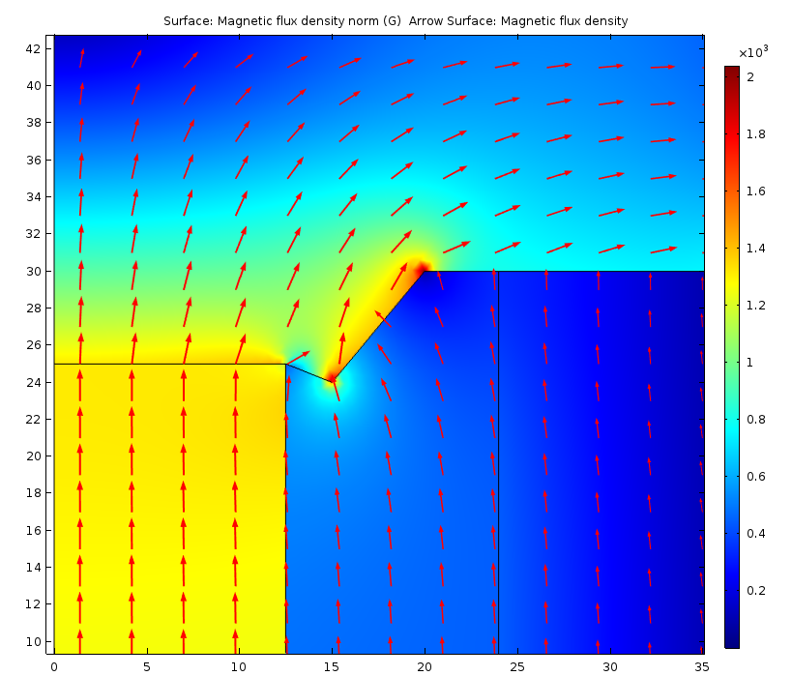

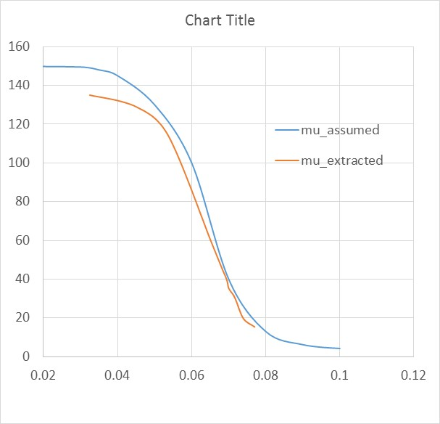

**What if we use a solenoid instead of a magnet ??**