Optimization of the magnetic field in the ferrite.
- Initial stage - the pole as described in the note. Iw = 6 kA
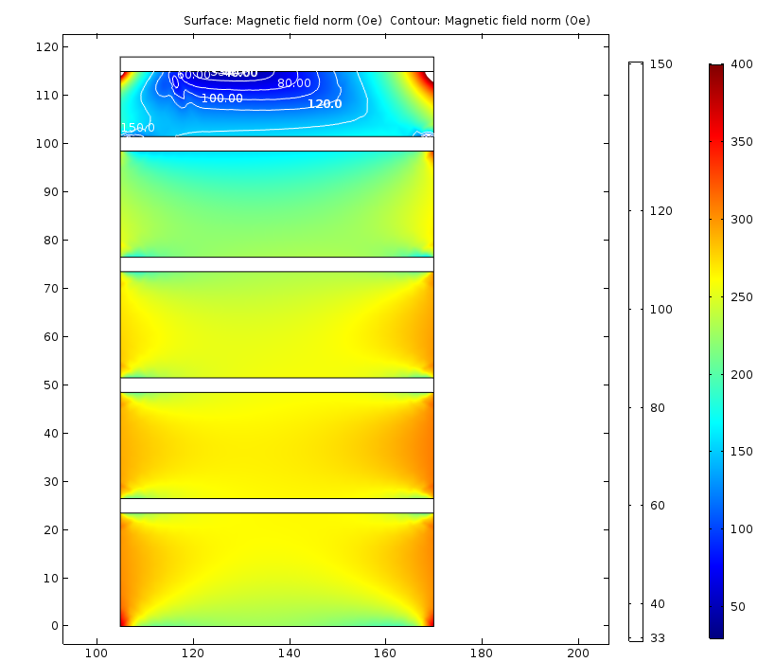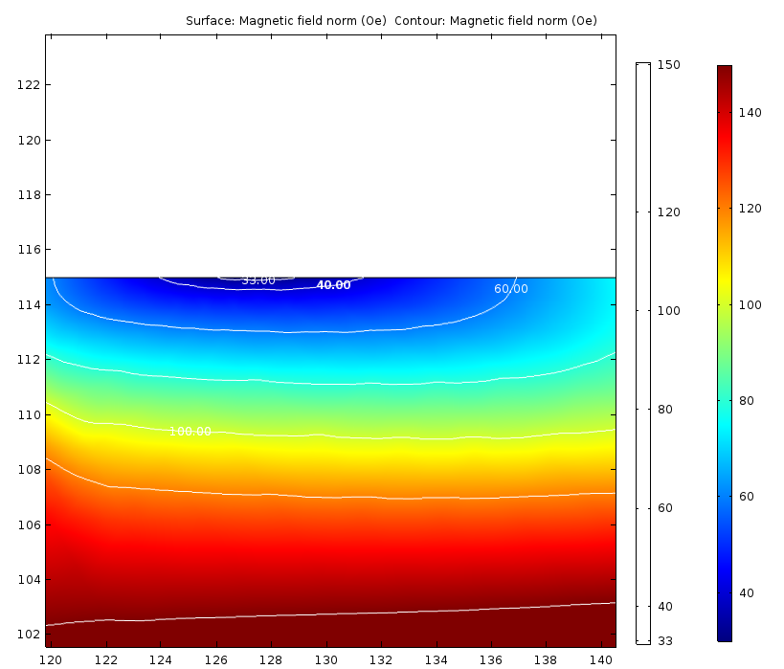
After additional block is added:
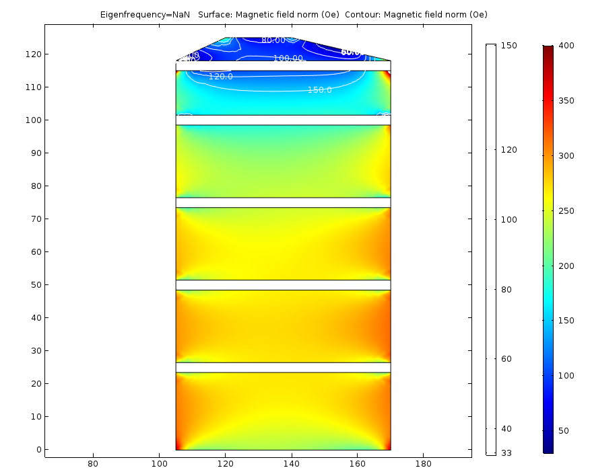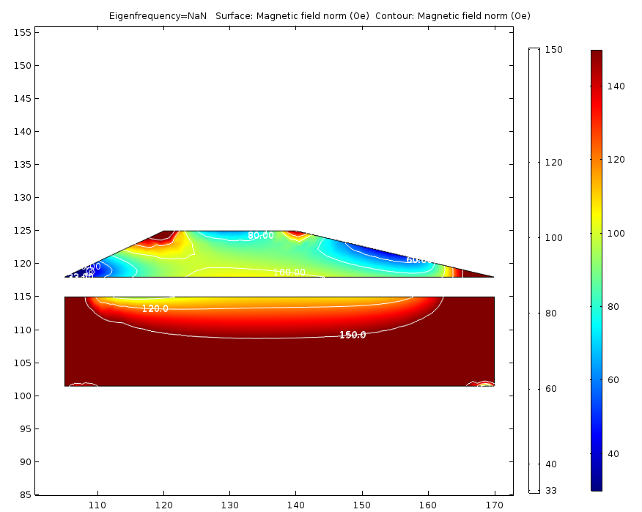
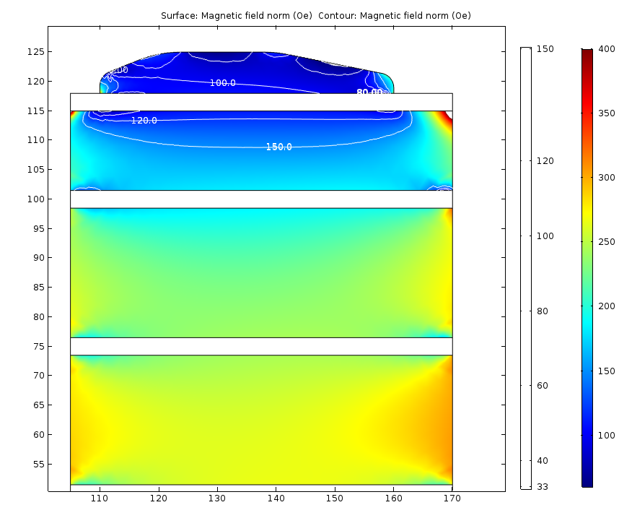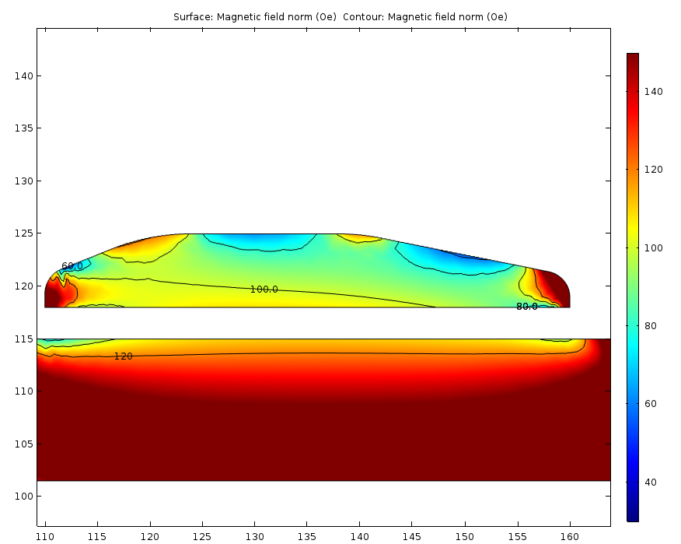
It looks promising; another iteration with the shape:
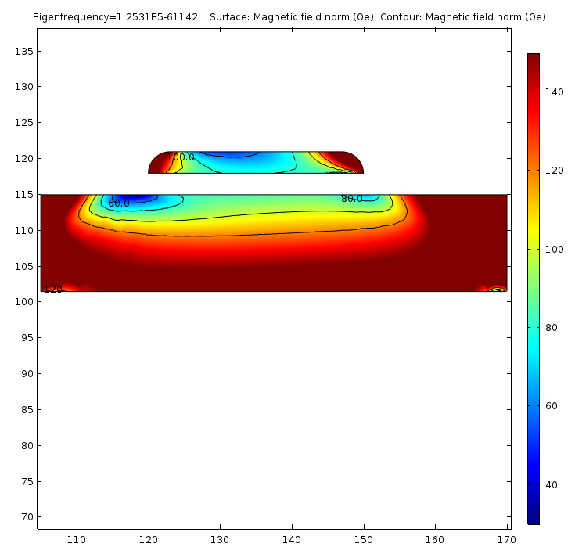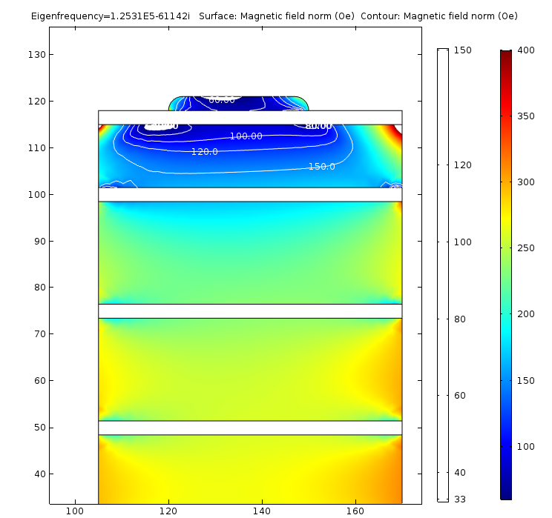
F = 70 MHz in this case. Min field in the scale is 60 Oe.
More iterations are needed, but we can use this approach to get needed increase of the minimum field in the top block.
What happens on the other side of the current range I = 20 kA
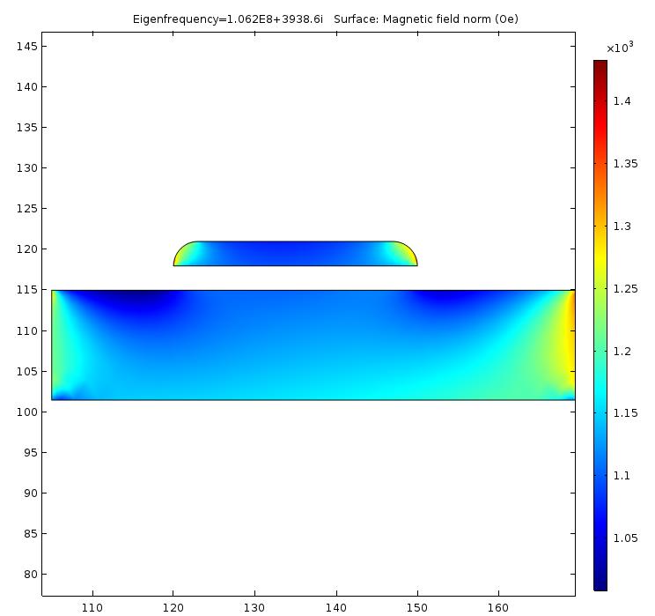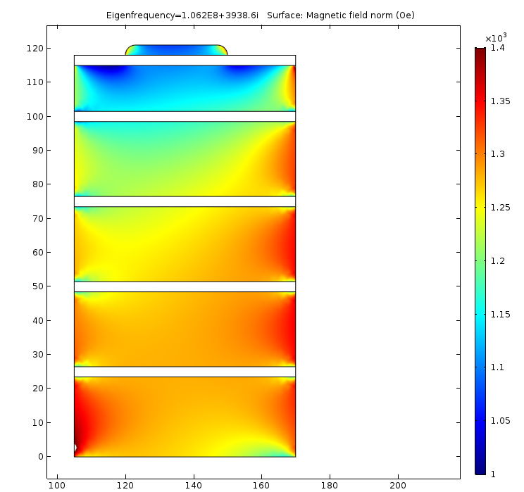
f = 106.2 MHz (it was 106.7 MHz without the addition)
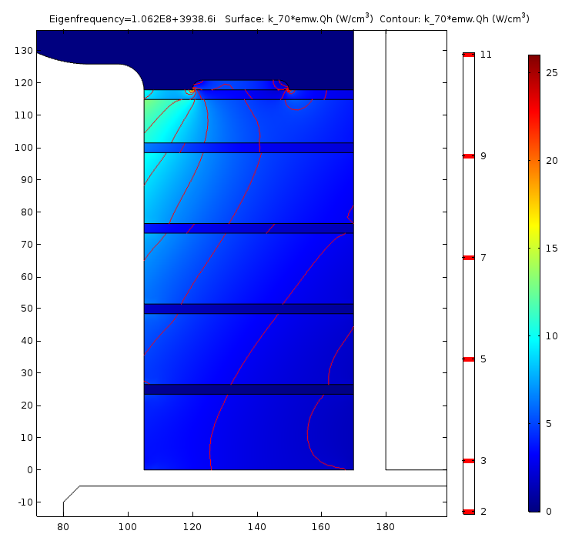

Plan:
- Re-configure thickness of the blocks in the tuner
e.g. 13.5 + 3 x 22 + 23.5 = 103 mm 4 x 20 + 22 = 103 mm
- Optimize the shape of the shim.
- Iterate the thermal study (simplified !!!)
- Approach to the tuner cooling system design.
- Material properties test stand. Can we get the vendor into the collaboration? Are they interested?

