Changes During Meson Shutdown

January 2016

This document outlines 2 of the 3 primary changes in the Meson Test beamline during the January 2016 shutdown. The changes for the shutdown are a new PWC in the air gap before MT5VT1, the high rate tracking area motion table was re-installed, and ultimately the vacuum system received much needed maintenance. The first two of these are covered in this document.

# A New PWC in Air Gap Before MT5VT1

Currently there is no working instrumentation between the MT4 Target and the Mt6 Section 1 enclosure to indicate beam position in the Meson Test Secondary beamline (M03-MT6-1). Fiber profile monitors were installed in place of standard Wire Chambers in the past in an effort to obtain beam profiles with minimal beam scattering. The scintillating fibers were only partially successful even after installation. Since then the scintillators have become less sensitive most likely due to clouding in the scintillating glass.

During the 1 month shutdown we installed a new Dan Schoo style Proportional Wire Chamber (PWC) in the air gap just before MT5VT1. This profile monitor is shown in the first image. The second image shows a drawing with details of the PWC. The PWC consists of 3 layers of 1 mil Kapton, 3 .125 inch air gaps which are filled with ArCo2 and 2 wire planes which consist of 10 Micron (.000010) wires. The wires are small and irrelevant to both energy deposistion and scattering. The ArC02 will be comparable to the air that the beam already passes through, thus the kapton is the primary medium that matters with the scattering and energy deposition.

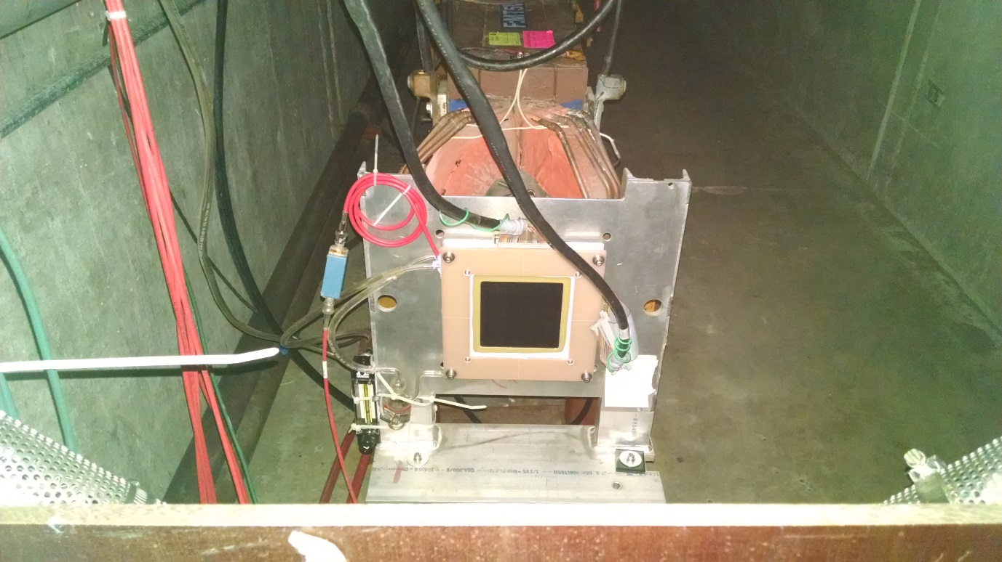



#### Beam Loss

According to the Particle Data Group Kapton is a Polyimide film or chemically (C22H10N2O5)n. The interaction length = 85.8 Grams/cm2. With a density 0f 1.42 Grams/cm3 the interaction length = 60.42 cm.

The nuclear interaction length is the mean path length required to reduce the number of particles by 1/e or .368. In other words 63.2% of the beam is lost in 1 interaction length. The beam left is

1-1/e

Our medium is not a full interaction length thus we determine the fractional interaction length. The length of 3 layers of kapton is 0.00762 cm. The interaction length for Kapton is 60.42 cm thus L/Li= .00762/60.42=.000126 or .0126% of an interaction length.

Percentage beam loss due to this material is then 1-1/(e(L/Li)) :

1-e-.000126=.000126

The highest intensities in the MTest beamline are for 32 GeV proton mode. In this mode we can deliver just over 1 million particles through the secondary MTest beamline. Thus using 1 Million particles as our maximum number we find that we might lose .000126*1,000,000 or just over 100 Particles due to the added Proportional Wire Chamber.

#### Scattering

According to the Particle Data Group the scattering angle of a particle traveling through medium is:

Theta=(13.6 MeV/Beta*c*p) *z*SquareRoot(X/X0)*[1+0.038*ln(X/X0)]

Where P is momentum Beta*c is velocity and z is the charge number. The Radiation length, X0, of Kapton is 40.56 Grams/cm2 or 28.6 cm. X is the thickness of the Kapton which is 0.00762 cm. For Meson Test momentums, Beta is always close to 1.

Considering a 32 GeV beam the additional scattering angle caused by our PWC is:

32 GeV Theta = 5 microRadians

Beams-doc-4697-v1 “The Addition of an Air Gap and Scintillator in the Meson Test Secondary Beamline” found that the air gap and upstream time of flight detector contribute 52 microRadians at 32 GeV. Adding in quadrature for a rough estimate shows a total scattering angle:

52.24 microRadians with the new PWC versus the 52 microRadians without.

Next considering a 2 GeV beam the additional scattering angle caused by our PWC is:

2 GeV Theta = 76 microRadians

Beams-doc-4697-v1 “The Addition of an Air Gap and Scintillator in the Meson Test Secondary Beamline” found that the air gap and upstream time of flight detector contribute 830 microRadians at 2 GeV. Adding in quadrature for a rough estimate shows a total scattering angle of:

833.5 microRadians with the new PWC versus the 830 microRadians without.

#### Transport Model to Determine Downstream Impact

Using the transport model of the MTest beamline one can model the impacts of the total scattering and estimate the increase in beam size at the MTest experiments for each momentum. The next plots show the beamline from the MT4 Target to 30 meters downstream of the entrance of MT6-1. The model with no additional scattering is without any scattering from the air gap, windows, scintillator and new PWC. The traces with both 32 GeV scattering and 8 GeV scattering are with the windows, air gap, scintillator and new PWC.

These results show no impact at 32 GeV. The results show that at 2 GeV there is less than a .010 m (10 cm) increase in either plane.

Figure 1 This plot shows a comparison of Horizontal beam half width with no additional scattering in blue. The red shows the 32 GeV scattering angle with the air gap, windows, scintillator and PWC. The Gray shows these at 2 GeV. The beam blows up less than 10 cm.

Figure 2 This plot shows a comparison of vertical beam half width with no additional scattering in blue. The red shows the 32 GeV scattering angle with the air gap, windows, scintillator and PWC. The Gray shows these at 2 GeV. The beam blows up less than 10 cm.

# Motion Table in the High Rate Tracking Area

A motion table was installed in the high rate trackikng area to accommodate future experiments. The table was tested and found to be fully functional. The table is positioned in its lowest position closest to the wall which makes it completely out of the beam path. The table has enough freedom to move into the beam path thus I turned off the controls in Meson Service building 3 and unplugged the cables in the tunnel thus rendering the table inoperable.

