Bulging analysis of the assembled tuner under the nominal heat load

Assumed material properties:

Al₂O₃ (99.5%) Al₂O₃ (99.9%) (ultra high purity)
Density 3.9 G/cm³ 3.92
Elastic Modulus 370 GPa 386
Poison ratio 0.22 0.22
Compressive strength 2600 MPa 2700
Flexural strength 379 MPa 400
Tensile strength 262 MPa 283
Specific heat 880 J/(kg*K) 870
Thermal conductivity 30 W/m.K 35
Thermal expansion coefficient 8.2x10⁻⁶ 1/⁰C 8.1x10⁻⁶
Dielectric constant 9.7 9.8
Dielectric loss coefficient 0.0001 <0.0001
Dielectric strength 8.7 kV/mm 8.7

Ferrites AL-800
Density 4.5 - 5 G/cm³
Elastic Modulus 120 – 150 GPa
Poison ratio
Compressive strength 410 – 2000 MPa
Flexural strength 120 – 150 GPa
Tensile strength
Specific heat 710 – 1100 J/kg-K
Thermal conductivity 3.5 – 6.3 W/m-K 5.4 W/m.K
Thermal expansion coefficient (8 – 11)x10⁻⁶ 1/K 1.04x10⁻⁵/⁰C
Dielectric constant 10 - 300

Stainless steel
Density 8.0
Elastic Modulus 193 GPa
Poison ratio 0.27 – 0.3
Tensile strength 500 MPa
Specific heat 500 J/kg-K
Thermal conductivity 16.3 W/m-K
Thermal expansion coefficient 15.9 x10⁻⁶ 1/K

Temperature field consistent with what was found earlier
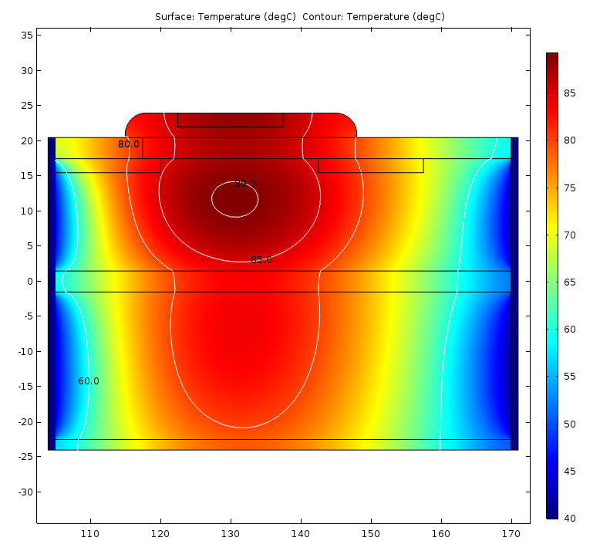

Von-Mises stress and deformation (R = 135 mm) with the outer pressure 100 kPa (1 Atm)
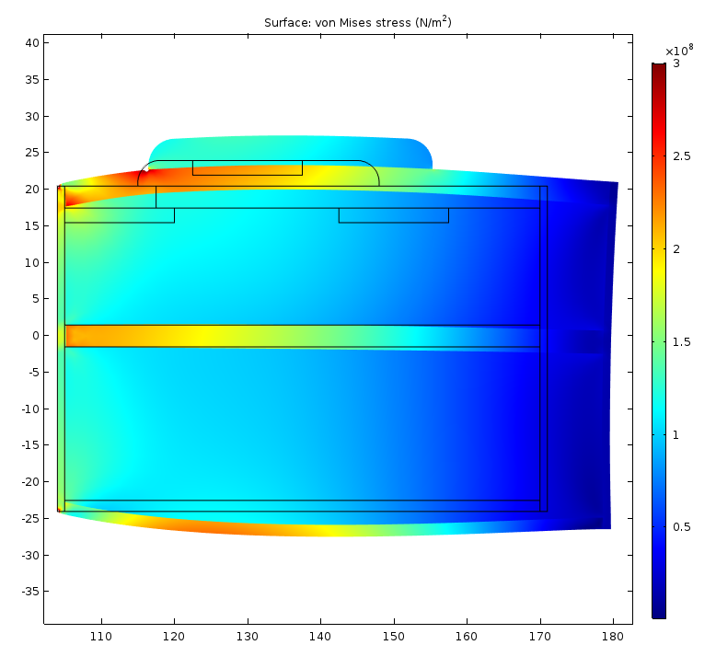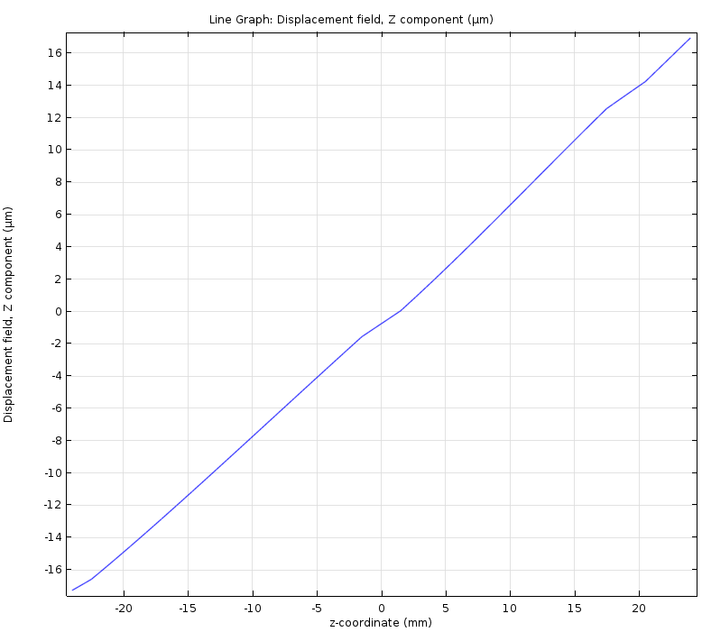

Von-Mises stress and deformation (R = 135 mm) with the outer pressure 1E8 Pa (1000 Atm)
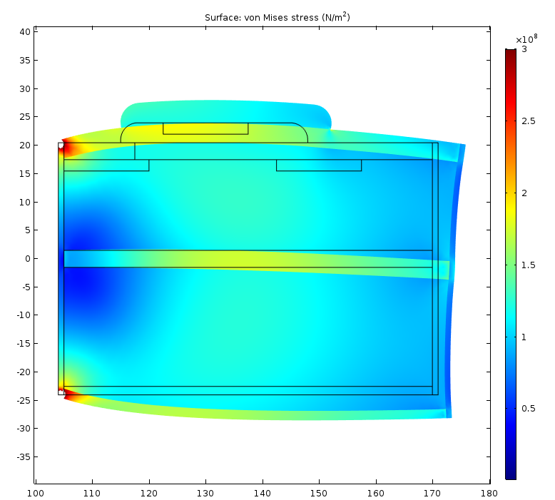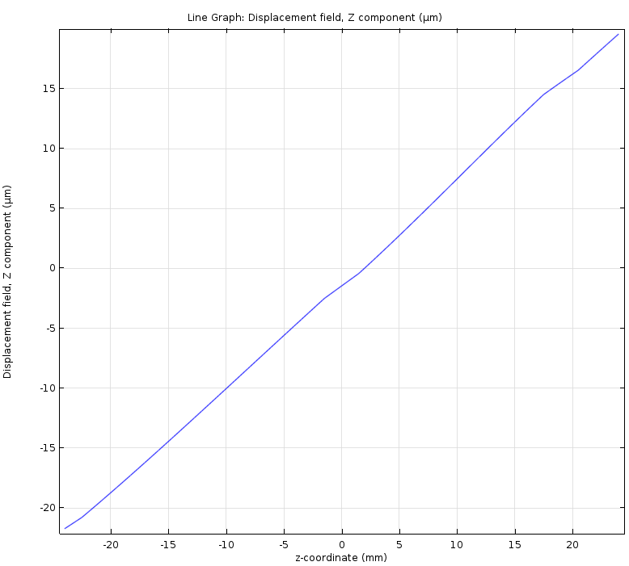

Different boundary conditions must be imposed on the structure to avoid the effect of the stainless steel shells. Let’s allow free movement of the steel shells (having in mind that there is no bonding between the blocks and the shells). This is equivalent to saying that the Young’s modulus of the shell material is very low.193

